Research Juan

- Look for a map of the electricity grid showcasing voltage levels
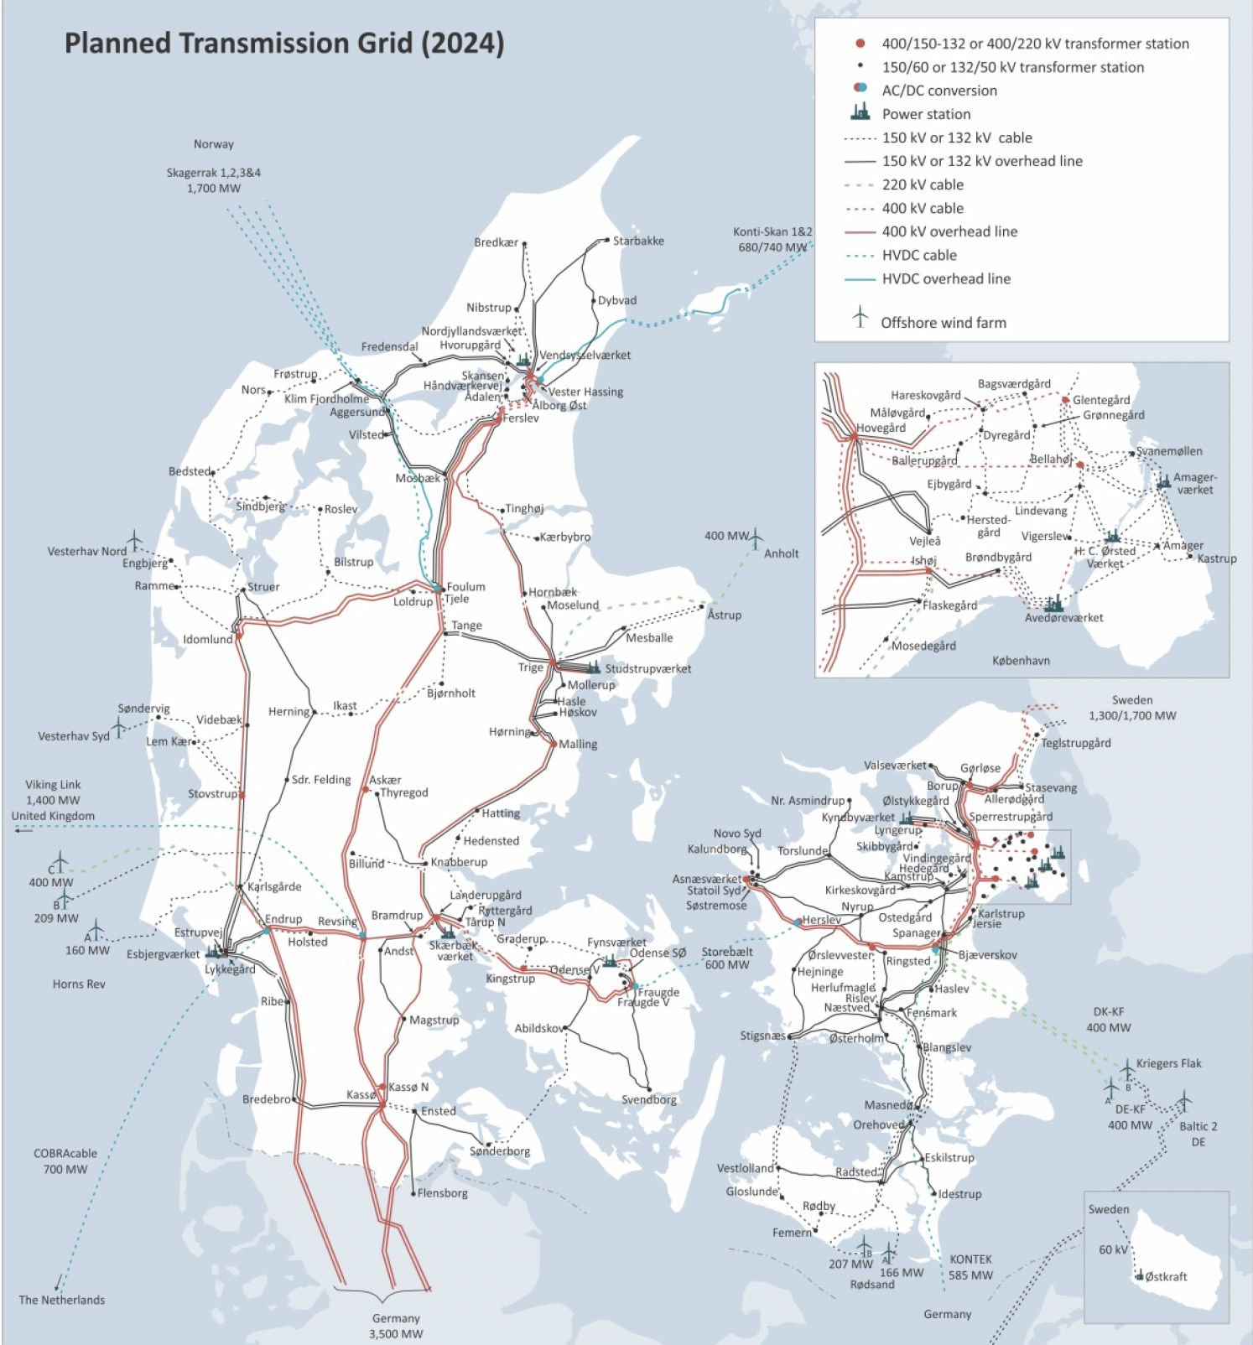
Figure 1 From Energinet - Technical Issues related to new transmission lines in Denmark
There is also this map, which shows lines and cables from the transmission system: https://storymaps.arcgis.com/stories/eb5b387e376f49b8996d5e7c47fbdd37
I could not find information about distribution lines and voltage levels

- Look at voltage levels data centres are connected
Generally a bit unclear, but it seems that data centres are connected at the highest level of the DSO grid
- Give the heat load profile with just large ones scaled
  - See appended file
  - 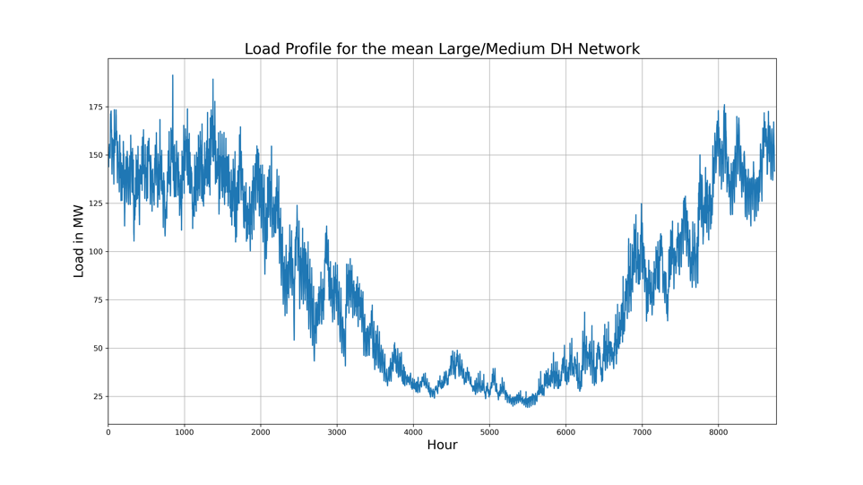
  - Different datacentre capacities will result in the following shares of the total heat covered (The total consumption of the L/M network is roughly 752 GWh), it is assumed that the datacentre is running 8760 hours on full capacity:

Datacentre size [MW] | Share of heat covered [%]
1 | 1.16
2 | 2.33
3 | 3.49
4 | 4.66
5 | 5.82
10 | 11.65
15 | 17.47

- Provide the table as follows: consumer what is paid, producer what is paid in unit EUR/MWh, based on currency conversion from 2020 (1DKK = 0.1341 EUR)

As discussed, this includes only the TSO tariffs, as we agreed that we don’t have any understanding on which voltage level the Datacentre is connected. If we assume the A-høj connection for a datacentre, we can find the following DSO tariffs in the second table (average values of the whole year).

 | Consumer | Producer
Transmissions nettarif forbrug | 5.3 øre/kWh | -
Systemtarif | 4.4 øre/kWh | -
Indfødningstarif | - | 0.3 øre/kWh
Balancetarif | 0.187 øre/kWh | 0.112øre/kWh
SUM | 9.887 øre/kWh | 0.412 øre/kWh
 | 13,25847 EUR/MWh | 0,552492 EUR/MWh

 | Consumer | Producer
Transport af el | (1.63/2.853/4.17)* øre/kWh

*in the timewindows low/high/peak

