Presidential emotional communication on X/Twitter and financial market dynamics in Colombia: tone, emotions, and discursive intensity
Juan José Echeverry De Mendoza
Miguelangel Palma Rojas
Luis Eduardo Sandoval Garrido
Affiliation. Faculty of Economics, Universidad Militar Nueva Granada, Bogotá, Colombia. All authors share the indicated institutional affiliation. Corresponding author: Luis Eduardo Sandoval Garrido, luis.sandoval@unimilitar.edu.co.
Abstract. This article examines whether the emotional tone, discrete emotions, and communicative intensity of the official X/Twitter account of the President of Colombia, @petrogustavo, precede or covary with the returns of four domestic financial markets: foreign exchange, equities, domestic sovereign debt, and electricity. Based on a census of 14,659 presidential posts issued between August 2022 and May 2026, we measure net sentiment polarity, the eight basic emotions of the Plutchik/NRC framework, and a standardized Informational Pressure Index (IPI). Each discursive window is linked to the return observed in the subsequent trading session. After excluding non-trading days, the sample comprises 934 unique sessions, 882 complete multivariate observations, and 881 effective observations in the VAR system. Temporal precedence tests across 112 contrasts of the presidential family identify five nominal associations ($p<0.05$), concentrated on net polarity and joy predicting the exchange rate of the Colombian peso (TRM). However, none remain statistically significant after correction for the false discovery rate (Benjamini-Hochberg FDR, $q≥0.791$). Conditional dependency analyses via DCC-GARCH models show no significant reaction of dynamic conditional correlations to discursive innovations ($a=0.0119;p=0.069$), while regime-switching and event analyses identify only transitory fluctuations during extreme communication episodes. The results suggest that daily variation in presidential emotional communication on X/Twitter does not show a robust association with Colombian financial market returns. The study contributes to research on digital executive communication by showing that, in a polarized context, the emotional intensity of presidential messages is rapidly absorbed by markets and exerts a limited effect compared to macroeconomic and institutional fundamentals.
Keywords: sentiment analysis, emotions, presidential communication, Twitter/X, financial markets, time series, Colombia.

1. Introduction
The relationship between the public statements of government leaders and financial market behavior has been a recurring subject of study in behavioral finance and narrative economics (Shiller, 2019; Tetlock, 2007). The extensive use of microblogging platforms such as Twitter (now X) allows heads of state to communicate economic policy stances, regulatory warnings, and political assessments directly, bypassing the intermediation and editorial filters of traditional media (Bianchi et al., 2024; Pérez Llorente, 2020). In emerging economies, where capital markets often exhibit less depth and greater sensitivity to uncertainty regarding the rules of the game, the question frequently arises as to whether the executive branch’s digital rhetoric systematically impacts volatility and risk premiums, or whether asset prices discount these communications as short-term fluctuations in attention that remain subordinate to macroeconomic fundamentals.
Gustavo Petro’s presidential term in Colombia (2022-2026) offers a favorable context for examining this issue. Petro leads the first leftist government in the country’s recent republican history and has maintained a consistent presence on Twitter/X. Through this platform, he debates structural reform proposals (regarding pensions, labor, healthcare, and taxation), comments on decisions made by the central bank’s board of directors or energy sector companies, and voices objections to judicial or legislative rulings (Casallas Felipe, 2020; Prada Espinel, 2018; Sandoval-Garrido & Marín-Jaramillo, 2022). Public discourse and local analyses often attribute an immediate impact on dollar exchange rates, stock prices, or public debt to these statements. However, such claims typically rely on informal correlations or isolated incidents, without undergoing time-series testing that accounts for the stock market trading calendar or the false discovery rate associated with testing multiple hypotheses.
Against this backdrop, the study investigates the extent to which sentiment tone, discrete emotions (polarity, anger, fear, joy, and trust), and communicative pressure from the official @petrogustavo account temporally precede or dynamically covary with returns on the Representative Market Exchange Rate (TRM), the MSCI COLCAP stock index, sovereign public debt (TES) yields, and the electricity market price in Colombia.
To address this question, the empirical strategy relies on four methodological components. First, the affective dynamics of the complete set of presidential posts (14,659 tweets) are characterized, rigorously distinguishing this source from the surrounding public conversation, whose collection reflects an artificial concentration of timing. Second, standardized indicators are constructed for lexical polarity, eight emotions based on Plutchik’s model (using the NRC lexicon), and an Informational Pressure Index (IPI), thereby mitigating distortions associated with communication volume and structural lexical levels. Third, a strict protocol for aligning data with market hours is established, linking messages sent on weekends and outside trading hours to the immediately following trading session: this eliminates look-ahead bias and the spurious duplication of non-traded returns. Fourth, the econometric relationship is evaluated using Granger causality tests across 112 specifications adjusted for the Benjamini-Hochberg False Discovery Rate (FDR), multivariate DCC-GARCH models, regime-switching Markov chains, and event analysis regarding extreme shocks in tone and volume.
The results indicate that Colombian financial market prices do not respond systematically to the president’s discursive tone on Twitter/X. While isolated signs of exchange rate predictability emerge in individual tests, these relationships vanish entirely once the bias from testing multiple hypotheses simultaneously is accounted for. Furthermore, dynamic correlations between message sentiment and asset returns are moderate, sensitivity to emotional shocks is negligible, and fluctuations accompanying periods of extreme communicative tension revert within a few business days. This behavior aligns with the semi-strong form of the efficient market hypothesis at a daily frequency, indicating that market participants treat social media statements as transitory noise and keep price formation anchored to macroeconomic fundamentals and monetary policy decisions.

2. Literature review and conceptual framework

2.1 Informational efficiency, noise, and limits to arbitrage
The starting point is the semi-strong form efficient market hypothesis (Fama, 1970): if prices rapidly incorporate all public information, a message posted on a public account such as @petrogustavo should be reflected in market prices within minutes, and its lagged content should not retain predictive power regarding returns on the following trading day. Under this framework, the benchmark null hypothesis posits that lagged discursive content lacks incremental predictive power regarding price variations on the subsequent trading day.
This prediction weakens when some participants trade based on unfounded beliefs. De Long et al. (1990) demonstrate that noise traders introduce a specific type of risk that finite-horizon arbitrageurs cannot eliminate, causing prices to persistently deviate from their fundamental value. Shleifer & Vishny (1997) complement this argument by showing that arbitrage is costly and capital-constrained, particularly during episodes when deviations are greatest. Empirically, M. Baker & Wurgler (2006) find that investor sentiment has a stronger impact on assets that are difficult to value and arbitrage, a characteristic frequently shared by the shallow capital markets of emerging economies.
A third mechanism is limited attention. Barber & Odean (2008) document that individual investors tend to be net buyers of assets that capture their attention through news, unusual volume, or extreme returns, while Da et al. (2011) show that increases in internet search intensity anticipate price surges followed by subsequent reversals. For the purposes of this analysis, if presidential discourse operates primarily through the channel of transient attention, one would expect short-lived fluctuations that quickly reverse, rather than sustained shifts in price levels.

2.2 Economic policy uncertainty and government communication
Macro-financial literature provides an analytical basis for government communication to affect prices even in the absence of accounting reports or prior formal decisions. Pástor & Veronesi (2012) model an economy in which the government can alter its policies and demonstrate that stock prices fall upon the announcement of regulatory changes, while uncertainty regarding future policy increases volatility and asset correlations. In a complementary study, the same authors (Pástor & Veronesi, 2013) show that policy uncertainty demands a higher risk premium in weak macroeconomic environments. S. R. Baker et al. (2016) operationalize this concept through the Economic Policy Uncertainty (EPU) index, documenting that increases in the index are associated with higher stock market volatility and lower investment in sectors sensitive to regulation.
This literature suggests three transmission channels affecting financial assets: first, the fundamental information channel, whereby statements regarding fiscal targets, structural reforms, or cabinet composition alter expected cash flows and sovereign solvency, prompting permanent valuation adjustments. Second, the policy uncertainty and risk premium channel (S. R. Baker et al., 2016; Pástor & Veronesi, 2012), in which ambiguity regarding the rules of the game raises the return demanded by investors, manifesting as higher volatility, elevated sovereign debt premiums, and increased conditional correlations. Third, the attention and sentiment channel (Barber & Odean, 2008; Da et al., 2011), through which highly emotionally charged publications capture public attention and trigger transitory price movements that dissipate within a few days.
Empirical evidence regarding social media has focused predominantly on the United States. Gjerstad et al. (2021) analyze Donald Trump’s posts and find that they are associated with transitory spikes in uncertainty and trading volume. Bianchi et al. (2024) use messages from members of the U.S. Congress within narrow intraday windows to identify the effect of their stances on asset prices. Within the Spanish-speaking context, Pérez Llorente (2020) analyzes the impact of Trump’s activity on various financial markets. These studies share a methodological feature: their identification strategy relies on intraday intervals, spanning minutes or hours surrounding each post. When working at a daily frequency, microstructure effects tend to dissipate, and inference comes to depend on the systematic accumulation of tone: this requires rigorous temporal alignment and explicit control for multiple testing.

2.3 Behavioral economics, emotions, and decisions under risk
The study of passions and sympathy as factors shaping economic decisions has roots in Smith (1759) and has been formalized within behavioral finance, which demonstrates that agents operate under bounded rationality and systematic heuristics (Mullainathan & Thaler, 2000). Kahneman & Tversky (1979) prospect theory posits that decisions under uncertainty are evaluated relative to a reference point using a value function that is concave for gains and steeper and convex for losses. This asymmetry regarding loss aversion suggests that presidential messages framed in terms of potential risks or losses, such as warnings about fiscal crises, institutional disputes, or sectoral interventions, can elicit stronger aversion responses than favorable messages of equivalent magnitude.
Loewenstein (2000) argues that emotional states act as direct determinants of economic decision-making. Experimental evidence from Lerner & Keltner (2001) is crucial for empirical design: although fear and anger are both negative-valence emotions, they produce divergent effects on risk perception. While fear induces pessimistic judgments and conservative stances, anger stimulates optimism and risk-taking. This asymmetry implies that a one-dimensional negativity metric aggregating fear and anger could cancel out effects of opposite signs, thereby justifying the decomposition of emotional tone into discrete emotions.
The transmission of mood to aggregate prices has been documented in relation to non-fundamental factors. Hirshleifer & Shumway (2003) find that morning weather in cities hosting stock exchanges correlates with daily returns across 26 markets, while Edmans et al. (2007) observe declines in stock market indices following defeats of national soccer teams. At the macroeconomic level, Shiller (2019) proposes the concept of narrative economics, whereby widely circulating stories spread through public opinion and shape aggregate expectations. In this context, a president’s continuous activity on social media represents a potential source of economic narratives that achieve broad collective dissemination.

2.4 From text to signal: textual sentiment in finance
Quantifying textual tone has demonstrated explanatory power in financial markets, albeit subject to important nuances. Tetlock (2007) constructs a pessimism index based on Wall Street Journal financial columns and finds that high levels of pessimism anticipate downward pressure on stock prices, followed by reversals toward fundamental values, as well as increases in trading volume. García (2013), examining a century of New York Times financial reporting, shows that this predictability is concentrated in periods of economic recession. Both findings support the interpretation of sentiment as a signal that is transitory and contingent upon the state of the economy.
Bollen et al. (2011) apply this approach to Twitter and report that indicators of collective calmness improve the directional prediction of the Dow Jones, albeit based on a sample limited to a few months in 2008. Ardia et al. (2021) structure the process within the framework of sentometrics, integrating document-level measurement, lexical aggregation, and time-decay schemes prior to econometric estimation.
This literature also documents measurement risks. Loughran & McDonald (2011) highlight that approximately three-quarters of the words classified as negative in general-purpose dictionaries lack an unfavorable connotation in economic and financial texts, which can lead to spurious signals. Grimmer & Stewart (2013) and Gentzkow et al. (2019) note that any quantitative model of language simplifies reality and that its validity must be assessed within its specific context of application. These challenges are intensified in the realm of political discourse (Medhat et al., 2014; Silge & Robinson, 2017): general dictionaries tend to overestimate the positivity of standard institutional vocabulary surrounding peace, justice, and development. Unigram-based schemes fail to capture irony or negation structures, and message transmission occurs in bursts that generate temporal heteroskedasticity. To address these factors, this article analyzes sentiment using standardized deviations ($z$-scores) and complements the net balance with discrete emotions.

2.5 Discrete emotions: Plutchik’s model and the NRC lexicon
Plutchik (2003) psychoevolutionary theory proposes eight primary emotions structured in opposing pairs within a circumplex model featuring concentric intensity gradations (Figure 1): protection (fear), destruction of obstacles (anger), reintegration following loss (sadness), rejection (disgust), incorporation (trust), exploration (anticipation), orientation toward the unexpected (surprise), and bonding (joy). Each petal of the emotional flower transitions from a high-intensity manifestation at the core (ecstasy, rage, terror, vigilance) to attenuated expressions at the periphery (serenity, annoyance, apprehension, interest). The combination of adjacent emotions within the circle generates primary affective dyads (Table 1), while opposing petals indicate poles of affective conflict.

Figure 1: Plutchik’s psychoevolutionary circumplex model of emotions: concentric intensity gradations, opposing polar pairs, and primary affective dyads. Source: Conceptual development based on Plutchik (2003).

Table 1: Plutchik’s model primary dyads and their hypothetical interpretation in presidential economic discourse. Source: Authors’ elaboration based on Plutchik (2003).
Primary dyad (Plutchik) | Compound emotion | Hypothetical interpretation in presidential economic discourse
Joy + Trust | Love | Explicit support for allied policies, institutions, or social actors
Trust + Fear | Submission | Calls for political cohesion in the face of external economic threats
Fear + Surprise | Awe | Official reaction to unexpected shocks (climate crises, sudden shortages)
Surprise + Sadness | Disapproval | Public rejection of decisions made by third parties (Congress, courts, Central Bank)
Sadness + Disgust | Remorse | Negative evaluation of inherited structural policies or historical situations
Disgust + Anger | Contempt | Disqualification of political adversaries, union leadership, or economic elites
Anger + Anticipation | Aggressiveness | Confrontational announcements of economic intervention or structural reforms
Anticipation + Joy | Optimism | Favorable macroeconomic projections regarding reforms or social indicators

Plutchik’s framework was not originally intended to explain financial behavior; the conceptual link to decision-making is grounded in the behavioral literature described in Section 2.3. Integrating these two frameworks yields distinct predictions: fear and disgust should correlate with greater risk aversion, manifesting as currency depreciation, stock market declines, and rising sovereign debt yields, whereas anger should correlate with a greater willingness to take risks (Lerner & Keltner, 2001), and trust and anticipation with lower required risk premiums.
Operationalization relies on the NRC lexicon developed by S. Mohammad & Turney (2010) and S. M. Mohammad & Turney (2013), which was created through the collective annotation of over fourteen thousand terms based on Plutchik’s eight dimensions and two polarities. Spanish adaptations were produced via computer-assisted translation, introducing a margin of lexical error that is explicitly acknowledged. Data extraction is performed using the syuzhet library (Jockers, 2017), a tool widely used in empirical literature (Hirschberg & Manning, 2015; Misuraca et al., 2020).

2.6 Text-based methods for political discourse
Beyond affective tone, discourse analysis requires specifying thematic content and latent stances. Regarding thematic structure, keyness metrics contrast empirical frequencies against expected distributions to identify the lexicon distinguishing a corpus (Bondi & Scott, 2010), while collocations identify stable co-occurrence patterns (Schweinberger, 2023; Stefanowitsch & Gries, 2003), implemented using quanteda (Benoit et al., 2018). Concerning ideological positions, scaling models estimate latent coordinates based on term frequencies: Wordscores utilizes anchor texts with pre-set positions (Laver et al., 2003), whereas Wordfish estimates relative positions without reference texts via Poisson parameterization (Slapin & Proksch, 2008). For latent topic detection, the LDA model (Blei et al., 2003) and Structural Topic Models (STM) (Roberts et al., 2019) allow topic prevalence to vary according to temporal covariates. In this study, these methods serve a descriptive control function to ensure that fluctuations in tone do not simply reflect reconfigurations of the thematic agenda (Grimmer & Stewart, 2013).

2.7 Evidence from Colombia and Latin America
In Colombia, research on social media and politics has focused on election campaigns and public perception. Prada Espinel (2018) examines the communication patterns of Gustavo Petro and Iván Duque during the 2018 elections, while Casallas Felipe (2020) analyzes the political perception of both leaders on Twitter. Romero Moreno et al. (2020) apply opinion mining for political communication purposes, whereas Gómez-Torres et al. (2018) analyze public sentiment within the political context of Ecuador. In the field of applied political economy, Sandoval-Garrido & Marín-Jaramillo (2022) document the impact of political electoral cycles on municipal development variables in Colombia.
In the context of the region’s emerging economies, existing literature lacks analyses that simultaneously integrate a full four-year presidential term on Twitter/X, a multidimensional characterization of tone based on polarity, discrete emotions, and an informational pressure index, joint coverage of four financial markets with their specific calendars, and a systematic correction of the false discovery rate across the entire family of tests.

3. Methodology

3.1 Design, observed population, and units
The research employs a quantitative, longitudinal, and observational design, encompassing descriptive, sentiment-based, and time-series econometric analyses. As it relies on observational data, without random assignment or experimental intervention, the estimates assess predictive temporal precedence and conditional covariation, distinguishing them from direct structural causal identification.
The units of analysis are structured at two levels: - Textual unit: each individual post with a unique 64-bit identifier and a timestamp recorded in Colombian legal time (America/Bogota, UTC-5). - Financial time unit: the observed active trading session for stock and sovereign debt markets, and the calendar day for the official exchange rate and the continuous electricity market.

3.2 Data sources, coverage, and cleaning

3.2.1 Textual data from Twitter/X
The textual data originate from two independent sources consolidated into the project dataset: 1. Primary Corpus (President): a complete historical census of posts issued directly by the official account @petrogustavo between August 7, 2022, and May 31, 2026. It comprises 14,659 posts, of which 14,437 contain processable lexical content, excluding 222 records consisting solely of links or multimedia elements. As it covers the full 24-hour daily cycle, it serves as the exclusive source for the econometric market analysis. 2. Secondary Corpus (Opinion): a sample of 13,648 posts from the public collected during the same period using the query "Gustavo Petro" OR @petrogustavo, while filtering out retweets, replies, quotes, and links. 97.49% of its records (13,305 posts) are concentrated at 18:00 COT, subject to a fixed daily limit of 10 messages. For this reason, this corpus is used as a descriptive reference and is not integrated into the market equations.

3.2.2 Financial market data
The financial series are derived from official records from the Banco de la República and the grid operator XM (1,400 consecutive calendar days): - Representative Market Exchange Rate (TRM): official exchange rate in COP/USD certified by the Financial Superintendence (1,400 consecutive observations). - MSCI COLCAP Equity Index: official stock market index of the Colombian Stock Exchange (935 observed trading sessions, 400 weekend carry-overs, and 65 non-trading holidays). - TES Sovereign Yield Curve (in pesos): zero-coupon rates for 1, 5, and 10-year maturities, along with the 10Y-1Y slope in percentage points (935 observed sessions). - Energy Exchange Spot Price: national weighted energy exchange price (COP/kWh) managed by XM (1,400 consecutive days).

3.3 Operationalization of variables
Table 2 summarizes the definition, formulation, unit, and analytical role of each variable in the study.
Table 2: Formal operationalization of analytical variables. Source: Authors’ elaboration.
Variable | Nature | Mathematical Definition | Unit | Econometric Role
Daily Polarity | Textual | ${\text{Pol}}_{d}=∑{\text{Positive}}_{d}−∑{\text{Negative}}_{d}$ | Net word count | Discursive predictor $I\left(0\right)$
NRC Emotions | Textual | Standardized frequencies of anger, fear, joy, sadness, trust | $z$-score | Discursive predictor $I\left(0\right)$
Informational Pressure Index (IPI) | Textual | ${\text{IPI}}_{d}=z\left({\overset{‾}{s}}_{d}\right)⋅z\left(ln\left(1+n_{d}\right)\right)$ | Standardized index | Composite discursive signal $I\left(0\right)$
TRM Return | Financial | $R_{TRM,t}=ln\left({\text{TRM}}_{t}/{\text{TRM}}_{t−1}\right)$ | Fraction / % | Exchange rate response $I\left(0\right)$
COLCAP Return | Financial | $R_{COL,t}=ln\left({\text{COLCAP}}_{t}/{\text{COLCAP}}_{t−1}\right)$ | Fraction / % | Equity index response $I\left(0\right)$
Change in TES Rate 10Y | Financial | $Δ{\text{TES}}_{10Y,t}={\text{TES}}_{10Y,t}−{\text{TES}}_{10Y,t−1}$ | Percentage points | Sovereign yield response $I\left(0\right)$
Change in TES Slope (10Y-1Y) | Financial | $Δ{\text{Slope}}_{t}={\text{Slope}}_{t}−{\text{Slope}}_{t−1}$ | Percentage points | Term structure response $I\left(0\right)$
XM Energy Return | Electrical | $R_{XM,t}=ln\left(P_{XM,t}/P_{XM,t−1}\right)$ | Fraction / % | Energy spot response $I\left(0\right)$

3.4 Multidimensional decomposition of sentiment and emotions
To capture the heterogeneity of communicative tone, the measurement is broken down into three components: 1. Lexical Polarity: the algebraic balance between favorable and unfavorable terms in each post, normalized by text length. 2. Plutchik Taxonomy and NRC Lexicon: quantification of eight discrete emotions: $\text{Emotions}=\{\text{anger},\text{fear},\text{disgust},\text{sadness},\text{anticipation},\text{surprise},\text{joy},\text{trust}\}$. Each dimension is calculated as the proportion of terms associated with the category relative to the total number of words analyzed for the day and is normalized using standard deviations ($z$-score). 3. Dynamic Aggregation (sentometrics): modeling the temporal decay of affective impact using weighted moving average structures (Ardia et al., 2021).
The daily temporal evolution of the eight Plutchik emotions over the analyzed period is presented in Figure 2, and the lexical distribution of the associated terms is illustrated in Figure 3.
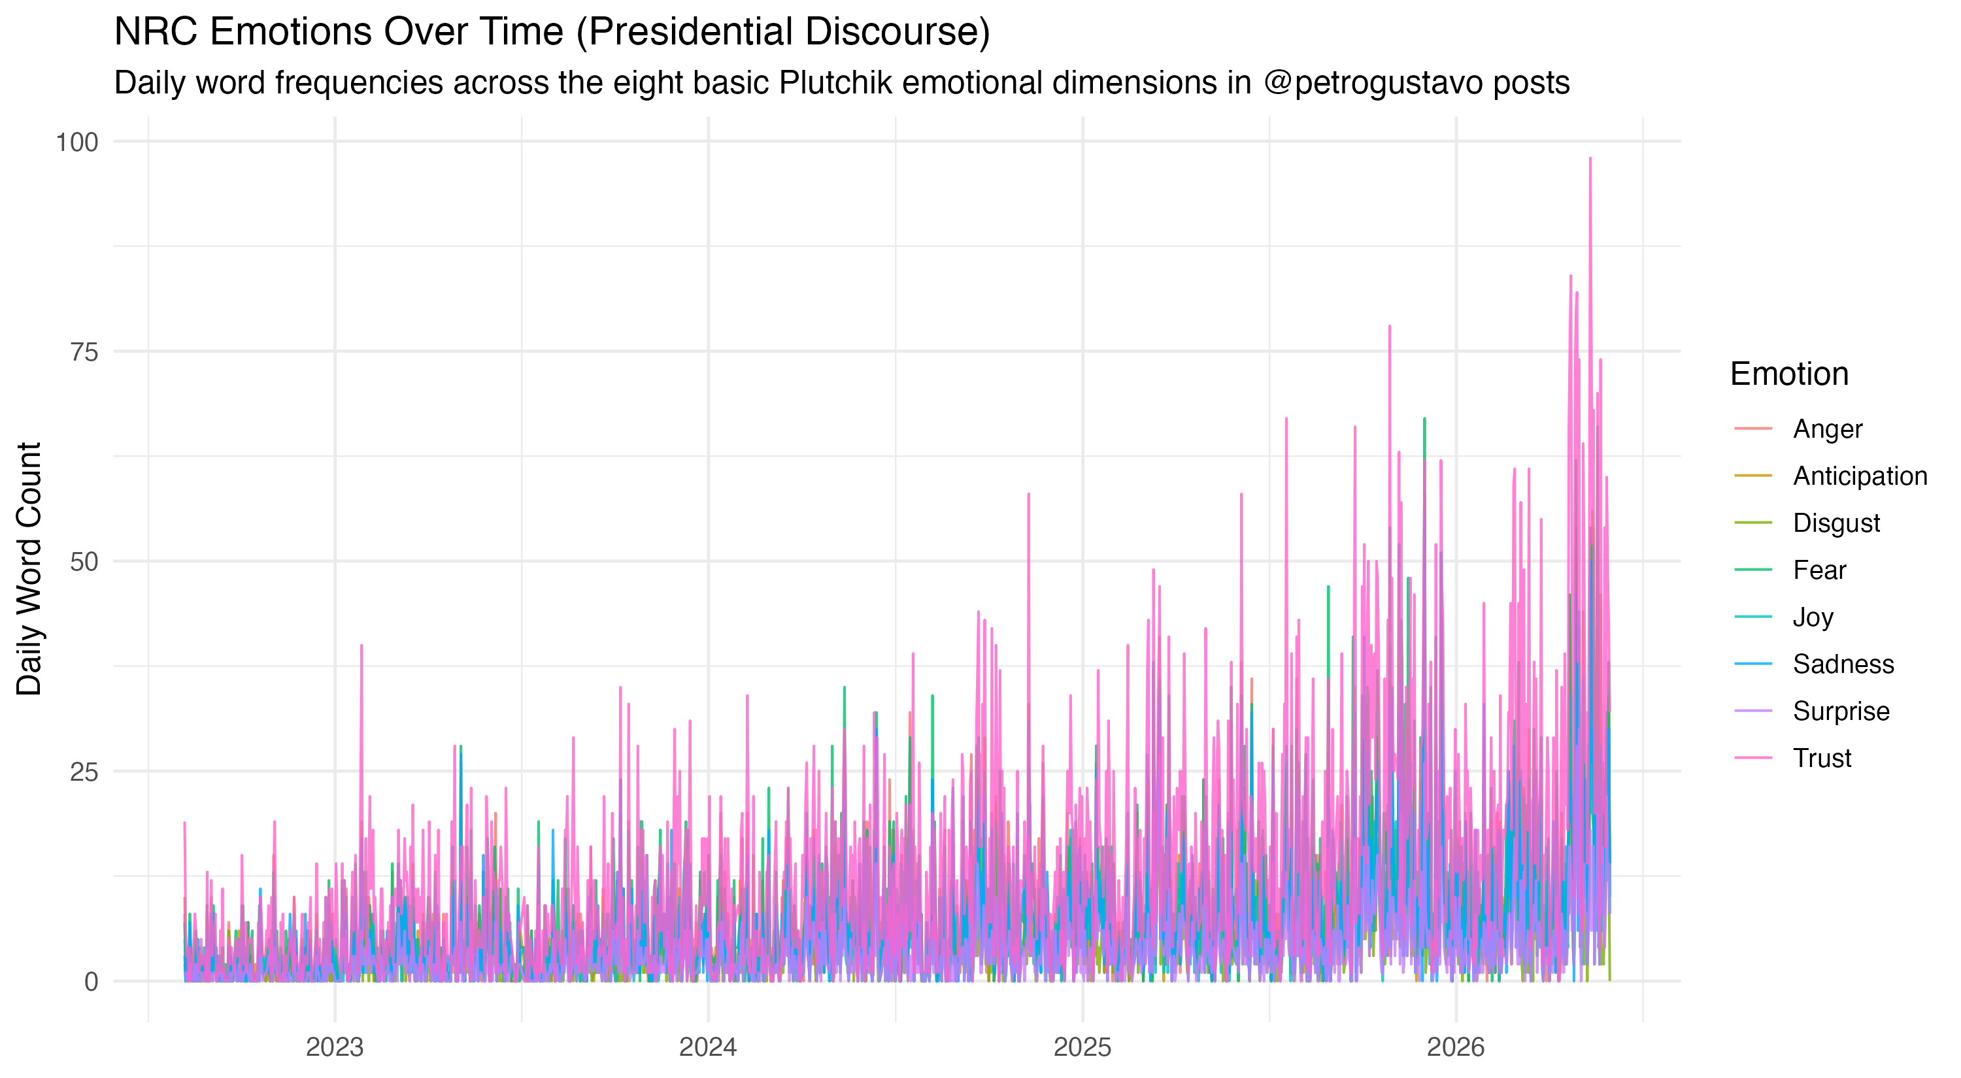
Figure 2: Temporal evolution of the eight NRC lexicon emotions in presidential communication (2022-2026). Source: Authors’ elaboration from reproducible notebook.

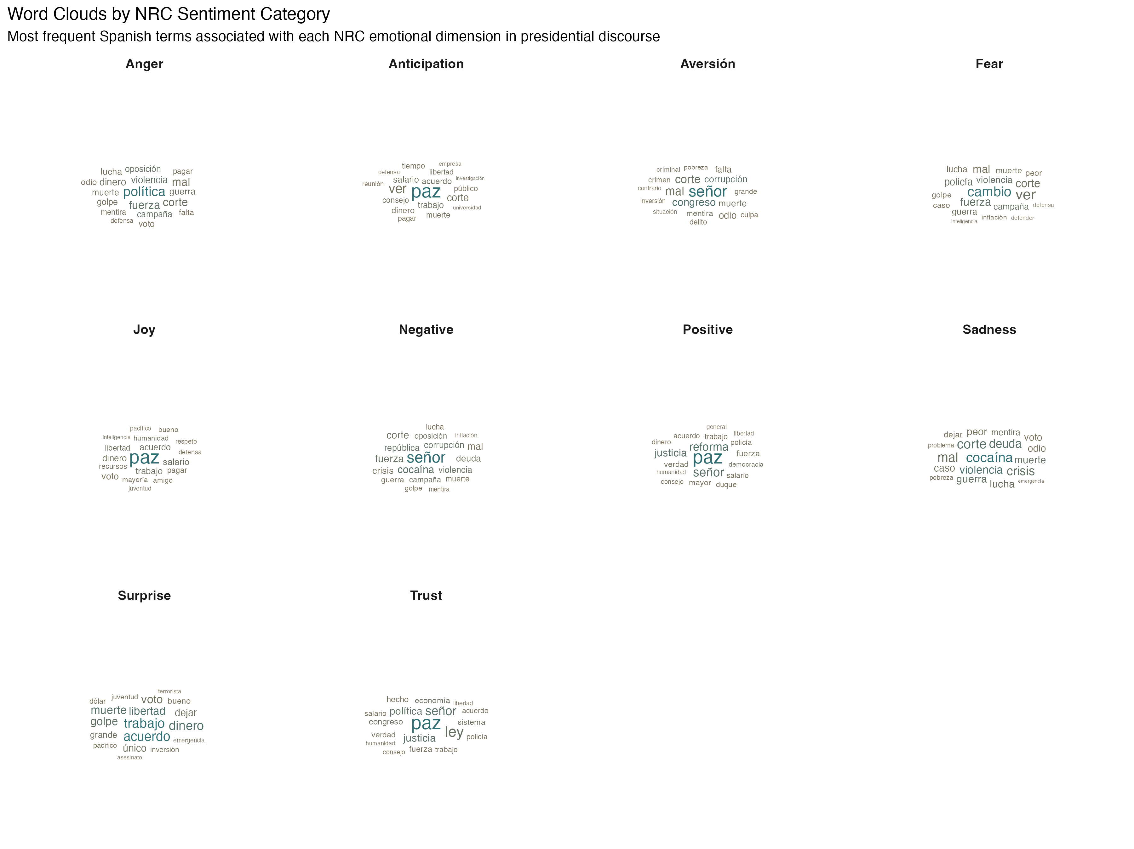
Figure 3: Word cloud classified by NRC sentiment and emotion categories. Source: Authors’ elaboration from reproducible notebook.

3.5 The Presidential Informational Pressure Index (IPI)
To identify episodes characterized by the simultaneous convergence of a pronounced tone and an unusual volume of posts, the Informational Pressure Index (IPI) regarding @petrogustavo’s activity is defined as:
$${\text{IPI}}_{d}=z\left({\overset{‾}{s}}_{d}\right)⋅z\left(ln\left(1+n_{d}\right)\right)$$
Where $n_{d}$ is the number of posts by the president on day $d$, and ${\overset{‾}{s}}_{d}={\text{Polarity}}_{d}/n_{d}$ is the average sentiment per message. The $z$-standardization is calculated based on the 1,187 days featuring presidential posts.
By mathematical construction, being the product of two standardized variables, the IPI yields positive values both on days of high volume and favorable tone and on those characterized by low activity and unfavorable tone. Consequently, the indicator captures the combined intensity and anomalous nature of the communicative episode, complementing the polarity analysis.

3.6 Temporal alignment and elimination of look-ahead bias
The linkage between the issuance of social media messages and Colombian financial market sessions is governed by a principle of non-anticipation:
$$S_{[t, t+1)}→R_{b\left(t\right)}$$
Where $b\left(t\right)$ is the first trading session observed strictly after the discursive date $t$. Any signal issued after market close, as well as activity accumulated over weekends and holidays, is consolidated and linked to the opening of the next business trading day. This procedure consolidates 934 unique response sessions and avoids the artificial repetition of non-traded prices observed in carry-forward schemes.

3.7 Econometric models and FDR control
The econometric toolkit comprises four linked specifications: 1. Unit Root Tests (ADF and KPSS): verification of non-stationarity in levels ($I\left(1\right)$) and stationarity in differences ($I\left(0\right)$). 2. Granger causality: estimation of linear bivariate autoregressive equations:
$$R_{j,t}=α_{j}+\sum_{k=1}^{p}{β_{j,k}}R_{j,t−k}+\sum_{k=1}^{p}{γ_{j,k}}S_{m,t−k}+ε_{j,t}$$
Evaluated using a joint $F$-test ($H_{0}:γ_{j,1}=…=γ_{j,p}=0$) for lags $p∈\{1,2,3,4\}$. 3. False Discovery Rate (FDR) control: Benjamini-Hochberg sequential adjustment applied to the 112 tests in the family to control the false positive rate resulting from multiple testing. 4. Vector Autoregression (VAR) and DCC-GARCH: multivariate estimation of volatility and dynamic conditional correlations to model temporal interdependence.

3.8 Event study design
The ten days with the highest negativity and the ten with the highest absolute IPI in the presidential series are selected. The trajectories of the assets are analyzed in subsequent windows of $h∈\{+1,+3,+5,+7\}$ calendar days, evaluating cumulative returns and variations in sovereign interest rates under an observational framework without counterfactuals.

4. Results

4.1 Coverage and publication flow
The study period spans 1,400 consecutive calendar days. Table 3 summarizes the effective availability of observations across sources.
Table 3: Empirical coverage audit by source and asset (2022-2026). Source: Authors’ elaboration from tweets_master.csv and market_master.csv.
Source / Corpus | Raw Observations | Days with Information | Sample Coverage | Audited Features
Presidential (@petrogustavo) | 14,659 tweets | 1,313 days | 95.1% monthly | 14,437 clean texts; continuous 24-hour census
Public opinion | 13,648 tweets | 1,348 days | 96.3% monthly | 97.5% at 18:00 COT; quota of 10/day
TRM (BanRep) | 1,400 days | 1,400 days | 100.0% | Official currency rate COP/USD; daily
COLCAP and TES Rates | 1,335 records | 935 sessions | 95.4% trading days | 935 actual trading sessions; 65 holidays without trades
Energy Spot Price (XM) | 1,400 days | 1,400 days | 100.0% | Continuous daily price; no carryover

Figure 4 compares the monthly publication volume of both corpora, highlighting the presidency’s expansive dynamics and bursts of communication versus the artificial stability imposed by the quota of the opinion corpus.
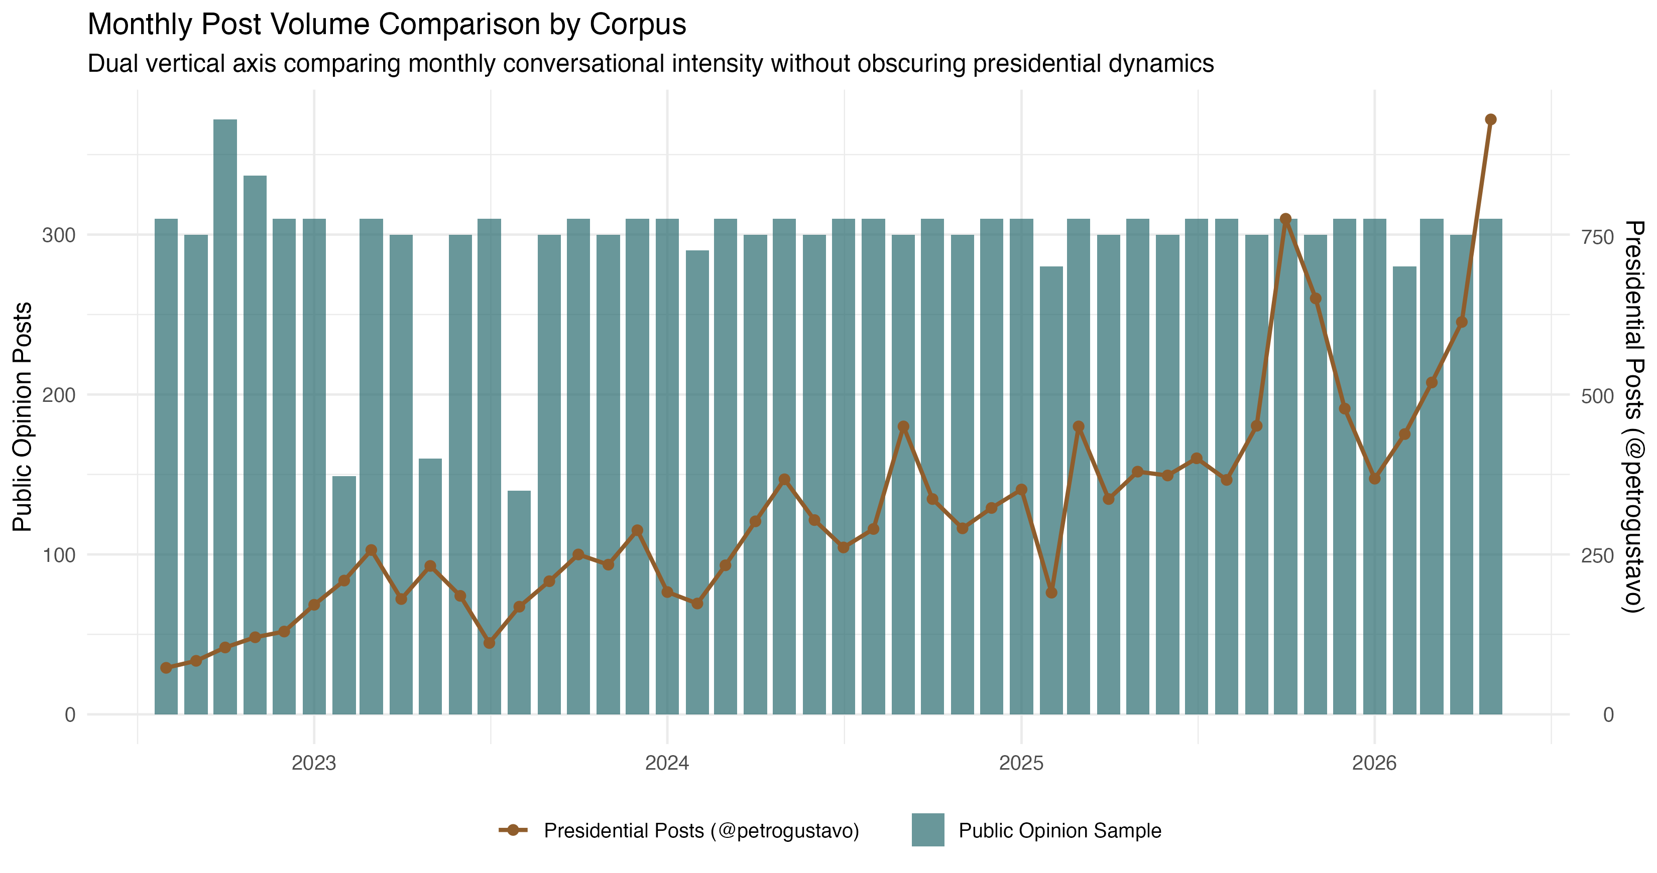
Figure 4: Observed monthly volume of the two corpora between August 2022 and May 2026. Source: Authors’ elaboration.

4.2 Temporal dynamics of sentiment, polarity, and the presidential IPI
Descriptive sentiment analysis confirms that @petrogustavo’s discourse exhibits a substantially positive average daily polarity ($μ=+6.10$; range -23 to +92), double that observed in public opinion ($μ=+3.07$). As established in the literature, this level reflects the recurrence of institutional terms related to governance (e.g., “life”, “justice”, “reform”, “peace”, “social”).
The daily presidential IPI (based on 1,187 observed days) shows a mean of $μ=−0.024$ and a standard deviation of $σ=1.097$, with extremes ranging from -8.295 to +7.901, thereby capturing episodes of acute communicative shock (Figure 5).
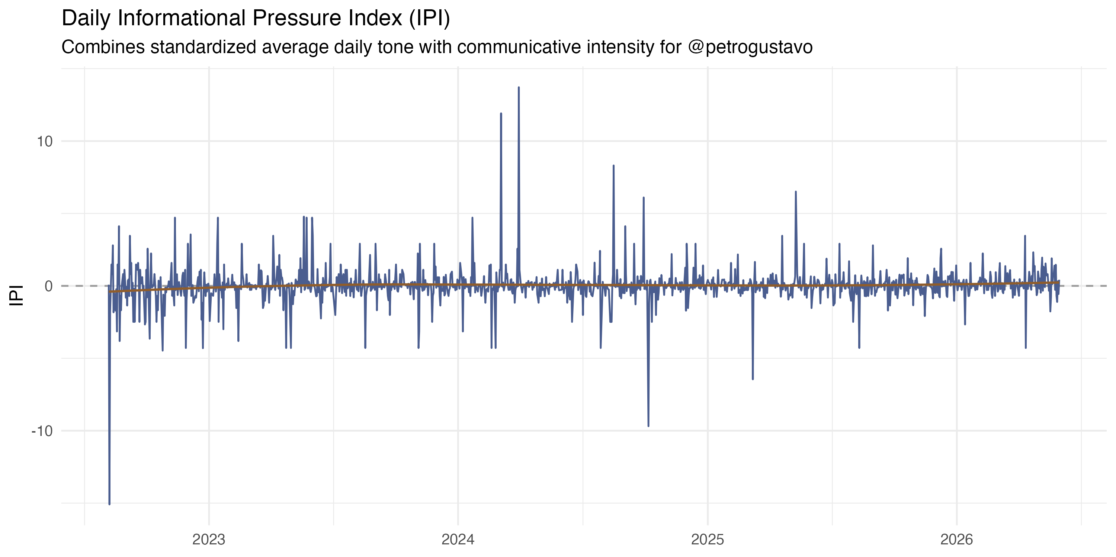
Figure 5: Daily Information Pressure Index (IPI) of the presidential account @petrogustavo. Source: Authors’ elaboration.

4.3 Thematic classification and the language of reforms
The thematic classification assigns 10,784 presidential texts to 13 non-residual agendas (Figure 6). The security agenda dominates presidential discourse (22.9%), followed by institutional affairs (20.1%), health (11.4%), international affairs (10.4%), labor (9.7%), and the economy (9.2%). Keyness analysis confirms that each reform possesses a highly distinctive and specialized lexical identity ($p<0.001$).
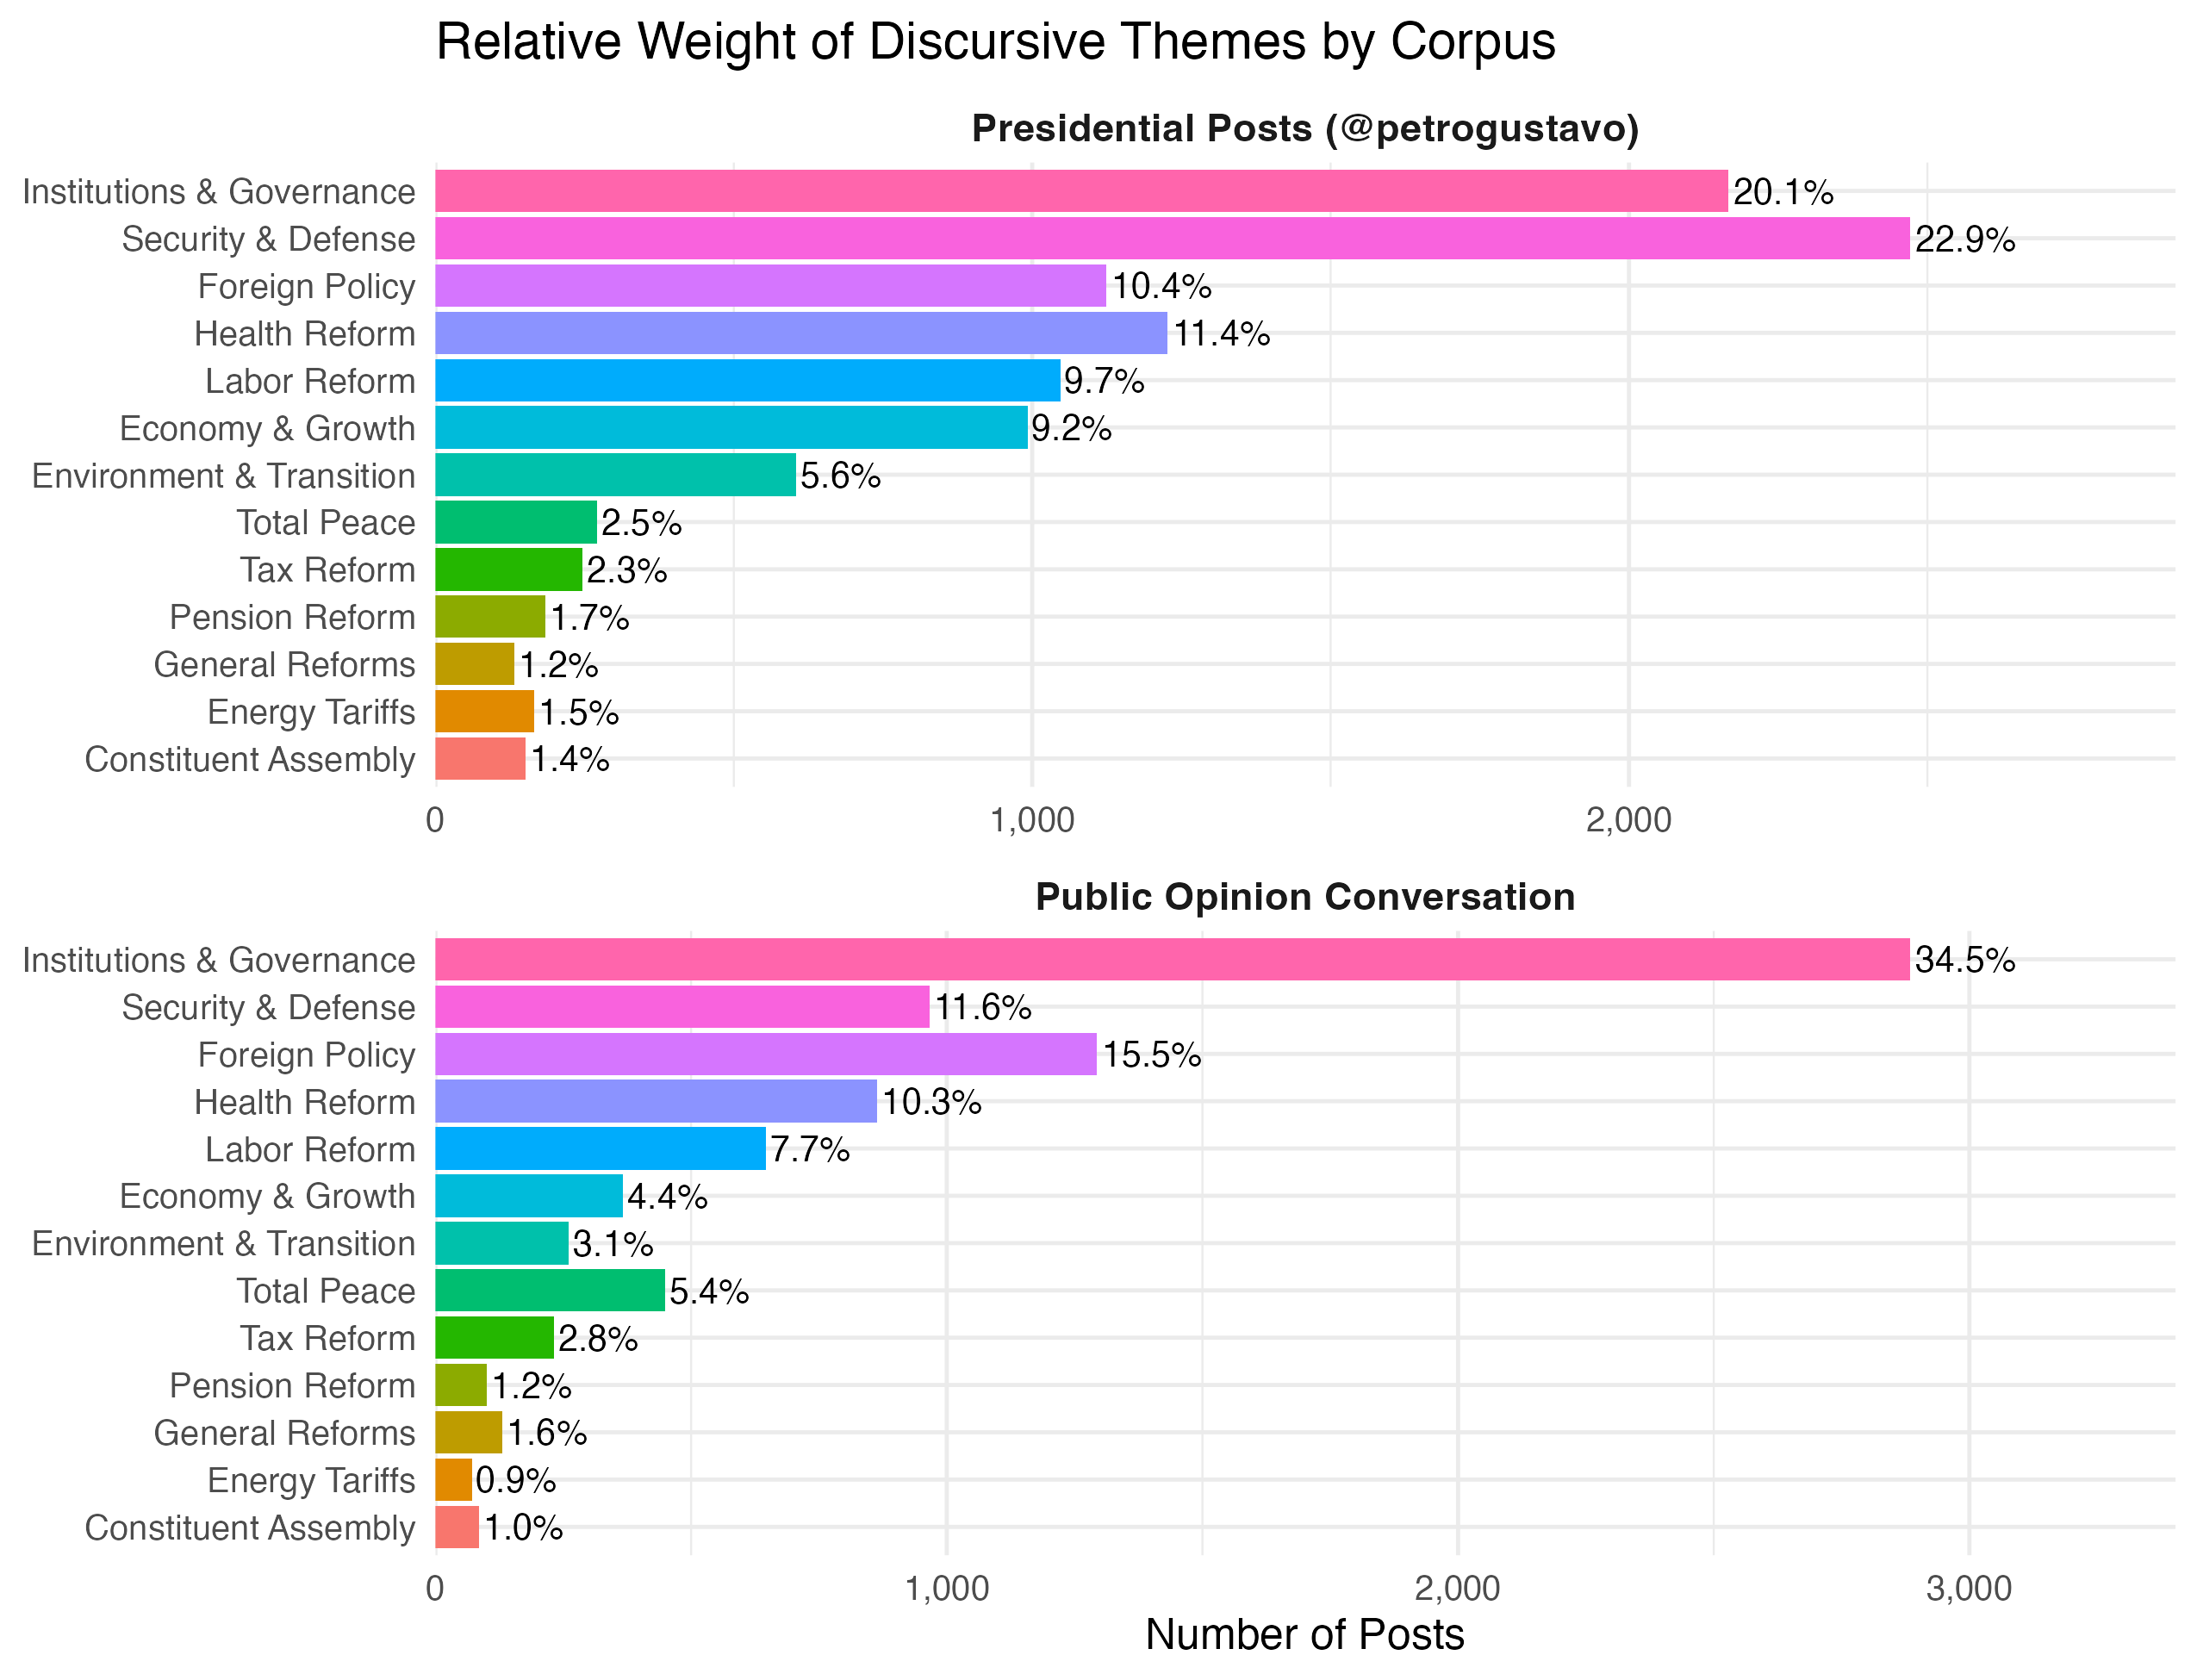
Figure 6: Distribution of non-residual public policy topics in presidential discourse and citizen conversation. Source: Authors’ elaboration.

4.4 Series diagnostics and VAR estimation
ADF and KPSS tests confirm that the financial series are non-stationary ($I\left(1\right)$) in levels and stationary ($I\left(0\right)$) in differences, while the Johansen trace statistic (27.85 against a 5% critical value of 34.91) rules out cointegration, thereby validating the estimation of a VAR model using stationary differences.
The VAR(1) model based on the 881 effective observations of the adjusted stock market sample proves to be dynamically stable (maximum root modulus of 0.281). However, residual diagnostics reveal remaining autocorrelation (Portmanteau $p=6.00×{10}^{−10}$) and ARCH conditional heteroskedasticity ($p<{10}^{−10}$); this precludes interpreting the mean equations as full causal explanations and necessitates a shift to conditional volatility models.

4.5 Conditional volatility and dynamic correlations (DCC-GARCH)
The multivariate stock-market DCC(1,1) model, based on the 882 complete sessions, yields a highly significant persistence parameter ($b=0.9224;p<{10}^{−10}$), but a parameter for the reaction to sentiment innovations that is not significant at the 5% level ($a=0.0119;p=0.069$), with a combined sum of $a+b=0.9343<1$ satisfying covariance stationarity.
The average dynamic conditional correlations between presidential signals and financial assets are moderate: - $\text{IPI}↔\text{Return TRM}$: mean of $+0.0171$. - $\text{IPI}↔\text{Return COLCAP}$: mean of $+0.0414$. - $\text{Polarity}↔\text{Change TES Rate 10Y}$: mean of $+0.0574$. - $\text{IPI}↔\text{Change TES Slope}$: mean of $−0.0430$.
The time paths of the conditional correlations are plotted in Figure 7.
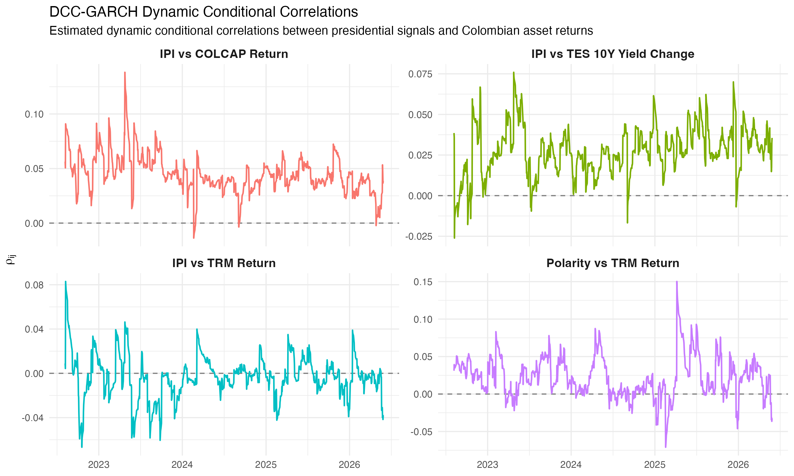
Figure 7: Paths of four DCC conditional correlations between presidential signals and financial variables. Source: Authors’ elaboration.
Furthermore, the Markov-Switching model estimates two persistence regimes for the IPI-TRM correlation: Regime 1, characterized by low dispersion ($μ=0.0121;σ=0.0090$, average duration of 24.4 sessions) and Regime 2, characterized by transitory stress ($μ=0.0216;σ=0.0356$, average duration of 27.3 sessions).

4.6 Granger predictive precedence focused on sentiments and emotions
Granger precedence tests across the 112 specifications within the presidential family reveal the following patterns (Table 4 and Figure 8):
In terms of nominal significance ($p<0.05$), exactly five significant tests are observed. Four of these involve net polarity predicting variations in the TRM (market exchange rate) at lags of 1 to 4 sessions ($p=0.00747$ at lag 1; $p=0.0230$ at lag 2; $p=0.0141$ at lag 3; $p=0.0312$ at lag 4), while one involves the emotion of joy ($z_{joy}$) predicting the TRM at lag 2 ($p=0.0466$). However, after applying a correction for multiple testing using the false discovery rate (Benjamini-Hochberg FDR), none of the tests remain statistically significant ($q≥0.791$). Meanwhile, the presidential IPI yields no nominal rejections for any of the assets evaluated ($p≥0.0686$).
Table 4: Granger causality results and FDR control in the presidential discourse family. Source: Authors’ elaboration from granger_resultados_completos.csv.
Textual Predictor Evaluated | Tests ($N$) | Nominal Rejections ($p<0.05$) | FDR Rejections ($q<0.05$) | Lowest $p$-value and Associated Asset
Daily Net Polarity | 16 | 4 | 0 | $p=0.00747$ (TRM, lag 1; $q=0.791$)
Standardized NRC Emotions | 80 | 1 | 0 | $p=0.04660$ (Joy $→$ TRM, lag 2; $q=0.838$)
Informational Pressure Index (IPI) | 16 | 0 | 0 | $p=0.06860$ (No nominal rejections)
Total Presidential Family | 112 | 5 | 0 | No significant contrast after FDR control

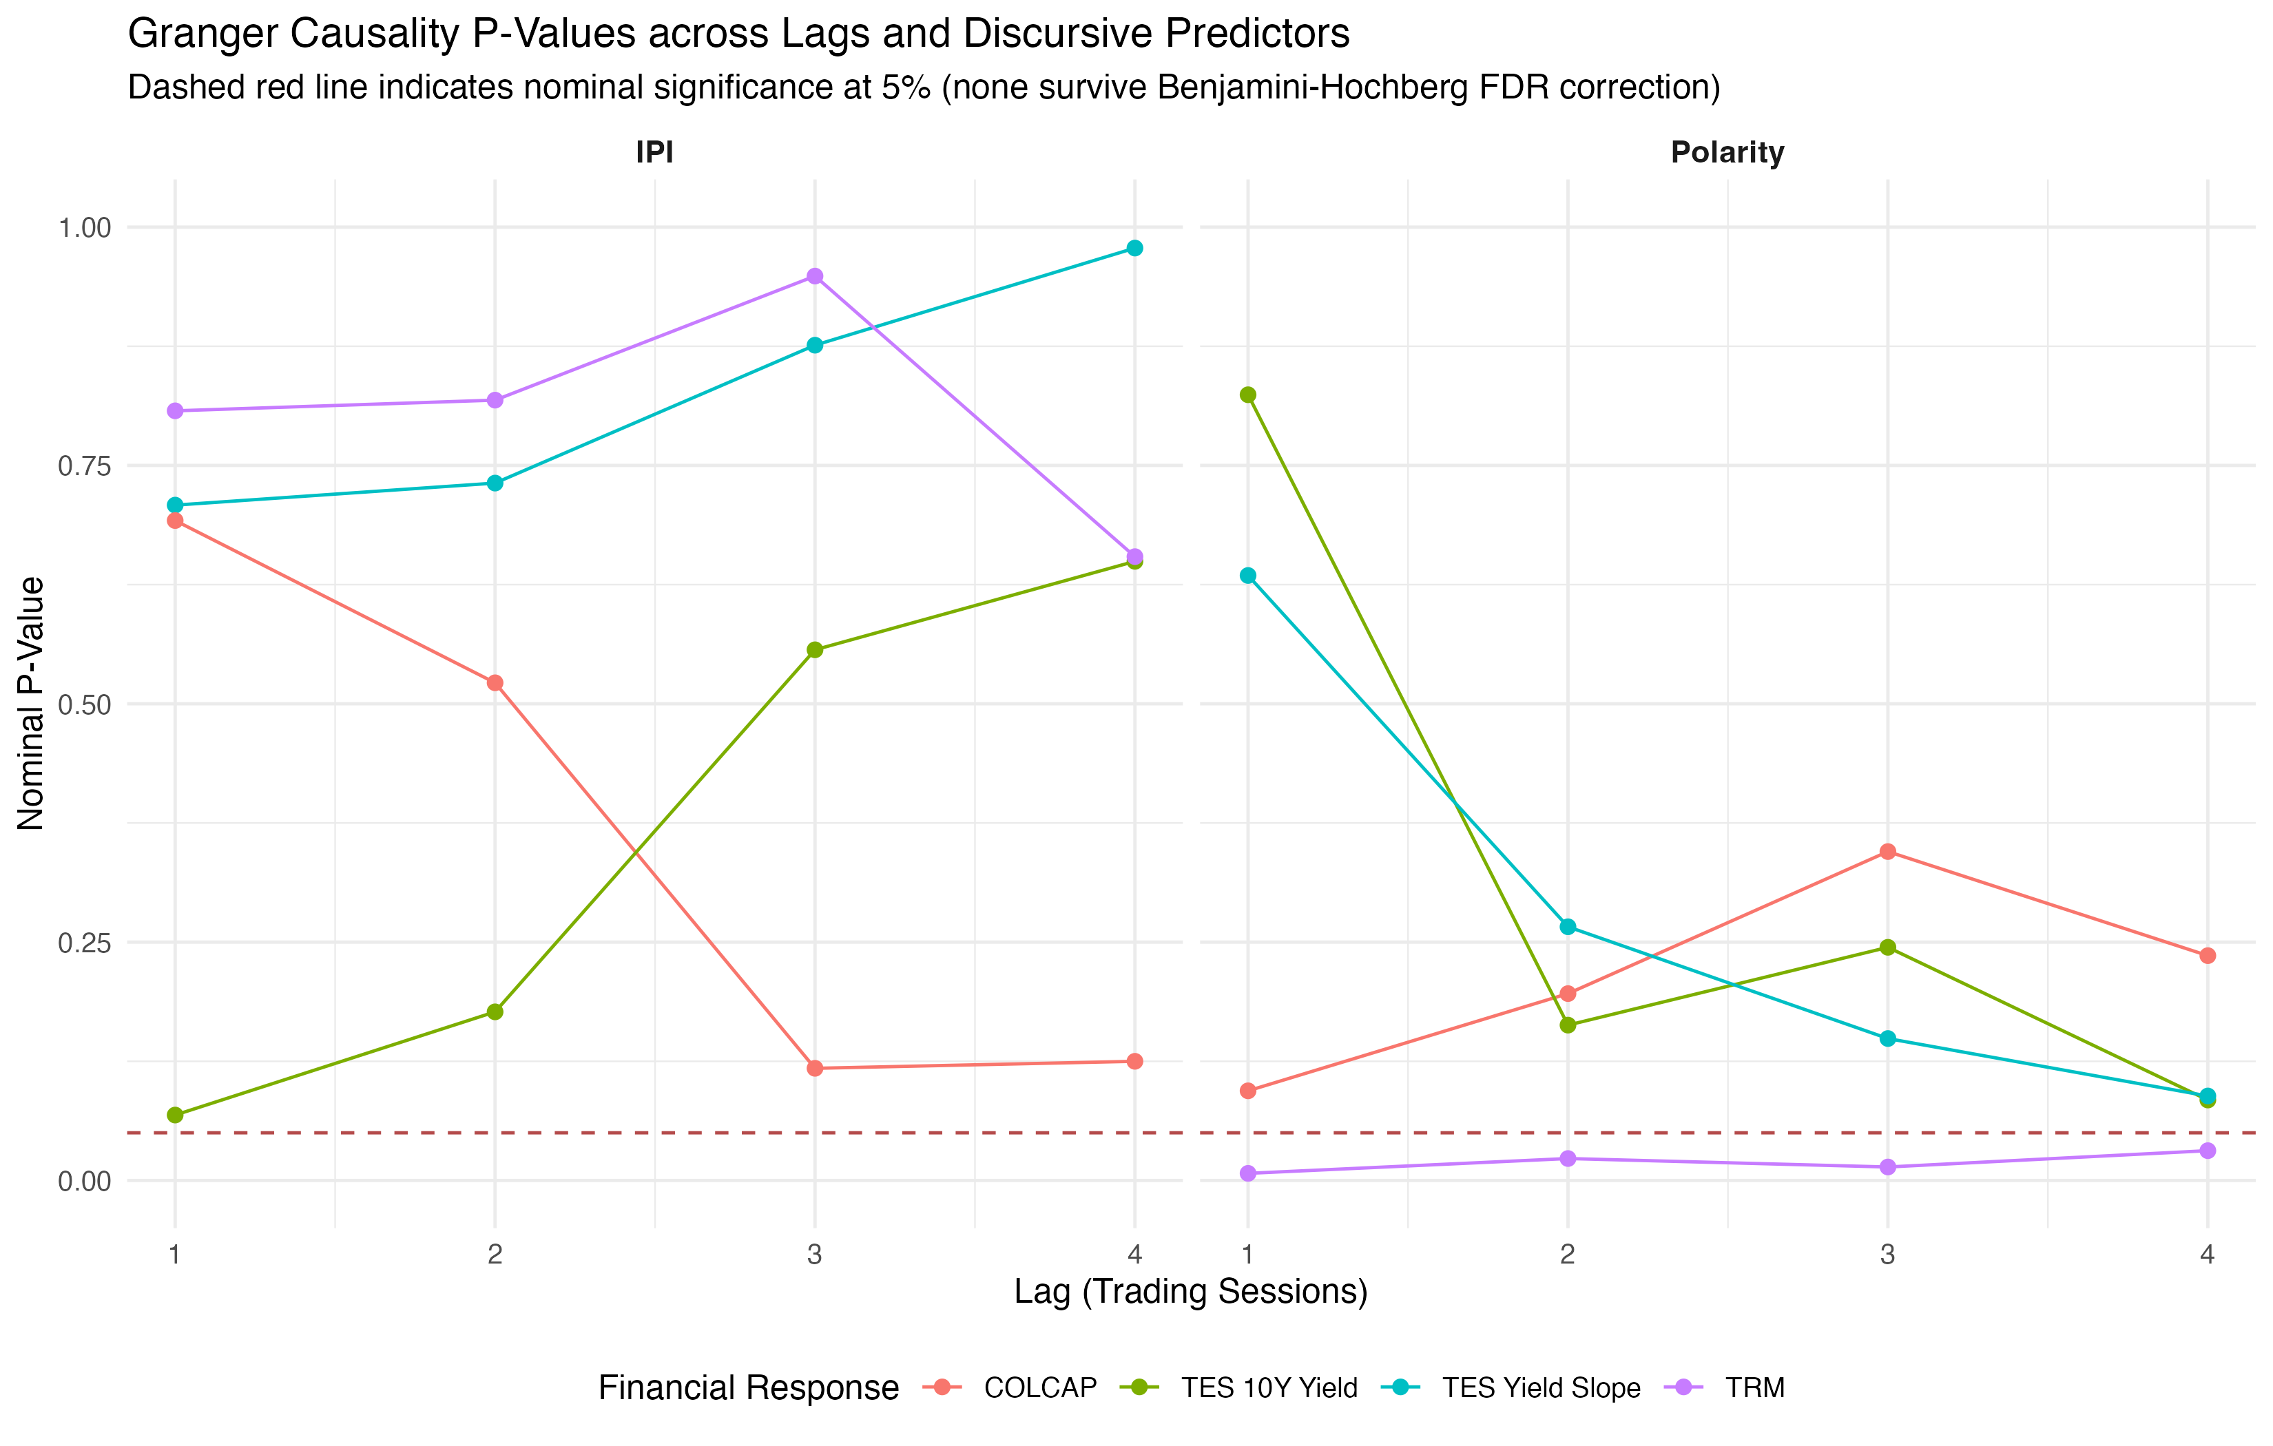
(a) Panel A: Granger $p$-values for presidential IPI and Net Polarity.

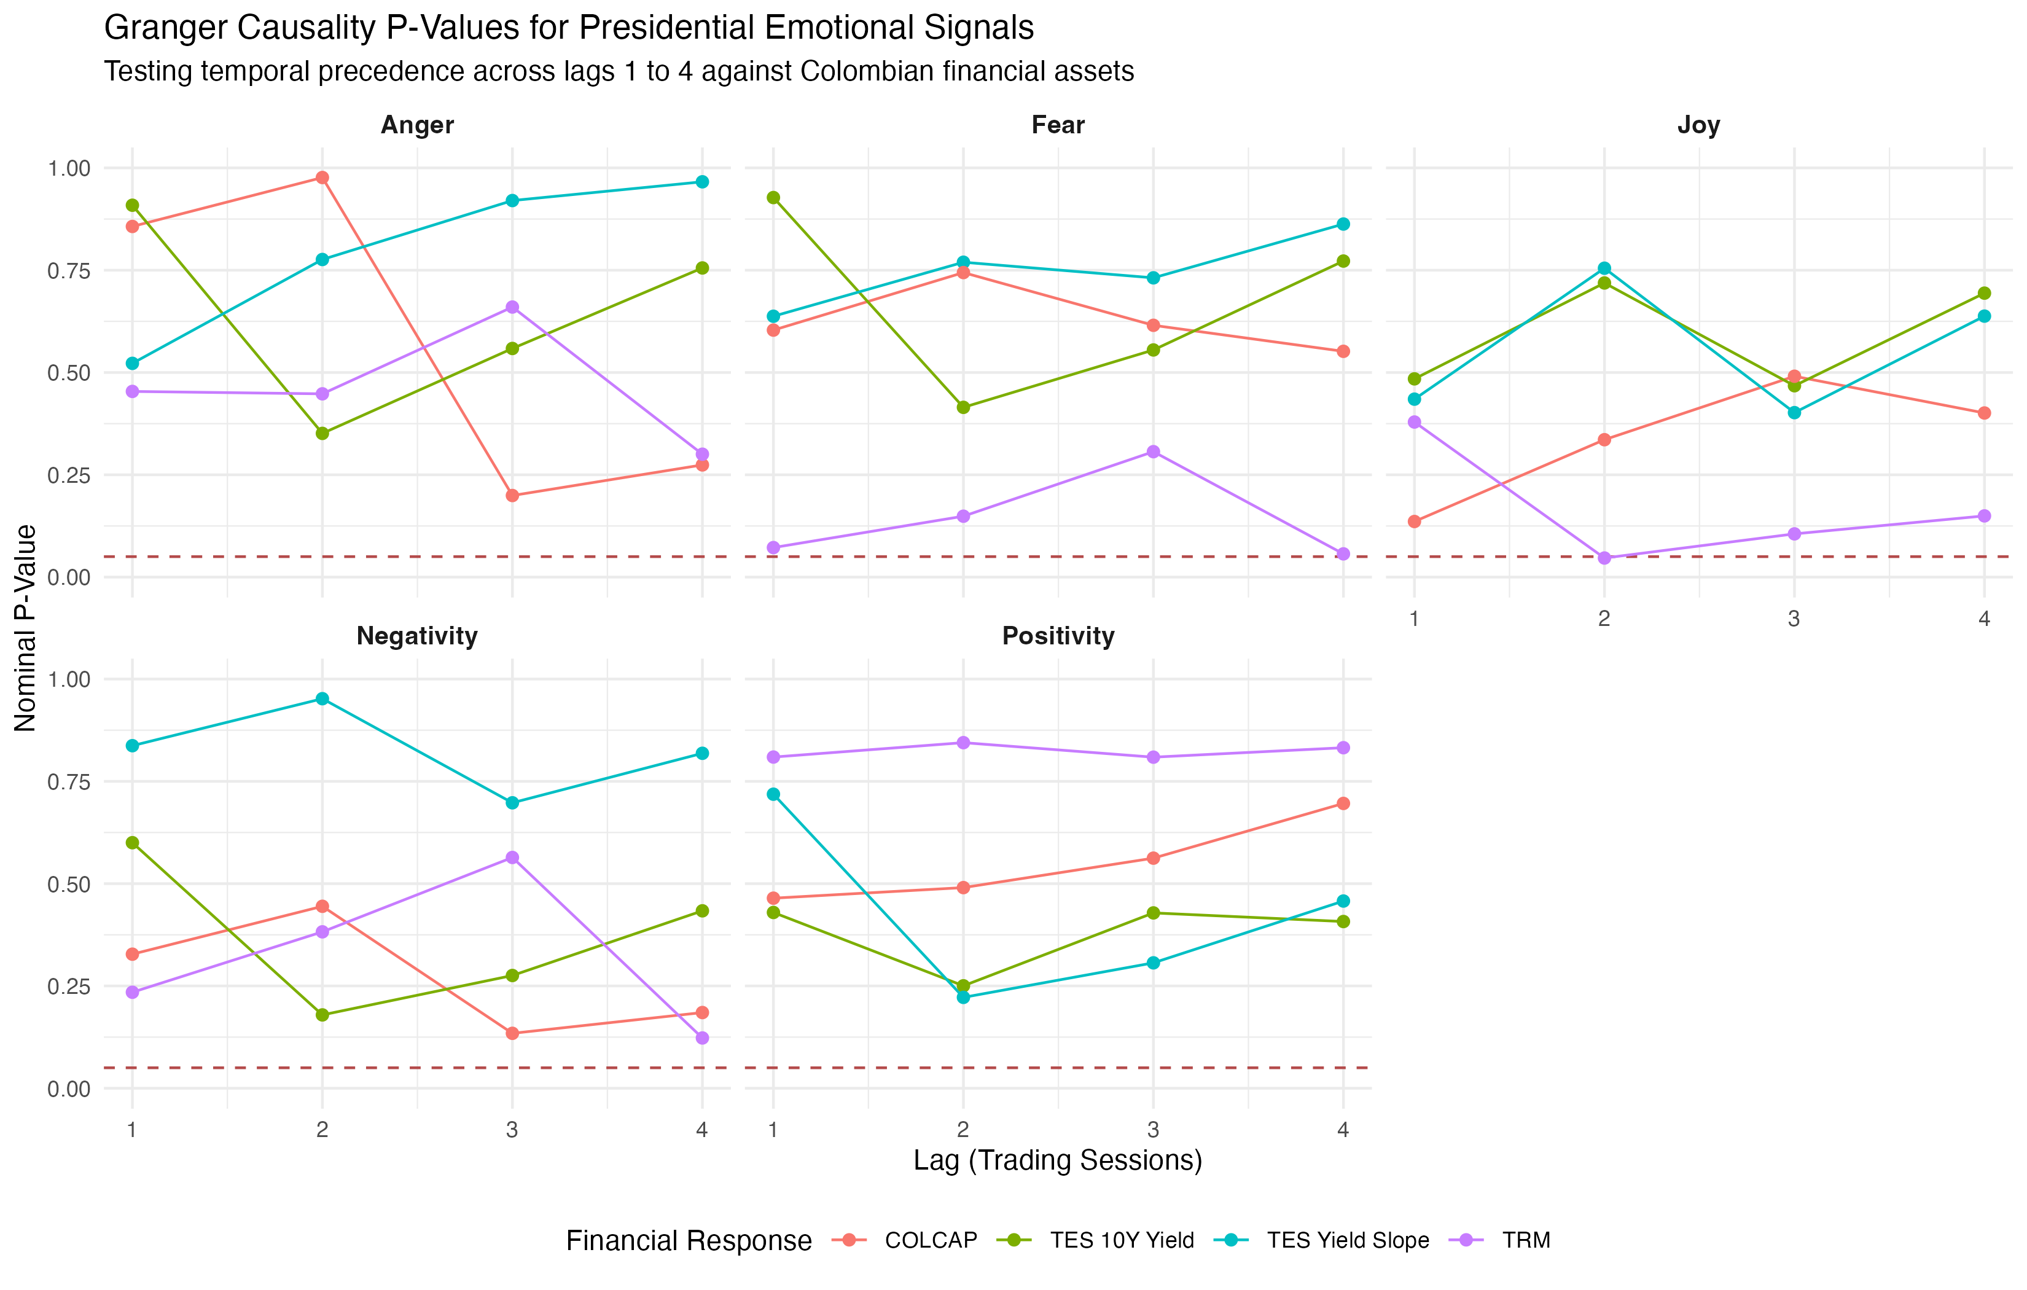
(b) Panel B: Granger $p$-values for presidential NRC affective and emotional signals.

Figure 8: Granger predictive precedence tests for presidential polarity, IPI, and NRC emotional signals versus financial assets. Source: Authors’ elaboration.

4.7 Financial reaction to episodes of extreme sentiment
The event study analyzes the cumulative responses of assets to the ten days characterized by the highest levels of negativity and the highest absolute IPI (Table 5 and Figure 9).
Table 5: Cumulative responses in the event study facing extreme discursive shocks. Source: Authors’ elaboration from event_study_resumen.csv. Horizons strictly reflect calendar days following the shock.
Emotional Shock / Asset | $t+1$ cal. day | $t+3$ cal. days | $t+5$ cal. days | $t+7$ cal. days | Events with Data | Financial Interpretation
Extreme IPI $→$ Return TRM | -0.16% | -0.73% | -0.71% | -1.28% | 10 / 10 | Moderate short-term cumulative appreciation
Extreme IPI $→$ Return COLCAP | -0.12% | -1.14% | -1.27% | +0.76% | 9 / 10 | Initial decline and recovery by day 7
Extreme IPI $→$ Change TES 10Y | +1.6 bps | +3.3 bps | -3.1 bps | +1.8 bps | 9 / 10 | Yield rise with rapid stabilization
Extreme IPI $→$ Return XM Energy | +2.70% | +16.03% | +24.47% | +31.89% | 10 / 10 | Upward drift in electricity spot prices
Extreme Negativity $→$ Return TRM | -0.09% | -0.45% | -0.52% | -0.84% | 10 / 10 | Moderate transient appreciation
Extreme Negativity $→$ Return COLCAP | +0.60% | +0.85% | +1.10% | +1.16% | 9 / 10 | Absence of sustained downward pressure
Extreme Negativity $→$ Change TES 10Y | -2.4 bps | -4.5 bps | -10.6 bps | +17.5 bps | 9 / 10 | Rebound in sovereign yields at day 7
Extreme Negativity $→$ Return XM Energy | +2.67% | +6.29% | +9.24% | +12.17% | 10 / 10 | Positive cumulative return

The heat map of cumulative responses (Figure 9) illustrates the rapid stabilization of emotional disturbances toward historical averages, without generating structural ruptures in financial valuations.
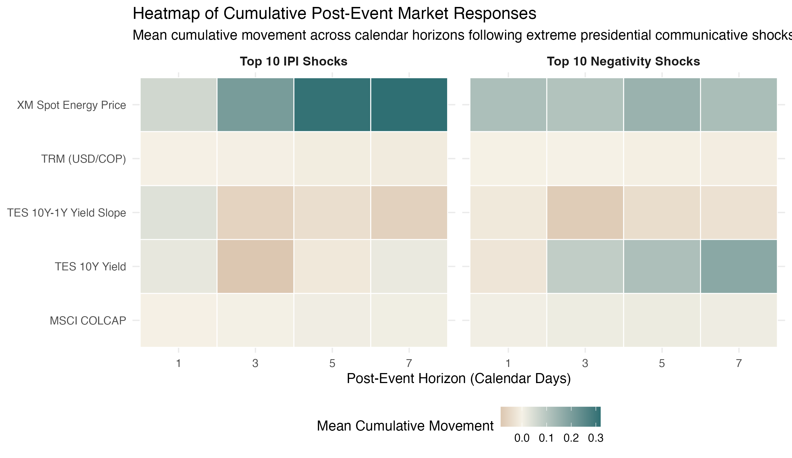
Figure 9: Heatmap of cumulative financial responses following extreme discursive events. Source: Authors’ elaboration.

5. Discussion
The empirical analysis of @petrogustavo’s posts and the four domestic financial markets allows the discussion to be structured around five fundamental analytical dimensions:
Institutional discursive orientation versus citizen debate: Unlike citizen conversation on social media, often characterized by polarization and reactive negativity, presidential discourse exhibits, on average, a clearly positive polarity, grounded in public policy and structural reforms. This distinction indicates that the content issued by the head of state functions as a channel for setting the government agenda rather than as a source of constant emotional tension.
Statistical independence of prices and limits to linear predictability: Contrary to the perception that presidential statements trigger direct movements in dollar exchange rates or stock prices, Granger causality tests rule out such a relationship at a daily frequency. Although five nominal rejections at the 5% level are observed, concentrated in the official exchange rate, none remain significant after adjusting for multiplicity using the Benjamini-Hochberg procedure ($q=0.791$). This finding is consistent with the semi-strong form of the efficient market hypothesis (Fama, 1970), according to which the prices of liquid assets absorb publicly available information without observable lags by the close of the trading day.
Lack of impact of the negative emotional chain on risk premiums: Behavioral finance literature suggests that emotions such as fear or anger can increase risk aversion or trigger overreactions (Lerner & Keltner, 2001; Loewenstein, 2000). However, within the presidential discourse, none of the negative-valence emotions demonstrate any incremental predictive power regarding COLCAP returns, TES yields, or electricity exchange prices. Market participants distinguish between the confrontational tone of political debate and the variables that determine the fundamental value of securities.
Transience of responses and absence of structural persistence: The multivariate DCC(1,1) estimation yields a non-significant parameter for the reaction to sentiment innovations ($a=0.0119;p=0.069$), along with moderate average dynamic conditional correlations ranging from -0.043 to +0.057. Furthermore, an event study concerning extreme shocks in the IPI and negativity reveals that price fluctuations revert within a window of three to seven business days. Discursive disturbances act as short-term attention shocks (Barber & Odean, 2008; Da et al., 2011) that do not trigger permanent regime shifts.
Primacy of macroeconomic and institutional determinants: The trajectories of the exchange rate (TRM), the COLCAP index, and the TES yield curve are primarily driven by the monetary policy decisions of the Banco de la República, the international sovereign risk premium, and global liquidity conditions. The market treats activity on Twitter as communicative noise, remaining anchored instead to macroeconomic fundamentals.
Theoretical and financial implications: On a daily basis, the discursive signals issued by the presidency on Twitter/X lack the capacity to systematically sway stock and exchange rates in Colombia. This decoupling supports the hypothesis of informational efficiency and demonstrates the institutional resilience of local financial markets in the face of social media rhetoric.

6. Limitations and future research directions
This analysis presents three limitations that define its scope and point toward future work:
First, the temporal concentration of the secondary public opinion corpus, with 97.49% of messages collected at 18:00 COT under a fixed daily quota, restricted the econometric modeling to the official @petrogustavo dataset. Future extensions could implement stratified sampling distributed uniformly across the 24-hour cycle to reintegrate citizen discourse into the dynamic analysis.
Second, while lexical dictionaries such as NRC and sentiment-analysis frameworks are transparent and reproducible, they struggle to capture the irony, sarcasm, and context-dependent language characteristic of political debate. Calibrating transformer-based language models specifically adapted to financial terminology represents a promising avenue for methodological refinement.
Third, aggregating data at a daily frequency obscures potential intraday microstructure effects. Incorporating minute-by-minute transactional records from foreign exchange and stock markets would allow for the investigation of very short-term responses that may be absorbed before the close of each trading session.

7. Conclusions
Empirical modeling based on the full set of posts from the official @petrogustavo account and their relationship to Colombian financial markets between August 2022 and May 2026 yields five main conclusions:
- Institutional rhetoric: The presidential discursive profile reflects an institutional rhetoric centered on public policy, with an average net positive polarity, a vocabulary focused on government reforms, and a prevalence of sentiments of confidence and anticipation, distinct from the patterns of reactive negativity typical of public discourse on social media.
- Statistical independence: Colombian financial variables are statistically independent of the discursive tone on social media. Granger causality tests rule out linear predictability regarding currencies, equities, fixed-income securities, and energy in the 112 specifications evaluated. None withstands rigorous control of the false discovery rate.
- No negative emotional contagion: Individual emotions with negative valence do not constitute a channel for contagion to risk premiums. Neither presidential fear nor anger demonstrates any explanatory power regarding the returns or volatility of the assets when evaluated on a daily basis.
- Transient disturbances: Disturbances associated with extreme discursive episodes are transient and revert within a few days. The DCC-GARCH model indicates low conditional sensitivity to discursive innovations, and the event study documents the absorption and stabilization of returns between days $t+3$ and $t+7$.
- Macroeconomic anchoring: Asset equilibrium prices remain anchored to macroeconomic fundamentals, reflecting the central bank’s stance, sovereign risk, and international market trends, rather than short-term digital rhetoric.
Implication for the study: The sentiment expressed in presidential discourse on Twitter/X mobilizes public attention and energizes public debate, yet it does not serve as a systematic determinant of prices in Colombian financial markets. Empirical evidence supports the semi-strong form efficiency hypothesis at a daily level and confirms the institutional robustness of domestic markets in the face of the flow of communication from social media.

Data and code availability
All cleaned datasets, results tables, high-resolution figures, and the reproducible methodological notebook in Quarto are publicly available in the GitHub repository: https://github.com/juanjo-edm/What_is_the_economic_impact_of_Colombian_President_tweets.

Conflict of interest statement
The authors declare that they have no conflicts of interest or financial commitments related to the publication of this article.

Funding statement
This research was conducted within the framework of the Oikos Research Group at the Faculty of Economics of the Universidad Militar Nueva Granada in Bogotá, Colombia, and did not receive external funding.

References
Ardia, D., Bluteau, K., Borms, S., & Boudt, K. (2021). The R package sentometrics to compute, aggregate, and predict with textual sentiment. Journal of Statistical Software, 99(2), 1–40. https://doi.org/10.18637/jss.v099.i02
Baker, M., & Wurgler, J. (2006). Investor sentiment and the cross-section of stock returns. The Journal of Finance, 61(4), 1645–1680. https://doi.org/10.1111/j.1540-6261.2006.00885.x
Baker, S. R., Bloom, N., & Davis, S. J. (2016). Measuring economic policy uncertainty. The Quarterly Journal of Economics, 131(4), 1593–1636. https://doi.org/10.1093/qje/qjw024
Barber, B. M., & Odean, T. (2008). All that glitters: The effect of attention and news on the buying behavior of individual and institutional investors. The Review of Financial Studies, 21(2), 785–818. https://doi.org/10.1093/rfs/hhm079
Benoit, K., Watanabe, K., Wang, H., Nulty, P., Obeng, A., Müller, S., & Matsuo, A. (2018). Quanteda: An r package for the quantitative analysis of textual data. Journal of Open Source Software, 3(30), 774. https://doi.org/10.21105/joss.00774
Bianchi, F., Gómez-Cram, R., & Kung, H. (2024). Using social media to identify the effects of congressional viewpoints on asset prices. The Review of Financial Studies, 37(7), 2244–2272. https://doi.org/10.1093/rfs/hhae001
Blei, D. M., Ng, A. Y., & Jordan, M. I. (2003). Latent dirichlet allocation. Journal of Machine Learning Research, 3(Jan), 993–1022.
Bollen, J., Mao, H., & Zeng, X. (2011). Twitter mood predicts the stock market. Journal of Computational Science, 2(1), 1–8. https://doi.org/10.1016/j.jocs.2010.12.007
Bondi, M., & Scott, M. (2010). Keyness in texts (Vol. 41). John Benjamins Publishing.
Casallas Felipe, M. A. (2020). Análisis de contenido sobre la percepción política de gustavo petro e iván duque en la red social twitter [{B.S.} thesis]. Universidad de La Sabana.
Da, Z., Engelberg, J., & Gao, P. (2011). In search of attention. The Journal of Finance, 66(5), 1461–1499. https://doi.org/10.1111/j.1540-6261.2011.01679.x
De Long, J. B., Shleifer, A., Summers, L. H., & Waldmann, R. J. (1990). Noise trader risk in financial markets. Journal of Political Economy, 98(4), 703–738. https://doi.org/10.1086/261703
Edmans, A., García, D., & Norli, Ø. (2007). Sports sentiment and stock returns. The Journal of Finance, 62(4), 1967–1998. https://doi.org/10.1111/j.1540-6261.2007.01262.x
Fama, E. F. (1970). Efficient capital markets: A review of theory and empirical work. The Journal of Finance, 25(2), 383–417. https://doi.org/10.2307/2325486
García, D. (2013). Sentiment during recessions. The Journal of Finance, 68(3), 1267–1300. https://doi.org/10.1111/jofi.12027
Gentzkow, M., Kelly, B., & Taddy, M. (2019). Text as data. Journal of Economic Literature, 57(3), 535–574. https://doi.org/10.1257/jel.20181020
Gjerstad, P., Meyn, P. F., Molnár, P., & Næss, T. D. (2021). Do president trump’s tweets affect financial markets? Decision Support Systems, 147, 113577. https://doi.org/10.1016/j.dss.2021.113577
Gómez-Torres, E., Jaimes, R., Hidalgo, O., & Luján-Mora, S. (2018). Influencia de redes sociales en el análisis de sentimiento aplicado a la situación política en ecuador. Enfoque UTE, 9(1), 67–78.
Grimmer, J., & Stewart, B. M. (2013). Text as data: The promise and pitfalls of automatic content analysis methods for political texts. Political Analysis, 21(3), 267–297. https://doi.org/10.1093/pan/mps028
Hirschberg, J., & Manning, C. D. (2015). Advances in natural language processing. Science, 349(6245), 261–266. https://doi.org/10.1126/science.aaa8685
Hirshleifer, D., & Shumway, T. (2003). Good day sunshine: Stock returns and the weather. The Journal of Finance, 58(3), 1009–1032. https://doi.org/10.1111/1540-6261.00556
Jockers, M. (2017). Package syuzhet. https://cran.r-project.org/web/packages/syuzhet
Kahneman, D., & Tversky, A. (1979). Prospect theory: An analysis of decision under risk. Econometrica, 47(2), 263–291. https://doi.org/10.2307/1914185
Laver, M., Benoit, K., & Garry, J. (2003). Extracting policy positions from political texts using words as data. American Political Science Review, 97(2), 311–331. https://doi.org/10.1017/S0003055403000698
Lerner, J. S., & Keltner, D. (2001). Fear, anger, and risk. Journal of Personality and Social Psychology, 81(1), 146–159. https://doi.org/10.1037/0022-3514.81.1.146
Loewenstein, G. (2000). Emotions in economic theory and economic behavior. American Economic Review, 90(2), 426–432. https://doi.org/10.1257/aer.90.2.426
Loughran, T., & McDonald, B. (2011). When is a liability not a liability? Textual analysis, dictionaries, and 10-ks. The Journal of Finance, 66(1), 35–65. https://doi.org/10.1111/j.1540-6261.2010.01625.x
Medhat, W., Hassan, A., & Korashy, H. (2014). Sentiment analysis algorithms and applications: A survey. Ain Shams Engineering Journal, 5(4), 1093–1113. https://doi.org/10.1016/j.asej.2014.04.011
Misuraca, M., Forciniti, A., Scepi, G., & Spano, M. (2020). Sentiment analysis for education with r: Packages, methods and practical applications. https://arxiv.org/abs/2005.12840
Mohammad, S. M., & Turney, P. D. (2013). Crowdsourcing a word–emotion association lexicon. Computational Intelligence, 29(3), 436–465.
Mohammad, S., & Turney, P. (2010). Emotions evoked by common words and phrases: Using mechanical turk to create an emotion lexicon. Proceedings of the NAACL HLT 2010 Workshop on Computational Approaches to Analysis and Generation of Emotion in Text, 26–34. https://aclanthology.org/W10-0204/
Mullainathan, S., & Thaler, R. H. (2000). Behavioral economics (7948). National Bureau of Economic Research. https://doi.org/10.3386/w7948
Pástor, Ľ., & Veronesi, P. (2012). Uncertainty about government policy and stock prices. The Journal of Finance, 67(4), 1219–1264. https://doi.org/10.1111/j.1540-6261.2012.01746.x
Pástor, Ľ., & Veronesi, P. (2013). Political uncertainty and risk premia. Journal of Financial Economics, 110(3), 520–545. https://doi.org/10.1016/j.jfineco.2013.08.007
Pérez Llorente, J. M. (2020). El impacto de los tweets de donald j. Trump sobre los mercados financieros. https://repositorio.comillas.edu/jspui/handle/11531/40872
Plutchik, R. (2003). Emotions and life: Perspectives from psychology, biology, and evolution. American Psychological Association.
Prada Espinel, Ó. A. (2018). Comportamiento comunicacional de twitter en las campañas presidenciales de colombia 2018: Caso gustavo petro e iván duque [Master’s thesis, Universidad Internacional de Andalucía]. https://dspace.unia.es/handle/10334/3936
Roberts, M. E., Stewart, B. M., & Tingley, D. (2019). Stm: An r package for structural topic models. Journal of Statistical Software, 91(2), 1–40. https://doi.org/10.18637/jss.v091.i02
Romero Moreno, F. Y., Sánchez Martelo, C. A., Alfonso Corredor, B. Y., Sánchez Cifuentes, J. F., & Ospina López, J. P. (2020). Análisis de sentimiento a las opiniones generadas en la red social twitter: Marketing político. RISTI: Revista Ibérica de Sistemas e Tecnologias de Informação, (E35), 187–203. https://www.risti.xyz/issues/ristie35.pdf
Sandoval-Garrido, L. E., & Marín-Jaramillo, M. (2022). Elecciones presidenciales y desarrollo municipal: El caso colombiano (1986-2014). Lecturas de Economía, (97), 113–148. https://doi.org/10.17533/udea.le.n97a346128
Schweinberger, M. (2023). Analyzing co-occurrences and collocations in r. https://ladal.edu.au/coll.html
Shiller, R. J. (2019). Narrative economics: How stories go viral and drive major economic events. Princeton University Press. https://doi.org/10.2307/j.ctvdf0k29
Shleifer, A., & Vishny, R. W. (1997). The limits of arbitrage. The Journal of Finance, 52(1), 35–55. https://doi.org/10.1111/j.1540-6261.1997.tb03807.x
Silge, J., & Robinson, D. (2017). Text mining with r: A tidy approach. O’Reilly Media.
Slapin, J. B., & Proksch, S.-O. (2008). A scaling model for estimating time-series party positions from texts. American Journal of Political Science, 52(3), 705–722. https://doi.org/10.1111/j.1540-5907.2008.00338.x
Smith, A. (1759). The theory of moral sentiments. Printed for A. Millar; A. Kincaid; J. Bell.
Stefanowitsch, A., & Gries, S. (2003). Collostructions: Investigating the interaction of words and constructions. International Journal of Corpus Linguistics, 8. https://doi.org/10.1075/ijcl.8.2.03ste
Tetlock, P. C. (2007). Giving content to investor sentiment: The role of media in the stock market. The Journal of Finance, 62(3), 1139–1168. https://doi.org/10.1111/j.1540-6261.2007.01232.x

