From Presidential Communication to Territorial Governance: The Effects of Gustavo Petro’s Tweets on Institutional Trust and Regional Financial Markets in Colombia
Juan Jos´e Echeverry De Mendoza^{a∗} Miguelangel Palma Rojas^{bc}
Luis Eduardo Sandoval Garrido.^{ac}
ªFaculty of Economics, Universidad Militar Nueva Granada, Bogota´, Colombia ^{b}Faculty of Economics, Universidad Militar Nueva Granada, Bogota´, Colombia ^{c}Faculty of Economics, Universidad Militar Nueva Granada, Bogota´, Colombia
∗Corresponsal author: Luis, E, Sandoval; luis.sandoval@unimilitar.edu.co

Abstract
The presidency of Gustavo Petro has been marked by a lot of activity on Twitter, which has had various effects on the media and local economic markets. As a result, this paper aims to examine President Gustavo Petro’s Twitter profile and the impact of his comments on the platform and the financial market. It demonstrates the need for promoting sanity and prudence in the media, particularly in individuals with a significant following on social media who can potentially cause economic problems with their comments, as reflected in various ways. The paper aims to analyze sentiment through Sentiment Analysis (SA) utilizing a Natural Language Processing (NLP) tool. The study employs unsupervised algorithms, such as Wordfish, structural topic modeling, and connection networks, for semantic characterization. The goal is to determine the impact of comments on a particular social network and how it affects financial markets.
Keywords: Tweet, Petro, Twitter, Sentiment, Politics, Reforms

Introduction
President Gustavo Petro is the first Colombian president to represent extreme left-wing ideology. He has formally belonged to a socialist group that has had a significant impact on the country’s economy and politics. The current president is known for his populist discourse and has gained a large following in his political career. This is considered a novelty in a country that has been characterized by conserva-tive policies and right-wing tendencies in the presidential office in recent years. Sandoval Garrido and Mar´ın Jaramillo (2022).
Gustavo Petro has a unique approach to politics that sets him apart from the norm. His political journey has been characterized by the significant use of Twitter as a political tool. This was evident during the first round of the presidential election held between April 27 and May 27, 2018. As a can-didate, he posted 1,374 tweets, out of which 486 were his own (35.4%), and 888 were retweets (64.6%). Prada Espinel et al. (2018). Out of Gustavo Petro’s 486 tweets, he used 148 hashtags. These hashtags revolved around mobilizing events organized by his campaign and inviting Colombians to topics of his political campaign.
We are analyzing President Gustavo Petro’s tweets to see if they have a short or long-term impact on the financial market. To do this, we are using the Coleqty index, which includes the 40 most liquid stocks in the Colombian market from sectors such as financial, energy, retail, food, and construction BVC (2013). It’s important to note that the composition of the index may change over time due to changes in the sector distribution of the companies included. We will be looking at the semantic orientation of each tweet and studying its impact on the market.

The term ”Fourth Industrial Revolution” was coined by the World Economic Forum back in 2016. It refers to a new era of industrial evolution that is characterized by a society that is more connected and smarter Bayod (2018). In this era, big data plays a crucial role in extracting valuable insights from information in the field of data science. As a result, data is now considered a productive factor, and it has changed the way citizens interact with their governments. Citizens can now better understand social and political objectives more transparently at the local, regional, national, and global levels of participation Cavanillas, Curry, and Wahlster (2016). To leverage this trend, the paper suggests using various analytical methodologies concerning textual data such as text classification.
In this research paper, we aim to increase awareness about the potential impact that high-ranking political officials can have on financial markets. We also want to encourage caution in the media and bridge the gap in academic literature regarding the influence of political discourse on the Colombian financial market. Given the current context of labor, pension, and health reforms, the study explores the impact of political discourse on the stock market and how this may fluctuate according to the expectations generated by President Gustavo Petro’s tweets. The paper is divided into six sections. Section 2 presents recent analyses involving lexical libraries associated with feelings and emotions in political contexts, which demonstrate how emotions expressed in social media posts can predict election outcomes based on the language used by candidates. Section 3 outlines a methodology that captures information about users’ sentiments on Twitter and combines it with data from a financial index to determine whether there is a short or long-term relationship between sentiment and the behavior of the proposed variable. Section 4 presents the results obtained from the methodology described in Section 3. Section 5 discusses the main findings, and Section 6 concludes the paper.

Sentiments and emotions in political contexts
Studies often emphasize the importance of quantitative analysis in research P´erez Llorente (2020). For instance, when measuring the growth of a country, the Gross Domestic Product is a commonly used indi-cator. However, nowadays there is a growing interest in qualitative analysis to gain insight into individual circumstances. For example, sentiment analysis can be performed using lexical databases and algorithms to classify words according to their sentiment. This was demonstrated by Medhat, Hassan, and Korashy (2014).
Around 1990, the field of behavioral economics emerged, which challenged the classical economic the-ory of rational agents Mullainathan and Thaler (2000). This was not entirely new, as Adam Smith had already proposed in his book that people’s behavior was influenced by social laws that were not fully understood Smith (1759). Today, the theory of Kahneman (1979) is a prominent example of this new approach to economics. It rethinks the traditional utility function by introducing a new value function based on experimental evidence that demonstrates how individuals often exhibit irrational behavior. This behavior can be attributed to a variety of cognitive biases such as overconfidence and cognitive dissonance.
According to Romero Moreno, Sanchez Martelo, Alfonso Corredor, Sanchez Cifuentes, and Ospina L´opez (2020), Robert Plutchik’s psychology identifies eight primary emotions for sentimental categorization. These emotions are joy, sadness, anger, fear, surprise, aversion, trust, and anticipation. These primary emotions are universal for all cultures and are the foundation of all complex emotions. Plutchik also sug-gests that the combination of these eight primary emotions can create secondary or complex emotions. For instance, love can be produced by the combination of joy and trust, while remorse can be produced by the combination of sadness and aversion. Plutchik also suggests that each of these emotions is associ-ated with specific physiological and behavioral response patterns. For instance, anger is associated with increased heart rate and blood pressure, along with aggressive behavior. In contrast, fear is associated with increased sweating and avoidance behavior.
Twitter has become a powerful tool for political activity in recent years, as demonstrated by Urdinez and Cruz (2020) who used political data to show how these techniques can be applied in a political context. One of the possibilities offered by Twitter analysis is hashtag analysis, where hashtags are words or phrases that link users in an online conversation. Examining these hashtags can provide insight into how, when, and by whom these conversations take place. There is extensive literature that addresses social protest through the viral spread of hashtags, including recent research that focuses on analyzing the hashtag-feminism Trott (2018) and racial minority activism hashtags, such as #blacklivesmatter Ince,

Rojas, and Davis (2017), that have also been investigated. In academic literature, hashtags play a fun-damental role in connective action, allowing individuals to establish links, strengthen communities, and promote individual and collective empowerment Trott (2018). Generally speaking, the use of a hashtag indicates an interest in a topic, regardless of whether someone is for or against it. Therefore, in this first exercise, we aim to identify participants who are debating specific topics rather than measure levels of support.
Sentiment analysis techniques have been implemented in the political arena in Colombia, as reported by Prada Espinel et al. (2018), who conducted a study on the use of Twitter during the presidential campaigns. The study analyzed the communication behavior of presidential candidates on Twitter, in-cluding the type of content shared, posting frequency, interaction with other users, and use of hashtags and mentions. Additionally, the authors explored the impact of Twitter on the presidential election by comparing polling data to candidates’ use of Twitter and voters’ perceptions of them.

Methodology
In order to conduct a preliminary analysis, we are using semantic analysis clustering modeling with Twitter microblogs and historical data of the Coleqty stock index. We are using textual, numeric, and date format variables within this methodology, utilizing structural topic modeling (STP) to identify the most frequent topics and their relationship with the variable of interest. To compare political ideologies, we are using the wordfish algorithm. We are also using a connection network to identify relationships, influences, and communication patterns in the political field. We’re scraping data from social networks by using Twitter’s API to download topics of interest, trends, and hashtags within the social network. Finally, we’re proposing a frequency analysis of the constructed time series to show if there is a long or short-term relationship between them.
The first step in this methodology involves using Twitter, a microblogging social network platform. To extract the required data, the “rtweet” library is utilized in R by Kearney (2019), which provides access to the Twitter application interface program (API). Within the period of March 14, 2023, to April 1, 2023, a total of 5,526 tweets are extracted. Out of these, 722 tweets relate to labor reform, 687 tweets are associated with pension reform, 1,616 tweets focus on health reform, 1,201 tweets are from Petro’s account, including retweets and 1,301 tweets are associated with the “#petro”. These tweets contain valuable metadata such as the comment’s opinion, location, date, and name. To estimate gender from the Spanish names, we use the ”gender” package which is available on R and is developed by Marin Diaz (2020). This package works with vectors and data frames and it is not only limited to first names but also works for full names. The package is based on a collection of typical names with their most common associated gender in both languages, which are utilized as lookup tables for gender inference.
The API (Application Programming Interface) is a set of protocols and functions that control certain interactions between users and web applications Urdinez and Cruz (2020). We use the data obtained through the API to perform textual analysis using the R package “quanteda” from Benoit, Nulty, Bar-ber, Watanabe, and Lauderdale (2018). This package helps us with metadata such as location, people retweeted, hashtags “#”, number of likes, and non-compound name fetching. After obtaining the nec-essary data, we use #Petro to perform network analysis techniques to determine the semantics of the debate around the person and their participation in the social network. We create a network of connec-tions based on public opinion using a feature co-occurrence matrix. This allows us to examine Petro’s interactions with other users, including political leaders, organizations, and followers. By analyzing this network of connections on Twitter, we gain insight into how Petro uses this platform to disseminate ideas, mobilize support, and build an engaged follower base.
The second step involves analyzing textual data using co-occurrence and collocation analysis, which is a technique used in natural language processing (NLP) and computational linguistics. This technique helps identify and study the relationships between words or terms in a text corpus. Simultaneously, a statistical keyword analysis is performed, which is a crucial technique in the field of natural language processing. It aims to extract relevant and meaningful information from textual datasets. These key-words are terms considered relevant in a particular context, and their statistical analysis contributes to obtaining a deep understanding of the structure and meaning of the text.

Co-occurrence analysis is a method that involves examining when two words or terms appear together in the same context or sentence. This analysis aims to identify whether words that tend to appear together frequently have any semantic or grammatical relationship. To achieve this, statistical measures such as the co-occurrence index or co-occurrence matrix can be calculated. This analysis technique can help to identify associations between words and provide insight into how they are used in natural language. In contrast, collocation analysis focuses on identifying sequences of words that appear together in a text at an unusually high frequency. These sequences are known as collocations, and they occur significantly more frequently than would be expected by chance. Schweinberger (2023)
To calculate co-occurrences and collocations, we create a document feature matrix by analyzing the sentences present in the given text. This matrix helps in determining how frequently the elements (which are the words in this case) occur in a set of documents (which are the sentences in the given text).

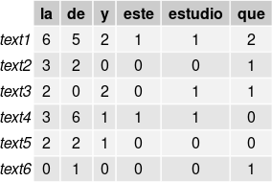

Figure 1: Matrix containing document characteristics for each tweet, Author’s calculations.

Afterwards, we utilized the computeCoocStatistics function from Wiedemann and Niekler (2017) to find out which words had the strongest collocation with our target term, “reform”. Additionally, we used dendrograms to visualize collocations, applying Ward’s hierarchical method as described by El-Hamdouchi and Willett (1986). These dendrograms display the similarity of items based on one or multiple features. We also made use of bigraph plots which depict the results of correspondence analyses, thereby helping us visualize the relationship between categories of categorical variables. These graphs are particularly useful when we are interested in the similarity of many terms, as opposed to a singular key term and its collocations Field, Miles, and Field (2012). In this context, semantic similarity refers to a shared meaning and distributional profile. Therefore, two words can be considered semantically similar if they have a common coexistence profile, meaning that they coexist with the same elements. Biplots are used to visualize collocations because they coexist and share semantic properties, making them more similar to each other Husson, Lˆe, and Pag`es (2016).
To utilize the graphical method, we must first create a distance matrix from our co-occurrence ma-trix. This matrix displays the frequency with which each element of the original matrix co-occurs with all other elements. We can then plot these co-occurrence patterns using the Benoit, Watanabe, et al. (2018) package in R.

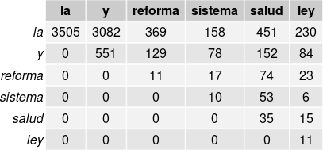

Figure 2: Co-occurrence matrix for each term, Author’s calculations

To identify which words tend to appear together more frequently than expected, we need to determine if their frequency of coexistence is statistically significant. This can be done either for specific keywords or for all the available data. However, in this paper, we focus on keyword selection. To determine which terms co-occur significantly with the key term “Reform” we use multiple Fisher’s exact tests that require

certain information.
Let me clarify the text you provided: a = represents the number of times that the cooccurring term appears with term j. b = represents the number of times that the cooccurring term appears without term
j. c = represents the number of times that other terms appear with term j. d = represents the number of terms that are neither cooccurring term nor term j.
Initially, we create a table containing these quantities.
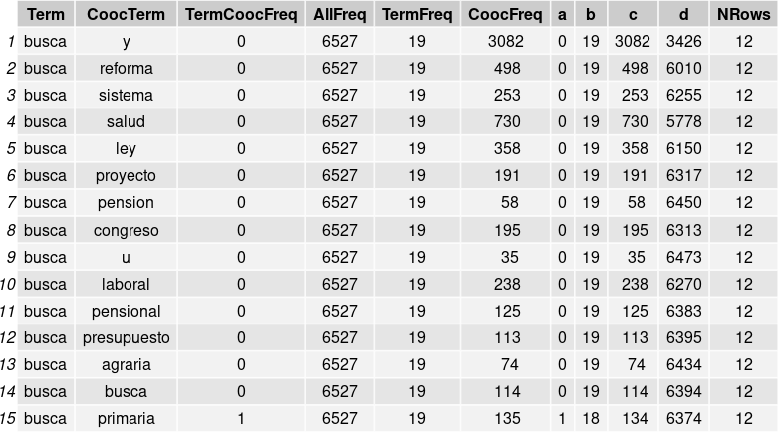

Figure 3: Table of Fisher’s exact multiple (or repeated) tests, Author’s calculations

When multiple tests are performed, corrections are necessary to ensure the reliability of the results. Repeated testing causes substantial inflation error in α. The Benjamini-Hochberg correction is preferable to the Bonferroni correction as it is less conservative and less likely to result in β errors. Field et al. (2012)
To sum up the process, statistical keyword analysis is conducted by assigning a score to features that appear differently across multiple categories. These categories are determined by a ”target” document index within the dfm. The reference group includes all other documents Benoit, Watanabe, et al. (2018). The ’quanteda.textstats’ module generates a data frame that contains calculated statistics and their respective values. Each row in the data frame represents a scored feature and displays the number of occurrences in both the target and reference groups. The statistics are calculated based on the measure selected. If ’chi2’ is the measure selected, the chi-square value is displayed with a positive sign if the observed value in the target group exceeds its expected value. If ’exact’ is the measure, the odds ratio estimate is displayed. If ’lr’ is the measure, the likelihood ratio G2 statistic is displayed. Finally, if ’pmi’ is the measure, the pointwise mutual information statistics are displayed.

In our analysis, we use the chi-square statistic to measure the observedΣsignificance and expected

frequency of a word. A larger statistic indicates greater significance. x² =
c
i
(Oi−Ei)2 where O
i
E
is the

observed frequency of the word and E_{i} is the expected value of word frequency.
The third step involves conducting sentiment analysis using the ”syuzhet” package of R Jockers (2017). This package allows for the quantification of the document collection using various dictionaries through a supervised algorithm. The unique feature of this package is the ability to access robust sentiment extrac-tion through natural language processing (NLP) provided by Hirschberg and Manning (2015). The lexical dictionary developed by Mohammad and Turney (2010) has associated each of its 13,901 words with a positive or negative polarity and one of eight emotions (anger, fear, anticipation, confidence, surprise, sadness, happiness, and disgust). This dictionary can be used for emotion analysis and is available in more than 100 languages. The RNC lexical dictionary criteria were used to classify the words. According to Misuraca, Forciniti, Scepi, and Spano (2020), this library performs better than other sentiment analysis packages.
According to Plutchik (2003), 8 primary feelings are proposed in a wheel in which the radius indicates

the intensity of the feeling, the closer it is to the center the more intense the feeling. Each primary emotion has its opposite part as follows: joy-sadness, anger-fear, aversion-confidence, surprise-anticipation. The model proposes a concept of primary dyads where the feelings caused by two primary feelings are linked in the white spaces of the basic emotions. Primary dyads are considered combinations of the contiguous elements. However, emotions in general do not have clear boundaries and do not always occur in isolation.
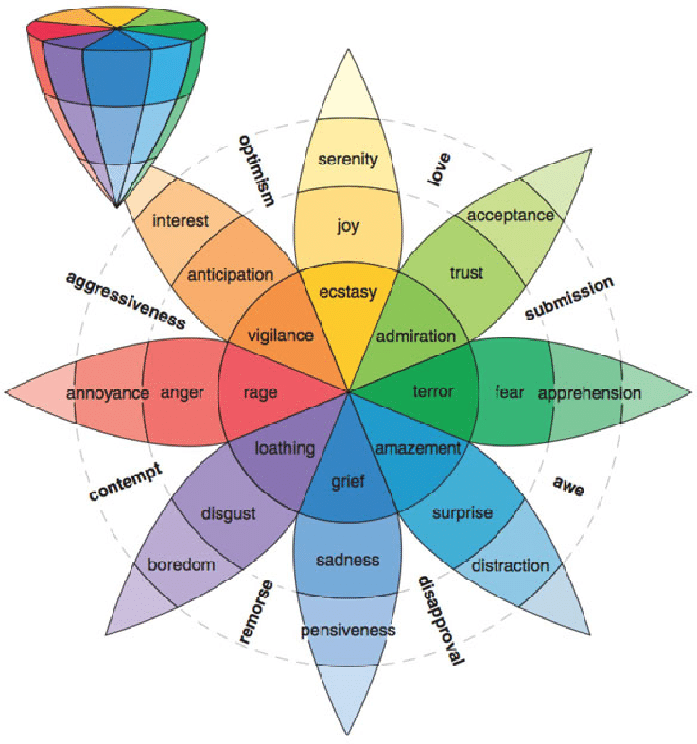

Figure 4: Wheel of emotions, Plutchik (2003)

A correlation matrix is used to analyze the relationship between different primary emotions. This ex-ploration helps to identify patterns and associations between emotions, providing a more comprehensive understanding of the complex human emotional experience surrounding Gustavo Petro’s political dis-course on Twitter. By examining the correlations between feelings, we can gain insight into how different emotions interact and influence each other.
The fourth step involves using the Wordfish algorithm, which creates a single-axis scale from multiple texts. Slapin and Proksch (2008). Documents are ranked on an axis based on their similarity to specific keywords, using a Poisson distribution to determine word frequency. This model uses a parameter λ to estimate the frequency of word repetition. This parameter represents the mean and variance in the Poisson probability distribution, as follows:
Wordcounttij ∼ Poisson(λ_{ij}). Where: λ_{ij} = exp(α_{i} + φ_{j} + β_{j} ∗ ϖ)

The count of the word ”j” in a document ”i” follows a Poisson distribution with a λ parameter specific to that word ”j” and document ”i”. The model estimates the parameter λ_{ij} and the term φ_{j}. When examining fixed effects, it’s important to account for variations in word frequency. The key parameter of concern is β_{j}, which measures the significance of individual words in distinguishing document positions on the latent X axis. As a result, documents may be categorized according to their similarity to one another based on specific keywords Slapin and Proksch (2008).
The fifth step involves the implementation of topic modeling, which aims to identify clusters of relevant words in large amounts of text automatically. One of the most widely used applications in political science is the Latent Dirichlet Allocation (LDA) model, which was developed by Blei, Ng, and Jordan (2003). Structural Topic Modeling (STM) is an unsupervised natural language processing (NLP) technique used to analyze large sets of texts. STM is unique in that it incorporates metadata in topic modeling, allowing for the discovery and exploration of topics, as well as the estimation of their relationship to specific vari-ables. This improves the quality of inferences and facilitates the interpretation of the results obtained. To employ the STM algorithm, the ”stm” package developed by Roberts, Stewart, and Tingley (2019) is available as a tool. w_{d,n}|z_{d,n}, β_{d,k} = z_{d,n} ∼ Multinomial(β_{d,k}, z_{d,n})
The function describes an algorithm called partially collapsed variational expectation maximization. Once the algorithm converges, it provides estimates for the model parameters. Specifically, the algorithm estimates the probability of word W occurring at the nth position in document d. This probability is conditioned on a multinomial distribution z_{d,n} of the document specified over k topics and a parameter β_{d,k} that estimates the topics according to the documents.
In the sixth step of the analysis, we examine the frequency of Tweets in relation to the behavior of financial indices, specifically the Coleqty and the Representative Market Exchange Rate (TRM its acronym in spanish ). This approach involves collecting and processing a large volume of data from Tweets to evaluate patterns and correlations with the movements of these two indices. This analysis is important because it can provide findings on market behavior and public perceptions. The Coleqty index measures the performance of a diversified set of publicly traded companies and includes a wide range of sectors such as financial, technology, energy, and healthcare. The composition of the index is based on specific criteria such as market capitalization and sector representativeness, which ensures that the sample is representative and equitable.
As a part of our research, we will be conducting a Granger analysis to determine if there is any causal relationship between public opinion sentiments expressed on structural reforms and the behavior of stock market indexes. To achieve this, we will be creating an index using the time series of sentiments derived from the proportion of the eight sentiments relative to the total number of tweets on each day. This will allow us to determine whether the variations in the sentiments expressed on people’s tweets precede or influence the movements of the stock market indices.

Results

Analysis of tweet metadata
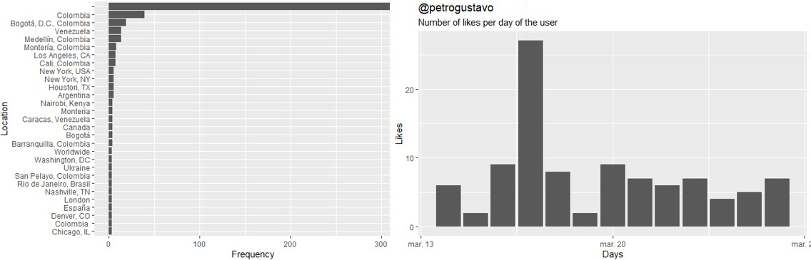
Figure 5: Location and Interactions of President Gustavo Petro, Author’s calculations

Most Twitter users do not share their location when giving their opinion, but it stands out that Bogot´a, Medell´ın, Monter´ıa, and Cali tweet more about the president in Colombia. In addition, participation is observed in Los Angeles and New York in the U.S. The president maintains a constant presence in social networks and media, but there are days of higher activity that may correspond to important events or relevant news.
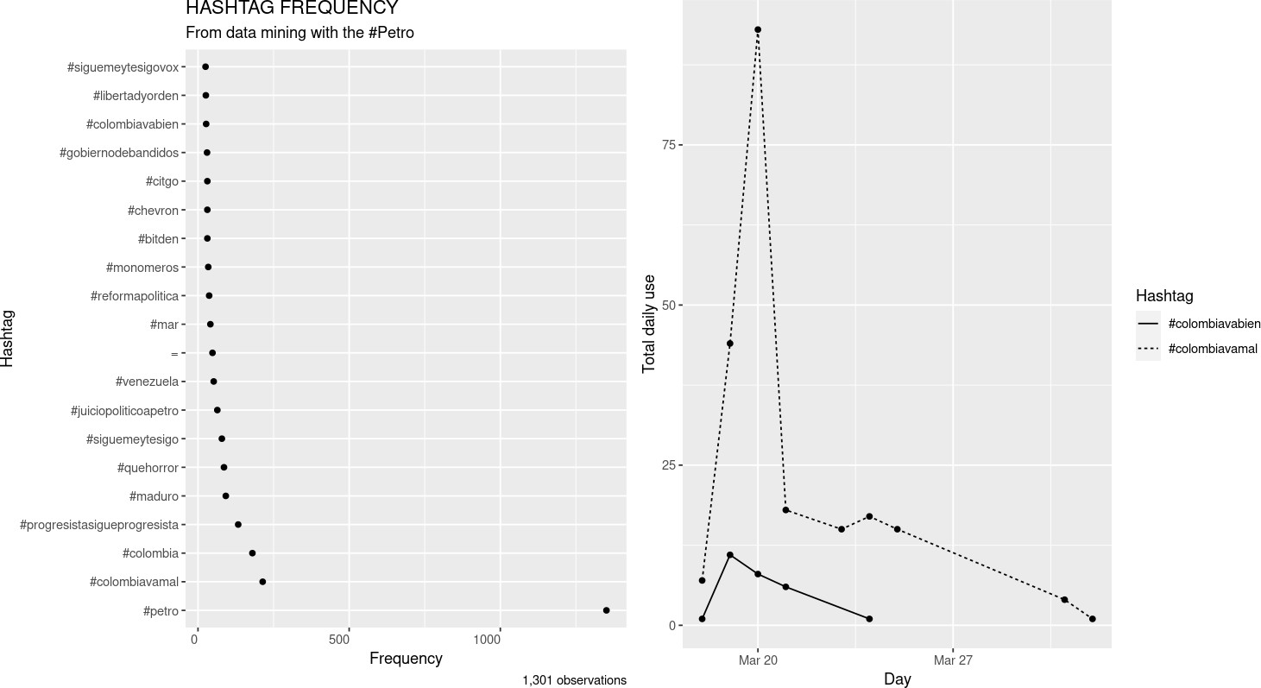

Figure 6: Hashtags associated with Gustavo Petro, Author’s calculations

The hashtags associated with a political candidate on Twitter can tell us about their political platform and the issues that matter most to their supporters. By comparing how often opposing hashtags are used, we can understand public opinion and how it may change over time. In the case of Gustavo Petro, the difference in usage between the hashtags ”Colombia va bien” and ”Colombia va mal” suggests that he faces greater opposition than support from the public. Network analysis is a useful tool for understanding the relationships between political and social actors, and how they can influence public perception.
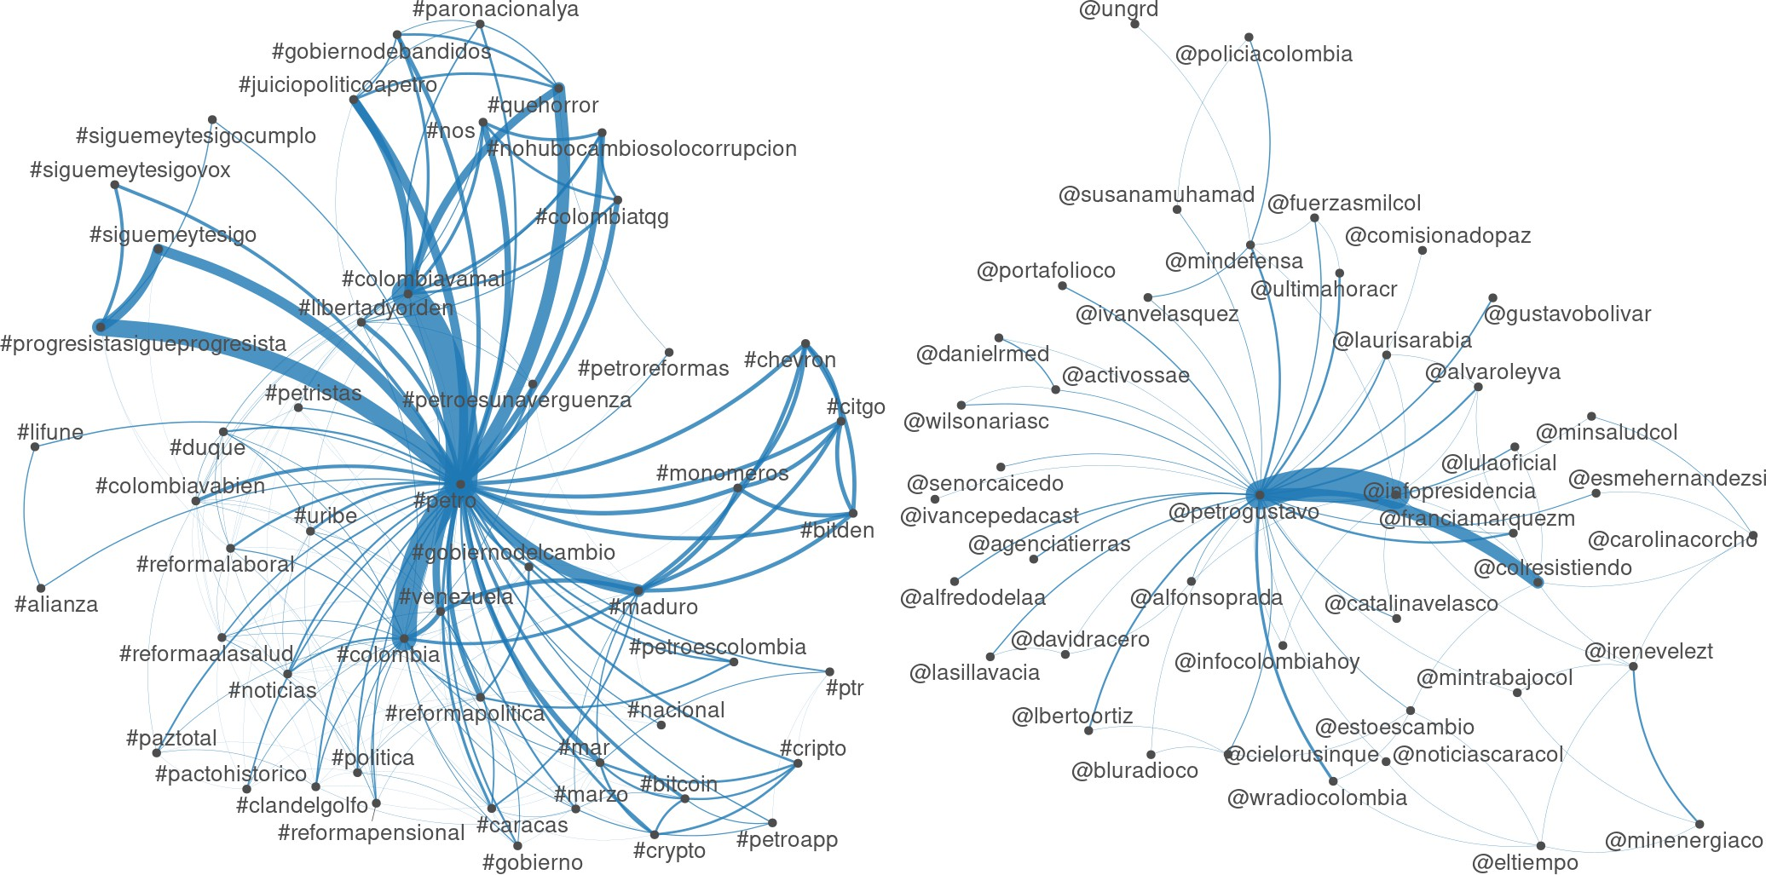

Figure 7: Network of connections, Author’s calculations

Upon analyzing tweets with the ”@” symbol, it becomes clear that the account of Gustavo Petro ”@petrogustavo” is the main node due to the high number of retweets where he is the main subject of the sentence. Another account with a strong influence and a strong link to the main node is the official account of the presidency ”@infopresidencia” and a non-governmental account named ”@colresitiendo”.

Additionally, an analysis of the hashtag network ”#” shows a constant confrontation of opinions for and against President Gustavo Petro, which can be categorized as political marketing Romero Moreno et al. (2020).

Analysis of co-occurrences and collocations:
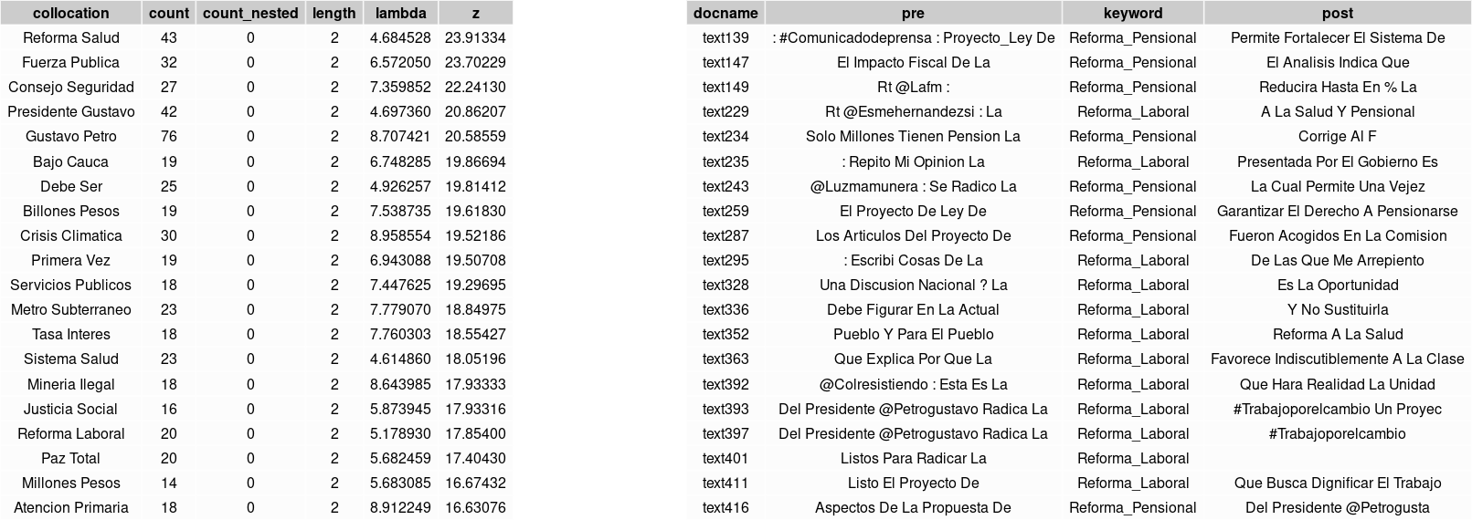

Figure 8: Analysis of co-occurrences, Author’s calculations

The drawback is that we only extract N-Grams with co-occurrence, while collocations may not appear in direct adjacency.
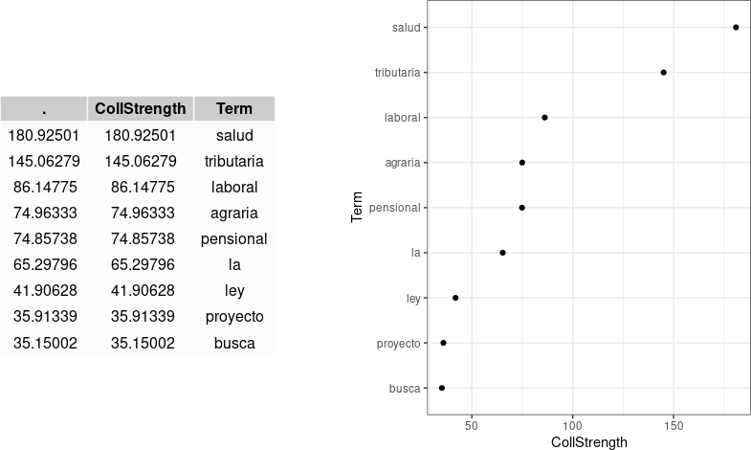
Figure 9: Stronger collocation with our target term ”Reform”, Author’s calculations According to the analysis, the term ”salud” is the word most frequently associated with reform in
Gustavo Petro’s tweets. The strong association between ”salud” and ”reforma” implies that these terms are collocations. Additionally, the dot plot reveals that ”salud” is more strongly linked to reform than any other term, validating the notion that health and reform are frequently intertwined in the president’s discourse.

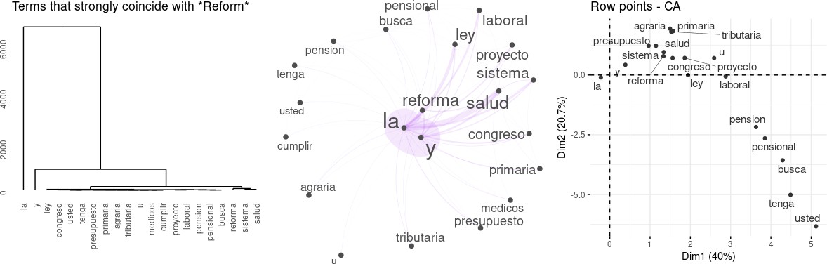

Figure 10: Patterns of co-occurrence in Gustavo Petro’s tweets, Author’s calculations

It is noteworthy that the biplot reveals that ”salud” and ”reforma” are placed very close to each other when plotted. The advantage of using a biplot is that it also shows the placement of other terms such as ”ley” and ”laboral”. Furthermore, we can determine which terms are overused or underused in conjunction with ”reforma”. This analysis is crucial for understanding whether certain constructions attract or repel specific words. The procedure reports both overuse and underuse.
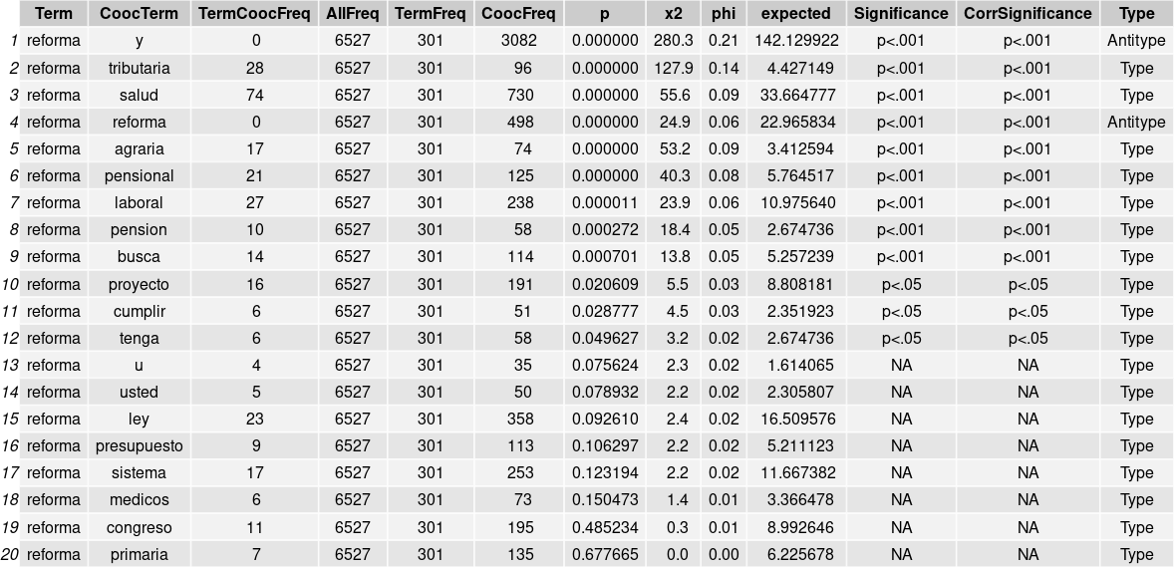

Figure 11: Table of statistical significance, Author’s calculations

The results indicate that reform significantly associates with the ”y” connector, as well as with ”tributaria” and ”salud”. After Benjamini-Hochberg correction for multiple/repeated tests, these are the only significant placements of selection.

Sentiment analysis of the tweets:
To understand how the president is being perceived and how his policy platform and positions are being perceived, an analysis is conducted to identify and evaluate the emotions expressed in his tweets. This can also help to assess whether his tweets generate a positive or negative emotional response. By performing sentimental analysis and semantic classification on tweets related to the president, we can identify certain words that are associated with public opinion. The president’s tweets generate controversy on the social network Twitter, with some users loving him and others hating him. This provides valuable information about the public perception of the president and his ability to connect with his Twitter followers emotionally.

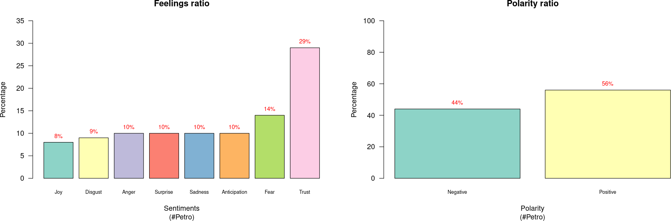

Figure 12: Classification of Petro hashtag semantics, Author’s calculations

According to the sample analysis performed in the previous graph on the distribution of polarity in President Gustavo Petro’s Tweets, it can be concluded that public opinion about the president is divided into 52% of positive opinions and 48% of negative opinions. This suggests that the president has moderate support but also faces significant opposition on the Twitter platform. It is important to keep in mind that the results obtained may vary depending on the timing of the study, the analysis sample and other external factors that may influence public opinion of the president. In addition, when performing a polarization of the Tweets with the hashtag ”Petro”, it can be observed that, according to Plutchik’s psychology, the two feelings that have a greater weight in the Tweets are trust with 28% and fear with 14%. This indicates that there is a variety of emotions experienced by President Petro´s followers when interacting on Twitter, and that trust is a predominant feeling among them, while fear also has a significant presence. In order to analyze the negative and positive polarity of tweets related to the president, the words with the highest frequency of negative and positive opinion of the president are extracted. These words may reveal the concerns or expectations that followers have of the president and how his actions and policies affect public opinion.
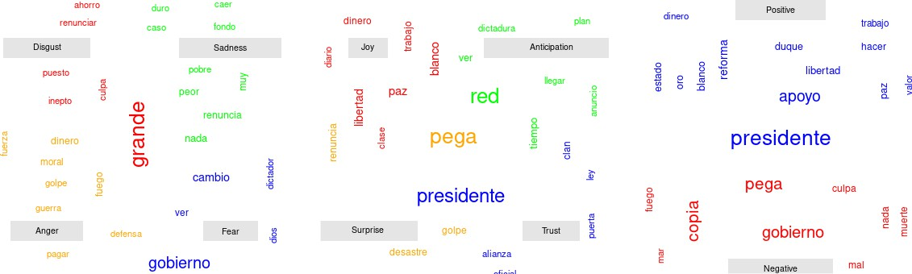

Figure 13: Negative and positive polarity word cloud, Author’s calculations

The analysis of the president’s tweets reveals that negative polarity is associated with emotions such as disgust, anger, fear, and sadness. This suggests that some of his followers may have a negative emotional response to his policies. On the other hand, positive polarity in his tweets indicates the presence of emotions such as confidence, surprise, happiness, and anticipation. This suggests that the president aims to generate a positive emotional response in his audience and convey a positive and hopeful vision of the future. These findings can be useful in understanding how the president is trying to influence his audience emotionally and which aspects of his policy platform generate a positive or negative response.

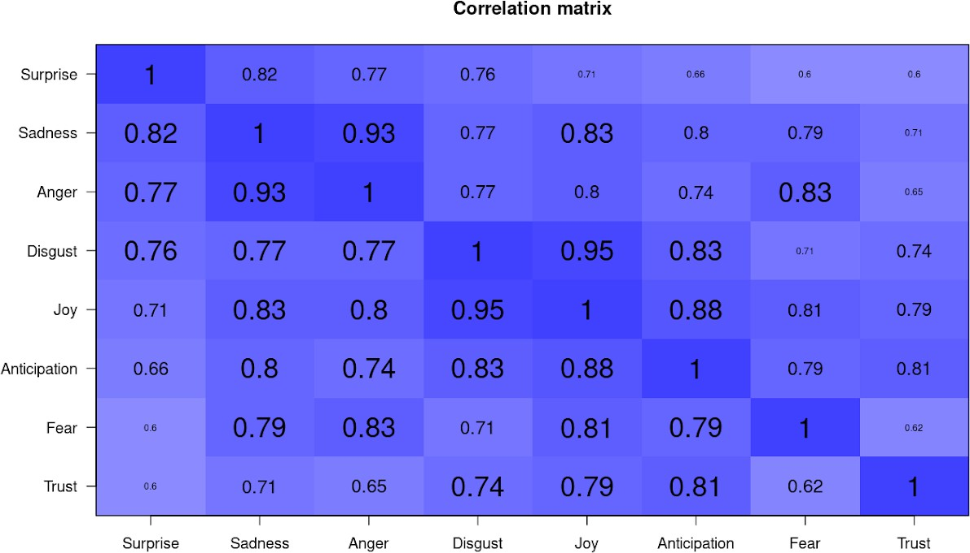

Figure 14: Sentimental Correlation, Author’s calculations

As per our analysis of the interactions of Twitter users with the president, we have found that composite sentiments are prevalent. These sentiments are a combination of primary emotions such as happiness and trust, which may result in a positive emotional response, or primary emotions such as surprise and sadness, which may lead to a negative emotional response. We have also observed feelings of anger and disgust, which could indicate a strong negative reaction to some aspect of the president’s policy.

Wordfish analysis:
By utilizing the Wordfish algorithm, we can analyze the main policies that will be implemented, such as healthcare reform, pensions, and other economic measures. This algorithm uses a statistical model to identify the issues that are being discussed most frequently and the positions that are being taken on these issues. By applying it to the aforementioned policies, we can obtain an overview of the policy positions being discussed around them, as well as how the conversations are developing in public opinion.
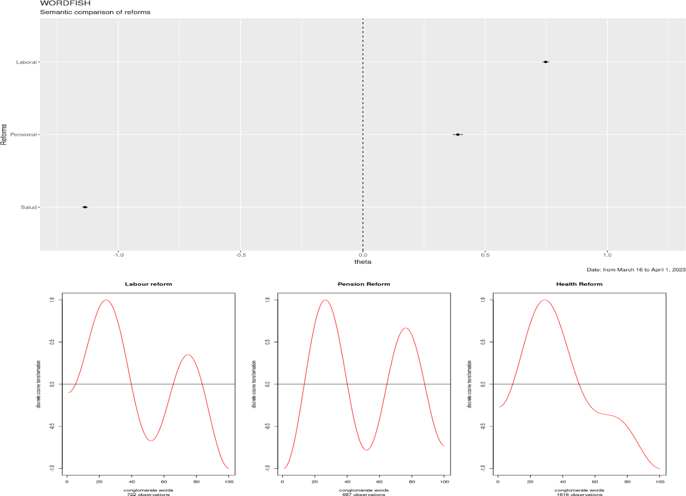

Figure 15: Wordfish Methodology, Author’s calculations

Wordfish assumes that words always have the same meaning within the text. Based on this assump-tion, when we evaluate and classify the reforms within the theta parameter, we find that the health reform has a negative characterization, while the labor reform and pension reform have a positive char-acterization, showing a stronger relationship. In summary, labor reform is an important topic within the database, as it appears more frequently than the selected cutoff frequency. We use a discrete cosine transformation to reduce the dimensionality of the frequency in the semantic polarities of the data by lowering the pressures with frequencies above the cutoff frequency. This helps us test the sentimental difference between the reforms.

Statistical analysis by keywords
Statistical keyword analysis is a vital tool for identifying patterns, trends, and relationships within large sets of text data. This approach is particularly useful in opinion mining and sentiment analysis, as it helps to identify words associated with positive or negative emotions and establish their meaning. For instance, it can be used to understand the President’s stance on his government’s current reforms.
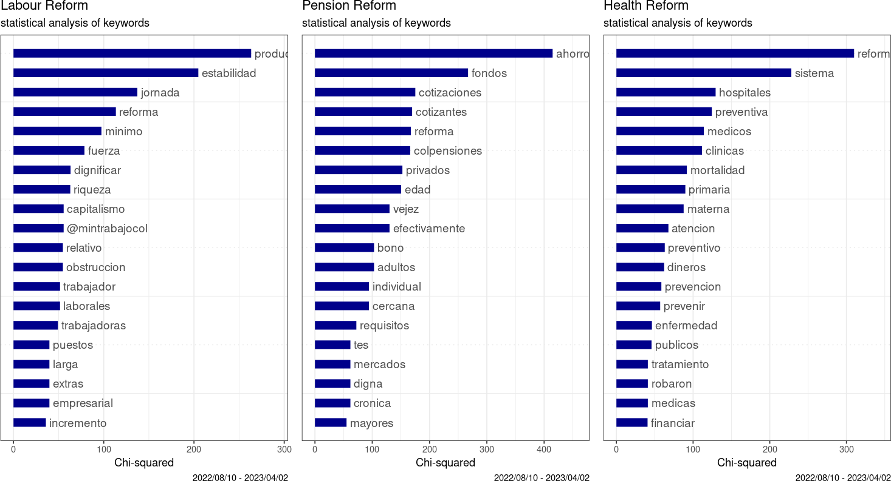

Figure 16: Statistics of keywords, Author’s calculations

A lexical dictionary is created based on keywords for each analyzed reform. The chi-square determines the most significant words written by Gustavo Petro about the reforms.
    - Labor reform: Gustavo Petro’s messages emphasize the importance of efficient and consistent pro-duction, and establishing an adequate work schedule to achieve those objectives..
    - Pension reform: The messages focus on the financial sustainability and operation of social security systems. In these systems, contributing workers put money into a savings fund that is utilized to finance benefits and services for members. Responsible management of these funds is crucial to guarantee the system’s stability and soundness.
    - Health reform: The messages are about implementing changes in healthcare systems to improve preventive care, reduce mortality rates, and provide quality care to the sick.

Structural modeling analysis of issues
To decide how many topics we need to cover in the STP (Semantic Topic Processing), we consider the size of the corpus. For smaller samples, a good starting point is to cover 5-50 topics. As the lexical database grows, we can increase the number of topics to improve our ability to interpret a higher percentage of the topics that are included in the database.

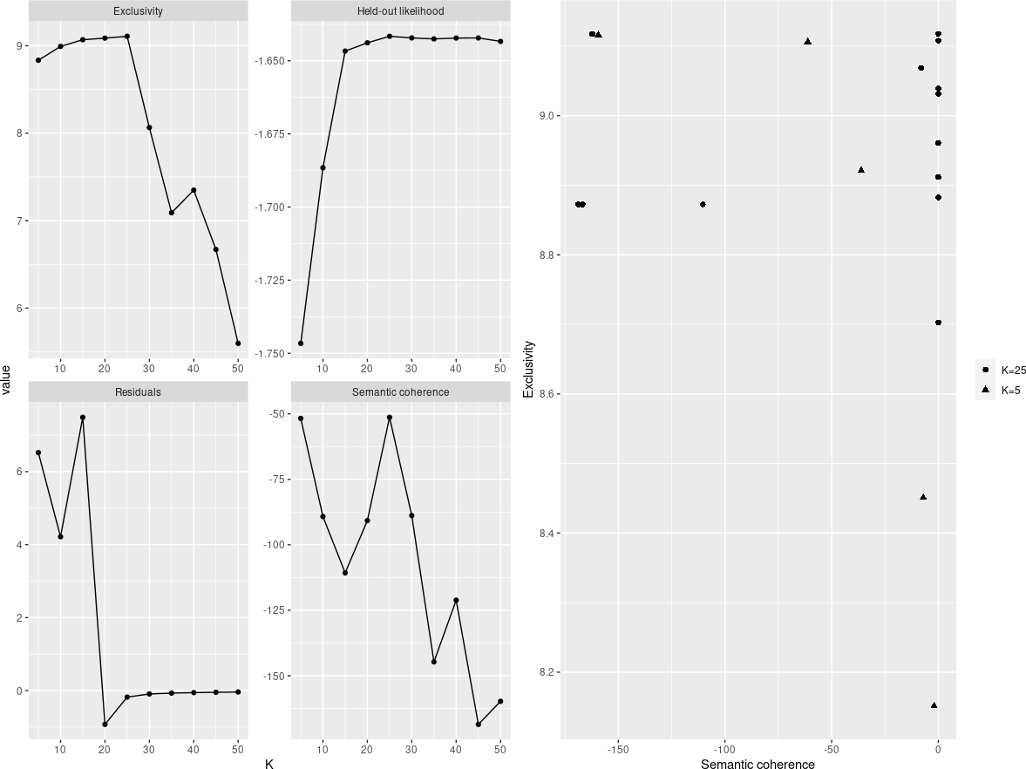

Figure 17: Diagnosis of issues, Author’s calculations

We use four main criteria for diagnosis: exclusivity, semantic coherence, residuals, and retained prob-ability. Out of these, semantic coherence is the most important factor in determining the quality of a topic as per society’s judgment. However, on Twitter, achieving semantic coherence is difficult for most topics. Therefore, we also need to analyze the exclusivity of the topic in conjunction with its coherence to understand the distinction between different topics and their coherence. Based on these two criteria, we have identified K = 10 and K = 25 as possible options. We will perform a separate analysis to determine which one is best suited for our study.
Based on a topic analysis, it has been discovered that the model with K = 10 is more effective than the model with K = 25. This is because the latter model has topics that stand out as outliers due to their lack of semantic consistency or uniqueness. Therefore, it was decided to use the K = 10 model to uncover a wide range of opinions about a leader. In this case, the 10 most significant themes in terms of semantic coherence and exclusivity can be more representative of the ideas and perspectives people have about the leader. This would allow for a better understanding of his public image and perception in society.
One of the ten topics being discussed stands out in the graph, which is related to current reforms. By using gender metadata, we can carry out a detailed analysis of how genders have different preferences regarding the issues discussed. By comparing gender preferences and perceptions, we can identify specific patterns and trends that can be of great interest for audience analysis.

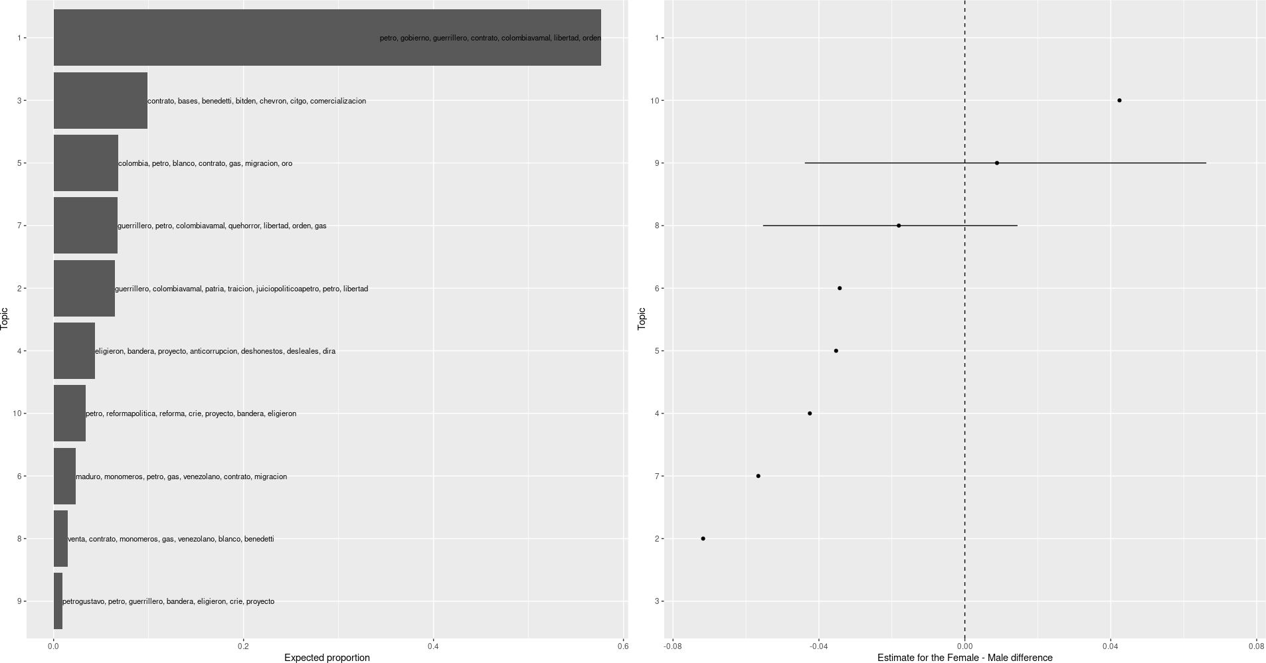

Figure 18: Gender effect, Author’s calculations

It has been observed that women tend to place greater importance on issues 1 and 10 compared to men. By understanding and acknowledging these specific gender preferences, it is possible to tailor strategies and policies to address the needs and concerns of each group more effectively.

Analysis of causality:
In time series analysis, an effective way to analyze the popularity of specific topics on Twitter is to observe the frequency of tweets posted over some time. For this purpose, we will present time-series data on the frequency of tweets related to the president, labor reform, health reform, and pension reform. This analysis will enable us to understand how public attention and interest in these topics have changed over time. By analyzing the frequency of tweets about the president, one can gain insights into the correlation between Twitter activity and political events, and how it impacts public opinion. Similarly, by monitoring the frequency of tweets related to labor, health, and pension reforms, it is possible to identify patterns and trends in how these issues are perceived by the general public.
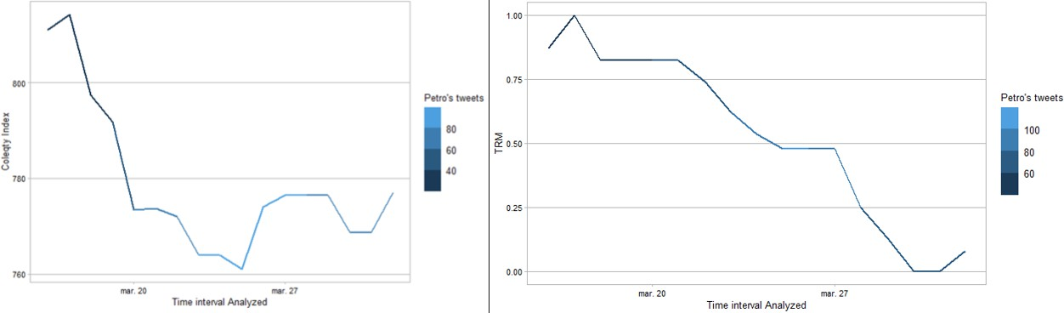

Figure 19: Tweets by Petro, Author’s calculations

The combined analysis of the Coleqty index and the Representative Market Exchange Rate (TRM), about the frequency of Gustavo Petro’s tweets, is a comprehensive approach to evaluate both the quality of his social media communication and its potential impact on financial and foreign exchange markets. Detecting a high Coleqty index and a TRM synchronized with tweet activity could reveal significant patterns in the interaction between the public sphere and markets. A high Coleqty index, indicative of consistent and quality tweets, in conjunction with a TRM that shows significant changes in response to Petro’s Twitter activity, could provide evidence of a causal relationship between his social media

communication and market volatility. This analysis will not only evaluate the effectiveness of Petro’s communication strategy on Twitter but also help to understand how his messages can influence market perceptions and, ultimately, investment and switching decisions. In this study, it is evident that as the frequency of Gustavo Petro’s tweets increases, his Coleqty index tends to decrease. This suggests that the quantity of tweets posted by the politician may be negatively affecting the coherence and quality of his message. Therefore, it could be beneficial for Gustavo Petro to reduce the frequency of his tweets and focus on the quality and coherence of his content to improve his presence and effectiveness on Twitter.
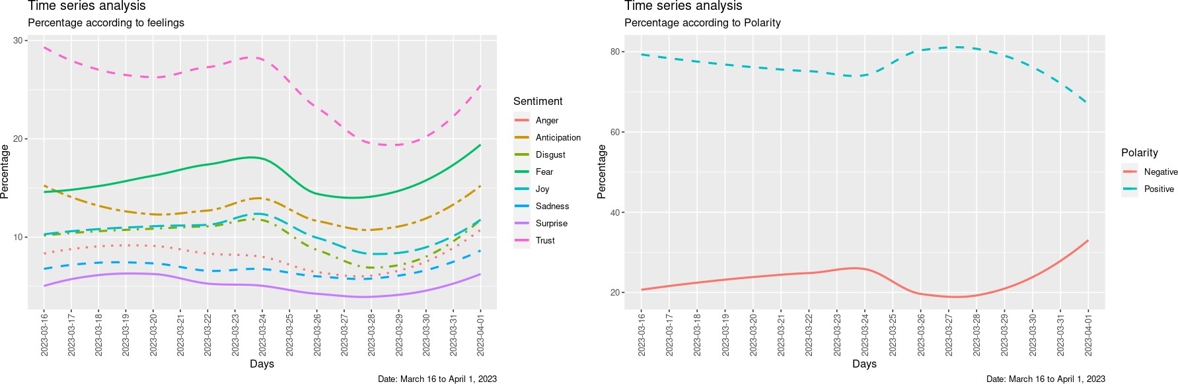

Figure 20: Smoothed time series of sentiments and polarities., Author’s calculations

Upon examining the graph provided, it becomes clear that the emotion of trust has the highest percentage throughout the study, followed by fear. This data highlights the significant impact emotions can have on human behavior and decision-making. In economic terms, confidence can greatly influence investment and consumption, while fear can negatively impact economic activity in general and the decision-making processes of both companies and consumers.
Lag | Anticipation | Sadness | Disgust | Trust
2 | 0.00257 | 0.02953 | 0.03943 | 0.03012
3 | 0.001882 | 0.08775 | 0.0453 | 0.1042
4 | 0.1319 | 0.1118 | 0.1691 | 0.3372
5 | 0.2177 | 0.1866 | 0.559 | 0.3432

Table 1: p-values using Granger causality with lags of the COLEQTY index, Author’s calculations We discovered that the emotions of anticipation, sadness, aversion, and confidence follow Granger
causality concerning the Coleqty index. Upon analyzing the behavior of this variable, we observed an inversely proportional relationship between the time lag and its impact on the system. This means that as the time lag increases, there is a significant reduction in the effect of the variable on the system. This phenomenon suggests a short-term pattern where the variable’s effect is more pronounced in the period before its measurement and tends to weaken progressively as the time lag period extends.

Lag | Disgust | Joy | Surprise
2 | 0.0322 | 0.0936 | 0.0646
3 | 0.2313 | 0.4172 | 0.1222
4 | 0.3076 | 0.2621 | 0.1415
Table 2: p-values using Granger causality with lags of the TRM, Author’s calculations

When analyzing the impact of emotions like disgust, happiness, and surprise on the exchange rate within a limited time frame, a significant short-term effect can be observed. These emotions, when displayed by economic agents, generate immediate reactions in financial markets, which then influence the TRM. Initially, these emotions increase the volatility of the exchange market, leading to abrupt fluctuations in the exchange rate. However, over time, a gradual reduction in the influence of these emotions on the exchange rate can be observed.
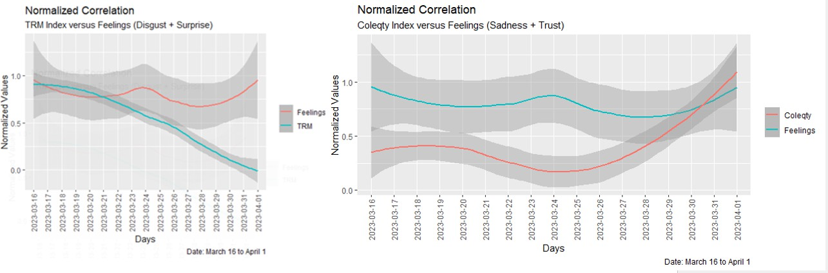

Figure 21: Normalized Correlation Trend, Author’s calculations

The graph depicted above displays the values of the Coleqty index, which are superimposed with the combined values of sadness and confidence, along with those of TRM, which are superimposed with disgust and surprise, for a brief period. This overlay indicates a subtle predictive trend. However, it is essential to keep in mind that such a predictive trend is not a guarantee of accuracy, as the results can be influenced by various external and unpredictable factors.

Preliminary Discussion
For politicians, it has been a priority to have an impact on the collective imagination through public image, especially when social networks have a great influence on the electorate. However, the results of this paper show the importance and responsibility that leaders have when gaining favorability in their discourse, since the repercussions of their messages have an impact on the markets beyond their favora-bility or unfavourability in the electorate, which can influence the decisions of investors and generate an indirect effect on the economic conditions of the country.
Advances in information and communication technologies have given rise to an abundance of data on economic behavior and enabled new forms of communication that can influence behavior patterns. This has opened up the possibility of discovering the underlying laws of society. The development of com-putational sciences has made it possible to interpret vast amounts of quantitative and qualitative data on individual activities, creating models that reflect the diversity and complexity of social phenomena. However, it is important to move beyond simply analyzing correlations and instead determine the causal relationships between social phenomena to better understand political actions.

Conclusions
Social media platforms such as Twitter have transformed the way in which political leaders interact with the population and how their leadership is perceived, highlighting their influence on public opinion. The

messages issued by Gustavo Petro through this platform can impact the construction of the collective imaginary and the political environment. In addition, it can be inferred that the country´s main cities are the epicenters where a higher level of discussion is generated around the policies proposed by Gustavo Petro. At the same time, the marked polarization surrounding the opinion about President Gustavo Petro is notable. This polarization is evident both in the use of hashtags and in the semantic polarity of public opinion, which is manifested through the primary sentiments expressed when addressing different perspectives on the president.
The networks of connections suggest that Gustavo Petro, a politician, uses Twitter to exercise politics beyond traditional media. There is a constant dynamic of polarization between government supporters and its opposition on Twitter. The analysis shows that the word ”salud” is strongly associated with the reform in Gustavo Petro’s tweets. This association suggests that ”salud” and ”reforma” are inseparable collocations in the president’s speech, highlighting the importance of health in the context of the proposed reforms. The analysis of keyword statistics concludes that Gustavo Petro’s messages about these reforms emphasize the need to address specific problems in areas such as efficiency and consistency in production, financial sustainability, proper management of savings funds, preventive care, reducing mortality, and improving the quality of care in the health system. Petro emphasizes significant reforms in these areas to ensure the well-being and prosperity of society at large.
In the application of the Wordfish algorithm, it is deduced that there is greater semantic similarity between the labor and pension reforms, in contrast to the health reform, which is primarily charac-terized by its difference. This observation is supported by the discrete cosine transformation analysis, which indicates greater similarity between the labor and pension reforms. In addition, the analysis of the differential participation of men and women in political comments and political discussion topics is significant. The modeling of structural issues reveals that female participation is considerably lower compared to current political discussions, and highlights differences in topics of interest compared to men.
According to the sentiment analysis, the President has moderate support, but he faced significant opposition at the time the sample was conducted. Additionally, based on Plutchik’s circumflex model, it is observed that the primary emotions of trust and fear can lead to feelings of fear and approval, thus generating a collective emotional state characterized by submission. The sentimental correlation analysis reveals that the most relevant emotional pairs are disappointment and optimism.
Finally, through time series analysis, it is shown that the president’s activity on Twitter and the frequency of discussion about his reforms emerge as indicators of public opinion regarding issues that have an impact on his policies. These elements offer a real-time view of the political agenda and its ability to influence public perception. This phenomenon is reflected in the way society perceives government policies. In relation to the temporal analysis of Gustavo Petro’s tweet frequencies, a negative incidence is presented in regards to the Coleqty indicator. This situation is mainly attributed to the feelings of sadness and trust that are manifested over time. On the other hand, it is observed that feelings of disgust and surprise are the main drivers of the behavior of the Representative Market Rate (TRM) index.

References
Bayod, M. J. R. (2018). ” big data”: crisis y nuevos planteamientos en los flujos de comunicaci´on de la cuarta revoluci´on industrial. Area abierta, 18 (2), 39.
Benoit, K., Nulty, P., Barber, P., Watanabe, K., & Lauderdale, B. (2018). Quantitative analysis of textual data. Retrieved.
Benoit, K., Watanabe, K., Wang, H., Nulty, P., Obeng, A., Mu¨ller, S., & Matsuo, A. (2018). quanteda: An r package for the quantitative analysis of textual data. Journal of Open Source Software, 3 (30), 774. Retrieved from https://quanteda.io DOI: 10.21105/joss.00774
Blei, D. M., Ng, A. Y., & Jordan, M. I. (2003). Latent dirichlet allocation. Journal of machine Learning research, 3 (Jan), 993–1022.
BVC. (2013). Metodolog´ıa para el c´alculo del ´ındice general coleqty. Bogot´a, DC, Colombia.
Cavanillas, J. M., Curry, E., & Wahlster, W. (2016). New horizons for a data-driven economy: a roadmap for usage and exploitation of big data in europe. Springer Nature.
El-Hamdouchi, A., & Willett, P. (1986). Hierarchic document classification using ward’s clustering method. In Proceedings of the 9th annual international acm sigir conference on research and de-velopment in information retrieval (pp. 149–156).
Field, Z., Miles, J., & Field, A. (2012). Discovering statistics using r. Discovering Statistics Using R, 1–992.
Hirschberg, J., & Manning, C. D. (2015). Advances in natural language processing. Science, 349 (6245), 261–266.
Husson, F., Lˆe, S., & Pag`es, J. (2016). Analyse de donn´ees avec r. Presses universitaires de Rennes.
Ince, J., Rojas, F., & Davis, C. A. (2017). The social media response to black lives matter: How twitter users interact with black lives matter through hashtag use. Ethnic and racial studies, 40 (11), 1814–1830.
Jockers, M. (2017). Package ‘syuzhet’. URL: https://cran. r-project. org/web/packages/syuzhet . Kahneman, D. (1979). Prospect theory: An analysis of decisions under risk. Econometrica, 47 , 278. Kearney, M. W. (2019). rtweet: Collecting and analyzing twitter data. Journal of open source software,
4 (42), 1829.
Marin Diaz, J. P. (2020). genero: Estimate gender from names in spanish and portuguese [Computer software manual]. Retrieved from https://github.com/datasketch/genero (R package version 0.1.0)
Medhat, W., Hassan, A., & Korashy, H. (2014). Sentiment analysis algorithms and applications: A survey. Ain Shams engineering journal , 5 (4), 1093–1113.
Misuraca, M., Forciniti, A., Scepi, G., & Spano, M. (2020). Sentiment analysis for education with r: packages, methods and practical applications. arXiv preprint arXiv:2005.12840 .
Mohammad, S., & Turney, P. (2010). Emotions evoked by common words and phrases: Using mechanical turk to create an emotion lexicon. In Proceedings of the naacl hlt 2010 workshop on computational approaches to analysis and generation of emotion in text (pp. 26–34).
Mullainathan, S., & Thaler, R. H. (2000). Behavioral economics. National Bureau of Economic Research Cambridge, Mass., USA.
P´erez Llorente, J. M. (2020). El impacto de los tweets de donald j. trump sobre los mercados financieros. Plutchik, R. (2003). Emotions and life: Perspectives from psychology, biology, and evolution. American
Psychological Association.
Prada Espinel, O´. A., et al. (2018). Comportamiento comunicacional de twitter en las campan˜as presi-denciales de colombia 2018: Caso gustavo petro e iv´an duque (Unpublished master’s thesis). Uni-versidad Internacional de Andaluc´ıa.
Roberts, M. E., Stewart, B. M., & Tingley, D. (2019). Stm: An r package for structural topic models.
Journal of Statistical Software, 91 , 1–40.
Romero Moreno, F. Y., Sanchez Martelo, C. A., Alfonso Corredor, B. Y., Sanchez Cifuentes, J. F., & Ospina L´opez, J. P. (2020). An´alisis de sentimiento a las opiniones generadas en la red social twitter: Marketing pol´ıtico.
Sandoval Garrido, L. E., & Mar´ın Jaramillo, M. (2022). Elecciones presidenciales y desarrollo municipal: el caso colombiano (1986-2014). Revista Lecturas de Econom´ıa(97), 113–148.
Schweinberger, M. (2023). Analyzing co-occurrences and collocations in r (2023.05.31 ed.) [Computer software manual]. Brisbane. (https://ladal.edu.au/coll.html)
Slapin, J. B., & Proksch, S.-O. (2008). A scaling model for estimating time-series party positions from texts. American Journal of Political Science, 52 (3), 705–722.

Smith, A. (1759). The theory of moral sentiments: By adam smith,... London:: printed for A. Millar; and A. Kincaid and J. Bell, in Edinburgh.
Trott, V. (2018). Connected feminists: foregrounding the interpersonal in connective action. Australian Journal of Political Science, 53 (1), 116–129.
Urdinez, F., & Cruz, A. (2020). R for political data science: A practical guide. CRC Press.
Wiedemann, G., & Niekler, A. (2017). Hands-on: A five day text mining course for humanists and social scientists in R. In Proceedings of the workshop on teaching NLP for digital humanities (Teach4DH@GSCL 2017), berlin, germany, september 12, 2017. (pp. 57–65). Retrieved from http://ceur-ws.org/Vol-1918/wiedemann.pdf

Disclosure of interest
In accordance with Taylor & Francis policy and our ethical obligations as researchers, we are reporting that we don’t receive financial funding that may be affected by the research reported in the enclosed paper.

Declaration of funding
No funding was received

