Lab1_JuanjoCarin.R

JuanJose

Thu Sep 25 18:42:13 2014

#### INIT ####  
  
rm(list = ls())  
route <- "C:/Users/JuanJose/Google Drive/ANL/MASTERS/Berkeley/"  
route <- paste(route, "DATASCI W203 Exploring and Analyzing Data/Labs/Lab1",  
 sep="")  
# Change the route if needed  
setwd(route)  
  
  
#### LIBRARIES ####  
  
library(car)

## Warning: package 'car' was built under R version 3.1.1

library(e1071)  
library(XLConnect)

## XLConnect 0.2-7 by Mirai Solutions GmbH  
## http://www.mirai-solutions.com ,  
## http://miraisolutions.wordpress.com

#### 1. VARIABLE MANIPULATION ####  
  
#### a) gdp_growth MEAN  
  
GDP_World_Bank<-read.csv("GDP_World_Bank.csv")  
GDP_World_Bank$gdp_growth <- GDP_World_Bank$gdp2012 - GDP_World_Bank$gdp2011  
  
nrow(GDP_World_Bank)

## [1] 212

sum(!complete.cases(GDP_World_Bank$gdp_growth))

## [1] 39

sum(is.na(GDP_World_Bank$gdp_growth)) # Another way of counting NA observations

## [1] 39

# There are missing valures of GDP in 2011 or 2012 or both for 39 out of the  
 # 212 countries. So the new variable has a numerical value for 173 countries  
# We can keep these 39 observations in the original dataframe (and use  
 # "na.rm=TRUE" when required by the functions) or create a new variable  
 # without the missing values  
gdp_growth <- na.omit(GDP_World_Bank$gdp_growth)  
names(gdp_growth) <- GDP_World_Bank$Country[!is.na(GDP_World_Bank$gdp_growth)]  
   
gdp_growth_mean <- mean(GDP_World_Bank$gdp_growth, na.rm=TRUE)  
mean(gdp_growth) # Another possible way of obtaining the mean

## [1] 7.172e+09

print(paste("The mean of the gdp_growth variable is",  
 format(gdp_growth_mean, digits=4, scientific=T)), sep=" ")

## [1] "The mean of the gdp_growth variable is 7.172e+09"

#### b) gdp_growth HISTOGRAM & FIT TO NORMAL  
  
# Now we plot the histogram, comparing it with an estimate of its Probability  
 # Density Function and the normal PDF with the same mean and standard deviation  
hist(gdp_growth, breaks=50, freq=F, col="green")  
curve(dnorm(x, mean=mean(gdp_growth), sd=sd(gdp_growth)),   
 add=TRUE, col="darkblue", lwd=3)   
lines(density(gdp_growth), col="red", lwd=2)  
legend("topright", legend=c("Histogram", "Normal distrib. w/ same mean & SD",  
 "Density estimate"),  
 col=c("green","darkblue","red"),lwd=2)

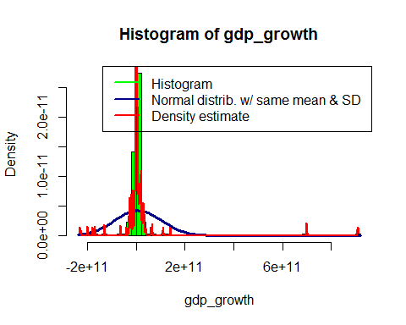

# Since there are some observations far from the mean, we now zoom the  
 # histogram  
hist(gdp_growth, breaks=200, freq=F, col="green", xlim=c(-1e11,1e11),  
 main="Histogram of gdp_growth: Zoom between -1e11 and +1e11")  
curve(dnorm(x, mean=mean(gdp_growth), sd=sd(gdp_growth)),   
 add=TRUE, col="darkblue", lwd=3)   
lines(density(gdp_growth), col="red", lwd=2)  
legend("topright", legend=c("Histogram", "Normal distrib. w/ same mean & SD",  
 "Density estimate"),  
 col=c("green","darkblue","red"),lwd=2)

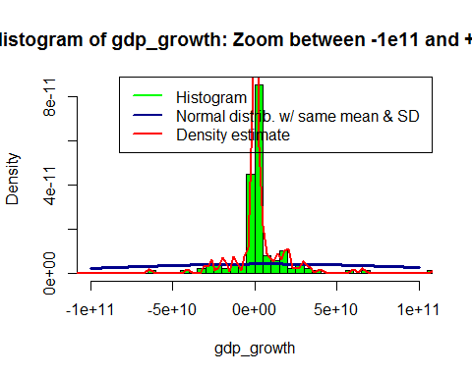

# The first histogram shows a long right tail, i.e., the distribution is  
 # positively skewed (the corresponding function confirms this)  
skewness(gdp_growth, type=2)

## [1] 7.151

# The comparison against the Probability Density Function of a normal  
 # distribution with the same mean and standard deviation shows that the  
 # distribution under analysis is clearly leptokurtic (i.e., the kurtosis is  
 # positive and high), and hence far from normal  
kurtosis(gdp_growth, type=2)

## [1] 64.35

# The numerous outliers causes the standard deviation to be higher  
 # than it would be in the absence of those outliers, so a normal distribution  
 # with the same standard deviation (and mean) has a more rounded peak and  
 # thinner tails  
  
# Now we display the boxplot (which says the same about normality)  
 # With & without outliers  
Boxplot(gdp_growth,labels=names(gdp_growth),id.n=5,  
 main="Boxplot of gdp_growth with outliers")

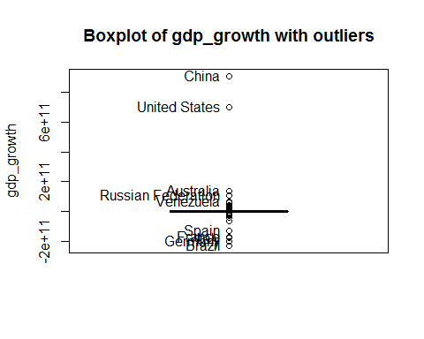

## [1] "Brazil" "Germany" "Italy"   
## [4] "France" "Spain" "China"   
## [7] "United States" "Australia" "Russian Federation"  
## [10] "Venezuela"

boxplot(gdp_growth, outline=F,  
 main="Boxplot of scaledgdp_growth without outliers")

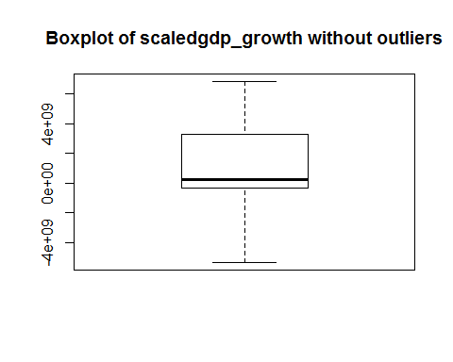

# With & without outliers, and scaling the variable  
Boxplot(scale(gdp_growth),labels=names(gdp_growth),id.n=5,  
 main="Boxplot of scaled gdp_growth with outliers")

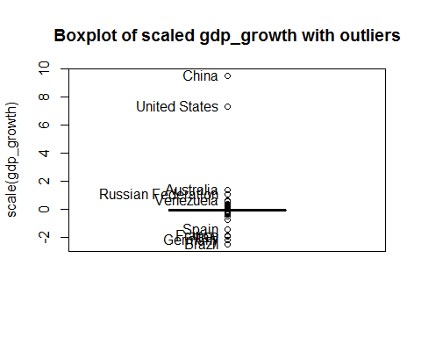

## [1] "Brazil" "Germany" "Italy"   
## [4] "France" "Spain" "China"   
## [7] "United States" "Australia" "Russian Federation"  
## [10] "Venezuela"

boxplot(scale(gdp_growth), outline=F,  
 main="Boxplot of scaled gdp_growth without outliers")

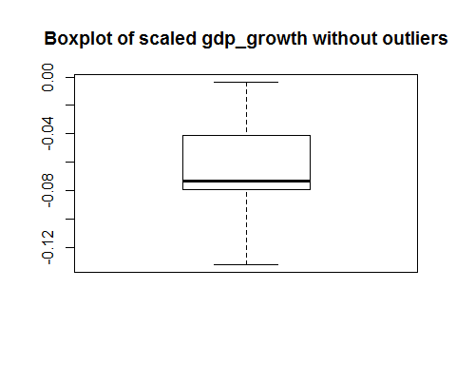

# Conclusions:  
# There are 2 outliers (China and U.S.) almost 8 and 10 standard deviations  
 # far from the mean. The probability of 2 observations like these in a sample  
 # of size 173 from a normal distribution is infintesimal (the probability of  
 # a single observation more than 3 or 4 standard deviations far from the mean  
 # is already close to null  
# The boxplot shows that the median is much lower than the mean...  
median(GDP_World_Bank$gdp_growth, na.rm=T)

## [1] 201700000

mean(GDP_World_Bank$gdp_growth, na.rm=T)

## [1] 7.172e+09

# ... and that's another indication that the data doesn't fit to the normal  
 # distribution very well... but nothing can be said now about skewness  
 # (though the older notion of skew implied a relationship between the mean  
 # the median, the modern definition does not, and for some distributions the  
 # relationship we observe doesn't necessarily mean that the skewness is  
 # positive)  
# The IQR range is very small (in terms of standard deviations): about 0.4 SD  
IQR(gdp_growth)/sd(gdp_growth)

## [1] 0.03832

# while the IQR range of a normal distribution is about 1.5 SD. That's  
 # another proof of the normal distribution being a poor fit to our data, and  
 # also means that the distribution is leptokurtic  
  
# The Q-Q plot is another indication of non-normality  
qqnorm(scale(gdp_growth))  
abline(0,1)

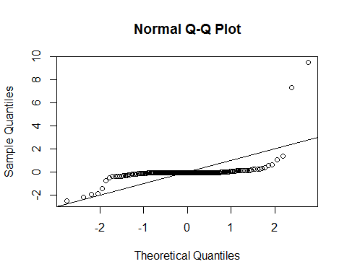

# We finally use the Shapiro-Wilkes test  
shapiro.test(gdp_growth)$p.value

## [1] 1.341e-25

# The p-value is so low that we would have to reject the null hypothesis that  
 # the samples came from a normal distribution  
  
  
#### c) high_growth & COUNTRIES ABOVE MEAN  
  
high_growth <- gdp_growth > mean(gdp_growth)  
# or  
# GDP_World_Bank$high_growth <-   
# GDP_World_Bank$gdp_growth > mean(GDP_World_Bank$gdp_growth,na.rm=T)  
  
print(paste(length(high_growth[high_growth==TRUE]),   
 "countries have above average growth", sep=" "))

## [1] "31 countries have above average growth"

print(paste(length(high_growth[high_growth==FALSE]),   
 "countries have below average growth", sep=" "))

## [1] "142 countries have below average growth"

# As previously explained, the mean was much larger than the median, so a lot  
 # more than 50% of the countries have below average growth  
 # Actually, less than 18% of the countries have above average growth   
(prob_below_avg <- 1-table(high_growth)[2]/(length(high_growth)))

## TRUE   
## 0.8208

as.numeric(format(quantile(gdp_growth,probs=prob_below_avg),  
 digits=4, scientific=T))

## [1] 7.221e+09

as.numeric(format(mean(gdp_growth), digits=4, scientific=T))

## [1] 7.172e+09

# That is coherent with what the histogram showed: a long right tail,  
 # causing the distribution to be positively skewed  
  
#### 2. DATA IMPORT ####  
  
#### a) New metric country-level variable  
  
# I found a very powerful source (needless to say, GOOGLE:  
 # http://www.google.com/publicdata), which not only gathers data from multiple  
 # sources but also allows to plot them in multiple ways.  
# My first thought was considering one of the sources mentioned there: the  
 # International Monetary Fund (IMF):  
 # http://www.google.com/publicdata/explore?ds=k3s92bru78li6_  
 # http://www.imf.org/external/pubs/ft/weo/2014/01/weodata/download.aspx  
 # http://www.imf.org/external/pubs/ft/weo/2014/01/weodata/WEOApr2014all.xls  
 # Where you can download information by countries about several measures of  
 # GDP, Purchasing-Power-Parity (PPP), Inflation, Volume of Imports & Exports  
 # of Goods & Services, Unemployment Rate, General Government Revenue, etc.  
 # (from 1980 to 2011 or 2013 depending on the country, and estimates until  
 # 2019)  
# But most of those variables are related to GDP, so it would have been a  
 # similar exercise  
  
# As we've previosly tried to fit a sample distribution to normality, I thought  
 # of possible variables (on a country level) that may fit to that distribution  
# Intelligence Quotient (IQ) is actually designed to fit to a normal  
 # distribution (http://en.wikipedia.org/wiki/Intelligence_quotient), where the  
 # mean is 100 points, and the standard deviation is 15 points  
# And found what I was looking for in this other source (IBM):  
 # http://www-958.ibm.com/software/analytics/manyeyes/datasets  
 # http://www-958.ibm.com/software/analytics/manyeyes/datasets/national-iq-scores-country-ranking/versions/1.txt  
# Since the number of Countries slightly varied from the ones mentioned in  
 # "GDP_World_Bank.csv", I modified the tab-delimited text file (and used that  
 # modified version instead)   
  
IQ <- read.delim("new1.txt",header = T, sep = "\t")  
newDF <- merge(GDP_World_Bank, IQ, by="Country", all=T)  
nrow(newDF[!is.na(newDF$Avg.IQ), ])

## [1] 184

mean(newDF[!is.na(newDF$Avg.IQ), ]$Avg.IQ)

## [1] 84.7

sum(newDF[!is.na(newDF$Avg.IQ), ]$Avg.IQ < 70)

## [1] 25

hist(newDF$Avg.IQ, breaks=50, freq=F, col="green",   
 main="Histogram of Average IQ by Country")  
curve(dnorm(x, mean=mean(newDF$Avg.IQ, na.rm=T), sd=sd(newDF$Avg.IQ, na.rm=T)),   
 add=TRUE, col="darkblue", lwd=3)   
lines(density(newDF$Avg.IQ, na.rm=T), col="red", lwd=2)  
legend("topright", legend=c("Histogram", "Normal distrib. w/ same mean & SD",  
 "Density estimate"),  
 col=c("green","darkblue","red"),lwd=2)

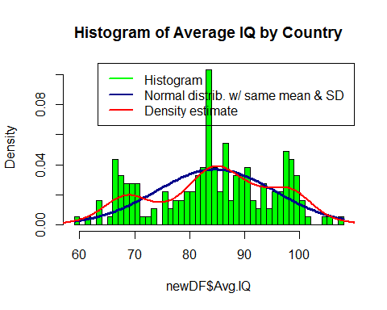

# Regardless of whether the IQ variable is normal, we are working with samples of  
 # means. Therefore, by the Central Limit Theorem, the distribution of the  
 # sample mean should approach the normal distribution... and that's not the  
 # case. We just have to look at the histogram to see that the distribution is  
 # multimodal, and far from normal  
# For example, we can observe the following facts:  
 # The mean of the sampling distribution is 84.7, 1 standard deviation -of the  
 # the population, according to IQ test design, not of the sampling  
 # distribution- below the expected mean of the population (100 points). That   
 # contradicts the Law of Large Numbers.  
 # And 25 out of the 184 countries have an average IQ 2 standard deviations (30  
 # points) below the expected mean. That's the 13.6% of the samples, when the  
 # expected probability in a normal distribution would be less than 2.5%  
# Was sir Francis Galton wrong? Probably. But there are 3 main PROBLEMS here:  
# 1. IQ tests are not 100% infallible. That leads to effects like  
 # http://en.wikipedia.org/wiki/Flynn_effect, or the fact that there are  
 # huge differences between countries (some people argue that IQ tests are not  
 # perfectly adapted to each country)  
# 2. We don't have evidence that the samples were purely random or well selected  
 # in each country  
# 3. Each sample was drawn from completely different groups: we should not make  
 # conclusions about individuals between groups (Ecological Fallacy). Moreover,  
 # the tool (the test) used to measure the variable was not always the same  
# CONCLUSIONS:  
# The IQ tests do not seem to be a valid tool to measure intelligence (based on  
 # which countries have a lowest average IQ, all of them in Africa, it seems  
 # it measures culture & education rather than intelligence)  
# OR the assumption that IQ is normally distributed is wrong (maybe it is  
 # within a country -we can't know it with just the aveage- ...but probably not  
 # with a mean of 100 points in many cases)  
# AND, unless the same tool is used to measure a variable, we're working with  
 # samples of different variables  
# AND FINALLY we should know if the samples have been drawn appropriately  
 # within each country  
  
scatterplot(as.vector(scale(newDF$Avg.IQ[complete.cases(newDF)])),  
 as.vector(scale(newDF$gdp_growth[complete.cases(newDF)])),   
 xlab="standardized Avg IQ", ylab="standardized GDP growth")

