FDA Post-Approval Exclusivity Codes and other relevant information

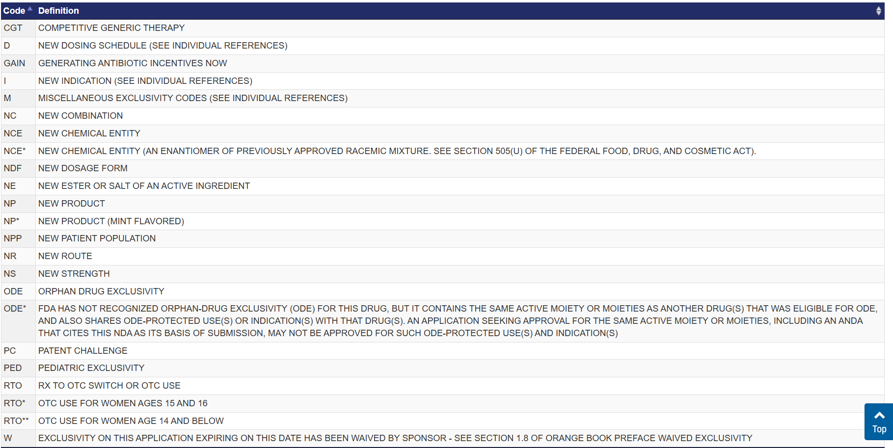

When exclusivity is granted while the patent is still active, the NDA applicant benefits in several ways, as the exclusivity and patent provide complementary protections. Here's how:

1️. Blocking Generic Competition More Effectively
- Exclusivity (FDA-based protection):
  - Prevents the FDA from approving or even reviewing generic (ANDA) or 505(b)(2) applications for a set period.
  - Works independently of patents.
- Patent (Legal protection):
  - Prevents generics from launching the drug unless they successfully challenge the patent in court.
  - Allows the NDA holder to sue generic manufacturers for patent infringement.
✅ Benefit: If an NDA applicant holds both exclusivity and an active patent, generics are blocked from both filling applications and launching the product, maximizing market control.

2. Delaying Generic Entry Even After Exclusivity Ends
Even if exclusivity expires, a strong patent portfolio can still prevent generic entry.
🔹 Example Scenario:
- Drug approval: Jan 1, 2025
- NCE Exclusivity (5 years) expires: Jan 1, 2030
- Patent expires: Jan 1, 2040
What happens?
- Until Jan 1, 2030 → FDA cannot accept generic applications due to NCE exclusivity.
- After Jan 1, 2030 → Generics can file ANDAs, but if patents are still valid until 2040, they must either:
  - Wait until 2040 to launch, OR
  - Challenge the patents in court (Paragraph IV certification)—which can take years.
✅ Benefit: Even after exclusivity ends, patents extend market exclusivity for years, keeping generics out.

3. Extending Revenue Maximization
- During the exclusivity period, the NDA holder enjoys premium pricing without generic competition.
- Even after exclusivity ends, patents prevent generics from launching, allowing continued revenue from branded sales.
- This is especially useful if multiple exclusivities apply (e.g., NCE + Pediatric Exclusivity adds 6 more months).
✅ Benefit: More time to recoup R&D costs and maximize profits before generic erosion starts.

4. Patent Linkage in the Orange Book
- NDA holders list patents in the FDA's Orange Book.
- If a generic company files a Paragraph IV certification challenging a listed patent, the NDA holder gets an automatic 30-month stay of FDA approval while the patent lawsuit is resolved.
✅ Benefit: Further delays generic competition even after exclusivity ends
🔹 Conclusion:
When both exclusivity and patents overlap, the NDA holder benefits from multiple layers of protection, keeping generics out for as long as possible and maximizing market exclusivity & profits. 🚀

