Dashboard Design Notes

1. Define the Purpose and Audience
Goal: Know exactly who you're designing for and why.
- Ask:
  - Who will use this dashboard? The dashboard will be used by pharmaceutical industry experts who want to gain insights on FDA-approved drugs market, specially on patents and exclusivities granted by the FDA: pharmaceutical business strategists, sales representatives, regulators and other industry experts.
  - What key questions should it answer? It should offer a general overview on the FDA-approved drug market volume, the top firms holding active patents and specific trends on patents and exclusivity grants.
  - How often will they check it? (daily, weekly?) The dashboard will not be updated periodically because I have not configured an ETL connection with the FDA Orange Book database. However, ideally, it would be checked yearly to take the temperature on the situation regarding patents and exclusivities granted by the FDA.
  - What actions will they take based on the dashboard? Insights extracted from the dashboard will serve as a starting point to build robust and intelligent business strategies or to refine the existent ones. The dashboard will be intended to offer, at a glance, the current situation regarding patents and exclusivities, in comparison to the historical data.

2. Collect and Prioritize Metrics
Goal: Focus on what matters most.
- Gather all possible metrics (KPIs, performance stats, trends, etc.).
  - Total number of drug applications at the FDA Orange Book
  - Total number of FDA-approved drugs at the FDA Orange Book
  - Total number of firms with FDA-approved drugs at the FDA Orange Book
  - Total number of patents at the FDA Orange Book
  - Total number of active patents at the FDA Orange Book (compare year-to-date)
  - Average Patent Duration
  - Total number of exclusivities at the FDA Orange Book
  - Total number of active exclusivities at the FDA Orange Book (compare year-to-date)
  - Total number of exclusivities expiring this year (vs last year)
  - Innovators vs generic distribution
  - FDA approval tendency over the last years
  - Top Ingredients in FDA-approved drugs
  - Top firms with more approved drug applications
  - Top Dosage Forms
  - Top Administration Routes
  - Top firms with active patents
  - Top firms with active exclusivities
  - Top patent uses
  - Top exclusivity types
  - Co-occurrence matrix for exclusivity types
- Prioritize by importance to the user goals.
- Group similar metrics into logical categories.
General Overview
Patents Analysis
Exclusivities Analysis
3. Choose the Right Layout
Goal: Organize information to match how the brain processes it.
- Follow Information Hierarchy: Important stuff at the top or top-left.
  - KPI cards (Top)
  - Pie distribution (Middle left)
  - Historical trends (Middle right)
  - Bar charts (Bottom right)
  - Co-occurrence matrix (Bottom left)
- Use the Z-Pattern or F-Pattern reading habits. Z pattern will be the one used.
- Group related info together with proximity and whitespace

FDA Orange Book | Overview
1,987

3,987

23,987

Firms with FDA-approved drugs

FILTERS
Distribution of NDAs vs ANDAs

Drug applications

FDA-approved drugs

FDA Approval over the last years
Innovator, Generic

OTC, Prescription

Top Ingredients, Top Routes by Approved Drugs

Top Firms, Top Dosage Form by Approved Drugs

FDA Orange Book | Patents
Top Firms, Top Patent Use codes

13.9 years pasyear

3,987

2,987

Average Patent Duration

Patent Duration Distribution

Route
Dosage Form
OTC, Prescription
FILTERS
Total Patents

Active Patents
-15% YTD

FDA Orange Book | Exclusivities
Route
Dosage Form
OTC, Prescription
Co-occurrence matrix for exclusivities. (Maybe we need a tooltip for explaining exclusivities)
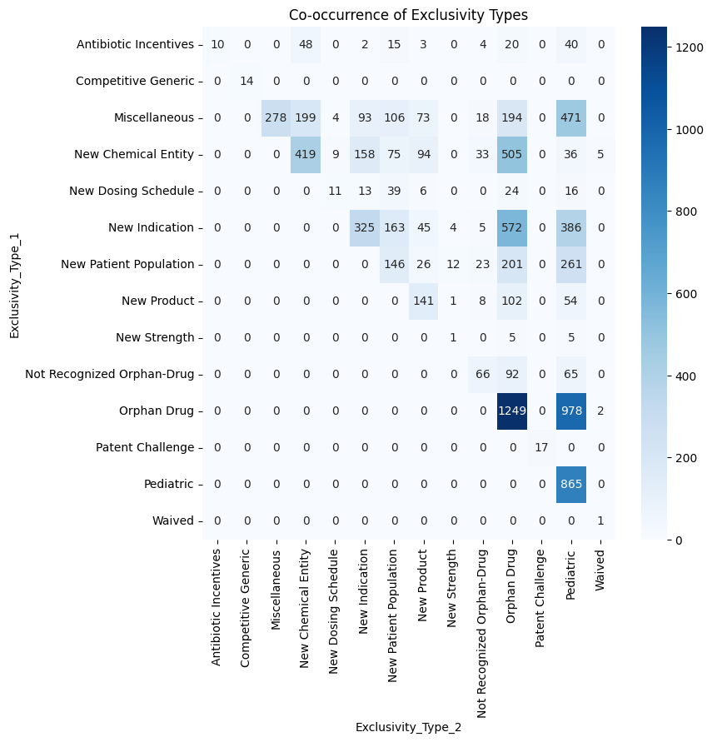
87 +5% LY

987 +1.5% LY

Active Exclusivities

3,987

Exclusivities expiring this year

Top Firms, Top Exclusivities

FILTERS
Total Exclusivities

4. Pick the Right Visualizations
Goal: Show each type of data in the clearest way possible.
- Trends over time? → Line Chart
- Comparing categories? → Bar/Column Chart
- Parts of a whole? → Pie Chart (sparingly) or Donut Chart
- Performance against a goal? → Bullet Chart, Gauge, or KPI Card
- Maps/geography? → Heatmaps or Geo Charts
✅ Action: Match each metric to its ideal chart type.

5. Apply Visual Design Best Practices
Goal: Make it clean, easy to scan, and beautiful without distractions.
- Keep it simple: Avoid 3D effects, fancy fonts, unnecessary colors.
- Use consistent colors: E.g., blue for neutral, red for bad, green for good.
- Emphasize critical info: Bigger, bolder, or different color.
- Limit colors: 4–5 max per dashboard.
- Align everything perfectly: Use grids.
✅ Action: Create a color and typography guide for your dashboard.
6. Optimize for Interactivity (if needed)
Goal: Let users explore without overwhelming them.
- Add filters (date ranges, categories). Filters: Product type (OTC, Prescription and Discontinued), Application type (Innovator and Generic) Dosage Form and Route.
- Add drill-downs: Click on a chart to see more details. Maybe interesting for trends (from year to quarters, from quarters to months)
- Add tooltips: Hover to get more info without clutter. Interesting for explaining patent and exclusivity codes.
✅ Action: Map where interactivity will improve user experience.

7. Test and Refine
Goal: Make sure it works for real users, not just for you.
- Share early drafts with users (or people similar to them).
- Watch them use it (even 5–10 minutes can reveal issues).
- Ask:
  - Is anything confusing?
  - Can you find [specific KPI] easily?
  - What do you want to click on?
✅ Action: Iterate based on feedback — clean, tweak, simplify.

8. Launch and Monitor Usage
Goal: Ensure the dashboard stays relevant and useful.
- Track:
  - Are people using it?
  - Which sections are most/least used?
- Plan periodic reviews (every 3–6 months) to update metrics or visuals.
✅ Action: Set a reminder for dashboard review sessions.

