**Instructions:**

The test starts in Screen Space.

In order to switch between ScreenSpace and WorldSpace, click on the “Change Render Mode” component (1), and then choose the options in the “Type” variable (2)

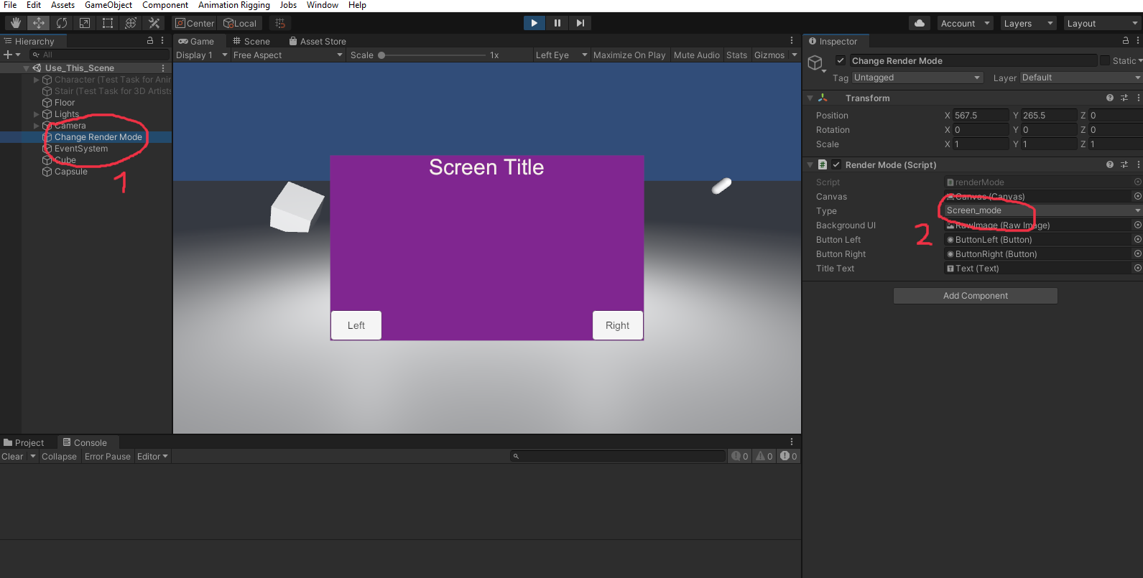

* To test that the UI is not affected by the movement in the world, camera... I have placed in the world two objects: A cube and a capsule that just keeps rotating
* Also, there is some camera movement/rotation that can be done by the arrow keys:
* Left and right rotate the camera
* Up and down moves the camera