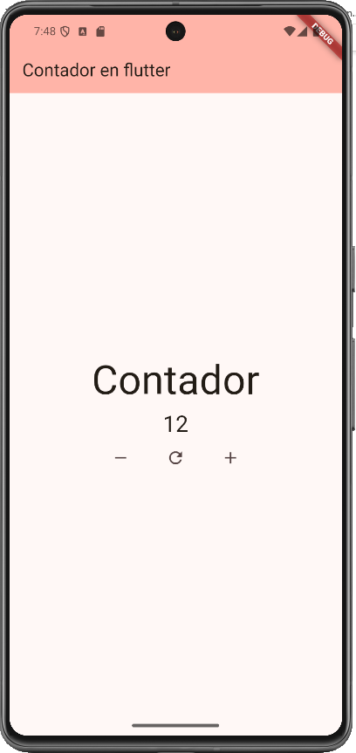
import 'package:flutter/material.dart';

void main() {
runApp(const MyApp());
}

class MyApp extends StatelessWidget {
const MyApp({super.key});

// This widget is the root of your application.
@override
Widget build(BuildContext context) {
return MaterialApp(
title: 'Flutter Demo',
theme: ThemeData(
// This is the theme of your application.
//
// TRY THIS: Try running your application with "flutter run". You'll see
// the application has a purple toolbar. Then, without quitting the app,
// try changing the seedColor in the colorScheme below to Colors.green
// and then invoke "hot reload" (save your changes or press the "hot
// reload" button in a Flutter-supported IDE, or press "r" if you used
// the command line to start the app).
//
// Notice that the counter didn't reset back to zero; the application
// state is not lost during the reload. To reset the state, use hot
// restart instead.
//
// This works for code too, not just values: Most code changes can be
// tested with just a hot reload.
colorScheme: ColorScheme.fromSeed(
seedColor: const Color.fromARGB(255, 255, 0, 0),
),
),
home: const MyHomePage(title: 'Contador en flutter'),
);
}
}

class MyHomePage extends StatefulWidget {
const MyHomePage({super.key, required this.title});

// This widget is the home page of your application. It is stateful, meaning
// that it has a State object (defined below) that contains fields that affect
// how it looks.

// This class is the configuration for the state. It holds the values (in this
// case the title) provided by the parent (in this case the App widget) and
// used by the build method of the State. Fields in a Widget subclass are
// always marked "final".

final String title;

@override
State<MyHomePage> createState() => _MyHomePageState();
}

class _MyHomePageState extends State<MyHomePage> {
int _counter = 0;

void _incrementCounter() {
setState(() {
// This call to setState tells the Flutter framework that something has
// changed in this State, which causes it to rerun the build method below
// so that the display can reflect the updated values. If we changed
// _counter without calling setState(), then the build method would not be
// called again, and so nothing would appear to happen.
_counter++;
});
}

void _decrementCounter() {
setState(() {
_counter--;
});
}

void _resetCounter() {
setState(() {
_counter = 0;
});
}

@override
Widget build(BuildContext context) {
// This method is rerun every time setState is called, for instance as done
// by the _incrementCounter method above.
//
// The Flutter framework has been optimized to make rerunning build methods
// fast, so that you can just rebuild anything that needs updating rather
// than having to individually change instances of widgets.
return Scaffold(
appBar: AppBar(
// TRY THIS: Try changing the color here to a specific color (to
// Colors.amber, perhaps?) and trigger a hot reload to see the AppBar
// change color while the other colors stay the same.
backgroundColor: Theme.of(context).colorScheme.inversePrimary,
// Here we take the value from the MyHomePage object that was created by
// the App.build method, and use it to set our appbar title.
title: Text(widget.title),
),
body: Center(
// Center is a layout widget. It takes a single child and positions it
// in the middle of the parent.
child: Column(
// Column is also a layout widget. It takes a list of children and
// arranges them vertically. By default, it sizes itself to fit its
// children horizontally, and tries to be as tall as its parent.
//
// Column has various properties to control how it sizes itself and
// how it positions its children. Here we use mainAxisAlignment to
// center the children vertically; the main axis here is the vertical
// axis because Columns are vertical (the cross axis would be
// horizontal).
//
// TRY THIS: Invoke "debug painting" (choose the "Toggle Debug Paint"
// action in the IDE, or press "p" in the console), to see the
// wireframe for each widget.
mainAxisAlignment: MainAxisAlignment.center,
children: <Widget>[
Text('Contador', style: TextStyle(fontSize: 50)),
Text(
'$_counter',
style: Theme.of(context).textTheme.headlineMedium,
),
const SizedBox(width: 20),

Row(
mainAxisAlignment: MainAxisAlignment.center,
children: <Widget>[
IconButton(
icon: const Icon(Icons.remove),
tooltip: 'Disminuir',
onPressed: _decrementCounter,
),

const SizedBox(width: 20),

IconButton(
icon: const Icon(Icons.refresh),
tooltip: 'Reiniciar',
onPressed: _resetCounter,
),

const SizedBox(width: 20),

IconButton(
icon: const Icon(Icons.add),
tooltip: 'Aumentar',
onPressed: _incrementCounter,
),
],
),
],
),
),
);
}
}

