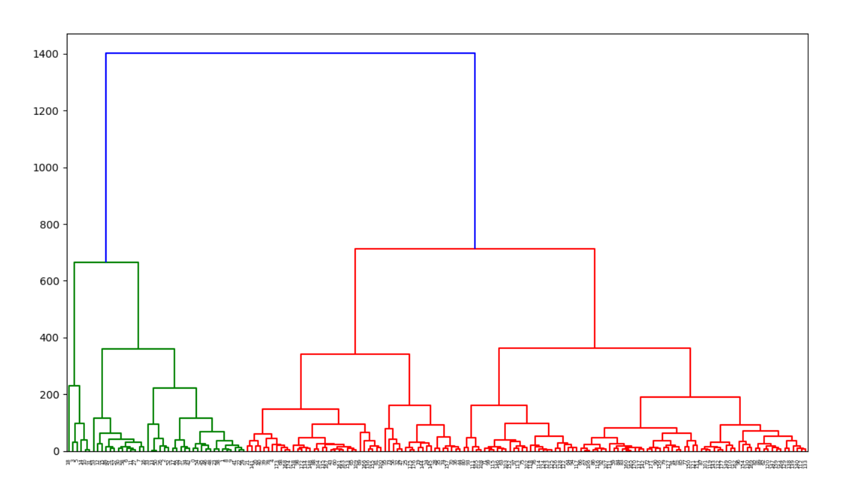

Complete link-using max distance

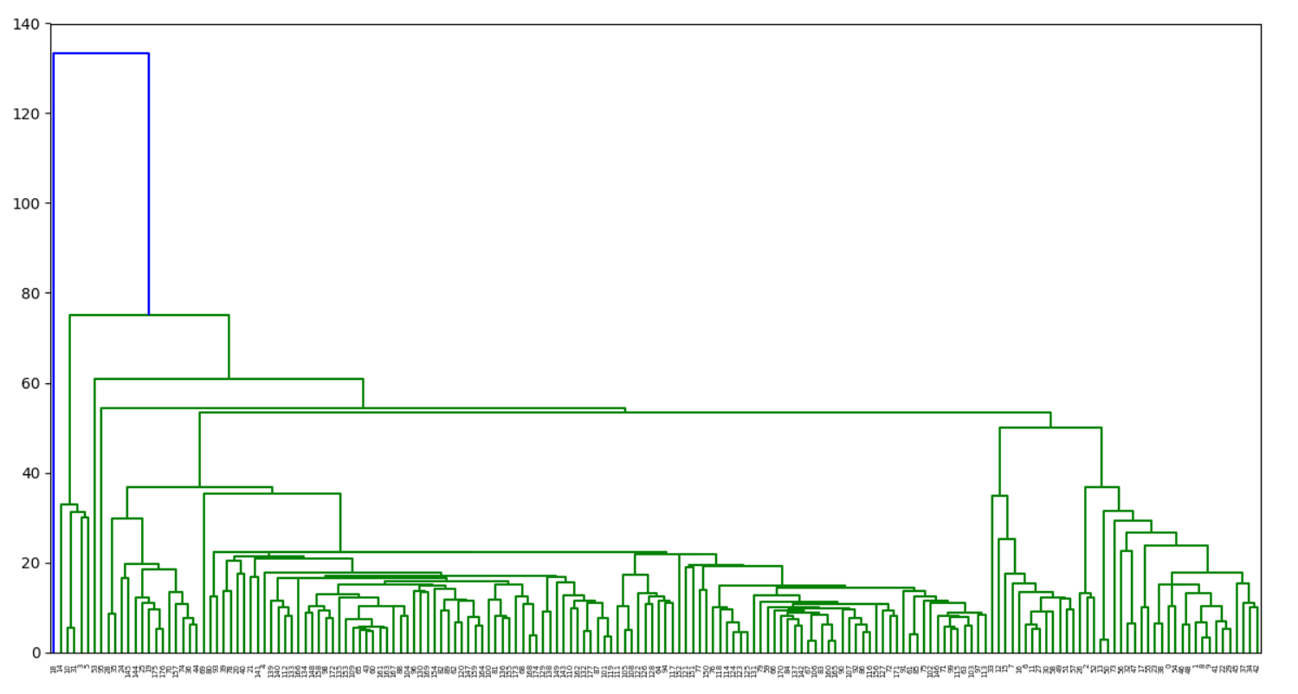

Single link-using min distance

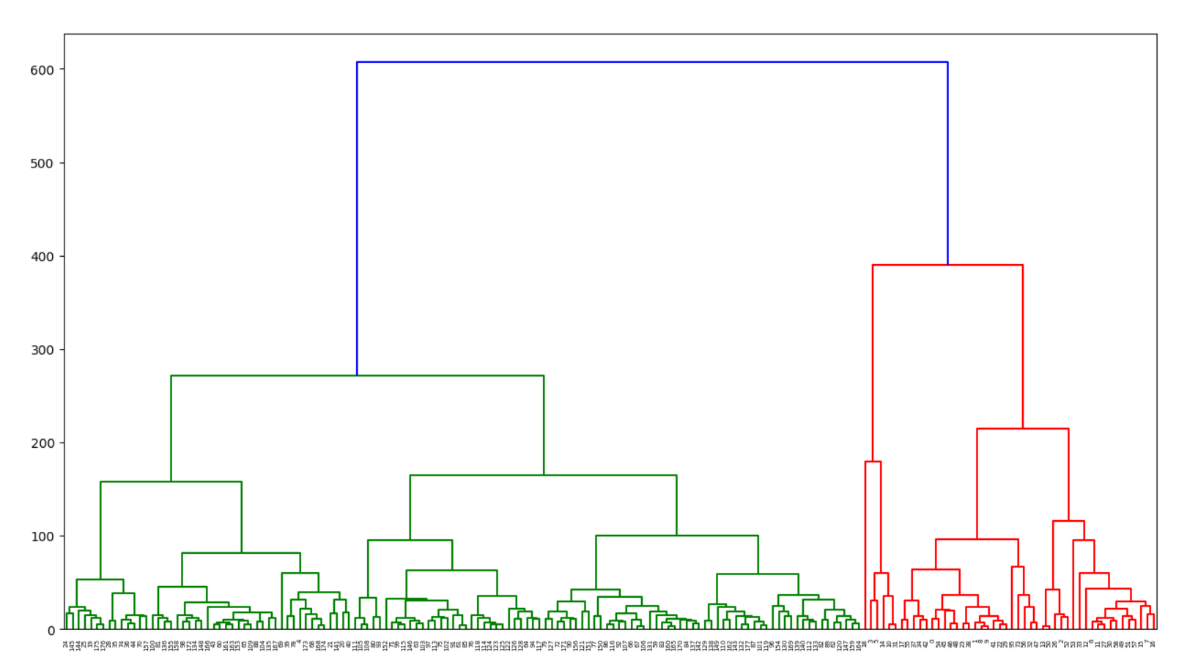

Average

1. Difference between complete, single link and average

Firstly, we compare the complete and single link. The significant difference is complete generated 3 clusters but single only generated 2 clusters.

We can see that complete link has a bigger range (from 0 to 1400) compare to single link (from 0 to 140) as complete link is using the maximum distance; while single link is using the minimum distance.