1. Training and testing set has been used to train. The result has been summarized as below:

|  |  |  |
| --- | --- | --- |
| n_estimators | Training Set  Accuracy score | Testing Set  Accuracy Score |
| 1 |  |  |
| 12 |  |  |
| 100 |  |  |

We can see the trend easily for both training and testing data set. When *n_estimators=1*, the accuracy score is the lowest as it just generates 1 tree from large data set and it has low reliability. The accuracy score starts to increase when *n_estimators=12* as more trees were generated as more attributes were considered. However, when *n_estimators=100* the score goes down slightly as there are too much trees and it may make the outliers become significant.

Apparently, testing data set gets higher score than training because testing set contains more data. Although it may contain more outliers, since random forest won’t overfit, it won’t influence the accuracy score.

Random forest doesn’t have the overfit problem; however, This comes at the expense of a small increase in the bias and some loss of interpretability, but generally greatly boosts the performance in the final model.

The accuracy score for original optimal tree and each tree has been summarized as below:

|  |  |
| --- | --- |
|  | Training Set  Accuracy score |
| Original Random forest model |  |
| Component Trees | |
| A |  |
| B |  |
| C |  |

By select *n_estimators=12* with the highest performance, it shown that all the component trees that used to form the final random forest model has lower accuracy score than the final model. Looking more closer to each individual component trees, it is found that all these component trees contain redundant roots and are overfitting the model.

Below are the component trees A, B and C which is selected:

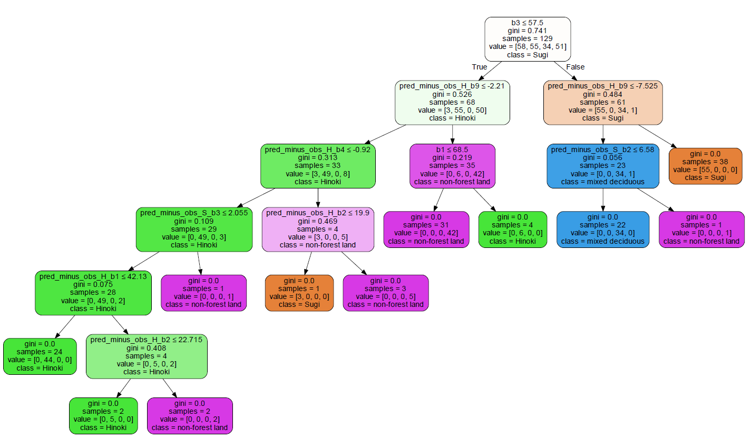

Tree A

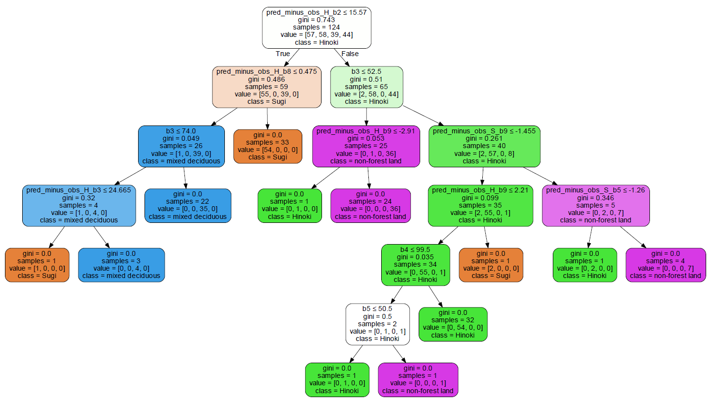

Tree B

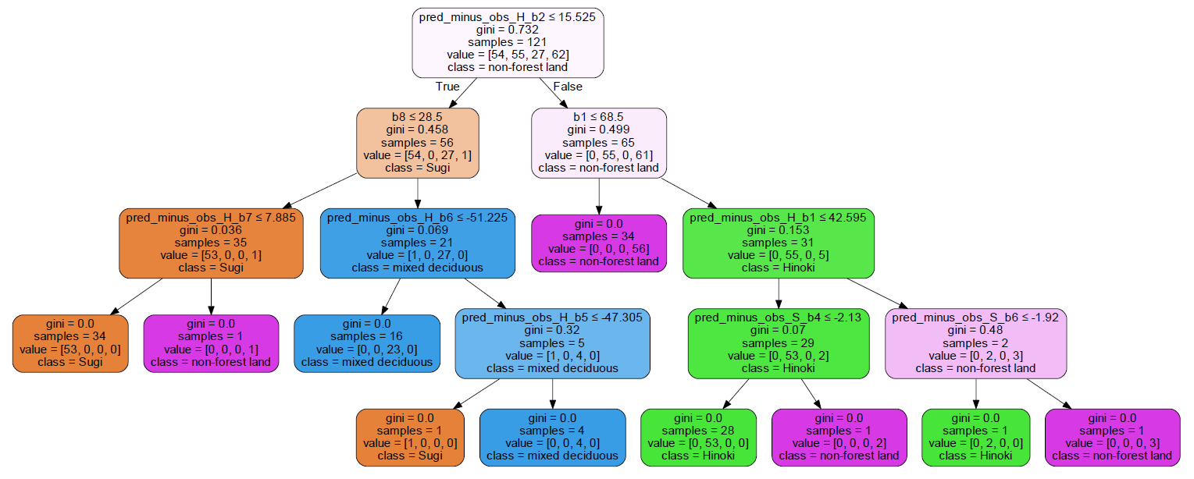

Tree C

The roots that are circled red are redundant, because they are overfitting the particular randomly selected data set. These roots will be removed when they are combined to for the final random forest model.

(c)

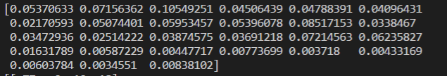

This corresponding array values are the feature importance of the final random forest model. The corresponding attribute is:

[b1,b2,b3,b4,b5,b6,b7,b8,b9,pred_minus_obs_H_b1,pred_minus_obs_H_b2,pred_minus_obs_H_b3,pred_minus_obs_H_b4,pred_minus_obs_H_b5,pred_minus_obs_H_b6,pred_minus_obs_H_b7,pred_minus_obs_H_b8,pred_minus_obs_H_b9,pred_minus_obs_S_b1,pred_minus_obs_S_b2,pred_minus_obs_S_b3,pred_minus_obs_S_b4,pred_minus_obs_S_b5,pred_minus_obs_S_b6,pred_minus_obs_S_b7,pred_minus_obs_S_b8,pred_minus_obs_S_b9]

The feature importance which have its’ score larger than 0.6

|  |  |
| --- | --- |
| Feature | Importance value |
| B3 | 0.10549251 |
| pred_minus_obs_H_b2 | 0.08517153 |
| pred_minus_obs_H_b8 | 0.07214563 |
| B2 | 0.07156362 |
| pred_minus_obs_H_b9 | 0.06235827 |

Having a closer look on the Test A, B and C:



Test A

The most important features are: b3, pred_minus_obs_H_b9



Test B

The most important features are: pred_minus_obs_H_b2, pred_minus_obs_H_b8, b3



Test C

The most important features are: pred_minus_obs_H_b2, pred_minus_obs_H_b8