- info 1 sample SQL
SELECT STAT_ORD.LID, STAT_ORD.LPERIOD, STAT_ORD.ORDNB, STAT_ORD.REC_SITE_NB, STAT_ORDANAEL.MC, STAT_ORDANAEL.RES_NUM, STAT_ORDANAEL.RES_TXT, STAT_SAMPLEPOS_CONT_V.CONTMC, STAT_SAMPLEPOS_CONT_V.CONTMCSEQ, STAT_SAMPLEPOS_CONT_V.POS, STAT_ORDANAEL.SPSEQ, STAT_ORDANAEL.NBINT, STAT_SAMPLEPOS_CONT_V.BCSEQ, STAT_SAMPLEPOS_CONT_V.BC
FROM (STAT_ORD INNER JOIN STAT_ORDANAEL ON (STAT_ORD.ORDNB = STAT_ORDANAEL.ORDNB) AND (STAT_ORD.LPERIOD = STAT_ORDANAEL.LPERIOD) AND (STAT_ORD.LID = STAT_ORDANAEL.LID)) INNER JOIN STAT_SAMPLEPOS_CONT_V ON (STAT_ORDANAEL.ORDNB = STAT_SAMPLEPOS_CONT_V.ORDNB) AND (STAT_ORDANAEL.LPERIOD = STAT_SAMPLEPOS_CONT_V.LPERIOD) AND (STAT_ORDANAEL.LID = STAT_SAMPLEPOS_CONT_V.LID)
WHERE (((STAT_ORD.LID)="H2") AND ((STAT_ORD.LPERIOD)="0482") AND ((STAT_ORD.ORDNB)=685));
- MOLIS test codes
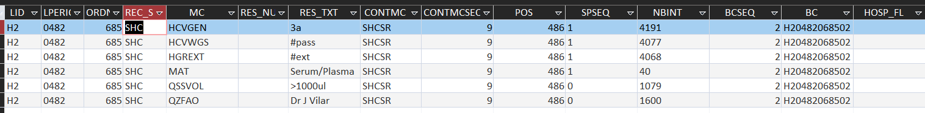
Fields we are looking for
CSV heading | Table | MOLIS test code | Result field
LID
LPERIOD
ORDNB
HCVGEN | STAT_ORDANEAL | MC(=HCVGEN) | RES_TXT
SAMPLE_DT | STAT_ORD | SAMPLE_DT
RECEPT_DT | STAT_ORD | RECEIPT_DT
CORORDNB | STAT_ORD | CORORDNB (Hosp code)
ORDPATBIRTHDT | STAT_ORD | ORDPATBIRTHDT
ORDPATNAME | STAT_ORD | ORDPATNAME
NHS | STAT_ORD | CORORDSUBNB
ORDPATSX | STAT_ORD | ORDPATSX
REFEXT | STAT_ORD | REFEXT
EXTPATIDNB | STAT_ORD | EXTPATIDNB
 | STAT_ORD | REC_SITE_NB (SHC)
 | STAT_ORD | HOSP_FL

Query to recreate CSV
SELECT [STAT_ORD.LID] & [STAT_ORD.LPERIOD] & (Format([STAT_ORD.ORDNB],"0000")) AS ID,
Max(IIf([MC]="HCVGEN",[RES_TXT])) AS HCVGEN,
Max(IIf([MC]="MAT",[RES_TXT])) AS MAT,
STAT_ORD.SAMPLE_DT, STAT_ORD.RECEPT_DT, STAT_ORD.CORORDNB, STAT_ORD.HOSP_FL, STAT_ORD.ORDPATNAME, STAT_ORD.ORDPATBIRTHDT, STAT_ORD.ORDPATSX, STAT_ORD.ORDPATIDNB, STAT_ORD.CORORDSUBNB, STAT_ORD.REFEXT, STAT_ORD.EXTPATIDNB, STAT_ORD.REC_SITE_NB
FROM
((STAT_ORD INNER JOIN STAT_ORDANAEL ON
(STAT_ORD.ORDNB = STAT_ORDANAEL.ORDNB) AND (STAT_ORD.LPERIOD = STAT_ORDANAEL.LPERIOD) AND (STAT_ORD.LID = STAT_ORDANAEL.LID))
INNER JOIN STAT_COR ON STAT_ORD.CORORDNB = STAT_COR.CORNB)
INNER JOIN STAT_SAMPLEPOS_CONT_V ON (STAT_ORDANAEL.ORDNB = STAT_SAMPLEPOS_CONT_V.ORDNB) AND (STAT_ORDANAEL.LPERIOD = STAT_SAMPLEPOS_CONT_V.LPERIOD) AND (STAT_ORDANAEL.LID = STAT_SAMPLEPOS_CONT_V.LID)
GROUP BY STAT_ORDANAEL.LID, STAT_ORDANAEL.LPERIOD, STAT_ORDANAEL.ORDNB, [STAT_ORD.LID] & [STAT_ORD.LPERIOD] & (Format([STAT_ORD.ORDNB],"0000")), STAT_ORD.SAMPLE_DT, STAT_ORD.RECEPT_DT, STAT_ORD.CORORDNB, STAT_ORD.HOSP_FL, STAT_ORD.ORDPATNAME, STAT_ORD.ORDPATBIRTHDT, STAT_ORD.ORDPATSX, STAT_ORD.ORDPATIDNB, STAT_ORD.CORORDSUBNB, STAT_ORD.REFEXT, STAT_ORD.EXTPATIDNB, STAT_ORD.REC_SITE_NB
HAVING (((STAT_ORDANAEL.LID)="H2") AND ((STAT_ORDANAEL.LPERIOD) Between "1016" And "1050") AND ((STAT_ORD.REC_SITE_NB)="SHC"));
AND SHE

Tables:
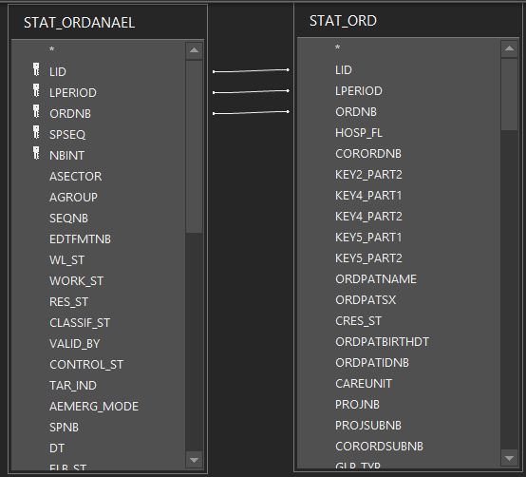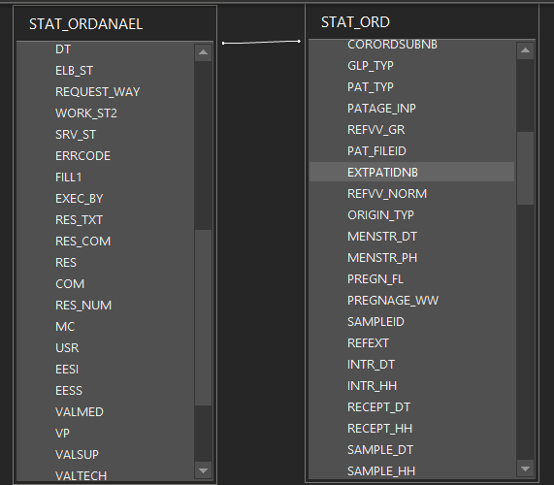

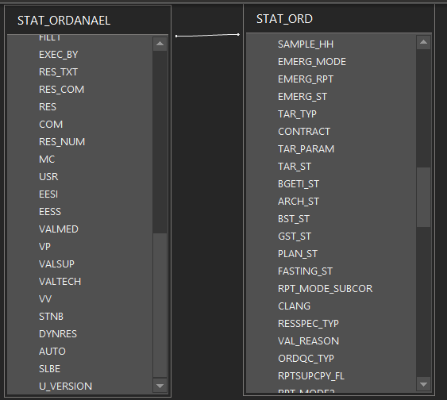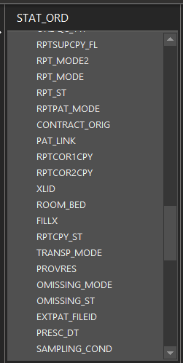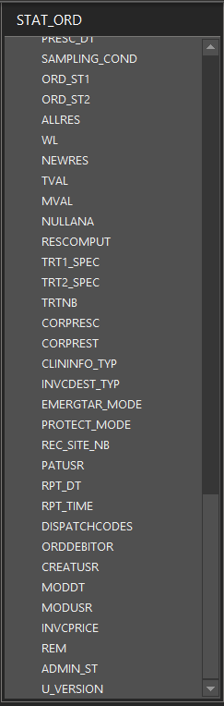
constraint (LID, LPERIOD)

select * from STAT_ORD inner join STAT_ORDANAEL ON (STAT_ORD.LID = STAT_ORDANAEL.LID) AND (STAT_ORD.LPERIOD = STAT_ORDANAEL.LPERIOD) AND (STAT_ORD.ORDNB = STAT_ORDANAEL.ORDNB) ;

select STAT_ORD.LID as HHH from
STAT_ORD inner join
STAT_ORDANAEL ON
(STAT_ORD.LID = STAT_ORDANAEL.LID) AND (STAT_ORD.LPERIOD = STAT_ORDANAEL.LPERIOD) AND (STAT_ORD.ORDNB = STAT_ORDANAEL.ORDNB)
;

select * from STAT_ORDANAEL inner join STAT_SAMPLEPOS_CONT_V
ON (STAT_ORDANAEL.LID = STAT_SAMPLEPOS_CONT_V.LID) AND (STAT_ORDANAEL.LPERIOD = STAT_SAMPLEPOS_CONT_V.LPERIOD) AND (STAT_ORDANAEL.ORDNB = STAT_SAMPLEPOS_CONT_V.ORDNB) ;

SELECT STAT_ORD.LID || printf('%04d',STAT_ORD.LPERIOD) || printf('%04d',STAT_ORD.ORDNB) AS ID, STAT_ORD.LID, STAT_ORD.LPERIOD, STAT_ORD.ORDNB,
IIF(MC='HCVGEN',RES_TXT,'') AS HCVGEN,
--IIF(MC='MAT',RES_TXT,'') AS XX,
STAT_ORD.SAMPLE_DT, STAT_ORD.RECEPT_DT, STAT_ORD.CORORDNB, STAT_ORD.HOSP_FL,
STAT_ORD.ORDPATNAME, STAT_ORD.ORDPATBIRTHDT, STAT_ORD.ORDPATSX, STAT_ORD.ORDPATIDNB,
STAT_ORD.CORORDSUBNB, STAT_ORD.REFEXT, STAT_ORD.EXTPATIDNB, STAT_ORD.REC_SITE_NB
FROM
(
(STAT_ORD INNER JOIN STAT_ORDANAEL ON (STAT_ORD.ORDNB = STAT_ORDANAEL.ORDNB) AND (STAT_ORD.LPERIOD = STAT_ORDANAEL.LPERIOD) AND (STAT_ORD.LID = STAT_ORDANAEL.LID))
INNER JOIN STAT_COR ON STAT_ORD.CORORDNB = STAT_COR.CORNB)

INNER JOIN STAT_SAMPLEPOS_CONT_V ON (STAT_ORDANAEL.ORDNB = STAT_SAMPLEPOS_CONT_V.ORDNB)
AND (STAT_ORDANAEL.LPERIOD = STAT_SAMPLEPOS_CONT_V.LPERIOD) AND (STAT_ORDANAEL.LID = STAT_SAMPLEPOS_CONT_V.LID)

GROUP BY STAT_ORDANAEL.LID, STAT_ORDANAEL.LPERIOD, STAT_ORDANAEL.ORDNB, STAT_ORD.LID || printf('%04d',STAT_ORD.LPERIOD) || printf('%04d',STAT_ORD.ORDNB),
STAT_ORD.SAMPLE_DT, STAT_ORD.RECEPT_DT, STAT_ORD.CORORDNB, STAT_ORD.HOSP_FL, STAT_ORD.ORDPATNAME, STAT_ORD.ORDPATBIRTHDT,
STAT_ORD.ORDPATSX, STAT_ORD.ORDPATIDNB, STAT_ORD.CORORDSUBNB, STAT_ORD.REFEXT, STAT_ORD.EXTPATIDNB, STAT_ORD.REC_SITE_NB
HAVING (((STAT_ORDANAEL.LID)="H2") AND ((STAT_ORDANAEL.LPERIOD) Between "1016" And "1050") AND ((STAT_ORD.REC_SITE_NB)="SHC"));

