LUMA: User's guide


By: Juan Luis Garcia Rodriguez
version 0.1 – 30/03/2011

Content
1. Introducción 3
2. Configuración 4
Servidores 4
Directorios de configuración 11
Plugins 12
3. Navegador 13
Plantillas 17
Nuevas entradas 22
Exportación de datos 25
4. Búsquedas 27
5. Utilidades para el administrador 29
6. Navegador de clases de objetos 29
7. Libreta de direcciones 29
8. Creación masiva de usuarios 29
9. Gestión de usuarios 30
10. Sobre este manual 31

Introduction
Luma is graphical browser, editor and other utilities for LDAP directories. Created by Wido Depping and can be downloaded freely from http://luma.sourceforge.net/. Luma is organized by plugins that cover different functions:
- Addressbook.
- Admin utilities.
- Browser.
- Massive user creation.
- Schemabrowser.
- Search.
- Templates.
- Usermanagement.
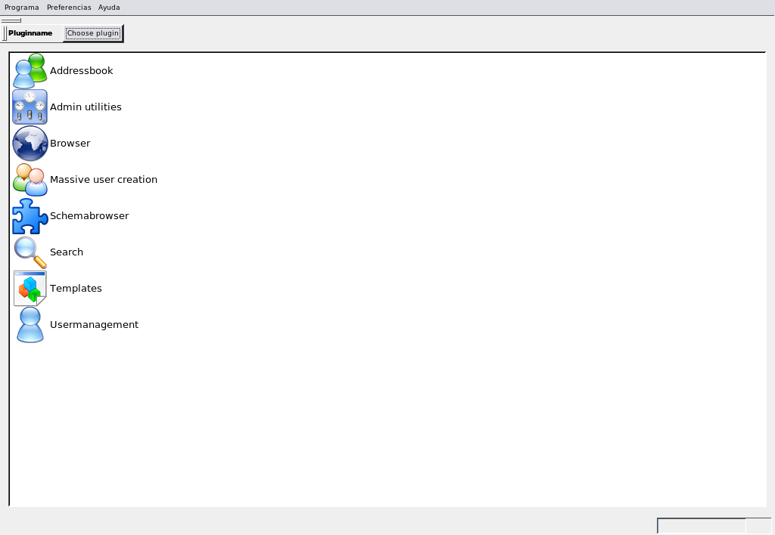

Settings

Edit server list
The first step to start using the tool should be to configure the connection to LDAP servers to which you want to access. In the top menu select Settings → Edit Server List, or press the keyboard combination CTRL + E, with which to access the following form:

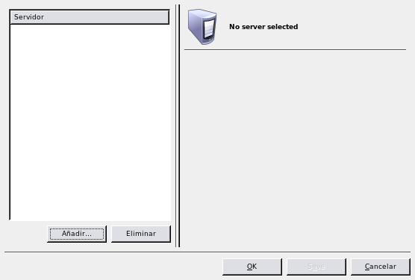
Clicking the Add... button at the bottom of the list on the left, the application will ask a name for the new server..
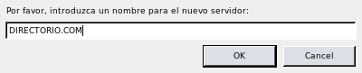
Then, will appear the options for setting all parameters as required.
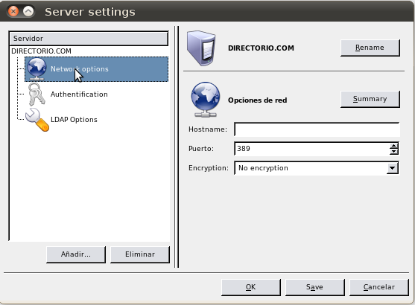
The first set of parameters relates to the network settings, including:
- Hostname: Name or IP address of LDAP server.
- Port: Through which communication occurs. In most cases will be in the 389 or 636, the latter in the case of using SSL.
- Encryption: Encryption type (if used) with which to perform the communication.
  - No encryption
  - TLS (Transport Layer Security)
  - SSL (Secure Socket Layer)
Following, have to configure the authentication data to establish the connection.
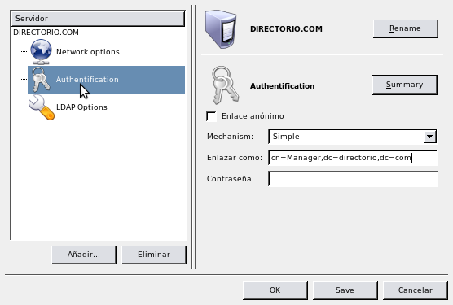
You can choose between anonymous or authenticated connection, in the latter you need to specify the authentication mechanism with username and password.
In LDAP options can be set the possibility of further possible references to other LDAPs. It also specifies the DN suffix or base directory, with the possibility of limiting access to it.
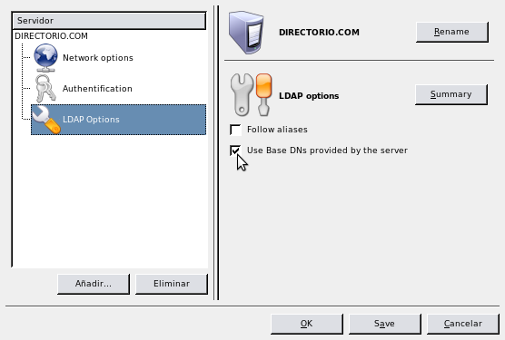

When defining the base DN or suffix, It's possible to obtain it automatically from the server, or enter them manually.
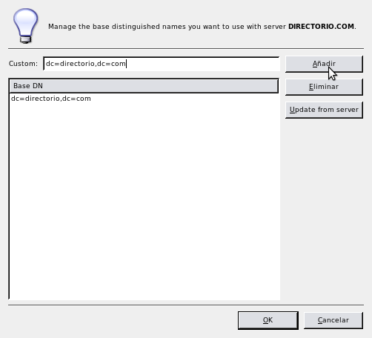

In the case of encryption is selected - TLS or SSL - in network settings, then enable a more aparrtado where you can configure the client certificate.
- Certificate file.
- Certificate keyfile.
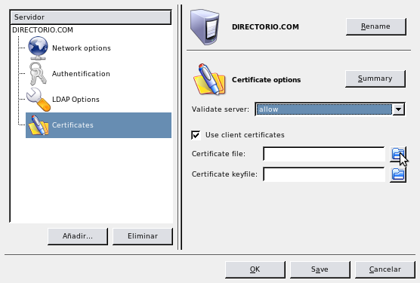

Config directories
In those servers have configuration directory cn=config, instead of the traditional slapd.conf file, it will be possible to access such information in the same way you do with the data. This requires creating a new server configuration, with the same server, but indicating cn=config as much as Base DN as login user, along with your password.

Plugins
Through the menu Settings → Configure Plugins... or by Ctrl + C allows the selection of those modules that wish to have available within the application, and some specify certain configuration parameters thereof.
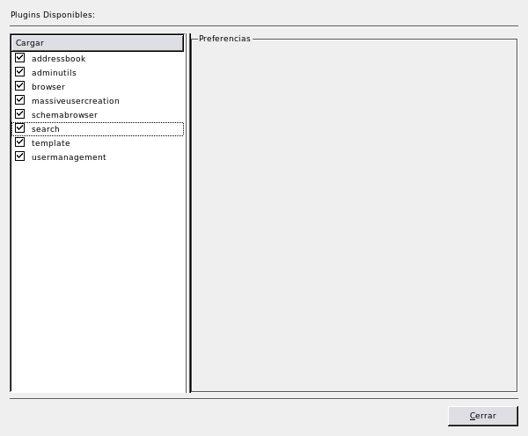

Browser
The fundamental component of the application is undoubtedly the browser. Through it we have a complete view of the structure and contents of the directory, and the provision of tools for editing and exporting information.
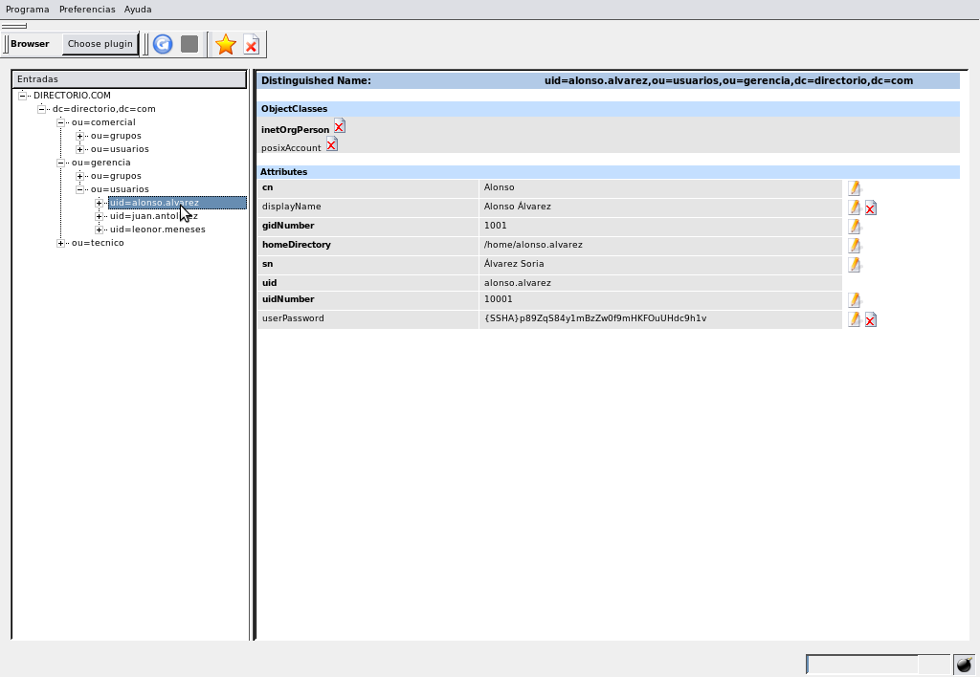
The navigation screen is divided into two parts:
- On the left tree representation appear in the directory with its root (base DN or suffix) at the top. In principle, the tree appears fully retracted and as it expands by the different branches will display the directory contents. It is important to notice that once displayed a branch or entry, this information will not remain in real time and detect possible changes that could be done on the server unless the user manually refresh the option through recharge button
- On the right side of the screen content (attributes and object classes) entry is selected in the tree. To the right of the editable attribute values may appear in editing buttons and/or delete . In the first of the options will display a small form attribute editing.
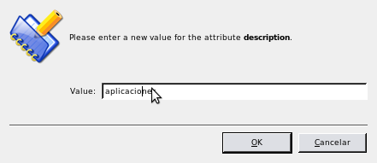
Once editing is done, then press OK and the change will be reflected in the editor, but does not effect the operation on the directory until you click the save button . The same happens when you press delete , it disappears in the graphical tree but the attribute editor will not be removed from the directory until you click save . If, however, before saving, you want to cancel the operation - whether to keep or delete - it can be done using the refresh button .
To insert new attributes should be pointed on the entry at the tree and click the right mouse button. Select Add → Attribute in pop-up menu, or press the button .
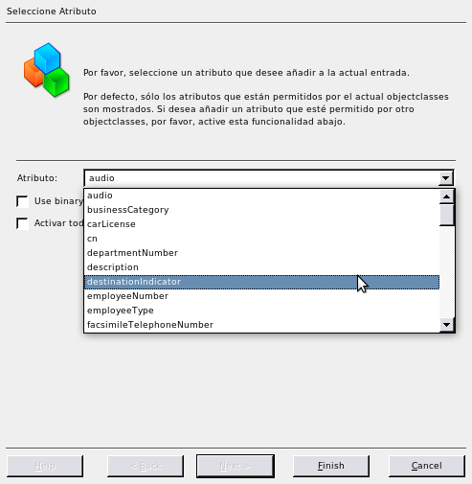
Then you will see a dropdown with the attributes available to the objectClass that implements the input. If you want to include an attribute that is contained in an object class that no implements the input but is included in the server directory schema, we must check the "Enable all attributes wich are allowed by the server.". Keep in mind that if you need to implement a new class of object, it will include all required attributes in addition to the attribute is selected. Once selected attribute is highlighted in red on the detail of the entrance waiting to be edited and saved.

Templates
Before you can enter new entries in the directory is necessary to define templates.
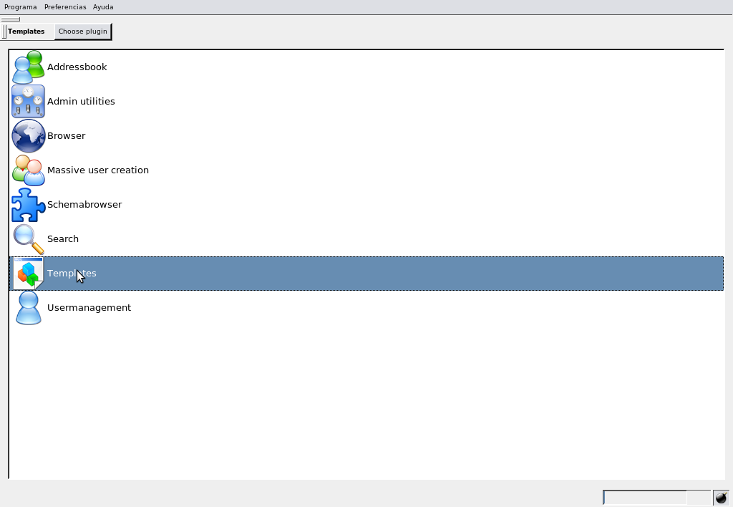
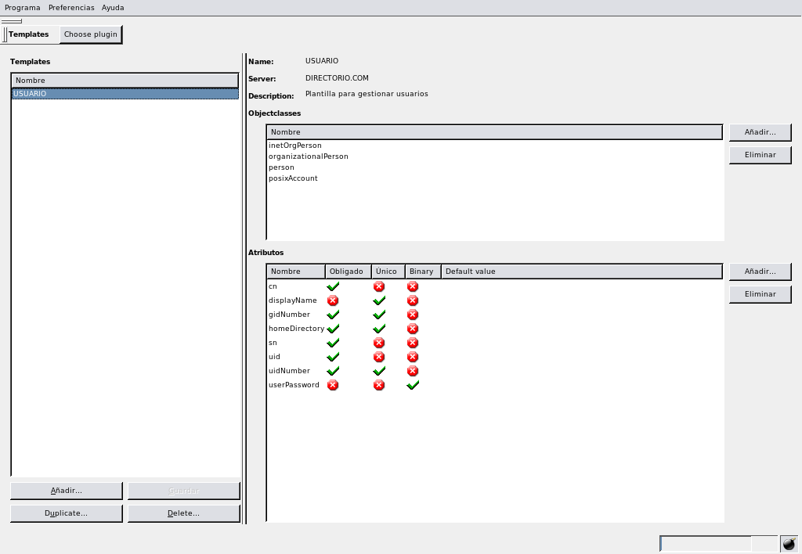
A template is a mold which defines the attributes that will be needed at the time of create an entry. To create a new template, first is to assign it a name, link it to one of the servers configured and optionally write a brief description of their duties.
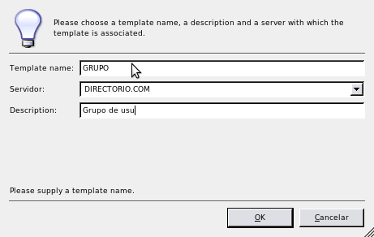

Pressing the OK button, the template appears in the list, but not saved until you press the Save button. The next step is to select the object classes that provide the attributes you want in the template. With the selected template, on the right side sections, appear object class (objectClasses) at the top, and attributes in the bottom. Before adding attributes, logically, you must select at least one object class.
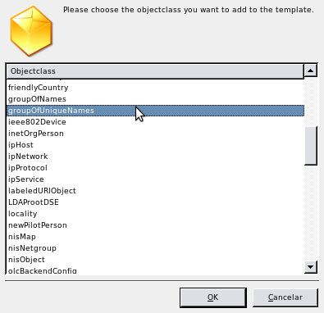

After selecting the object class, in the list of attributes will appear those required in the implementation of that class. In the list of attributes appear, addition the name, shows whether the attribute is mandatory, if has unique value, if is binary and if you have assigned a default value. The latter value can be modified by clicking the mouse.
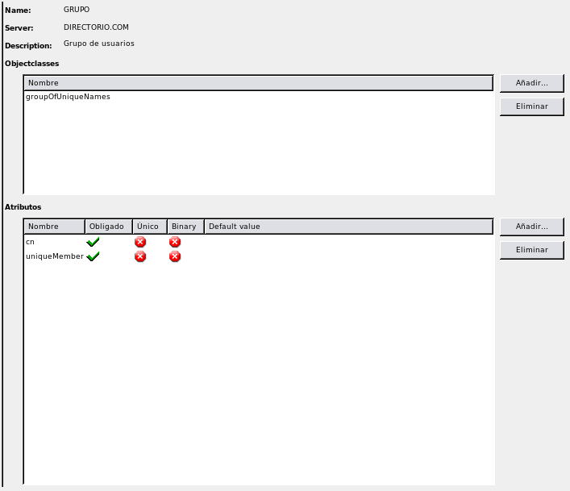
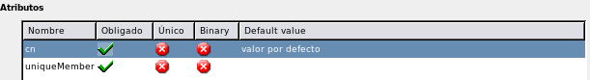
To continue adding attributes need to press the button Add... and then a form will appear with the list and attribute information available.
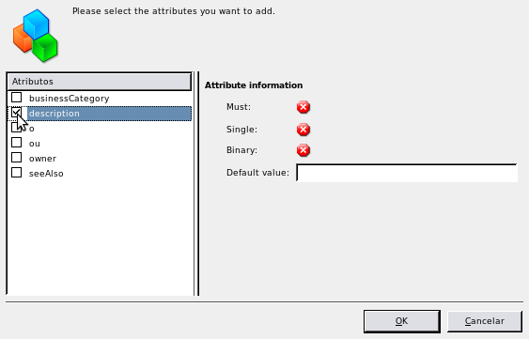
Once completed to define the template with all object classes and attributes, it is necessary to save all by pressing the Save button.
You can create new templates based on other already created with option Duplicate... that creates a copy of the selected template and will serve to be modified and adapted to new needs.

News entries
With templates already defined for the server, the process to register new entries is as follows:
- Click with the right mouse button on the father of the new entry.
- In the popup menu, select the Add... → <Template Name>. In the bottom of the menu are available all the templates you previously defined.
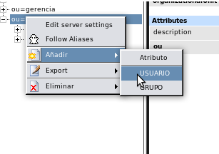

- The screen for selected template will appear showing the information of the new entry divided into three parts.
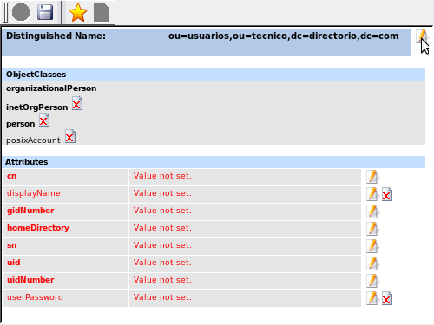

  - Distinguished Name (DN). It will be necessary to select one of the attributes - along with its corresponding value - from the entry, to be able to distinguish uniquely within the directory.
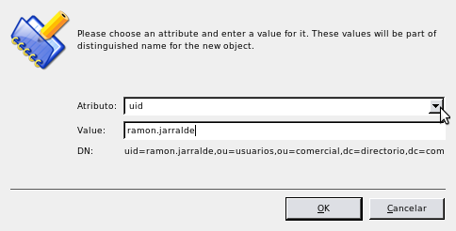
  - Objectclasses. Shows the object classes that implement the input and corresponding to the attributes defined in the template. You can delete classes, although it should be noted that this might entail the removal of some attributes likewise.
  - Attributes. Displays the repertoire of attributes defined in the template and that they can add new ones by pressing Add attribute... You can select attributes outside of the object classes defined in the template and will be included in the new entry. We must be careful to attribute-value pair must match that specified in the definition of DN, and finally, press the save button for save the changes in the directory.

Data export
The export option is used to generate data files in LDIF or DSML formats, which can contain a whole directory, individual entries or those branches you select.
To perform an export must be placed on the entrance from which you wish to export and press the right mouse button, then a popup menu where the Export option, which in turn offers three alternatives:
- Item: only selected entry.
- Subtree: selected entry along with their daughters.
- Subtree with parents: selected entry along with their parent and daughters.
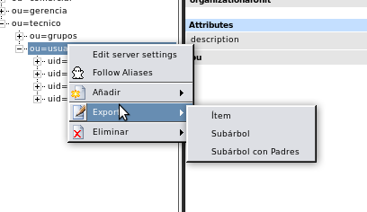
Once selected, a screen appears which requests the format (LDIF or DSML) that you want to export, the location and file name and, finally, allows exclude from a list those entries that are not want to export, pressing the Remove from list.
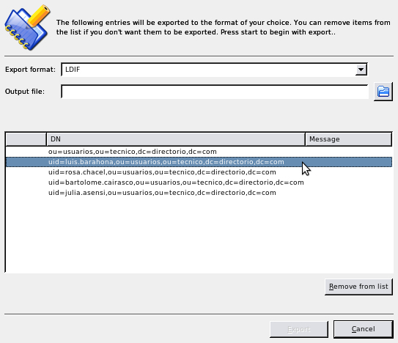

Searchs
This module is used to define search operations on directories.
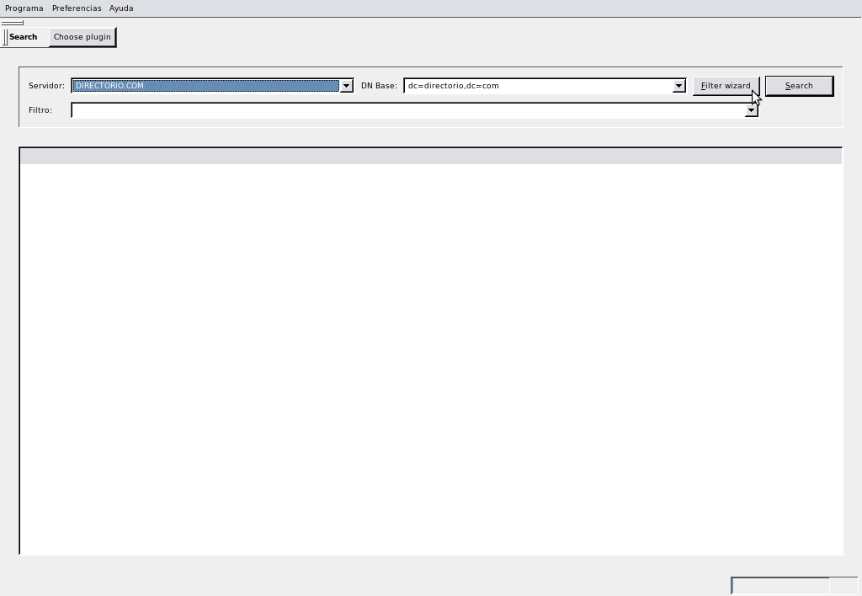
It is need to select the server and base DN (the system proposes the suffix by default) to search. The user must also define the search filter, either directly on the box labeled Filter, either through a wizard accessing by clicking Filter wizard.
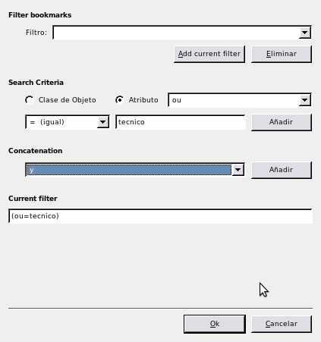
In the wizard filter is necessary to select the search criteria: class object or attribute and the type of comparison to the value of search. If more than one criterion at concatenate them with logical operators (and, or, not). It is possible to store the filters for future searches.
Then of defining filters, there is only click the Search button and the search results are displayed in the list at the bottom of the screen.

Admin utilities
This plugin include two tools:
- Passwords: To encrypt passwords, either by entering the string, or by generating a random. The hash methods available are: plaintext (cleartext), crypt, MD5, SHA, SMD5, SSHA.
- Date / Time: Allows conversions to UNIX format time.

Schema browser
Allows browse through the directory schema, including object classes, attributes, LDAP syntax and rules.

Addressbook
Allows use an LDAP directory as an address book, providing entries for those people and providing a useful interface for querying and maintaining contact information (phone, address, e-mail ...)

Massive user creation
Its usefulness lies in being able to set the parameters needed to launch automatic processes to create multiple users.

User management
Interfaz amigable para el mantenimiento de cuentas de usuario. Es mucho más ágil que hacerlo desde la función del navegador.

About this user's guide
This manual has been written by Juan Luis Garcia Rodriguez.

This work is licensed under the following CreativeCommons conditions:
- May be freely distributed.
- Original author attribution.
- Commercial use not allowed.
- Derivative works are allowed, provided that use of the same license of the original.

To contact the author: juanluisga@ldapconfig.net
www.ldapconfig.net
http://ldapconfig-en.blogspot.com/

