- Which grammatical features (tense,person,case) are hardest to retain long term?
- Optimal review interval as a function of prior history
- Which language pairs are the hardest? (native-learning)
- Who has the hardest time to learn english?
- Cluster learners (fast, slow learners)
- PCA
- Fit a RNN and see if it can beat the HLR model.
- Is power law decay better than exponential ? at least in some categories??

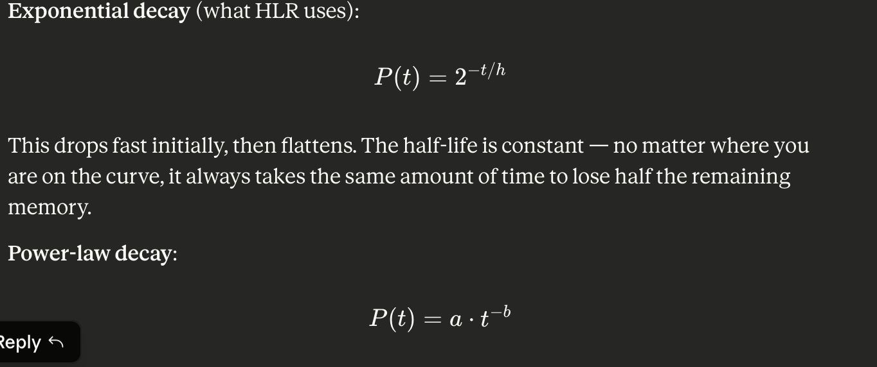

9)
