Consultas
1. Plan de ejecución con árbol de acciones:
Sort (cost=133932.99..133935.54 rows=1021 width=63) (actual time=4155.025..4157.231 rows=41793 loops=1)
Sort Key: streak_summary.weeks_improving DESC, streak_summary.total_points_in_streak DESC
Sort Method: quicksort Memory: 3679kB
-> Subquery Scan on streak_summary (cost=1739.48..133881.96 rows=1021 width=63) (actual time=32.091..4121.051 rows=41793 loops=1)
-> GroupAggregate (cost=1739.48..133871.75 rows=1021 width=75) (actual time=32.090..4117.022 rows=41793 loops=1)
Group Key: artist_streaks.artist_id, artist_streaks.artist_name, artist_streaks.streak_group
Filter: (count(*) >= 2)
Rows Removed by Filter: 50950
-> Incremental Sort (cost=1739.48..133763.14 rows=3133 width=63) (actual time=32.081..4045.224 rows=166901 loops=1)
Sort Key: artist_streaks.artist_id, artist_streaks.artist_name, artist_streaks.streak_group
Presorted Key: artist_streaks.artist_id
Full-sort Groups: 1039 Sort Method: quicksort Average Memory: 27kB Peak Memory: 27kB
Pre-sorted Groups: 1165 Sort Method: quicksort Average Memory: 56kB Peak Memory: 63kB
-> Subquery Scan on artist_streaks (cost=1076.26..133657.80 rows=3133 width=63) (actual time=29.353..3992.097 rows=166901 loops=1)
Filter: (artist_streaks.improved = 1)
Rows Removed by Filter: 232966
-> WindowAgg (cost=1076.26..125824.19 rows=626689 width=71) (actual time=29.349..3955.903 rows=399867 loops=1)
-> Subquery Scan on artist_rank_evolution (cost=1073.12..111723.68 rows=626689 width=59) (actual time=29.339..3718.327 rows=399867 loops=1)
-> WindowAgg (cost=1073.12..111723.68 rows=626689 width=59) (actual time=29.339..3680.750 rows=399867 loops=1)
-> Subquery Scan on artist_weekly_rank (cost=1070.29..100756.63 rows=626689 width=55) (actual time=29.328..3495.535 rows=399867 loops=1)
-> GroupAggregate (cost=1070.29..100756.63 rows=626689 width=55) (actual time=29.327..3458.741 rows=399867 loops=1)
Group Key: a.artist_id, c.chart_date
-> Incremental Sort (cost=1070.29..86656.12 rows=626689 width=28) (actual time=29.316..3201.606 rows=658255 loops=1)
Sort Key: a.artist_id, c.chart_date
Presorted Key: a.artist_id
Full-sort Groups: 1309 Sort Method: quicksort Average Memory: 28kB Peak Memory: 28kB
Pre-sorted Groups: 1670 Sort Method: quicksort Average Memory: 1402kB Peak Memory: 1517kB
-> Nested Loop (cost=1035.02..53236.21 rows=626689 width=28) (actual time=21.665..3045.360 rows=658255 loops=1)
-> Merge Join (cost=1034.60..1320.02 rows=12391 width=24) (actual time=18.887..29.311 rows=12391 loops=1)
Merge Cond: (a.artist_id = sa.artist_id)
-> Index Scan using artist_pkey on artist a (cost=0.28..94.34 rows=2204 width=15) (actual time=0.900..3.737 rows=2204 loops=1)
-> Sort (cost=1034.31..1065.29 rows=12391 width=13) (actual time=17.980..21.064 rows=12391 loops=1)
Sort Key: sa.artist_id
Sort Method: quicksort Memory: 772kB
-> Seq Scan on song_artist sa (cost=0.00..191.91 rows=12391 width=13) (actual time=0.897..15.718 rows=12391 loops=1)
-> Index Scan using idx_chart_song on chart c (cost=0.42..3.22 rows=97 width=12) (actual time=0.145..0.237 rows=53 loops=12391)
Index Cond: (song_id = sa.song_id)
Planning Time: 60.143 ms
Execution Time: 4160.037 ms
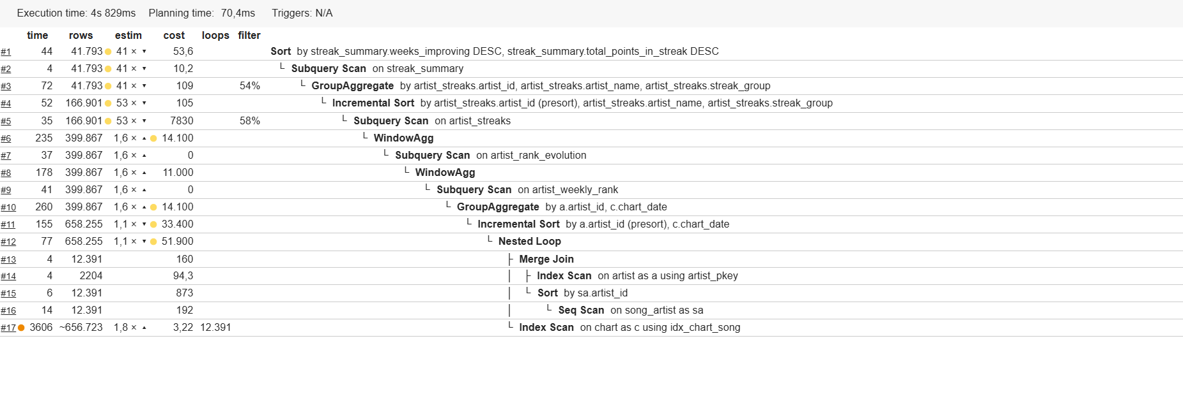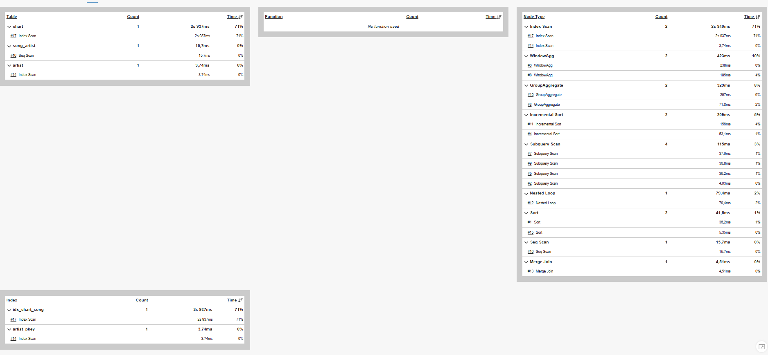
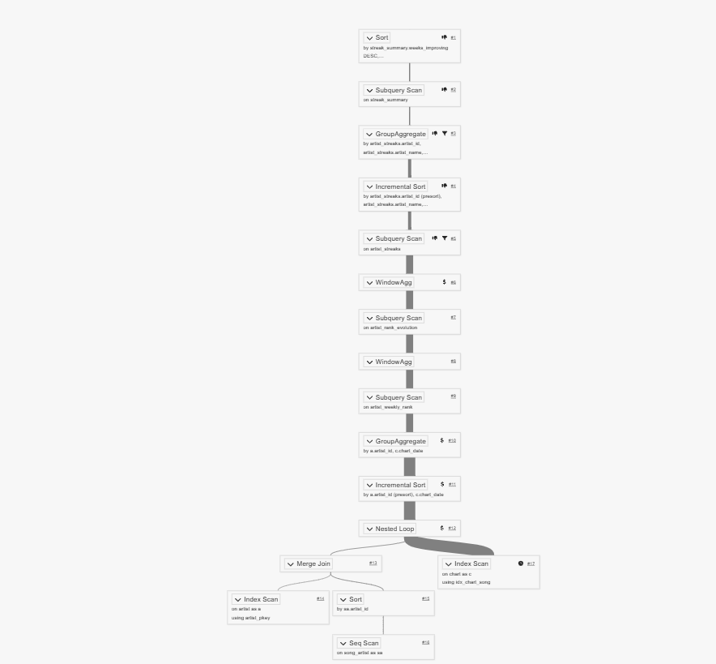

Resultado de la consulta:
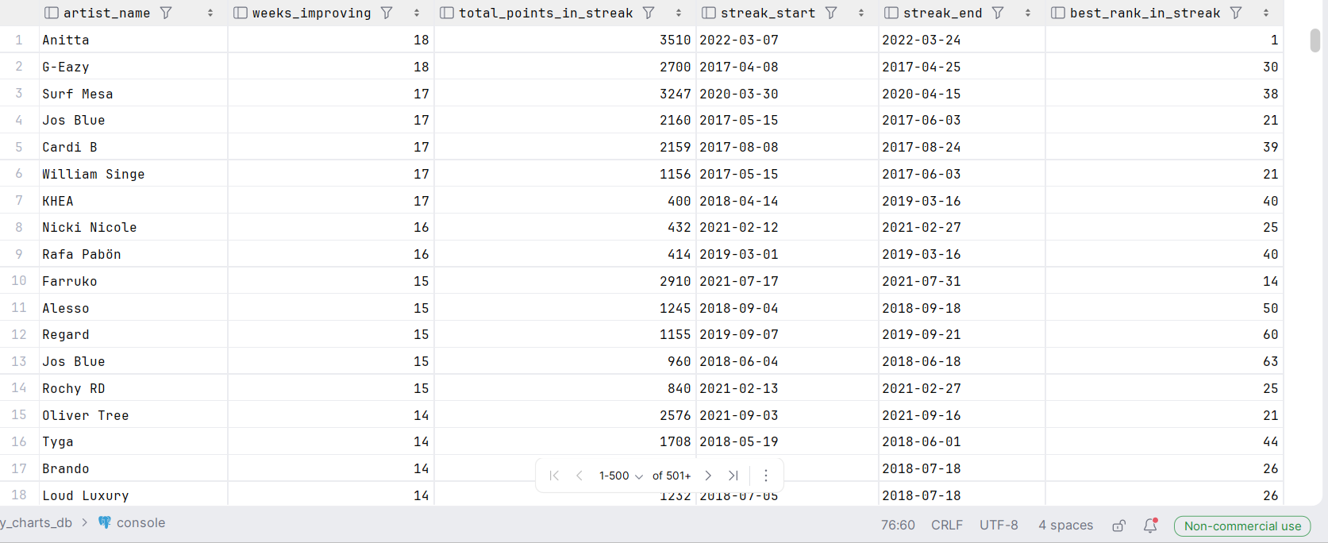

2. Plan de ejecución con árbol de acciones:
Incremental Sort (cost=128289.11..267429.81 rows=626689 width=326) (actual time=8.374..1395.183 rows=13921 loops=1)
Sort Key: cwp.chart_date, (rank() OVER (?))
Presorted Key: cwp.chart_date
Full-sort Groups: 392 Sort Method: quicksort Average Memory: 27kB Peak Memory: 27kB
CTE continent_weekly_points
-> GroupAggregate (cost=47.06..127267.00 rows=626689 width=258) (actual time=1.461..1363.688 rows=13921 loops=1)
Group Key: c.chart_date, co.continent_id
-> Incremental Sort (cost=47.06..114733.22 rows=626689 width=231) (actual time=1.428..1265.437 rows=658255 loops=1)
Sort Key: c.chart_date, co.continent_id
Presorted Key: c.chart_date
Full-sort Groups: 2336 Sort Method: quicksort Average Memory: 27kB Peak Memory: 27kB
Pre-sorted Groups: 2336 Sort Method: quicksort Average Memory: 36kB Peak Memory: 36kB
-> Nested Loop (cost=1.32..81573.62 rows=626689 width=231) (actual time=0.042..1125.597 rows=658255 loops=1)
-> Nested Loop (cost=1.16..65928.79 rows=626689 width=13) (actual time=0.037..916.643 rows=658255 loops=1)
-> Nested Loop (cost=1.01..50380.36 rows=626689 width=13) (actual time=0.034..714.816 rows=658255 loops=1)
-> Nested Loop (cost=0.72..34043.64 rows=626689 width=13) (actual time=0.026..499.785 rows=658255 loops=1)
-> Index Scan using idx_chart_date on chart c (cost=0.42..20942.44 rows=465979 width=8) (actual time=0.012..222.516 rows=465979 loops=1)
-> Memoize (cost=0.30..0.31 rows=1 width=13) (actual time=0.000..0.000 rows=1 loops=465979)
Cache Key: c.song_id
Cache Mode: logical
Hits: 456819 Misses: 9160 Evictions: 0 Overflows: 0 Memory Usage: 1190kB
-> Index Scan using song_artist_pk on song_artist sa (cost=0.29..0.30 rows=1 width=13) (actual time=0.002..0.002 rows=1 loops=9160)
Index Cond: (song_id = c.song_id)
-> Memoize (cost=0.29..0.32 rows=1 width=8) (actual time=0.000..0.000 rows=1 loops=658255)
Cache Key: sa.artist_id
Cache Mode: logical
Hits: 656051 Misses: 2204 Evictions: 0 Overflows: 0 Memory Usage: 233kB
-> Index Scan using artist_pkey on artist a (cost=0.28..0.31 rows=1 width=8) (actual time=0.002..0.002 rows=1 loops=2204)
Index Cond: (artist_id = sa.artist_id)
-> Memoize (cost=0.15..0.18 rows=1 width=8) (actual time=0.000..0.000 rows=1 loops=658255)
Cache Key: a.nationality_id
Cache Mode: logical
Hits: 658185 Misses: 70 Evictions: 0 Overflows: 0 Memory Usage: 8kB
-> Index Scan using nationality_pkey on nationality n (cost=0.14..0.17 rows=1 width=8) (actual time=0.002..0.002 rows=1 loops=70)
Index Cond: (nationality_id = a.nationality_id)
-> Memoize (cost=0.16..0.86 rows=1 width=222) (actual time=0.000..0.000 rows=1 loops=658255)
Cache Key: n.continent_id
Cache Mode: logical
Hits: 658248 Misses: 7 Evictions: 0 Overflows: 0 Memory Usage: 1kB
-> Index Scan using continent_pkey on continent co (cost=0.15..0.85 rows=1 width=222) (actual time=0.001..0.001 rows=1 loops=7)
Index Cond: (continent_id = n.continent_id)
-> WindowAgg (cost=362.29..95934.82 rows=626689 width=326) (actual time=5.331..1391.342 rows=13921 loops=1)
-> Incremental Sort (cost=362.15..80267.60 rows=626689 width=286) (actual time=5.323..1380.504 rows=13921 loops=1)
Sort Key: cwp.chart_date, cwp.continent_points DESC
Presorted Key: cwp.chart_date
Full-sort Groups: 392 Sort Method: quicksort Average Memory: 26kB Peak Memory: 26kB
-> Merge Join (cost=0.00..36039.62 rows=626689 width=286) (actual time=2.073..1375.969 rows=13921 loops=1)
Merge Cond: (cwp.chart_date = continent_weekly_points.chart_date)
-> CTE Scan on continent_weekly_points cwp (cost=0.00..12533.78 rows=626689 width=254) (actual time=1.463..2.573 rows=13921 loops=1)
-> GroupAggregate (cost=0.00..15669.73 rows=200 width=36) (actual time=0.607..1370.330 rows=2336 loops=1)
Group Key: continent_weekly_points.chart_date
-> CTE Scan on continent_weekly_points (cost=0.00..12533.78 rows=626689 width=36) (actual time=0.000..1366.638 rows=13921 loops=1)
Planning Time: 0.617 ms
Execution Time: 1396.042 ms

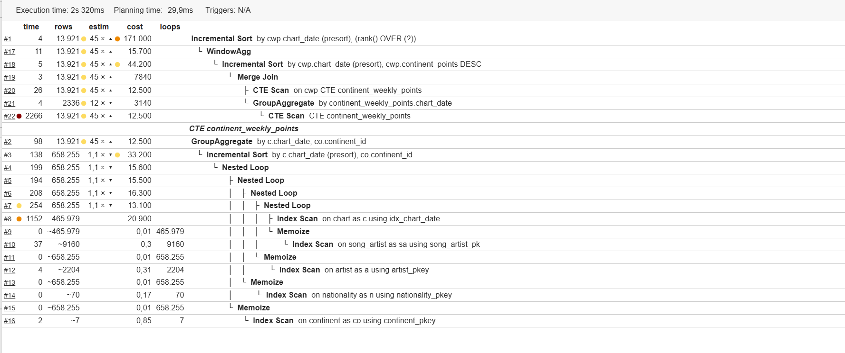
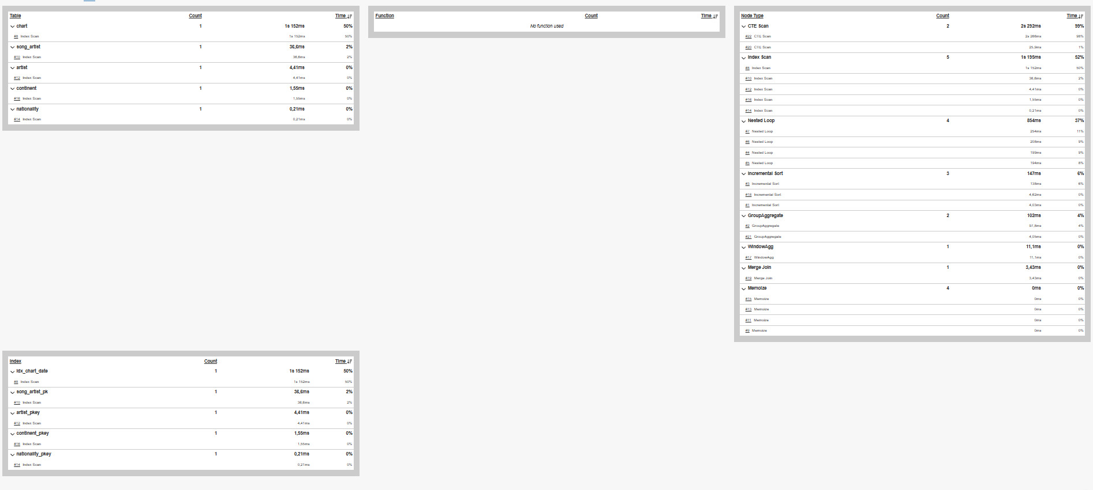
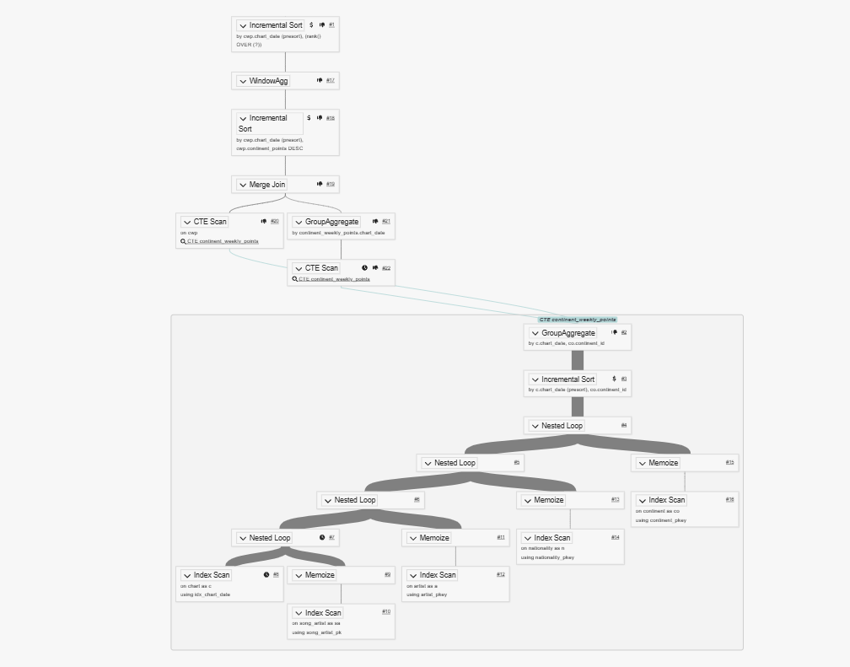

Resultado de la consulta:
