Práctica R-Markdown

Juan Manuel Martin Jiménez

## R Markdown

This is an R Markdown document. Markdown is a simple formatting syntax for authoring HTML, PDF, and MS Word documents. For more details on using R Markdown see <http://rmarkdown.rstudio.com>.

When you click the **Knit** button a document will be generated that includes both content as well as the output of any embedded R code chunks within the document. You can embed an R code chunk like this:

vv <- rep(1:20,200)  
summary (vv)

## Min. 1st Qu. Median Mean 3rd Qu. Max.   
## 1.00 5.75 10.50 10.50 15.25 20.00

boxplot(vv, main = "my vector")

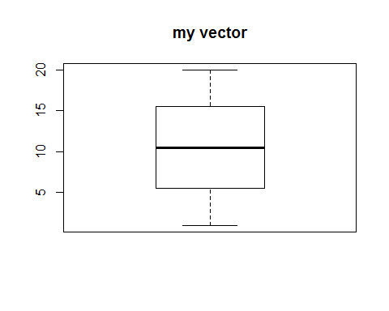

## Including Plots

*You can* ***also embed*** plots, for example:



Note that the echo = FALSE parameter was added to the code chunk to prevent printing of the R code that generated the plot.

El valor medio del listado es1

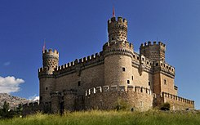

alt text

# Encabezado 1

$A=π*r^{2}$

## Encabezado 2