Channel Analyser
Next figure show the correct app where to incorporate CHANNEL_ANALYZER module.
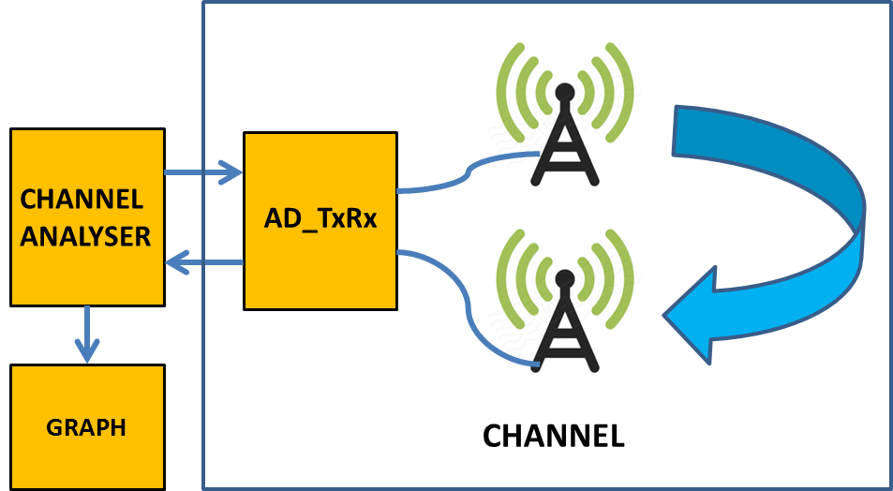
Output_0
Input_0
Output_1

Channel Analysis
This module can be configure to implement two methods to evaluate the channel frequency response. They are:
- Impulse Response (IMPULSE): It consist in sending an impulse and capture the channel response.
- Spectrum Analyzer (FREQUENCY SWEEPT. It is based in performing a frequency sweep, sending a tone that varies its frequency to the channel. By collecting the output we can determine the channel behavior from the analysis of the changes, in terms of modulus and phase, introduced in the tone sent.
By means of a “mode” parameter we should select which method will be used.
An additional parameter “modephase” allow us to select the phase values in rads or to calculate the Group Delay in seconds.
In IMPULSE mode a bypass allow to send the received signal to the GRAPH module. In FREQUENCY SWEEPT mode the Phase or Group Delay is computed and the data sent through output_1 to the GRAPH.
ANNEX A. Frequency Sweep Method 1
Algorithm Approach followed by “CHANNEL_ANALYZE” module.

cos(x)·cos(y) = [cos(x-y) + cos(x+y)]·1/2
if x = ω_{o}t and y = (ω_{o}t + φ) = ω_{o}(t – t_{o})

Then φ = -ω_{o}t_{o}

A·cos(x)·B·cos(y) = (AB/2)·[cos φ + cos(2ω_{o}t + φ)] =

= (AB/2)·cos φ + (AB/2)·cos(2ω_{o}t + φ)
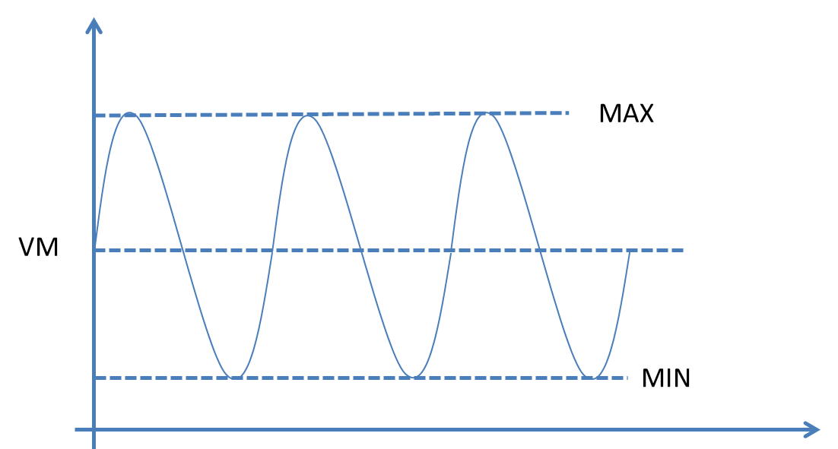

Where VM = (MAX + MIN)/2

MAX = (AB/2)·(cos φ + 1) and MIN = (AB/2)·(cos φ - 1)

Then VM = (AB/2)·cos φ

And φ = arcos[2VM/AB]

Notice that with that method we can not properly distinguish angles (0, π) from (π, 2π).
We need to take into account that the phase = φ = -ω_{o}t_{o} (with t₀ fixed for a FIR filter).
Then when we increase f_{o}, the phase describes a falling line with f starting at φ = 0 and with slope t₀ (FIR filter). The fact that the phase is moving between π and –π make the rest.

ANNEX A1. Frequency Sweep. Method 2
Algorithm Approach followed by “CHANNEL_ANALYZE” module.

Consider the transformation of the pas-band received signal B.cost(ω_{o}t + φ) onto its base-band equivalent signal.

Asuming cos(x+y) = cos(x)·cos(y) - sen(x)·sen(y)

B·cos(ω_{o}t + φ) = cos(ω_{o}t)·cos(φ) – sen(ω_{o}t)·sen(φ)

For the I channel, we multiply by cos(ω_{o}t) and obtain:
B·cos(ω_{o}t + φ) · cos(ω_{o}t)=cos²(ω_{o}t)·cos(φ) – sen(ω_{o}t)·sen(φ)·cos(ω_{o}t)=
B·cos(ω_{o}t + φ) · cos(ω_{o}t)=(1-sen²(ω_{o}t))·cos(φ) – sen(ω_{o}t)·sen(φ)·cos(ω_{o}t)=
B·cos(ω_{o}t + φ) · cos(ω_{o}t)=
= cos(φ) -sen²(ω_{o}t)·cos(φ) – sen(ω_{o}t)·sen(φ)·cos(ω_{o}t)

Computing the DC (average level) we obtain: DC_I = cos(φ);

For the Q channel, we multiply by -sen(ω_{o}t) and obtain:
B·cos(ω_{o}t + φ)·(-sen(ω_{o}t))= -sen(ω_{o}t)·cos(ω_{o}t)·cos(φ) + sen²(ω_{o}t)·sen(φ)=
B·cos(ω_{o}t + φ)·(-sen(ω_{o}t)) = -sen(ω_{o}t)·cos(ω_{o}t)·cos(φ) + (1-cos²(ω_{o}t))·sen(φ) =
B·cos(ω_{o}t + φ)·(-sen(ω_{o}t))=
= sen(φ) - sen(ω_{o}t)·cos(ω_{o}t)·cos(φ) – cos²(ω_{o}t)·sen(φ)

Computing the DC (average level) we obtain: DC_Q = sen(φ);

Then we can compute φ = arctag (DC_Q/ DC_I)
Annex B: Octave Tools
Use Octave to check the filter designed behaviour
1) Create a file (file2.txt for example) with the proper name that contains in a column the filter coefficients (floats)

2) Open a terminal a go to the folder that contains the file2.txt file.
3) Put the command "octave".
4) In the “octave” command line do:
x=load('file2.txt');
fft= fft(x, 2048);
module=10*log(abs(fft));
module=module(1:1024);
phase=atan2(imag(fft), real(fft));
phase=phase(1:1024);
f1=figure(); hold on;
f2=figure(); hold on;
figure(f1); plot(module);
figure(f2); plot(phase);

That will generate two graphs: Magnitude and Phase of the designed filter.

