namespace backendDay1

{

internal class Program

{

static void Main(string[] args)

{

//data for string interpolation

string firstName1 = "Deli";

string lastName1 = "Cruz";

int age1 = 25;

double height1 = 5.3;

bool isEnrolled1 = true;

char grade1 = 'B';

int subjects1 = 6;

int totalScore1 = 522;

//requirements

double averageScore1 = (double)totalScore1 / subjects1;

int ageIn10Years1 = age1 + 10;

double halfScore1 = totalScore1 / 2.0;

//outputs

Console.WriteLine("=== Profile 1: Deli Cruz ===");

Console.WriteLine($"Name: {firstName1} {lastName1}");

Console.WriteLine($"Age: {age1}");

Console.WriteLine($"Height: {height1} ft");

Console.WriteLine($"Currently Enrolled: {isEnrolled1}");

Console.WriteLine($"Grade Received: {grade1}");

Console.WriteLine($"Subjects Taken: {subjects1}");

Console.WriteLine($"Total Score: {totalScore1}");

Console.WriteLine($"Average Score: {averageScore1}");

Console.WriteLine($"Age after 10 years: {ageIn10Years1}");

Console.WriteLine($"Half of Total Score: {halfScore1}");

Console.WriteLine();

//data for string conctenation

string firstName2 = "Juan";

string lastName2 = "Salcedo";

int age2 = 25;

double height2 = 5.7;

bool isEnrolled2 = false;

char grade2 = 'A';

int subjects2 = 5;

int totalScore2 = 475;

double averageScore2 = (double)totalScore2 / subjects2;

int ageIn10Years2 = age2 + 10;

double halfScore2 = totalScore2 / 2.0;

Console.WriteLine("=== Profile 2: Juan Salcedo ===");

Console.WriteLine("Name: " + firstName2 + " " + lastName2);

Console.WriteLine("Age: " + age2);

Console.WriteLine("Height: " + height2 + " ft");

Console.WriteLine("Currently Enrolled: " + isEnrolled2);

Console.WriteLine("Grade Received: " + grade2);

Console.WriteLine("Subjects Taken: " + subjects2);

Console.WriteLine("Total Score: " + totalScore2);

Console.WriteLine("Average Score: " + averageScore2);

Console.WriteLine("Age after 10 years: " + ageIn10Years2);

Console.WriteLine("Half of Total Score: " + halfScore2);

}

}

}

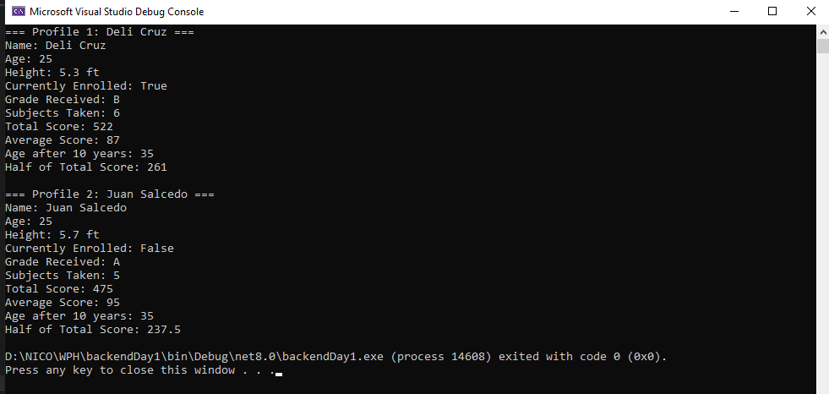

EXPLANATION:

This C# console program is a simple activity where I practiced using variables, string formatting, and basic arithmetic operations. I worked with two different profiles such as **Deli Cruz and Juan Salcedo.**

For **Deli**, I used **string interpolation** (the $"" format) to display her info, and for **Juan**, I used **string concatenation** with +. I made sure to use the correct data types like int, double, char, and bool for each variable. I also named the variables based on the information and put a number at the end for better identification which profile it is (ex. firstName1, firstname2).

I find using interpolation a little difficult because I am used to print outputs with concatenation so that was a new thing for me but overall, it is a simple and fun activity to do.

I also did 3 math operations for each person:

* Calculated their **average score**
* Added 10 years to their **age**
* Found **half of their total score**

This activity helped me get more comfortable with writing clean C# code, naming variables properly, and using different ways to display output.