**DEFINITION**

A linked list is a fundamental linear data structure in computer science, consisting of a sequence of elements called nodes, where each node stores data and a reference (link) to the next node in the sequence.

**TYPES:**

* Single linked list
* Double linked list
* Circular linked list

**IMPORTANCE | BENEFITS**

**Efficient insertion and deletions**

* Unlike arrays or List<T>, Linked list allows insertions and deletions from the beginning, middle or end (once you have a reference to the node).
* It makes ideal for scenarios where the collection size changes frequently.

**Doubly link nodes**

* Each node contains references to both the next and previous nodes.

**No shifting needed (no resizing)**

* Useful when working with large datasets or in real-time systems where performance predictability matters.

**Supports non-contiguous memory (Flexible memory use)**

* Nodes are allocated independently in memory, which can be useful in systems where contiguous memory allocation is a constraint.

**USEFUL SCENARIO**

**Browser History (Going Back and Forward on Web Pages)**

* When you use a web browser (like Chrome or Edge), you can click Back to go to the previous page, and forward to go to the next one.

**Undo and Redo Functionality in Editors (Like MS Word or VSCode)**

* When you type something and press Undo (Ctrl + Z), it brings back your last change. If you press Redo (Ctrl + Y), it puts it back again.

**Music and Video Playlist (Like Spotify or YouTube)**

* In a music or video streaming app, you can play songs or videos one after another, skip, or go back.

**SAMPLE SYNTAX**

class Program

{

static void Main()

{

// Create a linked list of strings

LinkedList<string> cities = new LinkedList<string>();

// Add elements to the list

cities.AddLast("Manila");

cities.AddLast("Quezon City");

cities.AddFirst("Davao");

cities.AddLast("Cebu");

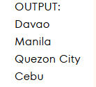 // Display the list

Console.WriteLine("Cities:");

foreach (var city in cities)

{

Console.WriteLine(city);

}

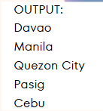 // Insert after a specific node

LinkedListNode<string> node = cities.Find("Quezon City");

if (node != null)

{

cities.AddAfter(node, "Pasig");

}

// Remove an element

cities.Remove("Davao");

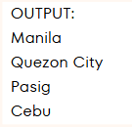 Console.WriteLine("\nUpdated Cities:");

foreach (var city in cities)

{

Console.WriteLine(city);

}

}

}

class Geeks {

static void Main()

{

// Create a new LinkedList of strings

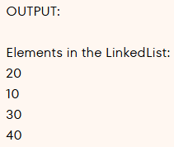 LinkedList<int> l = new LinkedList<int>();

// Adds at the end

l.AddLast(10);

// Adds at the beginning

l.AddFirst(20);

// Adds at the end

l.AddLast(30);

// Adds at the end

l.AddLast(40);

// Display the elements in the LinkedList

Console.WriteLine("Elements in the LinkedList:");

foreach(var i in l) {

Console.WriteLine(i);

}

}

}

**ADDITIONAL METHODS**

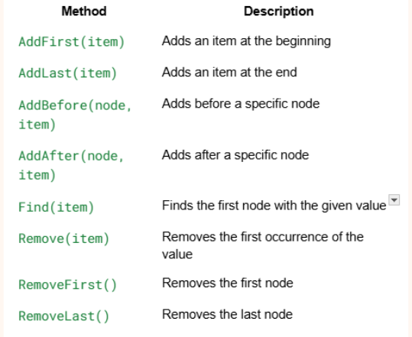

LinkedList<int> list = new LinkedList<int>();

list.AddLast(10);

list.AddLast(20);

list.AddLast(30);

var node = list.Find(20);

if (node != null)

{

node.Value = 99; // Update the value of the node

}

**REFERENCES**

[LinkedList<T> Class- Microsoft](https://learn.microsoft.com/en-us/dotnet/api/system.collections.generic.linkedlist-1?view=net-9.0)

GeeksforGeeks. (2025, July 11). C# LinkedList. GeeksforGeeks. <https://www.geeksforgeeks.org/c-sharp/linked-list-implementation-in-c-sharp/>

Dotnet-Bot. (n.d.). LinkedList Class (System.Collections.Generic). Microsoft Learn. https://learn.microsoft.com/en-us/dotnet/api/system.collections.generic.linkedlist-1?view=net-9.0

**MEMBERS & CONTRIBUTIONS**

MARMITO – Provided information & references

NICOLAS – PPT, Presenter, & provided information

PAMPILON - Presenter, & provided information

RABARA - Presenter, & provided information

SILDORA - Presenter, & provided information