Designing for the Absent Grid: Simultaneous Synthesis, Sizing and Seasonal Operation of an Off-Grid Pineapple Whole-Plant Biorefinery in Bajo Atrato, Colombia
Nov 6, 2026 · @JuanMurciaPala
Thesis draft, version 2 (expanded), built on version 12 of the models and on the text of the 222-page manuscript.

Front Matter
Degree, programme, institution, supervisors, date: [to be completed by the author].

Abstract
The department of Chocó, Colombia, produces about 6,146 t/year of pineapple in a non-interconnected zone, where electricity comes from diesel gensets and fruit arrives in two harvest peaks. This thesis asks whether one model that decides process synthesis, equipment sizing and seasonal operation together finds better whole-plant biorefinery designs for such a site than sequential design by fractions.
The design problem is written as a generalized disjunctive program over a superstructure of the four fruit fractions (pulp, peel, core and crown) and of the plant leaves left at crop renewal, with 23 processing steps and 152 catalogue options. Economies of scale, capacity–time products, winery sizing by Moresi's procedure, vinegar blending and market demand are reformulated exactly as a mixed-integer linear program with 177 binary variables over 24 continuous-time periods per year. Fermentation kinetics and pooled streams stay in calibrated satellite models; the cost of that hierarchy is measured at 7.1–9.0 % of the fermentation-train cost, and a shared sugar hub is tested and rejected. The designs are evaluated by a techno-economic assessment verified in spreadsheets, a cradle-to-gate life-cycle assessment against a no-plant baseline, social indicators, correlated Monte Carlo sampling, a two-stage stochastic program and an ε-constraint front.
With bottled wine taxed under Law 1816 of 2016 and market caps of 500,000 bottles and 3,000 m³ of vinegar per year, the optimal plant processes 1,276 t/year of fruit (20.8 % of the supply) and 3,746 t/year of leaves. It sells wine, vinegar fermented from peel and leaf juices with panela, and fibre flour, for an annual margin of 3,164 MM COP, certified within 1.5 % of the optimum, and a net present value of 5,273 MM COP (MIRR 13.4 %, P(NPV > 0) = 0.78). Designing the same superstructure fraction by fraction gives an NPV of only 27 MM COP.
Viability is judged by NPV, not by margin, and it depends on markets. The plant needs about 890,000 bottles a year without vinegar, or no more than about 1,950 m³ of vinegar with 500,000 bottles and about 2,600 m³ with 250,000 bottles. A plant that makes vinegar alone needs no more than about 2,750 m³; at 3,000 m³ its NPV is 1,393 MM COP. That vinegar plant is also the best design found if the wine excise rises to the rates of the emergency decree of December 2025, which the Constitutional Court struck down. Those rates roughly tripled the specific component, and under them wine stops paying.
The ethanol yield of leaf juice rests on one source whose mass balance does not close. It is set at 90 % of its stoichiometric maximum, with a range down to the value compatible with the source's yeast yield. Across that range the design does not change, the NPV of the optimum stays between 3,857 and 5,273 MM COP, and the vinegar plant remains viable at least down to about 8 kg of ethanol per tonne of juice.
Against a site where fruit and leaves decompose, the optimum emits 121–558 t CO₂e/year more over the plausible range of the decomposition factor, and 853–1,166 t more if the leaves would otherwise be burned. A design that burns leaf pulp in a biomass boiler reaches net zero for 83 MM COP/year. It does so only for a factor at or above the central value and with credit for the 1,162 t of extra fruit it buys.
Linking the plant model to yeast kinetics, the fermentation train, an hourly weekly schedule and leaf collection shows that the value of integration lies inside the plant scale. The sugar hub, gasification, bromelain and ethanol are not selected. For Bajo Atrato the conditions of the project are now three: validating the vinegar market, measuring the leaf-juice fermentation and securing the fiscal treatment of fruit wine. Developing technology is not among them.
Keywords: process systems engineering; superstructure optimization; generalized disjunctive programming; simultaneous design and scheduling; pineapple biorefinery; non-interconnected zones; techno-economic assessment; life-cycle assessment; stochastic programming.

Resumen
El Chocó produce unas 6 146 t/año de piña en una zona no interconectada, donde la electricidad viene de grupos diésel y la fruta llega en dos picos de cosecha. Esta tesis pregunta si un solo modelo que decide a la vez la síntesis del proceso, el tamaño de los equipos y la operación estacional encuentra mejores diseños de biorrefinería de planta completa que el diseño secuencial por fracciones.
El problema se escribe como un programa disyuntivo generalizado sobre una superestructura de las cuatro fracciones de la fruta y de las hojas de la renovación del cultivo, con 23 pasos y 152 opciones de catálogo, y se reformula de forma exacta como un MILP con 177 variables binarias y 24 periodos de tiempo continuo por año. La cinética de las fermentaciones queda en modelos satélite calibrados; el costo de esa jerarquía se mide (7,1–9,0 % del costo del tren de fermentación), y el hub de azúcares se prueba y se descarta. Los diseños se evalúan con TEA verificado en hojas de cálculo, ACV de la cuna a la puerta contra una línea base sin planta, indicadores sociales, Monte Carlo correlacionado, programa estocástico en dos etapas y frente de Pareto por ε-restricción.
Con el vino embotellado y su impuesto al consumo (Ley 1816 de 2016), y con topes de mercado de 500 000 botellas y 3 000 m³ de vinagre al año, el óptimo procesa 1 276 t/año de fruta y 3 746 t/año de hojas. Vende vino, vinagre de jugos de cáscara y de hojas con panela y harina de fibra. Da un margen de 3 164 MM COP/año, certificado dentro del 1,5 % del óptimo, y un VPN de 5 273 MM COP (TIRM 13,4 %; P(VPN > 0) = 0,78). Diseñar la misma superestructura fracción por fracción deja un VPN de solo 27 MM COP.
La viabilidad se juzga por el VPN y depende del mercado. Hacen falta unas 890 000 botellas sin vinagre, o no más de unos 1 950 m³ de vinagre con 500 000 botellas y unos 2 600 m³ con 250 000. Una planta solo de vinagre necesita no más de unos 2 750 m³; a 3 000 m³ su VPN es de 1 393 MM COP. Esa planta de vinagre es también el mejor diseño hallado si el impuesto al vino sube a las tarifas del decreto de emergencia de diciembre de 2025, que la Corte declaró inexequible. Esas tarifas aproximadamente triplicaban el componente específico, y con ellas el vino deja de pagar.
El rendimiento en etanol del jugo de hoja se apoya en una sola fuente cuyo balance no cierra. Se fija en el 90 % de su máximo estequiométrico, con un rango que baja hasta el valor compatible con la levadura que reporta la fuente. En todo ese rango el diseño no cambia, el VPN del óptimo queda entre 3 857 y 5 273 MM COP y la planta de vinagre sigue siendo viable al menos hasta unos 8 kg de etanol por tonelada de jugo.
Frente a un sitio donde la fruta y las hojas se descomponen, el óptimo emite entre 121 y 558 t CO₂e/año más según el factor de descomposición, y entre 853 y 1 166 t más si las hojas se quemaran. Un diseño que quema pulpa de hoja en una caldera de biomasa alcanza emisión neta nula por 83 MM COP/año, pero solo con un factor igual o mayor al central y con el crédito de las 1 162 t de fruta adicional que compra.
El valor de integrar queda dentro de la escala de planta. Ni el hub de azúcares, ni la gasificación, ni la bromelaína, ni el etanol entran. Validar el mercado del vinagre, medir la fermentación del jugo de hoja y asegurar el tratamiento fiscal del vino de fruta, no desarrollar tecnología, son ahora las condiciones del proyecto.
Palabras clave: ingeniería de sistemas de procesos; optimización de superestructuras; programación disyuntiva generalizada; diseño y programación simultáneos; biorrefinería de piña; zonas no interconectadas; evaluación técnico-económica; análisis de ciclo de vida; programación estocástica.

Acknowledgements
[To be written by the author.]

Abbreviations
Abbreviation | Meaning
COD | Chemical oxygen demand
COP; MM COP | Colombian peso; million Colombian pesos
CVaR | Conditional value at risk
EEV, EV, RP, WS | Expected result of the mean-value solution; mean-value problem; recourse (stochastic) problem; wait-and-see
EVPI, VSS | Expected value of perfect information; value of the stochastic solution
FCI | Fixed-capital investment
GDP | Generalized disjunctive programming
GWP | Global warming potential (100 years, IPCC AR6)
HTST | High-temperature short-time (flash) pasteurization
LCA, TEA | Life-cycle assessment; techno-economic assessment
LPG | Liquefied petroleum gas
MF, UF | Microfiltration; ultrafiltration
MILP, MINLP, NLP | Mixed-integer linear, mixed-integer nonlinear, nonlinear program
MIRR, NPV | Modified internal rate of return; net present value
PSE | Process systems engineering
TRL | Technology readiness level
UHPH | Ultra-high-pressure homogenization
UVT | Tax value unit (Unidad de Valor Tributario)
ZNI | Non-interconnected zone (Zona No Interconectada)
ZOMAC | Municipalities most affected by the armed conflict
[T], [C], [L], [S] | Provenance tags: thesis datum, Corsano datum, literature, assumption

Nomenclature
Symbol | Meaning | Unit
u, s, t, m | Processing step, catalogue entry, period, month | —
y_us, y³, w_t | Size choice, third shift, direct-filling mode (binary) | —
n_t | Press changeovers in period t (integer) | —
d_t, H̄_t | Length of period t; its upper bound | h
g_ust, h_ut | Hours of size s of unit u; operating hours of unit u | h
cap_us, C_us | Capacity and purchase cost of catalogue entry s of unit u | unit/h; COP
F_ut | Flow processed by unit u in period t | t or m³
I_kt | Inventory of intermediate k at the boundary of period t | t or m³
W_t, J^c_t, J^h_t, Z_t, A_t | Wine diverted, peel and leaf juice to vinegar, panela, acid | m³, t, t, t, kg
N_F, V_F, t_proc, Q | Number and volume of fermenters, processing time, must flow | —, m³, h, m³/h
τ_max | Maximum direct filling time | h
AF | Annual capital charge per unit of purchase cost | 1/year
a₂, a₃, a_c | Availability of staffed units (two, three shifts) and continuous units | —
D_vin, D_wine | Vinegar and wine demand caps | m³/year
ε | Bound of the ε-constraint (GWP or fossil utilities) | t CO₂e/year; MWh/year
λ, β | CVaR weight; CVaR confidence level | —
Figure numbers in this draft refer to the figures of the models report (figs. 1–47) until the final layout; the exhibits drawn in the draft are inserted at its end.

Chapter 1. Introduction
When the grid is absent and fruit arrives by seasons, a whole-plant biorefinery can only be designed well if the synthesis of its network, the size of its equipment and its operation through the year are decided in one model. Solved that way, the case of Bajo Atrato shows that the value of such a plant lies not in a shared sugar hub but in wine, in vinegar made from residue juices with added sugar, and in a small amount of fibre flour, and that its size and viability are set by two markets that have yet to be measured. This chapter states the problem, positions it in the literature, and sets out the research question, the hypotheses, the objectives and the contributions.

1.1 Designing for the Absent Grid: Off-Grid Siting and Seasonal Supply in Bajo Atrato

1.1.1 The pineapple value chain and whole-plant valorization
Pineapple (Ananas comosus) is among the most important tropical fruits, with world production above 25 million tonnes a year in more than 80 countries (Hossain et al., 2016 [verify authorship]). Its global markets have concentrated around varietal change, retailer standards and logistics, while the benefits remain unevenly spread along the chain from smallholder to exporter (Bairwa et al., 2025). Value concentrates downstream while biomass and risk concentrate upstream. This thesis argues that the asymmetry can be partly corrected at the scale of a processing plant through whole-plant valorization.
Industrial processing of pineapple remains mostly single-product: pulp is pressed for juice or canned, and processing leaves around 60 % of the fruit's weight as peel, core, stem and crown, which is routinely discarded (Aili Hamzah et al., 2021; Sarangi et al., 2022; Campos et al., 2020). Pineapple production in Colombia leaves on the order of 185,000 t/year of peel, pulp, stem and leaf waste (Celis Cabeza et al., 2024 [verify authorship]). The fraction carrying the most immediately saleable product, the fermentable sugar of the pulp, is extracted, while the fractions that carry an enzyme (bromelain), phenolics, dietary fibre and lignocellulose are treated as waste (Sarangi et al., 2023).
The pattern is neither a technological accident nor a simple market failure; it is a failure of design method. Process design has historically been sequential: a target product is chosen, a flowsheet is built to make it at minimum cost, and only the residual streams that flowsheet cannot avoid are considered afterwards. Whole-plant valorization inverts the sequence. It starts from the full composition of the feedstock and lets each fraction compete for the products and the shared equipment for which it has most value, a cascade in which higher-value, lower-volume products are recovered before residual streams go to higher-volume, lower-value platforms (Nath et al., 2023; Louw et al., 2023; Mansoornejad et al., 2010). Bench-scale studies have shown integrated sequences on pineapple waste, such as bromelain recovery followed by sugar-platform fermentation (Banerjee et al., 2021) or bioethanol with bromelain extraction (Seguí and Fito, 2018). A bibliometric review of nearly 8,000 pineapple documents found research concentrated on chemistry, food technology and the clinical properties of bromelain, with little on rural extension or technology transfer (Villalobos et al., 2023); process integration and systems-level design do not appear among its dominant topics, an inference from its keyword map rather than a finding it states. That absence is the gap this thesis addresses from the side of process systems engineering.

1.1.2 The absent grid
Colombia's electricity system separates the interconnected grid (SIN) from the Zonas No Interconectadas (ZNI), which cover about half of the country's land but a small share of its population and have historically depended on costly and unreliable diesel generation (Bustos et al., 2014 [not verified]). Around 1.9 million Colombians, all in rural areas, still lacked electricity in 2020, and a decade of subsidies and regulation has struggled to move ZNI communities off diesel (Garces et al., 2021). System-dynamics modelling shows that a transition from diesel to renewables in the ZNI is technically and economically viable, and that it should start as soon as possible with a zero-diesel policy by 2040 (Garces et al., 2023). Hybrid photovoltaic–wind–diesel systems have been assessed for Colombian off-grid villages (Haghighat Mamaghani et al., 2016), and a fuzzy-AHP framework for non-interconnected areas of the Caribbean region ranked solar photovoltaics first among six renewables, with all six within five percentage points of each other (Moreno et al., 2022).
Bajo Atrato, in Chocó, lies in a ZNI: agro-industrially promising, with pineapple already grown, but without a firm, low-cost electricity supply. Most biorefinery techno-economic studies assume grid connection. For a site like this that assumption is a hidden boundary condition: it excludes most of rural Chocó before any design is attempted. Designing for the absence of the grid changes which configurations are feasible and what they cost: electricity comes from a diesel genset at about 1,400 COP/kWh, heat from LPG, and surplus power from residues has no buyer.
The earlier formulation of this thesis treated the off-grid condition as a hard design driver, an energy island fed by gasification of leaves and crown with diesel only as backup for aerated fermentation. This thesis keeps the condition as a driver but lets the optimization decide how to meet it: diesel and LPG remain purchasable, and a crown boiler, a gasifier with engine, and a digester with biogas engine compete to replace them. Whether full autonomy is affordable becomes a question the model answers (hypothesis H2), not an assumption it starts from.

1.1.3 The seasonal harvest
The second driver is seasonality. The municipal agricultural evaluations of 2022 record 1,039 ha planted, 888 ha harvested and 6,146 t of pineapple in Chocó, with two harvest peaks (April–May and September–November) and a trough in February (Section 2.1). Fruit reaches Quibdó by river without refrigeration, and after two to three days a share of it fails the grade and is discarded; in one municipality about 12 t/month of reject fruit went to the open-air dump (Murcia Palacios, 2013). Fruit and its fractions keep only a few days. Seasonality therefore passes directly to the equipment: a unit sized for the annual average saturates in the peak months and loses fruit, and a unit sized for the peak sits idle most of the year. The earlier formulation sized the plant on an annual average and left multi-period scheduling out of scope; this thesis brings the seasonal calendar inside the design problem.

1.2 Problem Statement: Whole-Plant Valorization of Pineapple Reject Fruit and Plant Residues

1.2.1 Statement
The problem is stated in the usual form of process systems engineering:
- Given the seasonal supply of reject fruit in Chocó, the leaves left in the field at crop renewal, product and input prices and markets, a catalogue of technologies with their maturity (TRL), and the conditions of a ZNI (diesel electricity, no export of surplus power);
- determine which feedstocks to process, which products to make, which technology to use at each step, the size of each unit, the operation of the plant period by period through the year, and where to collect the leaves;
- so as to maximize the annual margin and then the net present value, subject to mass and energy balances, catalogue capacities, the shift calendar, the perishability of the fractions, limited storage and market demand, with environmental and social performance evaluated on the same balance.
Three features of the case make this a systems problem rather than a sequence of unit designs. The fractions of the same fruit compete for the same equipment and utilities. Seasonality makes the right size of each unit depend on what happens upstream and downstream in every month. And in a ZNI the energy balance decides which routes are viable, which only becomes visible when the whole plant is modelled.

1.2.2 Literatures that each see part of the problem
Existing work addresses parts of this problem, each from a different tradition. The bromelain literature compares recovery routes, for instance ultrafiltration against aqueous biphasic extraction (Simões et al., 2021) or an optimized polysaccharide precipitation (Campos et al., 2019), treating the enzyme as the product; with exceptions such as the fermentation of UF permeate to ethanol (Seguí and Fito, 2018), it is largely silent on what happens to the other streams. Fruit-residue gasification for off-grid power is documented from olive mills in Morocco to rural mini-grids in India (Sánchez-Lozano et al., 2023; Chambon et al., 2020), from an energy-systems perspective in which the downstream product question does not arise. Superstructure synthesis with economic and environmental objectives is mature in process systems engineering, with NPV and GWP optimized jointly for gasification-based hydrocarbon biorefineries (Wang et al., 2013) and yield, cost and waste optimized in turn for multi-product lignocellulosic biorefineries (Zondervan et al., 2011), but it usually treats the feedstock and product slate as a case-study detail (with exceptions such as Kenkel et al., 2022).
What is missing is the combination: a whole-plant pineapple superstructure, under off-grid conditions treated as part of the design, with sizing and seasonal operation decided simultaneously with synthesis, and with uncertainty treated with the precision the decisions require. The absence has two costs. Because biorefinery TEA assumes grid access, sites like rural Chocó never enter the feasible set. And because sequential design fixes each line before the next is sized, it cannot see the trade-offs between lines that share equipment, utilities and markets; it returns a solution no better, and in a nonconvex system possibly worse, than the simultaneous one. The claim of novelty is one of combination: no individual technical component of this thesis is claimed to be new in isolation.

1.2.3 Why simultaneous design and operation, and why the core is an MILP
A superstructure embeds every candidate configuration in one network, with binary variables activating units and technologies and continuous variables governing flows and operating conditions; optimizing over it selects the configuration and its operation together instead of fixing the configuration by judgment first. The systematic representation through state-task and state-equipment networks, formalized as a generalized disjunctive program and reformulated as an MILP or MINLP, traces to Yeomans and Grossmann (1999).
The earlier formulation argued that the problem had to be an MINLP, because a shared sugar hub whose concentration depends on what is mixed is a bilinear pooling problem (Quesada and Grossmann, 1995; Misener and Floudas, 2009). That argument was correct for the hub as formulated, and it made the problem unsolvable at full scale. This thesis keeps the simultaneous philosophy and changes the formulation. Most nonlinearities of the design problem (economies of scale, capacity–time products, winery sizing and product blending) can be reformulated exactly as an MILP once equipment is chosen from catalogues, and the truly nonconvex parts (fermentation kinetics and pooling) can be kept in satellite models whose error is measured and whose need is tested (Section 3.1). The hub is then a candidate the model can reject, and it does. The price is that kinetics are fixed before sizing; the benefit is that seasonal operation, which the MINLP had to leave out, enters the design problem, and that the model can be solved repeatedly across scales, prices, markets and scenarios.

1.3 Background and Research Gap
This section condenses the literature the thesis builds on into four strands and ends with a positioning table. The extended review of the earlier manuscript (its sections 2.1 to 2.9), with every citation checked against its source, moves to Appendix C. Each later chapter opens with the specific literature it uses.

1.3.1 Pineapple biorefineries and their products
Fractions and products. Reviews of pineapple waste agree on the products each fraction can carry and on the variability of their composition (Aili Hamzah et al., 2021; Sarangi et al., 2022; Nath et al., 2023). Pulp juice is the default feedstock for juice, wine and vinegar, because its sugar is directly fermentable (Huang et al., 2021). Pineapple wines reach 7–8 % v/v with commercial S. cerevisiae, with aroma shaped by strain and temperature (Roda et al., 2017b), and reject Chocó fruit fermented at 30 °C reached 65.31 g/L of ethanol in 12.5 h (Murcia Palacios, 2013). Peel and stem give a juice and a fibre-rich cake that can be dried into a flour with antioxidant phenolics (Campos et al., 2020; Huang et al., 2020). Core and stem carry bromelain, whose ranking among fractions changes with cultivar and protocol (Banerjee et al., 2021; Chiarelli et al., 2024; Misran et al., 2022); it is recovered by polysaccharide precipitation (Campos et al., 2019), by ultrafiltration (Nor et al., 2016; 2018) or by aqueous two-phase systems (Simões et al., 2021). Peel juice ferments to ethanol at 0.23–0.43 g/g, and bromelain and ethanol can be recovered in one integrated sequence (Seguí and Fito, 2018). Pineapple-waste wines have been acetified to 5 % vinegar (Roda et al., 2017a), and adding sugar to peel juice before fermentation is a documented practice (Tanamool et al., 2020, cited by Ebrahimi, 2026).
Leaves. Pineapple leaves, a field residue of crop renewal usually burned or left to decompose, have recently been studied as a feedstock in their own right: their pressed juice for ethanol and yeast (Chen et al., 2020), techno-economic and life-cycle assessment of leaf routes (Liao et al., 2022), and a circular bioenergy strategy for the Costa Rican pineapple industry with anaerobic digestion of leaf juice (Liao et al., 2026).
Sugar-platform products. Citric acid, xanthan and ethanol are established fermentation products on molasses and glucose, and have been studied on pineapple residue at bench scale (Kareem et al., 2010; Amenaghawon et al., 2024). The xanthan yield on pineapple residue is about a seventh of the yield on glucose (Rashidi et al., 2024, cited by Iakovchenko, 2026), and organic-acid recovery adds downstream cost (Ahamed and Li, 2026).
What is missing. These studies optimize one fraction or one sequence at bench or pilot scale. They do not decide which of these routes survive when the fractions share presses, fermenters, utilities and markets in one plant, nor how large each unit should be when supply is seasonal.

1.3.2 Superstructure synthesis and simultaneous design and scheduling in PSE
Superstructures as disjunctive programs. Superstructure synthesis represents every candidate configuration in one network and chooses among them by mathematical programming. State-task and state-equipment networks, formalized as generalized disjunctive programs and reformulated as MILP or MINLP, go back to Yeomans and Grossmann (1999). The reformulation of disjunctions by big-M constraints is compact but weak when M is loose, while the convex hull is at least as tight but larger (Grossmann, 2021, chs. 7 and 10); for disjunctions whose terms fix the variables, as catalogue choices do, the hull is exact and small.
Pooling. When a shared stream mixes sources whose properties matter downstream, its property balance is bilinear: the pooling problem. Its global optimization was established for multicomponent process networks by Quesada and Grossmann (1995) and reviewed across its sub-classes by Misener and Floudas (2009); generalized pooling has been solved within a verified 1.2 % gap by piecewise reformulation (Meyer and Floudas, 2006), and multiperiod versions by discretization (Kolodziej et al., 2013) or by global solvers on a tighter MINLP (Castro, 2015a). The earlier formulation of this thesis was built around such a hub.
Economic–environmental synthesis. Superstructure syntheses have optimized NPV and GWP together by ε-constraint: for gasification-based hydrocarbon biorefineries (Wang et al., 2013), algal carbon-sequestration networks (Gong and You, 2014), agave-bagasse biorefineries with a social criterion (Álvarez del Castillo-Romo et al., 2018), distributed multiproduct biorefineries as multiperiod MILPs (Santibáñez-Aguilar et al., 2014), and power- and biomass-to-methanol with multi-criteria assessment (Kenkel et al., 2022). Product-portfolio selection by value density has a parallel lineage in forest biorefineries (Sammons et al., 2008; Mansoornejad et al., 2010; Dansereau et al., 2014), synthesized recently by Louw et al. (2023). Systematic biorefinery synthesis frameworks organize alternatives in processing steps and intervals and add design, simulation and innovation stages (Bertran, Tula and Gani, 2022).
Fermentation trains and wineries. For batch fermentation, Corsano and co-workers showed that kinetics, cycle times, inoculum and equipment should be optimized simultaneously, as nonlinear superstructures without binaries (Corsano et al., 2004; 2006a), with vinasse recycle and environmental constraints (2006b), with mixed-product campaigns (2007), and comparing multiplant and multiproduct structures (2009). Moresi (1989a; 1989b) gave a procedure for sizing staggered batch wineries from fermentation kinetics.
Scheduling. Production scheduling with continuous-time and discrete-time MILP formulations, shared resources, storage limits and changeovers is mature (Maravelias, 2021). Its coupling with design is well studied for batch plants, but rarely for agro-industrial biorefineries: synthesis studies use annual average flows, and scheduling studies take the flowsheet as given.
What is missing. No study found combines catalogue sizing, technology choice and the seasonal operation of a whole-plant fruit biorefinery in one model, and none tests whether a shared hub is worth its nonconvexity before building it into the formulation.

1.3.3 Sustainability assessment of biorefineries under uncertainty
TEA. Biorefinery TEA is built on discounted cash flow with NPV, IRR, payback and minimum selling price (Scown et al., 2021). Reviews find large variability among published TEAs, with capital and feedstock cost as dominant drivers (Louw et al., 2023), and early capital estimates for novel biorefinery equipment that can diverge widely between heuristics (Tsagkari et al., 2016).
LCA. Under ISO 14040/14044, biorefinery LCAs differ in system boundary, allocation and functional unit enough to make published results mutually incomparable (Ahlgren et al., 2015). Of 59 biorefinery LCAs reviewed recently, only 28 % used primary data and 39 % performed no uncertainty or sensitivity analysis (Gaffey et al., 2024). Residue-based systems more often omit upstream agricultural impacts, a choice that must be stated (Saraiva, 2017).
Uncertainty. Two-stage stochastic programming chooses a design before uncertainty is resolved and reports the value of the stochastic solution and of perfect information (Grossmann, 2021, ch. 14), and risk measures such as the conditional value at risk express aversion to bad scenarios (Rockafellar and Uryasev, 2000). Flexibility analysis asks a different question, whether a fixed design can be operated feasibly over a range of parameters (Halemane and Grossmann, 1983; Swaney and Grossmann, 1985). Multi-objective methods and multi-criteria selection are reviewed by Marler and Arora (2010), Mavrotas (2009) and Kim and de Weck (2005).
Off-grid bioenergy. Downdraft gasification with engines serves small distributed power (Martínez et al., 2012), with cleanup demands that are well documented (Rios et al., 2017; Cortazar et al., 2023), and has been assessed for off-grid fruit residues and rural mini-grids (Chambon et al., 2020; Sánchez-Lozano et al., 2023; Indrawan et al., 2020; Ribó-Pérez et al., 2021), usually sizing the energy system after the product portfolio is fixed.
What is missing. Three weaknesses recur when these methods are applied to small agro-industrial plants: the production assumed in the TEA is the nominal capacity rather than what the plant processes through the seasons; the LCA reports what the plant emits rather than what it changes relative to the site without a plant; and markets are treated as unlimited at fixed prices.

1.3.4 Differentiation and positioning
Dimension | Typical pineapple-processing studies | Typical superstructure biorefinery studies | This thesis
Feedstock scope | One fraction; by-products treated separately (Sarangi et al., 2022) | Whole feedstock, not pineapple (Zondervan et al., 2011) | Four fruit fractions plus plant leaves, jointly optimized
Energy supply | Grid assumed or unspecified | Occasionally off-grid, sized after process design (Chambon et al., 2020) | ZNI conditions inside the design: diesel, LPG, boiler, gasifier, digester compete; autonomy tested as a constraint
Shared intermediate streams | Not applicable | Pooling linearized or absent (Misener and Floudas, 2009) | Hub kept as a tested alternative; rejected by the optimization and by a dedicated pooling model
Sizing and operation | Nominal capacity | Annual average flows | Catalogue sizing and 24-period seasonal operation in one MILP, with Moresi's winery and a filling rule
Kinetics | Bench data | Fixed yields | Calibrated satellite models; cost of the hierarchy measured (7.1–9.0 %)
Markets | Unlimited at a fixed price | Unlimited at a fixed price | Demand caps and excise tax inside the model; swept as the main uncertainty
Uncertainty | Rare, one parameter at a time | Stochastic or robust, rarely distinguished | Tornado, correlated Monte Carlo, Sobol with reoptimization, two-stage stochastic with CVaR, flexibility formulated
Environmental and social assessment | Rare | A GWP objective without full LCA (Wang et al., 2013) | LCA with a no-plant baseline and effluents; social indicators; ε-constraint front
Verification | Rare | Rarely reported | Registry tests, Python–Excel TEA, balance closure, simulator package, certified subproblems
The claimed novelty is this combination, not any element in isolation: bromelain ultrafiltration, catalogue disjunctions, Moresi's procedure, the ε-constraint method and two-stage stochastic programming are each credited to their literatures. What has not been done, to the best of this review's knowledge, is to assemble them into one simultaneous design-and-operation problem for a whole-plant fruit biorefinery under off-grid conditions, and to let that problem decide which of the routes the literature proposes are worth building.

1.4 Research Question, Hypotheses and Objectives

1.4.1 Research question
Can a simultaneous formulation of synthesis, sizing and seasonal operation of a whole-plant pineapple biorefinery in an off-grid zone identify configurations that are more profitable than sequential design by fractions, with non-trivial economic–environmental trade-offs, and how sensitive are they to supply, demand and uncertainty?
The question reformulates that of the earlier manuscript, which asked whether a simultaneous MINLP with a shared sugar hub under a hard energy-autonomy constraint beats a sequential single-fraction baseline. The reformulation keeps the comparison of simultaneous against sequential design, the off-grid site and the trade-offs, and changes two things: the hub becomes one alternative among others rather than the organizing structure, and seasonal operation and markets enter the question because the results show they decide the answer.

1.4.2 Hypotheses
 | Hypothesis | Earlier formulation | Tested in
H1 | Simultaneous synthesis, sizing and operation outperforms sequential design by fractions, with or without a sugar hub | A whole-plant superstructure with a shared hub yields a higher NPV than the sum of independently optimized lines (after Kong et al., 2016) | Sections 2.8, 3.12.1, 5.9.1, 5.10
H2 | Requiring energy autonomy (no diesel, no LPG) has a measurable cost in margin and portfolio | The autonomy constraint is binding, quantified by a flexibility index | Sections 3.12.2, 4.6, 5.9.3, 5.10
H3 | The margin–GWP front is non-dominated and non-degenerate, with GWP measured against a no-plant baseline | The NPV–GWP front is non-dominated and non-degenerate (after Wang et al., 2013; Gong and You, 2014) | Sections 3.12.3, 4.7, 5.9.4, 5.10
H4 (new) | With the current supply, viability depends more on the demand and price of the main products than on technology | — | Sections 3.12.4, 5.4, 5.9.2, 5.10
H1 and H3 are kept in substance. H2 is reworded because the reference model admits diesel and LPG, so autonomy becomes a constraint to test rather than an assumption. H4 is added because the results point there.

1.4.3 Objectives
General objective. To design and optimize a whole-plant pineapple biorefinery for Bajo Atrato by simultaneous synthesis, sizing and seasonal operation, and to evaluate it economically, environmentally and socially under uncertainty.
Specific objectives.
- Characterize the feedstocks of Bajo Atrato (fruit fractions and plant leaves), their seasonal supply and logistics, and the candidate technologies with their maturity, in a parameter registry with provenance (Chapter 2).
- Calibrate and verify the unit and fermentation-train models, and measure the cost of the hierarchical decisions the plant-level model imposes (Chapter 2).
- Formulate the simultaneous synthesis, sizing and seasonal operation problem as an exact MILP reformulation of a generalized disjunctive program, and solve and verify it (Chapter 3).
- Evaluate the designs by TEA, LCA against a no-plant baseline and social indicators, under parametric, stochastic and multi-objective uncertainty (Chapter 4).
- Determine the optimal biorefinery for Bajo Atrato, its balances, layout and schedule, the conditions under which it is viable, and test hypotheses H1–H4 (Chapter 5).
- Derive design rules, policy implications for non-interconnected zones and the data needed to close the remaining assumptions (Chapter 6).

1.5 Scope and System Boundaries
- Case and scale. The design case is the reject fruit of Chocó at the 2022 supply (6,146 t/year) plus the leaves of crop renewal. The original design basis, 78,300 hL/year of wine, needs about 21,856 t/year of fruit, 3.6 times the department's production; it is kept as the upper end of the scale sweep.
- System boundary. From fruit and leaves at the farm to products at the plant gate. Reject fruit is bought at a price (400 COP/kg [S]) rather than entering burden-free, because in Chocó it is whole fruit that fails the fresh-market grade, not the residue of an existing processor; leaves enter with their collection cost. Cultivation burdens are not allocated to the plant. Packaging enters only as the wine bottle; distribution and use are outside.
- Technology. The reference design uses only TRL-9 technologies; lower-TRL routes enter the superstructure as flagged alternatives.
- Time. The plant is designed with 24 periods of free length per year anchored to the months; weekly execution is checked with a scheduling model; the cash flow covers ten years from start-up in 2030. Staged investment over time is outside scope.
- Objective. The MILP maximizes an annual margin with an annualized capital charge; NPV, risk, environmental and social indicators are computed afterwards on the chosen designs.
- Quality. Must turbidity, stuck-fermentation risk and sensory quality are discussed, not optimized.
- Geography. The design is not claimed to transfer to other regions without re-parameterizing the registry; the method is.
The earlier manuscript described itself as a design-and-methodology study that specified protocols without an end-to-end solution. This thesis reports solved models, and states where evidence is still missing: the flexibility index for H2, the process-simulator run and the reconciliation with the reduced MINLP instance.

1.6 Contributions
 | Contribution | Where
C1 | A whole-plant superstructure with four fruit fractions, plant leaves as a second feedstock, crown as fuel, and the must-treatment alternatives of modern white-wine technology | Chapters 2 and 3
C2 | Energy coupled to the superstructure in a ZNI: crown boiler, seasonal electricity and heat balances, biogas without export, gasification as a screened alternative, autonomy as a testable constraint | Sections 2.7 and 3.6
C3 | The sugar hub as a tested and rejected alternative: when vinasse recycle pays, and why the hub is not chosen in Bajo Atrato | Sections 2.8.5, 3.1.3 and 6.2
C4 | Market and supply risk (two-stage stochastic, CVaR) treated separately from energy feasibility (flexibility) | Sections 4.5 and 4.6
C5 | TEA verified in spreadsheets, LCA with a no-plant baseline and effluent treatment, and social indicators, on one balance | Chapter 4
C6 | Central: an MILP for simultaneous design and annual operation, with catalogue disjunctions, exact size × hours products, Moresi's winery in linear form with a filling-time rule, perishable buffers, blending, added sugar and market demand | Chapter 3
C7 | The cost of hierarchical design and the kinetics–design coupling, with identifiability, quantified | Sections 2.5 and 2.8
C8 | A parameter registry with provenance and automated consistency tests as a reproducible protocol, with version-by-version decomposition of the effect of new data | Sections 2.4 and 3.11

1.7 Thesis Outline
Chapter 2 presents the case of Bajo Atrato, the feedstock data, the technologies and their maturity, the parameter registry, the fermentation models and the unit models, and closes with the fermentation-train superstructures that measure the cost of hierarchical design. Chapter 3 formulates the simultaneous synthesis, sizing and seasonal operation problem: its disjunctive representation and exact MILP reformulation, the annual operation, the winery, energy, quality and market constraints, the collection siting, the objective, the solution strategy and the verification protocol, and places the problem in its five scales. Chapter 4 sets out the economic, environmental and social assessment and the treatment of uncertainty. Chapter 5 presents the optimal biorefinery for Bajo Atrato, its balances and schedule, its sensitivity to scale, prices and markets, its performance under uncertainty, and the test of the hypotheses, and the value of each coupling between scales. Chapter 6 discusses the results, draws conclusions against each objective and lists limitations and future work. The appendices hold the complete formulation, the full parameter registry, the extended literature review, the TEA workbooks, the process-simulation package and the execution order of the code.
The structure also admits a thesis by compendium of three articles: Chapter 2 with Section 2.8 (fermentation trains and the cost of hierarchical design), Chapter 3 (the MILP of synthesis and seasonal operation), and Chapters 4–5 (the assessment of the Bajo Atrato biorefinery), joined by Chapters 1 and 6.

Chapter 2. Case Study, Data and Unit Models
A superstructure can only choose among alternatives it can describe with numbers, and those numbers decide the answer. This chapter sets out the case of Bajo Atrato, the composition of the feedstocks, the technologies admitted and their maturity, the parameter registry that holds every value, and the unit and fermentation-train models that feed the MILP of Chapter 3. Its last section measures what the MILP gives up by keeping fermentation kinetics outside it.
The chapter differs from the design basis of the earlier manuscript in three ways. Supply is described month by month rather than as an annual average, because Chapter 5 shows that seasonality sets equipment sizes. Plant leaves enter as a second feedstock with an extractable juice, which the earlier basis did not consider. And the a priori screening of technologies by value density is replaced by a superstructure that keeps every candidate the data can describe and lets the optimization discard it.

2.1 The Bajo Atrato Case: Supply, Seasonality and Logistics

2.1.1 Supply in the biomass supply-chain literature
Biomass supply chains combine spatial dispersion with seasonality, and both shape delivered cost and, in dedicated-crop systems, the siting and scale of the plant (Atashbar et al., 2018; Eksioglu et al., 2009). Ignoring the spatial and temporal variability of yield and quality can underestimate delivered feedstock cost (Roni et al., 2023), and spatio-temporally explicit models have been built to site biorefineries (De Meyer et al., 2024). Distributed depots that preprocess biomass near its source enlarged the draw area of one United States biorefinery by 57 % and its supply by 177 % without raising delivered cost (Roni et al., 2019). Where the plant is co-located with an existing agro-industrial activity, seasonality mainly changes allocation and inventory rather than location (Liu et al., 2017). Facility location and harvest logistics have been reviewed and optimized at regional scale for dedicated energy crops (Sahoo et al., 2016; Wang et al., 2020).
Pineapple residue in Bajo Atrato differs from those supply sheds in one respect and resembles them in another. It is a co-product of fruit that is already grown, so the cultivation area is not a decision; but it is seasonal, perishable and dispersed along rivers and roads, so allocation, inventory and collection are. The earlier design basis treated seasonality as parametric uncertainty around an annual average and excluded multi-period scheduling from scope. This thesis brings the seasonal calendar inside the design problem (Section 3.4), because a plant sized on the average saturates in the peak months.

2.1.2 Pineapple in Chocó
Pineapple is grown in Chocó by Afro-descendant and Indigenous communities, mainly two local cultivars: tabugana (round, spineless, with high water content) and la chocoana (spined and elongated) (Murcia Palacios, 2013). Fruit is harvested by hand and carried by river to the markets of Quibdó without refrigeration. After two to three days of transport, bruising during loading and unloading, and pest damage (chiefly fruit fly), a share of it fails the Colombian standard NTC 729-1 and is discarded before any processing; in one municipality this reject stream reached about 12,000 kg/month of whole fruit taken to the open-air dump (Murcia Palacios, 2013). Pineapple keeps four to five days after harvest under ordinary storage (Hossain et al., 2016).
The department grew 169 ha and 3,883 t in 2008, about 1 % of the national 436,044 t (Plan Frutícola Nacional, as reported by Murcia Palacios, 2013). The municipal agricultural evaluations of UPRA for 2022 report 1,039 ha planted, 888 ha harvested, 6.92 t/ha and 6,146 t, 58 % more than in 2008. This thesis takes the 2022 production as the reject-fruit supply available to the plant: fruit that is bought whole at 400 COP/kg [S] because it cannot reach the fresh market in grade, not a residue of an existing processor.

2.1.3 Seasonal profile and scale scenarios
The monthly profile used by the models has two peaks, April–May (615 and 640 t) and September–November (538 to 615 t), and a trough in February (399 t), with a monthly mean of 512 t (Figure 2.1). Fruit cannot be held for more than about three days of peak supply, so the profile passes to the equipment: in the MILP, the fruit inventory is limited to three days of peak arrival and the perishable intermediates to a few tonnes (Section 3.4).
Figure 2.1. Monthly reject-fruit supply in Chocó, EVA 2022 (t/month).
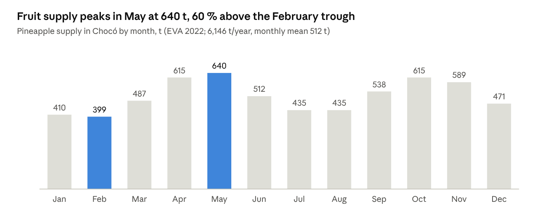
EVA 2022 (UPRA), Chocó
Supply scenario | Fruit (t/year) | Possible wine (hL/year) | Flour (t/year) | Bromelain (kg/year) | Share of the 78,300 hL design basis
Reject fruit, Quibdó market (12 t/month) | 144 | 516 | 5 | 43 | 0.7 %
Chocó total production, 2008 | 3,883 | 13,911 | 136 | 1,165 | 17.8 %
Chocó total production, 2022 (EVA) | 6,146 | 22,019 | 215 | 1,844 | 28.1 %
Chocó 2022 with 25 % post-harvest loss | 1,536 | 5,505 | 54 | 461 | 7.0 %
The original design basis of the project, 78,300 hL/year of wine, requires 21,856 t/year of fruit: 9,835 t of pulp, 6,557 t of peel, 2,186 t of core and 3,278 t of crown, 3.6 times the department's production. At that scale the front end would need 6.9 t/h of fruit on two shifts, the 90-day wine ageing would need 1,931 m³ of tanks, and drying the peel cake would demand 8,043 GJ/year of heat. It is kept as the upper end of the scale sweep (0.5 to 3.556 times the 2022 supply), not as the design case. For the stochastic program, supply takes 0.7, 1.0 and 1.3 times the central value with probabilities 0.25, 0.5 and 0.25.

2.1.4 Logistics and collection
Fruit reaches Quibdó and the candidate sites in Riosucio and Carmen del Darién by river and by a limited road network. Leaves are a different logistics problem: they are bulky (125 t/ha at renewal), spread over every farm, and have little value per tonne. A stylized location MILP (Section 3.8) chooses between a central plant that receives fresh leaves and depots that press leaves near the farms and ship only juice, with river or road transport for each flow. Its zones, areas and distances are placeholders [S] until farm locations are mapped; its output enters the registry as a delivered collection cost of 35,400 COP per tonne of leaves (range 25,000–80,000) and as the mean transport distance of fruit in the LCA inventory.

2.2 Feedstock Fractions: Fruit and Plant Leaves

2.2.1 Mechanical fractionation
Whole-plant processing starts with a mechanical separation of the fruit into pulp, core with stem, peel and crown. This is itself a unit operation with equipment, energy and yields: stems and peels can be ground and pressed separately with standard juice equipment, each giving a juice and a wet press cake that can be dried and milled into flour (Campos et al., 2020). The juice–cake template is used for pulp, peel and core. The fruit splits used by the models are 45 % pulp (range 25–55 %), 30 % peel, 10 % core and 15 % crown [L]; aggregate reviews put peel, core, crown and pomace together at 50 to 60 % of fresh fruit weight (Aili Hamzah et al., 2021; Sarangi et al., 2022).

2.2.2 Pulp: fermentable sugars
Pulp carries most of the reducing sugars and soluble fibre and little crude fibre (Huang et al., 2021), which makes it the default feedstock for juice, wine and vinegar. For Chocó fruit, Murcia Palacios (2013) measured by HPLC the sugars of whole-fruit juice (pulp, core and peel pressed together): first-grade fruit carried 574.64 g/L of fermentable sugar (363.29 g/L sucrose, 120.90 g/L glucose, 90.45 g/L fructose), whereas reject-grade fruit carried only 158.83 g/L (2.94, 75.62 and 80.27 g/L). More than 99 % of the sucrose was gone, against 37 % of the glucose and 11 % of the fructose, consistent with post-harvest invertase activity outpacing spoilage. The models use 158.8 g/L with an 87 % juice yield on pressed pulp, the only regional measurement for reject fruit, while noting that it is a whole-fruit juice rather than an isolated pulp stream.

2.2.3 Core and stem: bromelain and phenolics
The ranking of bromelain activity among fractions is not consistent across cultivars and protocols. Core ranks above peel among stem-free processing wastes (Banerjee et al., 2021) but below peel in MD2 by-products, where the basal stem is the most active (Chiarelli et al., 2024), and another study orders the fractions pulp > peel > core > crown > stem (Misran et al., 2022). Core and peel also carry phenolics: chlorogenic, caffeic and ferulic acids in stem and peel juices (Campos et al., 2020); catechin, gallic and ferulic acids across core, pulp and peel (Uslu et al., 2024); and p-coumaric and ferulic depsides with cysteine-derived conjugates in a tissue-resolved profile (Steingass et al., 2015). Only ferulic acid recurs. Bromelain activity is therefore carried as a range, and the core is the candidate source in configuration B (Section 2.6.3).

2.2.4 Peel: juice and insoluble fibre
Pressed peel yields 57.8 % juice and a cake with 17 % dry matter that retains 41 % of the peel solids (Campos et al., 2020). The juice carries about 104 g/kg of sugar, which ferments to ethanol at 0.36 g/g (range 0.23–0.43) and can feed vinegar (Seguí and Fito, 2018). The fibre-rich fraction of dried peel contains 41.8–48.0 g/100 g of insoluble fibre with lignin of 60.7–65.8 g/100 g in that fraction (Huang et al., 2020). The earlier manuscript assumed «about 67 % sugar on a juice basis» for peel juice, a value without a source and physically implausible for a juice of 10–15 °Brix; it is replaced here by the measured yields.

2.2.5 Crown and leaves: lignocellulose and juice
Crown and leaves are structural tissue. The earlier basis adopted 24–26 % lignin for both [verify against Saini et al., 2022]; MD2 leaves have been reported at 22 % lignin against 17 % in stem and 19 % in root (Mansor et al., 2019), and Colombian Perolera peel at 26.4 % on dry basis (Celis Cabeza et al., 2024). The crown, 15 % of the fruit with 20 % dry matter, is modelled as a fuel (Section 2.7) or composted.
Leaves are a second feedstock, not a fraction of the fruit. At crop renewal a plantation leaves about 125 t/ha of fresh leaves (Chen et al., 2020), usually burned or left to decompose (Liao et al., 2026). Pressed in a screw extractor, leaves give 76 % juice and 18 % fibrous pulp (Liao et al., 2026); the juice contains glucose and xylose that K. marxianus ferments to ethanol (Chen et al., 2020), and that can also be digested to biogas or acetified. With 25 % of the 1,039 ha renewed each year, the leaves available amount to 32,469 t/year; the collectable fraction is an assumption [S] tested at 10 and 50 %. This changes the earlier basis, which treated leaves only as lignocellulose for delignification or gasification.
Leaf juice. Extraction yields 0.76 t of juice per tonne of leaves (Liao et al., 2026; 0.77 in Chen et al., 2020).
Composition.
- The juice holds 6.2 % solids, of which 14 % is crude protein, 10.0 % ash and 3.5 % fat (Liao et al., 2022, Table 1, from Chen et al., 2020). By difference it holds about 44.9 g of carbohydrate per kg.
- The free monosaccharides reported are 10.6 g/L of glucose and 16.4 g/L of xylose (Chen et al., 2020). Liao et al. (2022) give 0.6 g/L of C6 sugars for the same juice, a discrepancy to be resolved in the original.
Fermentation. Fermented by Kluyveromyces marxianus at 35 °C without supplements, 46 kg of juice gave 35 kg of broth at 3.6 % v/v ethanol and 11 kg of wet yeast. That is about 1.0 kg of ethanol, or 21.7 kg per tonne of juice, and 16.1 kg of yeast dry matter per tonne.
Checks.
- The ethanol is 0.485 g/g of carbohydrate, 95 % of the stoichiometric maximum. The free sugars alone could not produce it (0.82 g/g on them), so the yeast must also use part of the soluble oligosaccharides.
- Ethanol and yeast together do not close. At a biomass yield of 0.5 g/g, the yeast alone would consume about 32 kg of sugar per tonne, which leaves room for at most 6.5 kg of ethanol.
Value adopted.
- This thesis takes the ethanol figure, which rests on a measured broth concentration, capped at 90 % of the stoichiometric maximum: 20.7 kg/t is the design value.
- Its range is 6.5–20.7 kg/t. The lower end is the most ethanol compatible with the reported yeast (100 % of theory on the residual sugar and the maximum biomass yield; 5.9 kg/t with the 0.90 ceiling). It is not a pessimistic floor.
- The yeast figure is flagged; it is used only by the leaf-ethanol route.
A fermentation of Chocó leaf juice that measures ethanol, residual sugars and biomass together is the first measurement this thesis asks for (Section 6.7).
Feedstock or fraction | Central value | Source
Pulp | 45 % of the fruit (25–55 %) | [L]
Peel | 30 % of the fruit | [L]
Core | 10 % of the fruit | [L]
Crown | 15 % of the fruit; 20 % dry matter | [L]
Pulp juice | 87 % of the pressed pulp; 158.8 g/L fermentable sugar | Murcia Palacios (2013) [T]
Peel juice | 57.8 % of the peel; about 104 g/kg sugar; cake with 17 % dry matter | Campos et al. (2020); Seguí and Fito (2018) [L]
Plant leaves | 125 t/ha fresh at renewal; 25 % of the area renewed per year | Chen et al. (2020) [L]; collectable fraction [S]
Leaf juice and leaf pulp | 76 % and 18 % of the leaf | Liao et al. (2026) [L]
Leaf-juice ethanol | 20.7 kg/t juice (6.5–20.7); 44.9 g/kg carbohydrate by difference | Chen et al. (2020), capped at 90 % of the stoichiometric maximum; Liao et al. (2022) [L/S]

2.3 Technology Readiness Criterion and Candidate Alternatives

2.3.1 From value-density screening to an open superstructure
The earlier manuscript narrowed the candidate set before optimizing, by a value-density rule with roots in forest-biorefinery portfolio selection (Sammons et al., 2008; Mansoornejad et al., 2010; Dansereau et al., 2014; Louw et al., 2023). That screening was needed because the MINLP could not hold the full set. The MILP of Chapter 3 can, so the screening is reversed: every alternative with data enters the superstructure, and value density is used afterwards to explain the result (Section 6.3). Two consequences follow. Alternatives that the screening would have kept and the optimization rejects, such as the sugar hub and gasification, are reported as negative results with their reasons. And alternatives that the screening did not foresee, such as leaf juice to vinegar, can be selected.

2.3.2 The TRL-9 reference
The reference design uses only technologies with a commercial plant in operation (TRL 9). Lower-TRL technologies enter as flagged alternatives, so that the model reports what each would be worth if developed.
Technology | TRL | Basis
Washing, sorting, mechanical peeling and coring | 9 | Canneries and juice plants
Enzymatic maceration and belt pressing | 9 | Juice industry
Decanter centrifuge for pulp | 9 | Continuous extraction of juices and musts (Morata, 2022, ch. 4)
Flotation and disc centrifugation of must | 9 | White-must clarification (Morata, 2022, ch. 8)
Ceramic tangential microfiltration of juice or lees | 9 | Industrial juice clarification; lees recovery (Morata, 2022, ch. 8)
Flash pasteurization (HTST) and SO₂ | 9 | Standard winemaking
Jacketed stainless fermentation; nitrogen inertization; bottling | 9 | Winemaking (Morata, 2022, chs. 23 and 25)
Submerged acetification (Frings or Cetotec type) | 9 | More than 60 % of world vinegar (Emde, 2017; Bekatorou, 2020)
Belt dryer and mill for fibre flour; biomass boiler | 9 | Fruit by-product flours; agro-industrial boilers
Citric acid and xanthan by fermentation | 9 | Industrial on molasses or glucose; no reference on pineapple juice
UHPH of must (300 MPa) | 8 | Industrial units up to 10,000 L/h from one supplier (Morata, 2022, ch. 5)
Downdraft gasification with engine (≤ 100 kWe) | 8 | Commercial packages; limited reliability with wet biomass
Anaerobic digestion of leaf juice with biogas engine | 7 | Bench CSTR (Liao et al., 2026); mature agro-industrial digestion
Peel pressing with 0.1 % Ca(OH)₂ | 6 | Pneumatic pilot press (Seguí and Fito, 2018)
Leaf-juice extraction | 6 | Pilot extruder (Chen et al., 2020); industrial screw presses
Delignification and enzymatic hydrolysis of leaves and crown | 6 | Pilot; outside the TRL-9 reference
Bromelain by UF (10 kDa) and freeze-drying | 6 | Mature UF; pineapple juice only in the laboratory (Seguí and Fito, 2018)
Bromelain by polysaccharide precipitation | 5 | Laboratory with industrial juice (Campos et al., 2020)
Ethanol and yeast from leaf juice (K. marxianus) | 5 | Laboratory (Chen et al., 2020); conceptual TEA (Liao et al., 2022)
The lignocellulosic train (TRL 6) and the hub products on pineapple hydrolysate stay outside the TRL-9 reference. UHPH, gasification and digestion enter as alternatives; the MILP selects none of them in any case of Chapter 5.

2.4 Modelling Framework and Parameter Registry

2.4.1 A polylithic modelling framework
The models of this thesis form a chain rather than one program. An MILP decides synthesis, sizing and seasonal operation (Chapter 3); nonlinear satellite models (fermentation kinetics, fermentation-train superstructures, the winery procedure of Moresi) are solved, calibrated and verified on their own and pass yields and processing times to it; a TEA, an LCA and social indicators evaluate the designs it returns (Chapter 4); and a commercial simulator verifies the chosen design outside the optimization loop (Section 5.8). This is a polylithic architecture in the sense of Kallrath (2021). Its premise is that each model is solved with the method that suits it, and that every hand-over between models is a parameter in one registry, never a value retyped by hand.
The simulator is SuperPro Designer. Commercial simulators embed unit models, property data and costing correlations that reduce the modelling burden (Kasani et al., 2022), and SuperPro has a Colombian record directly relevant to this case: anaerobic digestion of sugarcane vinasse (Canizales et al., 2020), whey valorization at a dairy (Gómez et al., 2019) and a vinasse biorefinery of the baker's yeast industry (Gómez et al., 2024), and it remains suited to waste-to-product bioprocesses (Aranda-Barradas et al., 2025). General chemical simulators show compatibility problems with bioprocesses (Sreemahadevan et al., 2024), while SuperPro supports the batch and semi-continuous operations that dominate this plant: fermentation, membrane filtration, drying. Unlike the earlier manuscript, which planned to build the process models in the simulator, this thesis builds them in open Python code linked to the registry and uses the simulator to verify the optimum, with a package of procedures, streams and tolerances generated from the solution (Appendix E).

2.4.2 The registry
All data live in one file, datos/parametros.csv, with 152 parameters in version 12. Each entry has a key, a group, a central value, a minimum, a mode and a maximum, a distribution when it enters the Monte Carlo (Beta-PERT with λ = 4, or discrete scenarios), a unit, a provenance tag, a source and a note on the version that introduced it.
Tag | Meaning | Count
[T] | Datum of the project (Murcia Palacios, 2013) | 3
[C] | Datum of Corsano et al., used in the train models | (in the train modules)
[L] | Literature value with a source | 89
[S] | Assumption, to be replaced by field or market data | 55
Mixed | Literature value adapted, or thesis value with an assumed range | 5

Group | Parameters | Examples
LCA factors | 32 | Diesel electricity 0.97 kg CO₂e/kWh; glass bottle 0.5 kg CO₂e [S]; wetland CH₄ correction 0.1
Kinetics | 29 | Krishnan et al. (1999) constants for glucose and xylose; calibration factor 1.389
Leaves | 26 | 125 t/ha at renewal; 76 % juice; collectable fraction 25 % [S]; collection 35,400 COP/t [S]
Prices | 19 | Fruit 400 COP/kg; vinegar 2,200 COP/L; flour 12,000 COP/kg; panela 3,500 COP/kg; retail bottle 16,000 COP (all [S])
Fruit | 13 | Fractions; juice yield 87 %; 158.8 g/L sugar [T]
Hub | 11 | Xanthan yield on pineapple residue 0.083 g/g; citric acid and xanthan prices [S]
Taxes | 10 | Specific excise 243 COP per degree per 750 cm³; ad valorem 20 %; VAT 5 %; income tax 35 %; UVT 2026 = 52,374 COP
Other | 12 | Finance, vinegar, social, winery filling limit
The registry has two methodological functions. First, traceability: before every run a routine compares the registry with the constants of every module; version 12 shows 0 differences in 27 compared constants. Second, replacement of assumptions: a measured value replaces an assumption in the registry, the whole chain is rerun, and the effect is isolated by a margin decomposition between versions, first with the previous design fixed and the new data entered one at a time, then with the design reoptimized without and with the new options (Section 5.6).
The history of replacements shows why the registry matters. The microfiltration flux and retentate measured on pineapple juice (40–50 L/m²·h, 27 % retentate; Quesada Salas, 2013), replacing an assumed 60 L/m²·h with 2 % retentate, cut the margin of the TRL-9 reference from 1,519 to 625 MM COP/year and that of the best design with the old topology from 2,028 to 900. The juice yield and cake of Campos et al. (2020) and the ethanol yield of Seguí and Fito (2018) lowered the margin of the version 8 design from 3,200 to 2,400 MM COP/year. The xanthan yield on pineapple residue, a seventh of the glucose value, removed xanthan from consideration. And the excise tax on wine changed the design itself (Section 5.4). Every one of these values had looked like a detail.

2.5 Fermentation Models: Calibration, Identifiability and Thermal Validity
Fermentation sets three numbers the MILP needs: the yield of each fermented stream, the processing time t_proc that sizes each winery, and the inoculum and propagation that dominate the operating cost of the wine train. This section calibrates the kinetic models that produce them and states what the data can and cannot identify.

2.5.1 Pulp juice: the Murcia Palacios datum
Murcia Palacios (2013) fermented undiluted Chocó pineapple juice with commercial lyophilized S. cerevisiae at 30 °C and pH 4.5, reaching 65.31 g/L of ethanol in 12.5 h: 0.41 g of ethanol per g of fermentable sugar, 80.39 % of the stoichiometric 0.511 g/g, consistent with the 82–89 % reported for fresh pineapple juice (Kouakou et al., 1987, as cited by Murcia Palacios, 2013 [verify authorship]). Controlling temperature and pH cut the time to the same titre from about 72 h at ambient conditions to 12.5 h, which justifies jacketed, controlled fermenters. Ethanol yields of 7–8 % v/v across three strains and three temperatures have been reported for pineapple wine, with strain and temperature shaping the aroma (Roda et al., 2017b). The registry takes 8.3 % v/v as the alcoholic degree of the wine (65.31 g/L divided by 789 g/L), the value used for the excise tax.

2.5.2 Kinetic model, discretization and identifiability
The pulp-juice fermentation is described by Monod growth with ethanol inhibition and first-order death, as in Corsano et al. (2004):
$$μ=μ_{max}\frac{S}{K_{S}+S}\left(1−\frac{P}{P_{max}}\right), \frac{dX}{dt}=μX−k_{d}X, \frac{dS}{dt}=−\frac{μX}{Y_{X/S}}, \frac{dP}{dt}=Y_{P/S}\frac{μX}{Y_{X/S}}$$ | (2.1)
In the optimization models these equations are discretized by trapezoids on finite elements. Corsano et al. (2004) reported that five nodes match a simulator at the final point. With the ethanol-inhibited kinetics of wine that is not the case: five nodes err by 5.4 g/L of ethanol (8 %) and 13 g/L of sugar at the end of the batch, fifteen nodes by 0.14 and 0.35 g/L. All models use fifteen nodes, and every optimum is re-simulated a posteriori with a variable-step integrator (LSODA), agreeing within 0.15 % in final ethanol and 0.2 g/L in residual sugar (Figures 2.2 and 2.3).
Figure 2.2. Trapezoidal discretization against LSODA for 5 and 15 nodes. Figure 2.3. Final-point error against the number of nodes (models report, figs. 1–2).
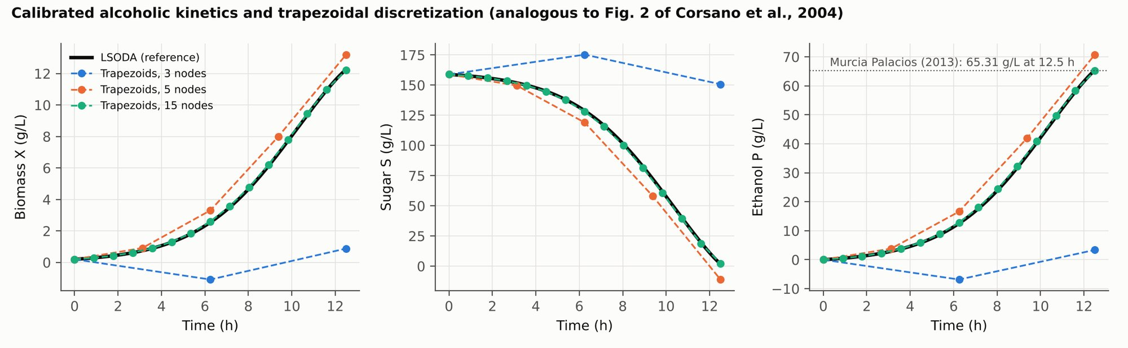
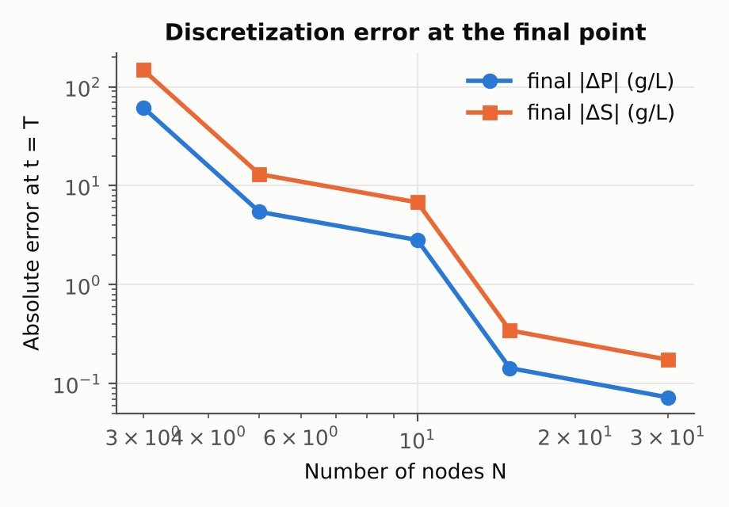
One end point cannot identify the maximum growth rate and the effective inoculum at once. A continuous family of pairs, from (µ_max = 0.55 h⁻¹; X₀ = 0.05 g/L) to (0.24 h⁻¹; 2 g/L), reproduces the datum equally well (Figure 2.4). The ambiguity has design consequences: for a 2 g/L starter culture the design fermentation time ranges from 5.3 to 12.3 h within the family, so the cycle time and the fermenter volume change by a factor of 2.3 within the set of parameters compatible with the data. Until a time course is measured, the family is carried as uncertainty into the global sensitivity analysis of Section 2.8. The first data need of the thesis is a fermentation time course of at least six points (sugar, ethanol, biomass) with the viable yeast dose recorded.
Figure 2.4. The family of (µ_max, X₀) pairs compatible with the single measured point (models report, fig. 3).
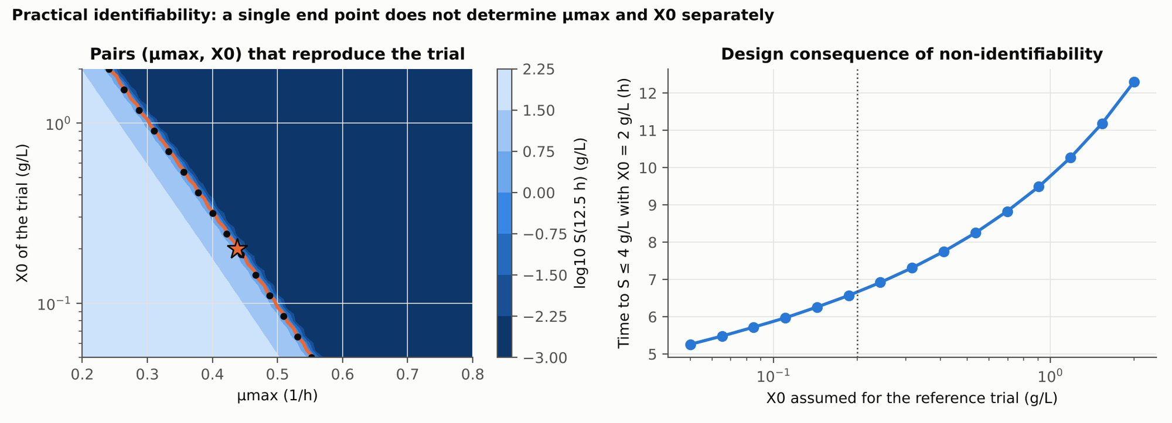

2.5.3 Moresi's model: replication and thermal validity
The complete model of Moresi (1989a; 1989b) was implemented: stoichiometry and kinetics with the parameters of his Table 1, dynamic balances with refrigeration load and ethanol stripping by CO₂, and his eleven-step winery design procedure. One formulation change was needed: substrate consumption and ethanol production follow growth only, because in the original form a negative net growth rate would return sugar and ethanol to the broth.
With the nominal inoculum of 0.2 g/L, the time to consume 85 % of the sugar is 60.5 h in the closed system (15 °C) and 66.5 h in the open system (15–22 °C), against 81 and 79 h published. One parameter was calibrated on the closed case, the effective viable inoculum (X₀ = 0.081 g/L); the open case then became an independent prediction, 87.5 h, 11 % above the published value. The sign of the temperature effect comes out inverted, because in Moresi's Table 1 the saturation and inhibition constants decrease with temperature; this cannot be resolved from his chapters, since the constants come from his references.
With the published fermentation times, the cost correlations of his Table 3 were recovered, including the Guthrie module factors (2.00, 2.13 and 1.78) and capital recovery at 15 % (10 years for fabricated equipment, 5 for machinery).
Item (published / reproduced) | 30,000 hL, closed | 60,000 hL, open | 120,000 hL, open
Fermenters N_F | 5 / 5 | 26 / 26 | 69 / 69
Refrigeration load (kW) | 288 / 307 | 517 / 688 | 1,000 / 1,178
Investment (MLit) | 577 / 590 | 928 / 1,058 | 1,872 / 1,989
Operating cost (MLit/year) | 206 / 211 | 355 / 398 | 622 / 665
Specific cost (Lit/L) | 68.7 / 70.3 | 59.1 / 66.3 | 51.8 / 55.4
Fermenter numbers, depreciation of fabricated equipment, maintenance, inoculum and labour coincide. The difference lies in the refrigeration of open systems, +15 to +31 % in machinery depreciation, which comes from how the 4-h cooling peaks of staggered fermenters overlap, a calculation Moresi does not detail (Figure 2.5).
Figure 2.5. Replication of Moresi (1989b): profiles with the calibrated kinetics and deviation of each cost item (models report, fig. 16).
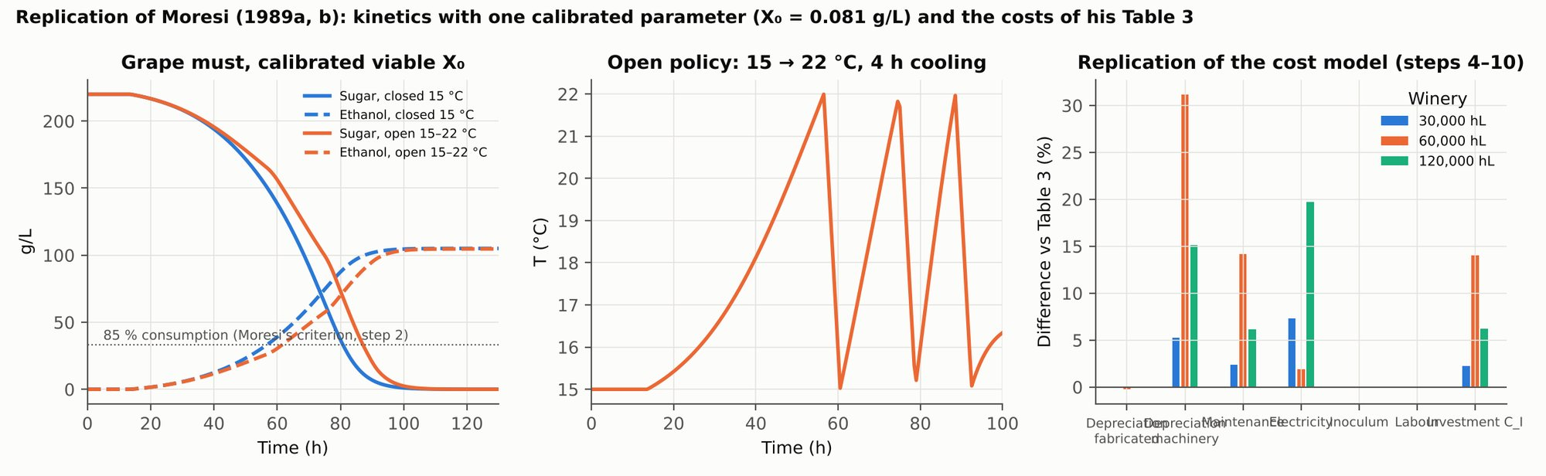
Applied to pineapple juice with 158.8 g/L of sugar, Moresi's kinetics give 64 to 75 h to consume 85–97.5 % of the sugar between 15 and 22 °C, 98–107 h at 25 °C, and do not finish at 28–30 °C, where the specific rate turns negative. The model is a white-wine regression valid between 15 and 25 °C and cannot describe the fast 30 °C line measured by Murcia Palacios (2013). The earlier manuscript compared a fast line (Murcia's datum at 30 °C) with a premium line (Moresi at 15–22 °C) and attributed to near-complete conversion a 15.4 % gain in ethanol per tonne of sugar. The decomposition shows otherwise: the ethanol ratio is 1.159, of which +15.1 % comes from the different stoichiometric yields of the two models (0.479 against 0.416 g/g) and only +1.3 % from conversion (100.0 % against 98.7 %). The premium advantage is an artefact of changing model, not a property of the premium line (Figure 2.6).
Figure 2.6. Moresi's model applied to pineapple: fermentation time by temperature, decomposition of the premium advantage, and fermentation cost against fermenter volume (models report, fig. 17).
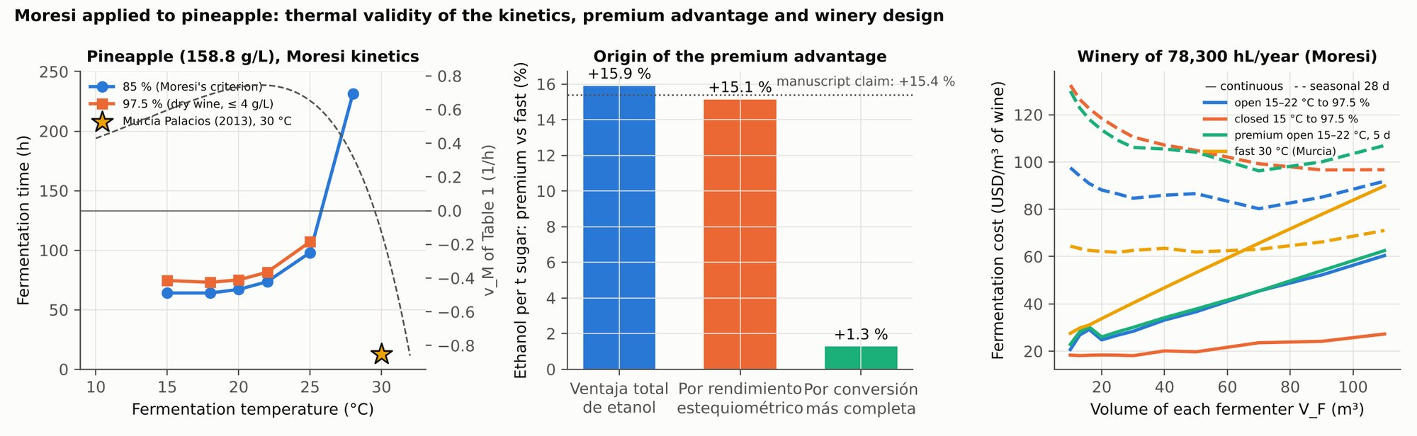

2.5.4 Peel and leaf juices: glucose–xylose kinetics coupled to the plant
Peel and leaf juices contain glucose and xylose. Their fermentation follows Krishnan, Ho and Tsao (1999), with substrate and product inhibition for each sugar:
$$μ_{g}=\frac{μ_{m,g}S_{g}}{K_{s,g}+S_{g}+S_{g}^{2}/K_{i,g}}{\left(1−\frac{P}{P_{m,g}}\right)}^{β_{g}}, μ_{x}=\frac{μ_{m,x}S_{x}}{K_{s,x}+S_{x}+S_{x}^{2}/K_{i,x}}{\left(1−\frac{P}{P_{m,x}}\right)}^{β_{x}}$$ | (2.2)
with analogous expressions for ethanol production and for the consumption of each sugar. The kinetics are coupled to the plant in three steps (Heinzle, Biwer and Cooney, 2006, ch. 7). The time scale is calibrated on the pulp juice: the model predicts 9.0 h where 12.5 h is measured, and the factor 1.389 is applied to the other juices. The measured yield is kept rather than the model's ideal yield: 0.36 g/g for peel juice (Seguí and Fito, 2018), the calibration absorbing losses and contamination. And the time to consume 95 % of the sugar, calibrated, plus 2.5 h of discharge and cleaning, goes to the registry as the processing time of the juice winery (Figure 2.7).
For peel juice this gives 10.1 h of fermentation and 12.6 h of processing, instead of the 32.5 h assumed before the kinetics were coupled, which shrinks the juice winery by a factor of about 2.5. For leaf juice the recombinant S. cerevisiae model gives 24.6 h, because it ferments xylose slowly; leaf juice is fermented with K. marxianus, for which Chen et al. (2020) measured 12 h, and the registry takes 12 + 2.5 = 14.5 h. Because both juices share the juice winery, leaf juice occupies capacity in proportion to its longer time.
Figure 2.7. Glucose–xylose kinetics of peel and leaf juices, calibrated time scale and processing times passed to the MILP (models report, fig. 41).
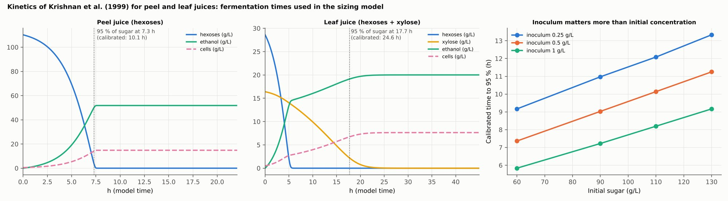

2.5.5 Acetification
Two acetification regimes appear in the pineapple literature. Static surface acetification of a pineapple-waste wine (7 % v/v) with Acetobacter aceti reached 5 % w/v acetic acid in 30 days at 32 °C (Roda et al., 2017a); it would need 174 m³ of working volume at the scale of the earlier design basis. Submerged acetification of the Frings type produces 40–60 kg of acid per m³ per day at about 94 % of the theoretical yield (Emde, 2017), with semi-continuous cycles of 24 to 48 h (Ebrahimi, 2026), and would need 5.8 m³. The models use the submerged regime with 50 kg/m³·day, a conservative value.

2.6 Unit Models of the Processing Trains
Each processing step of the superstructure offers two to six alternatives, each with its own yields, losses, utility use, variable cost and catalogue of sizes. Catalogue options bundle their companion equipment, so the MILP chooses whole functional units. Costs follow power laws from the catalogue of the TRL-9 design module, updated with the producer price index and the exchange rate (Section 4.1). Where pineapple-specific data exist they are used in preference to data from other fruits, even when the two behave alike in kind.

2.6.1 Pulp: extraction, must treatment, winery and bottling
Extraction. Washed, peeled and cored fruit is milled and macerated with a pectinase–polygalacturonase–cellulase preparation at 55–60 °C, 200–300 mg of enzyme per kg of pulp and 30–120 min, and pressed; Quesada Salas (2013), working for a pineapple processor, measured a maximum juice yield of 87 % w/w after this treatment. The company optimum within that envelope is redacted in the source, so the models use one hour at mid-envelope dose, consistent with 60 min as the maximum residence time accepted in industry (Vaillant et al., 1999, as cited by Quesada Salas, 2013) and with the advice to favour dose over time to limit spoilage during maceration (Dak et al., 2008, as cited). Two extraction alternatives compete: a belt press, dedicated to pulp or shared with peel and core, and a decanter centrifuge, continuous and with yields above 80 % but more energy (+4.5 kWh per t of pulp) and maintenance (Morata, 2022, ch. 4). Continuous screw presses and decanters give musts with more turbidity, higher pH, more extracted phenolics and fewer esters than pneumatic presses (Del Fresno et al., 2022). At the scale of Chocó even the smallest catalogued commercial crusher or press runs at 5–11 % of its rated capacity, so the vendor decision is which smallest unit to buy, which the catalogue disjunction represents directly.
Clarification target. The earlier design clarified the whole must by ceramic microfiltration at 0.2 µm. White-wine practice sets a target turbidity of 100–200 NTU before fermentation: clarifying further depletes the phytosterols and lipids that suspended solids supply to yeast, which they need to keep their membranes intact under anaerobic conditions, and raises the risk of stuck fermentation (Vernhet, 2022). Microfiltration removes essentially all suspended solids. Pineapple must also starts far above wine must: pulpy pineapple juice carries 2,850–3,570 NTU and 10.5 % insoluble solids, against 400–3,000 NTU and 0.7–4 % in grape must (Quesada Salas, 2013).
Clarification alternatives. Three technologies compete, with a fourth step for the lees:
Alternative | Pineapple data | Loss and cost in the model
Ceramic tangential microfiltration | 37 L/m²·h at 0.2 µm, 3.4 m/s, 0.7 bar (Laorko et al., 2010); 40–50 L/m²·h sustained over six-hour runs at a volume reduction factor of 3.7 (Quesada Salas, 2013); dead-end ceramic membranes of 0.56–0.87 µm (Arikrishnan et al., 2022) | 45 L/m²·h; 27 % of the must as retentate; membranes replaced at 15 %/year
Flotation | Continuous or batch clarification of white musts (Vernhet, 2022; Morata, 2022, ch. 8) | 2,900 COP/m³; 18 % foams, scaled to pineapple solids
Disc centrifuge | Dynamic clarification of musts (Morata, 2022, ch. 8) | 2,800 COP/m³; 12 % sludge, scaled to pineapple solids
Tangential MF of lees (optional) | Lees and foams hold 80–90 % juice in grape practice; lees MF is the main industrial use of MF in winemaking (Morata, 2022, ch. 8) | 30 L/m²·h; recovers 60 % of the juice in lees and foams [S]
Quesada Salas (2013) recommends centrifuging before microfiltering and valorizing the retentate; that is the sequence the optimization chooses (centrifuge or flotation for the must, MF only for the lees when the plant is large), with lees and retentate sent to the flour line rather than to compost.
Stabilization. The earlier design aimed to avoid sulfur dioxide altogether, relying on microfiltration. SO₂ has three functions in winemaking: antimicrobial, antioxidant and antioxidasic, the last inhibiting polyphenol oxidase (PPO), which causes enzymatic browning (Loira et al., 2022). A 0.2 µm membrane retains microorganisms but not PPO, a dissolved enzyme orders of magnitude smaller than the pores, so microfiltration does not replace SO₂. Ultra-high-pressure homogenization (UHPH, 300–400 MPa), approved by the OIV, has eliminated yeasts and bacteria, cut PPO activity by 90 % relative to an SO₂ control and raised antioxidant capacity in white must without SO₂ (Loira et al., 2022, citing studies not verified here). Three alternatives therefore compete: flash pasteurization (HTST, 500–3,000 L/h), sulfiting, and UHPH (500–2,000 L/h). UHPH uses about 100 kWh/m³ of compression energy, roughly 140,000 COP per m³ of must with diesel electricity, and is TRL 8 with a single industrial supplier. Nitrogen inertization and assimilable-nitrogen dosing (200 mg/L of diammonium phosphate; deficiency below 140 mg/L) are part of every design (Morata, 2022, chs. 12, 23 and 25).
Must store and winery. An aseptic store of 10 to 800 m³ can level must between months and, from version 12, feed the fermenters by pump (Section 3.5). The winery is a set of 2 to 12 jacketed fermenters of 10 m³, with chiller, disc centrifuge, cartridge filter and propagator, sized by the procedure of Moresi in linear form (Section 3.5). Fermentation takes 12.5 h at 30 °C plus 2.5 h of discharge and cleaning (Section 2.5.1).
Bottling, excise and the price of wine. Earlier versions valued bulk wine at 3,000 COP/L without tax. Pineapple wine sold in Colombia pays the departmental consumption tax of Law 1816 of 2016 (art. 20), which has a specific component per alcoholic degree in 750 cm³ and an ad valorem component of 20 % on the retail price before taxes, and VAT of 5 % (Tax Code, art. 468-1). With a specific rate e, the ad valorem rate a, retail price PVP, VAT rate i and distribution margin m, the tax per bottle T, the factory price F and the net to the plant N satisfy
$$T=e+a\left(\frac{PVP}{1+i}−T\right) ⇒ T=\frac{e+a PVP/\left(1+i\right)}{1+a}, F=\frac{PVP/\left(1+i\right)}{1+m}, N=F−T−c_{pack}$$ | (2.3)
With e = 243 COP × 8.3 degrees = 2,017 COP, PVP = 16,000 COP [S], m = 35 % [S] and packaging of 2,400 COP per bottle [S], the factory price is 11,287 COP, the tax 4,220 COP and the net 4,667 COP per bottle, or 6,223 COP/L. A bottling line of 500 to 4,000 bottles/h with one operator per shift enters the superstructure, and wine sales are capped at 500,000 bottles/year (375 m³) [S].
Retail price (COP per bottle) | Factory price | Excise | Net to the plant (COP/L)
10,000 | 7,055 | 3,268 | 1,849
16,000 | 11,287 | 4,220 | 6,223
25,000 | 17,637 | 5,649 | 12,784

2.6.2 Peel: pressing, enzyme, juice and flour
Peel is pressed with water or with 0.1 % Ca(OH)₂; lime extracts more juice at the expense of cake, as measured in a pneumatic pilot press (Seguí and Fito, 2018). With water the yield is 57.8 % juice and a cake with 17 % dry matter (Campos et al., 2020). A dedicated peel press can be bought, or peel shares the pulp press with one hour of cleaning per change of material (Section 3.4).
Before fermentation, bromelain can be recovered from the peel juice by polysaccharide (carrageenan) precipitation, with 80–90 % recovery and little auxiliary chemical (Campos et al., 2019), or by 10 kDa ultrafiltration with freeze-drying (Seguí and Fito, 2018), each in units of 0.25 to 1 t/h with a lyophilizer and one operator per shift. The juice, with or without enzyme recovery, can go to vinegar (Section 2.6.5), to the hub products (Section 2.6.6), or be sold at 150 COP/kg.
The cake and the clarification lees go to a belt dryer with a heat generator and a mill. Drying evaporates 0.81 t of water per t of cake and needs about 2,590 MJ/t; a tonne of lees gives 0.11 t of flour and loads the dryer as 1.16 t of cake. Fibre flour sells at 12,000 COP/kg [S]. Cake that is not dried is composted at 30 COP/kg.

2.6.3 Core: bromelain recovery and nutraceutical powder (configuration B)
Configuration B adds a dedicated core press and a bromelain module: two-stage ceramic ultrafiltration, which recovered 94–97 % of the enzyme with 2.5- to 4.4-fold purification depending on the enzymatic pretreatment (Nor et al., 2016; 2018), followed by spray drying; the bromelain-depleted retentate and part of the core juice become a spray-dried nutraceutical powder. Spray-drying parameters come by analogy from fruit-bioactive drying studies (Homayoonfal et al., 2022; Jafari et al., 2022), since no pineapple by-product study reports a comparable optimization, and carry a wider uncertainty. Crude bromelain is valued at 300,000 COP/kg [S]. The data needed to make a second UF stage and crown bromelain proper alternatives are the price of bromelain by purity and the proteolytic activity per kilogram of the Chocó variety.

2.6.4 Leaves: juice extraction and its destinations
Leaves collected at crop renewal are pressed in a screw extractor of 2 to 60 t/h into 76 % juice and 18 % fibrous pulp (Chen et al., 2020; Liao et al., 2026), with 18 kWh per tonne (Liao et al., 2026) and a delivered collection cost of 35,400 COP per tonne [S]. The juice has four destinations: vinegar, fermenting in the juice winery with the peel juice; ethanol and yeast with K. marxianus in a dedicated winery of 2 to 24 fermenters of 10 m³ and a distillation column of 10 to 400 L/h (Chen et al., 2020; Liao et al., 2022), with ethanol at 4,000 COP/L [S] and dried yeast at 2,000 COP/kg; anaerobic digestion (Section 2.7); or return to the field. The pulp can fire the biomass boiler (6,527 MJ/t) or return to the field.

2.6.5 Vinegar: submerged acetification, blending and added sugar
The submerged acetifier (Frings type, 2 to 40 m³) oxidizes ethanol to acetic acid at 50 kg/m³ per day and 94 % of the theoretical yield (46 g of ethanol give 60 g of acid), releases 493 kJ/mol that a chiller removes, and needs 1.2 kW/m³ of aeration that cannot stop: cuts of 10 to 45 s reduce productivity by up to 80 % (Emde, 2017), and a 30-s cut can kill the culture (Ebrahimi, 2026). Each acetifier option therefore bundles its chiller, an emergency genset, a foam centrifuge, a gas scrubber and a vinegar microfilter. Ebrahimi (2026, sec. 12.3.3) confirms the 94 % and reports vinegar at 12 % in about 35 h with semi-continuous cycles of 24 to 48 h, so the productivity used is conservative.
Vinegar leaves at 5 % acetic acid (50 kg/m³). Its substrates are wine diverted from bottling and the fermented peel and leaf juices. The acetifier only dilutes: the feeds must carry, together, enough potential acid for 5 %. Without that constraint an early version sold leaf juice as 5 % vinegar without concentrating it. Juices with 60–110 g/L of sugar give too little ethanol to reach 5 % alone, which in versions 7 to 10 forced the model to divert wine to the vinegar line. Adding sugar to the juices before fermentation is common practice in fruit vinegars (Ebrahimi, 2026, sec. 12.2.1) and was applied to pineapple peel juice with 100 to 200 g/L of sucrose (Tanamool et al., 2020, cited by Ebrahimi, 2026). The superstructure therefore admits panela, the non-centrifugal cane sugar produced across Colombia, up to 150 g per litre of juice (range 100–200); each tonne adds 438 kg of acetic acid, at 3,500 COP/kg [S] and 0.6 kg CO₂e/kg [S]. Vinegar sells at 2,200 COP/L [S] and its demand is capped at 3,000 m³/year [S], swept from 1,500 to 12,000 m³ in Chapter 5.

2.6.6 Sugar-platform products and the lignocellulosic train
The earlier formulation pooled three streams in a shared sugar hub: peel juice, the UF permeate of the core train and the hydrolysate of leaves and crown, feeding citric acid, xanthan, vinegar and ethanol. Pooling makes the hub concentration a decision and creates the bilinear balances of the classical pooling problem (Quesada and Grossmann, 1995; Misener and Floudas, 2009), the source of the nonconvexity of that formulation.
The lignocellulosic train would delignify leaves and crown with dilute alkali, which targets lignin rather than hemicellulose and is among the cheapest high-yield pretreatments (Loow et al., 2016), because residual lignin blocks cellulose, adsorbs cellulases and hinders hydrolysis (Cai et al., 2023). The pineapple-leaf precedent used hydrothermal rather than alkaline pretreatment (Saini et al., 2022), so its yields would be taken by analogy. The train is TRL 6 and in tension with energy use: lignin removed for hydrolysis is lignin not burned. It stays outside the TRL-9 reference.
In this thesis the hub products enter with fixed stream compositions, so no pool of variable quality is formed: citric acid by A. niger (5 to 100 kg/h; 8,000 COP/kg [S]; yields after Kareem et al., 2010, and Amenaghawon et al., 2024) and xanthan (2 to 25 kg/h; 36,000 COP/kg [S]) from peel juice, both costed from SuperPro examples at their total capital investment divided by the Lang factor; xanthan with the measured yield on pineapple residue, 0.083 g/g against 0.6 g/g on glucose (Rashidi et al., 2024, cited by Iakovchenko, 2026), and organic-acid recovery after Ahamed and Li (2026). Ethanol from leaf juice is the fourth route. Section 3.1.3 and Chapter 5 show that none of them is selected; the reasons are discussed in Section 6.2.

2.6.7 Membrane and green-processing unit models
Microfiltration and ultrafiltration units are sized from the flux at their operating point and the volume to process in the available hours, with membrane area as the catalogue variable (10 to 80 m² for must, 2 to 10 m² for lees) and membrane replacement as a fixed cost. Flux decline in pineapple juice is dominated by cake filtration, as across the fruit-juice membrane literature (Arikrishnan et al., 2022; Nandi et al., 2009), and the sustained fluxes used already include it. Retentate and permeate split by the measured volume reduction factor. Precipitation, spray drying and freeze-drying are modelled by recovery yield, product moisture and specific energy, with their capital from the catalogue. These are the coefficients the MILP needs; the detailed dynamics stay in the sources.

2.7 Energy Units: Crown Boiler, Gasifier–Engine, Anaerobic Digester and Diesel Genset
In a ZNI the plant buys electricity from its own diesel genset and heat from LPG unless it makes them from residues. The earlier manuscript designed an energy island around downdraft gasification of leaves and crown with an engine, with diesel kept only as firm backup for aerated fermentation. This section sets out the units that compete in the superstructure and the reasons the boiler, not the gasifier, is the relevant alternative.

2.7.1 Utilities purchased
Utility | Model | Cost and emissions
Electricity | Diesel genset at 33 % efficiency | 1,400 COP/kWh [S]; 0.97 kg CO₂e/kWh (diesel 3.2 kg CO₂e/L including upstream)
Process heat | LPG boiler at 85 % efficiency | 159 COP/MJ [S]; 0.071 kg CO₂e/MJ
Emergency power for aeration | Genset bundled with each acetifier option | Capital only; runs on failures
Diesel as a bounded backup rather than an eliminated source mirrors ZNI practice during a renewable transition (Garces et al., 2023). Aeration of the acetifier is the critical load: an interruption kills the culture (Section 2.6.5).

2.7.2 Biomass boiler
A biomass boiler of 100 to 500 kWt fires crown and leaf pulp, with a chipper and a crown dryer. With 20 % dry matter, 17 MJ/kg on dry basis and 80 % efficiency, a tonne of crown gives 2,720 MJ of useful heat; a tonne of leaf pulp gives 6,527 MJ. The boiler emits biogenic CO₂, counted as neutral, and CH₄ and N₂O counted with IPCC (2006) factors. Heat from biomass cannot exceed the heat demand of the period, which is dominated by the dryer.

2.7.3 Gasification with an engine
Downdraft gasification is mature and flexible for small distributed power (Martínez et al., 2012). Raw producer gas carries tar, particulates and trace contaminants that foul and corrode downstream equipment (Cortazar et al., 2023); tar is the most persistent contaminant and condenses in fuel lines and filters (Rios et al., 2017; Abdoulmoumine et al., 2015). At distributed scale a cyclone and a scrubber after primary in-gasifier measures are the usual cleanup (Rios et al., 2017; Chambon et al., 2020; Ribó-Pérez et al., 2021), far simpler than industrial gas conditioning (Andersson et al., 2017). The clean gas fuels an engine-generator whose jacket and exhaust heat can be recovered (Sánchez-Lozano et al., 2023; Indrawan et al., 2020).
The energy balance of the plant decides between the two. At the scale of the earlier design basis, drying the peel cake needs 8,043 GJ/year of heat. Gasifying the crown gives 2,675 GJ of recoverable heat (33 % of the 8,043 GJ drying demand) and 54.5 kWe; burning the same crown in a boiler gives about 8,917 GJ. The bottleneck is heat, not electricity, and the boiler covers it with less capital and without an engine that needs attention around the clock. Gasification stays in the superstructure as a TRL-8 alternative (≤ 100 kWe) and is never selected.

2.7.4 Anaerobic digestion of leaf juice
Leaf juice can be digested in a CSTR of 250 to 8,000 m³ with a hydraulic retention time from bench data (Liao et al., 2026), producing methane that drives a biogas engine of 50 to 800 kWe and recoverable heat. Biogas electricity replaces diesel only up to the monthly demand, because no one buys surplus power in a ZNI; a surplus valued at zero leaves the digester to compete only against diesel at the plant's own consumption. Biogas leaks are counted in the LCA.

2.7.5 Heat and power integration
The earlier manuscript framed the energy island in terms of Total Site heat, mass and power integration (Ong et al., 2017; Sadhukhan et al., 2014), aggregating demand in a few nodes rather than synthesizing a heat-exchanger network, which is adequate at conceptual design. The MILP keeps that level of aggregation but makes it seasonal: electricity and heat are balanced in each of the 24 periods (Section 3.6), so that the choice of boiler or digester sees the months in which the dryer or the acetifier actually runs. Maravelias (2021, §4.6–4.7) models electricity as a shared resource with time-varying capacity and cost in the same way.

2.8 Fermentation-Train Superstructures and the Cost of Hierarchical Design
The plant-level MILP fixes fermentation kinetics before sizing (Section 3.1.3). Corsano and co-workers argued that fermentation trains should be designed simultaneously: kinetics, cycle time, inoculum, structure and volumes in one nonlinear program. Four models reproduce their frameworks and adapt them to pineapple, to measure what the hierarchical decision costs and to test claims of the earlier manuscript that were only stated qualitatively. Unit costs, hub concentrations, the ethanol and vinegar prices and the wage in these models are illustrative [S]; their structural conclusions are what the thesis uses.
Model | Source | What it decides
M1. Wine train | Corsano et al. (2004; 2006a) | Propagation and fermentation in series or out-of-phase parallel, volumes, cycle time and inoculum, with a filling limit against oxidation
M2. Hub ethanol | Corsano et al. (2006b) | Blending of hub streams, vinasse recycle, centrifuge and batch distillation
M3. Mixed campaigns | Corsano et al. (2007) | Sequencing of wine and ethanol batches on shared equipment
M4. Multiplant or multiproduct | Corsano et al. (2009) | Dedicated plants with a mother plant versus one shared plant

2.8.1 M1: the wine train as an NLP superstructure
Following Corsano et al. (2006a), the superstructure lists every alternative explicitly. Propagation admits one unit, two in series or two in parallel; fermentation admits 1, 2, 3, 4, 6, 8 or 12 out-of-phase units, two in series, or 2 × 2. Each unit carries the dynamic model of Section 2.5.2, discretized by trapezoids with 15 nodes. The objective is the total annualized cost:
min TAC=CCFa​j​Maj A Vaj b+HTLcjuice∑F+cLSA∑inoculum+celec kW∑V T | (2.4)
subject to zero-wait out-of-phase operation T_L ≥ T_aj / M_aj, production Σ P_a V_a ≥ PR · T_L, a filling limit T_L ≤ τ against oxidation, dry wine (residual sugar ≤ 4 g/L) and bilinear biomass pools between operations. Because the cost exponent b is below one, keeping two structures costs more than concentrating the volume in one, so the optimum drives spare alternatives to zero volume and no binaries are needed. The base NLP has 688 variables and 1,957 constraints and solves in about 2 s.
The optimum reinvents the starter culture. The base optimum is a propagation cascade with two fermenters in series of 0.55 and 10.72 m³, a cycle of 10.38 h and a TAC of 338.9 k USD/year, of which capital is only 8.7 %. The small first fermenter (5 % of the volume) receives the propagator's culture and undiluted must, reaches about 11.7 g/L of biomass and seeds the main fermenter at about 0.6 g/L: the industrial pied de cuve, which the optimizer reaches without being told. With three fermenters in series added as an alternative, the optimum falls to 337.2 k USD/year. Because juice and inoculum dominate the cost, the structure is decided by substrate use, not by equipment size (Figure 2.8).
Local optima. Twenty-five random starts converge to ten different structures, with TAC between 338.9 and 394.5 k USD/year; the best value is reached in five of the 25 starts. A single run from an arbitrary initialization can land 16 % above the best optimum found, with another structure. This quantifies the criticism of the earlier manuscript against solving such models with a local solver (Figure 2.9).
Oxidation and the twelve fermenters. The earlier manuscript chose twelve small fermenters to shorten filling. M1 reproduces exactly that structure when each fermenter must fill within τ = 1 h (cycle 12.5/12 ≈ 1 h), at +60.3 k USD/year (+17.8 %) over the free optimum, with annualized capital rising from 29 to 72 k USD/year. The cost curve is convex: lowering τ from 7 to 3 h costs only +4.4 %, from 2 to 1 h another +6.1 %. If an antioxidant costs an order of magnitude less than the extra capital, a moderate filling time (3–4 h, 2 × 2 fermenters) with antioxidant dosing is the rational choice, not twelve fermenters (Figure 2.10). The plant-level MILP solves the same problem differently, by filling from the must store (Section 3.5.3).
Structure map. A map over the cost exponent b and the scale, polished by reoptimizing each cell with each candidate structure fixed, is monotone and physical: with b ≤ 0.4 two fermenters in series win; with b ≥ 0.5 a third pays; separate aerobic propagation returns only with b ≥ 0.7. With b = 1 the TAC per unit of production is identical at all scales, a consistency check. The polishing improved 17 of 32 cells by more than 1 % and revealed that the base superstructure lacked the three-in-series alternative: a superstructure without binaries is only as good as its list of alternatives, so a completeness test belongs in the verification protocol (Figure 2.11).

2.8.2 Hierarchical versus simultaneous
The earlier manuscript designed the wine train hierarchically: kinetics first, then a fixed cycle of 12.5 h with 0.2 g/L of dry yeast, then sizing. M1 compares that chain, an intermediate chain with the time fixed and the inoculum free, and the simultaneous optimum.
Filling limit τ | Hierarchical | Intermediate | Simultaneous | Saving | Share from inoculum and propagation | Share from time and structure
12.5 h | 364.6 (1 unit) | 343.5 | 338.9 (2 in series) | 7.1 % | 82 % | 18 %
3 h | 391.8 (6 in parallel) | 374.5 | 356.4 (2 × 2) | 9.0 % | 49 % | 51 %
1 h | infeasible | infeasible | 399.2 (12 in parallel) | — | — | —
TAC in k USD/year. Figure 2.12 shows the comparison (models report, fig. 8).
The hierarchical chain costs 7.1 to 9.0 % more. Without a filling limit, 82 % of the saving comes from optimizing the inoculum and propagation, because the chain fixes 0.2 g/L of dry yeast. With τ = 3 h, half comes from optimizing time and structure together, the simultaneous optimum moving from six parallel units to 2 × 2. With τ = 1 h the chain has no solution: with the time fixed at 12.5 h it would need at least 13 units, while the simultaneous optimum shortens fermentation to 12 h and meets the limit with 12. The trade-off between cycle time and reactor size, which the earlier manuscript left as an open question, exists in the pineapple kinetics and is worth 7–9 % of TAC. This is the bound used throughout Chapter 5 for keeping kinetics outside the plant-level MILP.

2.8.3 Solver comparison and global certification
With one stage per operation and the number of parallel units as an integer (Bonmin), the comparison of Corsano et al. (2006a) was repeated:
τ | Method | Structure | TAC (k USD/year) | CPU (s)
12.5 h | NLP superstructure, 9 starts | 1 propagator, 2 fermenters in parallel | 352.1 | 13.3
12.5 h | MINLP Bonmin B-BB | 1 · 1 | 342.6 | 0.2
12.5 h | MINLP Bonmin B-OA | 1 · 1 | 342.6 | 0.1
3 h | NLP superstructure, 9 starts | 2 in parallel · 4 in parallel | 366.4 | 20.6
3 h | MINLP Bonmin B-BB | 3 · 4 | 365.0 | 0.4
3 h | MINLP Bonmin B-OA | 2 · 2 | 402.7 | 0.2
Neither approach is reliable alone: the NLP without binaries missed the single-stage optimum that Bonmin found (2.8 % worse), and outer approximation stopped 10 % above branch-and-bound. A one-stage subproblem with an integer number of units, direct inoculum and ten nodes, reformulated with the Monod rate as an auxiliary variable and explicit bilinear terms, was solved to global optimality with SCIP by spatial branching:
τ | Method | TAC (k USD/year) | Units | Gap to global
12.5 h | SCIP global (certified gap 0 %) | 355.56 | 2 | —
12.5 h | Bonmin B-BB, 3 starts | 355.56 | 2 | 0.0 %
12.5 h | Bonmin B-OA, 3 starts | 362.86 | 1 | +2.1 %
12.5 h | IPOPT with enumeration of units (48 NLPs) | 355.56 | 2 | 0.0 %
3 h | SCIP global (certified gap 0.009 %) | 375.00 | 5 | —
3 h | Bonmin B-BB, 3 starts | 375.00 | 5 | 0.0 %
3 h | Bonmin B-OA, 3 starts | 386.99 | 4 | +3.2 %
3 h | IPOPT with enumeration of units (48 NLPs) | 375.00 | 5 | 0.0 %
Global certification of one-unit subproblems takes seconds, so it can be required. Outer approximation, the analogue of DICOPT, fails systematically on these models; branch-and-bound or enumeration with IPOPT succeed. And the certified subproblem chooses the minimum inoculum (0.05 g/L) and a longer fermentation (16.4 h): without propagation, inoculum cost pushes towards long cycles, a trade-off the full model resolves with the starter cascade.

2.8.4 Global sensitivity with reoptimization
In 640 Saltelli samples (N = 64, eight factors), each a full reoptimization with two starts and none failing, the optimal TAC ranges from 210 to 496 k USD/year (5th–95th percentiles; coefficient of variation 26 %). The cost of reject juice explains almost all its variance (first-order index 0.955, total 0.942; each USD/m³ of juice adds 7,838 USD/year); no other factor exceeds a total index of 0.03. The optimal number of fermenters, however, does not depend on prices but on kinetics: its correlation is −0.36 with µ_max and −0.28 with the ethanol inhibition limit, and across samples the optimum has two fermenters in 54 %, four in 18 %, one in 14 % and three in 13 % (Figure 2.13). Prices decide how much the train costs; kinetics decide what is built. The data the thesis most needs are therefore the delivered price of reject fruit and a kinetic time course.

2.8.5 M2: hub ethanol and vinasse recycle
M2 reproduces the plant of Corsano et al. (2006b): propagation, fermentation with series and parallel alternatives, a semi-continuous centrifuge and batch distillation (Fenske for the minimum stages, Underwood for the minimum reflux, 20 stages). Each fermenter decides how much it takes of each hub stream, how much vinasse it recycles (up to 40 % of its volume) and how much water it adds; the residual sugar in the vinasse is a decision, as in the original. The blend creates the hub's bilinear property balance at fermenter scale.
Vinasse penalty | TAC (k USD/year) | Ethanol recovery | Reflux | Vinasse discharged (m³/year)
None | 209.1 | 0.800 (bound) | 2.19 | 5,636
Volume only | 220.4 | 0.800 (bound) | 2.19 | 5,635
Volume and organic load, with residual ethanol | 305.3 | 0.905 | 3.73 | 4,942
The form of the environmental penalty decides the distillation design: if vinasse is charged only by volume, or its organic load excludes residual ethanol, the economic optimum drives recovery to its lower bound and leaves 20 % of the ethanol in the effluent. Any LCA or environmental objective must count residual ethanol as organic load.
Hub concentration decides whether recycle pays. Concentrating all hub streams by a factor f, with multiple-effect evaporation, the recycled fraction rises from 1 % (f = 1) to 10 % (f = 2), 61 % (f = 3) and 92 % (f = 5); discharged vinasse falls by 95 % and TAC from 305.3 to 215.2 k USD/year. Corsano recycles vinasse because molasses at 779 g/L needs dilution water that vinasse replaces; pineapple hub streams (60–110 g/L) need none, so recycle only dilutes the must, lowers the titre and raises distillation cost. With a dilute hub, cutting discharge by 20 % costs 46 USD per m³ avoided, three times the implicit treatment cost; treating vinasse is cheaper than recycling it. Under scarcity, the optimum uses peel juice (110 g/L) first, UF permeate (80 g/L) second and hydrolysate (60 g/L) last: concentration, not cost per kilogram of sugar, sets the order, and the marginal cost of ethanol rises in steps from 0.88–0.90 to 1.02 and 1.39–1.58 USD/kg, against an assumed price of 0.85 USD/kg (Figure 2.14).

2.8.6 M3 and M4: campaigns and plant structure
M3 shares propagator, fermenter and centrifuge between wine (A) and hub ethanol (B), with distillation only for B and acetifier and ageing tanks only for A. Following the four-step heuristic of Corsano et al. (2007), the single-product-campaign model gave a batch ratio of 0.62 (335 wine and 539 ethanol batches per year); the eleven primitive cyclic sequences closest to that ratio were solved, and the mixed campaign AB wins with 2.989 against 2.963 M USD/year (+25.3 k USD/year). The gain comes from more similar batch sizes on shared equipment: the fermenter shrinks from 27.9 to 22.1 m³ and investment from 3.970 to 3.864 M USD. With zero wait, the single-product model is not a relaxation of mixed campaigns, as the original presents it, but an estimator of the batch ratio (Figure 2.15).
M4 compares a multiplant complex (one plant for wine and vinegar, one for ethanol, with a mother plant supplying juice, hub sugar, electricity and steam) with the multiproduct plant running campaign AB, at equal production (7,830 m³ of wine, 1,500 m³ of vinegar and 300 t of ethanol per year).
Item (USD/year) | Multiplant | Multiproduct, campaign AB | Difference
Total investment | 3,913,233 | 3,864,103 | −1.3 %
Annualized capital | 880,477 | 869,423 | −11,054
Profit without labour | 2,977,721 | 2,988,663 | +10,942
Operators (three shifts) | 15 | 9 | −6
Profit with labour | 2,865,221 | 2,921,163 | +55,942
The two architectures are close (0.4 % of profit without labour) and staffing decides, as in Corsano's book, which mentions but does not value it. The investment advantage of sharing is much smaller than the 19 % of the book, because much of the capital sits in equipment shared in neither configuration (ageing tanks, distillation, acetifier). In the Bajo Atrato the six extra jobs of the multiplant option carry social weight of their own, so confirming that a shared hub beats independent trains says nothing about whether equipment should also be shared (Figure 2.16).
Figures 2.8–2.16: M1 base optimum, multistart, oxidation cost, structure map, hierarchical versus simultaneous, Sobol indices, hub allocation, campaigns and plant structure (models report, figs. 4–15).
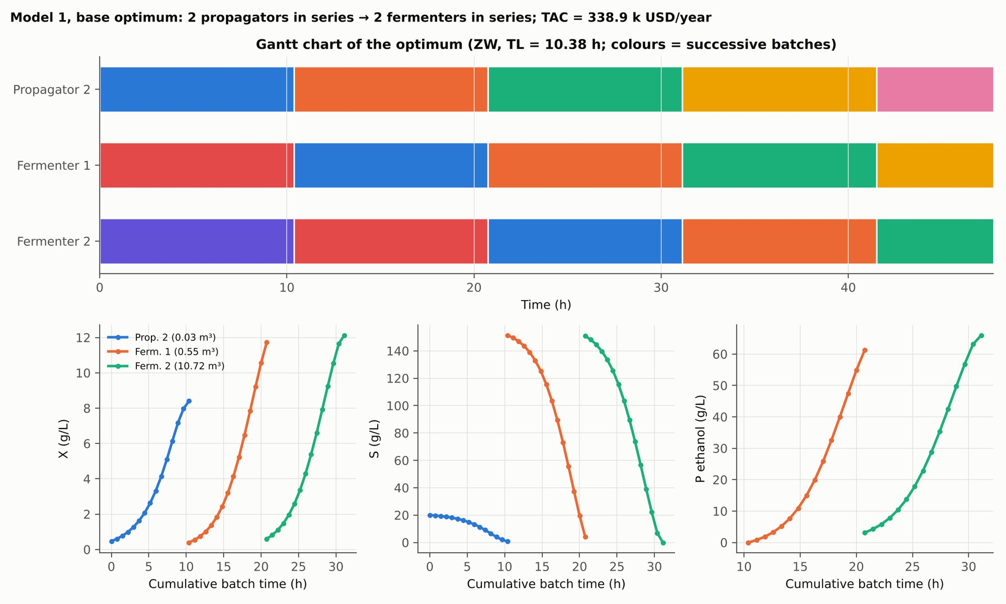
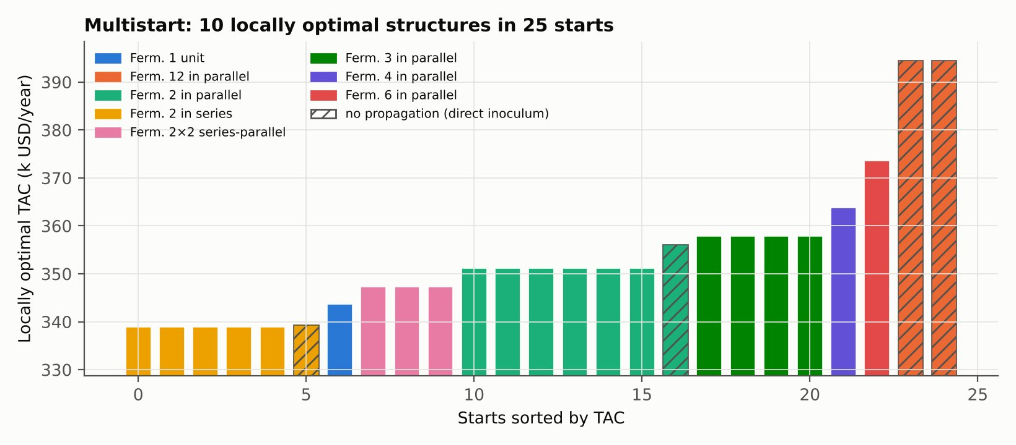
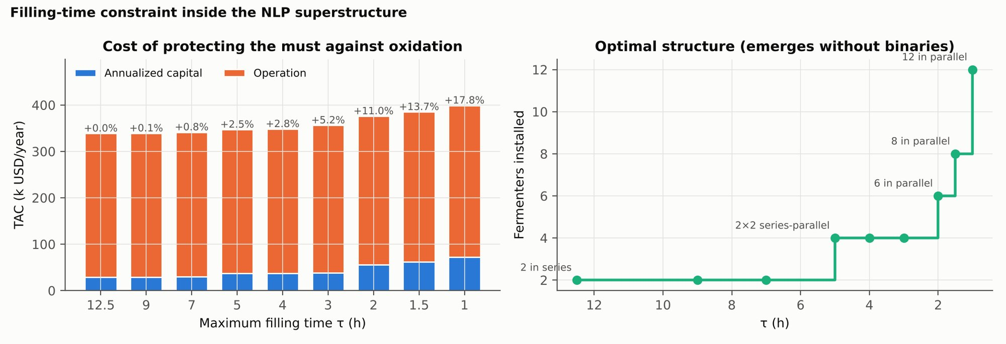
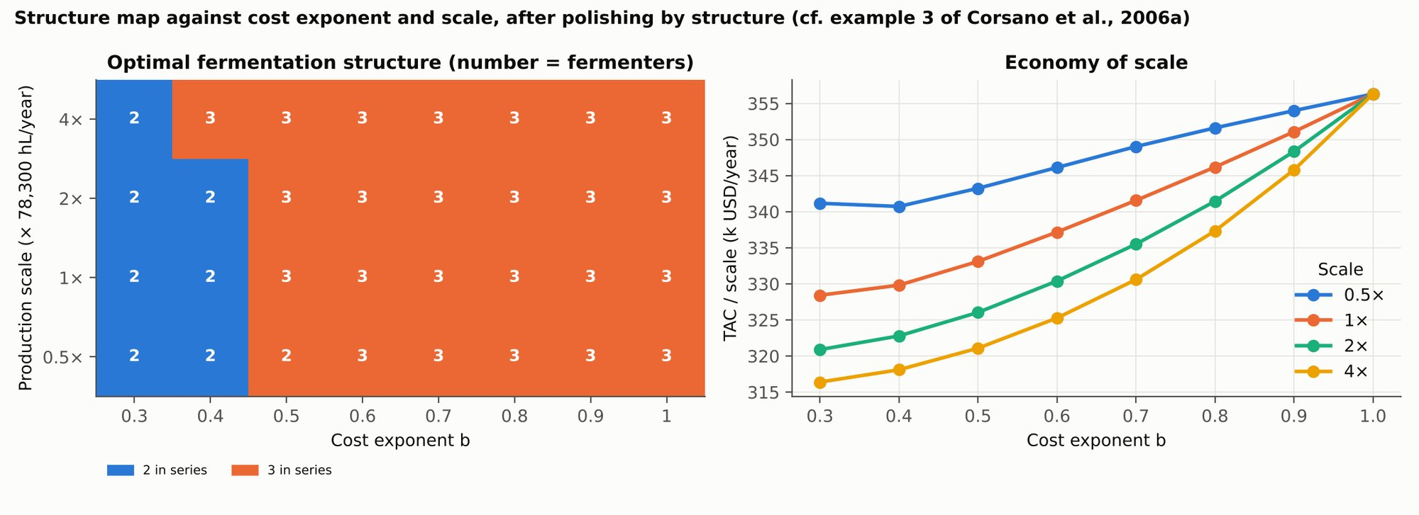
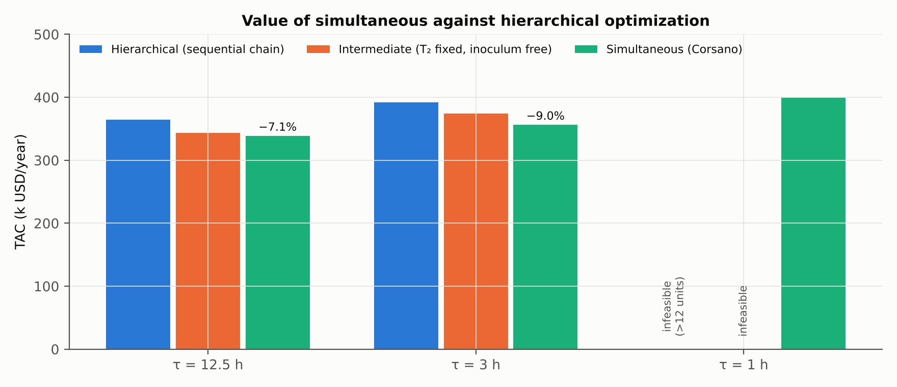
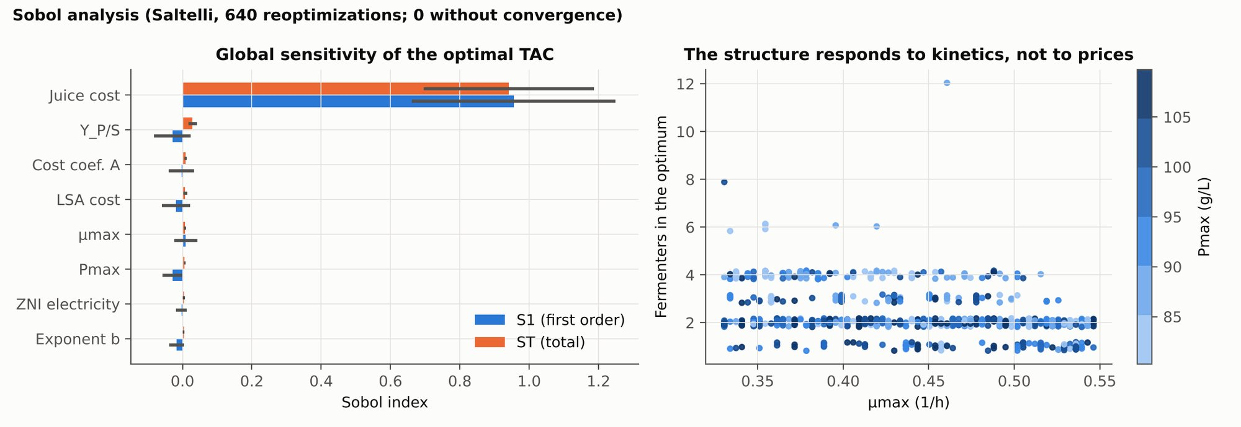
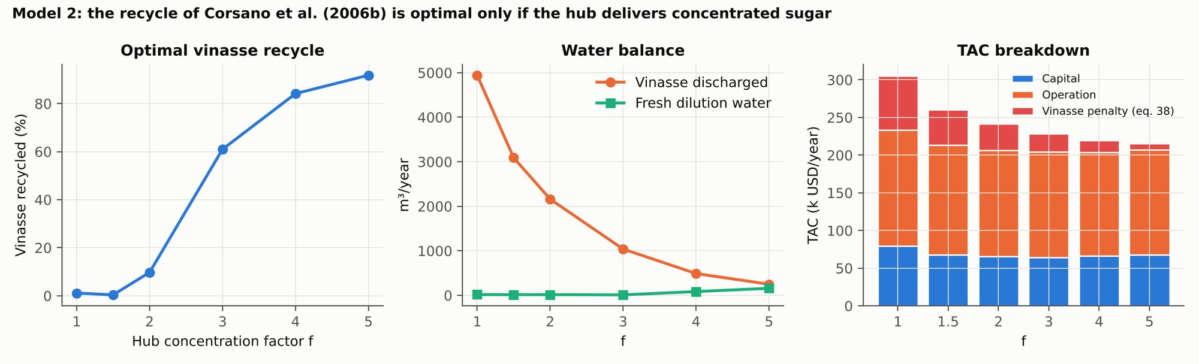
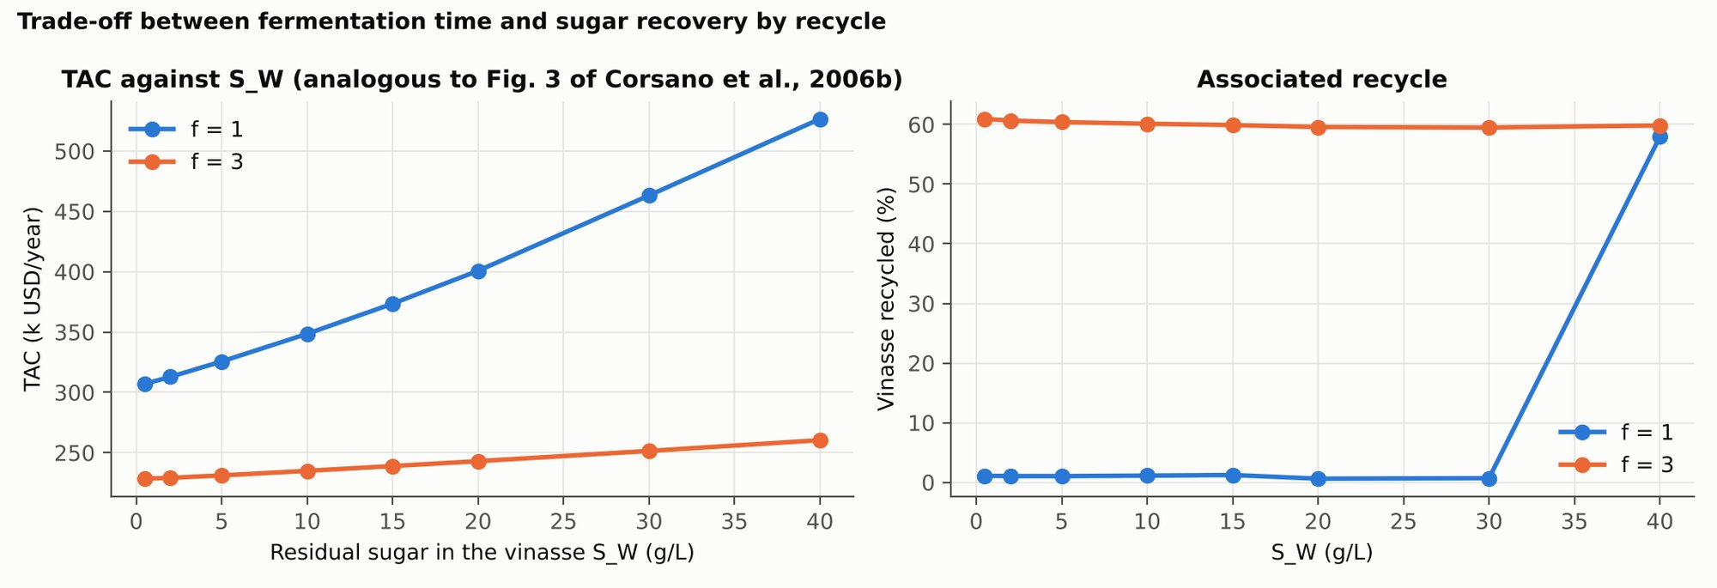
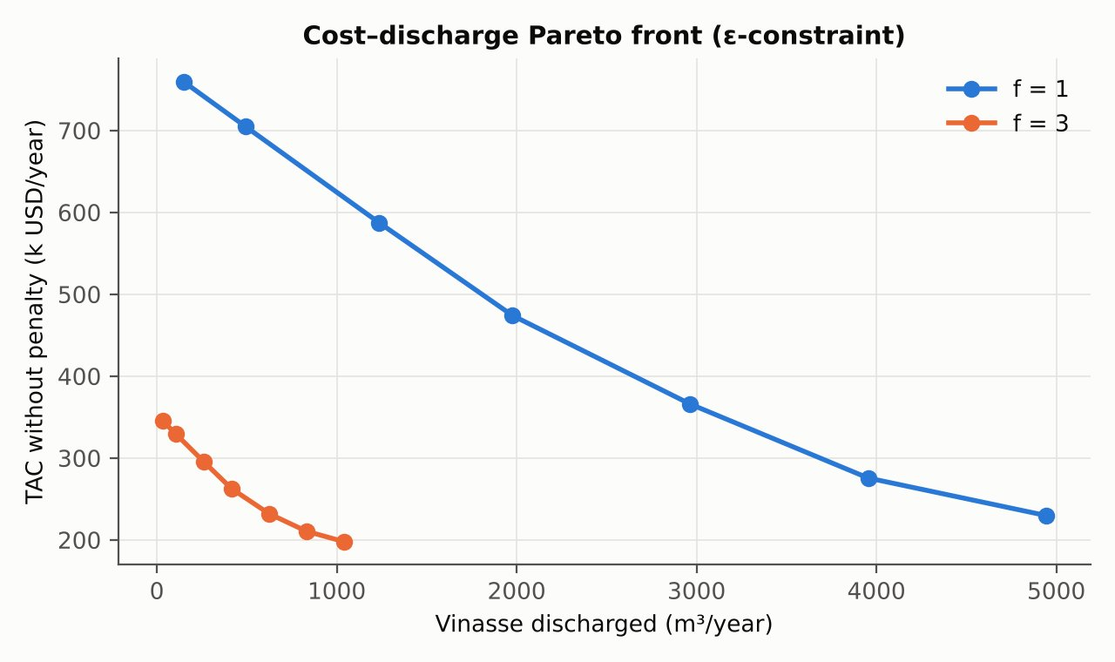
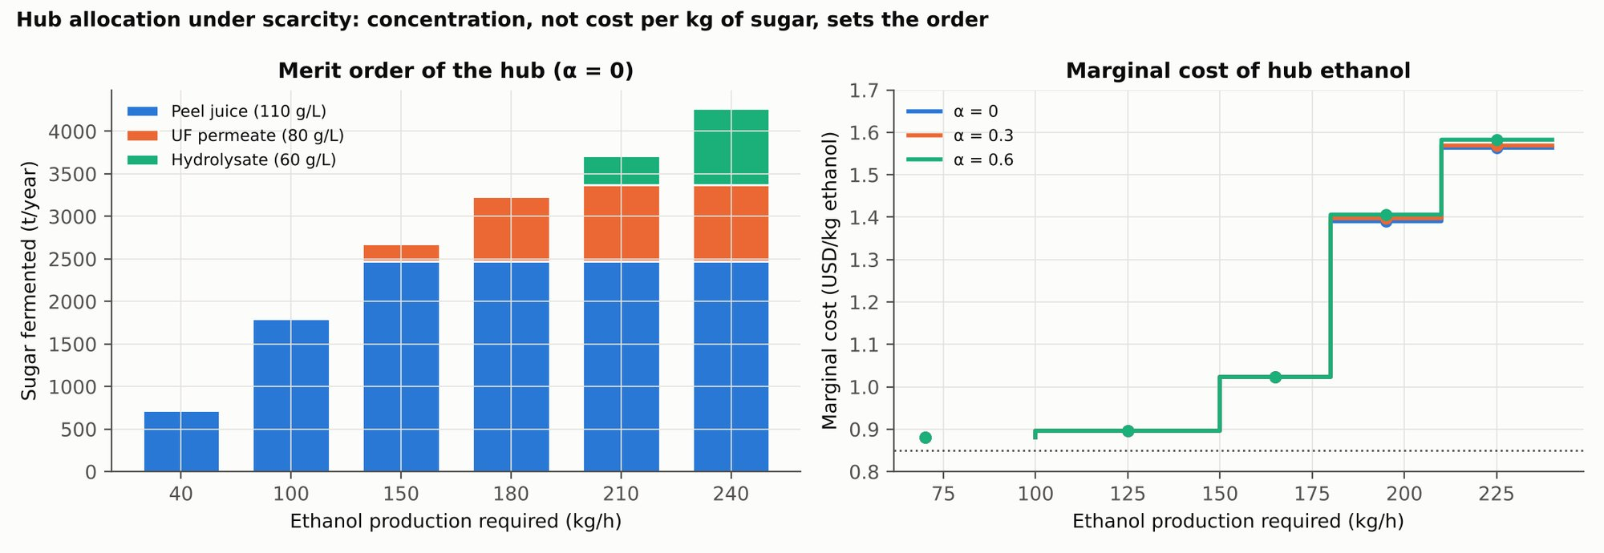
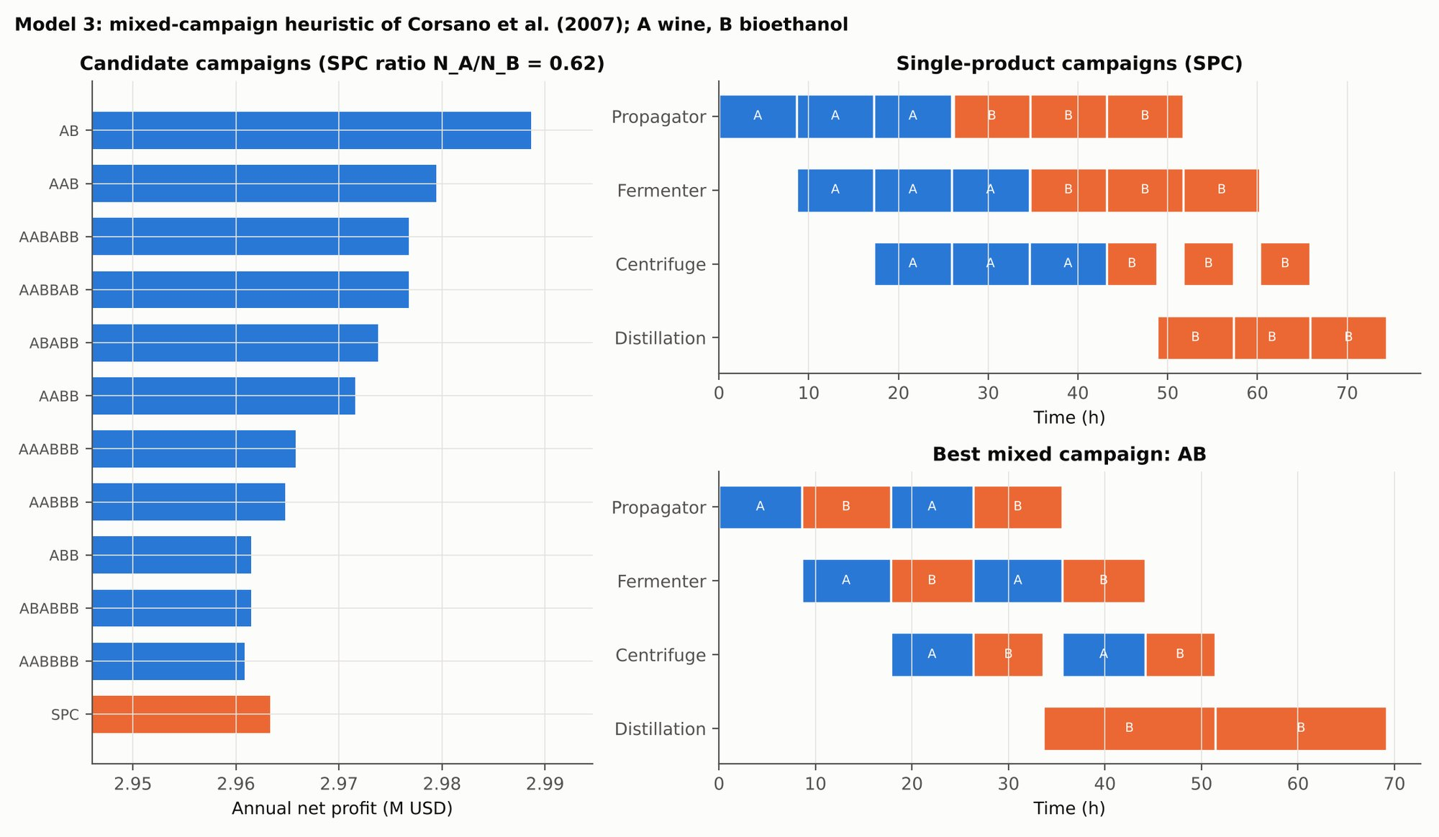
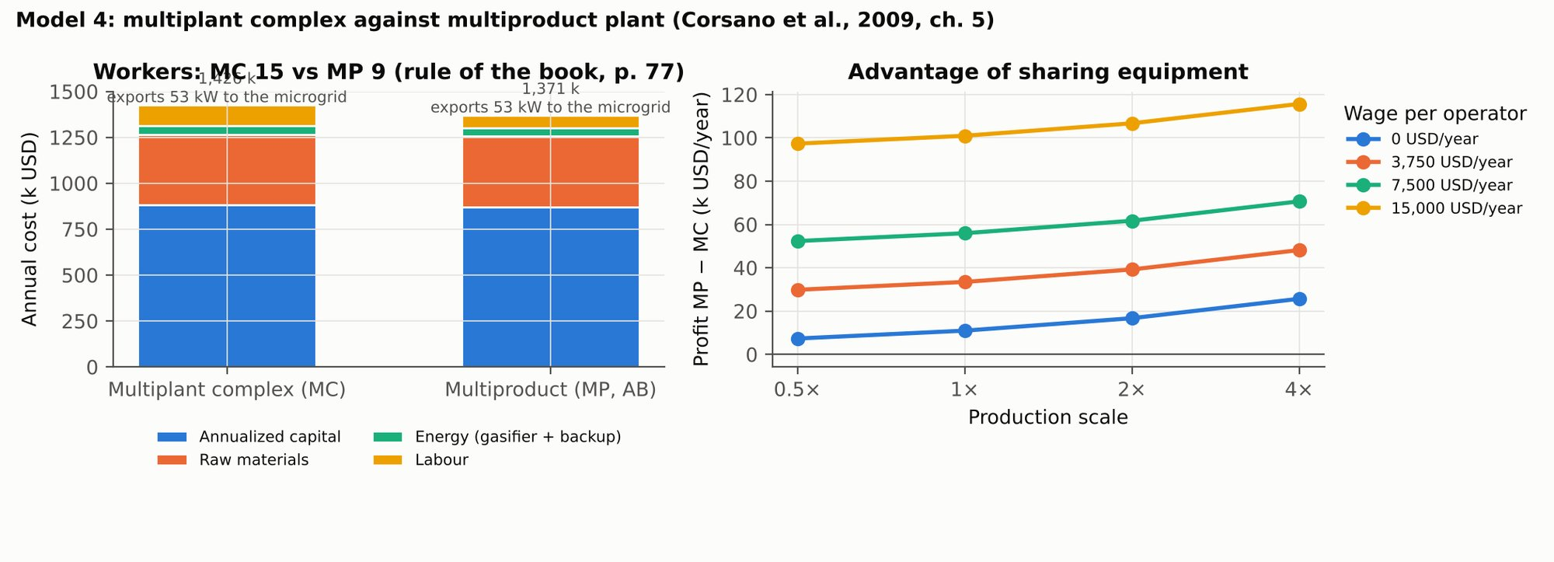

Chapter 3. Simultaneous Synthesis, Sizing and Seasonal Operation
The core contribution of the thesis is one mixed-integer linear program that chooses technologies, equipment sizes and the operation of every period of the year together, and that is an exact reformulation of the disjunctive design problem except for the fermentation kinetics. This chapter derives it, explains what stays outside and why, describes each family of constraints, and states how the model is solved and verified.

3.1 Superstructure as a Generalized Disjunctive Program and Its Exact MILP Reformulation
Stated in its most general form, the design of a whole-plant pineapple biorefinery is a nonconvex mixed-integer nonlinear program (MINLP): discrete choices of technology and equipment size interact with concave capital-cost laws, with products of equipment capacity and operating time, with fermentation kinetics, and with the bilinear balances of any intermediate pool whose composition is itself a decision. The earlier formulation of this project took that MINLP as its object. It could only be solved for a reduced instance of six product lines, by enumeration of its structural combinations, without the sugar hub, the energy island or the environmental objective, and without the seasonal operation that Section 2.1 shows to be decisive for equipment sizing.
This chapter takes a different route. Rather than approximating the MINLP or solving it locally, it separates its nonlinearities into two classes. The first class (economies of scale, capacity–time products, the winery sizing relation and product-quality blending) admits an exact reformulation as an MILP once the superstructure is written as a generalized disjunctive program (GDP) over catalogue sizes. The second class (fermentation kinetics and the pooling of streams of variable quality) is intrinsically nonconvex; it is removed from the plant-level problem and treated in the unit and train models of Chapter 2, which pass yields and processing times to the MILP as parameters and, crucially, quantify the error of doing so. The result is a polylithic architecture in the sense of Kallrath (2021): an MILP core that decides synthesis, sizing and seasonal operation simultaneously, surrounded by nonlinear satellite models that are solved, calibrated and verified on their own.
Figure 3.1. The superstructure: two feedstocks, six fractions, six routes and their products, with the routes selected in the version 12 optimum.
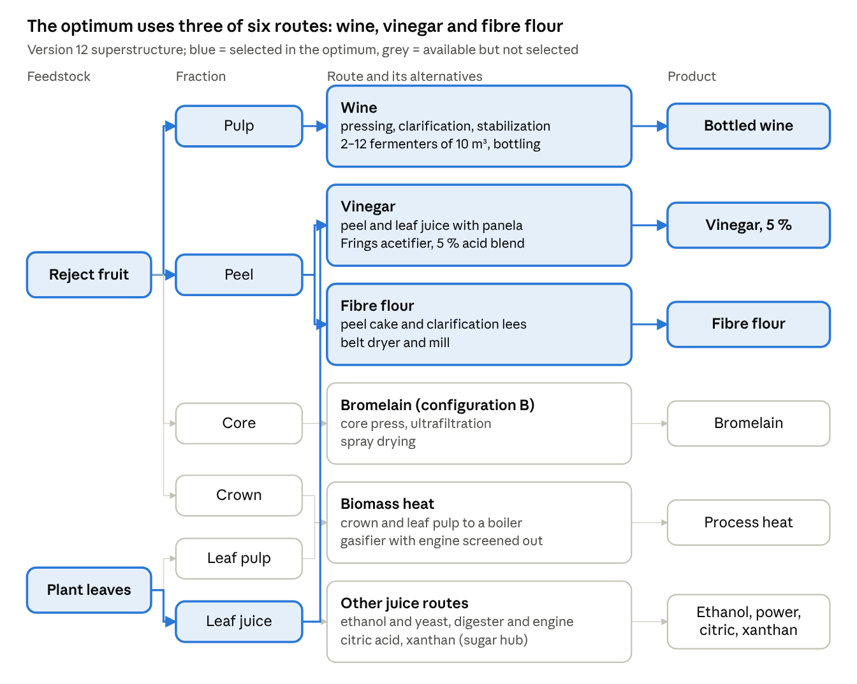
Version 12 superstructure and optimum

3.1.1 Sources of nonlinearity in the whole-plant design problem
Five families of nonlinear terms appear when the superstructure is written with continuous equipment sizes and explicit process models.
(i) Economies of scale. The purchase cost of unit u follows a power law of its capacity, which is concave for exponents below one:
$$C_{u}=C_{u}^{ref}{\left(\frac{{cap}_{u}}{{cap}_{u}^{ref}}\right)}^{n_{u}}, 0<n_{u}<1$$ | (3.1)
(ii) Capacity–time products. The quantity a unit processes in period t is its capacity times the hours it operates, both of which are decisions: F_ut ≤ cap_u · h_ut. With continuous capacities this is a bilinear term; with discrete sizes it becomes the product of a binary and a continuous variable.
(iii) Winery sizing. For a staggered winery of N_F fermenters of volume V_F fed at rate Q, the procedure of Moresi (1989b), corrected for the filling time at low flow, gives
$$N_{F}=\frac{Q Δt_{c}}{V_{F}}, Δt_{c}=\frac{V_{F}}{Q}+t_{proc}$$ | (3.2)
which is nonlinear in Q, V_F and t_proc jointly.
(iv) Product-quality blending. Vinegar must leave the acetifier at 5 % acetic acid. If the acid content of each feed were a decision, the specification would couple flows and concentrations bilinearly, as in any pooling problem.
(v) Fermentation kinetics and pooled feedstocks. The time a fermenter needs, its inoculum and its yield follow nonlinear differential equations (Monod-type growth with product inhibition for the pulp juice; the glucose–xylose model of Krishnan et al. (1999) for the peel and leaf juices). The earlier formulation also pooled peel juice, hydrolysate and permeate in a shared sugar hub whose concentration is a decision, which produces the bilinear balances of the classical pooling problem (Quesada and Grossmann, 1995).
Families (i) to (iv) are structural: they come from how equipment is bought, operated and specified. Family (v) is physical: it comes from how microorganisms and mixtures behave. The two classes are treated differently in what follows.

3.1.2 Generalized disjunctive representation and exact MILP reformulation
Catalogue disjunctions. Equipment is not bought in continuous sizes: vendors offer discrete models, and the cost law (i) is in practice a fit through those models. Each step u of the superstructure is therefore written as a disjunction over its catalogue entries s ∈ S_u, one of which is «not installed» where the step is optional:
$$\underset{s∈S_{u}}{⋁}\left[\begin{matrix}Y_{us} \\ {cap}_{u}={cap}_{us} \\ C_{u}=C_{us}\end{matrix}\right], {\underline{⋁}}_{s∈S_{u}}Y_{us}$$ | (3.3)
Because every term of the disjunction fixes the capacity and the cost, its convex hull is described exactly by binary variables (Grossmann, 2021, chs. 7 and 10):
capu=s∈Su​capus yus, Cu=s∈Su​Cus yus, s∈Su​yus=1 | (3.4)
The concavity of (i) is thus absorbed into the data: each catalogue cost C_us already contains it, and no nonlinear term remains. Logical relations between steps are translated from propositions into inequalities (Grossmann, 2021, ch. 7.1): vinegar requires wine or fermented juice; leaf ethanol requires the extractor; lees recovery requires a clarifier that produces lees; bromelain requires its press; and every product line requires the peeling front end.
Capacity–time products. With capacities fixed per catalogue entry, the product in (ii) becomes a binary times a continuous variable. It is linearized exactly by disaggregating the operating hours by size (Grossmann, 2021, ch. 7.3):
Fut≤s∈Su​capus gust, s∈Su​gust=hut, 0≤gust≤Ht yus | (3.5)
where H̄_t is the length of period t. Since only one y_us equals one, only the hours of the chosen size can be positive, and F_ut is bounded by exactly cap_u · h_ut. The same construction serves the shared press, whose time is split among materials, and the coupling of the front end with the perishable buffers (Section 3.4).
Winery sizing. With V_F taken from the tank catalogue and t_proc supplied by the kinetic models of Section 2.5, relation (iii) can be solved for the admissible feed rate. While one fermenter fills, the remaining N_F − 1 ferment, so Q ≤ (N_F − 1) V_F / t_proc, which is linear in the integer number of fermenters and exact for the given t_proc (Section 3.5).
Blending. Each fermented stream reaches the acetifier with a known potential acid content, so the acid produced is a linear combination of flows, A_t = a_W W_t + a_c J^c_t + a_h J^h_t + a_Z Z_t, and the 5 % specification becomes a linear volume constraint (Section 3.7). No intermediate pool of variable quality feeds more than one outlet, so the bilinear structure of (iv) never arises.
Term | Treatment | Exact?
(i) Concave capital cost | Disjunction over catalogue sizes, convex hull with binaries | Yes, with respect to the catalogue
(ii) Capacity × hours | Disaggregated hours bounded by the size binaries | Yes
(iii) Winery sizing | Linear in N_F for catalogue V_F and given t_proc | Yes, for the given t_proc
(iv) Vinegar blending | Linear acid balance with fixed potential contents and fixed specification | Yes
(v) Kinetics and pooling | Unit and train models of Chapter 2; parameters passed to the MILP | No: bounded approximation (Section 3.1.3)
The reformulated model is the MILP of Sections 3.2 to 3.9. For the reference case (one supply scenario, 24 periods per year) it has 177 binary variables (152 catalogue choices, the third shift, and 24 winery filling modes), 24 integer variables (press changeovers per period), about 5,800 continuous variables and about 7,100 constraints.

3.1.3 What stays outside the MILP, and the bound on the error
Kinetics. Fermentation time, inoculum and yield are not decisions of the plant-level model. They are computed by the kinetic and train models of Chapter 2 at the operating point of each fermentation and enter the MILP as yields and as the processing time t_proc of the winery constraint. This is a hierarchical decision: the kinetics are fixed before sizing.
The cost of that hierarchy is not assumed to be small; it is measured. Section 2.8 solves the fermentation train of the pulp juice as a nonconvex NLP superstructure in which kinetics, cycle time, inoculum and equipment are optimized together (Corsano et al., 2004; 2006a), and compares it with the hierarchical chain in which the kinetics fix the cycle time first. The hierarchical chain costs between 7.1 and 9.0 % more in total annualized cost, depending on the filling constraint imposed to limit oxidation; without that constraint, 82 % of the difference comes from the inoculum and propagation policy rather than from equipment sizing. This range is the bound on the error introduced by keeping kinetics outside the MILP, and it is reported with every result of Chapter 5.
Pooling. The bilinear balances of a shared sugar hub appear only if the hub is built. Two results show that it should not be, for the conditions of Bajo Atrato. First, the hub model of Section 2.8.5, a reproduction of the vinasse-recycle plant of Corsano et al. (2006b) adapted to pineapple streams, shows that with dilute streams (60 to 110 g/L of sugar) recycling vinasse is not profitable and the marginal cost of hub ethanol rises above its assumed price. Second, the MILP, which includes ethanol, citric acid and xanthan from peel and leaf juices as candidate routes with fixed stream compositions, does not select any of them at any supply scale between 0.5 and 3.6 times the 2022 supply, and the measured xanthan yield on pineapple residue (Iakovchenko, 2026) makes that route weaker still. Keeping each stream on its own route with known composition therefore loses no optimal design for the case studied. Should new data make the hub attractive, it would return as a nonlinear subproblem solved with the routes fixed by the MILP, or through piecewise relaxations of its bilinear terms, without changing the MILP core.

3.1.4 Consequences for tractability, bounds and verification
Tractability. Because the reformulation is exact, the MILP keeps every design and operating decision of the original problem except the kinetic ones, and it can be solved at the size the case requires: the whole plant, including plant leaves, energy units and blending, over 24 periods of a seasonal year. The same model is then solved repeatedly, which a nonconvex MINLP of this size would not allow: across eight supply scales, under a three-scenario two-stage stochastic program (Section 4.5), along an ε-constraint front (Section 4.7), and in about 60 sensitivity cases. Seasonal operation, which the earlier formulation had to leave out of scope, becomes part of the design problem; that is where the peak-month bottlenecks of Chapter 5 come from.
Bounds. A branch-and-bound MILP solver returns a valid dual bound with every solution. Local MINLP methods do not: on a one-stage fermentation subproblem certified to global optimality, outer approximation stopped 2.1 to 3.2 % above the global optimum without reporting it (Section 2.8.3). The MILP does not remove the optimality question, but it makes it visible. The reference solution of Chapter 5 is reported with its nominal gap against the dual bound of the free run (16.9 % in version 12), after warm starts, a neighbourhood search over catalogue sizes and a cross-evaluation of the designs of all sibling cases (Section 3.10). The polishing matters: the free run stopped at 2,511 MM COP/year, below several restricted cases, and the polished optimum is 3,196 MM COP/year. The gap mainly reflects a weak linear relaxation of the disjunctions over many periods, and it is stated as a limitation rather than hidden.
Verification. Exactness of the reformulation can be checked. Restricted cases cannot outperform the free optimum; the stochastic indicators must satisfy EEV ≤ RP ≤ WS; mass and energy balances must close; and the time grid must give the same solution with two and four periods per month (Section 3.11). A direct cross-check against the reduced MINLP instance of the earlier formulation, solving the MILP with that instance's parameters, is pending.
Limitations. Three simplifications remain. Unit efficiencies (boiler, gasifier, engine, digester) are constant per unit of flow, which is adequate for equipment operating near its rated point. The catalogue fixes the granularity of the sizes, so a design between two catalogue entries is not represented. And the kinetic decisions are fixed before sizing, with the error bounded as above.

3.2 Sets, Parameters and Variables
Symbol | Meaning
u ∈ U | 23 processing steps and utilities (Table 3.1)
s ∈ S_u | Catalogue entries of step u, including «not installed» where the step is optional
m = 1…12 | Months, with fixed boundaries
t ∈ T | Periods of the continuous-time grid, K = 2 per month (24 per year)
i ∈ I | Materials that may share the press: pulp, peel, core
j ∈ J | Perishable fractions buffered while the press works on another material
k ∈ K | Storable intermediates: fruit, pulp, peel, cake, leaves, must
p ∈ P | Products: bottled wine, vinegar, fibre flour, bromelain, powder, enzyme, ethanol, yeast, citric acid, xanthan, electricity, heat
ω ∈ Ω | Supply scenarios of the stochastic program

Variable | Type | Meaning
y_us | binary | Size s chosen for step u
y³ | binary | Third shift on the front end
w_t | binary | Direct filling of the winery in period t (Section 3.5.3)
n_t | integer | Press changeovers in period t
d_t | continuous | Length of period t (h), free within its month
w̃_t | continuous | Exact linearization of d_t · y³
g_ust | continuous | Hours of size s of unit u in period t
τ_ikt, v_fit | continuous | Press hours on material i with press size k; front-end linearization
F_t, P_it, W_t, J^c_t, J^h_t, Z_t, A_t, … | continuous | Fruit bought, material pressed, wine, peel and leaf juice to each destination, panela, acid, and every other stream
I_kt | continuous | Inventory of intermediate k at the boundary of period t
E_t, Q_t | continuous | Electricity and heat demand; biomass heat used; biogas power produced and used
Parameters come from the registry (Section 2.4): seasonal supply rates σ_m, fraction splits, yields and losses per alternative, catalogue capacities cap_us and costs C_us, utility coefficients, prices, demand caps, emission factors and calendar availabilities.

3.3 Catalogue Sizing and the Exact Size × Hours Linearization
Every equipment choice is a catalogue disjunction taken from the TRL-9 design module. Sizes span the range the case can need, from half to more than three times the 2022 supply, and each option bundles its companion equipment.
Step (u) | Options | Catalogue entries | Purchase cost (MM COP) | Bundled equipment
Front end (washing, peeling, coring) | 5 | 1, 2, 3, 5, 8 t/h | 172–868 | Washer, sorting belt, peeler-corers
Shared press | 6 | none; 1–8 t/h | 267–927 | Crusher, enzymatic macerator
Pulp decanter | 5 | none; 1–5 t/h | 454–1,169 | —
Dedicated peel press | 4 | none; 1–3 t/h | 198–383 | —
Must clarification | 15 | MF 10–80 m²; flotation 0.5–4 m³/h; centrifuge 0.5–5 m³/h | 74–1,234 | Feed tanks, CIP
Lees MF | 4 | none; 2, 5, 10 m² | 101–311 | —
Stabilization | 8 | HTST 500–3,000 L/h; SO₂; UHPH 500–2,000 L/h | 26–2,578 | Doser or heat exchanger
Must store | 7 | 10 to 800 m³ | 55–2,170 | Aseptic tank, pump
Wine winery | 11 | 2 to 12 × 10 m³ | 534–3,454 | Chiller, disc centrifuge, cartridge filter, propagator
Bottling line | 5 | none; 500–4,000 bottles/h | 337–1,172 | Filler, capper, labeller
Belt dryer | 6 | 50–800 kg water/h | 421–1,902 | Heat generator, mill
Juice winery | 6 | none; 2–8 × 10 m³ | 212–1,000 | Chiller
Acetifier | 7 | none; 2–40 m³ | 820–4,733 | Chiller, emergency genset, foam centrifuge, scrubber, vinegar MF
Crown boiler | 5 | none; 100–500 kWt | 245–644 | Chipper, crown dryer
Peel pretreatment | 2 | water; Ca(OH)₂ 0.1 % | 0–72 | Lime mixer and doser
Peel-juice enzyme | 7 | none; precipitation or UF, 0.25–1 t/h | 596–5,293 | Tanks or UF, centrifuge, freeze-dryer
Leaf extractor | 7 | none; 2–60 t/h | 172–2,051 | Screw press
Leaf-ethanol winery | 11 | none; 2–24 × 10 m³ | 331–3,620 | Centrifuge
Distillation | 7 | none; 10–400 L/h | 291–4,640 | Column, reboiler
Digester | 7 | none; 250–8,000 m³ | 555–5,861 | —
Biogas engine | 6 | none; 50–800 kWe | 340–2,918 | Heat recovery
Citric acid | 6 | none; 5–100 kg/h | 1,618–9,766 | Plant at TCI/Lang
Xanthan | 5 | none; 2–25 kg/h | 2,581–11,746 | Plant at TCI/Lang
Table 3.1. The catalogue of version 12: 23 steps and 152 options.
For every unit and period, the size × hours construction bounds what the unit processes by the capacity of the chosen size times its operating hours, and the hours by the calendar of the unit:
s​gust≤Htstaff=a2 dt+a3−a2 wtstaffed unitsac dtcontinuous units, wt≤dt, wt≤Hm y3, wt≥dt−Hm1−y3 | (3.6)
with a₂ = 0.36 (two six-hour shifts Monday to Saturday, 3,187 h/year), a₃ the availability with a third shift, and a_c = 0.90 for units that run around the clock (7,889 h/year). Staffed units are the front end, presses, decanter, clarification, lees MF, stabilization, enzyme recovery, leaf extractor and bottling; continuous units are the wineries, acetifier, dryer, boiler, distillation, digester, engine and hub plants. The third shift costs 368 MM COP/year of payroll with benefits and supervision and is the operating alternative to buying equipment.
Alternatives whose losses or variable costs depend on the option chosen (clarification, stabilization and enzyme recovery) carry their flow disaggregated by option with the same construction, x_ust ≤ cap_us g_ust, so that the loss and the variable cost of the chosen technology are the ones applied.

3.4 Annual Operation on a Continuous-Time Grid
The earlier manuscript left multi-period scheduling out of scope and sized the plant on an annual average. The models of this thesis show why that is not enough: a unit sized for the average saturates in the peak months and the fruit it cannot process is lost, because it cannot be stored. The MILP therefore carries the operation of the whole year, built from the scheduling formulations of Maravelias (2021).

3.4.1 The grid
Operation uses a common continuous grid anchored to the months (Maravelias, 2021, ch. 7.3, eqs. 7.35–7.36). Month boundaries are fixed points; each month m has K periods whose lengths are decisions:
T0=0, TT=η, Tt≥Tt−1, dt=Tt−Tt−1, t∈m​dt=Hm | (3.7)
Free period lengths let the model place a campaign of one material, or the peak of the harvest, within a month without fixing its date. With K = 2 the year has 24 periods. The solution was recomputed with K = 4 and did not change, so the grid is not driving the result.

3.4.2 Supply, processes and inventories
Supply. Fruit arrives at the seasonal rate of its month times the length of the period, σ_m d_t, which is linear in d_t and keeps the model linear. The plant may leave fruit unbought; fruit bought and not processed within the storage limit is lost. Leaves arrive in the same way at the rate of crop renewal.
Continuous processes (Maravelias, 2021, ch. 9.2): what a unit produces in a period is its rate times the time it runs, with the rate bounded by the capacity of the chosen size through the size × hours construction of Section 3.3.
Inventories with capacity (ch. 8.2): for each storable intermediate k,
$$I_{k,t}=I_{k,t−1}+{in}_{k,t}−{out}_{k,t}, 0≤I_{k,t}≤χ_{k}, I_{k,0}=I_{k,\left|T\right|}$$ | (3.8)
with capacities of three days of peak supply for fruit, 1.5 t for pulp, 3 t for peel, 12 t for cake, three days of peak arrival for leaves, and the store chosen for must. The schedule is periodic: the inventory at the end of the year equals that at the start.

3.4.3 The shared press, changeovers and perishable buffers
Changeovers (ch. 9.3.2): a press shared by pulp, peel and core splits its staffed time among materials and loses one hour of cleaning σ at each change of material:
i​k​τikt+σ nt≤Htstaff, Pit≤k​capk τikt, τikt≤H ykpress | (3.9)
A dedicated press or the decanter removes its material from the shared press: the press time of a material is forced to zero when its dedicated unit is installed.
Coupling with perishable buffers. While the press works on material i, the fruit still being peeled produces the other fractions j, which accumulate in their small buffers. With the front-end capacity F_max chosen by the model and n_m the cycles per period, the material balance of a campaign gives
$$f_{j} F_{max} n_{m} τ_{i}≤χ_{j} n_{t} ∀j≠i$$ | (3.10)
which is bilinear in the front-end size and the press time. It is linearized exactly with v_fi = y_f · τ_i for each front-end option f (v_fi ≤ H̄ y_f, v_fi ≤ τ_i, v_fi ≥ τ_i − H̄ (1 − y_f)), so that F_max τ_i = Σ_f cap_f v_fi. A dedicated press for fraction j relaxes the constraint for j by a big-M term, because then j no longer waits for the shared press. The coupling is what makes the number of changeovers a real trade-off: more campaigns per period mean shorter buffers but more cleaning time.
Seasonal must storage. The aseptic store can carry must from peak months to valley months for the winery to ferment later, which competes with buying a larger winery or front end.

3.4.4 What the annual model revealed
The annual model was first used on the line-selection plan of the earlier stage (wine and flour with a shared 2 t/h press), and the bottlenecks it found shaped the superstructure:
Configuration | Fruit lost (t/year) | Changeovers | Wine (m³) | Flour (t) | Bromelain (kg) | Bottleneck
A: wine + flour, shared 2 t/h press (K = 2) | 519 | 1,022 | 2,016 | 197 | 0 | Press (100 %)
A, with K = 4 | 522 | 1,026 | 2,015 | 197 | 0 | Press (100 %)
B: wine + flour + bromelain, shared 2 t/h press | 1,578 | 1,243 | 1,637 | 160 | 1,371 | Press (100 %)
B with a 3 t/h press | 220 | 1,073 | 2,123 | 207 | 1,778 | Front end (100 %)
With wine and flour and a 2 t/h shared press, the press was at 100 % in ten of twelve months: about 2.8 changeovers per day took its time even with little supply, and about 520 t of fruit a year (8 %) was lost in April–June and September–November. Adding bromelain made the press split its time among three materials and the loss rose to 26 %. A 3 t/h press cut the loss to 3.6 % and moved the bottleneck to the peeling front end. Microfiltration (≤ 63 %) and the dryer (≤ 35 %) were never limiting. These findings are the reason the superstructure offers dedicated peel and core presses and a decanter (Figures 3.2 and 3.3).
Figure 3.2. Annual Gantt of the shared press by material, with changeovers, and load of each unit by period. Figure 3.3. Occupation of each unit by month and fruit not processed for lack of capacity (models report, figs. 24–25).
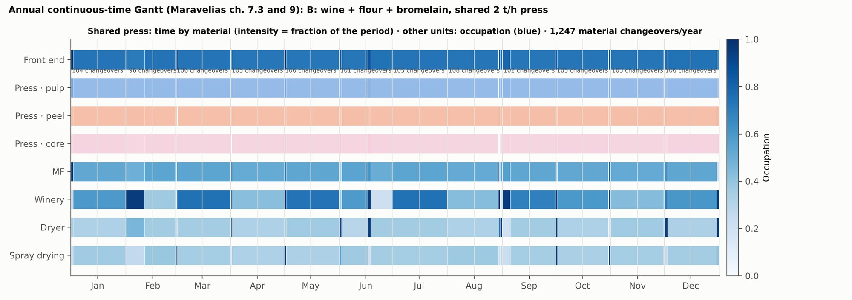
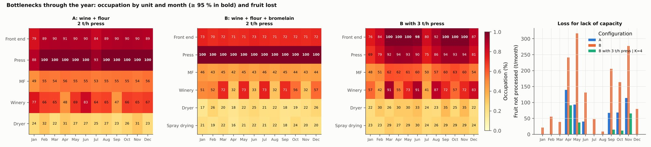

3.5 Winery Sizing: Moresi's Procedure in Linear Form
The winery sets the plant's wine output, carries its largest refrigeration load and is the unit where product quality is most exposed to how the must is handled. This section explains why the MILP sizes it with Moresi's (1989b) batch-cascade procedure written as a linear capacity bound instead of a scheduling sub-model. It also states what that bound assumes, and how version 12 adds a filling-time rule that the original procedure leaves implicit. The argument has three parts: Moresi's relation is linear in the number of fermenters once volume and processing time are fixed; the catalogue makes it exact rather than approximate; and the one place where it hides a physical risk, slow filling and must oxidation, can be handled with a linear disjunction instead of a nonlinear model.

3.5.1 Moresi's procedure and the filling-time correction
Moresi (1989b) sizes a batch winery in three steps. First, the fermentation conditions are fixed: temperature, inoculum and therefore the fermentation time, taken from the kinetics. Second, the cycle time of one fermenter is the sum of the time needed to fill it and the processing time (fermentation, discharge and cleaning):
$$Δt_{c}=t_{fill}+t_{proc}$$ | (3.11)
Third, the number of fermenters of volume V_F needed to absorb a must flow Q is
$$N_{F}=\frac{Q Δt_{c}}{V_{F}}$$ | (3.12)
Moresi takes the filling time as a short pumping operation of about 1.5 h, which suits a grape harvest that delivers large volumes over a few weeks. A pineapple plant in the Bajo Atrato instead receives a small, nearly continuous flow over the whole year, and a fermenter fills at the rate the must arrives: t_fill = V_F / Q. Substituting this correction gives
$$N_{F}=1+\frac{Q t_{proc}}{V_{F}} ⇔ Q≤\frac{\left(N_{F}−1\right) V_{F}}{t_{proc}}$$ | (3.13)
The reading is simple: at any moment one fermenter is filling while the other N_F − 1 ferment, and those N_F − 1 vessels set the throughput. The procedure was first replicated against Moresi's own worked example (his numbers of fermenters, 5, 26 and 69, are reproduced; Section 2.5.3) and then applied to pineapple must. Two results carry into the MILP. Year-round operation divides the fermentation investment by 7.7 to 9.2 relative to a 28-day harvest regime. And the cost-optimal winery without a filling limit, a closed 30 m³ system, needs about 29 h to fill one vessel at the plant's must flow, which is precisely the oxidation risk the earlier manuscript discussed for its pulp train. The second result is the reason for the filling rule of Section 3.5.3.

3.5.2 Linear form in the MILP, and why it is exact
The winery enters the superstructure as one more catalogue unit. Each option n ∈ {2, …, 12} is a set of n fermenters of V_F = 10 m³ with the processing time fixed at t_proc = 12.5 h of fermentation plus 2.5 h of discharge and cleaning. Its capacity and purchase cost are computed before the model is built:
$${cap}_{n}=\frac{\left(n−1\right) V_{F}}{t_{proc}}, C_{n}=C_{ferm}\left(n\right)+C_{chiller}\left({cap}_{n}\right)+C_{centrifuge}\left({cap}_{n}\right)+C_{filter}\left({cap}_{n}\right)+C_{propagator}$$ | (3.14)
In each period t, the wine fermented is bounded with the same size × hours construction used for every other unit:
Wt≤n​capn gn,t, gn,t≤H yn, n​gn,t≤ac dt, n​yn=1 | (3.15)
The peel-juice and leaf-juice fermenters for vinegar and ethanol use the same form with their own processing times (12.6 h and 14.5 h, from the calibrated kinetics of Section 2.5.4). This is not a linearization of a nonlinear winery model. Three facts make it exact:
- Moresi's sizing relation is already linear in N_F once V_F and t_proc are fixed. The only product in it, N_F · V_F, disappears because V_F is fixed at a standard 10 m³ vessel. A continuous V_F would create a bilinear term, and that is exactly what the catalogue avoids.
- Every nonlinearity lives inside the catalogue constants. Economies of scale in fermenter cost (exponent 0.6), the chiller sized from the fermentation heat, and the centrifuge and cartridge filter sized from the throughput are all evaluated per option, offline. The MILP sees one capacity and one cost per option, and the disjunction over options has an exact convex hull.
- The time scales separate. A fermenter cycle lasts 15 to about 40 h, while a period of the continuous-time grid is half a month (about 360 h), so each period contains 9 to 24 staggered cycles. A bound on the average flow within a period is therefore the right quantity; the cycle-level schedule is drawn afterwards from the solution and does not change the sizes.
What would make the winery nonlinear is letting V_F or t_proc vary continuously: vessel size, or fermentation temperature traded against time and cooling duty. Both are design choices the thesis treats as discrete alternatives, and either can be added as extra catalogue options without leaving the MILP class.

3.5.3 Filling time, the must buffer and oxidation
The correction t_fill = V_F / Q has a consequence that the capacity bound alone does not show. Because Q ≤ (N_F − 1) V_F / t_proc, the time to fill a fermenter directly from the press line is
$$t_{fill}=\frac{V_{F}}{{\overset{‾}{Q}}_{t}} ≥ \frac{t_{proc}}{N_{F}−1}, {\overset{‾}{Q}}_{t}=\frac{W_{t}}{a_{c} d_{t}}$$ | (3.16)
With the two fermenters that most solutions choose, a vessel takes at least 15 h to fill even at full load, and much longer in the low-supply months. During that time pasteurized or sulfited pineapple must sits uninoculated or partly fermented, and browns and oxidizes. Moresi's procedure does not face this, because a grape harvest fills a vessel by pumping in about an hour.
The plant already has the remedy in its superstructure: the aseptic must store, which in the model levels supply between peak and valley months. If the must accumulates in that store and the fermenter is filled from it by pump, the filling time is set by the pump, not by the supply. The cost is space: while a batch accumulates, the store level rises by up to V_F above its seasonal inventory. Version 12 writes this as a disjunction per period, with a binary w_t that selects direct filling (w_t = 1) or filling from the store (w_t = 0):
Wt≥VFτmax ac dt−H1−wt, Iqmust+VF1−wt≤s​Vs ysstore q∈{t−1,t} | (3.17)
Here τ_max = 6 h is the longest acceptable direct filling time ([S], range 3–12 h), I^must_q is the seasonal must inventory at the period boundaries and V_s are the store sizes in the catalogue. The big-M term is exact because d_t ≤ H̄. The rule adds one binary per period and scenario (24 in the deterministic cases) and keeps the model an MILP.
The rule is not decorative. Checked after the fact, the version 11 solutions violate it in 15 to 23 of the 24 periods: their 10 m³ store is kept full of seasonal must and leaves no room for a batch. Under the version 12 parameters it costs nothing for the version 11 design (2,511 MM COP/year with and without the rule): once wine sales are capped at 500,000 bottles a year, the winery runs below capacity and the store is no longer full. Enlarging the store to 25 m³ would cost 39 MM COP/year. All final version 12 results are solved with the rule. It does not bind in the optimum (3,196 MM COP/year with and without it), nor in the cases without a cap on wine or vinegar sales (10,530 and 16,027 MM COP/year): in all three the store holds no seasonal inventory, so its 10 m³ are always free for the batch and the winery can be filled from the store in every period. The rule therefore changes the operating policy, not the design or the margin. Its value is to rule out solutions like those of version 11, which looked feasible only because the filling problem was invisible to the model.
The treatment is conservative in one respect. When a fermenter is filled from the store in about an hour, its cycle is t_proc + 1 h rather than t_proc + V_F / Q, and the winery could carry roughly one fermenter's worth of extra capacity, N_F V_F / (t_proc + τ_pump) instead of (N_F − 1) V_F / t_proc. The model does not credit it, because the same store also carries the seasonal inventory.
Figure 3.4. Gantt of the winery with staggered fermenters at the scale of Chocó and of the earlier design basis (models report, fig. 26).
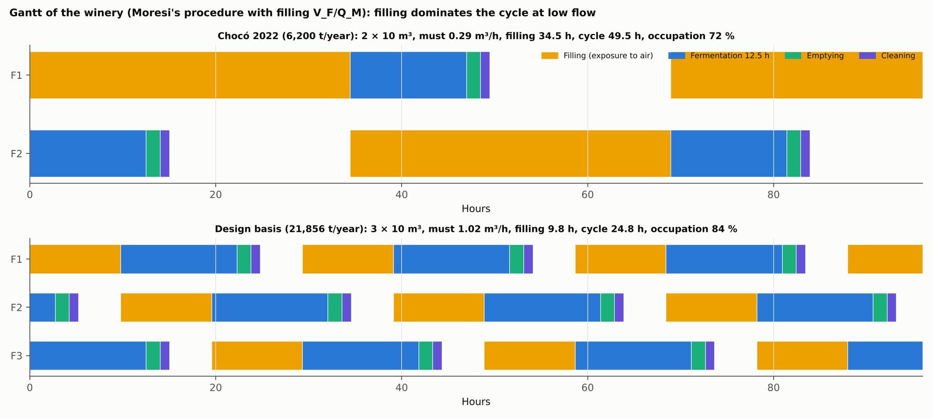

3.5.4 What the linear form does not capture
- Fixed processing time. Moresi's first step fixes the fermentation conditions before sizing. Temperature trades fermentation time against cooling duty and aroma, and the MILP does not choose it. The extension that keeps the model linear is to add operating regimes as catalogue options (for example 18 °C and 25 °C), each with its own t_proc, chiller and cost.
- Overlapping cooling peaks. The chiller is sized from the average fermentation heat with a 10 % margin. In the replication of Moresi's example, the overlap of the 4-h cooling peaks of staggered fermenters raised the refrigeration cost of open systems by 15 to 31 %. The jacketed closed fermenters of the design spread that peak, but the chiller cost may be underestimated in the larger options.
- Start-up, shutdown and phasing. The bound assumes staggered fermenters in steady rotation within each period. The first batches after a supply gap, and the integer phasing of cycles inside a half month, are not represented; they are drawn afterwards in the Gantt chart.
- Juice fermenters. The filling rule applies to the wine winery only. Peel and leaf juice go to vinegar or ethanol, whose quality is less sensitive to oxidation, so their fermenters keep the plain Moresi bound.
- Single vessel size. V_F = 10 m³ is fixed. In the year-round Moresi experiments the cost per m³ of wine is flat between 10 and 30 m³ for closed fermenters at 15 °C and rises with V_F for fast fermentation at 30 °C, so 10 m³ is at or near the minimum; larger vessels would also lengthen the filling time of Section 3.5.3.

3.6 Energy Coupling: Seasonal Electricity and Heat Balances and the Autonomy Constraint

3.6.1 Balances per period
Energy enters the MILP period by period, so that the choice of energy units sees the seasonal profile of the demand they serve. For each period t:
Qtdem=u​quFut, Qtbio≤Qtdem, QtLPG=Qtdem−Qtbio | (3.18)

Etdem=u​euFut+eairs​Vsacetysacet acdt, Etuse≤minEtbio, Etdem, Etdiesel=Etdem−Etuse | (3.19)
The heat coefficients q_u cover the dryer (about 2,590 MJ per t of cake), pasteurization when chosen, distillation and digester heating; biomass heat comes from crown (2,720 MJ/t) and leaf pulp (6,527 MJ/t) in the boiler and from engine heat recovery. The electricity coefficients e_u come from the unit models, and the acetifier aeration (1.2 kW/m³) runs continuously, so it scales with the installed volume, not with the flow. Biogas power can only displace diesel up to the period's own demand, because a ZNI has no buyer for surplus power.

3.6.2 Linear GWP
A linear expression adds the process emissions of each period with the factors of the LCA (Section 4.2): diesel electricity, LPG, boiler CH₄ and N₂O, composting, biogas leaks, diesel for leaf collection, fruit transport, chemicals, panela, bottles and effluent treatment. It serves as the alternative objective of the minimum-GWP problem and as the ε-constraint of the Pareto front (Section 4.7), and its total agrees with the LCA within the water and effluent detail the LCA adds (1,277 against 1,288 t CO₂e/year for the optimum, both including the leaf pulp returned to the field).

3.6.3 Energy autonomy as feasibility
The earlier manuscript treated energy autonomy as a hard feasibility condition and proposed to test it with the flexibility index. The flexibility test of a design d asks whether, for every parameter realization θ in a box T of expected deviations, there exist controls z that satisfy every constraint f_j (Halemane and Grossmann, 1983; Swaney and Grossmann, 1985):
$$χ\left(d\right)=\max_{θ∈T} \min_{z} \max_{j} f_{j}\left(d,z,θ\right)≤0$$ | (3.20)
The flexibility index F is the largest scaling of the box for which χ stays non-positive. When the constraints are quasiconvex the critical point lies at a vertex of the box and 2^p vertices suffice; when that cannot be shown, the active-set mixed-integer formulation avoids the vertex assumption (Grossmann and Floudas, 1987). Because the sizing model is linear, its flexibility test is itself an MILP over the seasonal grid.
The reference model keeps diesel electricity and LPG heat as purchasable utilities, because a site with neither has no feasible plant at the scale of the case. Autonomy is therefore tested in two steps that are formulated but not yet run for version 12: an upper bound ε_D on diesel electricity (and on LPG heat), swept down to zero, gives the cost of autonomy in margin and in portfolio; and, for the designs that remain feasible, the flexibility index with respect to supply and leaf collection measures how far the seasonal supply can deviate before autonomy fails. That is the evidence hypothesis H2 needs (Section 4.6). Formulated as a two-stage program with guaranteed feasibility (Grossmann, 2021, §15.2), it joins the stochastic design of Section 4.5 and the flexibility question in one model.

3.7 Product Quality and Market Constraints

3.7.1 Vinegar blending
The acetifier only dilutes, so the fermented feeds must carry enough potential acid for a 5 % vinegar (c_v = 50 kg/m³). With W_t the wine diverted (m³), J^c_t and J^h_t the fermented peel and leaf juices (t), Z_t the panela added (t) and A_t the acid produced (kg):
At=aWWt+acJtc+ahJth+aZZt, Wt+Jtcρc+Jthρh≤Atcv, Atcv 24≤s​prods gstacet | (3.21)
The potential acid of each feed follows from its ethanol and the 94 % yield (60/46 g of acid per g of ethanol). Wine, at 65 g/L of ethanol, carries about 80 kg of acid per m³, so one m³ of wine makes about 1.6 m³ of 5 % vinegar. Peel juice, with about 104 g/kg of sugar fermented at 0.36 g/g, carries about 46 kg of acid per tonne, just below 5 % by volume; leaf juice carries only about 27 kg/m³. Without the blending constraint an early version sold leaf juice as 5 % vinegar without concentrating it; with it, versions 7 to 10 had to divert wine to lift the juices to 5 %.

3.7.2 Added sugar
Panela added to the juices before fermentation raises their acid potential. It is limited per volume of juice and adds a_Z = 438 kg of acid per tonne (85 % fermentable sugar, 0.42 g/g ethanol yield, 94 % acetification):
$$Z_{t}≤z_{max}\left(\frac{J_{t}^{c}}{ρ_{c}}+\frac{J_{t}^{h}}{ρ_{h}}\right), z_{max}=0.15 t/m^{3} \left(0.10–0.20\right)$$ | (3.22)
Panela is charged at its price (3,500 COP/kg [S]) and its emission factor (0.6 kg CO₂e/kg [S]). With panela, wine is no longer the only way to bring juices to 5 %, and the volume of vinegar is limited by its market rather than by the wine.

3.7.3 Bottling and the two markets
Wine not diverted to vinegar is bottled by staff, within the capacity of the chosen bottling line, and annual sales of both products are bounded by their markets:
Wtb=YW Mt−Wt≤s​capsbot gstbot, t​Atcv≤Dvin, t​Wtb≤Dwine | (3.23)
with M_t the must fermented and Y_W its wine yield, D_vin = 3,000 m³/year and D_wine = 500,000 × 0.75 L = 375 m³/year, both [S] until market studies exist. The revenue per litre of bottled wine is the net of Section 2.6.1 (6,223 COP/L at the central retail price), so the excise is inside the objective: it is departmental and is not waived by the ZOMAC regime. In earlier versions the wine market was unbounded at a bulk price, which is why the optimum then bought all the fruit.

3.8 Feedstock Collection Siting
Leaves are bulky and dispersed, so synthesis is extended with location and transport, the extended processing-step network of Bertran, Tula and Gani (2022, sec. 5.1). A separate MILP chooses the plant site (binary y_s), the zones that host an extraction depot shipping only juice (binary z_j), and the mode of each flow (river or road), minimizing the annual cost of cutting and loading (15,000 COP/t), freight (900 COP/t·km by river, 600 by road) and depots, these with annualized investment and one operator per shift:
minj​ccutLj+m​cm δjm1−zjLj+zj ϕ Lj+j​Cdep zj s.t. s​ys=1 | (3.24)
where L_j is the leaf supply of zone j and φ the juice share shipped from a depot. Four zones with assumed areas and distances [S] give a clear answer: the central plant at the riverside town with road access wins, at 35,400 COP per tonne of leaves delivered, against 46,950 at the other site and 80,500 or more with depots in all four zones. Depots save only 24 % of the freight, because the leaf pulp stays in the zone, and each needs equipment and an operator per shift. The cost does not change between 10 and 50 % of collectable area, and the mean fruit distance, 34 km, goes to the LCA (Figure 3.5).
Figure 3.5. Stylized collection siting: cost by configuration and assumed zones (models report, fig. 42).
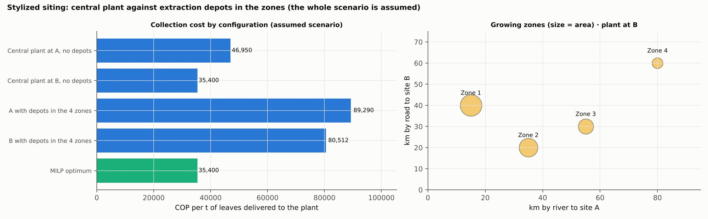

3.9 Objective Function and Weekly Scheduling Check

3.9.1 Annual margin
The MILP maximizes the annual margin:
max t​p​πpPpt−u,s​cusvarxust−πfruitFt−ccolLt−πZZt−cσnt−πEEtdiesel−πQQtLPG−u,s​AF Cus+Cusfixyus−Cshift y3 | (3.25)
Revenues are net of excise and packaging for wine. Variable costs include consumables, membranes, chemicals and effluent treatment for each option chosen. Fruit costs 400 COP/kg [S] and leaves 35,400 COP/t delivered [S]. The annual capital charge AF = 0.762 per unit of purchase cost combines the equivalent Lang factor of the TEA templates (3.14) with capital recovery at 10 % over 10 years, 5 % maintenance and 3 % local taxes:
$$AF=L_{eq} \left(CRF_{10\%,10}+0.05+0.03\right)$$ | (3.26)
Fixed costs that depend on the option (operators of enzyme recovery, membrane replacement, aeration) enter as C^fix. Base payroll and fixed costs that do not depend on size do not change the choice and are left out, so the margin is a decision criterion, not the NPV, which is computed afterwards with the full TEA (Section 4.1).

3.9.2 Weekly scheduling check
The annual grid averages within half-months. A discrete-time state-task network of the peak week (Maravelias, 2021, ch. 7.2.2) checks that the plan can actually be executed shift by shift: one task at a time per unit (eq. 7.4), bounded batch sizes (eq. 7.5), inventory balances with storage limits (eq. 7.6), cleaning on change of material in a shared unit, and shift windows. On the peak week of the earlier wine + flour plan (119 t of fruit with daily deliveries, pulp buffer 1.5 t, peel 3 t, cake 12 t, must 50 m³):
Configuration | Status | Binaries | Fruit (t) | Unprocessed (t) | Occupation
Shared press 3 t/h | optimal | 918 | 119 | 0 | Front end 100 %, MF 100 %, press 58 %, dryer 100 %, fermenters 10–31 %
Shared press 2 t/h | optimal | 918 | 119 | 0 | Front end 100 %, MF 100 %, press 64 %, dryer 100 %, fermenters 10–21 %
Two presses of 2 t/h | optimal | 918 | 119 | 0 | Front end 100 %, MF 100 %, presses 100 %, dryer 100 %, fermenters 10–21 %
The shared press avoids a second press, and any growth in supply requires the front end, the MF and the dryer to grow before the fermenters. The weekly model showed the press at 64 % where the annual model showed it at 100 %: the weekly supply was capped by the front end of the plan, while in the annual model the peak supply reaches 640 t/month and the linear coupling is conservative, so the two results bound the real occupation (Figure 3.6). For the version 12 optimum, the weekly schedule is drawn from the solution in the Gantt chart of Section 5.2.
Figure 3.6. Optimal weekly schedule with a shared 2 t/h press and intermediate inventories (models report, fig. 21).
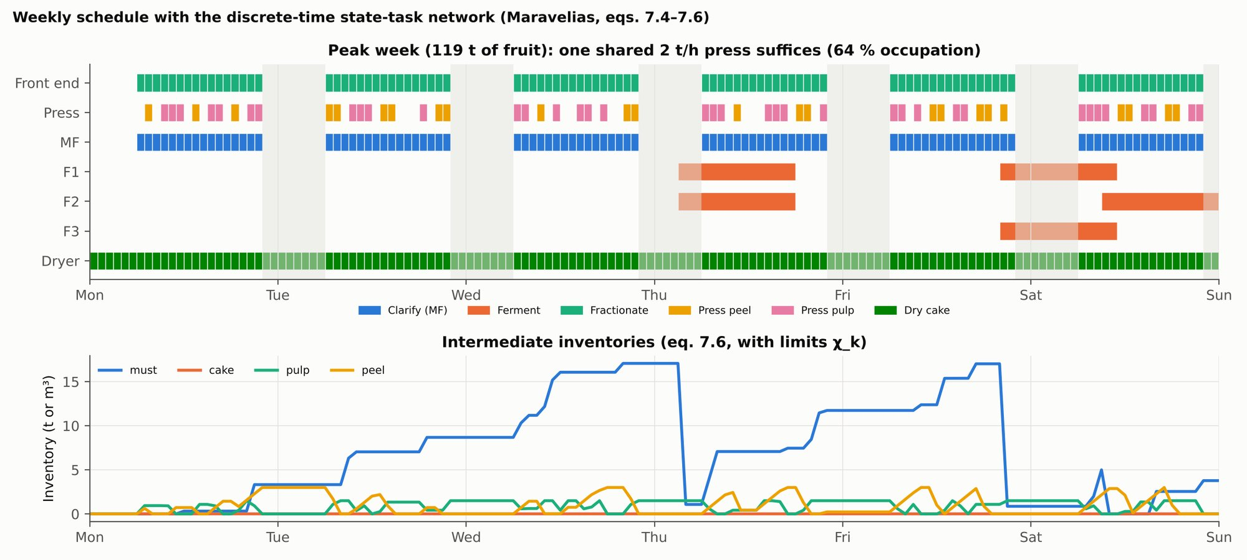

3.10 Solution Strategy: Warm Start, Neighbourhood Polishing and Reported Gaps

3.10.1 Solver and experiments
The MILP is built in Python and solved with SCIP through PySCIPOpt, with a time limit per case and a relative gap target of 0.5 %. It is solved for nine groups of experiments, each answering one design question:
Group | Question | Cases
E1 | Which design pays with the current supply? | TRL-9 reference; reference with one shared press; best design with the earlier topology; optimum; optimum without each option (SO₂, vinegar, crown boiler, version 10 options, leaf ethanol, digester, panela); without the vinegar cap; without the wine cap; version 11 design with version 12 parameters
E2 | How does the design change with scale? | 0.5, 0.75, 1, 1.5, 2, 2.5, 3 and 3.556 times the 2022 supply
E3 | What are the must store and the third shift worth? | At twice the supply, with and without each lever
E4 | What changes under supply uncertainty? | Two-stage stochastic program, mean-value problem, wait-and-see
E5 | Does bromelain from the core pay? | Configuration B: reference, earlier topology, optimum
E6 | Where does the wine go as prices change? | Three retail prices of the bottle × two vinegar prices
E7 | How robust is the leaf route? | Collectable fraction 10 and 50 %; collection at 80,000 COP/t; ethanol at 3,000 COP/L
E8 | How much vinegar does the design absorb? | Vinegar demand 1,500, 6,000 and 12,000 m³/year; panela at 5,000 COP/kg; 6,000 m³ without panela
E9 | How much wine, and at what price? | 250,000, 1 million and 2 million bottles; retail 10,000 and 25,000 COP; bulk wine without tax
The groups are solved in parallel, four at a time, each writing its own results file, and merged afterwards.

3.10.2 Why free runs are not enough
With a crown boiler and many seasonal periods the linear relaxation of the disjunctions weakens, and SCIP stops at its time limit with large gaps. Some free runs then return a free optimum worse than a restricted case, which is impossible at true optimality, because a restricted case is the same model with options removed. In version 12 the free run of the reference case stopped at 2,511 MM COP/year while the case without the crown boiler reached 3,196. The strategy has three steps.
- Warm start. Each run starts from the design of the previous model version: that design is solved first with sizes fixed, a small and exact MILP, and its solution is passed to SCIP as a feasible incumbent. The reported solution is therefore at least as good as the previous design under the new data.
- Neighbourhood polishing. For every case, candidate designs are evaluated with sizes fixed: its own design; each of the units most likely to move (leaf extractor, ethanol winery, distillation, digester, engine, citric acid, xanthan, dryer, acetifier, juice winery, bottling line, must store and winery) one catalogue size down, one size up and «not installed»; every crown-boiler size; both peel pretreatments; the main enzyme options; and the designs of sibling cases. Restricted cases accept only candidates that respect their restrictions. The best candidate is kept. Each candidate is a small MILP solved in seconds to a 0.2 % gap.
- Cross pass. Because groups are polished in parallel, a group cannot see what another group found. A final pass evaluates every case with the best designs found for the reference case and its closest siblings, without neighbours.
The gap of each polished case is then recomputed against the dual bound of its free run, which remains valid. Polishing guarantees a local optimum in the neighbourhood of catalogue sizes, not a global one.
Case | Free run | After polishing | After cross pass | Reported gap
Optimum (at 20.7 kg/t; certified by nesting and monotonicity, Section 5.1.1) | — | — | 3,164 | 1.5 % (upper bound 3,210)
Optimum, version 12 (at 21.8 kg/t) | 2,511 | 2,614 | 3,196 | 16.9 %, superseded by the certificate above
Scale 1.5 × (at 21.8 kg/t) | 2,204 | 3,196 | 3,196 | 41.6 %
Scale 3 × (at 21.8 kg/t) | 1,328 | 3,196 | 3,196 | 47.4 %
Vinegar demand 1,500 m³ (at 21.8 kg/t) | 245 | 592 | 1,164 (design found at 20.7 kg/t, evaluated at 21.8) | 123 % (dual bound 2,593, version 13 map)
Vinegar demand 6,000 m³ (at 21.8 kg/t) | 5,548 | 6,634 | 7,086 (version 13 map) | 7.5 % (dual bound 7,619)
1 million bottles (at 21.8 kg/t) | 4,366 | 4,469 | 4,942 (version 13 map) | 36.7 % (dual bound 6,757)
Stochastic RP (at 21.8 kg/t) | 2,511 | 2,709 | 3,196 | superseded: 3,164.0 ≤ RP ≤ 3,202.1 at 20.7 kg/t (Section 5.6.3)
Margins in MM COP/year.
The vinegar case of 1,500 m³ was reported as 817 MM COP/year in version 12 and as 926 in the version 13 map. The design found in the re-optimization at 20.7 kg/t earns 1,164 at 21.8 kg/t, which supersedes both values. The optimum's former gap of 16.9 % is superseded by the certificate of Section 5.1.1.
The large reported gaps of some cases do not mean their designs are poor; they mean the dual bounds of their free runs are weak. They are reported because they are what the solver certifies.

3.11 Verification Protocol and Consistency Tests
The earlier manuscript set out a verification protocol (Section 6.9 of the manuscript) without results to apply it to. Every run of the present models passes a set of consistency tests. A failed test signals an implementation error or a suboptimal solution, not a result.
Test | Criterion | Status
Registry against code | 0 differences between registry and module constants | 0 differences in 27 constants
Stoichiometric coherence and closure | Y ≤ 0.511 g/g for every sugar–product pair; design ceiling 0.90 of the maximum; closure with reported biomass | One source failed (leaf juice) and was corrected (Section 2.2.5; Table 3.11b)
Restricted and free cases | A case with an option forbidden cannot beat the free optimum | Enforced by the cross pass; residual differences below 0.1 % (fixed-design tolerance 0.2 %)
Stochastic program | EEV ≤ RP ≤ WS | Satisfied after each wait-and-see scenario was re-solved from the known design (the first run had stopped at its time limit); at 20.7 kg/t, 3,164.0 ≤ RP ≤ WS ≤ 3,202.1
Optimality intervals | Every hypothesis verdict reports [solution, dual bound] | Reported in Sections 5.1.1, 5.6.3 and 5.9.2–5.9.4; the central optimum is certified by nesting of supply and monotonicity in the leaf-juice yield
Mass balance | Closure by fraction | Closed (Section 5.2)
Energy balance | Closure by utility | Closed (Section 5.2)
TEA | Python NPV equal to the NPV of the recalculated workbook | Relative difference below 10⁻¹⁴ in the 27 current workbooks
Discretization | Re-simulation of the NLP optimum within 0.2 % in ethanol | 0.15 %
Time grid | Same solution with K = 2 and K = 4 | Yes
Local optimality of satellite NLPs | Multistart and global certification of subproblems | Done (Section 2.8.3)
Superstructure completeness | Adding an alternative does not improve an optimum found without it | Applied in M1 (Section 2.8.1)
Winery filling | No period violates the filling rule | Enforced in the model since version 12
Process simulator | 13 indicators within tolerance | Package generated; run pending (Section 5.8)
Reduced MINLP instance | MILP with the instance's parameters reproduces its ranking | Pending
The tests have caught real errors, which is their point. In version 10 the wait-and-see value came out below the stochastic solution: each scenario had been solved with a time limit that left poor solutions, and it was fixed by evaluating each scenario also with the known designs. In version 12 free optima came out below restricted ones, fixed by the cross pass. And once the filling rule was written, the version 11 designs were found to violate it in most periods; the rule is now part of the model, and the version 12 designs satisfy it.
In version 12 the same failure of the stochastic test recurred: the wait-and-see problem of the central scenario had stopped at its time limit below a design already known, and re-solving each scenario from that design restored the inequality (Section 5.6.3).
Stoichiometric coherence and closure of the registry. Every pair in the registry that links a sugar to a fermentation product is tested in three steps.
- Stoichiometric bound. The apparent yield Y = product / fermentable substrate must not exceed the stoichiometric maximum:
  - glucose and fructose give at most 2 mol of ethanol per mol (0.511 g/g);
  - xylose gives at most 5 mol of ethanol per 3 mol, also 0.511 g/g;
  - acetic acid from ethanol is bounded by 60/46 g/g, before the acetification yield of 0.94.
The substrate must be stated with its basis: free sugars, total carbohydrate by difference, or sugar equivalent after hydrolysis.
- Design ceiling. A design value above 0.90 of the maximum is not accepted, because industrial fermentations rarely exceed 90–92 % of theory once yeast growth and by-products are accounted for. Above that ceiling, the design value is set at 0.90 of the maximum and the source value is kept in the notes.
- Closure of the source. When the source also reports biomass, the sugar consumed must not exceed the fermentable substrate: product / 0.511 + biomass / 0.5 ≤ carbohydrate, with the biomass yield on sugar taken at its aerobic maximum of 0.5 g/g. A source that fails this test cannot have all its outputs right. The thesis then states which output it adopts and why, and it extends the parameter's range to the value compatible with the other output.
The test runs with the registry-against-code test before every model version. A failure stops the run, as an implementation error would.
Table 3.11b. Stoichiometric coherence and closure of the registry.
Stream | Substrate (basis) | Product | Apparent yield (g/g) | Fraction of maximum | Result
Pulp juice (Murcia Palacios, 2013) | 158.8 g/L sugar | 65.3 g/L ethanol | 0.411 | 0.80 | pass
Peel juice (Seguí and Fito, 2018) | 104 g/kg sugar | 37.4 g/kg ethanol | 0.360 | 0.70 | pass
Panela (registry) | 850 g/kg fermentable sugar | 357 g/kg ethanol | 0.420 | 0.82 | pass
Leaf juice, source ethanol on free sugars (glucose 10.6 + xylose 16.4) | 27 g/L | 22.2 g/L ethanol | 0.824 | 1.61 | fail
Leaf juice, source ethanol on carbohydrate by difference | 44.9 g/kg | 21.8 g/kg ethanol | 0.485 | 0.95 | above the design ceiling
Leaf juice, closure with the source's yeast (16.1 kg/t) | 44.9 g/kg | sugar used: 42.7 (ethanol) + 32.2 (yeast) = 74.9 g/kg | — | 1.67 | fail: ethanol and yeast cannot both hold
Leaf juice, old upper bound | 44.9 g/kg | 24.5 g/kg ethanol | 0.545 | 1.07 | fail (removed)
Leaf juice, design value adopted | 44.9 g/kg | 20.7 g/kg ethanol | 0.460 | 0.90 | pass; yeast flagged
Leaf juice, lower end of the range (closure with the yeast) | 44.9 g/kg | 6.5 g/kg ethanol + 16.1 g/kg yeast | 0.145 | 1.00 of the substrate | closes

3.12 Baselines and Extensions for Testing the Hypotheses
The hypotheses of Section 1.4 need comparisons the model above does not make by itself: a sequential design on the same superstructure (H1), the cost of reducing fossil energy (H2), a front on net rather than process GWP (H3) and the demand at which the plant stops being viable (H4). This section states how each is built. Two of the devices, the average-flow design and the weighted compromise between objectives, follow the open superstructure framework OUTDOOR (Kenkel, 2022; Kenkel et al., 2022), which solves superstructures in steady state with yearly average flows and selects among objectives by distance to the ideal point.

3.12.1 Sequential and average-flow baselines (H1)
All baselines use the same superstructure, the same parameters and the same evaluation: once a design is fixed, its seasonal operation over the year is optimized with the full model, so differences come only from how the design was chosen.
- Average flows. The design MILP is solved with the supply of each month replaced by the yearly average (no seasonal profile for fruit or leaves), as a steady-state superstructure would do; the design is then operated with the real harvest.
- Sequential by fractions. Units are chosen in three stages, each maximizing the plant margin with the previous stages fixed and the later ones set to "no" (or their minimum size where "no" is not an option): first the pulp and wine line (front end, press, decanter, clarification, lees MF, stabilization, winery, must store, bottling), then the peel line (peel press and pretreatment, enzyme, dryer, peel-juice winery, acetifier, crown boiler, hub products), then the leaf line (extractor, ethanol, digester, engine).
- Sequential with average flows. Both simplifications together, the classic design chain.
Because the market caps make the plant small relative to the supply, the average-flow test is repeated without caps at 2 and 3.56 times the 2022 supply, where capacity binds.

3.12.2 Heat pump and fossil-energy cap (H2)
The superstructure gains a heat pump that lifts the heat of acetification (about 30 °C, 493 kJ per mol of acid, today removed by chillers) to the dryer, the macerator and the digester (≤ 80 °C; distillation is excluded). With coefficient of performance c, the pump delivers heat Q_HP, takes Q_HP(1 − 1/c) from the acetifier and uses Q_HP/c of electricity; the chiller load falls accordingly:
$$Q_{mt}^{HP}≤{Cap}_{mt}^{HP}, Q_{mt}^{HP} \left(1−1/c\right)≤ΔH_{ac} A_{mt}, hb_{mt}+hbu_{mt}+Q_{mt}^{HP}≤Q_{mt}^{dem}$$ | (3.27)
Sizes are 25 to 200 kWt at 700 USD/kWt of purchase cost at 100 kWt (range 400–1,000) with exponent 0.7 and c = 3.0 (range 2.5–3.5) (Arpagaus et al., 2018; IEA, 2022). Fossil primary energy is the diesel burned in the genset for the electricity not supplied by biogas, aeration included, plus the LPG burned for the heat not supplied by the boiler, the engine or the pump:
F=3.6ηgenmt​Emtdem+m​Emaer−mt​eumt+1ηLPGmt​Qmtdem−hbmt−hbumt−QmtHP≤εF | (3.28)
The autonomy sweep lowers ε_F from the value of the unconstrained optimum to zero in steps of 20 %.

3.12.3 Net GWP, field return and compromise designs (H3)
Net GWP subtracts from process GWP the emissions of the no-plant baseline for the fruit received and the leaves collected, which would otherwise decompose in the field, and adds the emissions of what the plant returns to the field (Section 4.2.5):
Gnet=G−ebasemt​femt+hhmt, G+=epulpmt​PH hxmt−hpbmt+ejuicemt​hjrmt | (3.29)
The front is computed by ε-constraint on G^net between the economic optimum and the minimum-net-GWP design. Compromise designs follow Kenkel et al. (2022): each objective is normalized between its best and worst values on the front, and the model maximizes the weighted sum of the normalized margin and the normalized reduction in net GWP, which is the design at minimum weighted L1 distance from the ideal point:
$$max w \frac{Π−Π^{worst}}{Π^{best}−Π^{worst}}+\left(1−w\right) \frac{G^{net,worst}−G^{net}}{G^{net,worst}−G^{net,best}}, w∈\{0.25,0.5,0.75\}$$ | (3.30)

3.12.4 Demand map (H4) and cross-design polishing
The minimum viable demand is mapped by re-optimizing the design on a grid of bottled-wine demand (100,000 to 2,000,000 bottles/year) and vinegar demand (0 to 12,000 m³/year), and computing the NPV of each design with the TEA; the NPV = 0 line is the frontier. Runs stopped at a time limit can return a worse design where a looser cap should never lower the optimum. Since any design is feasible at any grid point or ε (caps limit sales and fossil use, not equipment), every point is also evaluated with every distinct design found anywhere in the study, and keeps the best. This cross-design polishing makes the map monotone and the fronts non-dominated, and it extends the neighbourhood polishing of Section 3.10.

3.13 Multiscale Structure of the Design Problem and Tests of Its Couplings
The design problem spans five scales. Each scale has its own model, and a few variables link each pair of scales (Figure 3.7). Process systems engineering has framed design in this way since Grossmann and Westerberg (2000) widened its object from the unit to the "chemical supply chain", running from molecules and kinetics through equipment and plants to the enterprise. Later reviews treat the same hierarchy, from molecules through plants to enterprise and macroeconomic levels, as the frame for sustainability problems (Guillén-Gosálbez et al., 2019; Pistikopoulos et al., 2021). For biorefineries, Hosseini and Shah (2011) argued that cost and sustainability are set by the whole chain from feedstock to product, not by the conversion step alone. Martín et al. (2023) note that multiscale approaches have rarely been carried into biorefinery design because of the experimental and modelling work they demand.
Most multiscale biorefinery studies couple two scales. Some iterate a supply-chain MILP with a flowsheet simulator until capacities and yields agree (Galanopoulos et al., 2020). Others carry variability from a kinetic model through the flowsheet into TEA and LCA (Nickel et al., 2020), or propagate kinetic uncertainty into stochastic process optimization (Morales-Rodriguez et al., 2012). In operations, integrating planning and scheduling is itself a multiscale problem in time (Castro et al., 2018). Mamo et al. (2023) found that an operational model of transport raised the logistics costs of a strategic biofuel supply-chain model by a factor of two to three.
This thesis already holds models at all five scales (Table 3.2). The simultaneous MILP integrates the plant scale fully: synthesis, sizing and seasonal operation are decided together, and Section 3.12 measures what that is worth. Until version 13, the other interfaces passed information in one direction only:
- the kinetics gave the MILP a single fermentation time;
- the fermentation-train superstructure was sized for the original design basis and never received the flow of the optimum;
- the collection cost entered as a number from the siting model.
Version 14 tests each interface in both directions.
Table 3.2. Scales of the design problem, their models and the linking variables.
Scale | Time and space | Models in this thesis | Passed upward | Passed downward
Microorganism (kinetics) | minutes–hours; litre | Monod with ethanol inhibition calibrated on Murcia Palacios (2013); Krishnan et al. (1999) for peel and leaf juices; identifiability analysis (Section 2.5) | processing time t_proc and yield Y_P/S, with the band left by the non-identifiable pair (µ_max, X₀) | inoculum, initial sugar, temperature
Equipment and fermentation train | hours–days; m³ | model 1 superstructure (Section 2.8); Moresi's rule and the filling rule (Section 3.5); weekly STN (Section 3.9) | capacity per winery Q ≤ (N − 1)·V/t_proc and cost per vessel | must flow, number and volume of fermenters, peak-week load
Plant | weeks–year; t/year | GDP superstructure and exact MILP on a 24-period continuous grid (Sections 3.1–3.7) | margin, investment, energy, GWP, jobs | sizes, monthly flows and occupation
Territory | harvest year; km | EVA 2022 supply and its seasonality; leaf-collection siting MILP (Section 3.8) | monthly fruit and leaf supply, collection cost per tonne | fruit and leaves the plant takes
Economy and policy | 10 years; country | Burk's TEA, Monte Carlo and Sobol; excise tax and ZOMAC; cradle-to-gate LCA (Chapter 4) | prices, taxes and demand caps | margin, NPV, net GWP
Value of a coupling. The value of a coupling is the margin lost when the link is cut. A link is cut when the information crosses it only one way, or as a fixed number. The loss is measured with the more detailed model of the two scales, against the solution in which both scales are decided together. Section 3.12 and Chapter 5 already measure four couplings of this kind:
- fractions within the plant (sequential against simultaneous design, H1);
- seasonality (average-flow against seasonal design, H1);
- markets (the demand map, H4);
- kinetics and train sizing (model 1, Section 2.8).
Version 14 adds four tests.
U, upward: kinetic band to plant design. One end point of the reference fermentation (65.3 g/L of ethanol at 12.5 h) fixes neither the rate scale nor the inoculum of the assay (Section 2.5). If the plant inoculates as the assay did, the band hardly matters, because the calibration absorbs it. If the plant inoculates at another level, every fermentation time is known only within a band.
The band is computed with the Krishnan model as follows:
- the assay inoculum x is moved from 0.05 to 2 g/L;
- for each x, the time scale is recalibrated so that pulp juice still reaches 65.3 g/L at 12.5 h;
- the plant times are then computed at the plant inoculum of 0.5 g/L.
For the plant inoculum, the scale factor on every fermentation time equals the ratio of the calibrated time scales, f(x) = k(x)/k(0.5). The 2.5 h of discharge and cleaning do not change. The MILP is then re-solved with the pulp, peel-juice and leaf-juice times at both ends of the band. The central design is also evaluated with fixed sizes at each end, which measures the loss from not knowing the kinetics.
D1, downward: plant to week. The monthly MILP spreads each unit's capacity over the staffed or continuous hours of a period. A cyclic state–task network of 168 one-hour slots (Maravelias, 2021, eqs. 7.4–7.6, with periodic inventories) schedules the week of the month with most fruit processed. It uses the sizes of the optimum, and the weekly loads and conversion ratios are taken from the MILP itself. The STN adds what the monthly model averages away:
- staffed shifts of 6 effective hours, Monday to Saturday;
- a one-hour cleaning when the shared press changes material;
- whole batches of 8–10 m³;
- filling as an occupation of the vessel, as in Moresi's rule;
- finite buffers between steps;
- an acetifier whose aeration never stops, fed through a 10 m³ buffer of juice wine.
Losses of fruit, leaves, must or juice, and shortfalls of acid or bottled wine, are allowed at a high penalty, so the STN reports whether the week fits rather than failing. Three further weeks test the margin of the design:
- a week with a Monday holiday;
- the slow end of the kinetic band;
- the week of April, the month of highest supply. Its 14.6 m³ of must per week cannot be split into whole batches of 8–10 m³ inside one closed week, so April is scheduled on a cyclic horizon of two weeks and batches can cross the week boundary.
D2, downward: plant to fermentation train. The model 1 superstructure (Section 2.8) was sized with the original design basis of 7,830 m³ of wine per year. It is solved again at the wine flow of the optimum, 375 m³ per year, in two forms:
- hierarchical: kinetics fixed first at 12.5 h with direct inoculation;
- simultaneous: kinetics, inoculum propagation and sizes decided together.
Both forms are solved with and without the 3 h filling limit.
T, plant to territory. The leaf-collection cost of 35,400 COP/t comes from the siting model (central plant at the site with road access, no depots). The test has three parts:
- Re-solve the siting at the quantity of leaves the optimum actually takes, to check that the two models agree.
- Re-solve the MILP with the cost per tonne of each alternative collection configuration.
- Evaluate each resulting design at the true cost. The loss is the value of deciding plant and collection together.
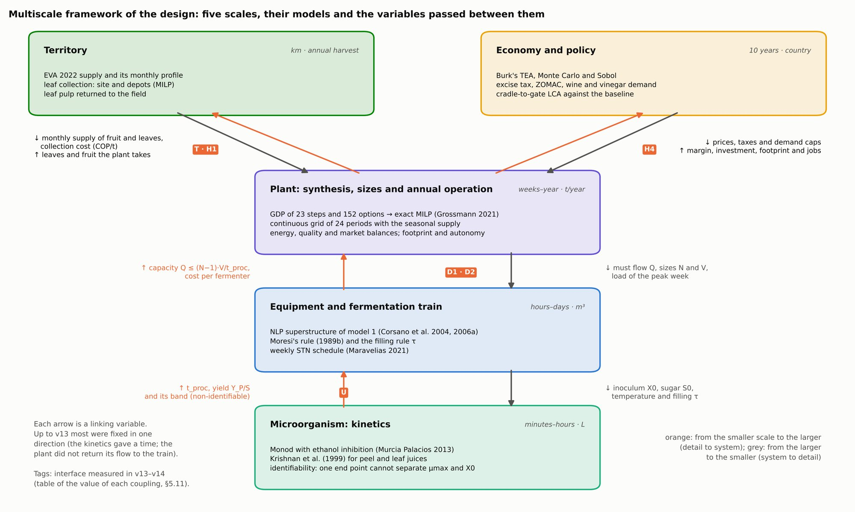
Figure 3.7. Multiscale framework of the design: five scales, their models and the variables passed between them; tags mark the couplings measured in versions 13 and 14 (models report, fig. 50).

Chapter 4. Sustainability Assessment under Uncertainty
Every design that leaves the MILP is evaluated in three dimensions on the same cases and the same balance (Heinzle, Biwer and Cooney, 2006, ch. 4): economically by a full techno-economic assessment, environmentally by a cradle-to-gate life-cycle assessment against the site without a plant, and socially by employment and value retained in the territory. The assessment uses the production of the annual schedule, not the nominal capacity. Uncertainty is treated at four levels, from one parameter at a time to design under uncertainty, and the economic–environmental trade-off is mapped by ε-constraint. The earlier manuscript set these methods out as protocols; here each comes with the results it produced (Chapter 5).

4.1 Techno-Economic Assessment and Its Spreadsheet Verification

4.1.1 Framework
Biorefinery TEA is built on a discounted cash flow: capital is spent up front, operating cash flows accrue each year as revenue minus operating cost and taxes, and both are discounted to a present value (Ellamla et al., 2020; Scown et al., 2021). The comparative TEA literature usually reports a minimum selling price for one product (Aui et al., 2021; Patel et al., 2025). That metric is ill-defined for a plant whose product mix is itself an optimization output: solving for the break-even price of one product while holding the others fixed privileges that product arbitrarily. This thesis reports portfolio-level NPV, modified internal rate of return (MIRR), payback and the probability of a positive NPV at fixed prices for every product, and uses single-product break-even prices only as diagnostics.
The margin optimized by the MILP (Section 3.9) is not the NPV. It omits base payroll, taxes, depreciation, working capital and the time profile of the project. The TEA is therefore recomputed for every design the MILP returns, with its equipment and its monthly production, so that the ranking of the MILP is checked by the measure an investor uses.

4.1.2 Structure: the Burk templates
The TEA follows the structure of the Burk templates for açaí (v5.19) and coconut water (v12) plants, implemented in Python and exported to Excel.
Block | Central assumptions
Equipment cost | Power laws from the catalogue, updated with the producer price index (182.84) and the exchange rate; installation factor 1.3; 10 % for unlisted equipment; 5 % freight
Capital (FCI) | Sinnott and Towler factors: outside-battery-limits 0.23 and civil works 0.15 on inside-battery-limits cost; engineering, procurement and construction 0.30 and contingency 0.20 on direct costs; equivalent Lang factor 3.14
Operating cost | Colombian payroll with all benefits (health 8.5 %, pension 12 %, severance and its interest, service bonus, holidays, family fund, occupational risk and transport allowance); supervision 0.6 × labour; maintenance 5 % of FCI; local taxes and insurance 3 %; one month of working capital
Raw materials | All fruit bought at 400 COP/kg [S]; leaves at 35,400 COP/t delivered [S]; panela; packaging per bottle; composting of unused fractions at 30 COP/kg; effluent treatment at 2,500 COP/m³ [S]
Utilities | Diesel electricity at 1,400 COP/kWh [S]; LPG heat at 159 COP/MJ [S]; or none where biomass or biogas cover them
Revenue | Products at the prices of Table 4.1; 95 % of production sold
Cash flow | 10 years; investment split 30/70 over two years; first operating year at 50 %; straight-line depreciation (Tax Code, art. 137); income tax by year with one-year lag; unlimited loss carry-forward
Indicators | NPV at 10 %, MIRR, simple and discounted payback, levelized cost, break-even price of each product, P(NPV > 0)
The equivalent Lang factor of 3.14 (FCI over purchased equipment) is below the 4.74 Burk uses for fluid plants, which is reasonable for small food plants but is declared because it sets the scale of every capital figure. The capital estimate is of study class (about ±30 %; Burk, 2026, §6.1), and that range is used in the tornado. Early capital estimates for first-of-a-kind biorefinery equipment can diverge by more than a factor of two between heuristics (Tsagkari et al., 2016); the equipment of the optimal plant is mature (presses, flotation, fermenters, acetifier, dryer, bottling), which keeps it within the study class.
Product | Price | Tag
Bottled wine (factory price, 750 mL) | 11,287 COP, net of 4,220 COP excise and 2,400 COP packaging | [S] retail price; [L] tax
Vinegar at 5 % (bulk) | 2,200 COP/L (1,500–4,000) | [S]
Fibre flour | 12,000 COP/kg (6,000–20,000) | [S]
Crude bromelain | 300,000 COP/kg (120,000–600,000) | [S]
Peel juice sold | 150 COP/kg | [S]
Ethanol | 4,000 COP/L | [S]
Citric acid; xanthan | 8,000; 36,000 COP/kg | [S]
Table 4.1. Product prices of the TEA.

4.1.3 Taxes on the product and on income
Excise and VAT. The consumption tax on wine (Law 1816 of 2016, art. 20) is paid by the producer on delivery and is part of the factory price (Law 223 of 1995, art. 204); the TEA books it as a cost per bottle and the product at the factory price. VAT of 5 % on wine (Tax Code, art. 468-1) is collected on behalf of the state and stays outside the plant's revenue. The specific component (243 COP per degree per 750 cm³ in 2026) is updated yearly by the Ministry of Finance; the departmental rate of Chocó may differ from the certified national figure and is listed as a datum to confirm.
Income tax and ZOMAC. Riosucio and Carmen del Darién are municipalities most affected by the armed conflict (ZOMAC; Decree 1650 of 2017). Law 1819 of 2016 (art. 237) gave new companies there reduced income-tax rates graduated by size until 2027: micro and small firms 0 % until 2021, 25 % of the general rate in 2022–2024 and 50 % in 2025–2027; medium and large firms 50 % until 2021 and 75 % in 2022–2027; the general rate from 2028 [verify against the statute]. The TEA therefore takes the rate year by year. With start-up in 2030 every operating year falls under the general rate of 35 % (Tax Code, art. 240). Company size is not an input: it follows from the design, by annual ordinary revenue in tax units (UVT), with the thresholds of Decree 957 of 2019 for manufacturing (small up to 204,995 UVT, medium up to 1,736,565 UVT) and the UVT of 2026 (52,374 COP). Bill 435 of 2025, not approved, would extend a rate of 25 % of the general rate to micro, small and medium ZOMAC firms until 2033; it enters as a scenario.

4.1.4 Indicators and discount rate
NPV is computed at 10 %; MIRR, which reinvests positive flows at the discount rate and finances negative flows at the same rate, is used rather than the internal rate of return because cash flows with early losses can give multiple or misleading IRRs. Payback is reported because a local investor weights early capital recovery more than an NPV ranking does. The discount rate is varied to 18 % in the tornado. The levelized cost of the main product and the break-even price of each product (NPV = 0 with the other prices fixed) complete the set.

4.1.5 Verification in spreadsheets
Each case is exported to an Excel workbook with live formulas and the sheet structure of the Burk templates: start, dashboard, process model, equipment costs, CapEx, OpEx and revenue, cash flow, tornado, break-even and Monte Carlo. The workbook is recalculated in LibreOffice and its NPV compared with Python's. Across the 27 current workbooks (Appendix D), the relative difference is below 10⁻¹⁴. The export once caught an error that the Python model shared with the template: a waste stream other than wastewater (here, composting) took the wastewater tariff; earlier workbooks had no other waste and did not change. The workbooks let a reader audit every number of Chapter 5 without running the code (Appendix D).

4.1.6 Regulatory risk of the wine excise
The rates in force. The excise rates of Section 4.1.3 are those in force in 2026:
- a specific component of 243 COP per alcoholic degree in 750 cm³ (Certification 003 of 2025, Ministry of Finance);
- an ad valorem component of 20 % (Law 1816 of 2016, art. 20);
- VAT of 5 % (Tax Code, art. 468-1; DIAN, Oficio 4031 of 2026).
Why they are in force. They are in force because of a court decision. Legislative Decree 1474 of 29 December 2025, issued under a declared economic emergency, raised the taxes on liquors and wines. The Constitutional Court suspended it provisionally on 29 January 2026 (Order 082, file RE-387). It then declared it unconstitutional in Ruling C-079 of 2026 and ordered the indirect taxes collected under it to be refunded. A fiscal bill presented to Congress in 2026 would again move wines from 5 % to the general 19 % VAT and raise the consumption tax, mainly from 2027.
The rates proposed. According to the evaluation committee:
- the decree set a specific component of 750 COP per degree, with a 30 % ad valorem component and 19 % VAT;
- the 2026 bill proposes 750 COP per degree with a 35 % ad valorem component, indexed at inflation plus four points from 2028. That indexation would bring the specific component to roughly 900–1,000 COP per degree by 2030.
These rates are taken from the committee's report and remain to be verified against the texts [verify]. For a project that starts in 2030 and whose largest single cost is this excise, the rate is a project risk, not a constant.
The regimes evaluated. Five regimes are evaluated, per bottle by the relation of Section 4.1.3 and for the whole plant by re-solving the MILP and the TEA (Table 5.6.1b):
- the current one;
- the specific component tripled (729 COP per degree);
- the decree rates with 5 % VAT;
- the decree rates with 19 % VAT;
- the 2026 bill without indexation.
Indexation would only deepen the loss on wine. From regime 2 onwards the best design already makes no wine, so its result also holds for the indexed bill.

4.2 Cradle-to-Gate LCA with a No-Plant Baseline and Effluent Treatment

4.2.1 Goal and scope
The goal of the assessment is to compare the environmental performance of the designs of the superstructure with each other and with the site without a plant, to support design decisions and the ε-constraint front, following the goal-and-scope logic of ISO 14040/14044 (Finkbeiner et al., 2006). It is an attributional, cradle-to-gate assessment: it describes the burdens attributable to the plant's operation rather than the consequences of a market change (Ekvall et al., 2001; Schrijvers et al., 2016).
- Functional unit. The plant's product mix is an optimization output, so a product-based functional unit would privilege one product. The functional unit is one year of plant operation, normalized to one tonne of fruit processed for comparison across scales.
- System boundary. From fruit and leaves at the farm to products at the gate, including transport of fruit and collection of leaves, process utilities, chemicals, panela, packaging glass for wine and effluent treatment. Capital goods, distribution and use are excluded.
- Inventory. The inventory is taken from the MILP solution with the same consumption coefficients the MILP uses, plus process water from the TEA. The linear GWP of the MILP and the GWP of the LCA therefore agree, within the water and effluent detail the LCA adds.

4.2.2 Impact categories and method
The earlier manuscript chose ReCiPe 2016 (Huijbregts et al., 2016) for its breadth of midpoint categories (Rashedi et al., 2020), noting that results for climate change agree across methods more than for other categories (Owsianiak et al., 2014). This thesis reports four indicators that the design decisions actually move and the data support: global warming potential over 100 years with the factors of the IPCC Sixth Assessment Report (non-fossil CH₄ 27 and N₂O 273 kg CO₂e/kg); fossil energy; water use; and particulate matter avoided by not burning leaves. A full ReCiPe profile is listed as future work once the inventory of chemicals and packaging is drawn from a database rather than from order-of-magnitude factors.

4.2.3 Inventory and emission factors
Contribution | Factor | Source
Diesel electricity | 3.2 kg CO₂e/L of diesel (2.68 combustion + 0.52 upstream), 35.9 MJ/L, genset efficiency 33 % → 0.97 kg CO₂e/kWh | IPCC (2006) vol. 2 [L/S]
LPG heat | 0.071 kg CO₂e/MJ; boiler efficiency 85 % | IPCC (2006) [L/S]
Biomass boiler | 0.3 g CH₄ and 0.004 g N₂O per MJ of fuel; biogenic CO₂ neutral | IPCC (2006) vol. 2, table 2.4 [L]
Composting of unused fractions | 4.0 g CH₄ and 0.3 g N₂O per kg wet | IPCC (2006) vol. 5, table 4.1 [L]
Leaf burning (baseline) | 80 % of dry matter burned; 1.6 kg CH₄, 0.21 kg N₂O and 11.5 kg PM per t of dry matter | Liao et al. (2026), table 3 [L]
Leaf collection | 200 MJ of diesel per t of leaves | Liao et al. (2022) [L]
Fruit transport | 0.12 kg CO₂e/t·km over 34 km | [S]; distance from Section 3.8
Chemicals | DAP 1.5, metabisulfite 1.0, lime 0.75, enzyme 8.0, yeast 1.5 kg CO₂e/kg | [S], order of magnitude
Panela | 0.6 kg CO₂e/kg | [S]
Glass bottle | 0.5 kg CO₂e per 750 mL bottle | [S]; the bottle is among the largest impacts of wine (García García et al., 2023; Zhang and Rosentrater, 2019)
Effluent treatment | See Section 4.2.4 | [L] and [S]
The factors marked [S] are order-of-magnitude values; their combined weight in the optimum is quantified in Section 5.6, and the bottle and panela, the largest of them, are flagged as data to replace.

4.2.4 Effluent treatment
Earlier versions ignored effluents. From version 11 the plant treats its wastewater, 90 % of the process water [S], with an assumed chemical oxygen demand of 3 kg/m³ [S], in two steps described for fruit-vinegar plants (Ebrahimi, 2026): electrocoagulation with aluminium electrodes, which removed 90 % of COD (Yılmaz et al., 2018, cited by Ebrahimi, 2026) at 1.5 kWh per kg of COD removed [S], followed by a hybrid constructed wetland, which removed 60–85 % (central 70 %) of the remaining COD (Justin et al., 2009, cited by Ebrahimi, 2026). The wetland emits methane from the COD it removes, with the IPCC maximum capacity and the correction factor for horizontal subsurface flow:
$$CH_{4}=B_{o}⋅MCF⋅{COD}_{removed, wetland}, B_{o}=0.25 kg CH_{4}/kg COD \text{(IPCC, 2006)}, MCF=0.1 \text{(IPCC, 2014)}$$ | (4.1)
Treatment is charged in the TEA at 2,500 COP/m³ [S]. Residual ethanol in any vinasse counts as organic load, the lesson of model M2 (Section 2.8.5): without it, an economic optimum leaves 20 % of the ethanol in the effluent.

4.2.5 Biogenic carbon and the no-plant baseline
Biogenic CO₂ from short-cycle biomass (fermentation CO₂, boiler flue gas, composting CO₂) is counted as neutral, while biogenic CH₄ and N₂O are counted with their GWP. The earlier manuscript compared the designs with a diesel-only off-grid reference serving the same processing. This thesis uses a no-plant baseline instead, because the decision in Bajo Atrato is whether to build a plant at all: reject fruit that is not processed decomposes in the field, and the leaves of crop renewal are either burned (Liao et al., 2026) or left to decompose. Process GWP measures what the plant emits; net GWP, process minus baseline, measures what the plant changes. A design can have a large process GWP and a negative net GWP if it diverts residues that would otherwise emit methane. Credits from system expansion (ethanol replacing gasoline, surplus electricity replacing diesel) are reported separately, not added to the main result.
Material the plant returns to the field is counted where it decomposes. The leaf extractor returns 0.18 t of pulp per tonne of leaves, with 51.6 % dry matter against 13.8 % in the fresh leaf, so the pulp carries about two thirds of the leaves' dry matter. Its emissions are the baseline factor for fresh leaves scaled by dry matter, 710 kg CO₂e per tonne of pulp; leaf juice returned to the field is scaled the same way (82 kg CO₂e/t). Versions before 13 credited the plant for every tonne of leaves collected and did not count this return, which turned a net increase into an apparent saving; Section 5.6.4 reports the corrected result.

4.2.6 Allocation
Multifunctional biorefinery LCAs choose between system expansion and allocation (Cherubini et al., 2011; Ekvall et al., 2001; Weidema, 2010; Schrijvers et al., 2020). The total burden of the plant is the result; to give each product a footprint, burdens are allocated by economic value, using the same prices as the TEA so that the allocation keys and the revenues cannot diverge.

4.3 Social Indicators: Jobs and Value Retained in the Territory
In a rural ZNI with a peasant and ethnic-community economy, a public decision weighs employment and local value as much as NPV (Heinzle, Biwer and Cooney, 2006, ch. 4.4). The social indicators use the same balance and payroll as the TEA:
Indicator | Calculation
Direct jobs in the plant | Equivalent operators and professionals of the TEA payroll, by shift calendar
Jobs in leaf collection | Leaves collected / 2,000 t per job-year [S] (manual cutting and loading)
Payment to growers | Fruit purchased × price, plus the leaf-collection service paid locally
Local payroll | 90 % of payroll with benefits and supervision [S]
Local purchases | 30 % of inputs other than fruit [S]
Value retained in the territory | Payment to growers + local payroll + local purchases, per year and per tonne of fruit
The excise tax on wine is not counted as local purchase, although it stays in the department's budget. The local shares and the collection productivity are assumptions to be replaced with the productive structure of the region. The indicators do not measure distribution among households or communities, which a field study would need to address.

4.4 Local and Global Sensitivity: Tornado, Monte Carlo and Sobol
Uncertainty is treated at four levels, each answering a different question.
Level | Method | Question answered
One parameter at a time | Tornado, break-even prices and parametric sweeps (E6–E9) | Which parameter moves the NPV most, and from what price does a product pay?
Joint, design fixed | Monte Carlo with correlated sampling | How likely is the chosen design to be profitable?
Joint, design free | Variance-based (Sobol) sensitivity with reoptimization | Which parameters change the optimal design, not only its cost?
Decision under uncertainty | Two-stage stochastic program with CVaR | Which design to choose before supply and prices are known?
Distributions come from the registry: Beta-PERT with λ = 4 for parameters with a range, and discrete scenarios for supply.
Tornado and break-even prices. Each parameter is moved alone to the ends of its range and parameters are ranked by the change in NPV: product prices ±30 %, fruit cost ±50 %, capital ±30 % (the study class), discount rate 6–18 %, production 80–100 %, panela price, the peel-juice ethanol yield (0.23–0.43 g/g) and crown availability (40–100 %). The break-even price of each product is the price at which NPV = 0 with the others fixed.
Monte Carlo. Latin hypercube sampling (McKay, Beckman and Conover, 1979) with 1,000 samples draws all parameters jointly, and the rank-correlation method of Iman and Conover (1982) imposes a correlation of 0.45 between product price and raw-material cost, which tend to move together. With the design fixed, each sample recalculates the full TEA. The outputs are the NPV distribution, its percentiles, the conditional value at risk at 5 % and P(NPV > 0).
Sobol indices with reoptimization. A tornado and a Monte Carlo hold the design fixed and measure how much it costs. They cannot say whether the design itself would change. In the fermentation train (Section 2.8.4) every Saltelli sample (Saltelli et al., 2010) is a full reoptimization of the superstructure, so the first-order and total indices separate two questions: what explains the variance of the optimal cost, and what explains the change of structure. The family of (µ_max, X₀) pairs compatible with the single kinetic datum enters as a factor. Extending this to the plant-level MILP would cost one MILP solve per sample and is listed as future work.

4.5 Two-Stage Stochastic Design and CVaR

4.5.1 Formulation
Following Grossmann (2021, ch. 14), the design decisions d (technologies, sizes, front end, third shift) are taken here and now, before supply and prices are known, and the operating decisions z(θ) (fruit bought, flows per period, fuels) adapt to each scenario θ. The deterministic equivalent is one large MILP solved with SCIP:
maxd, zθ −c⊤d+θ​pθ Πzθ,θ s.t. hd,zθ,θ≤0 ∀θ | (4.2)
In the sizing MILP this means replicating the 24-period operation once per scenario with shared design binaries. The standard indicators are reported: RP, the stochastic problem; EV, the problem with mean values; EEV, the EV design evaluated in the scenarios; WS, wait-and-see with perfect information; VSS = RP − EEV, the value of the stochastic solution; and EVPI = WS − RP, the expected value of perfect information. The inequality EEV ≤ RP ≤ WS is used as an implementation test.
Risk aversion enters through the conditional value at risk at 90 % (Rockafellar and Uryasev, 2000), weighted against the expectation:
max 1−λ EΠ+λ CVaR0.9Π, CVaRβ=ζ−11−βθ​pθmax0, ζ−Πθ | (4.3)
The max(0, ·) terms are linearized with one continuous variable per scenario, so the risk-averse problem stays an MILP. Sweeping λ traces the mean–risk frontier and the weight at which the decision changes.

4.5.2 What the method revealed at line-selection level
The method was first applied to the line-selection MILP of the earlier stage (which lines to build at the 2022 supply), with 27 scenarios combining supply (0.7, 1.0 and 1.3 times; probabilities 0.25, 0.5, 0.25), bulk-wine price (2,200, 3,000 and 4,000 COP/L; 0.3, 0.4, 0.3) and flour price (8,000, 12,000 and 16,000 COP/kg; 0.25, 0.5, 0.25):
Indicator | MM COP/year
EV: mean-value problem (what it promises) | 672
RP: stochastic problem | 471
EEV: EV decision in the scenarios | 471
WS: wait-and-see | 1,021
VSS | 0
EVPI | 550
CVaR at 90 % of the RP solution | −1,871
VSS was zero: the mean-value design (wine and flour at 6,200 t/year) was also the stochastic design. What changed was the promise: the EV problem announced 672 MM COP/year, and the same plant earned 471 in expectation, because with asymmetric prices and supply a plant capped by its capacity cannot use the good scenarios but suffers the bad ones. The EVPI of 550 MM COP/year was large: measuring supply and securing price contracts before investing was worth more than any model refinement. With perfect information the plant would build wine and flour in 54 % of scenarios, nothing in 41 % and wine alone in 6 %. The risk-averse decision switched abruptly at λ* ≈ 0.20 (λ* = E/(E − CVaR)): below it, build wine and flour; above it, with fruit bought at 400 COP/kg, do not build. No intermediate design appeared, because small scales do not pay their fixed cost (Figure 4.1).
Figure 4.1. Profit distribution over 27 scenarios, stochastic indicators and mean–CVaR frontier (models report, fig. 23).
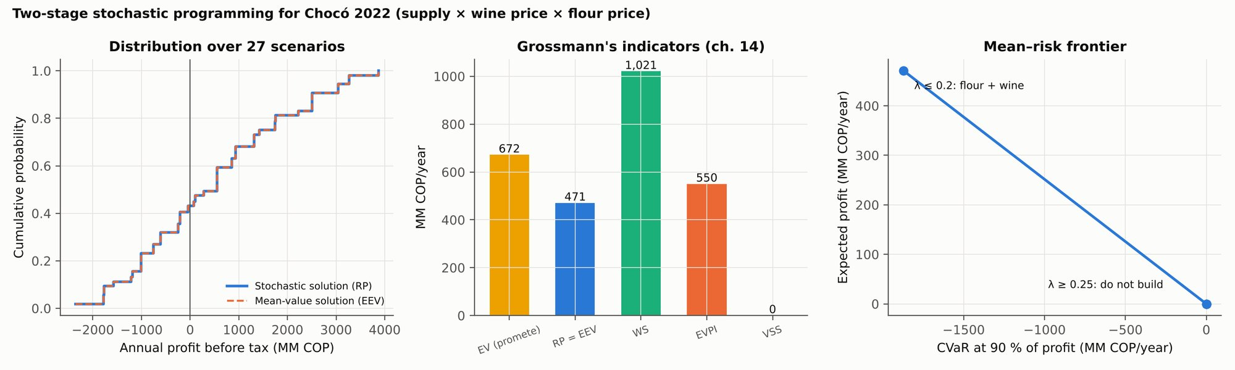
In the sizing MILP, the version 12 instance uses the three supply scenarios; its results are in Section 5.6.

4.6 Flexibility of the Energy-Autonomy Constraint
The earlier manuscript insisted on separating an economic risk criterion, how a design performs in expectation or under a risk measure, from a feasibility guarantee, whether a fixed design can always be operated (Section 3.6.3). This thesis keeps the separation: Section 4.5 treats market and supply risk, and this section treats autonomy.
The protocol has two parts. First, an ε sweep on fossil utilities: the MILP is solved with an upper bound on diesel electricity and LPG heat, lowered step by step to zero, and the margin, the portfolio and the energy units of each solution are recorded. The curve gives the cost of autonomy, and the point where the problem becomes infeasible gives the largest autonomy the superstructure can reach with its alternatives (boiler, digester and engine, gasifier, and, in a next version, photovoltaics with storage). Second, for each design on that curve, the flexibility index with respect to supply and leaf collection measures how large a deviation from the nominal supply the design can absorb while staying autonomous; with a linear model this is an MILP over the vertices or, without the vertex assumption, the active-set formulation (Grossmann and Floudas, 1987).
The first part, the ε sweep on fossil energy, is run in Section 5.9.3 with the heat pump of Section 3.12.2 added to the superstructure; it answers H2. The second part, the flexibility index of each design on the curve, remains formulated but not run: with the market caps binding and supply uncertainty worth nothing (Section 5.6.3), the deviations it would measure are not the ones that decide this plant.

4.7 Margin–GWP Pareto Front by ε-Constraint
The trade-off between margin and GWP is obtained by the ε-constraint method (Haimes et al., 1971) on the sizing MILP:
$$max Π \text{s.t.} GWP≤ε, ε∈\left[{GWP}_{min}, GWP\left(Π^{*}\right)\right]$$ | (4.4)
The extremes are the economic optimum and the minimum-GWP design, the latter solved with a small margin tie-break so that it is not dominated. Five intermediate values of ε are equally spaced. Each point starts from the design of the previous one, is solved with a time limit and is polished with neighbouring sizes (removing the leaf extractor, the leaf-ethanol units, the acetifier or the juice winery as candidates); dominated points, which can appear because runs stop at their time limit, are discarded.
The earlier manuscript planned a front of NPV against GWP. Two choices differ here. The margin replaces the NPV because the ε problems must be solved repeatedly as MILPs; the NPV of each point is computed afterwards with the TEA. And because process GWP rewards processing less, its minimum is to not operate; the front that answers H3 is therefore built on net GWP against the no-plant baseline, with the field-return correction of Section 4.2.5 (Section 3.12.3, results in Section 5.9.4). It replaces the process-GWP front of earlier versions (Section 5.6.6). Instead of the PROMETHEE ranking the earlier manuscript proposed, compromise designs are chosen inside the MILP by weighted distance to the ideal point (Kenkel et al., 2022), which keeps the selection in the same model and makes the weights explicit.

Chapter 5. The Bajo Atrato Biorefinery
The optimal biorefinery for Bajo Atrato is a small plant limited by its markets: it buys 1,276 t/year of fruit (20.8 % of the 2022 supply) and 3,746 t/year of leaves, sells 500,000 bottles of wine, 3,000 m³ of vinegar and 40 t of fibre flour, and earns an annual margin of 3,164 MM COP with an NPV of 5,273 MM COP. This chapter presents that design and the alternatives it beats, its balances and schedule, how it changes with scale, prices and markets, how it performs under uncertainty, and what it says about the four hypotheses. All results are from version 12 of the models, solved with the filling-time rule and polished as in Section 3.10; the hypothesis tests of Section 5.9 use the version 13 extensions of Section 3.12 (heat pump, fossil cap, field-return accounting, compromise designs), which leave the economic optimum unchanged.
Leaf-juice yield and labels. After the stoichiometric test of Section 3.11, the ethanol yield of leaf juice was lowered from 21.8 to 20.7 kg/t (Section 2.2.5). The optimum, the demand map (Section 5.9.2), the fiscal regimes, the life-cycle assessment, the TEA and the sequential baseline were re-run at 20.7 kg/t, and the design did not change. Figures computed at the former value, the upper end of the corrected range, are labelled «(at 21.8 kg/t)»; they include the comparison of topologies (Section 5.1.2), the balances, schedule and scale sweep (Sections 5.2–5.3), the price sweeps (Section 5.4), the autonomy sweep (H2) and the interior of the margin–GWP front (H3). At the optimum the correction lowers the margin by 32 MM COP/year (1.0 %).
Optimality. The central optimum is certified within 1.5 % (Section 5.1.1); every hypothesis test reports its dual bound beside the solution. The kinetics–train coupling is worth 3.8–12.5 % of the fermentation-train cost at the flow of the optimum (Section 5.11.3), and the kinetic band does not change the plant design (Section 5.11.1).

5.1 Optimal Design and Comparison of Topologies

5.1.1 The optimum
The optimum (case E1) consists of:
- a front end of 1 t/h for washing, sorting, peeling and coring, on two shifts without a third;
- one belt press of 1 t/h shared by pulp and peel, with enzymatic maceration, and no decanter or dedicated peel press;
- flotation of 0.5 m³/h for the must, without lees microfiltration;
- SO₂ stabilization, with nitrogen inertization and nutrient dosing;
- an aseptic must store of 10 m³ that feeds the fermenters by pump;
- a wine winery of 2 × 10 m³ and a bottling line of 500 bottles/h;
- a juice winery of 2 × 10 m³ for peel and leaf juices with panela, and a submerged acetifier of 10 m³;
- a leaf extractor of 2 t/h, with the leaf pulp returned to the field;
- a belt dryer of 50 kg of water per hour with its mill, for peel cake and clarification lees.
There is no crown boiler, no bromelain module, no leaf ethanol, no digester and no hub product; crown and core are composted.
Capital. The catalogue options chosen cost 4,026 MM COP to purchase. With the equivalent Lang factor of 3.14, the MILP estimates their fixed capital at 12,640 MM COP. The annualized capital charge it subtracts is 3,314 MM COP/year: 3,068 for annuity, maintenance and local taxes on purchased equipment (AF = 0.762), plus 246 of fixed costs tied to the chosen options and to the nitrogen generator and nutrient doser.
The itemized TEA lists 5,225 MM COP of purchased equipment. The difference of 1,199 MM COP is equipment the MILP catalogue does not size:
- storage tanks for 30 days of vinegar and 90 days of wine ageing (930);
- the nitrogen generator (128), which the MILP charges as a fixed item;
- the flour packer (85);
- a cold room (35);
- the nutrient doser (21), which the MILP charges as a fixed item.
The TEA arrives at a fixed-capital investment of 16,405 MM COP: 10,936 direct, 3,281 engineering, procurement and construction, and 2,187 contingency. Section 6.6 discusses the consequence of leaving storage out of the MILP. Table 5.1.1b gathers the canonical figures of this design.
Certification. The margin of this design is 3,164 MM COP/year at the corrected leaf-juice yield, and it is certified within 1.5 % of the optimum. Two properties of the model give the certificate:
- Supply enters the MILP only as an upper limit (unprocessed fruit and leaves carry no cost), so a larger supply cannot lower the optimum.
- A higher leaf-juice yield cannot lower it either: the same flows make more acid, and the panela or juice they no longer need can be dropped.
The optimum at 20.7 kg/t is therefore bounded by the dual bound of the run with 1.3 times the supply at 21.8 kg/t, 3,210 MM COP/year.
Table 5.1.1b. Canonical figures of the central design (500,000 bottles; 3,000 m³ of vinegar; leaf-juice ethanol 20.7 kg/t).
Quantity | Value | Basis
Annual margin | 3,164 MM COP/year | MILP; certified within 1.5 % (upper bound 3,210)
Contribution before capital charge | 6,478 MM COP/year | MILP
Annualized capital charge | 3,314 MM COP/year | MILP: AF × 4,026 purchase + 246 fixed
Purchased equipment | 4,026 (MILP catalogue) / 5,225 (TEA, with storage and auxiliaries) MM COP
Fixed-capital investment | 12,640 (MILP, Lang 3.14) / 16,405 (TEA) MM COP
Revenue; revenue less variable costs | 12,089; 6,992 MM COP/year | TEA (95 % of production sold)
Variable / fixed / operating costs | 5,097 / 2,227 / 7,324 MM COP/year | TEA
NPV; MIRR; payback | 5,273 MM COP; 13.4 %; 5.0 years (6.6 discounted) | TEA
P(NPV > 0); median NPV; CVaR 5 % | 0.78; 3,543; −6,347 MM COP | Monte Carlo, 1,000 samples
Break-even vinegar price | 1,723 COP/L | TEA tornado
Panela | 154.6 t/year | MILP
Process GWP; net GWP | 1,293 t; +339 t (inventory) / 1,282 t; +328 t (MILP) | LCA / MILP
Figure 5.1. Equipment chosen in each E1 case and annual margin, against the TRL-9 reference (models report, fig. 27).
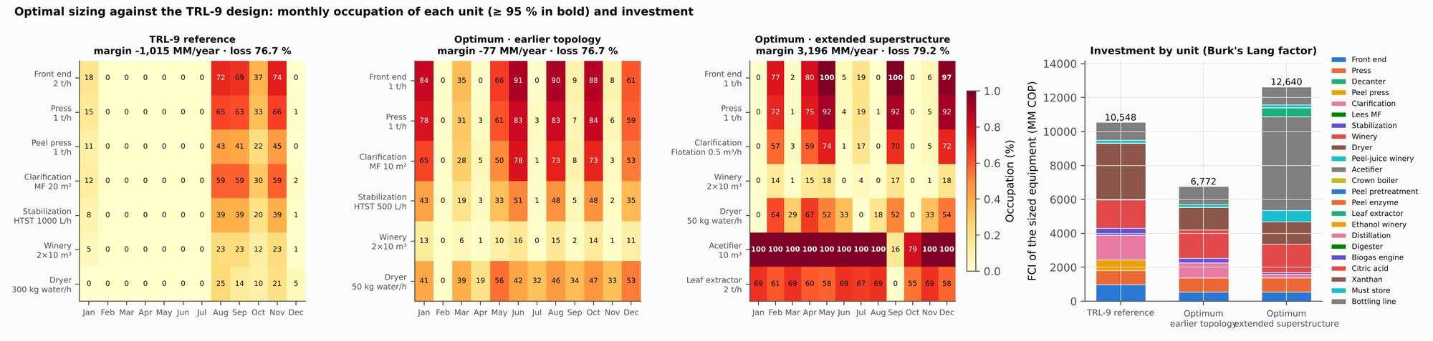

5.1.2 The alternatives it beats
Margins of the E1 cases in MM COP/year, at 21.8 kg/t; at 20.7 kg/t the optimum earns 3,164 with the same design.
Case (E1) | Margin (MM COP/year) | Fruit (t/year) | Vinegar (m³) | Design differences from the optimum
Optimum | 3,196 | 1,276 | 3,000 | —
Without crown boiler | 3,195 | 1,276 | 3,000 | Same design (the optimum has none)
Without leaf ethanol / without digester | 3,196 | 1,276 | 3,000 | Same design
Without SO₂ | 3,004 | 1,276 | 3,000 | HTST 500 L/h; dedicated peel press
Without leaves or hub (version 10 options) | 2,525 | 5,417 | 3,000 | 3 t/h front end; dedicated peel press; centrifuge; 100 kWt crown boiler; dryer 100 kg/h; wine diverted to vinegar
Without panela | 2,467 | 4,362 | 3,000 | As the version 11 design
Version 11 design, version 12 parameters | 2,511 | 1,189 | 3,000 | 3 t/h front end; dedicated peel press; centrifuge; lees MF 2 m²; 100 kWt crown boiler; dryer 100 kg/h
Without vinegar | 184 | 1,276 | 0 | No juice winery, acetifier or extractor
Previous topology (press, must MF, HTST) | −77 | 1,434 | 0 | MF 10 m²; HTST 500 L/h; no vinegar
Reference TRL-9, sized by average flows | −1,015 | 1,434 | 0 | 2 t/h front end; dedicated peel press; MF 20 m²; HTST 1,000 L/h; dryer 300 kg/h
Reference with one shared 3 t/h press | −1,047 | 1,434 | 0 | As the reference with one 3 t/h press
Four readings follow.
The topology of the must train decides more than its size. The TRL-9 reference sizes each unit for the average flow and keeps the earlier topology: whole-must microfiltration and flash pasteurization. Replacing them by flotation and SO₂ lifts the margin of the plant without vinegar from −77 to 184 MM COP/year with 853 MM COP less equipment, because microfiltration of pineapple must loses 27 % of it as retentate (Quesada Salas, 2013). If the market demands wine without SO₂, the model returns to HTST and the margin falls by 191 MM COP/year; UHPH is never chosen, because its compression energy costs about 140,000 COP per m³ of must with diesel electricity. The decanter is never chosen either: at the Chocó scale a 1 t/h belt press is cheaper and, dedicated or shared, has no changeover problem at this throughput.
Dedicated presses or one shared press. In the reference design, replacing the two dedicated 1 t/h presses by one shared 3 t/h press costs more (10,664 against 10,548 MM COP of equipment) and earns less (−1,047 against −1,015): it needs 181 changeovers a year with their cleaning, and the fruit processed does not rise because the bottleneck is the front end. In the optimum, by contrast, one 1 t/h press shared by pulp and peel suffices, because the plant processes little fruit in campaigns and has time for changeovers.
Vinegar carries the plant. Without the vinegar routes the optimum earns 184 MM COP/year; with them, 3,164. Its substrate is mostly leaf juice with panela: 2,847 t of leaf juice against 221 t of peel juice, and no wine diverted.
The source and its two checks. The acid potential of leaf juice rests on one source, and that source does not close. In Chen et al. (2020), as balanced by Liao et al. (2022), 46 kg of juice give 35 kg of broth at 3.6 % v/v ethanol and 11 kg of wet yeast: 1.0 kg of ethanol, or 21.7 kg per tonne of juice. Two checks follow:
- Ethanol alone. The free sugars of the juice (27 g/L at most) cannot produce that much ethanol (0.82 g/g). On the 44.9 g/kg of carbohydrate the juice holds by difference, the yield is 0.485 g/g, 95 % of the stoichiometric maximum.
- Ethanol and yeast together. The same source reports 16.1 kg of yeast dry matter per tonne of juice. At a biomass yield of 0.5 g/g, that yeast alone consumes about 32 kg of sugar, which leaves room for at most 6.5 kg of ethanol. Ethanol and yeast cannot both be right.
The value adopted. This thesis takes the ethanol figure, which rests on a measured broth concentration, as the design basis, capped at 90 % of the stoichiometric maximum: 20.7 kg/t. The range extends down to 6.5 kg/t, the ethanol compatible with the reported yeast (Table 5.1.2a). The yeast figure is used only by the leaf-ethanol route, which no economic design selects. It is flagged in the registry.
Effect on the optimum. The design is the same at every value of the range: the same equipment and the same 3,000 m³ of vinegar. Panela makes up the acid the leaf juice no longer supplies, from 155 t/year to as much as 288 t/year. The margin falls from 3,164 to 2,803 MM COP/year and the NPV from 5,273 to 3,857 MM COP at the lower end, losses of 11 % and 27 %. The designs at the lower values are the best found within the time limit; the table gives their gaps to the bound of Section 5.1.1, up to 14.5 % at 6.5 kg/t.
The leaf-juice yield changes the cost of vinegar, not whether vinegar is made. A plant that makes only vinegar is viable at least down to about 8 kg/t; below that its viability is not established (Section 5.6.1). A fermentation of Chocó leaf juice with the plant's strain is the measurement that would close this range (Section 6.7).
Table 5.1.2a. Optimum against the leaf-juice ethanol yield (500,000 bottles; 3,000 m³ of vinegar).
Leaf-juice ethanol (kg/t juice) | Basis | Acid potential (kg/t juice) | Margin (MM COP/year) | Upper bound (gap) | Panela (t/year) | NPV (MM COP) | Net GWP (t; MILP)
21.8 (former value) | source ethanol; 95 % of maximum on carbohydrate | 26.7 | 3,196 | 3,210 (0.4 %) | 145.6 | 5,397 | +323
20.7 (design value) | 90 % of maximum on 44.9 g/kg carbohydrate | 25.3 | 3,164 | 3,210 (1.5 %) | 154.6 | 5,273 | +328
13.5 | maximum (0.511 g/g) on free sugars only | 16.6 | 2,965 | 3,210 (8.3 %) | 211.6 | 4,491 | +363
11.1 | 0.42 g/g on free sugars only | 13.6 | 2,897 | 3,210 (10.8 %) | 230.8 | 4,225 | +374
6.5 | compatible with the source's yeast yield | 8.0 | 2,803 | 3,210 (14.5 %) | 287.7 | 3,857 | +447
The upper bound is the dual bound of the run at 1.3 times the supply and 21.8 kg/t, valid at every lower yield by nesting and monotonicity (Section 5.1.1). The bounds of the runs at each yield are weaker (3,439; 4,424; 4,396) and are not used.
Leaves and panela substitute fruit. Without leaves the plant buys 5,417 t of fruit and diverts wine to vinegar to reach 5 % acid; without panela it buys 4,362 t. Both give lower margins. In version 12, with the wine market capped, fruit is worth buying only for the wine the market takes and for the peel that feeds vinegar and flour; leaves and panela make the rest of the vinegar more cheaply.
Configuration B, with the bromelain module available, chooses no bromelain and earns 3,193 MM COP/year, the same within tolerance; the TRL-9 design with three dedicated presses earns −1,338. Making bromelain from the core of 1,276 t of fruit does not pay the press, ultrafiltration, dryer and operator it needs.

5.1.3 How the design changed across versions
Version | Front end | Presses | Clarification | Stabilization | Acetifier | Boiler | Leaves | Margin
10 | 3 t/h | Pulp + dedicated peel | Centrifuge + lees MF | SO₂ | 20 m³ | 100 kWt | 2 t/h extractor | 4,040
11 | 3 t/h | Pulp + dedicated peel | Centrifuge + lees MF | SO₂ | 10 m³ | 100 kWt | 2 t/h extractor | 4,652
12 | 1 t/h | One shared press | Flotation | SO₂ | 10 m³ | none | 2 t/h extractor | 3,196
The version 12 design is smaller than its predecessors because the bottled-wine market is capped; with the cap removed it returns to the version 11 design with a 1,000 bottles/h line (Section 5.4).

5.2 Mass and Energy Balances, Process Flow Diagram, Layout and Schedule

5.2.1 Balances
Stream | Annual flow
Fruit purchased | 1,276 t
Pulp and peel pressed (shared press) | 574 t and 383 t
Core and crown | 128 t and 191 t, composted
Must clarified | 472 m³
Wine fermented and bottled | 375 m³ = 500,000 bottles
Peel juice to vinegar | 221 t
Peel cake and lees dried | 162 t and 85 t
Fibre flour (cake and lees) | 31 t + 9 t = 40 t
Leaves collected and pressed | 3,746 t
Leaf juice to vinegar; leaf pulp to the field | 2,847 t; 674 t
Panela added to juices | 146 t
Acetic acid; vinegar at 5 % | 150 t; 3,000 m³
Electricity (MILP coefficients; LCA inventory) | 182 MWh; 276 MWh
Process heat, all from LPG | 684 GJ
Effluent | 2,642 m³ with 7.9 t COD; 0.24 t COD discharged
Mass closes by fraction and energy by utility; the dilution water of the vinegar closes the mass balance of the acetification. The energy balance uses a genset at 33 %, an LPG boiler at 85 %, 96.6 kJ per mol of sugar fermented, 493 kJ per mol of acetic acid and 2.26 MJ/kg of latent heat. Both balances are drawn as Sankey diagrams (Figures 5.2 and 5.3).
Figure 5.2. Mass balance of the optimum (models report, fig. 34). Figure 5.3. Energy balance (fig. 35).
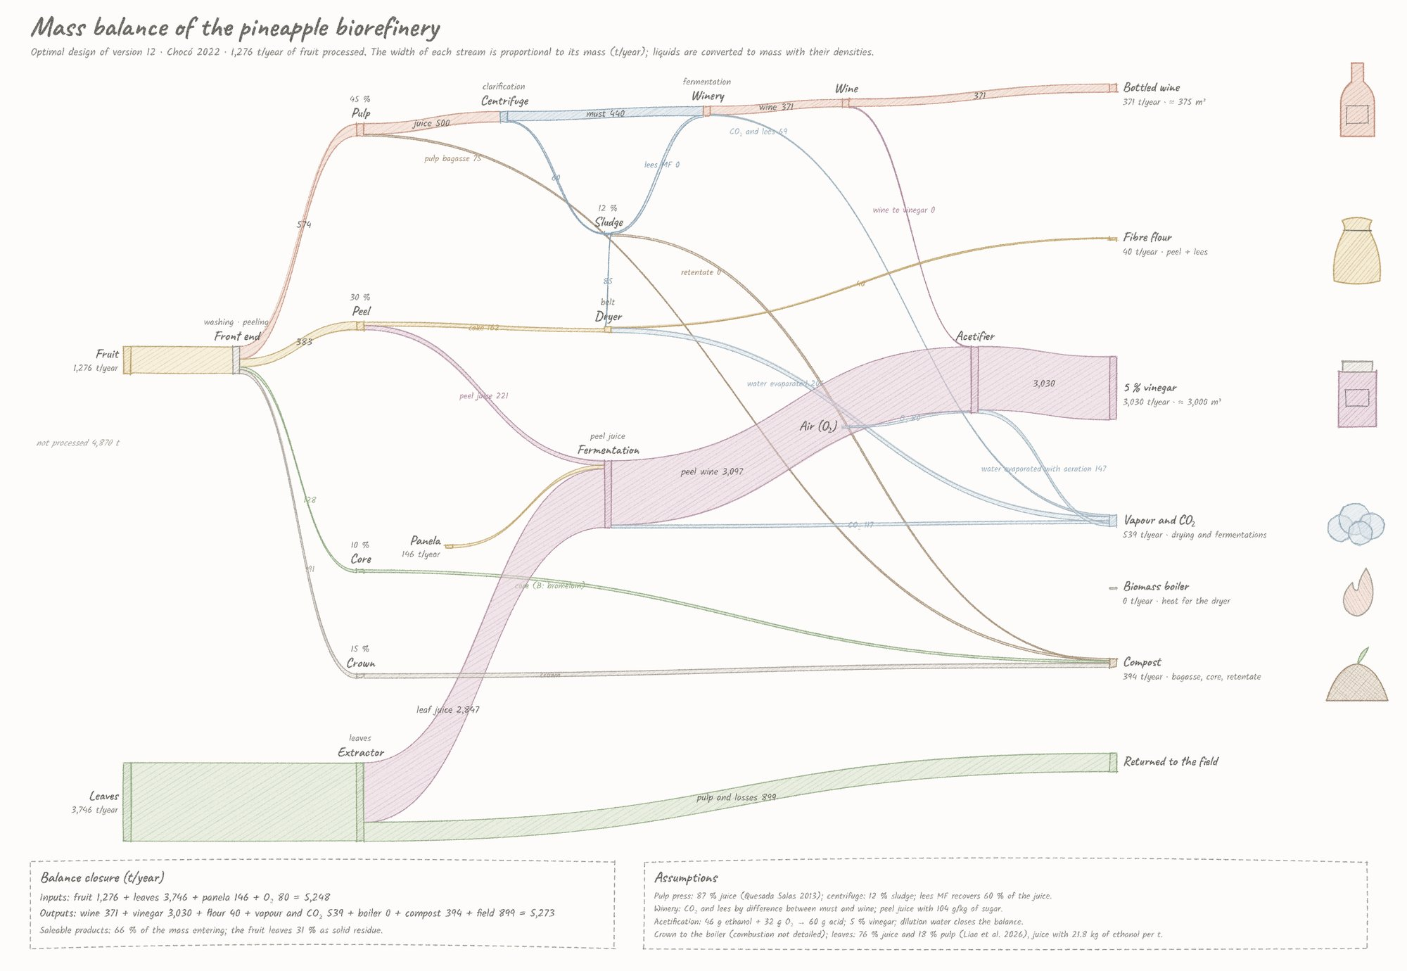
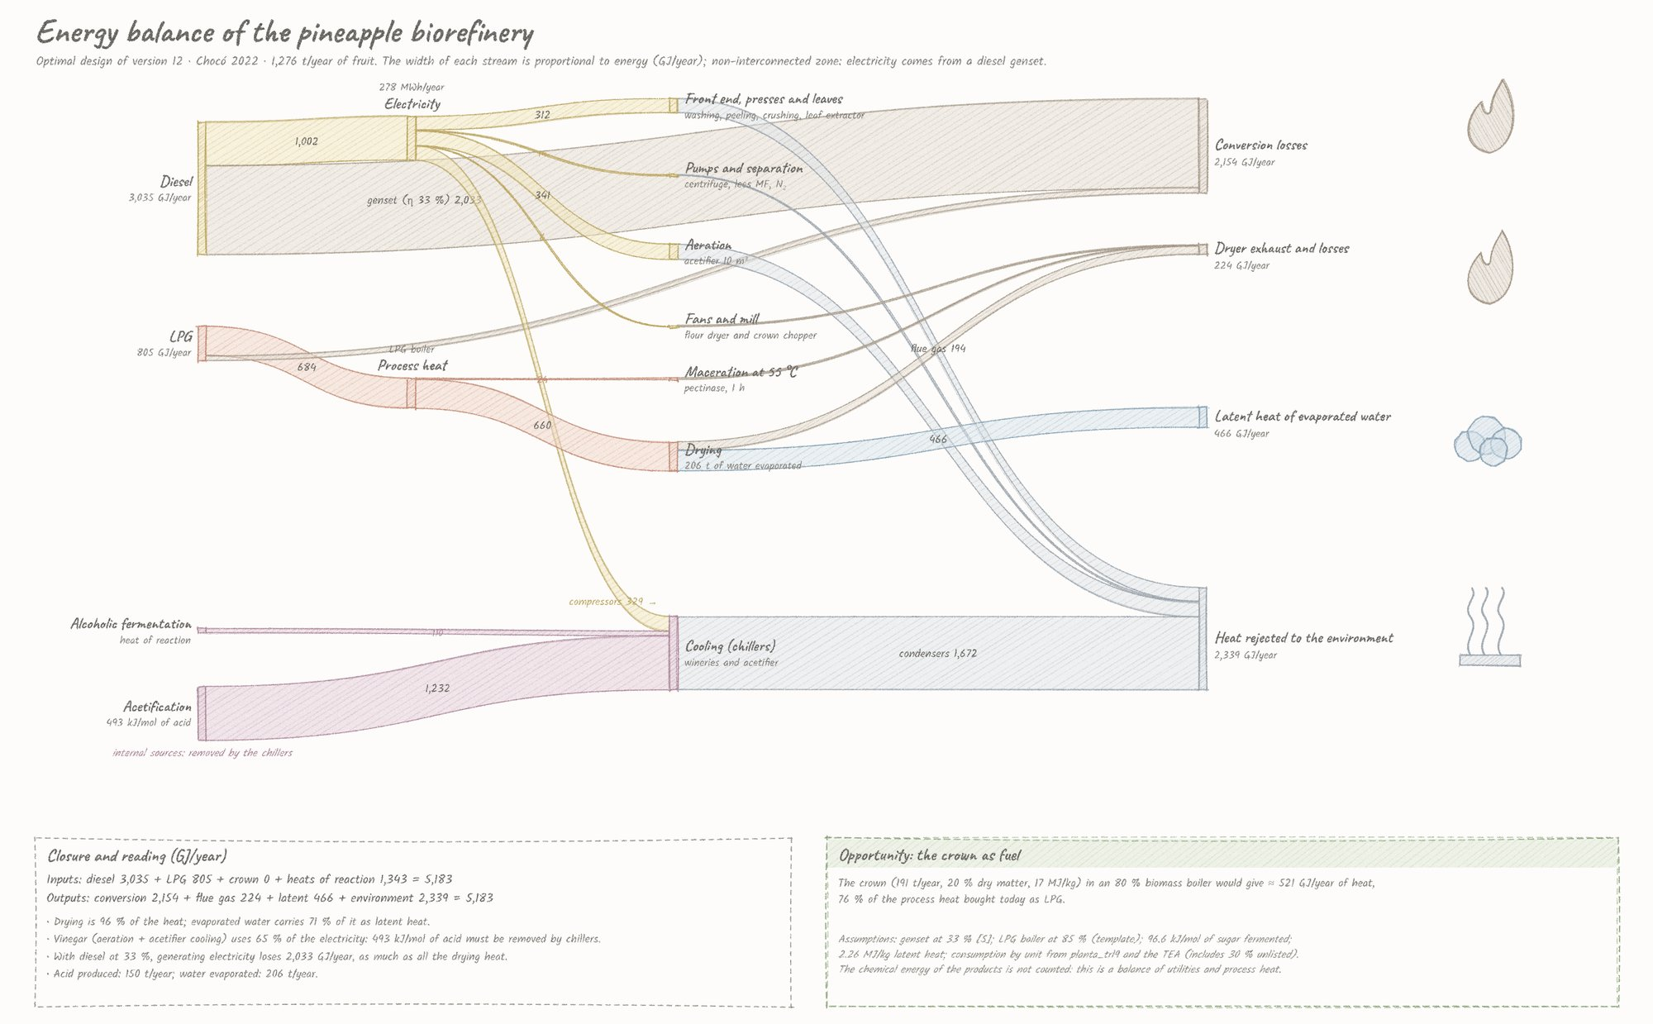

5.2.2 Process flow diagram and layout
The process flow diagram follows the routes of Figure 3.1: reception and peeling; the shared press with maceration; flotation, SO₂ dosing and the must store; the wine winery and bottling; the peel and leaf juices, panela dosing, the juice winery and the acetifier with its chiller and emergency genset; the dryer and mill; and effluent treatment by electrocoagulation and wetland. The conceptual layout groups the wet front end and pressing, the cellar (store, wineries, acetifier and bottling) and the dry area (dryer, mill and flour storage), with the leaf yard at the edge of the site (Figures 5.4 and 5.5).
Figure 5.4. Process flow diagram of the optimum (models report, fig. 36). Figure 5.5. Conceptual layout (fig. 37).
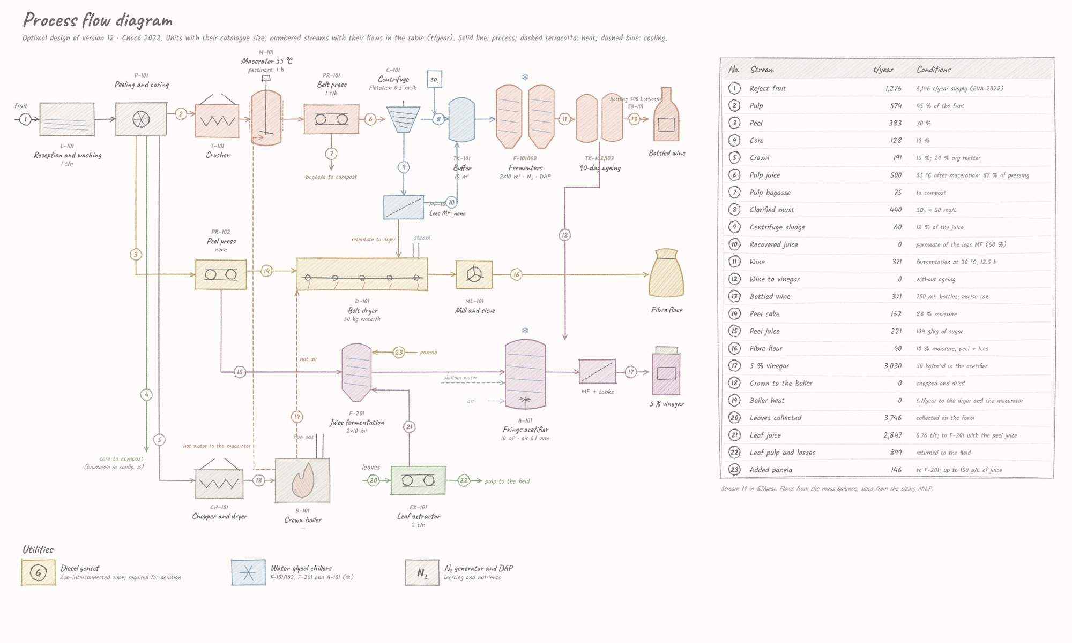
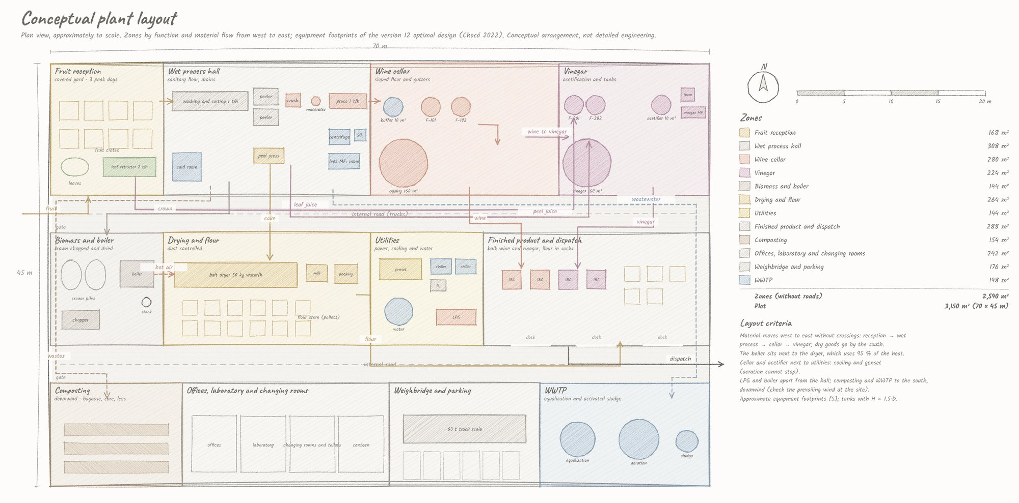

5.2.3 The annual schedule
The plant runs in campaigns. Monthly occupation of each unit:
Unit | Jan | Feb | Mar | Apr | May | Jun | Jul | Aug | Sep | Oct | Nov | Dec
Front end | 0 | 77 | 2 | 80 | 100 | 5 | 19 | 0 | 100 | 0 | 6 | 97
Press | 0 | 72 | 1 | 75 | 92 | 4 | 19 | 1 | 92 | 0 | 5 | 92
Flotation | 0 | 57 | 3 | 59 | 74 | 1 | 17 | 0 | 70 | 0 | 5 | 72
Wine winery | 0 | 14 | 1 | 15 | 18 | 0 | 4 | 0 | 17 | 0 | 1 | 18
Bottling | 0 | 61 | 4 | 62 | 78 | 1 | 18 | 0 | 74 | 0 | 5 | 76
Leaf extractor | 69 | 61 | 69 | 60 | 58 | 69 | 67 | 69 | 0 | 55 | 69 | 58
Juice winery | 59 | 58 | 59 | 58 | 58 | 59 | 59 | 59 | 8 | 47 | 59 | 58
Acetifier | 100 | 100 | 100 | 100 | 100 | 100 | 100 | 100 | 16 | 79 | 100 | 100
Dryer | 0 | 64 | 29 | 67 | 52 | 33 | 0 | 18 | 52 | 0 | 33 | 54
Occupation in % of the available hours of each unit.
The front end buys fruit in five months (February, April, May, September and December) and is nearly idle in the others: with the wine market capped, buying fruit when supply peaks is enough. The acetifier, the unit that earns most, is at 100 % in ten months, and the leaf extractor and juice winery feed it all year. The wine winery never exceeds 18 %: its two fermenters are set by the Moresi minimum (N_F ≥ 2), not by throughput. In September the leaf route stops while the front end and press run at full capacity, and the acetifier drops to 16 %.
In the peak week of April the must flow is 0.09 m³/h. Direct filling of a 10 m³ fermenter would take 114 h, so must accumulates in the store and each batch is pumped into a fermenter in about an hour, one batch every 114 h; the juice fermenters fill directly in 27 h and ferment in 12.6 h; the acetifier discharges half its volume every 14 h and its aeration never stops (Figure 5.6).
Figure 5.6. Gantt chart of the optimum: monthly occupation and a week of April with staggered batches (models report, fig. 38).
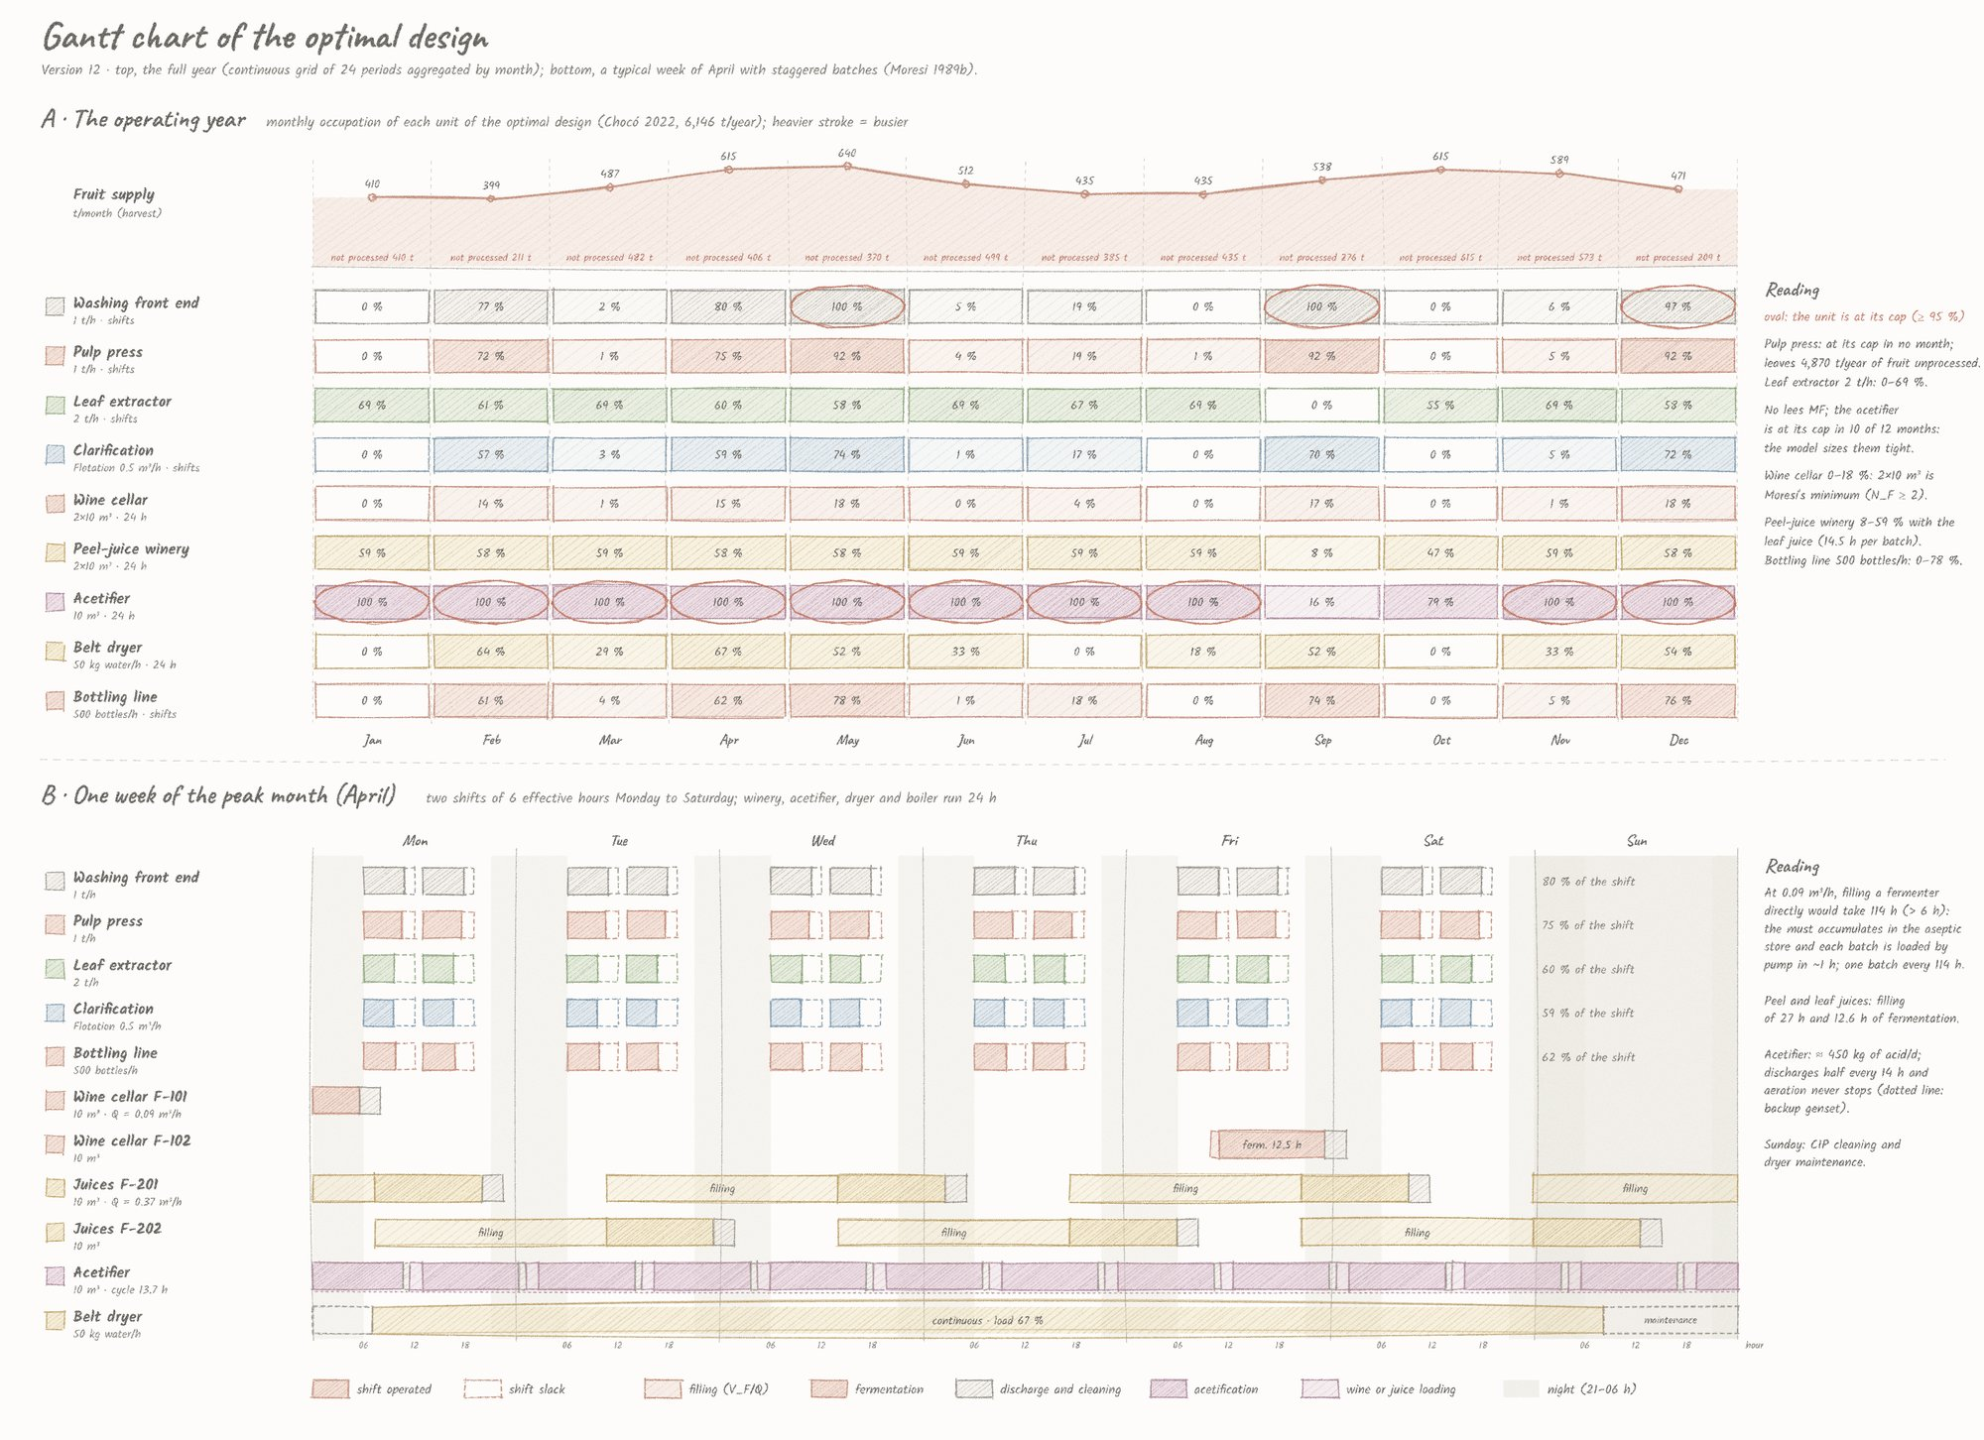

5.3 Sizing Rules by Supply Scale
With both markets capped, the design and the margin do not change with supply. The scale sweep (E2), from 0.5 to 3.556 times the 2022 supply (3,073 to 21,856 t/year), returns the same design and 3,195–3,196 MM COP/year at every scale; the NPV is 5,394–5,397 MM COP. At twice the supply the must store and the third shift add nothing (E3: 3,192–3,196 MM COP/year with and without each lever). The fruit left unprocessed is not lost for lack of capacity but for lack of market.
The sizing rules found in version 11, where bulk wine had no cap, describe what happens if the wine market grows:
Supply (× 2022) | Margin v11 | Fruit (t) | Front end | Presses | Clarification | Winery | Acetifier | Boiler | Enzyme | Leaf extractor | Third shift
0.5 | 3,189 | 2,963 | 1 t/h | 1 t/h shared | Flotation 0.5 | 2 × 10 | 10 m³ | — | — | 2 t/h | No
1.0 | 4,652 | 6,139 | 3 t/h | 1 + 1 t/h | Centrifuge 1 | 2 × 10 | 10 m³ | 100 kWt | — | 2 t/h | No
1.5 | 5,850 | 9,219 | 5 t/h | 2 + 1 t/h | Centrifuge 2 | 2 × 10 | 10 m³ | 100 kWt | — | 2 t/h | No
2.0 | 7,075 | 12,275 | 5 t/h | 2 + 1 t/h | Centrifuge 2 | 2 × 10 | 10 m³ | 100 kWt | — | 2 t/h | No
2.5 | 7,759 | 13,954 | 5 t/h | 2 + 2 t/h | Centrifuge 2 | 2 × 10 | 10 m³ | 200 kWt | — | 10 t/h | No
3.0 | 9,010 | 18,438 | 5 t/h | 3 + 2 t/h | Centrifuge 2 | 3 × 10 | 20 m³ | 500 kWt | Precipitation 1 t/h | 10 t/h | Yes
3.556 | 10,848 | 21,538 | 5 t/h | 3 + 2 t/h | Centrifuge 2 | 3 × 10 | 20 m³ | 500 kWt | Precipitation 1 t/h | 10 t/h | Yes
Margins in MM COP/year under version 11 parameters (bulk wine at 3,000 COP/L without tax or cap).
Four rules emerge when the market does not bind. The front end grows first and saturates at 5 t/h; presses follow, and a dedicated peel press pays from the current supply upwards. Centrifugation replaces flotation from 0.75 times the supply. The crown boiler enters from 0.75 times the supply and grows with the dryer. Enzyme recovery from peel juice and the third shift pay only from about three times the supply. The winery stays small throughout, because year-round operation spreads its load (Figure 5.7).
Figure 5.7. Design and margin by supply scale (models report, fig. 28).
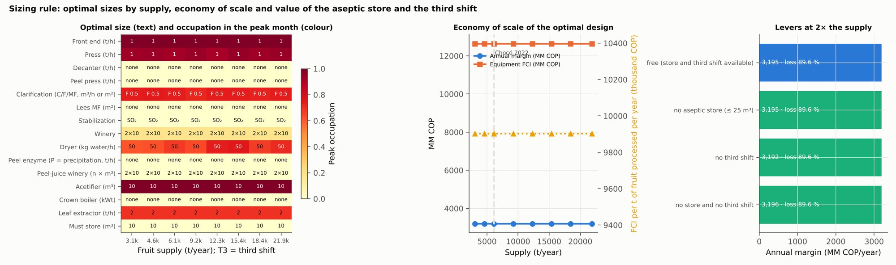
The design basis of 78,300 hL/year of wine, which needs 3.6 times the department's fruit, is not a design case: it would need a wine market about 21 times the central assumption (7,830 against 375 m³/year).

5.4 Prices, Excise Tax and Markets: Where the Wine Goes

5.4.1 From version 11 to version 12
The change from bulk wine without tax to bottled wine with excise and a market cap is decomposed with the version 11 design fixed, then reoptimized:
Step | Margin (MM COP/year) | Change
Version 11 optimum (bulk wine at 3,000 COP/L, no tax, no cap) | 4,652 | —
Bottled wine with excise and VAT, no cap (version 11 design plus bottling) | 10,530 | +5,877
Wine sales capped at 500,000 bottles/year | 2,511 | −8,018
Reoptimized design (version 12 optimum) | 3,196 | +684
Bottled at a retail price of 16,000 COP, the wine leaves the plant 6,223 COP/L after excise, distribution margin and packaging, twice the bulk value: the excise (4,220 COP per bottle) weighs less than the value bottling adds, as long as the market pays that price. The excise does not sink the project; the market cap does most of the damage. The earlier manuscript's reduced instance found that no configuration of its six lines was profitable with the excise; that conclusion holds for bulk wine with tax, not for bottled wine (Figure 5.8).
Figure 5.8. From version 11 to version 12: margin bridge with the version 11 design fixed and reoptimized, wine-demand sweep, products and NPV of comparable cases (models report, fig. 47).
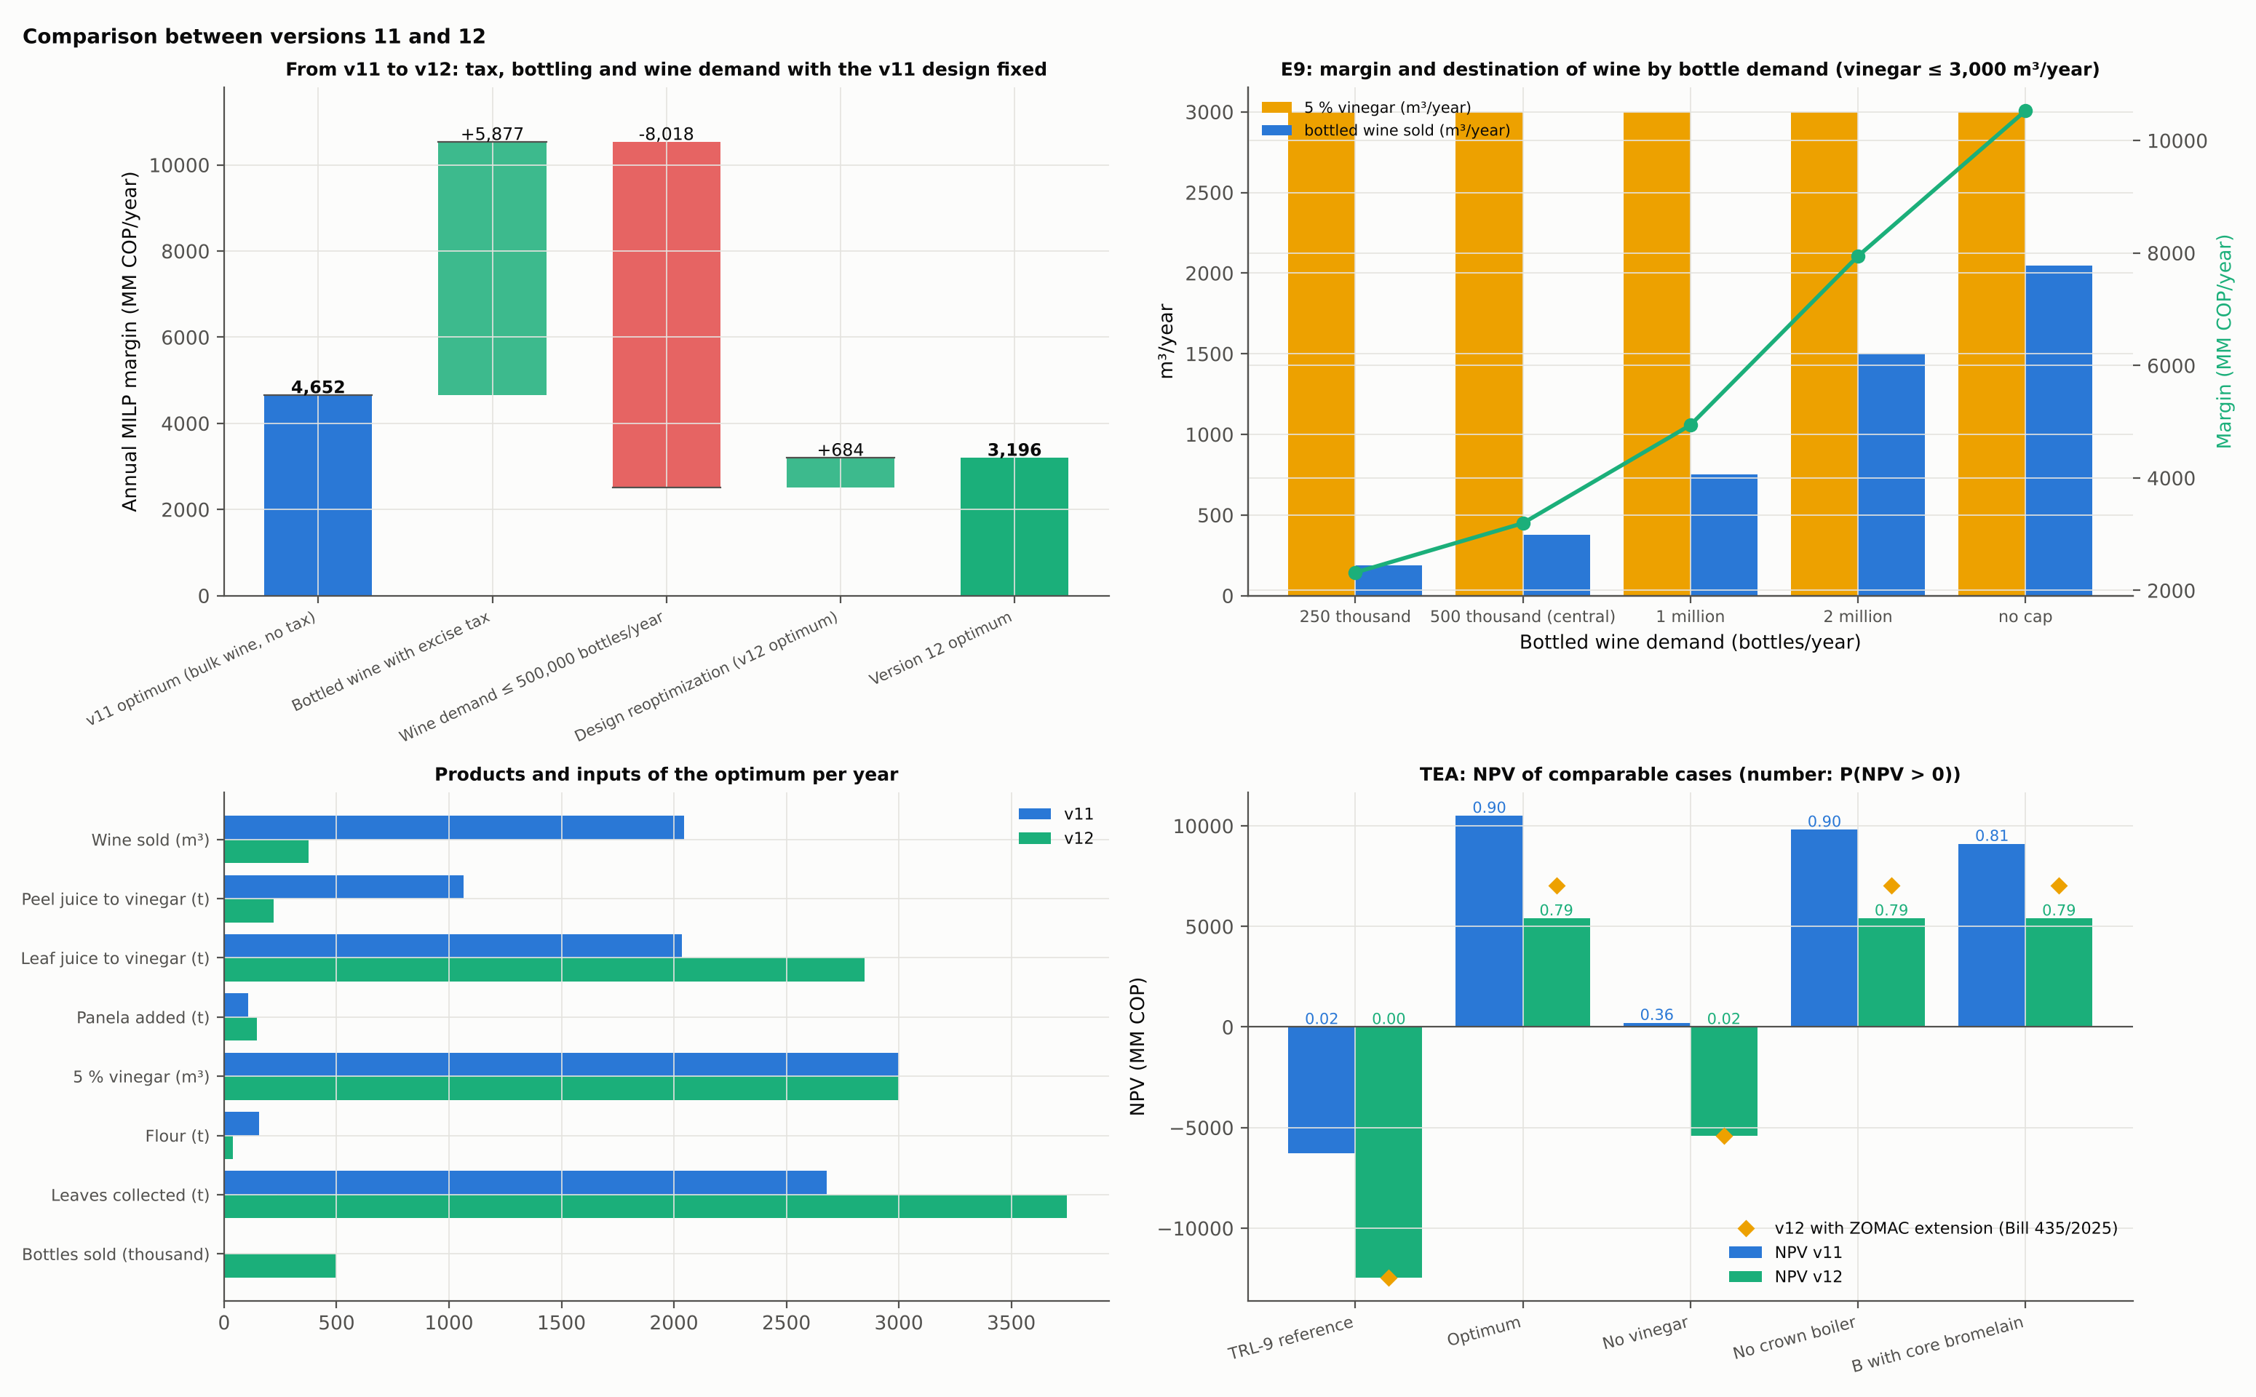

5.4.2 Wine price and vinegar price
Retail price (COP per bottle) | Net to the plant (COP/L) | Vinegar price (COP/L) | Margin (MM COP/year) | NPV (MM COP) | Fruit (t/year) | Wine produced (m³)
10,000 | 1,849 | 1,500 | −93 | — | 0 | 0
10,000 | 1,849 | 2,200 | 1,902 | — | 0 | 0
16,000 | 6,223 | 1,500 | 1,201 | −2,349 | 1,276 | 375
16,000 | 6,223 | 2,200 | 3,196 | 5,397 | 1,276 | 375
25,000 | 12,784 | 1,500 | 3,538 | 6,696 | 1,276 | 375
25,000 | 12,784 | 2,200 | 5,533 | 14,416 | 1,276 | 375
At 21.8 kg/t. The central point (16,000 COP; 2,200 COP/L) had stopped 0.06 % below the optimum, within the 0.2 % fixed-design tolerance, and is shown at the optimum's values. Wine produced; the TEA sells 95 % of it (Table 4.1).
At a retail price of 10,000 COP per bottle the optimum stops making wine altogether: it buys no fruit and makes vinegar only from leaf juice with panela; the TEA, which is built around the fruit plant, is not computed for those two cases. With cheap vinegar (1,500 COP/L) and the central wine price, the margin stays positive but the NPV turns negative. Between 16,000 and 25,000 COP per bottle the design does not change and the margin rises by 2,337 MM COP/year, all from price. Vinegar acts as a hedge against the wine price, as it did in earlier versions, but now it is the larger business (Figure 5.9).
Figure 5.9. Destination of wine and NPV of the optimal design for each pair of prices (models report, figs. 32 and 31).
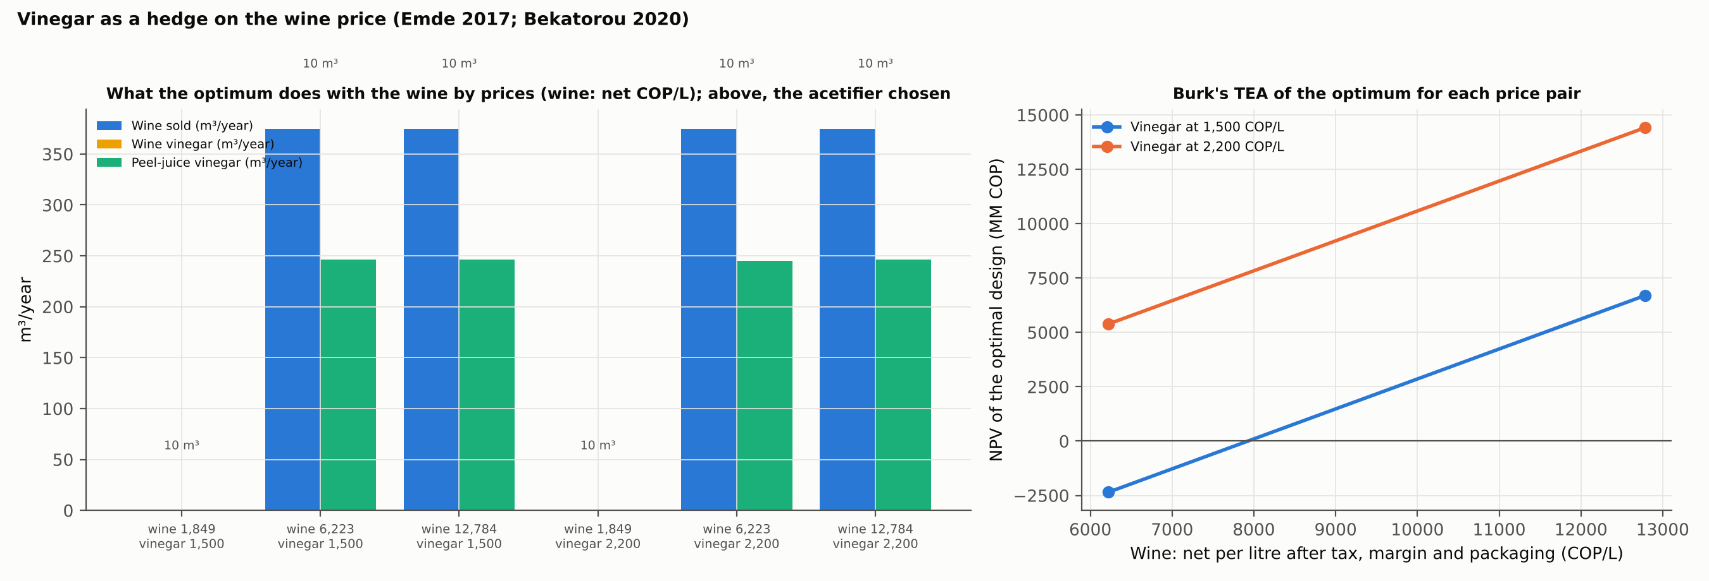

5.4.3 The two markets
Figure 5.10. Annual margin against the size of the wine and vinegar markets.
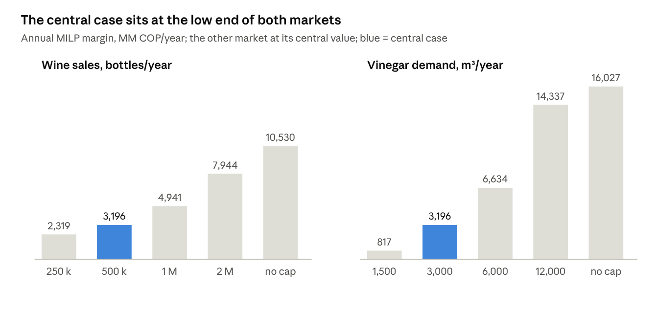
Sweeps E8 (vinegar) and E9 (wine)
Market case | Margin (MM COP/year) | Fruit (t/year) | Wine (m³) | Vinegar (m³) | Panela (t) | Leaves (t)
250,000 bottles | 2,317 | 638 | 188 | 3,000 | 151 | 3,886
500,000 bottles (central) | 3,196 | 1,276 | 375 | 3,000 | 146 | 3,746
1 million bottles | 4,942 | 2,553 | 750 | 2,999 | 135 | 3,466
2 million bottles | 7,944 | 4,758 | 1,500 | 3,000 | 118 | 2,982
No wine cap | 10,530 | 6,139 | 2,047 | 3,000 | 107 | 2,678
Vinegar demand 1,500 m³ | 1,164 | 1,276 | 375 | 1,500 | 68 | 1,733
Vinegar demand 6,000 m³ | 7,086 | 1,276 | 375 | 6,000 | 301 | 7,772
Vinegar demand 12,000 m³ | 14,337 | 1,276 | 375 | 12,000 | 613 | 15,825
No vinegar cap | 16,027 | 1,276 | 375 | 13,140 | — | —
Vinegar 6,000 m³ without panela | 4,491 | 6,139 | 2,047 | 4,836 | 0 | 2,899
Panela at 5,000 COP/kg | 2,977 | 1,276 | 375 | 3,000 | 146 | 3,746
All rows at 21.8 kg/t. The margins of 1,500 and 6,000 m³ of vinegar, 250,000 and 1 million bottles are those of the best designs found later (Section 3.10.2 and the version 13 map); the other columns of those rows describe the version 12 designs. Section 5.9.2 gives the demand map in NPV at 20.7 kg/t.
Across their ranges, wine sales move the margin 4.5-fold and vinegar demand almost 20-fold. Each additional 500,000 bottles adds about 1,500–1,750 MM COP/year and 1,100–1,300 t of fruit; each additional 1,000 m³ of vinegar adds about 1,150–1,600 MM COP/year, 1,340 t of leaves and 52 t of panela, with the fruit unchanged. Without panela, 6,000 m³ of vinegar can only be reached by buying all the fruit and diverting wine, and the plant falls short (4,836 m³). Panela at 5,000 COP/kg costs 219 MM COP/year and does not change the design.
Without a wine cap the optimum (10,530 MM COP/year) returns to a design like version 11's: a 3 t/h front end, a dedicated peel press, centrifugation, lees MF, a 100 kWt crown boiler and a 1,000 bottles/h line, processing 6,139 t of fruit. Without a vinegar cap (16,027 MM COP/year) it keeps the small fruit front end and grows the leaf route: a dedicated peel press, a 10 t/h extractor, a 4 × 10 m³ juice winery and a 40 m³ acetifier for 13,140 m³ of vinegar. The two markets, how many bottles of pineapple wine at what price and how much bulk fruit vinegar, now set both the size and the value of the plant.

5.5 Plant Leaves and Energy: What Enters and What Does Not

5.5.1 Leaves
Leaves enter as a vinegar substrate, not as fuel or ethanol feedstock. The optimum collects 3,746 t/year, about 12 % of the 32,469 t collectable, presses them into 2,847 t of juice that ferments with the peel juice and panela, and returns the leaf pulp to the field. The route is robust:
Case (E7) | Margin (MM COP/year)
Central (25 % of area collectable; 35,400 COP/t) | 3,196
10 % of area collectable | 3,196
50 % of area collectable | 3,195
Collection at 80,000 COP/t | 3,028
Ethanol at 3,000 COP/L | 3,194
The collectable fraction does not bind, because the plant uses only 12 % of the leaves even at the central value; what limits the leaf route is the vinegar market. In version 10, before panela entered, leaf juice (about 27 kg/m³ of potential acid) needed wine to reach 5 %, and the whole wine output went to the acetifier; panela removed that dependence.
The other leaf routes are never chosen, at any scale or price tested. Ethanol and yeast must pay distillation heat and diesel electricity at a scale of a few hundred thousand litres a year; biogas power can only replace the plant's own diesel, because no one buys surplus power in a ZNI; and citric acid and xanthan, scaled down from plants of 18,000 and 5,000 t/year, carry an investment the juice volume does not pay. Removing ethanol or the digester leaves the optimum unchanged.

5.5.2 Energy
The energy picture follows from the small plant. Drying 162 t of cake and 85 t of lees needs 684 GJ/year, too little to pay a crown boiler, so all process heat comes from LPG; the 100 kWt crown boiler chosen in versions 8 to 11 returns only when the wine market is uncapped and the plant processes 6,139 t of fruit. When it enters, it burns the crown and replaces LPG for drying. Electricity, 276 MWh/year in the LCA inventory, comes from the diesel genset; the acetifier's continuous aeration is its largest single use, followed by leaf extraction. Gasification is never selected, at any scale or version: the bottleneck is heat, and a boiler delivers about three times the heat of a gasifier from the same crown. The off-grid condition still shapes the design, but through the cost and emissions of diesel electricity, which makes renewable electricity the first improvement target (Section 5.7).

5.6 Economic, Environmental and Social Performance under Uncertainty

5.6.1 Techno-economic assessment
Case | FCI (MM COP) | NPV (MM COP) | MIRR | Payback (years) | P(NPV > 0) | Company size
Optimum (configuration A) | 16,405 | 5,273 | 13.4 % | 5.0 | 0.78 | Medium
Vinegar only (100,000-bottle cap or high excise) | 13,721 | 1,393 | 11.2 % | — | — | Micro or small
Optimum (configuration B; at 21.8 kg/t) | 16,405 | 5,395 | 13.5 % | 4.9 | 0.79 | Medium
Without SO₂ (at 21.8 kg/t) | 17,207 | 4,522 | 12.8 % | 5.2 | 0.72 | Medium
Without version 10 options (at 21.8 kg/t) | 18,723 | 2,407 | 11.4 % | 5.8 | 0.51 | Medium
Version 11 design, version 12 parameters (at 21.8 kg/t) | 19,578 | 2,267 | 11.3 % | 5.8 | 0.53 | Medium
Without panela (at 21.8 kg/t) | 19,578 | 2,075 | 11.2 % | 5.9 | 0.49 | Medium
Without vinegar | 7,737 | −5,409 | −1.5 % | — | 0.02 | Micro or small
Previous topology | 8,590 | −6,895 | −5.0 % | — | 0.01 | Micro or small
Reference TRL-9 | 12,365 | −12,454 | −22.8 % | — | 0.00 | Micro or small
Reference TRL-9 with bromelain (B) | 15,224 | −16,269 | −30.9 % | — | 0.00 | Micro or small
No wine cap (at 21.8 kg/t) | 23,044 | 31,771 | 21.5 % | 2.8 | 0.99 | Medium
No vinegar cap (at 21.8 kg/t) | 33,991 | 53,243 | 23.3 % | 2.5 | 1.00 | Medium
The TEA confirms the ranking of the MILP. From the TRL-9 reference to the optimum the NPV rises from −12,454 to 5,273 MM COP and the MIRR from −22.8 % to 13.4 %; P(NPV > 0) rises from 0 to 78 %. Without vinegar the optimum loses money (NPV −5,409 MM COP, P(NPV > 0) = 0.02): the vinegar routes add 10,682 MM COP of NPV at 2,200 COP/L. The crown boiler adds nothing in version 12, and bromelain adds nothing (configuration B equals A).
Margin is not viability. The annual margin of the MILP is computed after the annualized capital charge. It comes before payroll, supervision, the other fixed costs, income tax and the phased start-up, which the TEA includes. Over the designs of the demand map, NPV and margin follow approximately
$$NPV≈−\text{5,409}+3.588 \left(m−184\right) \text{MM COP}$$ | (5.1)
The relation passes through the design without vinegar and the optimum at 21.8 kg/t. Against the full TEA of 26 other designs it deviates by 881 MM COP on average and by 2,706 at most; the largest deviation is at 12,000 m³ of vinegar, an extrapolation. It places the break-even margin at about 1,692 MM COP/year.
The relation is empirical. It is used only to read the dual bounds of the MILP, which are in margin, as statements about NPV (Section 5.9.2), never in place of a TEA. For designs that process no fruit, the TEA sizes the wine and flour lines for a token 1 kg of fruit, which avoids a division by zero: their flows and consumables are zero, and the idle units the MILP selects are still costed, so the NPV of these designs is conservative. For designs with fruit the TEA is unchanged.
Cost structure of the optimum.
- Revenue is 12,089 MM COP/year: 5,362 from wine at the factory price and 6,727 from vinegar and flour.
- Variable costs are 5,097 MM COP/year. Raw materials account for 4,497 of them: the excise on the 475,000 bottles sold (95 % of the 500,000 produced, the sales convention of Table 4.1) about 2,000, packaging about 1,140, panela 541, fruit 511 and leaf collection 133, with composting and chemicals making up the rest. Utilities cost 580 and waste treatment 21.
- Fixed costs are 2,227 MM COP/year: payroll 572, supervision 343, maintenance 820 and local taxes and insurance 492. Working capital is 610 MM COP and operating cost totals 7,324 MM COP/year.
- The payback is 5.0 years (6.6 discounted), and the break-even vinegar price is 1,723 COP/L, 22 % below the assumed 2,200.
- Over 1,000 correlated Monte Carlo samples the NPV has a median of 3,543 MM COP, a 5th–95th percentile range of −4,127 to 11,526, and a CVaR at 5 % of −6,347.
The excise is the largest single cost of the plant, and its rate is not stable (Section 4.1.6).
Fiscal sensitivity (Table 5.6.1b). Under the current regime a bottle sold at 16,000 COP leaves 4,667 COP after excise, VAT, distribution and packaging. The other regimes leave:
- 1,306 COP with the specific component tripled;
- 583 COP with the rates of Decree 1474 of 2025 and 5 % VAT, and −332 COP with 19 % VAT;
- −537 COP under the 2026 fiscal bill.
The re-optimized plant. From the tripled specific component upwards, the re-optimized plant stops making wine. It becomes a vinegar plant fed by leaf juice and panela, earning 1,868 MM COP/year with an NPV of 1,393 MM COP and an MIRR of 11.2 %:
- under the decree and bill rates this design is certified optimal, because its dual bound equals its margin;
- with only the specific component tripled it is the best design found (dual bound 3,312).
The vinegar plant against the leaf-juice yield. Its viability rests on the leaf-juice yield. Its NPV is 553 MM COP at 13.5 kg/t, 269 at 11.1 kg/t and −154 for the best design found at 6.5 kg/t, the value compatible with the source's yeast yield. It is therefore viable at least down to about 8 kg/t. At 6.5 kg/t a viable design is not ruled out: that run stopped far from its own bound, and by monotonicity the vinegar-only optimum there cannot exceed 1,872 MM COP/year, the bound at 20.7 kg/t.
The vinegar plant is thin. Its MIRR of 11.2 % is close to the 10 % discount rate, and its break-even vinegar price is 2,074 COP/L, only 5.7 % below the assumed 2,200.
The current design kept. If the design optimized for the current regime is kept, it does worse:
- with the specific component tripled it earns 1,567 MM COP/year and its NPV is −993 MM COP;
- under the decree and bill rates it stops buying fruit and earns 1,408 MM COP/year.
The wine line is therefore the part of the project exposed to fiscal risk. A high excise changes what the plant sells, not whether it is viable, unless the leaf-juice yield is also at the low end of its range.
Table 5.6.1b. Wine excise regimes: net revenue per 750 mL bottle and whole-plant result (leaf-juice ethanol 20.7 kg/t). Net = factory price − excise − packaging (2,400 COP); factory price = retail price / (1 + VAT) / (1 + distribution margin). The excise follows the relation of Section 4.1.3.
Regime (specific COP/degree; ad valorem; VAT) | Excise per bottle at 16,000 COP | Net per bottle at 10,000 / 16,000 / 25,000 COP | Re-optimized plant (MM COP/year; NPV) | Current design kept: margin (MM COP/year) and NPV (MM COP)
Current (243; 20 %; 5 %) | 4,220 | 1,387 / 4,667 / 9,588 | 3,164; NPV 5,273 (500,000 bottles; 3,000 m³) | 3,164; 5,273
Specific component tripled (729; 20 %; 5 %) | 7,582 | −1,975 / 1,306 / 6,226 | 1,868, vinegar only (best found; dual bound 3,312); NPV 1,393 | 1,567; −993
Decree 1474/2025 rates, 5 % VAT (750; 30 %; 5 %) | 8,305 | −2,332 / 583 / 4,954 | 1,868, vinegar only (certified); NPV 1,393 | 1,408, buys no fruit
Decree 1474/2025 rates, 19 % VAT (750; 30 %; 19 %) | 7,891 | −2,903 / −332 / 3,525 | 1,868, vinegar only (certified); NPV 1,393 | 1,408, buys no fruit
2026 fiscal bill, no indexation (750; 35 %; 19 %) | 8,097 | −2,965 / −537 / 3,104 | 1,868, vinegar only (certified); NPV 1,393 | 1,408, buys no fruit
Vinegar-only plant at lower leaf-juice yields | — | — | NPV 553 at 13.5 kg/t; 269 at 11.1 kg/t; −154 at 6.5 kg/t | —
With 19 % VAT the excise per bottle is lower than with 5 %, because the ad valorem base, the retail price before VAT, is smaller. The net per bottle is still lower.
Company size and income tax. By its revenue in UVT the optimum is a medium-sized company, so with start-up in 2030 it pays the general rate of 35 % in every year. At 21.8 kg/t, the proposed ZOMAC extension (Bill 435 of 2025) would raise the optimum's NPV by 1,632 MM COP; the no-cap designs would gain 6,457 (wine) and 10,448 (vinegar). The ZOMAC location does not exempt the wine from the departmental excise.
Figure 5.11. TEA of the optimal designs: NPV by case, cost structure and Monte Carlo distribution (models report, fig. 31).
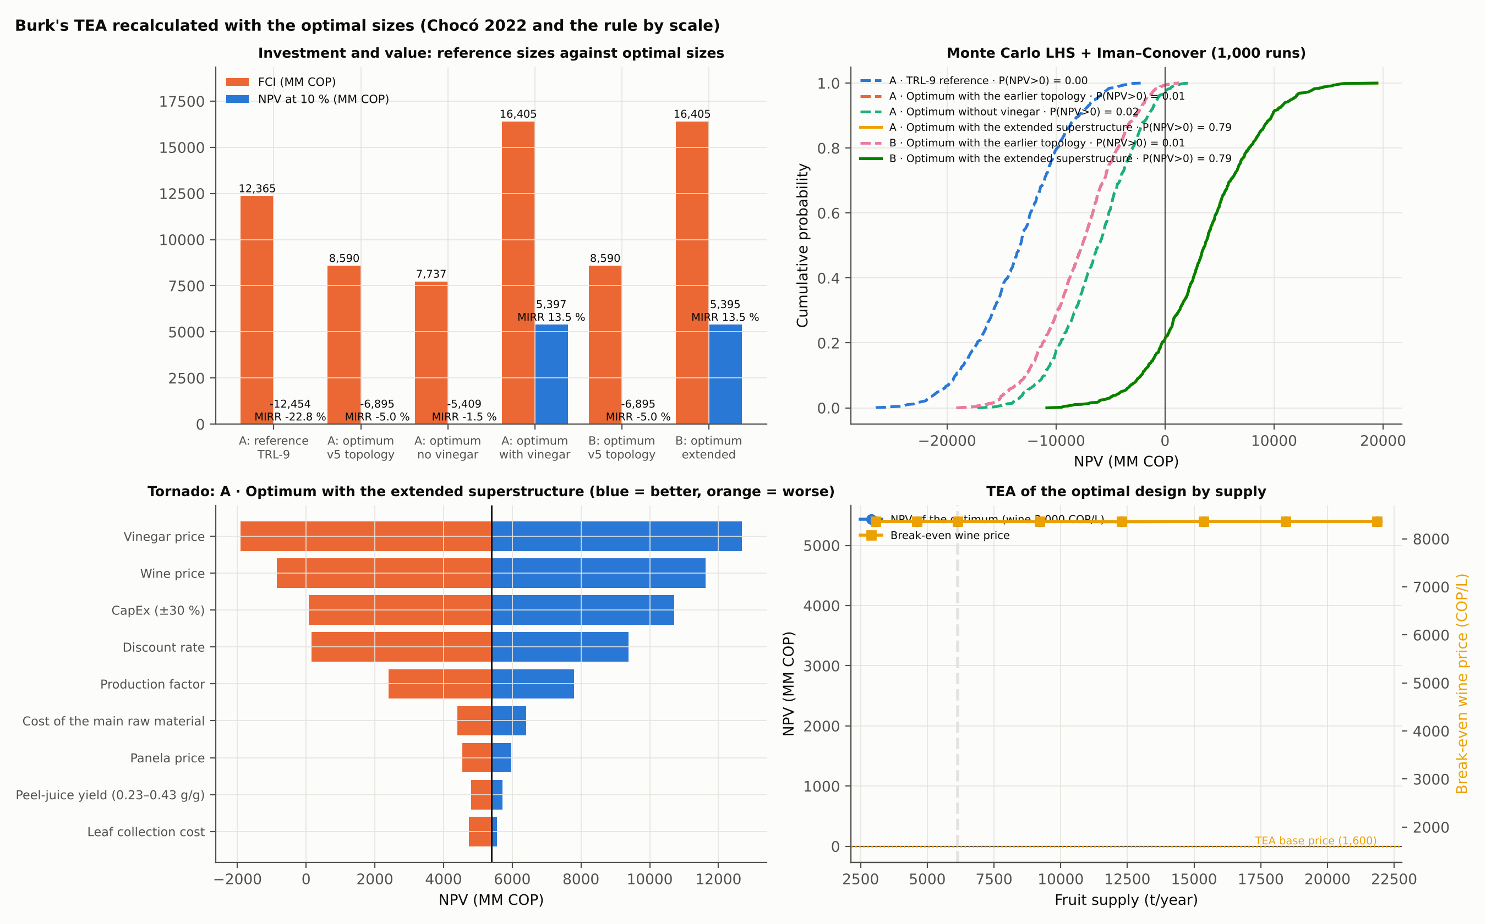

5.6.2 Which prices carry the project
Parameter (range) | NPV at worst (MM COP) | NPV at best (MM COP)
Vinegar price (±30 %) | −2,027 | 12,558
Wine price (±30 %) | −968 | 11,504
Capital (±30 %) | −52 | 10,585
Discount rate (6–18 %) | 65 | 9,236
Production factor (80–100 %) | 2,284 | 7,665
Fruit cost (±50 %) | 4,272 | 6,275
Panela price | 4,363 | 5,880
Peel-juice ethanol yield (0.23–0.43 g/g) | 4,678 | 5,594
Leaf collection cost | 4,618 | 5,426
The NPV turns negative with vinegar or wine 30 % cheaper, and only just with 30 % more capital (−52 MM COP); an 18 % discount rate brings it to about zero (65). Fruit cost, the variable that dominated the fermentation-train sensitivity (Section 2.8.4), matters little here because the plant buys little fruit. The break-even vinegar price is 1,723 COP/L, 22 % below the assumed 2,200. Without vinegar, wine would need a factory price of 13,774 COP per bottle against 11,287 assumed. The leaf-juice yield and the wine excise, the two uncertainties outside this tornado, are treated in Sections 5.1.2 and 5.6.1.
Monte Carlo. Over 1,000 correlated samples the NPV has a median of 3,543 MM COP, a 5th–95th percentile range of −4,127 to 11,526, a conditional value at risk at 5 % of −6,347, and P(NPV > 0) = 0.78. The distribution is wide because both product prices are assumptions with wide ranges; it narrows only with market data.

5.6.3 Stochastic design
The two-stage program varies supply only, at 0.7, 1.0 and 1.3 times the central value with probabilities 0.25, 0.5 and 0.25.
The violated test. At 21.8 kg/t the version 12 run reported RP = 3,196 and WS = 3,195 MM COP/year, which violates EEV ≤ RP ≤ WS. By the protocol of Section 3.11 that is an error, not a result. The wait-and-see problem of the central scenario had stopped at its time limit (3,193.7), below a design already known; the mean-value problem EV is the same scenario and had stopped at the same value. Re-solving each scenario from that design gives WS = 3,195.6 ≥ RP = 3,195.5 MM COP/year, with the same design in every scenario.
Bounds. Supply enters the MILP only as an upper limit, so the feasible sets are nested and the optimum with more supply bounds the optimum with less. A higher leaf-juice yield likewise cannot lower the optimum. At the corrected yield the runs give:
Supply scenario | Solution at 20.7 kg/t | Valid upper bound
0.7 | 3,164.1 | 3,178.1 (its own run)
1.0 | 3,164.0 | 3,210.1 (run at 1.3 times the supply, 21.8 kg/t)
1.3 | 3,164.1 | 3,210.1 (same run)
Hence:
- 3,164.0 ≤ RP ≤ WS ≤ 0.25 × 3,178.1 + 0.75 × 3,210.1 = 3,202.1;
- EVPI and VSS lie between 0 and 38 MM COP/year, 1.2 % of the margin;
- the same bounds certify the central optimum within 1.5 %.
What the program shows. The stochastic design is the deterministic one. This was expected: with both markets capped, supply is not an active constraint, and even the low scenario offers more fruit than the wine market absorbs. The two-stage program answers only the supply question, and the answer is that supply does not matter at this scale.
Market and fiscal uncertainty, which do matter, are not represented in this program. They are treated by the demand map (Section 5.9.2), the price tornado and the Monte Carlo (Section 5.6.2), and the fiscal regimes (Table 5.6.1b). A two-stage program with demand and excise as uncertain parameters is future work (Section 6.7).

5.6.4 Life-cycle assessment
Contribution | t CO₂e/year | Share
Leaf pulp returned to the field | 479 | 37 %
Diesel electricity | 269 | 21 %
Glass bottles | 250 | 19 %
Panela | 93 | 7 %
Diesel for leaf collection | 67 | 5 %
Composting of crown and core | 61 | 5 %
LPG heat | 57 | 4 %
Effluent treatment | 11 | 1 %
Fruit transport | 5 | 0.4 %
Chemicals | 2 | 0.2 %
Process total | 1,293 | 100 %
Process GWP is 1,293 t CO₂e/year, or 1,013 kg per tonne of fruit processed. The largest item is the leaf pulp the extractor returns to the field: 674 t/year that carry about two thirds of the leaves' dry matter and still decompose there. Earlier versions credited the plant for all the leaves it collects but did not count this return. The correction (Section 4.2) raises process GWP and changes the sign of the net result. Diesel electricity and glass bottles follow. Effluent treatment removes 97 % of 7.9 t of COD for 11 t CO₂e. Fossil energy is 4.7 TJ/year and water 2,936 m³/year.
The net result and its two assumptions. The net GWP subtracts what the site would emit without a plant. It rests on two assumptions:
- One decomposition factor. A single IPCC factor (4 g CH₄ and 0.3 g N₂O per kg of wet material, 190 kg CO₂e/t) values the fruit and leaves in the baseline, the fractions composted in the plant and the leaf pulp returned to the field.
- The fate of the leaves. Without a plant they would decompose, or they would be burned.
Table 5.6.4b varies both:
- From 90 to 290 kg CO₂e/t, the optimum adds between 121 and 558 t CO₂e/year against a decomposing baseline, and between 853 and 1,166 t against a burning baseline.
- Raising the factor lowers the net result, because it multiplies 954 t CO₂e of baseline emissions but only 539 t CO₂e of process emissions.
- The sign is robust: under every combination tested, the economic optimum emits more than the site without a plant.
- At the lower end of the leaf-juice range, the optimum needs more panela, and its net GWP on the MILP basis rises to +447 t (Table 5.1.2a).
Burning leaves emits little GWP but much particulate matter, and the plant then avoids 4.8 t/year of particulates.
Table 5.6.4b. Net GWP of the economic optimum against the decomposition factor and the leaf counterfactual (t CO₂e/year; life-cycle inventory).
Decomposition factor (kg CO₂e/t wet) | 90 | 190 (central) | 290
Process GWP | 1,009 | 1,293 | 1,577
Baseline: fruit and leaves decompose | 452 | 954 | 1,456
Net GWP, decomposing baseline | +558 | +339 | +121
Baseline: fruit decomposes, leaves burned | 156 | 284 | 412
Net GWP, burning baseline | +853 | +1,009 | +1,166
The figures of this section use the life-cycle inventory: 1,293 t of process emissions and +339 t net. The MILP carries a linear GWP of 1,282 t (+328 t) that omits effluent treatment (11 t). Each figure in this thesis names its basis.
The supply premise. The baseline also assumes that the fruit the plant buys would otherwise be discarded. This thesis takes the 2022 production of Chocó as the supply available to the plant. The only measured reject stream, however, is 144 t/year in one municipality (Murcia Palacios, 2013), and Section 2.1.3 gives a scenario of 1,536 t at 25 % shrinkage. At 1,276 t/year the optimum stays within that scenario. Fruit diverted from the fresh market would carry no baseline credit; Section 5.9.4 shows why this matters for the low-GWP designs.
Credits and allocation. System-expansion credits are zero for the optimum, which makes neither ethanol nor surplus power. By economic allocation, a bottle of wine carries 1.15 kg CO₂e (44 % of the burden), a litre of vinegar 0.22 kg (52 %) and a kilogram of flour 1.22 kg (4 %).
Figure 5.12. LCA of the designs: contributions and net GWP against the baseline (models report, fig. 40).
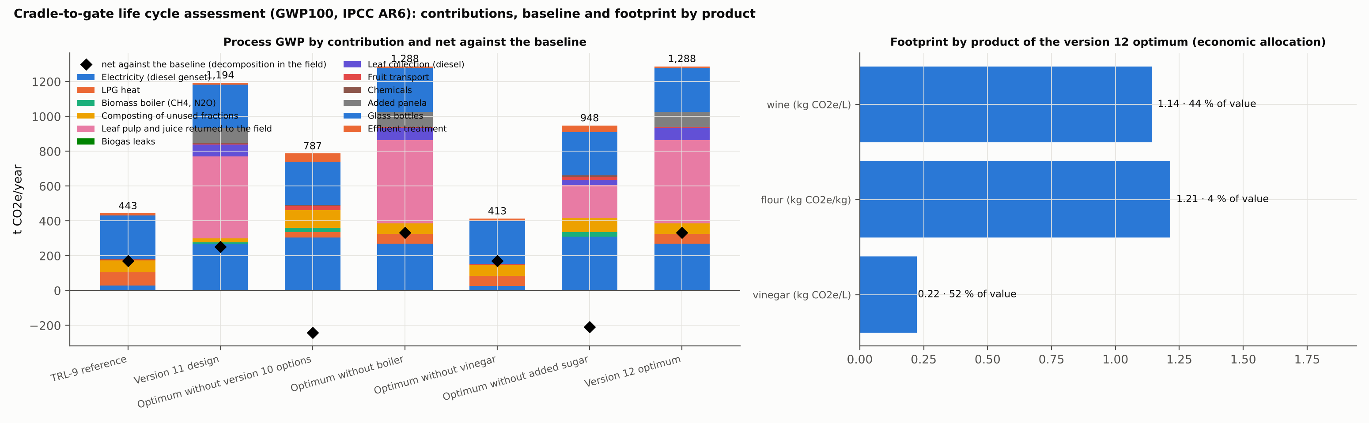

5.6.5 Social indicators
Indicator | Optimum
Direct jobs in the plant | 15
Jobs in leaf collection | 1.9
Payment for fruit | 511 MM COP/year
Payment for leaf collection | 133 MM COP/year
Local payroll | 823 MM COP/year
Local purchases | 555 MM COP/year
Value retained in the territory | 2,021 MM COP/year (1.6 MM COP per t of fruit)
At 20.7 kg/t. The correction of the leaf-juice yield changes only the local purchases, through the extra panela (545 MM COP/year at 21.8 kg/t), and lifts the value retained by 10 MM COP/year.
The value retained in Bajo Atrato, 2,021 MM COP/year at 20.7 kg/t, is 17 % of the plant's revenue. Payments to growers are smaller than in earlier versions because the plant buys a fifth of the fruit; a larger wine market would raise them first.

5.6.6 Margin against GWP
Earlier versions reported a front of margin against process GWP, from 798 t at the economic optimum down to the plant that does not operate. It is superseded for two reasons: process GWP rewards processing less, and it was computed without the leaf pulp returned to the field (Section 4.2.5). The front that answers H3, on net GWP against the no-plant baseline and with compromise designs, is in Section 5.9.4 and Figure 5.19.

5.6.7 Version history
Each version replaced assumptions with data or added alternatives, and the decomposition of Section 2.4 separates the two effects.
Version | What changed | Optimum margin (MM COP/year) | NPV (MM COP) | P(NPV > 0)
7 | Must-treatment superstructure calibrated with pineapple data; vinegar routes | 2,990 | — | —
8 | Crown boiler | 3,210 | 5,733 | 0.76
9 | Measured peel yields (Campos et al., 2020; Seguí and Fito, 2018); lime pressing and enzyme options | 2,400 | 2,577 | 0.52
10 | Leaves, ethanol, digestion, hub products; parameter registry; juice kinetics; vinegar blending | 4,040 | 8,195 | 0.77
11 | Panela, vinegar demand cap, measured xanthan yield, effluent treatment | 4,652 | 10,500 | 0.90
12 | Bottled wine with excise and VAT, wine demand cap, income tax by year and company size, filling-time rule | 3,196 | 5,397 | 0.79
Version 9 is the clearest case of data lowering value without changing the design: with the version 8 design fixed, the measured juice yield and cake of Campos et al. (2020) cost 479 MM COP/year (more juice, but a cake with less solids and less flour, which is worth more) and the measured peel-juice ethanol yield another 319. Version 12 is the clearest case of a market fact changing the design (Figures 5.14–5.16).
Figures 5.14–5.16. Comparisons between versions 8–9, 9–10 and 10–11 (models report, figs. 39, 45 and 46).
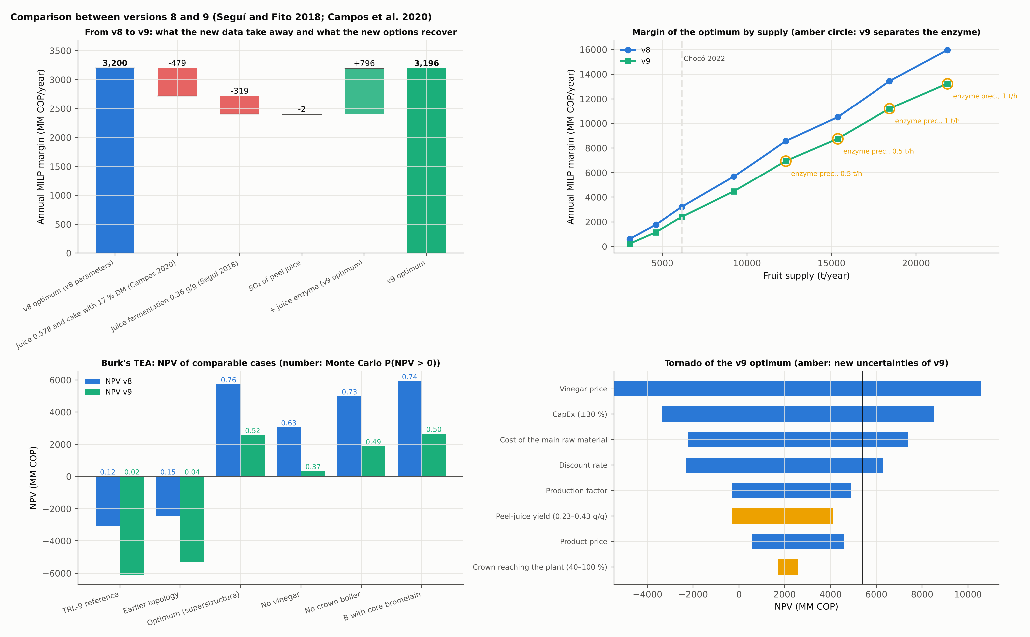
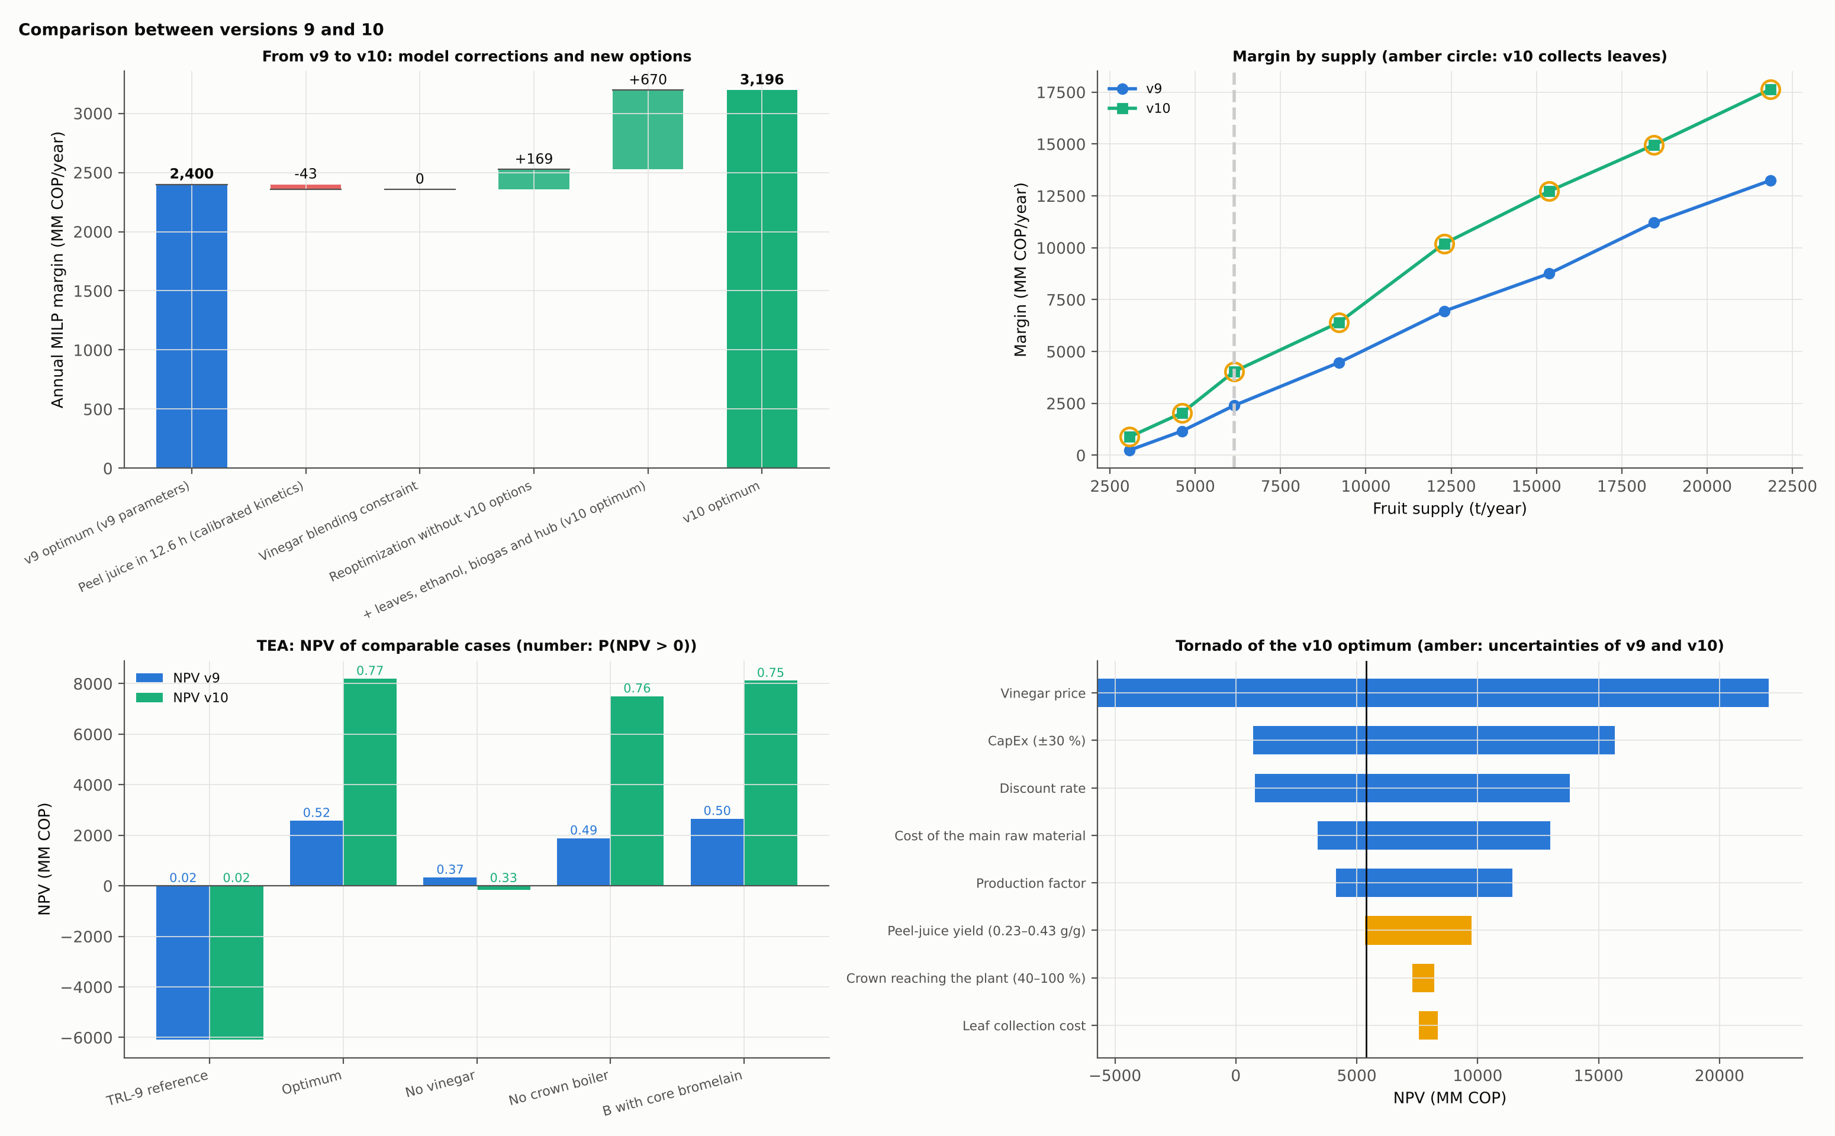
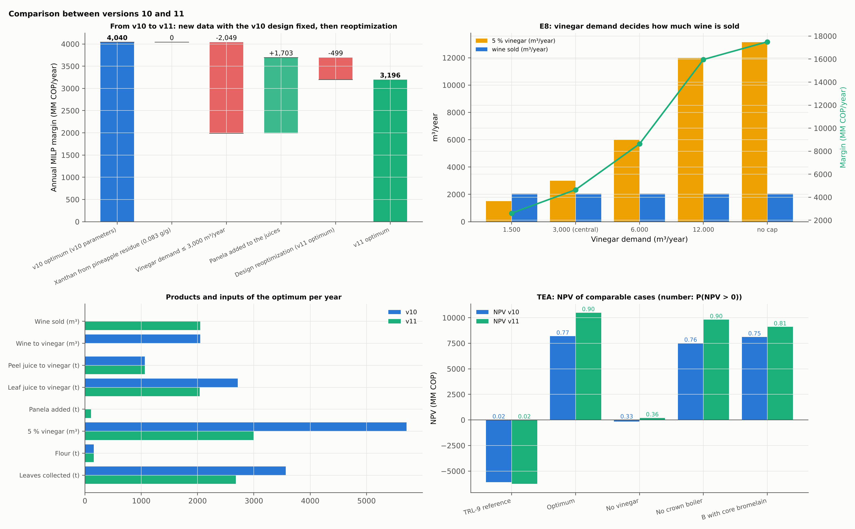

5.7 Hot Spots and Improvement Targets
Following stage 3 of Bertran, Tula and Gani (2022), the optimum is divided into sections, and each section receives its share of the capital charge, of the electricity and heat its flows demand (with the MILP coefficients) and of process GWP. A section is a hot spot for a burden if its share of that burden exceeds its share of revenue by more than 10 points:
Bk,bk′​Bk′,b>Ikk′​Ik′+0.10, b∈{capital, electricity, heat, GWP} | (5.2)
Section | Capital | Electricity | Heat | GWP | Revenue | Hot spot for
Front end and pulp | 10 % | 5 % | 5 % | 4 % | 0 % | Capital (upstream of wine)
Must and winery | 24 % | 3 % | 0 % | 2 % | 25 % | —
Peel and flour | 10 % | 3 % | 95 % | 16 % | 5 % | Heat, GWP
Vinegar | 51 % | 65 % | 0 % | 45 % | 70 % | —
Leaves | 4 % | 24 % | 0 % | 34 % | 0 % | Electricity, GWP (upstream of vinegar)
Shares of the central design at 20.7 kg/t. They are the same as at 21.8 kg/t to the percentage point: the design does not change, and the extra panela the correction requires belongs to no section.
Upstream sections deliver an intermediate, not a product, and are read against the revenue of the product they feed: the front end feeds wine and the leaves feed vinegar. Read that way, three targets remain, each translated into an alternative with a technical basis for the next version of the superstructure:
- Heat for the dryer. The peel-and-flour section takes 95 % of the heat for 5 % of revenue, all from LPG. Solar thermal drying or a small biomass heater fired with crown would remove most of it; the crown boiler of the catalogue is too large for 684 GJ/year.
- Electricity for aeration and extraction. Vinegar and leaves take 89 % of the electricity, all from diesel. Photovoltaics with storage, sized to the continuous aeration load, is the first candidate; biogas remains available but its digester is large for the load.
- Packaging. Glass bottles emit nearly as much as all the plant's electricity (250 against 269 t CO₂e/year). Lighter glass, returnable bottles or bag-in-box for part of the market would cut it.
Figure 5.17. Hot spots of the optimum by section (models report, fig. 44).
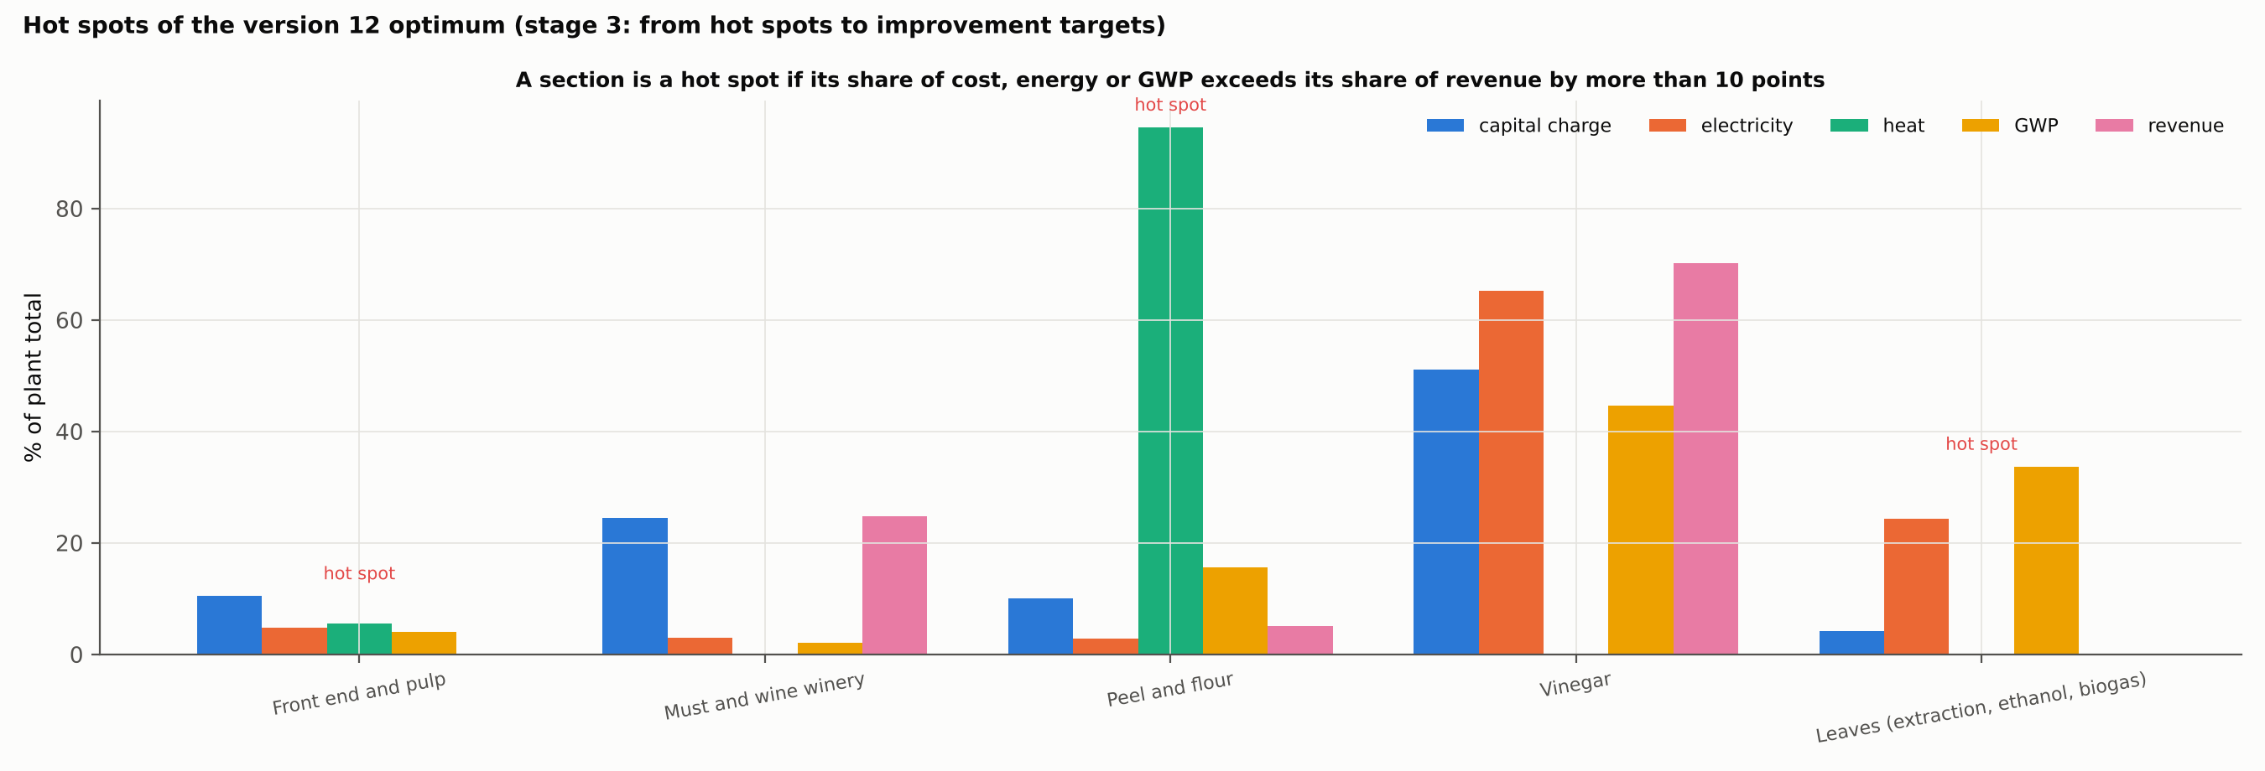

5.8 Verification of the Design: Balance Closure and Process Simulation
The balances close by fraction and utility (Section 5.2), and the TEA of every case is reproduced in its workbook (Section 4.1.5). Verification in a commercial simulator follows Foo (2023, chs. 10 and 11). A package generated from the solution gives SuperPro Designer the 15 unit procedures of the optimum with their mode, size, cycle, temperature and key specification; the 16 annual streams the simulation must reproduce; and 13 indicators with tolerances:
Indicator | Python model | Tolerance
Total process heat | 684 GJ/year | ±10 %
Heat from the biomass boiler | 0 GJ/year | ±10 %
Heat from LPG | 684 GJ/year | ±15 %
Process electricity without aeration | 182 MWh/year | ±15 %
Acetifier aeration | 95 MWh/year | ±15 %
Acetifier cooling | 1,233 GJ/year | ±10 %
Water evaporated in the dryer | 131 t/year | ±5 %
Interval between wine batches filled from the store | 204 h (annual average) | ±10 %
Cycle of the juice winery | 12.6 h | ±20 %
Wine produced | 375 m³/year | ±3 %
Vinegar at 5 % | 3,000 m³/year | ±3 %
Flour | 40 t/year | ±5 %
Peak occupation of the acetifier | 100 % | ±10 %
The wineries are modelled as staggered batch fermenters, as in the citric acid example of Koulouris (Foo, 2023, ch. 11); the wine fermenters are loaded from the must store in about an hour. Running the package requires the author's licence and is pending. A difference beyond tolerance will point to the registry coefficient to correct before reoptimizing. The cross-check against the reduced MINLP instance of the earlier formulation is also pending: five of its fourteen parameters lie outside the measured ranges used here, and the MILP should be solved with that instance's parameters to show that both tell the same story.

5.9 Hypothesis Tests against Baselines, Demand, Autonomy and Net GWP
This section reports the comparisons of Section 3.12. Unless stated, all designs face the central prices and the caps of 500,000 bottles and 3,000 m³ of vinegar, and all are polished across the full set of designs found.

5.9.1 Simultaneous against sequential design (H1)
Design method, same superstructure and parameters | Annual margin (MM COP/year) | NPV (MM COP) | MIRR | P(NPV > 0)
Simultaneous, seasonal operation (optimum) | 3,164 | 5,273 | 13.4 % | 0.78
Simultaneous, average flows | 3,164 | 5,273 | 13.4 % | 0.78
Sequential by fractions, seasonal operation | 1,816 | 27 | 10.0 % | 0.38 (at 21.8 kg/t)
Sequential by fractions, average flows | 1,816 | 27 | 10.0 % | 0.38 (at 21.8 kg/t)
At 20.7 kg/t. P(NPV > 0) from 1,000 Monte Carlo runs for the optimum; for the sequential designs it was not recomputed and the value at 21.8 kg/t (500 runs; margin 1,836, NPV 79) is shown.
Designing the fractions in sequence costs 1,348 MM COP/year, 42.6 % of the margin, and almost all of the NPV. The loss has a precise cause. The wine line alone earns 184 MM COP/year. The peel stage then sizes the acetifier for peel juice (6 m³) and adds a 100 kWt crown boiler. When the leaves arrive in the third stage, the extractor is added, but the acetifier is already fixed, so only 1,652 t of leaves and 1,971 m³ of vinegar fit, against 3,746 t and 3,000 m³ when the acetifier is sized knowing that leaf juice and panela will feed it. The sequential protocol has no feedback between stages, so the gap measures sequential design without iteration. The value of simultaneous design here is the coupling between fractions through a shared unit, which no stage of a sequential method can see.
Seasonal operation, the other half of the claim, adds nothing at this scale: the average-flow design is identical to the optimum, because the market caps keep the plant at 21 % of the fruit and no unit is pressed by the harvest peaks. Without caps and with capacity binding, it does matter:
Supply (× 2022), no market caps | Seasonal design (MM COP/year) | Average-flow design, operated seasonally | Loss
2.0 | 32,862 | 28,867 | 3,995 (12.2 %)
3.56 (earlier design basis) | 46,918 | 44,861 | 2,057 (4.4 %)
H1 is therefore supported with a qualification: at the scale of Chocó the gain comes from synthesis across fractions; the gain from coupling design with seasonal operation appears only when capacity, not the market, is the limit.
Figure 5.18. Left: margin and NPV of the same superstructure designed simultaneously or fraction by fraction (average flows give the same values). Right: NPV of the re-optimized design for each pair of market sizes (full TEA), with the line NPV = 0 interpolated between grid points; solid frames mark the points robustly not viable by their dual bounds, dashed frames those not viable as found but not established (Table 5.9.2b). Leaf-juice ethanol 20.7 kg/t.
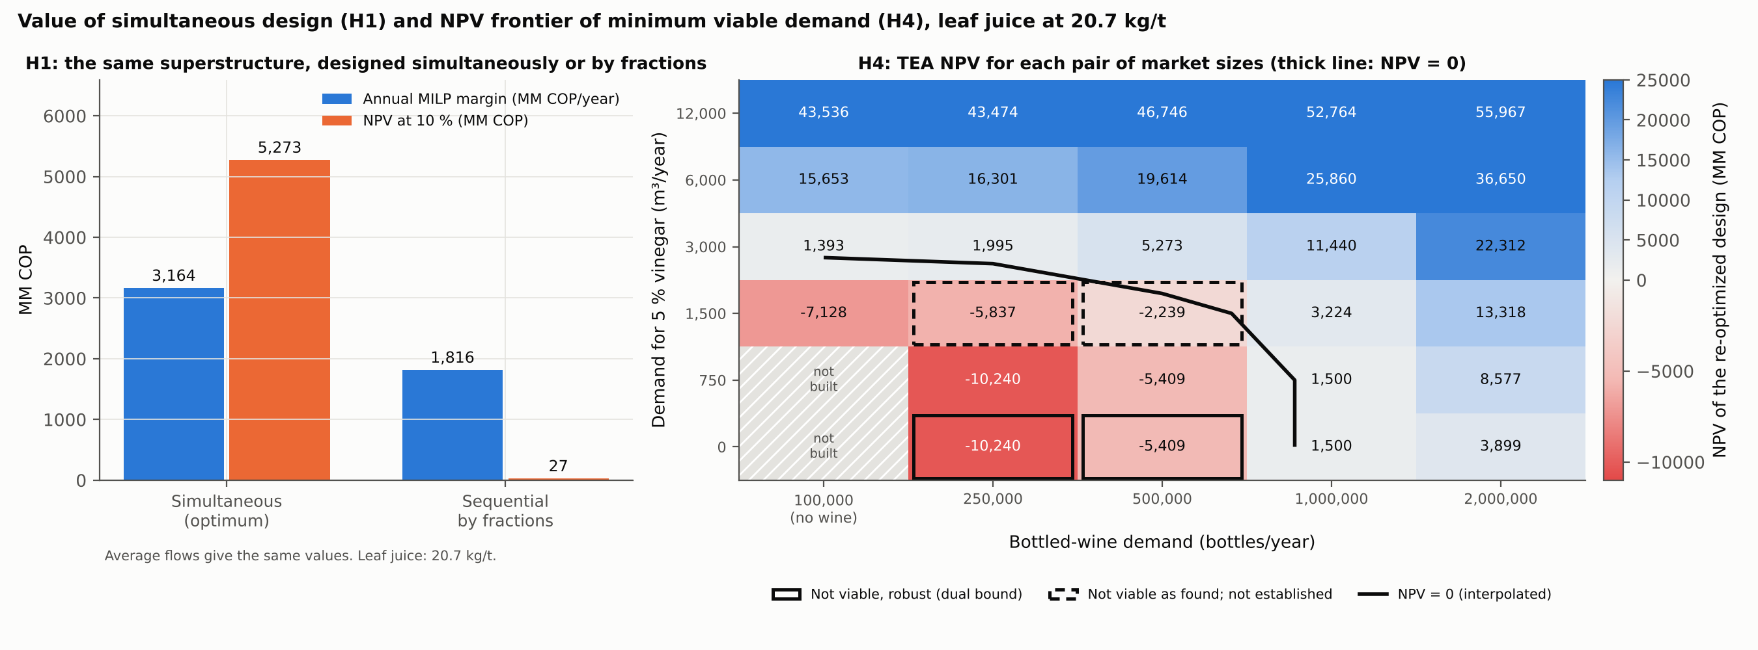

5.9.2 Minimum viable demand (H4)
Section 3.12.4 defines the H4 frontier as the line NPV = 0. The design was re-optimized over 30 combinations of market size, and the dual bound of each free run was recorded:
- the rows with 1,500 m³ of vinegar or more were re-optimized at the corrected leaf-juice yield;
- the rows with 0 and 750 m³ use no leaf juice and are unchanged;
- the TEA was run on every design that builds a plant, 28 points (Table 5.9.2a);
- the two points at 100,000 bottles with 0 or 750 m³ have as best design the mandatory minimum front end, with a margin of −1,090 MM COP/year; the real alternative, not building, has an NPV of 0.
The frontier. Interpolating the NPV between grid points:
- Without vinegar, the plant is viable from about 890,000 bottles a year (NPV −5,409 at 500,000; +1,500 at 1,000,000).
- With 500,000 bottles it needs at most about 1,950 m³ of vinegar (NPV −2,239 at 1,500 m³; +5,273 at 3,000 m³).
- With 250,000 bottles it needs at most about 2,600 m³ (NPV −5,837 at 1,500 m³; +1,995 at 3,000 m³).
- A plant that makes vinegar alone needs at most about 2,750 m³ (NPV −7,128 at 1,500 m³; +1,393 at 3,000 m³).
- At 1,000,000 bottles and above, every vinegar level is viable.
The earlier reading of this map, «viable from about 500,000 bottles», took a positive margin for viability. It is withdrawn: that design has an NPV of −5,409 MM COP.
What the dual bounds establish. The margins are the best solutions found, and their dual bounds limit what any design could earn at that point (Table 5.9.2b). Four points that decide the frontier have dual bounds below the break-even margin of about 1,692 MM COP/year. Turning a bound in margin into a statement about NPV requires Equation 5.1, which is empirical, so the strength of each conclusion is measured by the NPV error the relation would have to make for a viable design to exist there:
- Not viable, robustly: 250,000 bottles without vinegar (error needed 8,514) and 500,000 bottles without vinegar (5,064). Both are far beyond the largest error observed, 2,706.
- Not viable as found, but not established: 250,000 bottles with 1,500 m³ (error needed 2,390) and 500,000 bottles with 1,500 m³ (error needed 616). A better, viable design cannot be ruled out at these two points, so the frontier at 500,000 bottles lies somewhere between 1,500 and about 1,950 m³ of vinegar.
- The 750 m³ points have no recorded bound.
Three points improved. The re-optimization at the lower leaf-juice yield found better designs than the earlier map:
Point (bottles; vinegar) | New design at 20.7 kg/t (MM COP/year) | Earlier map (at 21.8 kg/t)
500,000; 1,500 m³ | 1,150 | 926
250,000; 1,500 m³ | 272 | −7
2,000,000; 6,000 m³ | 11,847 | 10,563
Evaluated at 21.8 kg/t, these designs earn 1,164, 287 and 11,902 MM COP/year. The earlier map's solutions at those points were not optimal, which the weak bounds of its free runs had allowed.
What H4 now says. Viability depends on the demand for both products far more than on technology or supply. The frontier is more demanding than first reported:
- Below about 890,000 bottles the plant cannot rest on wine.
- The vinegar cap of 3,000 m³ is at least 50 % above the vinegar the plant needs at 500,000 bottles.
- A vinegar plant without wine is viable at 3,000 m³ and, by interpolation of the designs found, from no more than about 2,750 m³.
Vinegar demand is the market study that decides the project, and the wine market decides how much margin it has (Section 6.4).
Table 5.9.2a. NPV of the re-optimized design for each pair of market sizes (MM COP; full TEA; leaf-juice ethanol 20.7 kg/t). At 100,000 bottles the designs process no fruit and make no wine; «not built» means that the best design builds nothing.
Vinegar (m³/year) \ bottles/year | 100,000 (no wine) | 250,000 | 500,000 | 1,000,000 | 2,000,000
0 | not built | −10,240 | −5,409 | 1,500 | 3,899
750 | not built | −10,240 | −5,409 | 1,500 | 8,577
1,500 | −7,128 | −5,837 | −2,239 | 3,224 | 13,318
3,000 | 1,393 | 1,995 | 5,273 | 11,440 | 22,312
6,000 | 15,653 | 16,301 | 19,614 | 25,860 | 36,650
12,000 | 43,536 | 43,474 | 46,746 | 52,764 | 55,967
Table 5.9.2b. Points that decide the frontier: margin of the design found, dual bound of its free run (MM COP/year), NPV of the design found, and what the bound establishes. Break-even margin about 1,692; «error needed» is the NPV error of Equation 5.1 that would allow a viable design at the bound (largest observed error: 2,706).
Point (bottles; vinegar m³) | Margin found | Dual bound | NPV (TEA) | Error needed | Status
250,000; 0 | −683 | −682 | −10,240 | 8,514 | not viable, robust
500,000; 0 | 184 | 280 | −5,409 | 5,064 | not viable, robust
1,000,000; 0 | 1,911 | 2,255 | 1,500 | — | viable
250,000; 1,500 | 272 | 1,025 | −5,837 | 2,390 | not viable as found; not established
500,000; 1,500 | 1,150 | 1,520 | −2,239 | 616 | not viable as found; not established
100,000; 3,000 (vinegar only) | 1,868 | 1,872 | 1,393 | — | viable (margin within 0.25 % of its bound)
250,000; 3,000 | 2,286 | 2,647 | 1,995 | — | viable
500,000; 3,000 (central) | 3,164 | 3,210 | 5,273 | — | viable

5.9.3 The cost of energy autonomy (H2)
This sweep was computed at 21.8 kg/t with the heat pump available. In that model the unconstrained optimum does not change: a 25 kWt pump would cover all 684 GJ of LPG heat and cut fossil energy by 12 %, but costs 22 MM COP/year more than it saves at diesel-electricity prices. The unconstrained optimum earns 3,196 MM COP/year there, with a dual bound of 3,789. Lowering the cap on fossil energy (3,818 GJ/year in the optimum) gives the solutions below, with the dual bounds of their free runs.
The certified cost range of each cut is computed as follows:
- Lower end. A tighter cap only removes designs, so the true cost cannot fall as the cut deepens. The certified minimum cost of a cut is therefore the largest value of (3,196 − dual bound of the capped run) over that cut and all shallower ones.
- Upper end. The certified maximum is 3,789 minus the margin found.
The bounds are weak, so the costs at the solutions found are the ones this thesis reports.
Fossil cap (% of optimum) | Margin found | Dual bound | Cost at the solutions found | Certified cost range | Heat pump | Crown boiler | Vinegar (m³/year)
100 | 3,196 | 3,789 | — | — | no | no | 3,000
80 (a 20 % cut) | 3,039 | 4,957 | 157 | 0 to 750 | 25 kWt | no | 3,000
60 (a 40 % cut) | 1,673 | 2,488 | 1,523 | 708 to 2,116 | no | 300 kWt | 1,971
40 (a 60 % cut) | 742 | 2,147 | 2,453 | 1,049 to 3,047 | no | 300 kWt | 1,441
20 (an 80 % cut) | 30 | 2,660 | 3,166 | 1,049 to 3,759 | no | no | 0
0 (full autonomy) | −1,642 | none (no finite bound) | 4,838 | 1,049 to 5,431 | — | — | 0 (does not operate)
Margins and costs in MM COP/year; at 21.8 kg/t.
The first 20 % is cheap: 157 MM COP/year at the solutions found and at most 750 certified, and it is where the heat pump enters.
A 60 % cut costs 2,453 MM COP/year at the solutions found, and between 1,049 and 3,047 with certainty. It cuts vinegar, because aeration of the acetifier is the largest electricity use and only diesel supplies it: the digester and biogas engine are never chosen, the leaf juice being worth more as vinegar.
Full autonomy means not operating. H2 is supported in the form tested here, the ε-constraint sweep: autonomy has a large cost, and the superstructure lacks the option that would lower it, an electricity source other than diesel and biogas (photovoltaics with storage, Section 6.7). The flexibility index named in the original wording of H2 is formulated (Section 3.6.3) but not run, and the verdict does not rest on it.

5.9.4 Net GWP front and compromise designs (H3)
The ε-constraint front was computed at 21.8 kg/t. Each interior point was re-solved with a longer free run, and its dual bound was recorded.
At ε = −645 t the longer run found a design that earns 1,849 MM COP/year and emits −965 t net. The point published earlier (1,077 MM COP/year; −873 t) was dominated, and Table 5.9.4a replaces it.
Along the front, at 21.8 kg/t, the margin falls monotonically as the cap tightens, so the front is non-degenerate. It is the best front found, not a certified one: its dual bounds lie well above the solutions, and the points that do not operate profitably have no finite bound.
Table 5.9.4a. Margin–net GWP front (linear GWP of the MILP; at 21.8 kg/t).
Design | Margin found (MM COP/year) | Dual bound | Net GWP (t CO₂e/year) | NPV (MM COP) | What changes from the optimum
Economic optimum | 3,196 | 3,789 (with heat pump) | +323 | 5,397 | —
ε = −161 t | 2,525 | 3,548 | −288 | 2,407 | no leaves; 3 t/h front end, centrifuge, 100 kWt boiler
Compromise w = 0.50 | 2,330 | — | −502 | 1,495 | 5,555 t of fruit, 1,951 t of leaves, 100 kWt boiler
ε = −645 t (corrected) | 1,849 | 4,529 | −965 | −1,776 | 30,468 t of leaves, 10 t/h extractor, leaf ethanol, 300 kWt boiler
ε = −1,129 t | 125 | 4,485 | −1,129 | — | as above, operated for GWP
ε = −1,612 t and −2,096 t | −3,517 and −3,806 | none | −1,612 and −2,096 | — | all fruit and up to all leaves, digester and 200 kWe engine
Minimum net GWP (= compromise w = 0.25) | −4,084 | — | −2,580 | −31,880 | all 6,146 t of fruit and 32,469 t of leaves
The designs that use leaf ethanol (ε ≤ −645 t) also sell the yeast that the source reports (16.1 kg per tonne of juice). Section 5.1.2 shows that this figure cannot hold together with the source's ethanol, so their margins are upper values.
What makes a design net-zero (at 20.7 kg/t). At the corrected leaf-juice yield, the compromise found earlier (w = 0.75; 3,106 MM COP/year and −5 t at 21.8 kg/t) is no longer neutral: with its sizes fixed it earns 3,089 MM COP/year and emits +40 t.
A free run with net GWP ≤ 0, started from that design, keeps the same equipment. It earns 3,081 MM COP/year at net zero, with an NPV of 4,873 MM COP. Net zero therefore costs 83 MM COP/year at the solutions found. It costs at most 129 with certainty in the superstructure without heat pump, because there the unconstrained optimum cannot exceed 3,210; the net-zero design uses no heat pump, so it is feasible in that superstructure.
Its boiler, the option called «crown boiler» in the catalogue, burns 198 t of leaf pulp and only 5.7 t of crown. The earlier statement that this design buys fruit «partly for its crowns» is withdrawn.
Table 5.9.4b decomposes the 328 t that separate it from the economic optimum into four groups:
- Technical reduction, −183 t. Burning 198 t of leaf pulp instead of returning it to the field saves 141 t, and displacing all LPG heat saves 57 t, against +15 t of combustion emissions.
- Fruit purchase, −193 t. Buying 1,162 t more fruit earns 221 t of baseline credit. Composting its cores and crowns adds +54 t and transporting it +5 t. Diverting 341 m³ of wine to vinegar saves 31 t of panela.
- Leaf boundary, +32 t. Collecting 713 t fewer leaves avoids 91 t of field return and 13 t of collection diesel, but loses 135 t of baseline credit.
- Other, +16 t. Electricity and chemicals.
Two conditions. The net-zero design depends on both:
- The fruit credit. Without it (if the extra fruit came from the fresh market rather than from reject), the design would emit +221 t. At 2,439 t/year it buys more fruit than the 1,536 t of the 25 %-shrinkage scenario of Section 2.1.3, so part of that credit is not supported by the supply data.
- The decomposition factor. Its net GWP is zero or negative only for factors at or above the central 190 kg CO₂e/t: +357 t at 90 and −357 t at 290 (Table 5.9.4c).
The economic optimum emits more than the no-plant site under every combination tested. The net-zero design remains the one this thesis recommends if the environmental objective is weighted at all: 183 t of its improvement come from a real change of technology, and it costs little. Its claim to net zero must state both conditions.
Table 5.9.4b. Change in GWP from the economic optimum to the net-zero design (t CO₂e/year; linear GWP of the MILP; at 20.7 kg/t).
Term | Economic optimum | Net-zero design | Change | Group
Leaf pulp returned to the field: fewer leaves collected (713 t) | 478.8 | 247.0 | −91.2 | leaf boundary
Leaf pulp returned to the field: 198 t burned instead | (included above) | (included above) | −140.6 | technical
LPG heat | 57.2 | 0.0 | −57.2 | technical
Biomass boiler (CH₄, N₂O) | 0.0 | 15.0 | +15.0 | technical
Leaf collection (diesel) | 66.8 | 54.1 | −12.7 | leaf boundary
Composting of cores and crowns | 60.6 | 114.7 | +54.1 | fruit
Fruit transport | 5.2 | 9.9 | +4.7 | fruit
Panela | 92.8 | 61.4 | −31.4 | fruit
Diesel electricity (including aeration) | 207.0 | 214.1 | +7.0 | other
Glass bottles | 250.0 | 250.0 | 0.0 | other
Chemicals and other | 63.9 | 72.8 | +8.9 | other
Process GWP | 1,282.2 | 1,039.0 | −243.2
Baseline: fruit (1,276 → 2,439 t) | 242.4 | 463.1 | credit +220.7 | fruit
Baseline: leaves (3,746 → 3,033 t) | 711.4 | 575.9 | credit −135.5 | leaf boundary
Net GWP (process − baseline) | +328.4 | 0.0 | −328.4
By group: technical −182.7; fruit −193.2; leaf boundary +31.6; other +15.9.
Table 5.9.4c. Net GWP against the decomposition factor (t CO₂e/year; linear GWP of the MILP; at 20.7 kg/t; decomposing baseline).
Decomposition factor (kg CO₂e/t wet) | 90 | 190 | 290
Economic optimum | +547 | +328 | +110
Net-zero design | +357 | 0 | −357
Figure 5.19. Left: margin found against the fossil-energy cap, with the dual bound of each free run (at 21.8 kg/t, heat pump available). Right: margin–net GWP front found by ε-constraint and compromise weights at 21.8 kg/t, with dual bounds; the ε = −645 t point is the corrected one, and the point published earlier, dominated, is marked as withdrawn. Open diamonds: the optimum and the net-zero design at 20.7 kg/t (Table 5.9.4b).
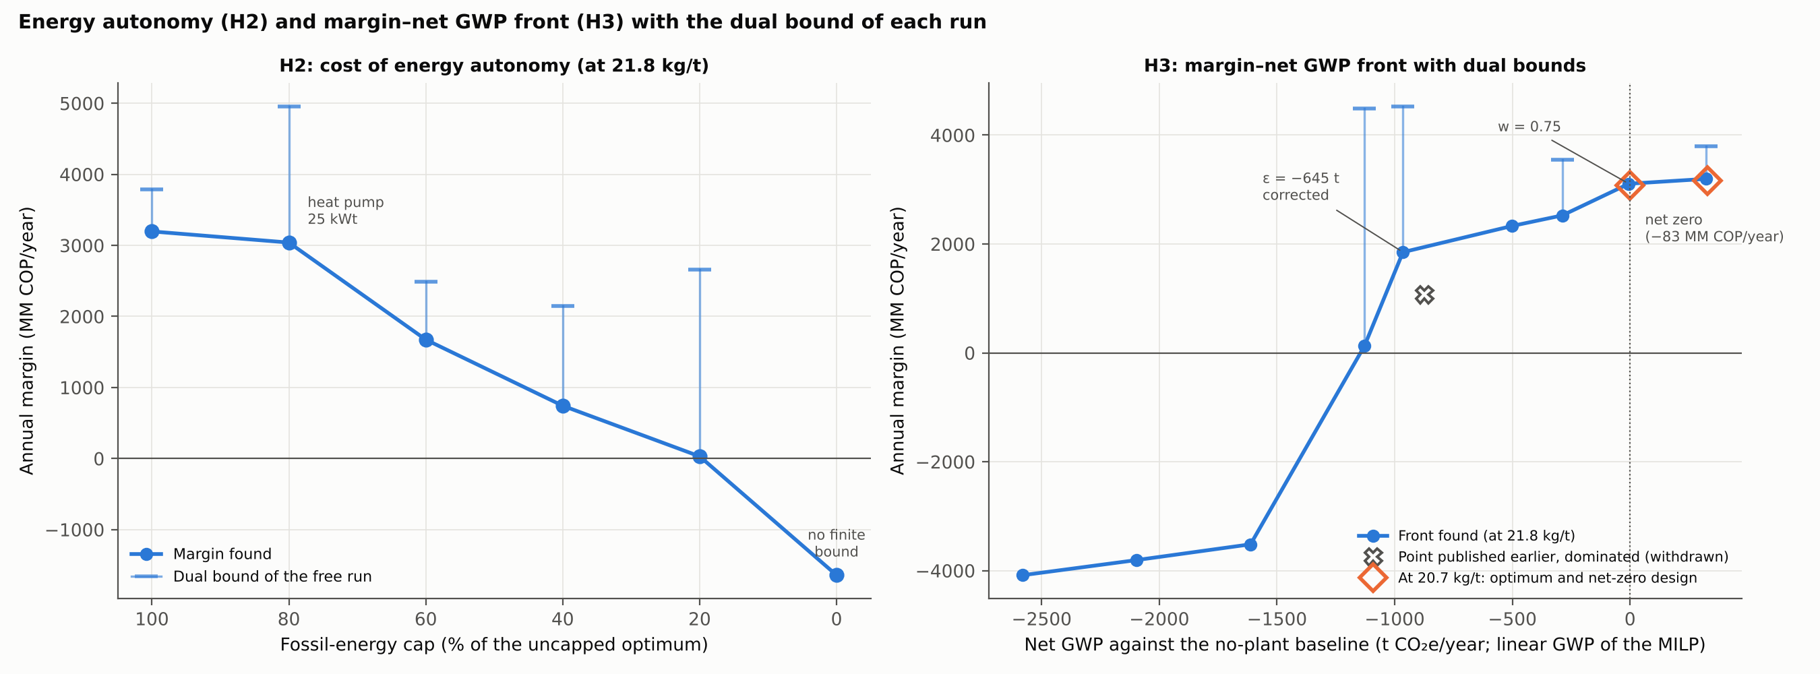

5.10 Testing Hypotheses H1–H4
Hypothesis | Verdict | Evidence
H1. Simultaneous synthesis, sizing and operation beat sequential design by fractions | Supported, with one qualification | The same superstructure designed by fractions in sequence earns 1,816 against 3,164 MM COP/year, 42.6 % less (NPV 27 against 5,273) (Section 5.9.1). The sequential protocol has no feedback between stages, so the gap measures sequential design without iteration. Seasonal coupling adds nothing at the capped scale and 4.4–12.2 % when capacity binds (at 21.8 kg/t). At train level the hierarchical chain costs 3.8–12.5 % more at the flow of the optimum (7.1–9.0 % at the original basis; Section 5.11). The sugar hub is never selected.
H2. Energy autonomy has a measurable cost in margin and portfolio | Supported (ε-constraint sweep) | A 20 % cut in fossil energy costs 157 MM COP/year at the solutions found (0–750 certified), with the heat pump. A 60 % cut costs 2,453 (1,049–3,047 certified) and cuts vinegar. Full autonomy means not operating (Section 5.9.3; at 21.8 kg/t). The flexibility index of the original wording is formulated but not run, and the verdict does not rest on it.
H3. The margin–GWP front is non-dominated and non-degenerate, with GWP against a no-plant baseline | Partly supported | A non-degenerate front exists (at 21.8 kg/t). It is the best found, not certified: its dual bounds lie far above the solutions, and one published point was dominated and has been replaced (Table 5.9.4a). The economic optimum emits more than the no-plant site for every decomposition factor from 90 to 290 kg/t (+121 to +558 t on the inventory basis; +110 to +547 t on the MILP basis). Net zero costs 83 MM COP/year (at most 129). It holds only for factors at or above 190 kg/t and with credit for 1,162 t of extra fruit (Section 5.9.4).
H4. With the current supply, viability depends more on the demand and price of the main products than on technology | Supported, with a corrected frontier | Over 30 market pairs the NPV ranges from −10,240 to +55,967 MM COP. The frontier NPV = 0 lies at about 890,000 bottles without vinegar, and at no more than about 1,950 m³ of vinegar with 500,000 bottles, 2,600 m³ with 250,000 and 2,750 m³ without wine (interpolated from the designs found). The designs without vinegar at 250,000 and 500,000 bottles are robustly not viable (Section 5.9.2). At high excise rates the best design found is the vinegar-only plant (NPV 1,393; Section 5.6.1). Supply from 0.5 to 3.6 times the central value leaves the capped optimum unchanged (at 21.8 kg/t); EVPI and VSS are between 0 and 38 MM COP/year.
H1 needs two qualifications. First, at the scale of Chocó its gain comes from synthesis across fractions, not from coupling design with seasonal operation, which matters only when capacity binds. Second, it says nothing about sharing equipment between products: the multiplant–multiproduct comparison (Section 2.8.6) shows that question is close economically and decided by staffing, which in Bajo Atrato has social weight of its own.
H4 is the hypothesis the thesis did not start with and the one its results support most strongly. Judged by NPV, its frontier is more demanding than first reported. It places the vinegar market, and the leaf-juice fermentation that feeds it, at the centre of the project.

5.11 Multiscale Couplings: What Each Interface Is Worth
This section reports the four tests of Section 3.13 and gathers them with the couplings measured earlier into a single table (Table 5.1; Figure 5.20). In each test the other scale is solved with its own model, around the version 12 optimum (3,196 MM COP/year of margin; NPV 5,397 MM COP).

5.11.1 Kinetic band to plant design (U)
The non-identifiable pairs that reproduce the reference end point leave a band of a factor 0.63–1.55 on every fermentation time, for an assay inoculum between 0.05 and 2 g/L and a plant inoculum of 0.5 g/L (Figure 5.20 A). The process times passed to the MILP range as follows:
- pulp: 10.4–21.9 h, against 15.0 h central;
- peel juice: 8.9–18.2 h, against 12.6 h;
- leaf juice: 10.1–21.1 h, against 14.5 h.
If the plant inoculates as the assay did, the band nearly vanishes: the peel-juice fermentation moves only between 10.0 and 10.6 h.
Re-solving the MILP at the fast end, at the slow end, and at the slow end with the leaf juice at the 27.1 h of the uncalibrated Krishnan model returns the central design every time: the same 23 decisions. The central design evaluated at each end therefore has zero regret.
The design does not move because the units the kinetics touch have slack:
- the pulp winery is at its catalogue minimum of 2 × 10 m³ (Moresi's N_F ≥ 2) and runs at 18 % of its capacity at most;
- the juice winery runs below 60 %;
- the binding unit is the acetifier, whose rate does not depend on yeast kinetics.
The margin still moves, from 3,011 MM COP/year at the fast end to 3,250 at the slow end (NPV 4,576 to 5,640 MM COP). This comes only from the auxiliary equipment of the wineries. The chiller, centrifuge and cartridge filters are sized on the nominal capacity (N − 1)·V/t_proc, which grows when fermentation is faster even though the wine made is the same. The chiller part is physical: the same heat is released in fewer hours. The centrifuge and filter part is a convention of the cost model, so the spread is an upper bound.
The single measured point is therefore enough to design this plant. It is not enough to operate it: the inoculation protocol of the plant should copy the assay, or a second kinetic point should be measured before commissioning.

5.11.2 Plant to week (D1)
In the week of May, the month with most fruit processed, the plant receives:
- 61.1 t of fruit and 71.4 t of leaves;
- 18.5 m³ of must to ferment;
- 3,150 kg of acetic acid to make.
The cyclic STN with the sizes of the optimum schedules this week with no loss of any material and no shortfall of acid or bottled wine (Figure 5.20 D). Unit occupation over their available hours is:
Unit | Occupation | Note
Front end | 86 % of staffed hours
Shared press | 68 % | 24 changeovers, each followed by one hour of cleaning
Flotation | 64 %
Bottling line | 67 %
Leaf extractor | 57 %
Pulp fermenters | 10 % | one batch each; the 10 m³ must store holds the must between batches
Juice fermenters | 35–44 % | seven batches between them
Acetifier | 90 % of its weekly capacity
At the slow end of the kinetic band the same week still fits with no loss. Both pulp batches go to one fermenter, and the juice winery rises to 46–62 %.
A week with a Monday holiday is the tight case. The front end loses 12 staffed hours, and the 122.1 t of fruit of two weeks must pass through the 132 staffed hours of a holiday week followed by a normal one, a slack of about 10 h. The STN search did not close on this two-week case: its best schedule loses 3.2 t of fruit (2.6 %), with a large remaining gap. Hour counting shows the capacity is there, but only just. A holiday in the peak month is the point where the 1 t/h front end, sized by the MILP to the month, has the least room. A third shift on such weeks, already an option of the MILP, would remove the risk.
April, the month of highest supply, processes less fruit than May because the wine and vinegar caps bind. Its 14.6 m³ of must per week cannot be split into whole batches of 8–10 m³ within one closed week. On a cyclic horizon of two weeks it is scheduled with no loss: three pulp batches of about 9.7 m³, the front end at 69 % and the juice fermenters at 40 %.
The monthly MILP is therefore a faithful aggregate of the hourly operation at this scale. Shifts, changeovers, whole batches and finite buffers do not remove capacity the MILP counted on.

5.11.3 Plant to fermentation train (D2)
The model 1 superstructure was first sized for 7,830 m³ of wine per year. At the 375 m³ of the optimum (3.3 kg of ethanol per hour), deciding kinetics and train together saves:
- 3.8 % of the train's annual cost without a filling limit, against 7.1 % at the original basis;
- 12.5 % with the 3 h filling limit, against 9.0 % at the original basis.
At the small scale the oxidation limit makes the coupling worth more. The hierarchical design needs six fermenters of 0.1 m³ in parallel to fill each within 3 h, while the simultaneous design uses two stages of two.
The train that model 1 wants at this flow, a single vessel of about 0.6 m³, is far below the 10 m³ catalogue vessel of the plant model. At Chocó scale the winery is set by the catalogue and by Moresi's two-vessel minimum, not by the train optimum. The gain of the simultaneous train is real but bounded by that floor.

5.11.4 Plant to territory (T)
Re-solving the siting at the 3,746 t of leaves the optimum actually takes gives the same answer as at the full collectable quantity: central plant at site B with no depots, 35,400 COP/t. The two models are consistent.
Re-solving the MILP with the cost of each alternative collection configuration changes neither the design nor the leaves collected:
Collection configuration | Cost (COP/t of leaves) | Optimal margin (MM COP/year) | Leaves (t/year) | That design at the true cost (MM COP/year)
Central at B, no depots (central) | 35,400 | 3,196 | 3,746 | 3,196
Central at A, no depots | 46,950 | 3,152 (−1.4 %) | 3,746 | 3,196
B with depots in the 4 zones | 80,512 | 3,027 (−5.3 %) | 3,746 | 3,196
A with depots in the 4 zones | 89,290 | 2,994 (−6.3 %) | 3,746 | 3,196
Double the central cost | 70,800 | 3,063 (−4.2 %) | 3,746 | —
Every design returns 3,196 MM COP/year at the true cost, so deciding plant and collection together is worth nothing in design. The siting decision itself is worth up to 6.3 % of the margin. Leaves are limited by the acetifier and the vinegar market, not by their cost: at any of these costs the plant takes every tonne it can turn into vinegar.

5.11.5 The value of each coupling
Table 5.1. Value of each coupling between scales: loss when the link is cut, measured with the more detailed model of the two scales.
Coupling | Test | Loss when cut | Note
Fractions within the plant (pulp → peel → leaves) | H1 (Section 5.9.1) | 42.6 % of margin | sequential design by fractions against simultaneous
Plant ↔ harvest seasonality | H1 (Section 5.9.1) | 0 % at the current scale; 4.4–12.2 % at 2–3.6 times the supply | demand caps bind at the current scale, capacity binds at larger scales
Kinetics ↔ fermentation train | D2 (model 1) | 3.8–12.5 % of the train's annual cost | 7.1–9.0 % at the original design basis
Kinetics → plant | U | 0 % (same design) | margin −5.8 % to +1.7 % through auxiliary sizing
Plant → week | D1 | 0 % (no losses in the peak week) | May and April fit with no loss; a week with a holiday leaves about 10 h of front-end slack over two weeks
Plant ↔ territory | T | 0 % (same design) | site and depots worth up to 6.3 % of margin
Plant ↔ markets | H4 (Section 5.9.2) | decides viability | below the minimum viable demand frontier the margin is negative
The ranking is clear. The largest value of integration lies inside the plant scale, in deciding the fractions together. Next come seasonality, when capacity binds, and the kinetics–train coupling. At the scale of Chocó, the couplings that cross from the plant to the scales above and below it carry no design regret:
- the kinetics band, because the wineries sit at their catalogue minimum;
- the week, because the monthly MILP aggregates the operation faithfully;
- the territory, because leaves are limited by the market, not by their cost.
They would gain value at larger supply, where capacity rather than markets binds. That is also where the seasonality coupling rises to 4–12 %.
The multiscale view thus supports the main design method of the thesis, simultaneous design at the plant scale, and shows where it can stop: at Chocó scale the outer scales can be passed one way without loss.
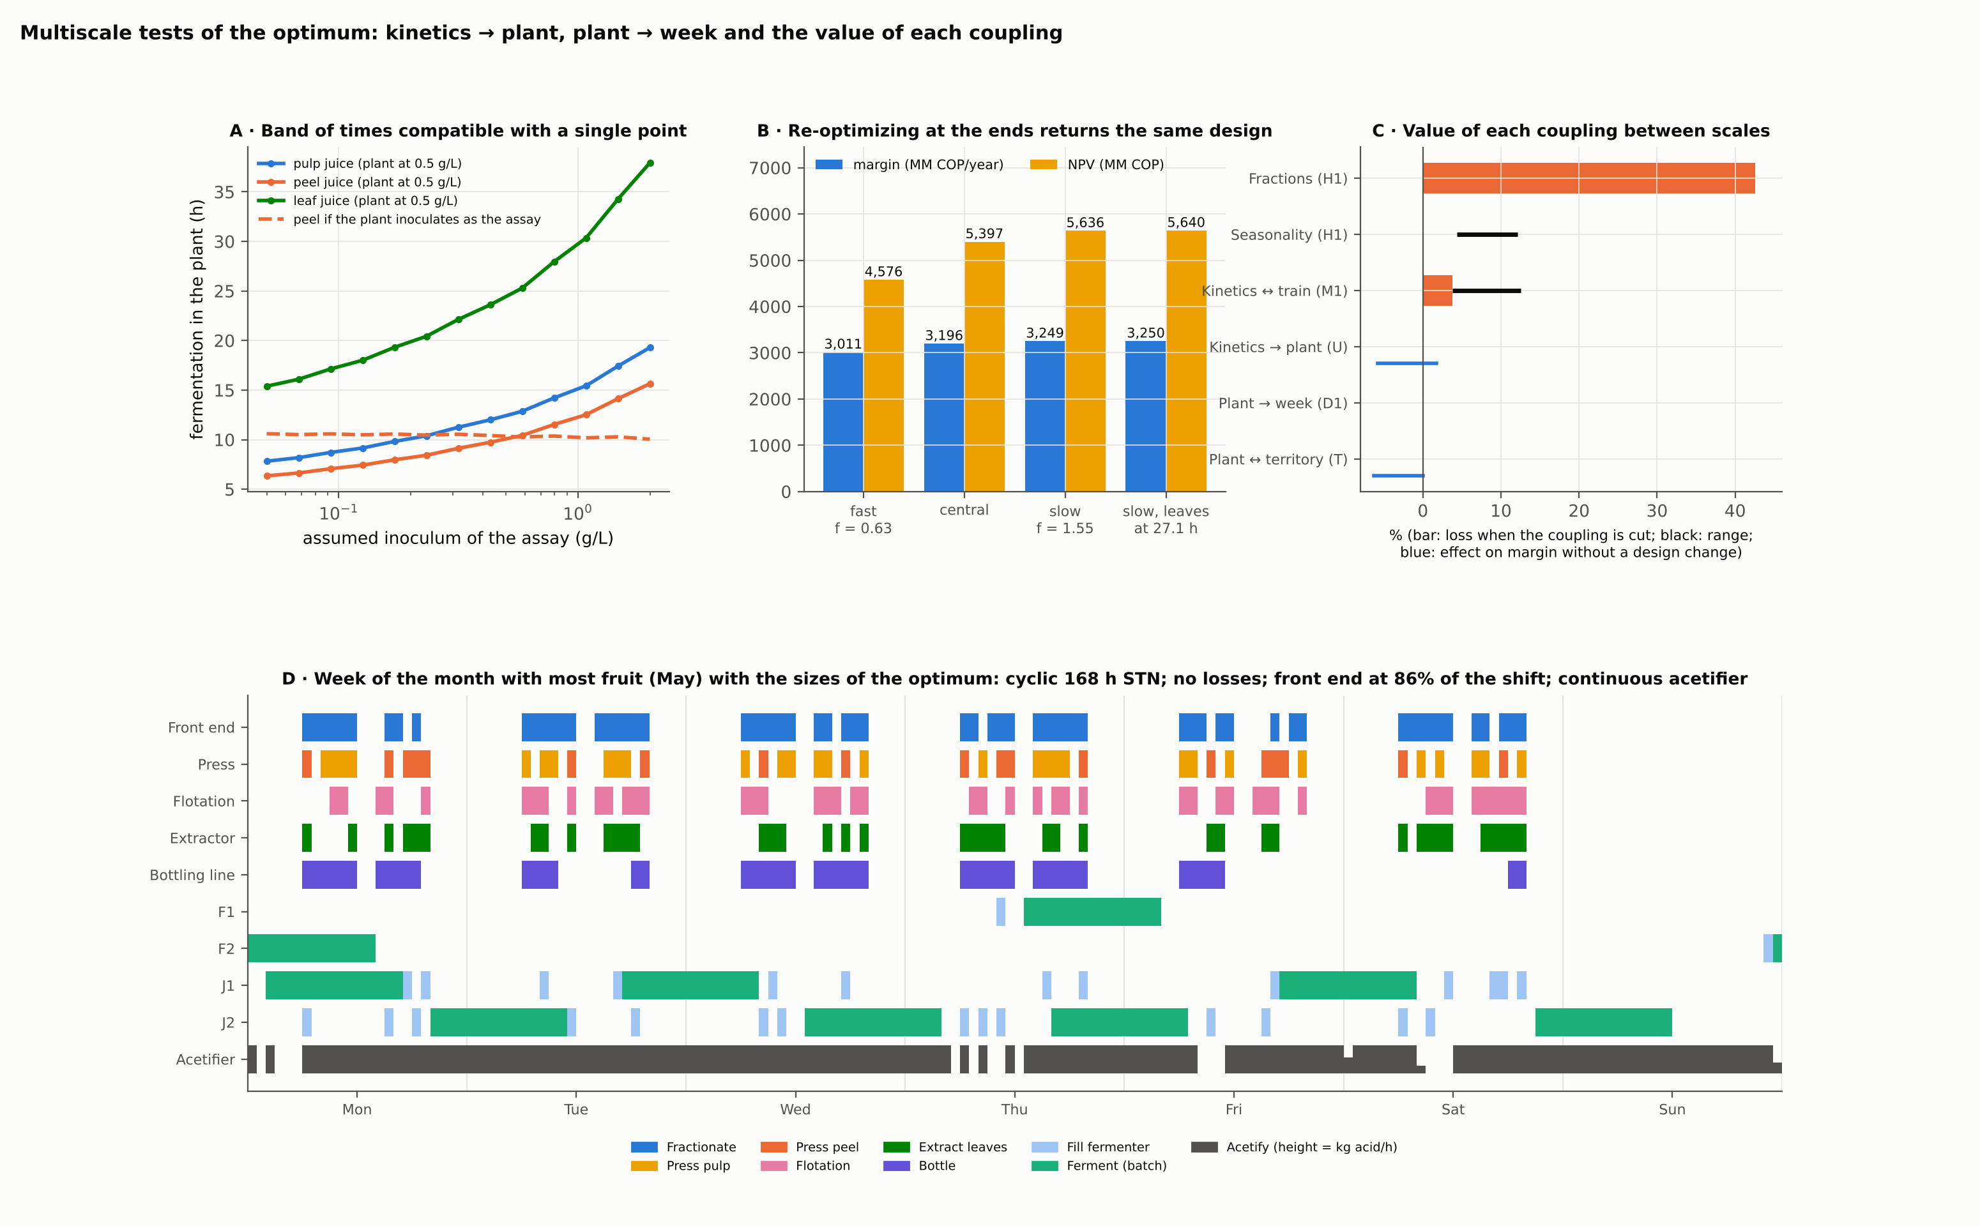
Figure 5.20. Multiscale tests of the optimum. A: band of fermentation times compatible with the single measured point. B: margin and NPV of the central design at the ends of the band (re-optimizing returns the same design). C: value of each coupling between scales. D: hourly schedule of the peak week with the sizes of the optimum (models report, fig. 51).

Chapter 6. Discussion and Conclusions
The simultaneous model changed the answer, not only its precision. The value of a Bajo Atrato biorefinery lies in bottled wine, in vinegar fermented from peel and leaf juices with panela, and in a little fibre flour; not in a sugar hub or an energy island. Its size is set by two markets that have no data yet. This chapter discusses why, what it means for design methodology and for policy in non-interconnected zones, and what remains to be done.

6.1 Simultaneous versus Hierarchical Design
The gain from deciding synthesis, sizing and operation together appears at two levels, and at each it has a different cause.
At the level of a fermentation train, fixing the kinetics before sizing costs 7.1 to 9.0 % of the total annualized cost (Section 2.8.2). Most of the loss comes from the inoculum and propagation policy, which the hierarchical chain fixes and the simultaneous model optimizes, rediscovering the industrial starter culture. Under a tight filling limit the hierarchical chain becomes infeasible where the simultaneous one is not. This is the classical argument of Corsano and co-workers, quantified for pineapple must; it is also the bound on the error the plant-level MILP accepts.
At the level of the plant, the gain is larger, and the clean comparison of Section 5.9.1 locates it. With the superstructure and the parameters fixed, designing the fractions in sequence (wine, then peel, then leaves) earns 1,816 MM COP/year and an NPV of 27 MM COP, against 3,164 and 5,273 for the simultaneous design. The loss comes from one shared unit: the acetifier sized for peel juice cannot take the leaf juice and panela that arrive in the last stage. Designing with average flows instead of the seasonal harvest changes nothing at the capped scale, because the market, not capacity, limits the plant; when capacity binds, at 2 and 3.56 times the supply without caps, it costs 12.2 and 4.4 % of the margin. The comparison with the TRL-9 reference (−1,015 MM COP/year, NPV −12,454) is larger but mixes the value of simultaneous design with that of a wider superstructure (flotation and SO₂ instead of microfiltration and pasteurization, leaf juice and panela as vinegar substrates); it is kept as a benchmark, not as the test of H1.
The multiscale tests of Section 5.11 say where this integration has to happen and where it can stop. Deciding the fractions together inside the plant is worth 42.6 % of the margin; seasonality is worth 4–12 % once capacity binds; deciding kinetics and train together saves 3.8–12.5 % of the train's cost. The interfaces between the plant and the scales around it carry no design regret at Chocó scale. The band of fermentation times that a single measured point leaves, the hourly operation of the peak week and the cost of collecting leaves all return the same design, because the wineries sit at their catalogue minimum, the monthly model aggregates the week faithfully and the leaves are limited by the vinegar market. These results support the method of the thesis, simultaneous design at the plant scale with the other scales passed one way. They also mark its limit: at larger supply, where capacity binds, the kinetic and seasonal couplings gain value and would have to be closed in both directions.
The seasonal model also exposed facts that annual averages hide: units that saturate in peak months while others idle; a winery sized by Moresi's minimum rather than by throughput; and a filling problem that appears only when winery and must store are modelled period by period, and that made the version 11 designs infeasible in practice although they looked optimal.
The price of simultaneity is an MILP gap that the solver does not close in free runs and a dependence on polishing to repair free runs that stop early. That price is paid openly: the dual bound is reported beside every verdict, restricted cases are checked against the free optimum, and two structural properties of the model (supply as an upper limit, monotonicity in the leaf-juice yield) certify the central optimum within 1.5 %. Other designs, the margin–GWP front among them, remain local optima in the catalogue neighbourhood, not certified global ones. The alternative, a nonconvex MINLP solved locally, would have offered no bound at all, and the fermentation-train experiments show that local MINLP methods stop 2–3 % above certified optima without saying so.

6.2 Why the Sugar Hub and Gasification Do Not Enter
The sugar hub. The hub was the organizing idea of the earlier formulation and gave the thesis its original subtitle. It does not enter for three compounding reasons. First, pineapple residue juices are dilute (60–110 g/L of sugar), which removes the benefit of vinasse recycle, the mechanism that makes Corsano's molasses hub pay, and puts the marginal cost of hub ethanol above its price (Section 2.8.5). Second, the products the hub was meant to feed are weak on pineapple: the measured xanthan yield on pineapple residue is about a seventh of the yield on glucose, and citric acid and xanthan plants scaled down to the juice available carry an investment the volume does not pay. Third, and decisively, the juices have a better use: fermented with panela into vinegar, where a market exists at the plant's scale and no pooling is needed. The hub is therefore a negative result with known reasons. It would return if concentrated sugar streams became available (concentration by a factor of three or more makes recycle pay) or if a higher-value product appeared, and it would return as a nonlinear subproblem with the routes fixed by the MILP, without changing the MILP core.
Gasification. The earlier formulation designed an energy island around downdraft gasification of leaves and crown. Gasification is never selected, at any scale or version, because the energy bottleneck of the plant is heat for drying, not electricity, and a biomass boiler delivers about three times the useful heat of a gasifier from the same crown, with less capital and without an engine that needs attention around the clock. In version 12 even the boiler leaves the design, because a market-limited plant dries too little cake to pay it.
What the off-grid condition does. The absent grid still shapes the design, through the cost and emissions of diesel electricity for the aeration of the acetifier and the extraction of leaf juice, and through the impossibility of selling surplus biogas power. It does not justify an energy island at this scale. It does make renewable electricity for the acetifier the first improvement target (Section 5.7), and full autonomy a question with a price that the ε sweep of Section 4.6 will put a number on.

6.3 Value Density, Markets and Transferability to Other Tropical Fruits
Value density, revisited. The earlier manuscript ranked fractions a priori by the value of their best product per tonne and used the ranking to screen technologies. The optimization agrees with the direction of that rule and corrects it twice. First, the binding constraint is not the fraction but the market of the product: once 500,000 bottles and 3,000 m³ of vinegar are sold, an additional tonne of fruit has no value, however rich its pulp. Second, a low-value residue can displace a high-value fraction when it substitutes for it in a capped market: leaf juice with panela displaces fruit as the vinegar substrate, so the plant buys a fifth of the fruit and about three tonnes of leaves for every tonne of fruit. Value density is a property of a product in a market, not of a fraction.
Markets. The finding with the most practical weight is that the plant is limited by its markets, not by its feedstock or its technology. Across their ranges, the wine market moves the margin 4.5-fold and the vinegar market almost 20-fold, while supply from half to three and a half times the 2022 harvest leaves it unchanged. The excise tax on wine takes 4,220 COP of a 16,000 COP bottle, almost as much as the 4,667 COP the plant keeps, yet bottling more than doubles the value of the wine relative to bulk. Judged by NPV, the plant needs about 890,000 bottles without vinegar, or no more than about 1,950 m³ of vinegar with 500,000 bottles (Section 5.9.2). The excise is also a project risk: at the rates of the annulled Decree 1474 of 2025 wine stops paying, and the best design becomes a thin vinegar-only plant (Section 5.6.1). Both markets are currently assumptions. The modelling consequence is to replace demand caps by demand curves, price against quantity, which turns the MILP into a joint pricing and design problem; the practical consequence is that market studies, not further process modelling, are the next investment.
Transferability. The method transfers to other seasonal tropical fruits in off-grid regions, mango, guava or passion fruit for example, with three requirements: a catalogue of TRL-9 alternatives for each fraction, with costs; a monthly supply profile; and demand caps or curves for each product. The specific result, that markets bind before feedstock at this scale, should be expected wherever the main product is a niche consumer good and the region's harvest exceeds what a local market can absorb. The specific design does not transfer: it depends on the Chocó registry, on the excise regime of Colombian wine and on the price of panela.

6.4 Policy Implications and Implementation Roadmap for Non-Interconnected Zones

6.4.1 Bioeconomy and rural development
Colombia's national bioeconomy strategy frames the valorization of biological resources as a development lever for regions dependent on extraction and primary production (Rojas-Jiménez, 2021), and launched after the 2016 Peace Agreement, it links the sustainable use of biodiversity with peace (Huddart et al., 2022). Its translation into regional funding and niches has been uneven across departments (Balanzó Guzmán et al., 2021 [verify authorship]), and Chocó is not among the departments where attention has concentrated. Decision-support frameworks for the Colombian bioeconomy transition call for expanding knowledge hubs and financial mechanisms (Grilli et al., 2024), and the OECD review of rural Colombia lists the bioeconomy and renewable energy among under-used opportunities, alongside structural barriers (land tenure, connectivity, services) that one plant cannot resolve but can address incrementally through its labour demand, its purchases and its infrastructure (OECD, 2022). The optimal plant would retain about 2,011 MM COP/year in the territory and employ about 17 people; a plant serving a wine market of 2 million bottles would buy nearly four times as much fruit (4,758 t/year).

6.4.2 Instruments
- Markets before plants. Public support in ZNI territories often funds equipment. For this case the scarce asset is demand: purchase agreements for bulk fruit vinegar and a tested retail channel for pineapple wine at around 16,000 COP per bottle are worth more than any equipment subsidy. Public procurement and regional brands for products of the Atrato could create part of that demand.
- Excise on fruit wines. The departmental excise is not waived by ZOMAC status and takes almost as much per bottle as the plant keeps. A differentiated rate for small regional fruit-wine producers, or earmarking part of the excise for rural agro-industry in the department, would change the economics more than the income-tax incentive does. The emergency decree of December 2025, annulled by the Constitutional Court, showed the other direction: at its rates the best design makes no wine (Section 4.1.6). A stable rate matters as much as its level.
- Income tax and works for taxes. With start-up in 2030 the reduced ZOMAC rate has expired; the proposed extension to 2033 for small and medium firms would add about 1,600 MM COP of NPV. The works-for-taxes mechanism can finance public infrastructure the plant needs, such as roads for leaf collection.
- Energy. Colombia's ZNI policy has continued to subsidize diesel supply even where renewable alternatives perform better, without disseminating pilot experiences (Garces et al., 2021), and the ZNI institutional environment is fragmented (Ortiz Jara, 2019). The incentive framework of Law 1715 of 2014 for non-conventional energy (Rodríguez-Urrego et al., 2018) and the distributed-energy instruments catalogued for ZNI territories (OECD, 2023) are the channels for replacing diesel aeration with solar electricity; biomass electricity outperforms diesel on most impact categories in comparable off-grid settings (Aberilla et al., 2019), but at this scale photovoltaics is the more likely substitute.

6.4.3 Barriers, enablers and roadmap
Three barriers are structural. Capital estimates are of study class (±30 %) and need vendor quotations before the NPV is bankable. The ZNI institutional environment adds a risk distinct from the technical and market risks quantified here. And the two markets are unmeasured, which no model can fix. Three enablers partly offset them: the incentive framework for non-conventional energy, the national bioeconomy funding oriented to biodiversity-based value addition (Alviar et al., 2021), and the fact that a fully specified facility proposal can route around the policy fragmentation and weak inter-institutional collaboration that Latin American circular-bioeconomy initiatives commonly face (Salvador et al., 2022).
The roadmap follows from the results, in three phases with indicative dates ending at the planned start-up in 2030:
- Validation (2027–2028). Market studies for bulk vinegar (buyers, volumes, contracts) and pilot sales of bottled pineapple wine; field data on supply by month, leaf logistics and farm locations; a fermentation time course of pulp juice, leaf-juice kinetics with K. marxianus, cake dry matter and effluent load with the Chocó variety; the SuperPro verification. Milestone: the demand caps and the [S] parameters that matter most replaced by data.
- Pilot (2028–2029). A pilot vinegar line on leaf and peel juices with panela, the most robust route, with a small solar system for aeration. Milestone: measured acetification yields and energy, and first vinegar sales.
- Plant (start-up 2030). The full plant, sized by the validated markets with the MILP rerun on the updated registry, and the wine line scaled to the measured demand. Milestone: the design of Chapter 5 updated, financed and built.

6.5 Conclusions against Each Objective
Objective 1: feedstocks, supply and technologies. The case was characterized with the 2022 supply of Chocó (6,146 t/year in two peaks, 399 to 640 t/month), the leaves of crop renewal (up to 32,469 t/year), and a catalogue of 23 processing steps with 152 options graded by maturity. The 152 parameters of the registry carry their provenance; 55 are still assumptions, and the ones that matter most are the two demand caps and the prices of wine and vinegar. Two corrections to the earlier design basis follow from the data: reject fruit sugar is 158.8 g/L, a quarter of first-grade fruit, and the peel-juice sugar content of «about 67 %» assumed earlier has no source and was replaced by measured yields. A stoichiometric and closure test of every sugar-to-product pair of the registry found one inconsistent source: the leaf juice, whose ethanol had been compared with its free sugars and whose reported ethanol and yeast cannot both hold. The design value was set at 90 % of the stoichiometric maximum on carbohydrate, 20.7 kg/t. The range extends to 6.5 kg/t, the value compatible with the reported yeast.
Objective 2: unit and train models. The fermentation models were calibrated and verified. The single measured point of pulp juice does not identify its kinetics: a family of parameter pairs fits it equally well and changes the design fermentation time by a factor of 2.3. Moresi's winery model was replicated, with his numbers of fermenters reproduced exactly, and its kinetics shown to be invalid at the 30 °C of the pineapple data; the premium-line advantage claimed earlier is an artefact of changing model. The glucose–xylose kinetics of the juices cut the processing time of the juice winery from 32.5 to 12.6 h. The cost of fixing kinetics before sizing is 7.1–9.0 % of the fermentation-train cost, mostly through inoculum policy. At the wine flow of the optimum the same coupling is worth 3.8–12.5 %, and the band of fermentation times left by the single point does not change the plant design (Section 5.11).
Objective 3: the simultaneous MILP. The design problem was reformulated exactly as an MILP, except for the kinetics, with catalogue disjunctions, exact size × hours products, a continuous-time seasonal grid of 24 periods, Moresi's winery in linear form with a filling-time rule, perishable buffers, blending, added sugar and market demand. With 177 binaries it is solved for about 60 cases, with a warm start, neighbourhood polishing and a cross pass, and verified by a protocol that has caught real errors. The dual bounds of the free runs are now reported beside every hypothesis test. Two properties of the model, supply as an upper limit and the monotonic effect of the leaf-juice yield, certify the central optimum within 1.5 %. The bounds show, robustly against the largest observed error of Equation 5.1, that the designs without vinegar at 250,000 and 500,000 bottles are not viable, but they do not certify the margin–GWP front, whose bounds remain weak. The monthly aggregation of the optimum was checked against an hourly cyclic schedule of the peak week, which fits with no losses; collection costs up to 2.5 times higher do not change its design.
Objective 4: assessment under uncertainty. The optimum has an NPV of 5,273 MM COP, an MIRR of 13.4 % and P(NPV > 0) = 0.78, with a break-even vinegar price 22 % below the assumed price. Two uncertainties outside the Monte Carlo were quantified:
- The leaf-juice yield. Across its range it lowers the NPV of the optimum to as little as 3,857 MM COP, without changing the design.
- The wine excise. At three times its current specific rate, or at the rates of the annulled Decree 1474 of 2025, wine stops paying. The best design found is then a vinegar-only plant of 1,868 MM COP/year and NPV 1,393, viable at least down to a leaf-juice yield of about 8 kg/t, but with a break-even vinegar price only 5.7 % below the assumed price. The current design kept unchanged would have an NPV of −993 MM COP.
The plant emits 1,293 t CO₂e/year in process. Against a site where fruit and leaves decompose, it adds 121–558 t over the plausible range of the decomposition factor; if the leaves would otherwise be burned, it adds 853–1,166 t. Burning leaf pulp in a biomass boiler makes it net-zero for 83 MM COP/year, but only at the central factor or above and with credit for the extra fruit it buys.
The plant retains 2,021 MM COP/year in the territory with about 17 jobs. Supply uncertainty has no value (VSS and EVPI between 0 and 38 MM COP/year); market and fiscal uncertainty dominate.
Objective 5: the Bajo Atrato biorefinery. The optimal plant processes 1,276 t/year of fruit and 3,746 t/year of leaves into 500,000 bottles of wine, 3,000 m³ of vinegar and 40 t of fibre flour. Its equipment:
- a 1 t/h front end, one shared press, flotation and SO₂;
- two 10 m³ fermenters and a 500 bottles/h line;
- a juice winery and a 10 m³ acetifier;
- a 2 t/h leaf extractor and a small dryer.
Under the current excise it is viable if vinegar sells above 1,723 COP/L and wine near 16,000 COP per bottle. The hypotheses come out as follows:
- H1 is supported against a sequential design of the same superstructure (NPV 27 against 5,273 MM COP).
- H2 is supported by the autonomy sweep.
- H3 is partly supported: the front is non-degenerate but not certified, and net zero is conditional.
- H4 is supported with a corrected frontier: the plant is viable from about 890,000 bottles without vinegar, or with no more than about 1,950 m³ of vinegar at 500,000 bottles, 2,600 m³ at 250,000, or 2,750 m³ without wine.
Objective 6: rules and policy. Markets, the excise on fruit wine and one fermentation datum now limit the project, not feedstock or technology. The design rules for a larger wine market are known from the scale sweep: front end first; then presses, centrifugation and the crown boiler; enzyme recovery and a third shift only from three times the supply.
The vinegar line carries the project under every fiscal regime tested, as long as the leaf-juice yield is not at the bottom of its range. Without wine, however, the margin of safety is small: the vinegar-only plant breaks even at 2,074 COP/L, 5.7 % below the assumed vinegar price. The order of work is therefore:
- a study of vinegar demand;
- a fermentation of Chocó leaf juice with the plant's strain;
- a study of the volume and price of bottled fruit wine.
The policy levers are demand, a stable and differentiated excise for small regional fruit-wine producers, and renewable electricity.

6.6 Limitations
- Optimality. The central optimum is certified within 1.5 % by nesting of supply and monotonicity in the leaf-juice yield (Section 5.1.1), but many other cases, the margin–GWP front among them, keep weak dual bounds. Polishing guarantees a local optimum among catalogue neighbours, not a global optimum, and every verdict reports its bound (Sections 5.9.2–5.9.4).
- Margin and NPV. The MILP optimizes an annual margin with an approximate capital charge; the NPV is computed afterwards. A positive margin does not imply a positive NPV: the design with 500,000 bottles and no vinegar earns 184 MM COP/year and has an NPV of −5,409 MM COP (Section 5.9.2). Every viability statement therefore uses the TEA, and the empirical relation between the two (Equation 5.1) is used only to read dual bounds.
- Kinetics outside the MILP. Fermentation time, inoculum and yield are fixed before sizing, with an error bounded at 7.1–9.0 % of the fermentation-train cost at the original basis and 3.8–12.5 % at the flow of the optimum; the band of times left by the single point does not change the plant design but moves the cost of winery auxiliaries; fermentation temperature is not optimized.
- Quality outside the objective. Must turbidity, stuck-fermentation risk, oxidation beyond the filling rule and sensory quality are discussed, not optimized.
- Catalogue and cost data. Costs are of study class (±30 %), and small differences between alternatives are not conclusive. The catalogue fixes the granularity of sizes.
- Assumptions [S]. The two demand caps, the wine and vinegar prices, the panela price and footprint, the bottle footprint, the effluent load, the collectable fraction and logistics of leaves, and the local shares of the social indicators are assumptions. The results most sensitive to them are reported as sweeps rather than single values.
- Data. Pulp juice has one kinetic point; leaf juice has no kinetics with the strain that ferments it; cake dry matter and effluent load have not been measured with the Chocó variety and press.
- Field-return accounting. The emissions of leaf pulp and juice returned to the field are scaled from the decomposition factor of fresh leaves by dry matter; a direct measurement of their decomposition would change the net GWP of every design that collects leaves.
- Leaf-juice ethanol. The acid potential of leaf juice rests on one source whose ethanol and yeast cannot both hold (Section 2.2.5). The design value of 20.7 kg/t is the source's ethanol capped at 90 % of theory; its range extends to 6.5 kg/t, at which the margin of the optimum falls by 11 % and the vinegar-only plant is no longer established as viable.
- Results at the former leaf-juice yield. The autonomy sweep (H2), the interior of the margin–GWP front (H3), the price sweeps of Section 5.4 and the multiscale tests of Section 5.11 were computed at 21.8 kg/t, the upper end of the corrected range. At the optimum the correction lowers the margin by 32 MM COP/year (1.0 %) without changing the design.
- Storage outside the MILP. Storage tanks for vinegar (30 days) and wine ageing (90 days), 930 MM COP of purchased equipment, are costed by the TEA but not sized by the MILP. Its objective therefore omits about 709 MM COP/year of capital charge (AF × 930), 22 % of the margin of the optimum. Every NPV reported includes them. Vinegar is produced in eight times the volume of wine and stored a third as long, so its tanks are about 2.7 times larger (620 of the 930 MM COP); leaving storage out therefore favours vinegar in the MILP's choice. The size of the omission makes adding storage to the catalogue the next model change.
- MILP contribution and TEA. The contribution of the MILP before capital charge (6,478 MM COP/year) and the revenue less variable costs of the TEA (6,992 MM COP/year) differ by 514 MM COP/year (7 %). The two accountings use different price and cost conventions (Sections 3.9 and 4.1) and were not built to coincide. An item-by-item reconciliation is pending. Every viability statement uses the TEA.
- Fiscal rates. The rates of Decree 1474 of 2025 and of the 2026 fiscal bill are taken from the evaluation committee's report and remain to be verified against the texts (Section 4.1.6).
- Multiscale tests. Each interface is tested on its own around the optimum, not in one model that closes all scales at once. The hourly schedule covers selected weeks; for a week with a holiday the STN search did not close, and only hour counting shows that the front end fits. The collection scenario behind the territory test is assumed.
- Pending evidence. The flexibility index (H2), the SuperPro verification, and the reconciliation with the reduced MINLP instance of the earlier formulation. The heat-pump cost and COP are literature ranges marked for verification.
- Scope. Staged investment over time, distribution of benefits among communities, and a full ReCiPe impact profile are outside the present scope.

6.7 Future Work
- Markets. A market study for bulk fruit vinegar and bottled pineapple wine in Colombia, and replacement of the demand caps by price–quantity curves, turning the MILP into a joint pricing and design problem; a stochastic program over market and fiscal scenarios, with demand and the wine excise as uncertain parameters.
- Energy autonomy (H2). Photovoltaics with storage as an alternative in the superstructure, since the autonomy sweep shows aeration has no other non-diesel source; the flexibility index of the autonomous designs with respect to supply.
- Net GWP (H3). Measured decomposition of leaf pulp returned to the field, a burning baseline for the leaves on the same front, and a full ReCiPe profile with database inventories.
- Field and laboratory data. A fermentation time course of reject pulp juice with the viable yeast dose; a fermentation of Chocó leaf juice with the plant's strain that measures ethanol, residual sugars and biomass together, closing the range of Section 2.2.5, with its kinetics; cake dry matter and effluent COD with the Chocó variety and press; monthly supply by municipality; farm locations and distances for the collection model; the departmental excise rate of Chocó and the texts of Decree 1474 of 2025 and the 2026 fiscal bill.
- Model. Tighter formulations or decomposition to close the MILP gap; fermentation temperature as a catalogue choice; staged investment over time as the markets grow; extension of the reoptimizing Sobol analysis to the plant-level MILP.
- Verification. The SuperPro run of the design package and the reconciliation with the reduced MINLP instance; vendor quotations for the main equipment.
- Transfer. Application of the method to another seasonal tropical fruit in a non-interconnected zone, to test which of the results are general.
- Closing the scales at larger supply. At two or more times the present supply, where capacity binds, rerun the multiscale tests and close the kinetic and seasonal couplings in both directions, embedding the fermentation time as a decision through a surrogate of the kinetic model and checking every month with the hourly schedule.

References
Entries marked [verify] or [complete] must be checked against the original before submission. Works cited through a 2026 chapter are listed under the citing source until the originals are consulted. Laws, decrees and tax regulations are listed by their number.
- Abdoulmoumine, N., Adhikari, S., Kulkarni, A., & Chattanathan, S. (2015). A review on biomass gasification syngas cleanup. Applied Energy, 155, 294–307. https://doi.org/10.1016/j.apenergy.2015.05.095
- Aberilla, J. M. O., et al. (2019). Environmental sustainability of small-scale biomass power technologies for agricultural communities in developing countries. Renewable Energy. https://doi.org/10.1016/j.renene.2019.04.036
- Ahamed, M. S., & Li, Y. (2026). Production of organic acids. In Biological Processes in the Food Industry, ch. 10. Elsevier. https://doi.org/10.1016/B978-0-12-819533-8.00010-5
- Ahlgren, S., Börjesson, P., & Di Lucia, L. (2015). Review of methodological choices in LCA of biorefinery systems. Biofuels, 6(3–4), 149–160. https://doi.org/10.1002/bbb.1563
- Aili Hamzah, A. F., Hamzah, M. H., Che Man, H., Jamali, N. S., Siajam, S. I., & Ismail, M. H. (2021). Recent updates on the conversion of pineapple waste (Ananas comosus) to value-added products, future perspectives and challenges. Agronomy, 11(11), 2221. https://doi.org/10.3390/agronomy11112221
- Álvarez del Castillo-Romo, A., Mata-Sánchez, J. I., Ponce-Ortega, J. M., Napoles-Rivera, F., Serna-González, M., & El-Halwagi, M. M. (2018). Multiobjective optimization for the socio-eco-efficient conversion of lignocellulosic biomass to biofuels and bioproducts. Clean Technologies and Environmental Policy, 20(5), 1041–1058. https://doi.org/10.1007/s10098-018-1490-x
- Alviar, M., et al. (2021). Measuring the contribution of the bioeconomy: The case of Colombia and Antioquia. Sustainability. https://doi.org/10.3390/su13042353
- Amenaghawon, A. N., Anyalewechi, C. L., Okieimen, C. O., & Kusuma, H. S. (2024). Data-driven intelligent modeling, optimization and global sensitivity analysis of a xanthan gum biosynthesis process. Heliyon, 10(3), e25432. https://doi.org/10.1016/j.heliyon.2024.e25432
- Andersson, K., Fogh Jespersen, N., & Sørensen, H. K. (2017). Industrial-scale gas conditioning including Topsoe tar reforming and purification downstream biomass gasifiers: An overview and recent examples. Fuel, 203, 1026–1030. https://doi.org/10.1016/j.fuel.2017.02.085
- Aranda-Barradas, J., et al. (2025). Addressing challenges in large-scale bioprocess simulations: A circular economy approach using SuperPro Designer. Processes, 13(7), 2259. https://doi.org/10.3390/pr13072259
- Arpagaus, C., Bless, F., Uhlmann, M., Schiffmann, J., & Bertsch, S. S. (2018). High temperature heat pumps: Market overview, state of the art, research status, refrigerants, and application potentials. Energy, 152, 985–1010. https://doi.org/10.1016/j.energy.2018.03.166 [verify]
- Arikrishnan, D., et al. (2022). Pineapple juice clarification by continuous dead-end microfiltration using a low-cost ceramic membrane. Journal of Food Measurement and Characterization, 16, 2721–2733. https://doi.org/10.1007/s11694-022-01634-5
- Atashbar, N. Z., Labadie, N., & Prins, C. (2018). Modelling and optimisation of biomass supply chains: A review. International Journal of Production Research, 56(10), 3482–3506. https://doi.org/10.1080/00207543.2017.1343506
- Aui, A., et al. (2021). Evaluating the economic feasibility of cellulosic ethanol: A meta-analysis of techno-economic analysis studies. Renewable and Sustainable Energy Reviews. https://doi.org/10.1016/j.rser.2021.111098
- Bairwa, S. L., et al. (2025). Global pineapple markets and value chains: Dynamics, governance and sustainability challenges. Journal of Scientific Research and Reports, 31(1). https://doi.org/10.9734/jsrr/2025/v31i123835
- Balanzó Guzmán, A., et al. (2021). Is bioeconomic potential shared? An assessment of policy expectations at the regional level in Colombia. Innovation and Development. https://doi.org/10.1080/2157930x.2021.1956713
- Banerjee, S., Ranganathan, V., Patti, A., & Arora, A. (2021). Integrated biorefinery strategy for valorization of pineapple processing waste into high-value products. Waste and Biomass Valorization, 12(10), 5915–5925. https://doi.org/10.1007/s12649-021-01542-7
- Bekatorou, A. (2020). Current industrial vinegar production: Acetators, processes, and consumables. In A. Bekatorou (Ed.), Advances in Vinegar Production (pp. 83–116). CRC Press.
- Bertran, M.-O., Tula, A. K., & Gani, R. (2022). Sustainable biorefinery process synthesis, design, and simulation: Systematic computer-aided methods and tools. In A-Z of Biorefinery, ch. 16, pp. 559–605. Elsevier.
- Burk, [initials] (2026). [Techno-economic assessment textbook and templates for açaí (v5.19) and coconut water (v12)]. [complete]
- Bustos, J., et al. (2014). Zonas no interconectadas eléctricamente en Colombia: Problemas y perspectiva. SSRN. https://doi.org/10.2139/ssrn.2603023
- Cai, C., Zhan, X., Zeng, M., et al. (2023). Changing the role of lignin in enzymatic hydrolysis for a sustainable and efficient sugar platform. Renewable and Sustainable Energy Reviews, 184, 113445. https://doi.org/10.1016/j.rser.2023.113445
- Campos, D. A., Ribeiro, A. C., Costa, E. M., Fernandes, J. C., Pintado, M. E., & Oliveira, R. (2019). Optimization of bromelain isolation from pineapple byproducts by polysaccharide complex formation. Food Hydrocolloids, 87, 792–799. https://doi.org/10.1016/j.foodhyd.2018.09.009
- Campos, D. A., Ribeiro, T. B., Teixeira, J. A., Pastrana, L., & Pintado, M. M. (2020). Integral valorization of pineapple (Ananas comosus L.) by-products through a green chemistry approach towards added value ingredients. Foods, 9(1), 60. https://doi.org/10.3390/foods9010060
- Canizales, L., Rojas, F., Pinzón, A. M., & Serrato, J. C. (2020). SuperPro Designer®, user-oriented software used for analyzing the techno-economic feasibility of electrical energy generation from sugarcane vinasse in Colombia. Processes, 8(9), 1180. https://doi.org/10.3390/pr8091180
- Castro, P. M. (2015a). New MINLP formulation for the multiperiod pooling problem. AIChE Journal, 61(11), 3728–3738. https://doi.org/10.1002/aic.15018
- Castro, P. M., Grossmann, I. E., & Zhang, Q. (2018). Expanding scope and computational challenges in process scheduling. Computers & Chemical Engineering, 114, 14–42. https://doi.org/10.1016/j.compchemeng.2018.01.020 [verify pages]
- Celis Cabeza, M. V., et al. (2024). Characterization of pineapple peel (Ananas comosus) Perolera variety as a potential resource for bioethanol production. Revista ION, 37(3). https://doi.org/10.18273/revion.v37n3-2024006 [verify authorship]
- Chambon, C. L., Chiaramonti, D., Barratt, C. E. R., & Zhang, X. (2020). Techno-economic assessment of biomass gasification-based mini-grids for productive energy applications: The case of rural India. Renewable Energy, 154, 432–444. https://doi.org/10.1016/j.renene.2020.03.002
- Chen, A., Guan, Y. J., Bustamante, M., Uribe, L., Uribe-Lorío, L., Murillo Roos, M., & Liu, Y. (2020). Production of renewable fuel and value-added bioproducts using pineapple leaves in Costa Rica. Biomass and Bioenergy, 141, 105675.
- Cherubini, F., et al. (2011). Influence of allocation methods on the environmental performance of biorefinery products—A case study. Resources, Conservation and Recycling. https://doi.org/10.1016/j.resconrec.2011.06.001
- Chiarelli, P. G., Perry, K. W., & Balasubramaniam, V. M. (2024). Enhancing bromelain recovery from pineapple by-products: A sustainable approach for value addition and waste reduction. Foods, 13(4), 589. https://doi.org/10.3390/foods13040589
- Constitutional Court of Colombia (2026a). Order 082 of 2026, 29 January 2026, file RE-387: provisional suspension of Legislative Decrees 1390 and 1474 of 2025.
- Constitutional Court of Colombia (2026b). Ruling C-079 of 2026: Legislative Decree 1474 of 2025 declared unconstitutional.
- Corsano, G., Iribarren, O. A., Montagna, J. M., & Aguirre, P. A. (2004). Batch fermentation networks model for optimal synthesis, design and operation. Industrial & Engineering Chemistry Research, 43, 4211–4219.
- Corsano, G., Iribarren, O. A., Montagna, J. M., Aguirre, P. A., & González Suárez, E. (2006b). Economic tradeoffs involved in the design of fermentation processes with environmental constraints. Chemical Engineering Research and Design, 84(10), 932–942.
- Corsano, G., Montagna, J. M., Aguirre, P. A., & Iribarren, O. A. (2006a). Design and operation issues using NLP superstructure modeling. Applied Mathematical Modelling, 30(9), 974–992.
- Corsano, G., Montagna, J. M., Aguirre, P. A., & Iribarren, O. A. (2007). A heuristic method for the optimal synthesis and design of batch plants considering mixed product campaigns. Industrial & Engineering Chemistry Research, 46(9), 2769–2780.
- Corsano, G., Montagna, J. M., Iribarren, O. A., & Aguirre, P. A. (2009). Mathematical Modeling Approaches for Optimization of Chemical Processes. Nova Science. [verify]
- Cortazar, M., Santamaria, L., Lopez, G., Alvarez, J., Zhang, L., Wang, R., Bi, X., & Olazar, M. (2023). A comprehensive review of primary strategies for tar removal in biomass gasification. Energy Conversion and Management, 276, 116496. https://doi.org/10.1016/j.enconman.2022.116496
- Dak, M., et al. (2008). [Enzymatic treatment of pineapple pulp; cited by Quesada Salas, 2013]. [complete]
- Dansereau, L. P., El-Halwagi, M., Mansoornejad, B., & Stuart, P. (2014). Methodology for biorefinery portfolio assessment using supply-chain fundamentals of bioproducts. Biofuels, Bioproducts and Biorefining, 8(5), 716–727. https://doi.org/10.1002/bbb.1490
- De Meyer, A., Cornelissen, S., Van Passel, S., & Ceulemans, R. (2024). Spatio-temporal feedstock availability and techno-economic constraints in the design and optimization of supply chains: The case of domestic woody biomass for biorefining. Journal of Cleaner Production, 434, 140873. https://doi.org/10.1016/j.jclepro.2024.140873
- Decree 1474 of 2025 (Colombia). Legislative Decree of 29 December 2025 raising the taxes on liquors and wines under a declared economic emergency [verify rates].
- Decree 1650 of 2017 (Colombia). Designation of the municipalities most affected by the armed conflict (ZOMAC).
- Decree 957 of 2019 (Colombia). Classification of companies by size according to ordinary revenue.
- Del Fresno, J. M., Cardona, M., Ossorio, P., Loira, I., Escott, C., & Morata, A. (2022). White must extraction methods. In A. Morata (Ed.), White wine technology (pp. 39–48), Academic Press. https://doi.org/10.1016/B978-0-12-823497-6.00013-2
- DIAN (2025). Resolution 000238: value of the tax unit (UVT) for 2026.
- DIAN (2026). Oficio 4031 of 2026: VAT of 5 % on wines after the suspension of Decree 1474 of 2025.
- Ebrahimi, M. (2026). Industrial production of vinegar: A biotechnological perspective. In Biological Processes in the Food Industry, ch. 12. Elsevier. https://doi.org/10.1016/B978-0-12-819533-8.00015-4 (cites Justin et al., 2009; Tanamool et al., 2020; Yılmaz et al., 2018)
- Eksioglu, S. D., Acharya, A., Leightley, L. E., & Arora, S. (2009). Analyzing the design and management of biomass-to-biorefinery supply chain. Computers & Industrial Engineering, 57(4), 1342–1352. https://doi.org/10.1016/j.cie.2009.07.003
- Ekvall, T., et al. (2001). Allocation in ISO 14041—a critical review. Journal of Cleaner Production. https://doi.org/10.1016/s0959-6526(00)00052-4
- Ellamla, H. R., et al. (2020). Technoeconomic analysis of biorefinery processes for biofuel and other important products. In Waste Biorefinery, Wiley. https://doi.org/10.1002/9781119568858.ch15
- Emde, F. (2017). Vinegar. In Ullmann's Encyclopedia of Industrial Chemistry. Wiley-VCH.
- Finkbeiner, M., et al. (2006). The new international standards for life cycle assessment: ISO 14040 and ISO 14044. The International Journal of Life Cycle Assessment. https://doi.org/10.1065/lca2006.02.002
- Foo, D. C. Y. (Ed.) (2023). Chemical Engineering Process Simulation (2nd ed.). Elsevier, chs. 10 and 11.
- Gaffey, J., McMahon, H., Marsh, E., Vollmer, I., Sy, M., & Fitzgerald, C. (2024). Review of methodological decisions in life cycle assessment (LCA) of biorefinery systems across feedstock categories. Journal of Environmental Management, 358, 120813. https://doi.org/10.1016/j.jenvman.2024.120813
- Galanopoulos, C., Giuliano, A., Barletta, D., & Zondervan, E. (2020). An integrated methodology for the economic and environmental assessment of a biorefinery supply chain. Chemical Engineering Research and Design, 160, 199–215. https://doi.org/10.1016/j.cherd.2020.05.016 [verify co-authors and pages]
- Garces, E., Franco, C. J., & Tomei, J. (2021). Lessons from last mile electrification in Colombia: Examining the policy framework and outcomes for sustainability. Energy Research & Social Science, 79, 102156. https://doi.org/10.1016/j.erss.2021.102156
- Garces, E., Franco, C. J., & Tomei, J. (2023). Sustainable electricity supply for small off-grid communities in Colombia: A system dynamics approach. Energy Policy, 174, 113314. https://doi.org/10.1016/j.enpol.2022.113314
- García García, [initials], et al. (2023). [Life-cycle assessment of wine packaging]. [complete]
- Gómez, J. A., Sánchez, Ó. J., & Alzate, C. A. C. (2019). Techno-economic and environmental evaluation of cheesemaking waste valorization through process simulation using SuperPro Designer. Waste and Biomass Valorization, 10(9), 2481–2498. https://doi.org/10.1007/s12649-019-00833-4
- Gómez, J. A., Sánchez, Ó. J., & Alzate, C. A. C. (2024). Design of a sustainable biorefinery for the valorization of waste from the baker's yeast industry through process simulation: A case study for the production of animal feed, fertilizers, and biofuels from vinasse. Bioresource Technology, 396, 131139. https://doi.org/10.1016/j.biortech.2024.131139
- Gong, J., & You, F. (2014). Global optimization for sustainable design and synthesis of algae processing network for CO2 mitigation and biofuel production using life cycle optimization. AIChE Journal, 60(9), 3195–3210. https://doi.org/10.1002/aic.14504
- Grilli, G., et al. (2024). A decision support procedure for the bioeconomy transition: A Colombian case study. Journal of Environmental Management. https://doi.org/10.1016/j.jenvman.2024.120042
- Grossmann, I. E. (2021). Advanced Optimization for Process Systems Engineering. Cambridge University Press.
- Grossmann, I. E., & Floudas, C. A. (1987). Active constraint strategy for flexibility analysis in chemical processes. Computers & Chemical Engineering, 11(6), 675–693.
- Grossmann, I. E., & Westerberg, A. W. (2000). Research challenges in process systems engineering. AIChE Journal, 46(9), 1700–1703. https://doi.org/10.1002/aic.690460902
- Guillén-Gosálbez, G., You, F., Galán-Martín, Á., Pozo, C., & Grossmann, I. E. (2019). Process systems engineering thinking and tools applied to sustainability problems: Current landscape and future opportunities. Current Opinion in Chemical Engineering, 26, 170–179. https://doi.org/10.1016/j.coche.2019.11.002 [verify co-authors and pages]
- Haghighat Mamaghani, A., Escandon, S. A. A., Najafi, B., Shirazi, A., & Rinaldi, F. (2016). Techno-economic feasibility of photovoltaic, wind, diesel and hybrid electrification systems for off-grid rural electrification in Colombia. Renewable Energy, 97, 293–305. https://doi.org/10.1016/j.renene.2016.05.086
- Haimes, Y. Y., Lasdon, L. S., & Wismer, D. A. (1971). On a bicriterion formulation of the problems of integrated system identification and system optimization. IEEE Transactions on Systems, Man, and Cybernetics, 1(3), 296–297.
- Halemane, K. P., & Grossmann, I. E. (1983). Optimal process design under uncertainty. AIChE Journal, 29(3), 425–433.
- Heinzle, E., Biwer, A. P., & Cooney, C. L. (2006). Development of Sustainable Bioprocesses: Modeling and Assessment. Wiley.
- Homayoonfal, M., Malekjani, N., Jafari, S. M., & Kharazmi, M. S. (2022). Optimization of spray drying process parameters for the food bioactive ingredients. Critical Reviews in Food Science and Nutrition. https://doi.org/10.1080/10408398.2022.2156976
- Hossain, M. F., Akhtar, S., & Anwar, M. (2016). World pineapple production: An overview. African Journal of Food, Agriculture, Nutrition and Development, 16(4), 11443–11456. https://doi.org/10.18697/ajfand.76.15620 [verify authorship]
- Hosseini, S. A., & Shah, N. (2011). Multi-scale process and supply chain modelling: From lignocellulosic feedstock to process and products. Interface Focus, 1(2), 255–262. https://doi.org/10.1098/rsfs.2010.0013
- Huang, [initials], et al. (2020). [Dietary fibre fractions of pineapple peel]. Journal of Food and Drug Analysis. https://doi.org/10.38212/2224-6614.2179 [complete]
- Huang, C. W., Weng, Y. M., Yeh, C. H., & Yang, K. M. (2021). Composition, enzyme and antioxidant activities of pineapple. International Journal of Food Properties, 24(1), 1152–1163. https://doi.org/10.1080/10942912.2021.1958840
- Huddart, J., et al. (2022). EBP-Colombia and the bioeconomy: Genomics in the service of biodiversity conservation and sustainable development. Proceedings of the National Academy of Sciences. https://doi.org/10.1073/pnas.2115641119
- Huijbregts, M., et al. (2016). ReCiPe2016: A harmonised life cycle impact assessment method at midpoint and endpoint level. The International Journal of Life Cycle Assessment, 22(2), 138–147. https://doi.org/10.1007/s11367-016-1246-y
- Iakovchenko, N. V. (2026). Production of xanthan. In Biological Processes in the Food Industry, ch. 13. Elsevier. https://doi.org/10.1016/B978-0-12-819533-8.00002-6 (cites Rashidi et al., 2024)
- IEA (2022). The Future of Heat Pumps. International Energy Agency, Paris.
- Iman, R. L., & Conover, W. J. (1982). A distribution-free approach to inducing rank correlation among input variables. Communications in Statistics – Simulation and Computation, 11(3), 311–334.
- Indrawan, N., et al. (2020). [Techno-economic analysis of a 60 kW downdraft gasification power system]. Energies, 13(14). https://doi.org/10.3390/en13143703 [complete title]
- IPCC (2006). 2006 IPCC Guidelines for National Greenhouse Gas Inventories, vols. 2 and 5. IGES.
- IPCC (2014). 2013 Supplement to the 2006 IPCC Guidelines for National Greenhouse Gas Inventories: Wetlands. IPCC.
- IPCC (2021). Climate Change 2021: The Physical Science Basis. Contribution of Working Group I to the Sixth Assessment Report. Cambridge University Press.
- Jafari, S. M., Esfanjani, A. F., Katouzian, I., & Assadpour, E. (2022). A decade overview and prospect of spray drying encapsulation of bioactives from fruit products: Characterization, food application and in vitro gastrointestinal digestion. Food Hydrocolloids, 134, 108068. https://doi.org/10.1016/j.foodhyd.2022.108068
- Kallrath, J. (2021). Business Optimization Using Mathematical Programming (2nd ed.). Springer. https://doi.org/10.1007/978-3-030-73237-0
- Kareem, S. O., Akpan, I., & Alebiowu, O. O. (2010). Production of citric acid by Aspergillus niger using pineapple waste. Malaysian Journal of Microbiology, 6(2), 161–165. https://doi.org/10.21161/mjm.19009
- Kasani, A. A., et al. (2022). [Review of simulation software for microalgal biorefineries]. Algal Research. https://doi.org/10.1016/j.algal.2021.102597 [complete]
- Kenkel, P. (2022). OUTDOOR: Open superstructure modeling and optimization framework (software, version of January 2022, MIT licence). https://github.com/PKenkel/OUTDOOR
- Kenkel, P., Wassermann, T., Zondervan, E., & König, A. (2022). Integrating multi-objective superstructure optimization and multi-criteria assessment: A novel methodology for sustainable process design. Physical Sciences Reviews. https://doi.org/10.1515/psr-2020-0058
- Kim, I. Y., & de Weck, O. L. (2005). Adaptive weighted-sum method for bi-objective optimization: Pareto front generation. Structural and Multidisciplinary Optimization, 29(2), 149–158. https://doi.org/10.1007/s00158-004-0465-1
- Kolodziej, S. P., Castro, P. M., & Grossmann, I. E. (2013). A discretization-based approach for the optimization of the multiperiod blend scheduling problem. Computers & Chemical Engineering, 53, 122–142. https://doi.org/10.1016/j.compchemeng.2013.01.016
- Kong, L., Sen, S. M., Henao, C. A., Dumesic, J. A., & Maravelias, C. T. (2016). A superstructure-based framework for simultaneous process synthesis, heat integration, and utility plant design. Computers & Chemical Engineering, 91, 68–77. https://doi.org/10.1016/j.compchemeng.2016.02.013
- Kouakou, A., et al. (1987). [Ethanol production from pineapple juice]. Journal of Fermentation Technology. https://doi.org/10.1016/0385-6380(87)90146-4 [verify authorship]
- Krishnan, M. S., Ho, N. W. Y., & Tsao, G. T. (1999). Fermentation kinetics of ethanol production from glucose and xylose by recombinant Saccharomyces 1400(pLNH33). Applied Biochemistry and Biotechnology, 77–79, 373–388.
- Laorko, A., Li, Z., Tongchitpakdee, S., Chantachum, S., & Youravong, W. (2010). Effect of membrane property and operating conditions on phytochemical properties and permeate flux during clarification of pineapple juice. Journal of Food Engineering, 100(3), 514–521. https://doi.org/10.1016/j.jfoodeng.2010.04.039
- Law 1715 of 2014 (Colombia). Integration of non-conventional renewable energy into the national energy system.
- Law 1816 of 2016 (Colombia). Fiscal regime of liquors, wines and aperitifs; art. 20 (consumption tax) and arts. 32–33 (VAT).
- Law 1819 of 2016 (Colombia). Structural tax reform; art. 237 (income-tax regime for ZOMAC).
- Law 223 of 1995 (Colombia), art. 204. Liability for the consumption tax on liquors and wines.
- Liao, A. Y., et al. (2026). Powering pineapple industry with pineapple residues: A circular bioenergy strategy for Costa Rica. Renewable Energy, 266, 125709.
- Liao, C. Y., Guan, Y. J., & Bustamante-Román, M. (2022). Techno-economic analysis and life cycle assessment of pineapple leaves utilization in Costa Rica. Energies, 15(16), 5784. https://doi.org/10.3390/en15165784
- Liu, Z., Qiu, T., & Chen, B. (2017). Reliable biomass supply chain design under feedstock seasonality and probabilistic facility disruptions. Energies, 10(11), 1895. https://doi.org/10.3390/en10111895
- Loira, I., Escott, C., Del Fresno, J. M., Bañuelos, M. A., González, C., Guamis, B., Suárez-Lepe, J. A., & Morata, A. (2022). White must preservation by ultra-high pressure homogenization without SO2. In A. Morata (Ed.), White wine technology (pp. 49–60), Academic Press. https://doi.org/10.1016/B978-0-12-823497-6.00014-4
- Loow, Y. L., Wu, T. Y., Jahim, J. M., Mohammad, A. W., & Teoh, W. H. (2016). Typical conversion of lignocellulosic biomass into reducing sugars using dilute acid hydrolysis and alkaline pretreatment. Cellulose, 23(3), 1491–1520. https://doi.org/10.1007/s10570-016-0936-8
- Louw, J., Farzad, S., & Görgens, J. F. (2023). Prioritisation of biomass-derived products for biorefineries based on economic feasibility: A review on the comparability of techno-economic assessment results. Renewable and Sustainable Energy Reviews, 183, 113840. https://doi.org/10.1016/j.rser.2023.113840
- Mamo, T., Montastruc, L., et al. (2023). Integrated strategic and tactical optimization planning of biomass to bioethanol supply chains coupled with operational plan using vehicle routing: A case study in Ethiopia. Computers & Chemical Engineering, 108186. https://doi.org/10.1016/j.compchemeng.2023.108186
- Mansoornejad, B., Chambost, V., & Stuart, P. (2010). Integrating product portfolio design and supply chain design for the forest biorefinery. Computers & Chemical Engineering, 34(9), 1497–1506. https://doi.org/10.1016/j.compchemeng.2010.02.004
- Mansor, A. M., Lim, J. S., Ani, F. N., Hashim, H., & Ho, W. S. (2019). Characteristics of cellulose, hemicellulose and lignin of MD2 pineapple biomass. Chemical Engineering Transactions, 72, 79–84. https://doi.org/10.3303/cet1972014
- Maravelias, C. T. (2021). Chemical Production Scheduling: Mixed-Integer Programming Models and Methods. Cambridge University Press.
- Marler, R. T., & Arora, J. S. (2010). The weighted sum method for multi-objective optimization: New insights. Structural and Multidisciplinary Optimization, 41(6), 853–862. https://doi.org/10.1007/s00158-009-0460-7
- Martín, M., Taifouris, M., & Galán, G. (2023). Lignocellulosic biorefineries: A multiscale approach for resource exploitation. Bioresource Technology, 385, 129397. https://doi.org/10.1016/j.biortech.2023.129397 [verify volume]
- Martínez, J. D., Mahkamov, K., Andrade, R. V., & Silva Lora, E. E. (2012). Syngas production in downdraft biomass gasifiers and its application using internal combustion engines. Renewable Energy, 38(1), 1–19. https://doi.org/10.1016/j.renene.2011.07.035
- Mavrotas, G. (2009). Effective implementation of the epsilon-constraint method in multi-objective mathematical programming problems. Applied Mathematics and Computation, 213(2), 455–465. https://doi.org/10.1016/j.amc.2009.03.037
- McKay, M. D., Beckman, R. J., & Conover, W. J. (1979). A comparison of three methods for selecting values of input variables in the analysis of output from a computer code. Technometrics, 21(2), 239–245.
- Meyer, C. A., & Floudas, C. A. (2006). Global optimization of a combinatorially complex generalized pooling problem. AIChE Journal, 52(3), 1027–1037. https://doi.org/10.1002/aic.10717
- Ministry of Finance and Public Credit of Colombia (2026). Fiscal bill presented to Congress in 2026 («ley de rescate») [verify number and rates].
- Misener, R., & Floudas, C. A. (2009). Advances for the pooling problem: Modeling, global optimization, and computational studies. Applied and Computational Mathematics, 8(1), 3–22.
- Misran, E., Idris, A., Rahman, N. A., & Ahmad, R. (2022). Bromelain extraction using single stage nanofiltration membrane process. Journal of Food Science and Technology, 59(11), 4265–4273. https://doi.org/10.1007/s13197-022-05618-7
- Morales-Rodriguez, R., Meyer, A. S., Gernaey, K. V., & Sin, G. (2012). A framework for model-based optimization of bioprocesses under uncertainty: Lignocellulosic ethanol production case. Computers & Chemical Engineering, 42, 115–129. https://doi.org/10.1016/j.compchemeng.2011.12.004 [verify co-authors and pages]
- Morata, A. (Ed.) (2022). White Wine Technology. Academic Press.
- Moreno, [initials], et al. (2022). [Fuzzy-AHP selection of renewable energy for non-interconnected rural areas of the Colombian Caribbean]. International Journal of Energy Economics and Policy. https://doi.org/10.32479/ijeep.12913 [complete]
- Moresi, M. (1989a). Fermenter design for alcoholic beverage production. In C. Cantarelli & G. Lanzarini (Eds.), Biotechnology Applications in Beverage Production (pp. 93–106). Elsevier Applied Science.
- Moresi, M. (1989b). Optimal fermenter design for white wine production. In C. Cantarelli & G. Lanzarini (Eds.), Biotechnology Applications in Beverage Production (pp. 107–125). Elsevier Applied Science.
- Murcia Palacios, J. F. (2013). Ensayos para la producción de etanol utilizando Ananas comosus de rechazo. Undergraduate thesis, Chemical Engineering, Universidad Pontificia Bolivariana, Medellín.
- Nandi, B. K., Uppaluri, R., & Purkait, M. K. (2009). Microfiltration of mosambi juice using low cost ceramic membrane. Journal of Food Engineering, 95(4), 597–605. https://doi.org/10.1016/j.jfoodeng.2009.06.024
- Nath, P. C., Ojha, A., Debnath, S., Sharma, M., Nayak, P. K., Sridhar, K., & Inbaraj, B. S. (2023). Recent advances in valorization of pineapple (Ananas comosus) processing waste by-products: A step towards circular bioeconomy. Trends in Food Science & Technology, 136, 111–123. https://doi.org/10.1016/j.tifs.2023.04.008
- Nickel, D. B., Fornell, R., Janssen, M., & Franzén, C. J. (2020). Multi-scale variability analysis of wheat straw-based ethanol biorefineries identifies bioprocess designs robust against process input variations. Frontiers in Energy Research, 8, 55. https://doi.org/10.3389/fenrg.2020.00055 [verify co-authors]
- Nor, M. Z. M., Ramchandran, L., Duke, M., & Vasiljevic, T. (2016). Separation of bromelain from crude pineapple waste mixture by a two-stage ceramic ultrafiltration process. Food and Bioproducts Processing, 98, 142–150. https://doi.org/10.1016/j.fbp.2016.01.001
- OECD (2022). OECD Rural Policy Review of Colombia 2022. OECD Publishing. [verify title]
- OECD (2023). [Distributed renewable energy for non-interconnected zones of Colombia]. OECD Publishing. [complete]
- Ong, B. H. Y., Walmsley, T. G., Atkins, M. J., & Walmsley, M. R. W. (2017). Total site mass, heat and power integration using process integration and process graph. Journal of Cleaner Production, 167, 32–43. https://doi.org/10.1016/j.jclepro.2017.08.035
- Ortiz Jara, R. P. (2019). Recomendación para la reforma institucional del sector eléctrico para las Zonas No Interconectadas – ZNI. Revista de Ingeniería. https://doi.org/10.16924/revinge.48.15
- Owsianiak, M., et al. (2014). IMPACT 2002+, ReCiPe 2008 and ILCD's recommended practice for characterization modelling in life cycle impact assessment: A case study-based comparison. The International Journal of Life Cycle Assessment. https://doi.org/10.1007/s11367-014-0708-3
- Patel, R., et al. (2025). A review on techno-economic analysis of lignocellulosic biorefinery producing biofuels and high-value products. Results in Chemistry. https://doi.org/10.1016/j.rechem.2025.102052
- Pistikopoulos, E. N., Barbosa-Póvoa, A., Lee, J. H., et al. (2021). Process systems engineering – The generation next? Computers & Chemical Engineering, 147, 107252. https://doi.org/10.1016/j.compchemeng.2021.107252
- Quesada Salas, M. C. (2013). Determinación de las condiciones óptimas del tratamiento enzimático acoplado a un proceso de microfiltración tangencial … para la obtención de jugo clarificado de piña (Ananas comosus). Undergraduate thesis, Universidad de Costa Rica.
- Quesada, I., & Grossmann, I. E. (1995). Global optimization of bilinear process networks with multicomponent flows. Computers & Chemical Engineering, 19(12), 1219–1242. https://doi.org/10.1016/0098-1354(94)00123-5
- Rashedi, A., et al. (2020). Life cycle assessment of most widely adopted solar photovoltaic energy technologies by mid-point and end-point indicators of ReCiPe method. Environmental Science and Pollution Research. https://doi.org/10.1007/s11356-020-09194-1
- Ribó-Pérez, D., Herraiz-Cañete, A., Alfonso-Solar, D., Vargas-Salgado, C., & Gutiérrez-Colomer, R. P. (2021). Modelling biomass gasifiers in hybrid renewable energy microgrids; a complete procedure for enabling gasifiers simulation in HOMER. Renewable Energy, 174, 501–512. https://doi.org/10.1016/j.renene.2021.04.083
- Rios, M. L. V., González, A. M., Lora, E. E. S., & Almazán del Olmo, O. A. (2017). Reduction of tar generated during biomass gasification: A review. Biomass and Bioenergy, 108, 345–370. https://doi.org/10.1016/j.biombioe.2017.12.002
- Rockafellar, R. T., & Uryasev, S. (2000). Optimization of conditional value-at-risk. Journal of Risk, 2(3), 21–41. https://doi.org/10.21314/jor.2000.038
- Roda, A., Lucini, L., Torchio, F., Dordoni, R., De Faveri, D. M., & Lambri, M. (2017a). Metabolite profiling and volatiles of pineapple wine and vinegar obtained from pineapple waste. Food Chemistry, 229, 734–742. https://doi.org/10.1016/j.foodchem.2017.02.111
- Rodríguez-Urrego, D., et al. (2018). Photovoltaic energy in Colombia: Current status, inventory, policies and future prospects. Renewable and Sustainable Energy Reviews. https://doi.org/10.1016/j.rser.2018.04.065
- Rojas-Jiménez, H. H. (2021). Local economic development and the Colombian strategy for a sustainable and inclusive bioeconomy. In Palgrave Studies in Democracy, Innovation, and Entrepreneurship for Growth, Palgrave Macmillan. https://doi.org/10.1007/978-3-030-80720-7_5
- Roni, M. S., et al. (2023). Importance of incorporating spatial and temporal variability of biomass yield and quality in bioenergy supply chain. Scientific Reports, 13, 2174. https://doi.org/10.1038/s41598-023-28671-4
- Roni, M. S., Thompson, D. N., & Hartley, D. S. (2019). Distributed biomass supply chain cost optimization to evaluate multiple feedstocks for a biorefinery. Applied Energy, 254, 113660. https://doi.org/10.1016/j.apenergy.2019.113660
- Sadhukhan, J., Ng, K. S., & Hernandez, E. M. (2014). Heat integration and utility system design. In Biorefineries and Chemical Processes: Design, Integration and Sustainability Analysis, Wiley. https://doi.org/10.1002/9781118698129.ch3
- Sahoo, K., Hawkins, G. L., Yao, X. A., Samples, K., & Mani, S. (2016). GIS-based biomass assessment and supply logistics system for a sustainable biorefinery: A case study with cotton stalks in the Southeastern US. Applied Energy, 182, 260–273. https://doi.org/10.1016/j.apenergy.2016.08.114
- Saini, R., Osorio-Gonzalez, C. S., Hegde, K., Brar, S. K., & Vezina, P. (2022). Valorization of pineapple leaves waste for the production of bioethanol. Bioengineering, 9(10), 557. https://doi.org/10.3390/bioengineering9100557
- Saltelli, A., Annoni, P., Azzini, I., Campolongo, F., Ratto, M., & Tarantola, S. (2010). Variance based sensitivity analysis of model output: Design and estimator for the total sensitivity index. Computer Physics Communications, 181(2), 259–270.
- Salvador, R., et al. (2022). Current panorama, practice gaps, and recommendations to accelerate the transition to a circular bioeconomy in Latin America and the Caribbean. Circular Economy and Sustainability. https://doi.org/10.1007/s43615-021-00131-z
- Sammons, N. E., Yuan, W., Eden, M. R., Aksoy, B., & Cullinan, H. T. (2008). Optimal biorefinery product allocation by combining process and economic modeling. Chemical Engineering Research and Design, 86(7), 800–808. https://doi.org/10.1016/j.cherd.2008.03.004
- Sánchez-Lozano, D., et al. (2023). Techno-economic assessment of an off-grid biomass gasification CHP plant for an olive oil mill in the region of Marrakech-Safi, Morocco. Applied Sciences, 13(10), 5965. https://doi.org/10.3390/app13105965
- Santibáñez-Aguilar, J. E., González-Campos, J. B., Ponce-Ortega, J. M., Serna-González, M., & El-Halwagi, M. M. (2014). Optimal planning and site selection for distributed multiproduct biorefineries involving economic, environmental and social objectives. Journal of Cleaner Production, 65, 270–294. https://doi.org/10.1016/j.jclepro.2013.08.004
- Saraiva, A. B. (2017). System boundary setting in life cycle assessment of biorefineries: A review. International Journal of Environmental Science and Technology, 14(2), 435–452. https://doi.org/10.1007/s13762-016-1138-5
- Sarangi, P. K., Nanda, S., Mishra, U., & Behera, B. (2023). Recent progress and future perspectives for zero agriculture waste technologies: Pineapple waste as a case study. Sustainability, 15(4), 3575. https://doi.org/10.3390/su15043575
- Sarangi, P. K., Subudhi, S., Bhatia, L., Saha, K., Mudgil, D., Shadangi, K. P., Srivastava, R. K., Pattnaik, B., & Arya, R. K. (2022). Sustainable utilization of pineapple wastes for production of bioenergy, biochemicals and value-added products: A review. Bioresource Technology, 351, 127085.
- Schrijvers, D., et al. (2016). Developing a systematic framework for consistent allocation in LCA. The International Journal of Life Cycle Assessment. https://doi.org/10.1007/s11367-016-1063-3
- Schrijvers, D., et al. (2020). Archetypes of goal and scope definitions for consistent allocation in LCA. Sustainability. https://doi.org/10.3390/su12145587
- Scown, C. D., Baral, N. R., Yang, M., Vora, N., & Huntington, T. (2021). Technoeconomic analysis for biofuels and bioproducts. Current Opinion in Biotechnology, 67, 58–66. https://doi.org/10.1016/j.copbio.2021.01.002
- Seguí Gil, L., & Fito Maupoey, P. (2018). An integrated approach for pineapple waste valorisation: Bioethanol production and bromelain extraction from pineapple residues. Journal of Cleaner Production, 172, 1224–1231. https://doi.org/10.1016/j.jclepro.2017.10.284 (cited as Seguí and Fito, 2018)
- Simões, A., et al. (2021). Bromelain recovery from pineapple subproducts by ultrafiltration and aqueous biphasic systems: Processes comparison and integration. Brazilian Journal of Chemical Engineering, 38, 741–752. https://doi.org/10.1007/s43153-021-00179-2
- Sreemahadevan, S., et al. (2024). Evaluation of the open source process simulator DWSIM for bioprocess simulation. Periodica Polytechnica Chemical Engineering. https://doi.org/10.3311/ppch.23166
- Steingass, C. B., et al. (2015). [Tissue-resolved phenolic profile of pineapple]. Analytical and Bioanalytical Chemistry. https://doi.org/10.1007/s00216-015-8811-2 [complete title]
- Swaney, R. E., & Grossmann, I. E. (1985). An index for operational flexibility in chemical process design. Part I: Formulation and theory. AIChE Journal, 31(4), 621–630. https://doi.org/10.1002/aic.690310412
- Tax Code (Estatuto Tributario, Colombia), arts. 137, 240 and 468-1.
- Towler, G., & Sinnott, R. (2022). Chemical Engineering Design (3rd ed.). Butterworth-Heinemann. [verify edition]
- Tsagkari, M., Couturier, J. L., Kokossis, A., & Dubois, J. L. (2016). Early-stage capital cost estimation of biorefinery processes: A comparative study of heuristic techniques. ChemSusChem, 9(17), 2284–2297. https://doi.org/10.1002/cssc.201600309
- UPRA (2022). Evaluaciones Agropecuarias Municipales (EVA): Chocó. Unidad de Planificación Rural Agropecuaria.
- Uslu, N., et al. (2024). [Phenolics of pineapple core, pulp and peel]. Journal of Food Safety and Food Quality. https://doi.org/10.31083/0003-925x-75-86 [complete title]
- Vaillant, F., et al. (1999). [Enzymatic maceration and microfiltration of tropical fruit juices; cited by Quesada Salas, 2013]. [complete]
- Vernhet, A. (2022). Settling. Clarification of musts. In A. Morata (Ed.), White wine technology (pp. 87–98), Academic Press. https://doi.org/10.1016/B978-0-12-823497-6.00025-9
- Villalobos, D., et al. (2023). Why do we need more research on pineapple (Ananas comosus L. Merr.)? A discussion based on a bibliometric review. Revista Brasileira de Fruticultura, 45, e-090. https://doi.org/10.1590/0100-29452023090
- Wang, B., Gebreslassie, B. H., & You, F. (2013). Sustainable design and synthesis of hydrocarbon biorefinery via gasification pathway: Integrated life cycle assessment and technoeconomic analysis with multiobjective superstructure optimization. Computers & Chemical Engineering, 52, 55–76. https://doi.org/10.1016/j.compchemeng.2012.12.008
- Wang, Y., Wu, J., & Saleh, M. (2020). Optimization of harvest and logistics for multiple lignocellulosic biomass feedstocks in the northeastern United States. Energy, 197, 117260. https://doi.org/10.1016/j.energy.2020.117260
- Weidema, B., et al. (2010). Avoiding allocation in life cycle assessment revisited. Journal of Industrial Ecology. https://doi.org/10.1111/j.1530-9290.2010.00236.x
- Yeomans, H., & Grossmann, I. E. (1999). A systematic modeling framework of superstructure optimization in process synthesis. Computers & Chemical Engineering, 23(6), 709–731. https://doi.org/10.1016/s0098-1354(99)00003-4
- Zhang, A., & Rosentrater, K. A. (2019). [Life-cycle assessment of wine production]. [complete]
- Zondervan, E., Nawaz, M., de Haan, A. B., Woodley, J. M., & Gani, R. (2011). Optimal design of a multi-product biorefinery system. Computers & Chemical Engineering, 35(9), 1752–1766. https://doi.org/10.1016/j.compchemeng.2011.01.042

Appendices
The appendices give what the chapters summarize: the complete formulation of the sizing and scheduling MILP (Appendix A), the parameter registry (Appendix B), the extended literature review from the earlier manuscript (Appendix C), the techno-economic workbooks (Appendix D), the SuperPro Designer verification package (Appendix E), and the code with its execution order (Appendix F).

Appendix A. Complete Formulation of the Sizing and Scheduling MILP
This appendix states the model that dimensionamiento.py builds (function build), constraint family by constraint family, in the notation of Chapter 3. Every product of a binary and a continuous variable is linearized exactly, so the model is a MILP with no approximation beyond the discrete catalogue and the time grid.

A.1 Sets and indices
- u ∈ U: processing steps of the superstructure (23 steps); k ∈ K_u: catalogue options of step u, including "no unit" (152 options in total).
- m = 1, …, 12: months; t = 1, …, K: sub-periods of a month (K = 2); (m, t) runs over 24 periods, numbered q = 0, …, 23 for the inventories.
- i, j ∈ M: fractions processed by the shared press (pulp and peel; core when bromelain is enabled).
- f ∈ F: front-end (reception and washing) options; s ∈ S: supply scenarios with probability p_s (a single scenario in the deterministic runs).
- Intermediate stores j ∈ J: fruit, pulp, peel, core, juice, lees, retentate, cake, core juice, leaves and must.

A.2 First-stage design decisions
Each step takes exactly one option, and a third shift is a separate binary:
k∈Ku​yuk=1 ∀u, y3∈{0,1} | (A.1)
Fixed options (fix), allowed subsets (allow) and a cap on the must store (store_max) enter as bounds on these binaries. The annualized capital charge is
Ccap=u​k​AF⋅Cuk+Cukfixyuk+Cshift y3+AF⋅Ceq | (A.2)
with C_uk the purchased cost of option k (six-tenths rule from a reference size), AF the annualization factor per COP of purchased equipment, AF = f_Lang·(CRF + maintenance + local taxes), with the equivalent Lang factor of the template (3.14), C^fix_uk an annual fixed cost where the option has one, and C^eq the purchased cost of the equipment common to every design.

A.3 Time grid and shifts
The hours H_m of month m are split among the K sub-periods, whose lengths d_mt are decisions. The staffed hours depend on whether the third shift is hired, through w_mt = y³·d_mt, linearized exactly:
t​dmt=Hm, wmt≤dmt, wmt≤Hm y3 | (A.3)

$$H_{mt}^{s}=a_{2} d_{mt}+\left(a_{3}−a_{2}\right) w_{mt}$$ | (A.4)
where a₂ and a₃ are the fractions of calendar time covered by two and three shifts. Continuous steps that run around the clock (winery, acetifier, dryer, digester, boiler) use a_c·d_mt hours instead.

A.4 Capacity–hours products
The quantity a step processes is its capacity times its operating hours. For each option the operating hours g_ukmt are bounded by the option's binary, and their sum by the hours available:
gukmt≤H yuk, k​gukmt≤Hmts (staffed) or ac dmt (24/7) | (A.5)

Fumt≤k​capuk gukmt | (A.6)
where H̄ is the longest month. This is exact: only the chosen option has non-zero hours. Where costs or losses depend on the option chosen (clarification, stabilization, peel enzyme), the flow is also split by option, x_ukmt ≤ cap_uk·g_ukmt, and the option-specific coefficients multiply x_ukmt.

A.5 Shared press and changeovers
The pulp, peel and core campaigns share the press with option k; press times τ_ikmt and the number of changeovers n_mt (integer) must fit in the staffed hours:
i​k​τikmt+σ nmt≤Hmts, τikmt≤H ypress,k | (A.7)

Pimt≤k​capkpress τikmt, k​τikmt≤H1−yided | (A.8)
The last constraint removes a fraction from the shared press when it has a dedicated press (decanter for pulp, peel press, core press).

A.6 Coupling with perishable buffers
While the press works on fraction i, the other fractions accumulate in their buffers. With F_max the front-end capacity, a campaign of length τ_i must not overfill the buffer χ_j of any other fraction:
$$fr_{j} \left|M\right| F_{max} τ_{i}≤χ_{j} n_{mt}+M_{j} y_{j}^{ded} ∀j≠i$$ | (A.9)
F_max·τ_i is bilinear; it is linearized exactly with v_fi = y_f·τ_i for each front-end option:
vfi≤H yf, vfi≤τi, vfi≥τi−H 1−yf, Fmax τi=f​capf vfi | (A.10)
The buffer limits are 1.5 t for pulp, 3 t for peel, 2 t for core, 4 t for juice, 12 t for cake, 2 t for lees, 4 t for retentate and 3 t for core juice; fruit and leaves may be held for three days of peak arrivals.

A.7 Mass balances and inventories
For each store j and period q = (m, t), the inventory changes by the balance of the period; inventories are cyclic over the year and bounded by the buffer limits, and the must inventory by the must store chosen:
Ij,q+1=Ij,q+Bj,q, Ij,0=Ij,24, 0≤Ij,q≤χj, Imust,q≤k​capkstore ystore,k | (A.11)
The balances B_jq are:
Store | Balance in the period
Fruit | arrivals r_m·d_mt − fruit received fe − losses
Pulp | fr_pulp·fe − pulp pressed (shared and dedicated)
Peel | fr_peel·fe − peel pressed − peel to compost
Core | fr_core·fe − core pressed − core to compost (bromelain case only)
Juice | juice yield × pulp pressed − juice to clarification
Lees | lees of the non-retentate clarifiers − lees to MF − lees to disposal − lees to the dryer
Retentate | retentate of membrane clarifiers − retentate to the dryer − retentate to disposal
Must | stabilized must − must to the winery
Cake | Σ_k cake fraction of pretreatment k × peel pressed with k − cake to the dryer
Core juice | core juice yield × core pressed − juice to spray drying
Leaves | leaves collected − leaves extracted
Fruit losses can be capped (loss_max) as a fraction of the annual supply.

A.8 Juice train and winery
Clarification, stabilization and lees microfiltration are written per option:
FmtMF=k​xkmtclar, k​xkmtstab=k​1−λk xkmtclar+ρlees Fmtlees,MF | (A.12)
with λ_k the loss of clarifier k and ρ^lees the juice recovered from the lees. The wine winery is a continuous-throughput step whose capacity per option comes from the staggered-winery rule of Moresi (1989b) corrected for filling, Q ≤ (N_F − 1)·V_F / t_proc, computed outside the model for each catalogue option (N_F fermenters of volume V_F); the model sees it as cap_uk in A.4, with 24/7 hours.

A.9 Maximum filling-time rule (version 12)
In each period a binary w^f_mt chooses between direct filling, in which the must flow fills a fermenter within τ_max, and loading from the must store, in which the store must hold one fermenter volume V_F free:
$$F_{mt}^{wine}≥\frac{V_{F}}{τ_{max}} a_{c}\left(d_{mt}−\overset{‾}{H} \left(1−w_{mt}^{f}\right)\right)$$ | (A.13)

Imust,q′+VF 1−wmtf≤k​capkstore ystore,k q′∈{q,q+1} | (A.14)
τ_max = 6 h in the base case (range 3–12 h).

A.10 Wine, bottling, vinegar and panela
Wine diverted to vinegar, wv, cannot exceed the wine produced, φ·F^wine (φ the wine per tonne of must); the rest is bottled by a staffed line:
$$wv_{mt}≤φ F_{mt}^{wine}, φ F_{mt}^{wine}−wv_{mt}≤{Cap}_{mt}^{bottling}$$ | (A.15)
Acetic acid comes from diverted wine, peel juice pj, leaf juice hjv and added panela az, with the gain of the peel-enzyme option where chosen; it is bounded by the acetifier:
Amt=aw wv+apj pj+alj hjv+aaz az+k>0​apj1+gE1−sk−1xkE ≤ Capmtacet | (A.16)
The peel-juice winery ferments peel and leaf juice (leaf juice weighted by its fermentation time):
$$\left(pj_{mt}+hjv_{mt} T_{leaf}/T_{peel}\right)/1.05≤{Cap}_{mt}^{peel winery}$$ | (A.17)
Blending: the acetifier only dilutes, so the 5 % vinegar cannot have less volume than the liquid that enters it; panela is limited by the concentration cap of Tanamool et al. (2020):
$$wv_{mt}+pj_{mt}/ρ_{j}+hjv_{mt}/1.02≤A_{mt}/c_{vin}, az_{mt}≤az_{max}\left(pj_{mt}/ρ_{j}+hjv_{mt}/1.02\right)$$ | (A.18)

A.11 Peel pretreatment and enzyme
Peel pressed in the period is split among pretreatment options (water or lime), each allowed only if chosen; the juice and cake fractions depend on the option:
k​Pkmtpeel=Pmtpeel, Pkmtpeel≤Mpeel ypretr,k | (A.19)

pjmt+pjmtcit+pjmtxan≤k​βkjuice Pkmtpeel, k​xkmtE≤pjmt | (A.20)

A.12 Leaves, ethanol and biogas
$$hh_{mt}≤r_{m}^{leaf} d_{mt}, hx_{mt}≤{Cap}_{mt}^{extr}, hje+hjv+hjd+hjr=J_{H} hx, hpb≤P_{H} hx$$ | (A.21)
Leaf juice goes to ethanol (hje), vinegar (hjv), the digester (hjd) or back to the field (hjr); leaf pulp hpb may be burned. Ethanol, et = e_L·hje, is bounded by the leaf-juice winery and the distillation column. The digester and engine give electricity eb and heat hbio:
$$hjd≤{Cap}^{AD}, eb≤η_{el} \frac{q_{CH_{4}}}{3.6} hjd, eb≤{Cap}^{engine}, eu≤eb, hbio≤\frac{η_{th}}{η_{el}} 3.6 eb, hbu≤hbio$$ | (A.22)
Citric acid and xanthan from peel juice are bounded by their plants: s·Y_p·pj^p ≤ Cap^p.

A.13 Heat and electricity
The crown and leaf-pulp boiler supplies heat hb, bounded by its capacity, by the crown available and by the heat demand of the period:
$$hb=q_{cr} cr+q_{pb} hpb≤{Cap}^{boiler}, cr≤c_{cr} fe, hb+hbu≤Q_{mt}^{dem}$$ | (A.23)

$$Q_{mt}^{dem}=Q_{cake} \left(F^{dry}+e_{lees}\left(lees^{dry}+ret^{dry}\right)\right)+Q_{mac} P^{pulp}+Q_{dist} et+Q_{AD} hjd$$ | (A.24)
Heat not covered by the boiler or the engine is bought as LPG. Biogas electricity displaces diesel only up to the month's demand, aeration of the acetifier included:
t​eumt≤t​Emtdem+Emaer | (A.25)
E^dem_mt sums the specific electricity of each step times its flow (reception, winery, peel press, flour, clarification by option, lees MF, UHPH, decanter, acetifier cooling, crown handling, leaf extraction, ethanol, digester and pulp handling).

A.14 Market caps
mt​Amt/cvin≤Dvin, mt​φ Fmtwine−wvmt≤Dwine | (A.26)
D^vin = 3,000 m³/year and D^wine = 375 m³/year (500,000 bottles) in the base case; E8 and E9 sweep them.

A.15 Objective
The model maximizes the expected annual contribution minus the annualized capital charge (MM COP/year):
max s​psmt​Πsmt−Ccap | (A.27)
The contribution Π collects, per period: wine at its net factory price (Sections 3.7 and 5.4, after excise, VAT and distribution margin, minus packaging), flour, bromelain, peel juice for the hub, vinegar at its price per kg of acid minus its variable cost and tank charge, ethanol and dry yeast, citric acid and xanthan, the value of boiler heat and biogas heat and electricity that replace LPG and diesel, and surplus electricity at its value; minus fruit purchases, composting of unused fractions, changeovers, option-specific variable costs of clarification and stabilization, lees MF and disposal, decanter, lime, panela, leaf collection and the electricity of the leaf line, distillation and digester heat, and engine O&M.

A.16 Environmental objective and ε-constraint
The GWP of each period, G_smt, adds diesel electricity net of biogas, LPG heat net of boiler and engine heat, boiler CH₄ and N₂O, composting of unused fractions, digester leaks, collection diesel, fruit transport, chemicals (DAP, yeast, pectinase, SO₂, lime), panela and glass bottles. The Pareto front is generated with
s​psmt​Gsmt≤ε | (A.28)
and, for the minimum-GWP end, the objective is replaced by min Σ p_s Σ G minus a small weight on the margin to break ties.

A.17 Size and solution
The base instance has 177 binary variables (152 option binaries, the third shift and 24 filling binaries) and the integer changeover counts. It is solved with SCIP through PySCIPOpt with a 240 s limit per run and a 0.5 % target gap, from a warm start, followed by neighbourhood polishing (each size fixed to its neighbours in the catalogue) and a cross pass (CRUCE=1) in which every case is re-solved with the best designs of E1. check_fill() re-checks the filling rule on saved solutions.

A.18 Extensions for the hypothesis tests (version 13)
Heat pump. One more step with options none and 25, 50, 100 and 200 kWt (purchase cost by the 0.7 rule from 700 USD/kWt at 100 kWt). With Q^HP_mt the heat it delivers in MJ:
$$Q_{mt}^{HP}≤{Cap}_{mt}^{HP}, Q_{mt}^{HP}\left(1−1/c\right)≤ΔH_{ac}A_{mt}, Q_{mt}^{HP}≤Q_{mt}^{dem}−Q_{dist} et_{mt}, hb_{mt}+hbu_{mt}+Q_{mt}^{HP}≤Q_{mt}^{dem}$$ | (A.29)
Its electricity, Q^HP/(3.6c) kWh, is added to E^dem and the chiller electricity it saves, Q^HP(1 − 1/c)/(3.6 · 4) kWh, is subtracted; the contribution gains the LPG it replaces and pays the net electricity. LPG emissions are charged on Q^dem − hb − hbu − Q^HP.
Fossil-energy cap. F (Section 3.12.2) ≤ ε_F, with η_gen = 0.33 and η_LPG = 0.85.
Field return and net GWP. G gains e_pulp(P_H hx − hpb) + e_juice hjr with e_pulp = e_base · MS_pulp / MS_leaf = 710 and e_juice = 82 kg CO₂e/t; G^net = G − e_base Σ(fe + hh). With gwp_net the ε-constraint and the minimum-GWP objective use G^net.
Compromise objective. max w(Π − Π^worst)/(Π^best − Π^worst) + (1 − w)(G^net,worst − G^net)/(G^net,worst − G^net,best).
Average-flow design. The seasonal profile of fruit and leaves is replaced by its mean (flat = True); everything else is unchanged.
The instance gains 4 binaries (heat pump) and, per period, one continuous variable and three constraints. Scripts: revisor_v13.py (runs) and revisor_v13_post.py (TEA, figures).
Version 14: multiscale tests. multiescala_v14.py runs the kinetic band into the MILP (U), the cyclic hourly STN of the peak week with the sizes of the optimum (D1, with two-week horizons for April and the holiday case), model 1 at the flow of the optimum (D2) and the collection configurations (T); multiescala_v14_post.py builds the table of the value of each coupling and figures 50–51. Results are in results/v14/.

Appendix B. Parameter Registry
The registry datos/parametros.csv holds the 152 parameters that the models read. Each carries a value, a range where one was used in the uncertainty analysis (minimum–maximum; the mode equals the value unless stated), a unit, a provenance tag and a source. Tags: [T] thesis data, [C] Corsano et al., [L] literature, [S] assumption; combined tags mark a literature value adapted by assumption. python datos.py check compares every entry with the constants in the code. Unit prices in the Prices group are per kg, L, kWh or MJ as the key name indicates. The 26 kinetic constants of Krishnan et al. (1999, example 8.1) are listed with the units of the original model (h⁻¹, g/L, g/g).
Key | Group | Value | Range | Unit | Tag | Source
oferta_fruta_t | Fruit | 6,146 | 4302.2–7989.8 | t/yr | L | EVA 2022 (UPRA), Chocó
area_sembrada_ha | Fruit | 1,039 |  | ha | L | EVA 2022 (UPRA), Chocó
frac_pulpa | Fruit | 0.45 | 0.25–0.55 | t/t fruit | L | capacidad.FR
frac_cascara | Fruit | 0.3 | 0.25–0.35 | t/t fruit | L | capacidad.FR; Campos et al. 2020
frac_corazon | Fruit | 0.1 | 0.08–0.12 | t/t fruit | L | capacidad.FR
frac_corona | Fruit | 0.15 | 0.1–0.2 | t/t fruit | L | capacidad.FR
jugo_pulpa | Fruit | 0.87 |  | t/t pulp | T | Quesada Salas 2013
jugo_cascara_frac | Fruit | 0.578 | 0.5–0.684 | t/t peel | L | Campos et al. 2020
ms_cascara | Fruit | 0.1765 |  | t/t | L | Campos et al. 2020, table 1
ms_retenida_torta | Fruit | 0.41 | 0.41–0.75 | fraction | L | Campos et al. 2020
ms_corona | Fruit | 0.2 |  | t/t | L | capacidad.Y
azucar_jugo_cascara | Fruit | 104 | 88–118 | g/kg | L | Seguí and Fito 2018 (103 ± 15 g/L)
etanol_jugo_cascara | Fruit | 0.36 | 0.23–0.43 | g/g sugar | L | Seguí and Fito 2018, tables 2 and 3
hojas_t_ha_ano | Leaves | 125 | 120–130 | t fresh/ha·yr | L | Chen et al. 2020; Liao et al. 2026 (120)
frac_acopio_hojas | Leaves | 0.25 | 0.1–0.5 | fraction of area | S | Assumption: farms reachable by river or road
ms_hojas | Leaves | 0.138 |  | t/t | L | Chen et al. 2020; Liao et al. 2026
jugo_hojas_frac | Leaves | 0.76 |  | t/t leaves | L | Liao et al. 2026 (Chen et al. 2020: 0.77)
pulpa_hojas_frac | Leaves | 0.18 |  | t/t leaves | L | Liao et al. 2026; Chen et al. 2020
ms_pulpa_hojas | Leaves | 0.516 |  | t/t | L | Chen et al. 2020, table 1
hhv_pulpa_hojas | Leaves | 19.4 |  | MJ/kg DM | L | Chen et al. 2020
elec_extraccion_hojas | Leaves | 18 |  | kWh/t leaves | L | Liao et al. 2026 (65 MJ/t)
costo_acopio_hojas | Leaves | 35,400 | 25,000–80,000 | COP/t leaves | S | localizacion.py (stylized case: central plant at a site with road); cutting 15,000 COP/t + freight [S]
diesel_acopio_hojas | Leaves | 200 |  | MJ/t leaves | L | Liao et al. 2022 (200 kJ/kg wet residue)
azucar_jugo_hojas | Leaves | 27 |  | g/L | L | Chen et al. 2020 (glucose 10.6 + xylose 16.4 g/L); free sugars only (C6 0.6 g/L in Liao et al. 2022 [verify])
glucosa_jugo_hojas | Leaves | 10.6 |  | g/L | L | Chen et al. 2020
xilosa_jugo_hojas | Leaves | 16.4 |  | g/L | L | Chen et al. 2020
carbohidrato_jugo_hojas | Leaves | 44.9 |  | g/kg juice | L | By difference from Liao et al. 2022, Table 1 (6.2 % solids; 14 % protein, 10.0 % ash, 3.5 % fat)
etanol_jugo_hojas | Leaves | 20.7 | 6.5–20.7 | kg/t juice | L/S | Chen et al. 2020 (4.2 t from 192.5 t juice, 21.8 kg/t, 95 % of theory), capped at 90 % of the stoichiometric maximum on 44.9 g/kg carbohydrate; old upper bound 24.5 removed (above stoichiometry); lower end compatible with the reported yeast (Section 3.11)
levadura_jugo_hojas | Leaves | 16.1 |  | kg DM/t juice | L | Chen et al. 2020 (3.1 t from 192.5 t); flagged: inconsistent with the source's ethanol (closure test, Section 3.11); used only by the leaf-ethanol route
t_ferm_hojas | Leaves | 12 |  | h | L | Chen et al. 2020 (35 °C)
biogas_jugo_hojas | Leaves | 17.1 |  | m³/t juice | L | Liao et al. 2026 (13 m³/t leaves ÷ 0.76)
ch4_biogas | Leaves | 0.56 |  | v/v | L | Liao et al. 2026
trh_digestor | Leaves | 20 |  | d | L | Liao et al. 2026 (CSTR at 35 °C)
calor_digestor | Leaves | 46 |  | MJ/t juice | L | Liao et al. 2026
elec_digestor | Leaves | 1.28 |  | kWh/t juice | L | Liao et al. 2026 (4.6 MJ/t)
eta_el_biogas | Leaves | 0.35 | 0.3–0.4 | fraction | S | Biogas engine-generator
eta_th_biogas | Leaves | 0.45 |  | fraction | S | Engine heat recovery
fuga_ch4_biogas | Leaves | 0.02 | 0.01–0.05 | fraction of CH4 | S | Digester and engine leaks
elec_etanol | Leaves | 4 |  | kWh/t juice | S | planta_trl9, line L6
vapor_destilacion | Leaves | 3 |  | kg steam/kg ethanol | S | planta_trl9, line L6
y_citrico | Hub | 0.856 |  | g/g glucose | L | Carmichael and Petrides, SuperPro (154/180)
y_xantana | Hub | 0.6 |  | g/g glucose | L | Misailidis and Petrides, SuperPro (60/100)
tci_citrico_ref | Hub | 50,100,000 |  | USD | L | SuperPro: 18,028 t/yr citric acid
cap_citrico_ref | Hub | 18,028 |  | t/yr | L | SuperPro
tci_xantana_ref | Hub | 64,000,000 |  | USD | L | SuperPro: 4,983 t/yr xanthan
cap_xantana_ref | Hub | 4,983 |  | t/yr | L | SuperPro
vc_citrico | Hub | 0.6 |  | USD/kg | S | From SuperPro: utilities, lime and H2SO4, without sugar or capital
vc_xantana | Hub | 4 |  | USD/kg | S | From SuperPro: utilities (3.2 USD/kg) and salts
precio_citrico | Hub | 8,000 | 6,000–10,000 | COP/kg | S | SuperPro 2 USD/kg × 4,000 COP/USD
precio_xantana | Hub | 36,000 | 28,000–44,000 | COP/kg | S | SuperPro 9 USD/kg × 4,000 COP/USD
precio_fruta_kg | Prices | 400 | 200–800 | COP/unit (kg, L, kWh or MJ) | S | tea_lineas.M
precio_vino_L | Prices | 1,600 | 1,200–3,000 | COP/unit (kg, L, kWh or MJ) | T/S | tea_lineas.M (per-line TEA, bulk)
precio_vinagre_L | Prices | 2,200 | 1,500–4,000 | COP/unit (kg, L, kWh or MJ) | S | tea_lineas.M
precio_bromelaina_kg | Prices | 300,000 | 120,000–600,000 | COP/unit (kg, L, kWh or MJ) | S | tea_lineas.M
precio_harina_kg | Prices | 12,000 | 6,000–20,000 | COP/unit (kg, L, kWh or MJ) | S | tea_lineas.M
precio_jugo_cascara_kg | Prices | 150 | 80–250 | COP/unit (kg, L, kWh or MJ) | S | tea_lineas.M
precio_etanol_L | Prices | 4,000 | 3,000–5,500 | COP/unit (kg, L, kWh or MJ) | S | tea_lineas.M
precio_elec_kWh | Prices | 1,400 | 1,000–2,000 | COP/unit (kg, L, kWh or MJ) | S | tea_lineas.M (ZNI, diesel)
precio_calor_MJ | Prices | 159 | 110–220 | COP/unit (kg, L, kWh or MJ) | S | tea_lineas.M (LPG)
precio_vino_dimensionado | Prices | 3,000 | 2,100–3,900 | COP/L | S | dimensionamiento.WINE_PRICE (version 11 bulk wine); Monte Carlo ±30 %
precio_levadura_seca | Prices | 2,000 | 1,200–3,000 | COP/kg | L/S | Liao et al. 2022 (0.5 USD/kg, feed)
valor_excedente_elec | Prices | 700 | 0–1,400 | COP/kWh | S | Surplus sold to the local ZNI grid (50 % of diesel cost)
TRM | Prices | 4,000 |  | COP/USD | S | tea_burk.COMMON
tasa_descuento | Finance | 0.1 | 0.06–0.18 | 1/yr | S | Burk template
horizonte | Finance | 10 |  | yr | S | Burk template
lang_equivalente | Finance | 3.14 |  | — | L | CapEx factors of the template (Towler and Sinnott 2022)
fraccion_vendida | Finance | 0.95 |  | — | S | Burk template
ef_diesel | LCA | 3.2 | 3–3.5 | kg CO2e/L | L/S | IPCC 2006 vol. 2 (2.68 combustion) + upstream 0.52 [S]
pci_diesel | LCA | 35.9 |  | MJ/L | L | IPCC 2006
eta_grupo_diesel | LCA | 0.33 |  | fraction | S | ZNI diesel generator set
ef_glp | LCA | 0.071 |  | kg CO2e/MJ | L/S | IPCC 2006 (63.1 g/MJ) + upstream [S]
eta_caldera_glp | LCA | 0.85 |  | fraction | S | Template
ef_caldera_bio_ch4 | LCA | 0.3 |  | g CH4/MJ fuel | L | IPCC 2006 vol. 2, table 2.4 (wood, commercial)
ef_caldera_bio_n2o | LCA | 0.004 |  | g N2O/MJ fuel | L | IPCC 2006 vol. 2, table 2.4
gwp_ch4 | LCA | 27 |  | kg CO2e/kg | L | IPCC AR6, non-fossil CH4
gwp_n2o | LCA | 273 |  | kg CO2e/kg | L | IPCC AR6
compost_ch4 | LCA | 4 | 0.03–8 | g/kg wet | L | IPCC 2006 vol. 5, table 4.1
compost_n2o | LCA | 0.3 | 0.06–0.6 | g/kg wet | L | IPCC 2006 vol. 5, table 4.1
quema_frac_ms | LCA | 0.8 |  | fraction | L | Liao et al. 2026, table 3
quema_ch4 | LCA | 1.6 |  | kg/t DM burned | L | Liao et al. 2026, table 3
quema_n2o | LCA | 0.21 |  | kg/t DM burned | L | Liao et al. 2026, table 3
quema_pm | LCA | 11.5 |  | kg/t DM burned | L | Liao et al. 2026, table 3
ef_dap | LCA | 1.5 |  | kg CO2e/kg | S | Order of magnitude from LCA databases
ef_metabisulfito | LCA | 1 |  | kg CO2e/kg | S | Order of magnitude
ef_cal | LCA | 0.75 |  | kg CO2e/kg | S | Order of magnitude
ef_enzima | LCA | 8 |  | kg CO2e/kg | S | Order of magnitude (industrial enzymes)
ef_levadura | LCA | 1.5 |  | kg CO2e/kg | S | Order of magnitude
ef_transporte | LCA | 0.12 |  | kg CO2e/t·km | S | Truck or small boat
dist_fruta_km | LCA | 34 | 10–80 | km | S | localizacion.py (weighted mean distance to the chosen site)
agua_ef | LCA | 1 |  | m³/t plant water | S | Process water = consumption
empleos_acopio_hojas | Social | 2,000 | 1,000–4,000 | t leaves/yr per job | S | Manual collection and loading
frac_nomina_local | Social | 0.9 |  | fraction | S | Staff hired in Bajo Atrato
frac_compras_locales | Social | 0.3 |  | fraction | S | Inputs bought in the region (excluding fruit)
kin_mu_m_glu | Kinetics | 0.662 |  |  | L | Krishnan et al. 1999 (ex. 8.1)
kin_mu_m_xil | Kinetics | 0.19 |  |  | L | Krishnan et al. 1999 (ex. 8.1)
kin_nu_m_glu | Kinetics | 2.005 |  |  | L | Krishnan et al. 1999 (ex. 8.1)
kin_nu_m_xil | Kinetics | 0.25 |  |  | L | Krishnan et al. 1999 (ex. 8.1)
kin_Ks_glu | Kinetics | 0.565 |  |  | L | Krishnan et al. 1999 (ex. 8.1)
kin_Ks_xil | Kinetics | 3.4 |  |  | L | Krishnan et al. 1999 (ex. 8.1)
kin_Ks_p_glu | Kinetics | 1.342 |  |  | L | Krishnan et al. 1999 (ex. 8.1)
kin_Ks_p_xil | Kinetics | 3.4 |  |  | L | Krishnan et al. 1999 (ex. 8.1)
kin_Ki_glu | Kinetics | 283.7 |  |  | L | Krishnan et al. 1999 (ex. 8.1)
kin_Ki_xil | Kinetics | 18.1 |  |  | L | Krishnan et al. 1999 (ex. 8.1)
kin_Ki_p_glu | Kinetics | 4,890 |  |  | L | Krishnan et al. 1999 (ex. 8.1)
kin_Ki_p_xil | Kinetics | 81.3 |  |  | L | Krishnan et al. 1999 (ex. 8.1)
kin_Pm_glu | Kinetics | 95.4 |  |  | L | Krishnan et al. 1999 (ex. 8.1)
kin_Pm_xil | Kinetics | 59.04 |  |  | L | Krishnan et al. 1999 (ex. 8.1)
kin_Pm_p_glu | Kinetics | 103 |  |  | L | Krishnan et al. 1999 (ex. 8.1)
kin_Pm_p_xil | Kinetics | 60.2 |  |  | L | Krishnan et al. 1999 (ex. 8.1)
kin_beta_glu | Kinetics | 1.29 |  |  | L | Krishnan et al. 1999 (ex. 8.1)
kin_beta_xil | Kinetics | 1.036 |  |  | L | Krishnan et al. 1999 (ex. 8.1)
kin_gamma_glu | Kinetics | 1.42 |  |  | L | Krishnan et al. 1999 (ex. 8.1)
kin_gamma_xil | Kinetics | 0.608 |  |  | L | Krishnan et al. 1999 (ex. 8.1)
kin_m_glu | Kinetics | 0.097 |  |  | L | Krishnan et al. 1999 (ex. 8.1)
kin_m_xil | Kinetics | 0.067 |  |  | L | Krishnan et al. 1999 (ex. 8.1)
kin_Yps_glu | Kinetics | 0.47 |  |  | L | Krishnan et al. 1999 (ex. 8.1)
kin_Yps_xil | Kinetics | 0.4 |  |  | L | Krishnan et al. 1999 (ex. 8.1)
kin_Yxs_glu | Kinetics | 0.115 |  |  | L | Krishnan et al. 1999 (ex. 8.1)
kin_Yxs_xil | Kinetics | 0.162 |  |  | L | Krishnan et al. 1999 (ex. 8.1)
t_proc_jugo_cascara | Kinetics | 12.64 | 12.64–32.5 | h | L/modelo | cinetica_jugos.py: Krishnan et al. 1999 calibrated to 12.5 h of pulp juice (Murcia Palacios 2013) + 2.5 h discharge; version 9 assumed 32.5 h
t_proc_jugo_hojas | Kinetics | 14.5 | 14.5–27.08 | h | L | Chen et al. 2020: 12 h at 35 °C with K. marxianus + 2.5 h discharge; the Krishnan model gives 27.1 h
inoculo_g_L | Kinetics | 0.5 | 0.25–1 | g/L | S | ≈ 10⁷ cells/mL
precio_panela_kg | Prices | 3,500 | 2,500–5,000 | COP/kg | S | Wholesale panela price in Colombia
azucar_fermentable_panela | Vinegar | 0.85 | 0.8–0.9 | g/g | S | Sucrose plus reducing sugars of panela
rend_etanol_azucar_anadido | Vinegar | 0.42 | 0.36–0.48 | g/g | S | Between Seguí and Fito 2018 (0.36 in peel juice) and 94 % of theoretical
azucar_max_jugo | Vinegar | 0.15 | 0.1–0.2 | t/m³ | L | Tanamool et al. 2020, cited by Ebrahimi 2026 (table 12.1): 100–200 g/L sucrose in pineapple peel juice
demanda_vinagre_m3 | Vinegar | 3,000 | 1,500–6,000 | m³/yr | S | No market study for bulk vinegar; swept in E8
ef_panela | LCA | 0.6 | 0.3–1 | kg CO2e/kg | S | Order of magnitude for panela
y_xantana_pina | Hub | 0.083 | 0.083–0.6 | g/g sugar | L | Rashidi et al. 2024, cited by Iakovchenko 2026 (table 13.1): 5.0 g/L xanthan from liquid pineapple residue at 60 g/L sugar; maximum = pure glucose (SuperPro)
frac_efluente | LCA | 0.9 |  | fraction of plant water | S | Assumption
dqo_efluente_kg_m3 | LCA | 3 | 1.5–6 | kg COD/m³ | S | Washing and vinegar-line effluent, not measured
remocion_dqo_ec | LCA | 0.9 |  | fraction | L | Yılmaz et al. 2018, cited by Ebrahimi 2026: electrocoagulation with aluminium electrodes
remocion_dqo_humedal | LCA | 0.7 | 0.6–0.85 | fraction | L | Justin et al. 2009, cited by Ebrahimi 2026: hybrid constructed wetland
kwh_ec_kg_dqo | LCA | 1.5 |  | kWh/kg COD removed | S | Assumption
bo_ch4_dqo | LCA | 0.25 |  | kg CH4/kg COD | L | IPCC 2006, vol. 5, ch. 6
mcf_humedal | LCA | 0.1 |  | fraction | L | IPCC 2014, Wetlands Supplement: horizontal subsurface flow
costo_ptar_m3 | Prices | 2,500 | 1,500–4,000 | COP/m³ | S | Electrocoagulation and constructed wetland
grado_vino | Taxes | 8.3 |  | % v/v | T | 65.31 g/L ethanol (Murcia Palacios 2013) / 789 g/L
impuesto_vino_especifico | Taxes | 243 |  | COP per degree in 750 cm³ | L | Certification 003 of 2025, Ministry of Finance (2026 rate); indexed to CPI
impuesto_vino_ad_valorem | Taxes | 0.2 |  | fraction of pre-tax retail price | L | Law 1816 of 2016, art. 20 (amends art. 50 of Law 788 of 2002)
iva_vino | Taxes | 0.05 |  | fraction | L | Tax Code art. 468-1 (Law 1816 of 2016, arts. 32–33); DIAN, ruling 4031 of 2026
pvp_vino_botella | Prices | 16,000 | 10,000–25,000 | COP per 750 mL bottle | S | No reference for bottled pineapple wine in Colombia
margen_distribucion_vino | Prices | 0.35 | 0.25–0.5 | fraction of factory price | S | Distributor and retail
costo_empaque_botella | Prices | 2,400 | 1,600–3,500 | COP per bottle | S | 750 mL bottle at 0.23–0.50 USD FOB plus freight, cap, label and case
demanda_vino_botellas | Prices | 500,000 | 250,000–2,000,000 | bottles/yr | S | No market study for bottled pineapple wine; swept in E9
ef_botella | LCA | 0.5 | 0.3–0.8 | kg CO2e per bottle | S | Order of magnitude; the bottle is among the largest impacts of wine (García García et al. 2023; Zhang and Rosentrater 2019)
renta_general | Taxes | 0.35 |  | fraction | L | Tax Code art. 240
anio_arranque | Taxes | 2,030 |  | year | T | Author's decision
uvt_2026 | Taxes | 52,374 |  | COP/unit (kg, L, kWh or MJ) | L | DIAN, Resolution 000238 of 2025
tope_uvt_pequena | Taxes | 204,995 |  | UVT of ordinary revenue | L | Decree 957 of 2019 (manufacturing; verify sector)
tope_uvt_mediana | Taxes | 1,736,565 |  | UVT of ordinary revenue | L | Decree 957 of 2019 (manufacturing; verify sector)
zomac_mipyme_prorroga | Taxes | 0.25 |  | fraction of general rate | S | Bill 435 of 2025, House (not passed): ZOMAC MSMEs until 2033; scenario only
tau_llenado_max | Winery | 6 | 3–12 | h | S | Design criterion: uninoculated must exposed to oxidation (pineapple browns within hours)
Version 13 adds two parameters to the registry (154 in all): cop_bomba_calor, the heat-pump coefficient of performance, 3.0 (2.5–3.5), tag L/S, after Arpagaus et al. (2018); and costo_bomba_calor_kWt, 700 USD/kWt of purchase cost at 100 kWt (400–1,000), tag S, after Arpagaus et al. (2018) and IEA (2022). Both are marked for verification.

Appendix C. Extended Literature Review
This appendix keeps the literature review of the earlier manuscript (its sections 2.1 to 2.9), shortened and with the citation checks of November 2026 applied: claims that the cited sources did not support were corrected or removed, and works cited here but not in the chapters are listed at the end. Chapter 2 uses this material where the design needs it; the appendix keeps the wider survey for the reader who wants it.

C.1 Pineapple biomass: composition and uses of the fractions
Whole-plant pineapple biomass splits into four fractions with different compositions and therefore different uses. The pulp is rich in fermentable sugars and is the basis of juice, wine and vinegar. The stem and core carry the most bromelain and phenolic compounds. The peel combines a sugar-bearing juice with insoluble dietary fibre and little bromelain. The leaves and crown are lignocellulosic. Direct characterization confirms the partition: peel juice and stem juice differ in phenolic content, antioxidant capacity and vitamin C, and their press-cake flours are high in insoluble fibre; peel juice and stem juice are about 17.3 % and 4.8 % of the fruit weight, and their flours a further 11.4 % and 3.1 % (Campos et al., 2020).
Bromelain activity varies across fractions enough to change the design, but the order is not settled. The stem is the most active fraction in three direct comparisons (Huang et al., 2021; Mardawati et al., 2023; Chiarelli et al., 2024; in the last, 717 CDU/mg for basal stem against 217 for peel and 124 for core, with no activity in the crown), yet the least active in a nanofiltration study that ranks flesh first (Misran et al., 2022). The order of core and peel also changes: peel exceeds core in MD2 by-products (Chiarelli et al., 2024), whereas core is the most active fraction among processing wastes that exclude the stem (Banerjee et al., 2021). The thesis treats this spread as parametric uncertainty in the bromelain price and yield (Section 5.6) rather than as a question the literature can settle.
Phenolic profiling shows structure finer than four fractions. Total phenolics, flavonoids and the phenolic acid profile differ between peel, core and pulp and between the inner and outer pulp (Uslu et al., 2024; Nordin et al., 2023). Crown tissue is characterized by depsides of p-coumaric and ferulic acid, which the peel also carries at elevated concentrations, whereas pulp is dominated by glutathione- and cysteine-derived conjugates (Steingass et al., 2015). The models work at the four-fraction resolution the superstructure needs; sub-fractionation for phenolic extracts is left for future work.

C.2 Cascading and whole-plant fractionation
The cascading principle recovers the highest-value, lowest-volume products first and sends the residues to higher-volume, lower-value uses. Reviews of integrative biorefineries for pineapple, sugarcane and banana by-products in Costa Rica suggest that whole-crop fractionation transfers across fruit biomass with similar fraction structures (Eixenberger et al., 2022). A pineapple-specific cascade co-producing bromelain, xylooligosaccharides and glucose from one waste stream has been shown at bench scale, with about 1 kg of bromelain, 24 kg of xylooligosaccharides and 88 kg of glucose per tonne of fresh waste (Banerjee et al., 2021), and a whole-plant concept for bromelain, ethanol and xylitol has been proposed for pineapple plant waste (Mardawati et al., 2023).
These are single-configuration demonstrations. A bench-scale result shows that one cascade works and what it yields; it cannot show that this cascade is the best among the many a whole-plant biorefinery could pursue. That second question is what a superstructure formulation answers, and it is the vacancy Chapter 3 fills.

C.3 Bromelain recovery: precipitation against ultrafiltration
Bromelain is the highest-value product of the stem and core. Head-to-head comparisons report ultrafiltration recovering far more bromelain activity than aqueous biphasic systems, 93.2 % against 18.5 %, although the biphasic route recovered as much or more total protein, so the two routes optimize different objectives (Simões et al., 2021). Precipitation with carrageenan, which avoids organic solvents and salts, reaches 80–90 % recovery with high purity from stem and peel juices (Campos et al., 2019). Two-stage ceramic ultrafiltration reports 94–97 % enzyme recovery and 2.5- to 4.4-fold purification depending on the pretreatment (Nor et al., 2016, 2018).
For the design, the decisive difference is what each route leaves behind. Precipitation leaves a stream loaded with the precipitant that needs its own treatment. Ultrafiltration leaves a sugar-bearing permeate that can be fermented, as in the integrated process where the permeate was fermented to ethanol after bromelain recovery (Seguí and Fito, 2018). The choice therefore cannot be made from the bromelain train alone, because it changes what the rest of the plant can use. In the version 12 superstructure, bromelain from peel juice by precipitation or ultrafiltration is an option, and a core-juice line with spray drying is evaluated as configuration B; at the central bromelain price the optimum recovers no bromelain (Section 5.1).

C.4 Sugar-platform products
Citric acid by Aspergillus niger has been produced from pineapple waste itself: pineapple peel with sucrose and ammonium nitrate gave 60.6 g of citric acid per kg of substrate at more than 90 % sugar conversion (Kareem et al., 2010), and an optimized submerged fermentation of pineapple waste with added glucose reached 15.5 g/L (Ayeni et al., 2019); the two figures are in different units and are not comparable. On other fruit residues, solid-state fermentation of apple pomace gave 66 g/kg of dry pomace, and 128 g/kg with an ethanol inducer (Dhillon et al., 2011).
Xanthan gum by Xanthomonas campestris has been produced on pineapple waste hydrolysate, with machine-learning-optimized conditions predicting 10.34 g/L, 11.9 % above the unoptimized control (Amenaghawon et al., 2024); reviews of agro-food-waste xanthan find yields close to those on glucose or sucrose once pretreatment is optimized (Khosravi et al., 2026). The registry of this thesis uses the lower yield reported on liquid pineapple residue, 5.0 g/L from 60 g/L of sugar (Rashidi et al., 2024, cited by Iakovchenko, 2026), which is why xanthan is never selected.
Vinegar from pineapple waste by alcoholic then acetic fermentation is documented for peel, core and pulp, with 5 % acetic acid (Roda et al., 2017a) to 7.2 % w/v, or 6.5 % at 6 L scale (Tanamool et al., 2020). Pineapple wine from peel and core has been characterized across yeast strains and temperatures (Roda et al., 2017b). Reviews of fruit vinegar find the acetification system, surface or submerged, among the most influential factors on the product (Luzón-Quintana et al., 2021).
Each platform has a literature with characterized yields; what is missing is their joint treatment as claimants on the same finite sugar. Treated one at a time, each platform's published potential assumes it has first claim on the sugar; treated jointly, that cannot hold for more than one. In the final model the competition is resolved by the blending and market constraints of Appendix A (A.10, A.14) rather than by a pooling hub; citric acid and xanthan remain options, but with the yields registered for pineapple juice they are never chosen (Section 6.2).

C.5 Membrane and green separation processes
Ceramic microfiltration, ultrafiltration, precipitation and controlled-temperature spray drying are favoured over solvent-intensive separations for product quality, especially of thermolabile bioactives, and for lower chemical demand (Castro-Muñoz et al., 2019). Reviews of membranes in agri-food waste recycling stress that pressure-driven processes run at 20–60 °C, with low energy demand and no added chemicals (Papaioannou et al., 2022). Reviews of membranes across the biorefinery value chain treat ultrafiltration and nanofiltration as standard for protein and lignin recovery (Abels et al., 2013), and reviews of ultrafiltration in food processing identify fouling as what erodes its performance and raises its cost (Mohammad et al., 2012).
The earlier manuscript argued that membranes trade chemical intensity for energy intensity. The sources above do not quantify that trade, and Papaioannou et al. (2022) say the opposite about energy. In this thesis the question is settled by the model's own coefficients: flotation and centrifugation add 1 and 2 kWh per tonne of juice to the base juice line, while microfiltration is charged through membrane replacement (15 % of its purchase cost per year) rather than energy. Flotation is chosen on cost; clarification energy is a small share of the plant's electricity.

C.6 Superstructure-based process synthesis
Superstructure synthesis is mature in process systems engineering, with state-task and state-equipment representations reformulated through generalized disjunctive programming into MILP or MINLP (Yeomans and Grossmann, 1999). Four bodies of work bear on the formulation.
Shared hubs as pooling problems. When a shared stream is formed by mixing sources whose properties matter downstream, the property balance is bilinear: the pooling problem. Its global optimization by reformulation–linearization and spatial branch-and-bound was set out for multicomponent networks by Quesada and Grossmann (1995) and reviewed across five sub-classes by Misener and Floudas (2009). A combinatorially complex generalized pooling problem was solved to a verified gap of 1.2 % with piecewise-linear reformulation (Meyer and Floudas, 2006). Multiperiod extensions, relevant to seasonal allocation, have been solved by a discretization-based MILP (Kolodziej et al., 2013) and by a new MINLP formulation that BARON and GloMIQO solve to global optimality (Castro, 2015a). Section 3.1 and Section 6.2 explain why the final model has no bilinear hub: the property that would have to be tracked (sugar or acid concentration) is fixed per stream, so blending is linear.
Line activation with fixed charges. Candidate lines carry a minimum scale and a fixed-charge cost. Big-M reformulations are compact but weak unless M is derived from tight bounds; convex-hull reformulations are at least as tight and larger (Grossmann, 2021). The final model uses the exact hull for every binary–continuous product (Appendix A).
Simultaneous economic–environmental optimization. Superstructures optimizing NPV and GWP with the ε-constraint method include a gasification-route hydrocarbon biorefinery whose Pareto front spans 3.17 to 4.43 USD per gallon of gasoline equivalent (Wang et al., 2013), algal biorefinery networks with thousands of routes (Gong and You, 2014), Agave bagasse biorefineries with a social criterion (Álvarez del Castillo-Romo et al., 2018), distributed multiproduct biorefinery siting as a multiperiod MILP with economic, environmental and social objectives (Santibáñez-Aguilar et al., 2014), and an integrated superstructure and multi-criteria framework for methanol (Kenkel et al., 2022).
Value-density selection. Forest-biorefinery work formalized product-portfolio selection: product allocation combining process and economic models (Sammons et al., 2008), portfolio design integrated with supply-chain design under a margins-based policy (Mansoornejad et al., 2010), and supply-chain screening of portfolios before detailed design (Dansereau et al., 2014). A review of TEA-based product prioritization found chemical, bioplastic and food products such as citric and lactic acid consistently favoured once methodological differences are controlled (Louw et al., 2023). The thesis uses value density as a screening and interpretation aid, not as a substitute for the optimization.

C.7 Distributed bioenergy for off-grid sites
Downdraft gasification with gas cleaning and an engine-generator is a well-documented off-grid configuration, valued for maturity and feedstock flexibility (Martínez et al., 2012). Assessments report positive NPV and paybacks of roughly 7 to 13 years: an 80 kWe CHP plant at a Moroccan olive mill paid back in 7–8 years (Sánchez-Lozano et al., 2023), and a 60 kW downdraft system in the United States in 7.7 years with an IRR of 10.9 % (Indrawan et al., 2020). Rural mini-grid studies in India find hybrid photovoltaic–biomass systems better than single sources on cost and reliability, with gasifier maintenance and biomass supply as the main risks (Chambon et al., 2020). A procedure for simulating gasifiers in HOMER was applied to isolated communities in Honduras and Zambia, where biomass–photovoltaic microgrids gave a lower cost of energy than grid extension (Ribó-Pérez et al., 2021). Optimal sizing of photovoltaic–diesel–gasification plants by Benders decomposition, with local biomass limits, cut project cost by up to 90 % against diesel alone for an off-grid community in Ghana (Tostado-Véliz et al., 2024).
For Colombia's non-interconnected zones, studies confirm the size of the diesel dependence (Bustos et al., 2014) and the viability of local renewables (Haghighat Mamaghani et al., 2016; García-Vera et al., 2020). These studies size the energy system for a given load. In this thesis the energy units are options in the same superstructure as the process, and the result (Sections 5.5 and 6.2) is that gasification is never chosen: the plant's bottleneck is heat, which the crown boiler supplies more cheaply when it is chosen at all.

C.8 Techno-economic and life-cycle assessment methods
TEA methods (equipment sizing and costing, operating costs and revenues, NPV, IRR, payback and minimum selling price) are established, though the tools are still evolving (Scown et al., 2021) and results vary substantially between studies (Louw et al., 2023). Early-stage capital estimation for novel biorefinery processes has been benchmarked across six heuristic methods, with the warning that conventional-refinery correlations may not hold for biorefinery equipment (Tsagkari et al., 2016).
LCA under ISO 14040/14044 needs a functional unit, a system boundary, an inventory and a characterization method. Reviews of biorefinery LCA return to the same unresolved issues: inconsistent boundaries, the co-product allocation method and the functional unit, which together make many published biorefinery LCAs mutually incomparable (Ahlgren et al., 2015). A 2024 review of 59 biorefinery LCAs found that only 28 % used primary data and 39 % did no uncertainty or sensitivity analysis (Gaffey et al., 2024). Boundary setting depends on whether the feedstock is dedicated biomass or residue; residue systems more often leave out upstream agricultural impacts, a choice that must be stated (Saraiva, 2017). Section 4.2 states the choices made here: a no-plant baseline in which residues decompose, system expansion for avoided products, and economic allocation as a check.

C.9 Multi-objective optimization and multi-criteria decision-making
Multi-objective optimization generates the set of non-dominated designs; multi-criteria decision-making chooses among them with the decision-maker's preferences. The weighted-sum method misses non-convex parts of a front and depends on scaling (Marler and Arora, 2010); adaptive weighting reduces that problem (Kim and de Weck, 2005). The ε-constraint method (Haimes et al., 1971), in the augmented form of Mavrotas (2009), reaches every efficient point and is the standard in biorefinery superstructures. After the front, ranking methods (TOPSIS, VIKOR), outranking methods (PROMETHEE, ELECTRE) and weighting schemes (entropy, AHP, SWARA) select a design; the integrated framework of Kenkel et al. (2022) chains superstructure optimization with such an assessment. The earlier manuscript planned a PROMETHEE step; Chapter 6 explains why it was left out: the margin–GWP front and the sensitivity analyses already separate the designs, and the remaining choice depends on markets that have no data yet.

References cited only in Appendix C
- Abels, C., Carstensen, F., & Wessling, M. (2013). Membrane processes in biorefinery applications. Journal of Membrane Science, 444, 285–317. https://doi.org/10.1016/j.memsci.2013.05.030
- Ayeni, A., Fadipe, O., Ojumu, T., Fagbenle, R., Bello, T., & Betiku, E. (2019). Production of citric acid from the fermentation of pineapple waste by Aspergillus niger. The Open Chemical Engineering Journal, 13(1), 88–97. https://doi.org/10.2174/1874123101913010088
- Castro-Muñoz, R., Conidi, C., & Cassano, A. (2019). Membrane technologies assisting plant-based and agro-food by-products processing: A comprehensive review. Trends in Food Science & Technology, 95, 219–232. https://doi.org/10.1016/j.tifs.2019.12.003
- Dhillon, G. S., Brar, S. K., Verma, M., & Tyagi, R. D. (2011). Utilization of different agro-industrial wastes for sustainable bioproduction of citric acid by Aspergillus niger. Biochemical Engineering Journal, 54(2), 83–92. https://doi.org/10.1016/j.bej.2011.02.002
- Eixenberger, D., Vega-Baudrit, J. R., & Sánchez-Kopper, A. (2022). Tropical agroindustrial biowaste revalorization through integrative biorefineries—review part II: Pineapple, sugarcane and banana by-products in Costa Rica. Biomass Conversion and Biorefinery, 14, 4331–4351. https://doi.org/10.1007/s13399-022-02721-9
- García-Vera, Y. E., Dufo-López, R., & Bernal-Agustín, J. L. (2020). Techno-economic feasibility analysis through optimization strategies and load shifting in isolated hybrid microgrids with renewable energy for the non-interconnected zone (NIZ) of Colombia. Energies, 13(22), 6146. https://doi.org/10.3390/en13226146
- Khosravi, A., et al. (2026). Advances in fermentative production of xanthan gum from agrofood industry wastes. Biofuels, Bioproducts and Biorefining. https://doi.org/10.1002/bbb.70113
- Luzón-Quintana, L. M., Castro, R., & Durán-Guerrero, E. (2021). Biotechnological processes in fruit vinegar production. Foods, 10(5), 945. https://doi.org/10.3390/foods10050945
- Mardawati, E., Rachimoellah, M., Putra, R. P., Fitriani, F., & Hariyanti, D. (2023). Application of biorefinery concept to the production of bromelain, ethanol, and xylitol from pineapple plant waste. Fermentation, 9(9), 816. https://doi.org/10.3390/fermentation9090816
- Mohammad, A. W., Ng, C. Y., Lim, Y. P., & Ng, G. H. (2012). Ultrafiltration in food processing industry: Review on application, membrane fouling, and fouling control. Food and Bioprocess Technology, 5(4), 1143–1156. https://doi.org/10.1007/s11947-012-0806-9
- Nor, M. Z. M., Ramchandran, L., Duke, M., & Vasiljevic, T. (2018). Performance of a two-stage membrane system for bromelain separation from pineapple waste mixture as impacted by enzymatic pretreatment and diafiltration. Food Technology and Biotechnology, 56(2), 218–227. https://doi.org/10.17113/ftb.56.02.18.5478
- Nordin, N. L., Rusli, N. D., & Salleh, R. (2023). Comparison of phenolic and volatile compounds in MD2 pineapple peel and core. Foods, 12(11), 2233. https://doi.org/10.3390/foods12112233
- Papaioannou, E. H., et al. (2022). [Membrane technology in agri-food waste recycling]. Sustainability, 14(3), 1483. https://doi.org/10.3390/su14031483 [complete]
- Roda, A., Lucini, L., Torchio, F., Dordoni, R., De Faveri, D. M., & Lambri, M. (2017b). Pineapple wines obtained from saccharification of pineapple waste and alcoholic fermentation with three strains of Saccharomyces cerevisiae. Journal of Food Processing and Preservation, 41(6), e13111. https://doi.org/10.1111/jfpp.13111
- Tanamool, V., Chantarangsee, M., Soemphol, W., & Kaewkod, T. (2020). Simultaneous vinegar fermentation from a pineapple by-product using the co-inoculation of yeast and thermotolerant acetic acid bacteria and their physiochemical properties. 3 Biotech, 10(4), 155. https://doi.org/10.1007/s13205-020-2119-4
- Tostado-Véliz, M., et al. (2024). Optimal sizing of hybrid PV-diesel-biomass gasification plants for electrification of off-grid communities: An efficient approach based on Benders' decomposition. Journal of Cleaner Production, 450, 142360. https://doi.org/10.1016/j.jclepro.2024.142360

Appendix D. Techno-Economic Workbooks and Their Verification
Every TEA case was exported from Python (excel_export.py, tea_excel_run.py, tea_dimensionado.py) to an Excel workbook with the structure of Burk's açaí and coconut-water templates. Each workbook has ten sheets: Inicio (start and case data), Tablero (dashboard), Modelo del proceso (process model), Costos de Equipos (equipment costs), CapEx, OpEx & Ingresos (operating costs and revenues), Flujo de Caja (cash flow), Tornado, Break-Even and Monte Carlo. Yellow cells are editable inputs; the cost, payroll, tax and cash-flow chains are live formulas, so a reader can change a price or a size and see the NPV move. The workbooks are in modelos_pina/TEA_excel/.
Verification: each workbook was recalculated in LibreOffice in headless mode and its NPV compared with the Python value. All 27 current workbooks agree to machine precision (relative differences below 6 × 10⁻¹⁵).
Workbook | Case | NPV, Python (MM COP) | NPV, Excel (MM COP) | Relative difference
TEA_Base_tesis_21856t_L1 | Line 1, pineapple wine (design basis, 21,856 t) | −20,674 | −20,674 | 2.0e-15
TEA_Base_tesis_21856t_L2 | Line 2, premium wine | −22,029 | −22,029 | 1.7e-15
TEA_Base_tesis_21856t_L3 | Line 3, vinegar | 752 | 752 | 1.1e-15
TEA_Base_tesis_21856t_L4 | Line 4, bromelain | 2,436 | 2,436 | 1.6e-15
TEA_Base_tesis_21856t_L5 | Line 5, peel flour | 8,889 | 8,889 | 6.4e-16
TEA_Base_tesis_21856t_L6 | Line 6, ethanol | −7,515 | −7,515 | 7.6e-16
TEA_Base_tesis_21856t_L7a | Line 7a, gasification | −5,439 | −5,439 | 7.0e-16
TEA_Base_tesis_21856t_L7b | Line 7b, crown boiler | −351 | −351 | 1.0e-15
TEA_Base_tesis_21856t_Planta_integrada_TRL_9 | Integrated TRL-9 plant, design basis | −3,656 | −3,656 | 1.8e-15
TEA_Choco2022_Plan_…_harina | Chocó 2022 plan, flour with processor residues | 1,582 | 1,582 | 2.1e-15
TEA_Choco2022_Plan_…_vino_harina | Chocó 2022 plan, wine and flour (bulk wine 3,000 COP/L) | 1,154 | 1,154 | 5.6e-15
TEA_Dimensionado_…_A_Referencia_TRL_9 | Sized reference TRL-9 design | −12,454 | −12,454 | 3.2e-15
TEA_Dimensionado_…_A_ptimo_con_la_topolog_a_anterior | Optimum with the earlier topology | −6,895 | −6,895 | 0
TEA_Dimensionado_…_A_ptimo_con_la_superestructura_ampliada | Optimum, configuration A | 5,397 | 5,397 | 1.8e-16
TEA_Dimensionado_…_A_ptimo_sin_vinagre | Optimum without vinegar | −5,409 | −5,409 | 3.5e-16
TEA_Dimensionado_…_A_ptimo_sin_caldera_de_corona | Optimum without crown boiler | 5,397 | 5,397 | 7.1e-16
TEA_Dimensionado_…_A_ptimo_sin_SO | Optimum without SO₂ | 4,522 | 4,522 | 2.1e-16
TEA_Dimensionado_…_A_Dise_o_v11_con_par_metros_v12 | Version 11 design with version 12 parameters | 2,267 | 2,267 | 4.8e-15
TEA_Dimensionado_…_A_ptimo_sin_az_car_a_adido | Optimum without added panela | 2,075 | 2,075 | 1.1e-15
TEA_Dimensionado_…_A_ptimo_sin_tope_de_demanda_de_vinagre | Optimum without vinegar demand cap | 53,243 | 53,243 | 4.3e-16
TEA_Dimensionado_…_A_ptimo_sin_tope_de_demanda_de_vino | Optimum without wine demand cap | 31,771 | 31,771 | 1.2e-16
TEA_Dimensionado_…_A_ptimo_sin_opciones_v10 | Optimum without the version 10 options | 2,407 | 2,407 | 4.2e-15
TEA_Dimensionado_…_A_ptimo_sin_etanol_de_hojas | Optimum without leaf ethanol | 5,397 | 5,397 | 1.8e-16
TEA_Dimensionado_…_A_ptimo_sin_digestor | Optimum without digester | 5,397 | 5,397 | 1.8e-16
TEA_Dimensionado_…_B_Referencia_TRL_9_con_bromela_na | Reference TRL-9 with bromelain (configuration B) | −16,269 | −16,269 | 2.0e-15
TEA_Dimensionado_…_B_ptimo_con_la_topolog_a_anterior | Configuration B, earlier topology | −6,895 | −6,895 | 1.4e-15
TEA_Dimensionado_…_B_ptimo_con_la_superestructura_ampliada | Optimum, configuration B | 5,395 | 5,395 | 3.4e-15
The cases without the boiler, the leaf ethanol or the digester give the same NPV as the optimum because the optimum does not use those units: removing them from the superstructure changes nothing. The uncapped cases show what the markets are worth, not designs the thesis proposes (Section 5.4). Five older workbooks in the same folder (the designs of versions 8 and 10 with the parameters of the next version, and three removal cases of version 9) are kept for traceability and are not cited in the chapters.
During the export one defect was found and corrected: a waste other than wastewater (composting) took the wastewater tariff. The eleven earlier workbooks had no other wastes and did not change.

Appendix E. SuperPro Designer Verification Package
The package in modelos_pina/superpro/ (also delivered as Paquete_SuperPro_v12.docx) lets a licensed user rebuild the optimal design in SuperPro Designer and check it against the Python model, the stage-2 verification of Bertran, Tula and Gani (2022). It is generated by superpro_paquete.py from the optimum (E1, economic optimum) and holds three tables.
How to build it. Create a batch process (Foo, 2023, ch. 10) with four sections: must and wine, peel and flour, vinegar, and utilities (plus leaves when the design uses the extractor). Register water, sucrose, glucose, fructose, xylose, ethanol, acetic acid, CO₂, O₂, biomass, fibre (cellulose as surrogate) and ash. Add the procedures of Table E.1 with their mode and size; model the winery as staggered fermenters with the number of units of the design, as in the citric acid example of Foo (2023, ch. 11), with the recipe cycle equal to the interval between batches. Load the stoichiometries: alcoholic fermentation with the measured yield, not the theoretical one; acetic fermentation 46 g ethanol → 60 g acid at 94 % of theoretical, ΔH = −493 kJ/mol. Use Table E.2 as the annual basis and compare with Table E.3.
Table E.1. Procedures.
Procedure | Suggested SuperPro procedure | Mode | Model size | Cycle or hours | Temperature | Key specification
Reception, washing and sorting | Generic Box / Washing | continuous (shifts) | 1 t/h | 3,187 h/year | 28 °C | fractions 45/30/10/15 %
Pulp extraction | Belt Filter Press | continuous (shifts) | 1 t/h |  | 28 °C | juice 0.87 t/t pulp
Enzymatic maceration | Blending Tank | continuous |  |  | 55 °C | 42 MJ/t pulp, 60 % recovery
Clarification | Flotation 0.5 m³/h | continuous (shifts) | 0.5 m³/h |  |  | sludge 12 % of must
Lees MF | Microfiltration | continuous (shifts) | none |  |  | recovers 60 % of juice
Stabilization | Blending Tank (dosing) | continuous | SO₂ |  |  | ≈ 50 mg/L SO₂
Alcoholic fermentation | Fermentation (Batch Stoich.) in Fermentor | staggered batch | 2 × 10 m³ | loading from store 1 h (one batch every 204 h) + 12.5 h + 2.5 h | 30 °C | 65.31 g/L ethanol at 12.5 h (Murcia Palacios, 2013)
Peel press | Belt Filter Press | continuous (shifts) | none |  |  | juice 0.578 t/t
Cake drying and milling | Belt Dryer + Grinder | continuous 24/7 | 50 kg water/h | 7,889 h/year |  | 0.81 t water/t cake; 2,590 MJ/t cake
Peel-juice fermentation | Fermentation in Fermentor | staggered batch | 2 × 10 m³ | 12.6 h (calibrated kinetics) | 30 °C | 0.36 g/g (Seguí and Fito, 2018)
Acetification | Airlift/Stirred Fermentor (semicontinuous) | semicontinuous 24/7 | 10 m³ | 50 % discharge | 30 °C with cooling | 50.0 kg/m³·d; ΔH = −493 kJ/mol; 1.2 kW/m³
Biomass boiler | Boiler / Generic Combustor | continuous 24/7 | none |  |  | crown 2,720 useful MJ/t; leaf pulp 6,527
Wine bottling | Filling / Generic Box (fill, cap, label) | continuous (shifts) | 500 bottles/h |  |  | 500,000 bottles of 750 mL per year
Panela dosing to juices | Blending Tank (dissolution) | continuous |  |  | 30 °C | up to 150 g/L of juice; 438 kg acid per t panela
Leaf juice extraction | Screw Press | continuous (shifts) | 2 t/h |  |  | juice 0.76 t/t; pulp 0.18 t/t
Table E.2. Annual streams of the optimum.
Stream | t/year (or unit shown)
Rejected fruit (input) | 1,276.5
Leaves collected (input) | 3,746.1
Clarified must | 471.5
Wine produced (m³) | 375.0
Wine sold (m³) | 375.0
750 mL bottles | 500,000
Wine to vinegar (m³) | 0
Peel juice to vinegar | 221.3
Leaf juice to vinegar | 2,847.0
Panela added | 145.6
Vinegar at 5 % (m³) | 3,000.0
Peel cake to the dryer | 161.6
Flour | 40.1
Crown burned | 0
Leaf pulp burned | 0
Hydrated ethanol (L) | 0
Table E.3. Indicators to compare. The SuperPro column is filled by the licensed user; a difference beyond the tolerance points to the coefficient to correct in datos/parametros.csv.
Indicator | Model (Python) | SuperPro | Tolerance
Total process heat (GJ/year) | 684.49 |  | ±10 %
Biomass boiler heat (GJ/year) | 0 |  | ±10 %
LPG heat (GJ/year) | 684.49 |  | ±15 %
Process electricity without aeration (MWh/year) | 181.53 |  | ±15 %
Acetifier aeration (MWh/year) | 94.67 |  | ±15 %
Acetifier cooling (GJ/year) | 1,232.5 |  | ±10 %
Water evaporated in the dryer (t/year) | 130.81 |  | ±5 %
Interval between wine batches, from the store (h) | 204.07 |  | ±10 %
Peel-juice winery cycle (h) | 12.64 |  | ±20 %
Wine produced (m³/year) | 375.0 |  | ±3 %
Vinegar at 5 % (m³/year) | 3,000.0 |  | ±3 %
Flour (t/year) | 40.13 |  | ±5 %
Peak acetifier occupancy | 1.0 |  | ±10 %
Heat and electricity are compared because the Python model uses coefficients per unit of flow while SuperPro computes enthalpies; cycles because the filling of the fermenters and the peel-juice cycle come from Moresi's procedure and the calibrated kinetics; production because wine, vinegar and flour must agree within a few percent if the balances close. SuperPro is not available where the models run; this step is left to a licensed user.

Appendix F. Code, Data and Execution Order
All models are in the repository juanmurcia-jpg/corsano, branch modelos-corsano-pina, folder modelos_pina/. They are written in Python 3 with CasADi and IPOPT/Bonmin for the NLP and MINLP models and SCIP (PySCIPOpt) for the MILP models; SALib for the Sobol indices; matplotlib for the figures; Node.js with the docx package for the Word reports.
Table F.1. Files and what they model.
File | Framework | What it models in the thesis
kinetics.py | Corsano et al. (2004), eqs. 1–11 | Alcoholic kinetics calibrated with Murcia Palacios (2013); acetification
m1_superestructura_vino.py | Corsano et al. (2004; 2006a) | Wine train NLP superstructure: propagation and fermentation, series/parallel, filling constraint
m2_hub_etanol_reciclo.py | Corsano et al. (2006b) | Ethanol line with vinasse recycle and distillation
m3_m4_campanas_multiplanta.py | Corsano et al. (2007; 2009) | Multiproduct plant with mixed campaigns against a multiplant complex
m1_experimentos.py, m1_post.py, m2_experimentos.py, m2_F5.py, m34_experimentos.py, m1_global.py | — | Numerical experiments (multistart, sweeps, Pareto, Sobol, MINLP, global certification with SCIP)
moresi.py, moresi_experimentos.py, moresi_pina.py | Moresi (1989a, b) | Replication of the kinetics and costs, and application to pineapple wine
capacidad.py, planta_trl9.py | — | Fruit-to-product balance, EVA 2022 supply; TRL-9 reference design
tea_burk.py, tea_lineas.py, excel_export.py, tea_excel_run.py | Burk templates | TEA per line and integrated plant; tornado; LHS Monte Carlo with Iman–Conover; Excel export
planificacion_milp.py, programacion_stn.py, estocastico.py, anual_continuo.py | Grossmann (2021); Maravelias (2021) | Monthly planning MILP; weekly STN schedule; two-stage stochastic program with CVaR; annual continuous-time schedule
dimensionamiento.py | Grossmann (2021); Maravelias (2021); Moresi (1989b) and others | The sizing and scheduling MILP of Chapter 3 and Appendix A, cases E1–E9, check_fill()
pulido_v12.py, comparativo_v11_v12.py | — | Neighbourhood polishing and cross pass; version 11 to 12 decomposition
tea_dimensionado.py | Burk templates | TEA of the sized designs; Excel workbooks of Appendix D
datos.py, datos/parametros.csv, params.py | Bertran et al. (2022); Heinzle et al. (2006) | Parameter registry of Appendix B and its check against the code
cinetica_jugos.py, localizacion.py | Krishnan et al. (1999); Bertran et al. (2022) | Juice-winery kinetics; collection siting
acv.py, social.py, multiobjetivo.py, puntos_calientes.py | Heinzle et al. (2006); IPCC | LCA, social indicators, Pareto front, hot spots
superpro_paquete.py, superpro_docx.js | Foo (2023) | SuperPro package of Appendix E
figuras*.py, *_dibujo.py, gen_informe_v2.py, html2blocks.py, make_docx.js | — | Figures 1–47, hand-drawn diagrams, HTML and Word reports
Execution order. From modelos_pina/, after creating a virtual environment and installing casadi numpy scipy matplotlib pandas SALib pyscipopt:
python m1_experimentos.py E1 E3 E4 E5 E6 E7 E8 # ~25 min on 4 cores
python m1_post.py V1 E6 E5b
python m2_experimentos.py && python m2_F5.py
python m1_global.py
python m34_experimentos.py
python figuras.py
python moresi_experimentos.py && python moresi_pina.py
python capacidad.py && python tea_lineas.py && python tea_excel_run.py
python planificacion_milp.py && python programacion_stn.py
python figuras_v2.py
python estocastico.py && python anual_continuo.py # ~10 min (SCIP)
python datos.py check
python cinetica_jugos.py && python localizacion.py
python dimensionamiento.py E1 E2 E3 E4 E5 E6 E7 E8 E9 # ~3 h in series
python pulido_v12.py
CRUCE=1 python pulido_v12.py
python tea_dimensionado.py
python acv.py && python social.py && python puntos_calientes.py && python superpro_paquete.py
python multiobjetivo.py # ~40 min
python comparativo_v11_v12.py decomp && python comparativo_v11_v12.py compare
python figuras_v3.py && python figuras_v4.py
python gen_informe_v2.py
The sizing cases can run in parallel with DIM_OUT=<file> python dimensionamiento.py E2 and be merged; pulido_v12.py accepts groups (FIJOS E1 E2 …). Results of earlier versions are kept in results/v10/, results/v11/ and figs/v10/, figs/v11/.
Caveat on parameters. Parameters tagged [S] (unit costs, hub concentrations and availabilities, blending coefficients, ethanol and vinegar prices, wages, market caps) are illustrative assumptions. The structural conclusions (which architecture wins and why) hold across the sweeps reported; absolute figures should not be quoted as results until those values are replaced by project data.

