EGN 321 - Assignment 6.1 Report
History Builder
Juan Pablo Osorio

1. Sensor and Dataset
Primary sensor: virtual NTC temperature sensor connected to an Arduino Uno in Velxio. Temperature is measured in degrees Celsius; raw ADC counts are retained separately.
Source: data/readings_failure_scenario.csv from my EGN321-Assignment5-2 repository. The file contains 125 records: 100 in run 1 and 25 in run 2. Record 110 is explicitly labeled SIMULATED_MISSING in the source. The original comparison CSV is included unchanged; it is not used to replace the missing value in the failure scenario.
The Module 5 rule accepts finite Celsius values from 0 to 50 °C inclusive. Jumps greater than 20 °C are flagged as suspicious but are not automatically rejected. This produces 103 OK, 2 SUSPICIOUS, 19 OUT_OF_RANGE and 1 MISSING record. The 2 suspicious readings remain accepted.
Supplementary evidence: the instructor-provided module6_sample_sensor_history.csv, included as data/instructor_sample_history.csv. Its temperature column is analyzed separately to demonstrate absent-record gaps. It contains 1,756 rows and uses a 60-second interval. Its other four sensor columns are preserved in the input file but are outside this analysis.

2. Timestamp Method
Primary timestamps are RECONSTRUCTED FOR CLASSROOM REPLAY. The chosen start is October 1, 2026 at 12:00:00, with UTC used only as a replay-clock convention. The sampling interval is 1 second, confirmed by the student. These are not acquisition dates recovered from the sensor.
The sample counter restarts at 1 in run 2. Within each run, time is derived from the original sample number. Run 2 is placed immediately after run 1 solely to create a replay axis: its first timestamp is 12:01:40. The final record is at 12:02:04. The real delay between the runs is unknown. Run boundaries are kept separate in gap calculations and plotted lines.
The instructor supplement retains its supplied timestamps, from October 1 at 08:00 to October 2 at 14:00, 2026. No timezone is supplied or inferred. Its 60-second cadence is separate from the 1-second cadence of the primary sensor.

3. Database Design
Database: results/primary/module6_sensor_history.db. Table: sensor_readings. The instructor supplement has its own database in results/instructor_supplement, so the two evidence sources are never mixed.
Record identity is retained through record_id, run_id and sample_number. Timestamp and timestamp_source record the replay time and its provenance. Sensor_name and unit identify the measurement. Raw_value retains the original numeric temperature, raw_text preserves the input text, and raw_adc retains the ADC value.
Accepted_value contains the usable temperature or SQL NULL. Status, source_status, source_filter_decision, spike_flag and failure_injected preserve validation decisions and the source failure label. Metadata records the interval, source filename, SHA-256, replay convention and analysis scope.
Unique constraints prevent duplicate identities and sensor timestamps. Indexed timestamps support parameterized SQL queries. A transaction refreshes each generated database without duplicating rows and rolls back a failed import.
Verification: 12 automated tests passed, including exact database round trips, duplicate-import rollback, gap size and count, query cutoffs, missing-value handling and plot segmentation. The executable tests are in test_history_builder.py; results are saved in results/test_results.txt.

4. Last-Hour Report
The last-hour query uses the latest stored timestamp, 2026-10-01 12:02:04, and an inclusive cutoff of 11:02:04. All 125 primary records fall within that window. The actual available coverage is only 12:00:00–12:02:04 on the reconstructed replay axis.
Status counts: 103 OK, 2 SUSPICIOUS, 19 OUT_OF_RANGE and 1 MISSING. Among the 105 accepted values, the minimum is 14 °C, maximum 36 °C and median 27 °C. These are sample statistics, not estimates of unobserved temperatures.
No absent-record gaps are detected inside either run. Record 110 has no temperature value, and the accepted series also has a break across the 19 range-rejected values. Missing measurements and rejected readings are not classified as absent database records.

5. Last-Day Report
The last-day query uses the inclusive interval from 2026-09-30 12:02:04 through 2026-10-01 12:02:04. It returns the same 125 primary records and the same status counts and accepted-value statistics as the last-hour query.
The replay shows sequences near 25, 27 and 23 °C, a group of out-of-range raw temperatures, a return to accepted values, and a later sequence at 27 °C with one missing value. This short, reconstructed record cannot establish a daily trend. No measurement history is available for the earlier portion of the nominal day window.
For comparison, the separate instructor last-day view spans October 1 at 14:00 through October 2 at 14:00. It contains 1,421 of 1,441 expected minute positions, including 1,419 OK and 2 OUT_OF_RANGE records. It has 20 absent records in one gap. The recorded temperature falls overnight and later rises, but the gap prevents a continuous account of that change.

6. Full-History Report
Primary history: 125 expected positions within the observed runs; 125 stored records; 0 absent records. Record completeness is 125 / 125 × 100 = 100%. There are 124 numeric measurements, so numeric completeness is 99.2%. There are 105 accepted measurements, so accepted-value completeness is 84%.
The explicit missing value is at record 110, run 2, sample 10, reconstructed time 12:01:49. Its numeric neighbors occur at 12:01:48 and 12:01:50: a 2-second separation surrounding one missing 1-second sample position. That is a measurement-availability break, not an absent-row gap.
The largest detected absent-record gap is 0 seconds in the primary history. The 19 out-of-range readings remain present as raw evidence; they are excluded only from the accepted series. Neither the missing value nor any rejected value is replaced, interpolated or smoothed.
Gap method: for consecutive records belonging to the same sensor and run, compute elapsed time Δt. A gap exists when Δt exceeds the expected interval. On the declared regular grid, missing positions = Δt / interval − 1. Duplicate or off-grid timestamps are rejected instead of silently rounded into a completeness claim.
Completeness is calculated from the first through last available record within each run, with both endpoints included. An unknown inter-run delay and the unobserved time before or after a run are not included in the denominator. The primary result therefore does not demonstrate real-world uninterrupted logging.
Instructor supplement: 1,801 expected positions; 1,756 received records; 45 absent records; 97.50% record completeness. Of the received records, 1,753 are OK and 3 are OUT_OF_RANGE. The accepted minimum is 19.29 °C, maximum 24.62 °C and median 22.57 °C.
Two instructor gaps are detected. October 1, 13:09–13:35 has a 1,560-second (26-minute) separation and 25 missing minute positions. October 2, 05:59–06:20 has a 1,260-second (21-minute) separation and 20 missing positions. The largest gap is reported as the 26-minute separation, not as 26 missing readings.
The instructor last-hour view contains 61 OK records and no gaps. There are 61 rather than 60 positions because both the 13:00 and 14:00 endpoints are included.

7. Plot Interpretation
Figure 1 presents the complete primary replay. Blue lines show accepted readings; orange crosses retain rejected raw temperatures. The line stops at the missing value, across range-rejected samples and at the run boundary. The dotted run boundary does not establish the actual time between acquisitions.
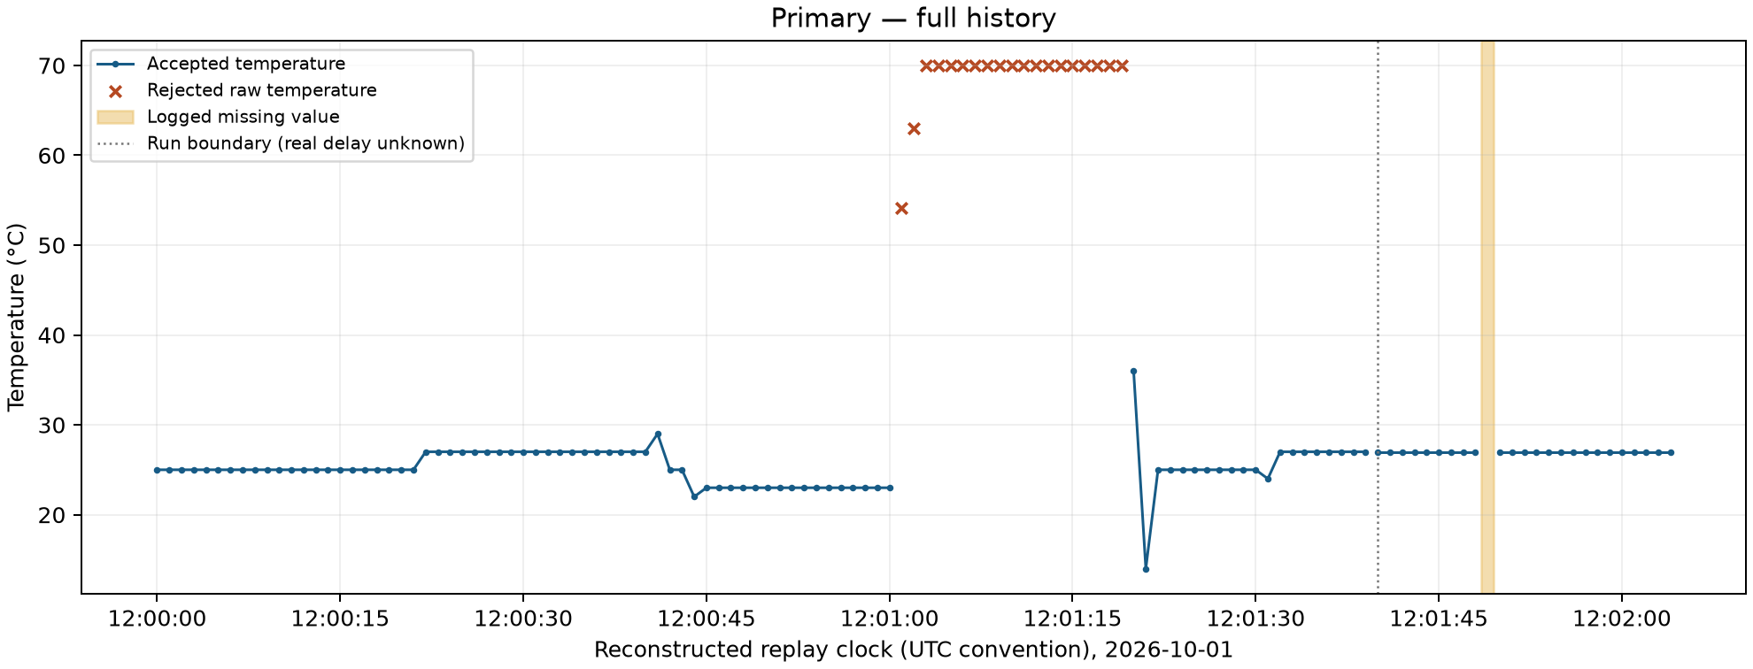
Figure 2 enlarges the missing measurement at 12:01:49. Although both neighboring readings are 27 °C, the missing temperature remains unknown. The highlighted area marks its expected sample position; no line bridges the absent measurement.
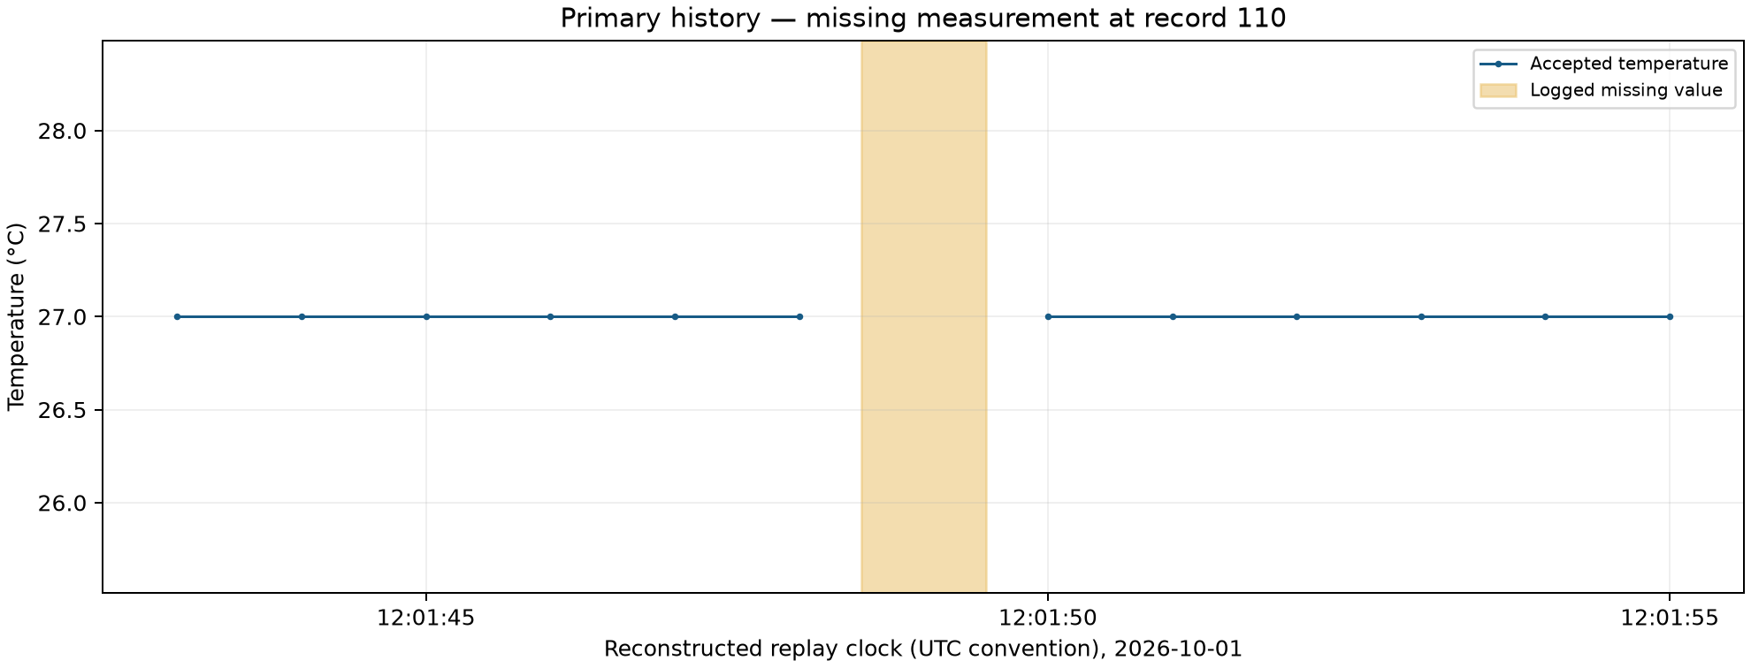

Figure 3 presents the instructor temperature supplement on its supplied time axis. Gray bands identify absent-record intervals. The plot supports comparisons among recorded portions of the history, but not a reconstructed trajectory inside either band.
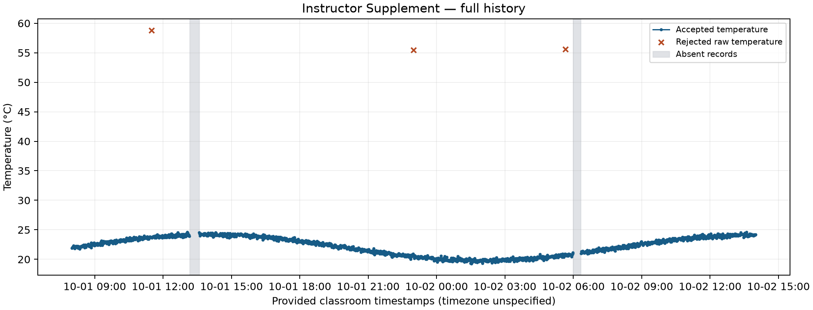
The visible history is consistent with changes in recorded temperature over time. It does not identify their physical cause. A temperature value, transition rate or time of change inside a missing interval cannot be established from this evidence.

8. Limitations
The primary data comes from a virtual sensor and includes a deliberately injected missing reading. Its dates are reconstructed, its cadence is student-confirmed rather than measured from acquisition timestamps, and the true separation between runs is unavailable.
The 0–50 °C interval is an application acceptance rule, not a demonstrated physical limit of the NTC sensor. Accepted status does not prove calibration or physical accuracy. The two suspicious but accepted values remain visible and identifiable.
The short primary history cannot support hourly or daily performance claims. Completeness inside the replayed runs does not measure uptime outside those runs. The supplementary instructor history is classroom evidence and is not represented as my own sensor acquisition.
No missing value was restored from the original comparison CSV. No interpolation, imputation or average across a gap was used. Minima, maxima and medians summarize only available accepted samples.
AI assistance was used to implement the analysis, tests and report. Reported quantities were verified with Python and SQLite. The optional Ollama section was not run, and no Ollama-generated result is claimed.

