# Reporte Mensual - Serviplagas

## Preventivos 1

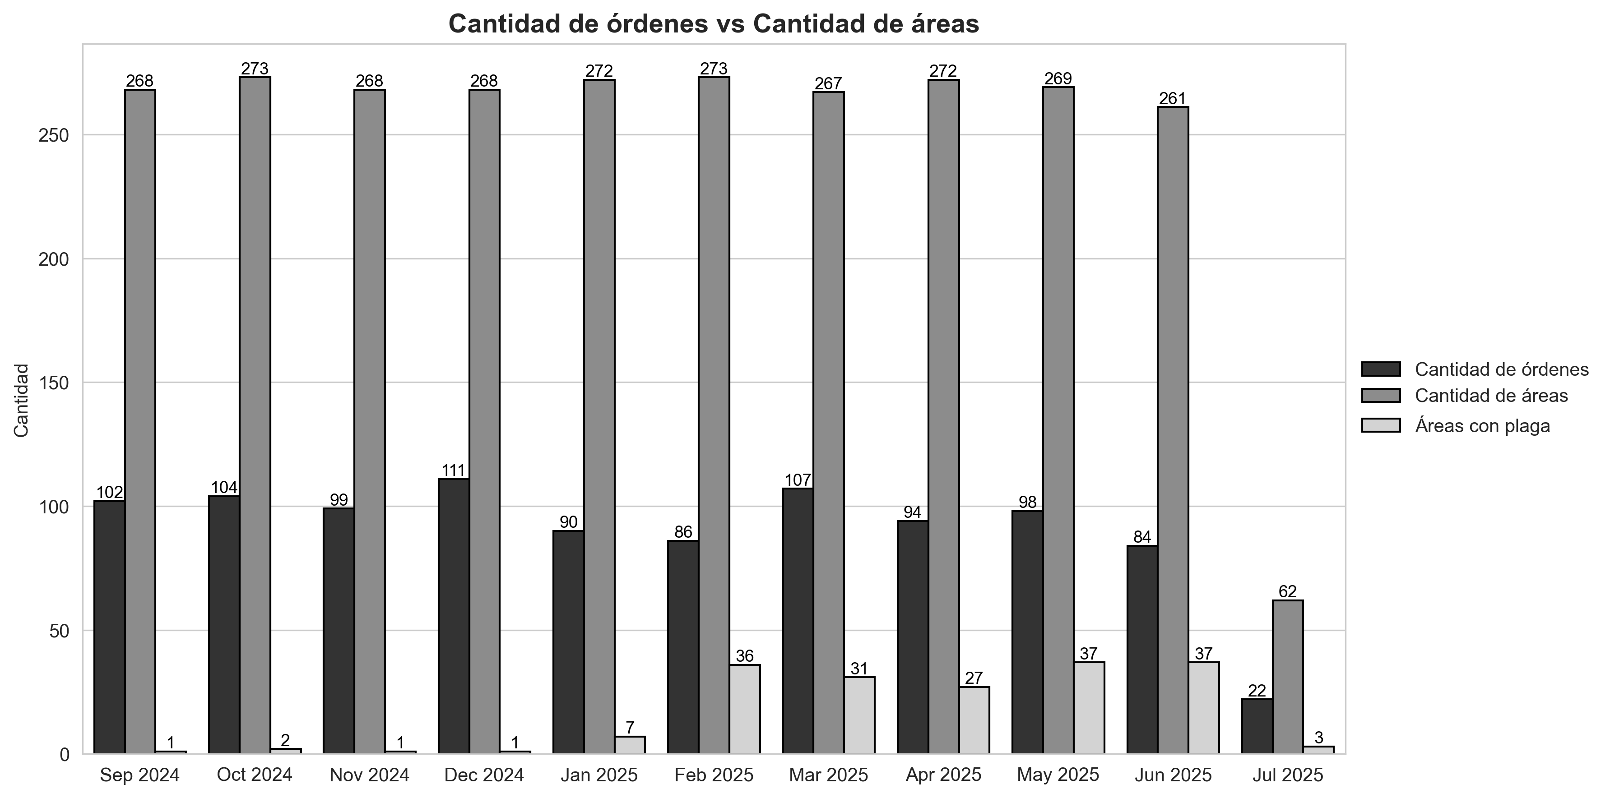

|  |  |  |  |
| --- | --- | --- | --- |
| Mes | Cantidad de órdenes | Cantidad de áreas | Áreas con plaga |
| Apr 2025 | 94 | 272 | 27 |
| Dec 2024 | 111 | 268 | 1 |
| Feb 2025 | 86 | 273 | 36 |
| Jan 2025 | 90 | 272 | 7 |
| Jul 2025 | 22 | 62 | 3 |
| Jun 2025 | 84 | 261 | 37 |
| Mar 2025 | 107 | 267 | 31 |
| May 2025 | 98 | 269 | 37 |
| Nov 2024 | 99 | 268 | 1 |
| Oct 2024 | 104 | 273 | 2 |
| Sep 2024 | 102 | 268 | 1 |

## Preventivos 2

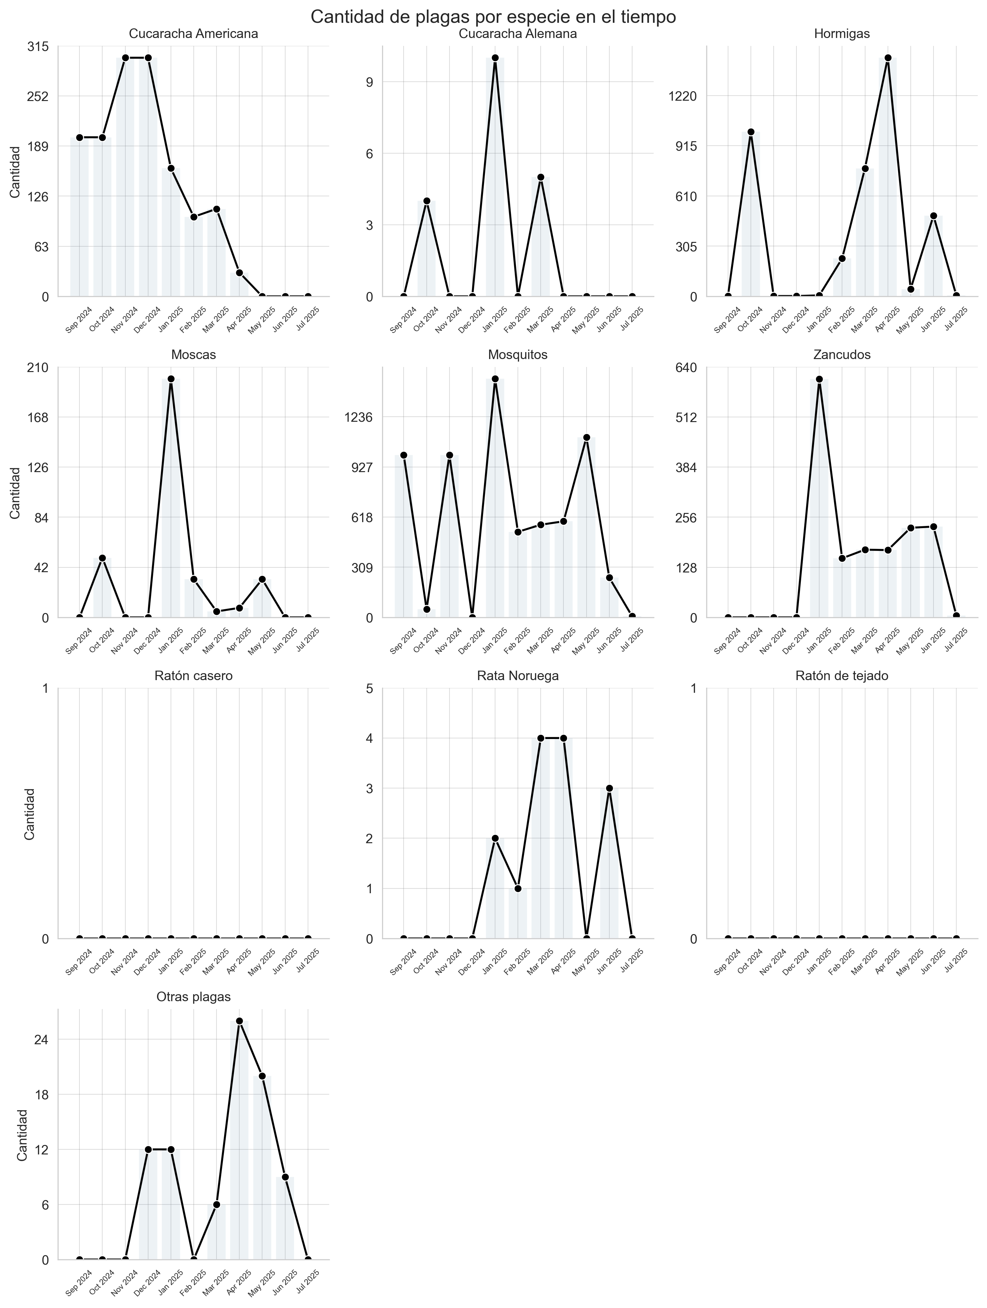

|  |  |  |  |  |  |  |  |  |  |  |
| --- | --- | --- | --- | --- | --- | --- | --- | --- | --- | --- |
| Mes | Cucaracha Americana | Cucaracha Alemana | Hormigas | Moscas | Mosquitos | Zancudos | Ratón casero | Rata Noruega | Ratón de tejado | Otras plagas |
| Apr 2025 | 30 | 0 | 1450 | 8 | 592 | 172 | 0 | 4 | 0 | 26 |
| Dec 2024 | 300 | 0 | 2 | 0 | 0 | 0 | 0 | 0 | 0 | 12 |
| Feb 2025 | 100 | 0 | 230 | 32 | 527 | 151 | 0 | 1 | 0 | 0 |
| Jan 2025 | 161 | 10 | 6 | 200 | 1470 | 609 | 0 | 2 | 0 | 12 |
| Jul 2025 | 0 | 0 | 6 | 0 | 7 | 5 | 0 | 0 | 0 | 0 |
| Jun 2025 | 0 | 0 | 490 | 0 | 245 | 232 | 0 | 3 | 0 | 9 |
| Mar 2025 | 110 | 5 | 778 | 5 | 571 | 173 | 0 | 4 | 0 | 6 |
| May 2025 | 0 | 0 | 45 | 32 | 1109 | 229 | 0 | 0 | 0 | 20 |
| Nov 2024 | 300 | 0 | 2 | 0 | 1000 | 0 | 0 | 0 | 0 | 0 |
| Oct 2024 | 200 | 4 | 1000 | 50 | 50 | 0 | 0 | 0 | 0 | 0 |
| Sep 2024 | 200 | 0 | 2 | 0 | 1000 | 0 | 0 | 0 | 0 | 0 |

## Preventivos 3

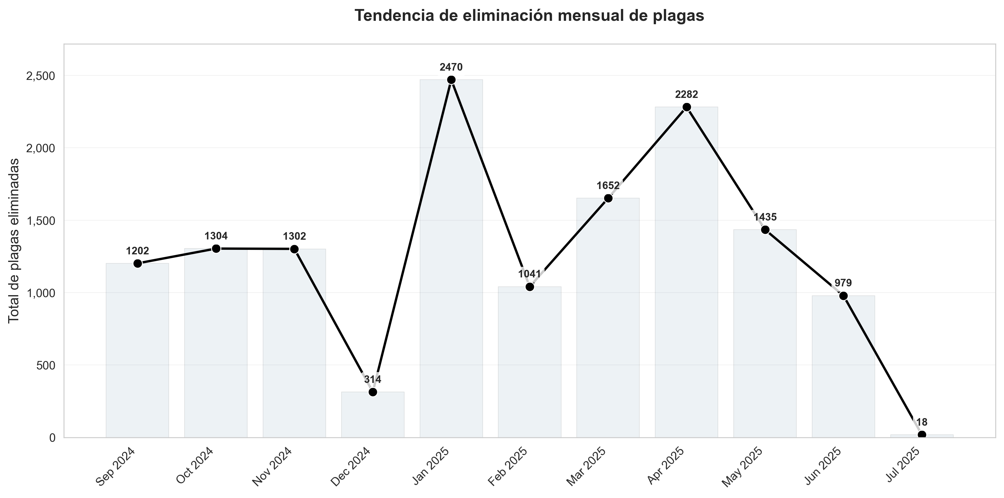

|  |  |
| --- | --- |
| Mes | total |
| Sep 2024 | 1202 |
| Oct 2024 | 1304 |
| Nov 2024 | 1302 |
| Dec 2024 | 314 |
| Jan 2025 | 2470 |
| Feb 2025 | 1041 |
| Mar 2025 | 1652 |
| Apr 2025 | 2282 |
| May 2025 | 1435 |
| Jun 2025 | 979 |
| Jul 2025 | 18 |

## Roedores 1

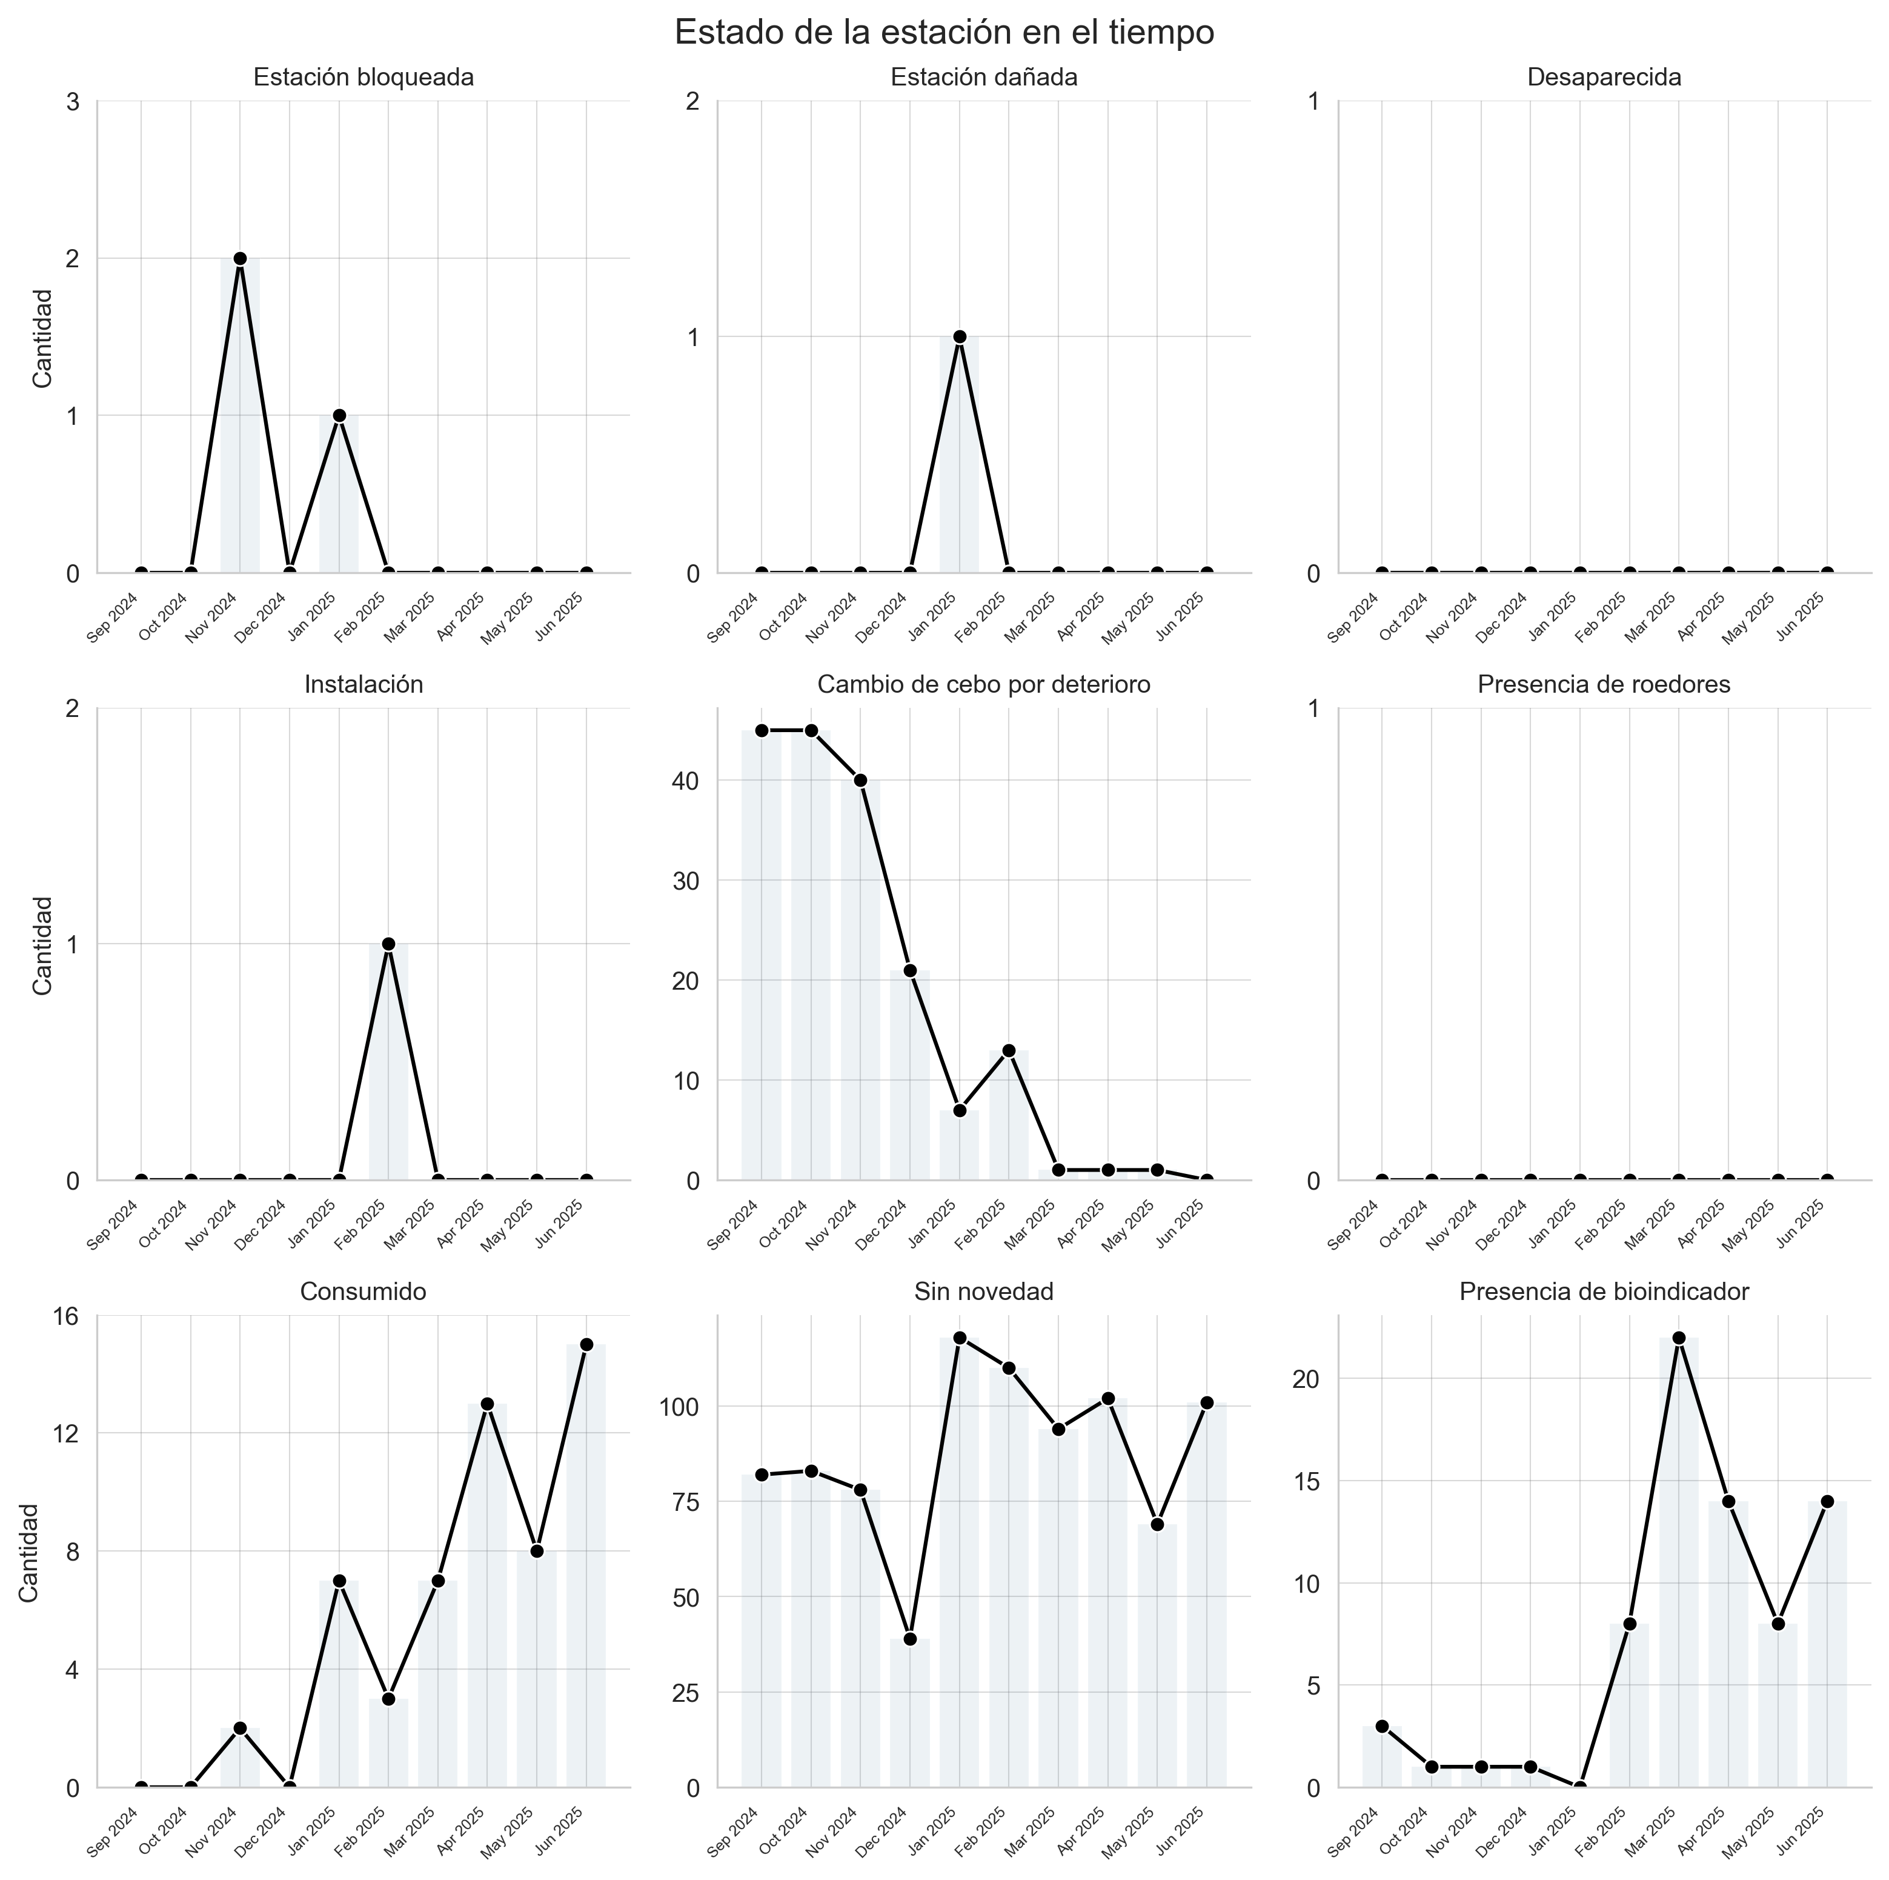

|  |  |  |  |  |  |  |  |  |  |
| --- | --- | --- | --- | --- | --- | --- | --- | --- | --- |
| Mes | Consumido | Instalación | Sin novedad | Presencia de roedores | Presencia de bioindicador | Cambio de cebo por deterioro | Desaparecida | Estación dañada | Estación bloqueada |
| Apr 2025 | 13.0 | 0 | 102 | 0 | 14 | 1 | 0 | 0 | 0 |
| Dec 2024 | 0.0 | 0 | 39 | 0 | 1 | 21 | 0 | 0 | 0 |
| Feb 2025 | 3.0 | 1 | 110 | 0 | 8 | 13 | 0 | 0 | 0 |
| Jan 2025 | 7.0 | 0 | 118 | 0 | 0 | 7 | 0 | 1 | 1 |
| Jun 2025 | 15.0 | 0 | 101 | 0 | 14 | 0 | 0 | 0 | 0 |
| Mar 2025 | 7.0 | 0 | 94 | 0 | 22 | 1 | 0 | 0 | 0 |
| May 2025 | 8.0 | 0 | 69 | 0 | 8 | 1 | 0 | 0 | 0 |
| Nov 2024 | 2.0 | 0 | 78 | 0 | 1 | 40 | 0 | 0 | 2 |
| Oct 2024 | 0.0 | 0 | 83 | 0 | 1 | 45 | 0 | 0 | 0 |
| Sep 2024 | 0.0 | 0 | 82 | 0 | 3 | 45 | 0 | 0 | 0 |

## Roedores 2

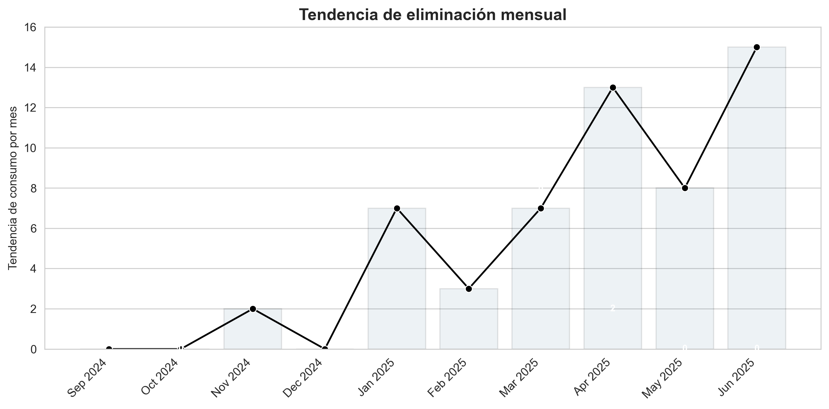

|  |  |  |  |  |  |  |  |  |  |
| --- | --- | --- | --- | --- | --- | --- | --- | --- | --- |
| Mes | Consumido | Instalación | Sin novedad | Presencia de roedores | Presencia de bioindicador | Cambio de cebo por deterioro | Desaparecida | Estación dañada | Estación bloqueada |
| Apr 2025 | 13.0 | 0 | 102 | 0 | 14 | 1 | 0 | 0 | 0 |
| Dec 2024 | 0.0 | 0 | 39 | 0 | 1 | 21 | 0 | 0 | 0 |
| Feb 2025 | 3.0 | 1 | 110 | 0 | 8 | 13 | 0 | 0 | 0 |
| Jan 2025 | 7.0 | 0 | 118 | 0 | 0 | 7 | 0 | 1 | 1 |
| Jun 2025 | 15.0 | 0 | 101 | 0 | 14 | 0 | 0 | 0 | 0 |
| Mar 2025 | 7.0 | 0 | 94 | 0 | 22 | 1 | 0 | 0 | 0 |
| May 2025 | 8.0 | 0 | 69 | 0 | 8 | 1 | 0 | 0 | 0 |
| Nov 2024 | 2.0 | 0 | 78 | 0 | 1 | 40 | 0 | 0 | 2 |
| Oct 2024 | 0.0 | 0 | 83 | 0 | 1 | 45 | 0 | 0 | 0 |
| Sep 2024 | 0.0 | 0 | 82 | 0 | 3 | 45 | 0 | 0 | 0 |

## Lámparas 1

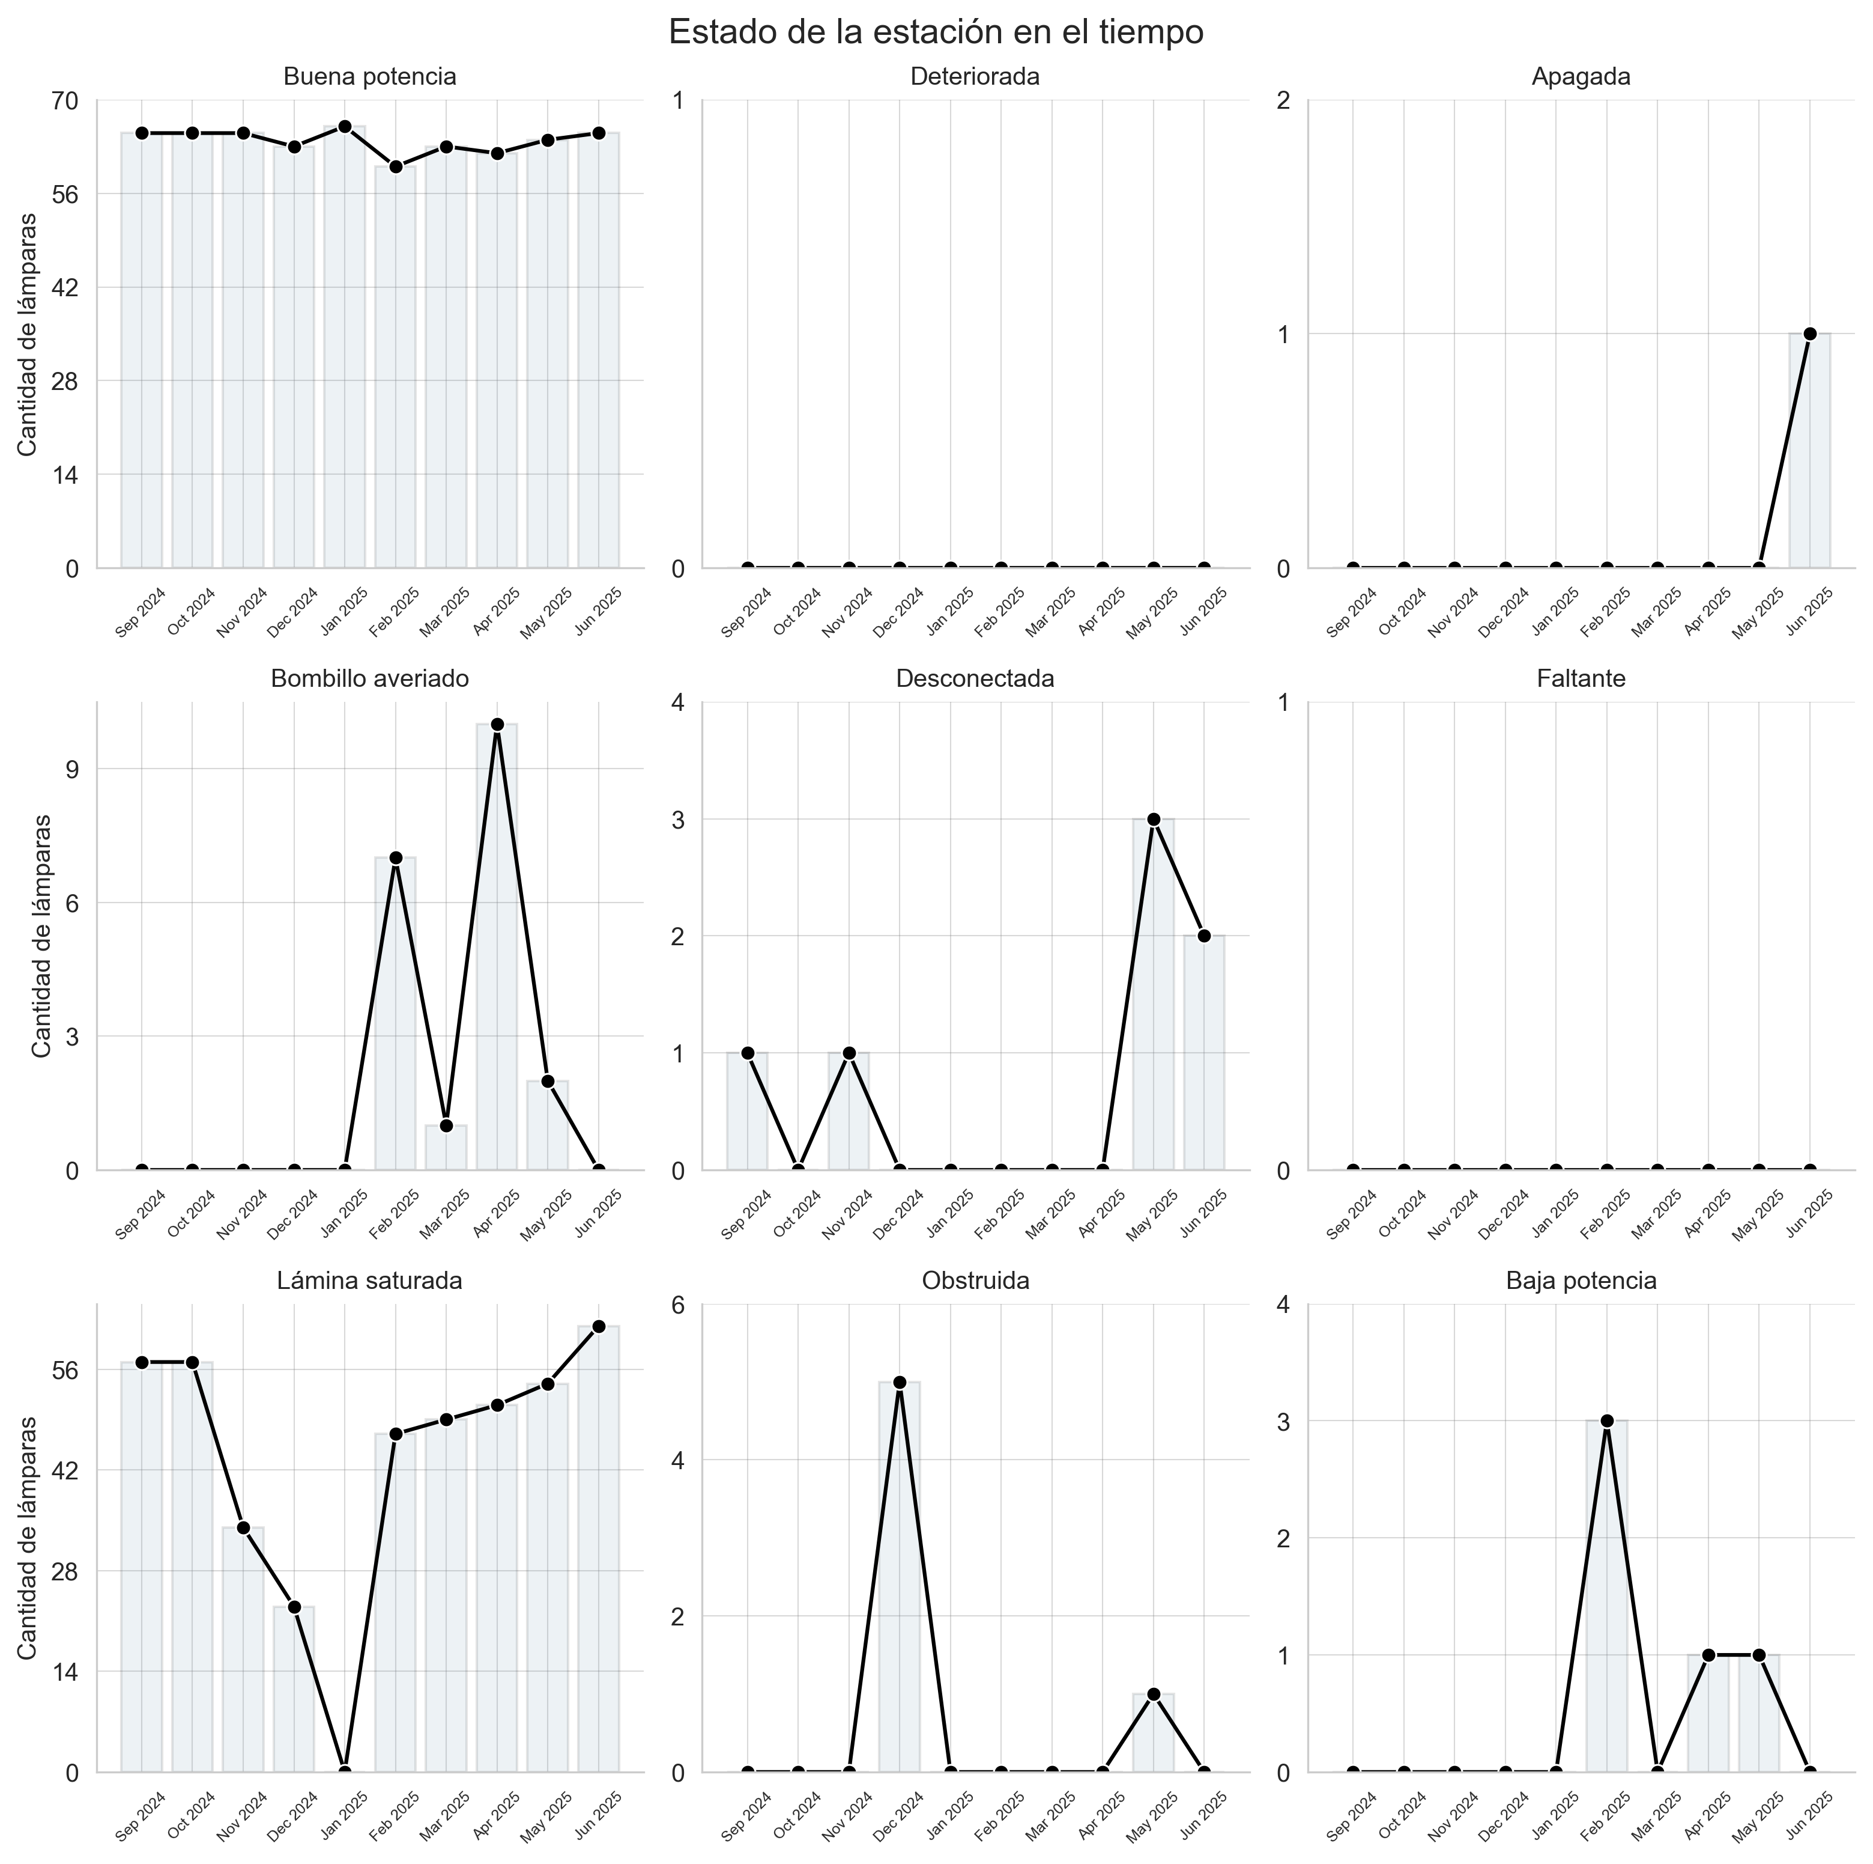

|  |  |  |  |  |  |  |  |  |  |
| --- | --- | --- | --- | --- | --- | --- | --- | --- | --- |
| Mes | Buena potencia | Deteriorada | Apagada | Bombillo averiado | Desconectada | Faltante | Lámina saturada | Obstruida | Baja potencia |
| Apr 2025 | 62 | 0 | 0 | 10 | 0 | 0 | 51 | 0 | 1 |
| Dec 2024 | 63 | 0 | 0 | 0 | 0 | 0 | 23 | 5 | 0 |
| Feb 2025 | 60 | 0 | 0 | 7 | 0 | 0 | 47 | 0 | 3 |
| Jan 2025 | 66 | 0 | 0 | 0 | 0 | 0 | 0 | 0 | 0 |
| Jun 2025 | 65 | 0 | 1 | 0 | 2 | 0 | 62 | 0 | 0 |
| Mar 2025 | 63 | 0 | 0 | 1 | 0 | 0 | 49 | 0 | 0 |
| May 2025 | 64 | 0 | 0 | 2 | 3 | 0 | 54 | 1 | 1 |
| Nov 2024 | 65 | 0 | 0 | 0 | 1 | 0 | 34 | 0 | 0 |
| Oct 2024 | 65 | 0 | 0 | 0 | 0 | 0 | 57 | 0 | 0 |
| Sep 2024 | 65 | 0 | 0 | 0 | 1 | 0 | 57 | 0 | 0 |

## Lámparas 2

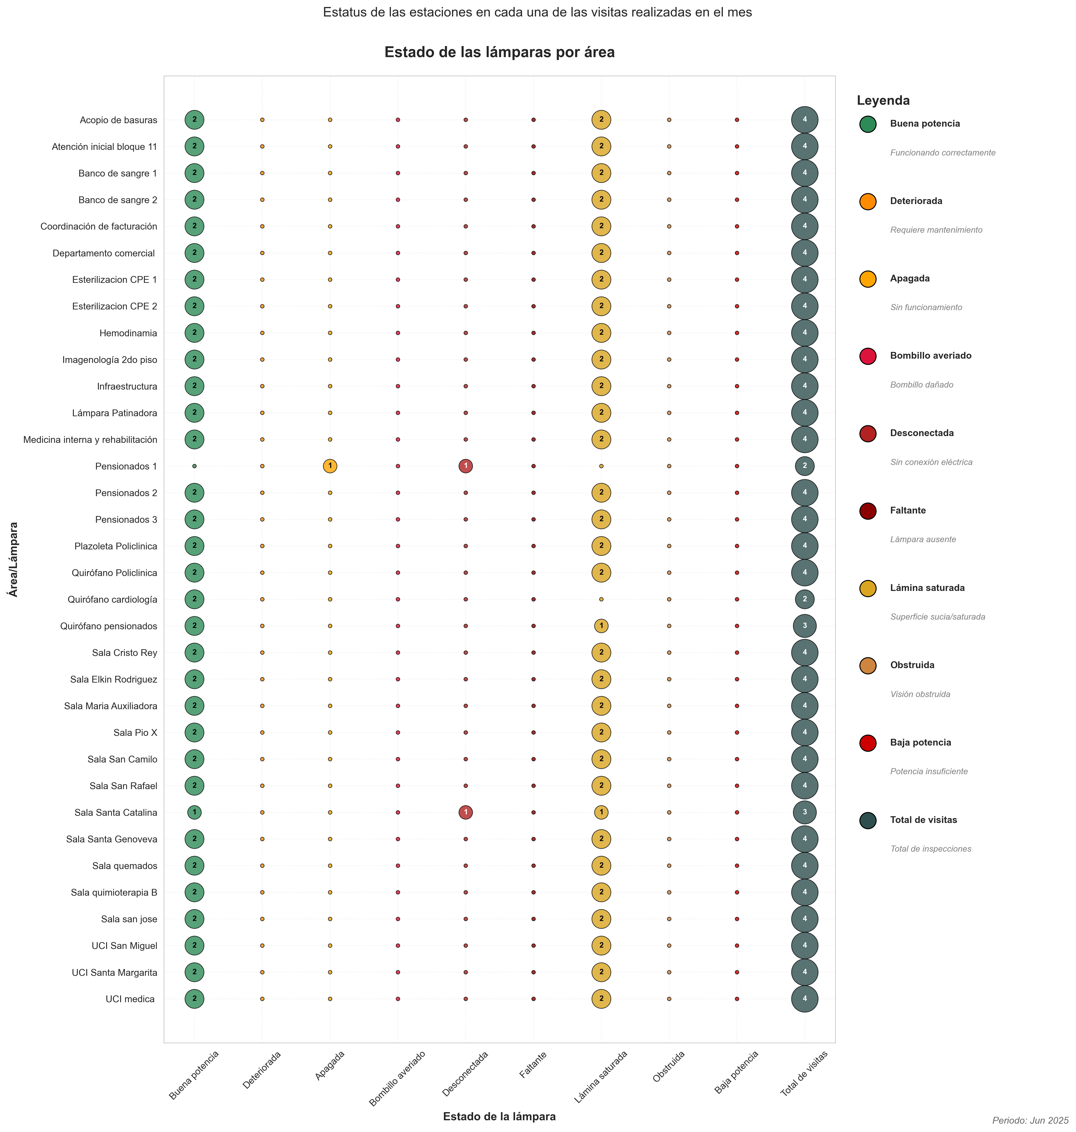

|  |  |  |  |  |  |  |  |  |  |  |
| --- | --- | --- | --- | --- | --- | --- | --- | --- | --- | --- |
| Lámpara | Buena potencia | Deteriorada | Apagada | Bombillo averiado | Desconectada | Faltante | Lámina saturada | Obstruida | Baja potencia | Total de visitas |
| Acopio de basuras | 2 | 0 | 0 | 0 | 0 | 0 | 2 | 0 | 0 | 4 |
| Atención inicial bloque 11 | 2 | 0 | 0 | 0 | 0 | 0 | 2 | 0 | 0 | 4 |
| Banco de sangre 1 | 2 | 0 | 0 | 0 | 0 | 0 | 2 | 0 | 0 | 4 |
| Banco de sangre 2 | 2 | 0 | 0 | 0 | 0 | 0 | 2 | 0 | 0 | 4 |
| Coordinación de facturación | 2 | 0 | 0 | 0 | 0 | 0 | 2 | 0 | 0 | 4 |
| Departamento comercial | 2 | 0 | 0 | 0 | 0 | 0 | 2 | 0 | 0 | 4 |
| Esterilizacion CPE 1 | 2 | 0 | 0 | 0 | 0 | 0 | 2 | 0 | 0 | 4 |
| Esterilizacion CPE 2 | 2 | 0 | 0 | 0 | 0 | 0 | 2 | 0 | 0 | 4 |
| Hemodinamia | 2 | 0 | 0 | 0 | 0 | 0 | 2 | 0 | 0 | 4 |
| Imagenología 2do piso | 2 | 0 | 0 | 0 | 0 | 0 | 2 | 0 | 0 | 4 |
| Infraestructura | 2 | 0 | 0 | 0 | 0 | 0 | 2 | 0 | 0 | 4 |
| Lámpara Patinadora | 2 | 0 | 0 | 0 | 0 | 0 | 2 | 0 | 0 | 4 |
| Medicina interna y rehabilitación | 2 | 0 | 0 | 0 | 0 | 0 | 2 | 0 | 0 | 4 |
| Pensionados 1 | 0 | 0 | 1 | 0 | 1 | 0 | 0 | 0 | 0 | 2 |
| Pensionados 2 | 2 | 0 | 0 | 0 | 0 | 0 | 2 | 0 | 0 | 4 |
| Pensionados 3 | 2 | 0 | 0 | 0 | 0 | 0 | 2 | 0 | 0 | 4 |
| Plazoleta Policlinica | 2 | 0 | 0 | 0 | 0 | 0 | 2 | 0 | 0 | 4 |
| Quirófano Policlinica | 2 | 0 | 0 | 0 | 0 | 0 | 2 | 0 | 0 | 4 |
| Quirófano cardiología | 2 | 0 | 0 | 0 | 0 | 0 | 0 | 0 | 0 | 2 |
| Quirófano pensionados | 2 | 0 | 0 | 0 | 0 | 0 | 1 | 0 | 0 | 3 |
| Sala Cristo Rey | 2 | 0 | 0 | 0 | 0 | 0 | 2 | 0 | 0 | 4 |
| Sala Elkin Rodriguez | 2 | 0 | 0 | 0 | 0 | 0 | 2 | 0 | 0 | 4 |
| Sala Maria Auxiliadora | 2 | 0 | 0 | 0 | 0 | 0 | 2 | 0 | 0 | 4 |
| Sala Pio X | 2 | 0 | 0 | 0 | 0 | 0 | 2 | 0 | 0 | 4 |
| Sala San Camilo | 2 | 0 | 0 | 0 | 0 | 0 | 2 | 0 | 0 | 4 |
| Sala San Rafael | 2 | 0 | 0 | 0 | 0 | 0 | 2 | 0 | 0 | 4 |
| Sala Santa Catalina | 1 | 0 | 0 | 0 | 1 | 0 | 1 | 0 | 0 | 3 |
| Sala Santa Genoveva | 2 | 0 | 0 | 0 | 0 | 0 | 2 | 0 | 0 | 4 |
| Sala quemados | 2 | 0 | 0 | 0 | 0 | 0 | 2 | 0 | 0 | 4 |
| Sala quimioterapia B | 2 | 0 | 0 | 0 | 0 | 0 | 2 | 0 | 0 | 4 |
| Sala san jose | 2 | 0 | 0 | 0 | 0 | 0 | 2 | 0 | 0 | 4 |
| UCI San Miguel | 2 | 0 | 0 | 0 | 0 | 0 | 2 | 0 | 0 | 4 |
| UCI Santa Margarita | 2 | 0 | 0 | 0 | 0 | 0 | 2 | 0 | 0 | 4 |
| UCI medica | 2 | 0 | 0 | 0 | 0 | 0 | 2 | 0 | 0 | 4 |

## Lámparas 3

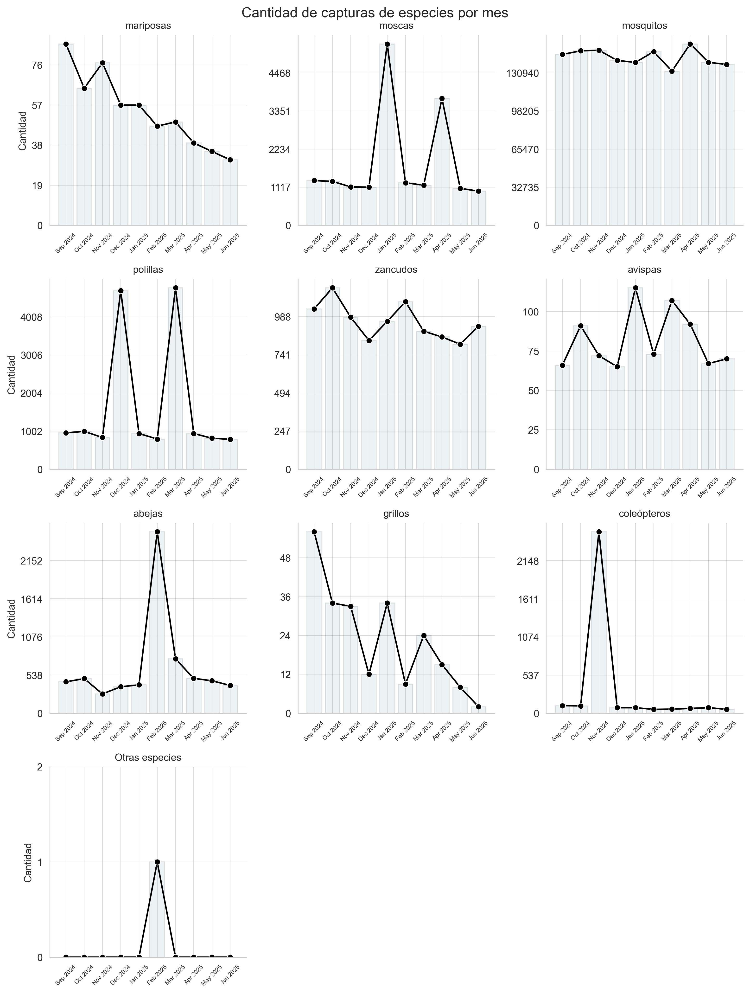

|  |  |  |  |  |  |  |  |  |  |  |
| --- | --- | --- | --- | --- | --- | --- | --- | --- | --- | --- |
| Mes | mariposas | moscas | mosquitos | polillas | zancudos | avispas | abejas | grillos | coleópteros | Otras especies |
| Apr 2025 | 39.0 | 3719.0 | 155878 | 938.0 | 857.0 | 92.0 | 491.0 | 15.0 | 67.0 | 0 |
| Dec 2024 | 57.0 | 1116.0 | 141677 | 4696.0 | 834.0 | 65.0 | 373.0 | 12.0 | 77.0 | 0 |
| Feb 2025 | 47.0 | 1246.0 | 149229 | 793.0 | 1085.0 | 73.0 | 2558.0 | 9.0 | 54.0 | 1 |
| Jan 2025 | 57.0 | 5318.0 | 139983 | 938.0 | 958.0 | 115.0 | 399.0 | 34.0 | 77.0 | 0 |
| Jun 2025 | 31.0 | 1000.0 | 138201 | 787.0 | 926.0 | 70.0 | 391.0 | 2.0 | 54.0 | 0 |
| Mar 2025 | 49.0 | 1174.0 | 132482 | 4768.0 | 894.0 | 107.0 | 766.0 | 24.0 | 57.0 | 0 |
| May 2025 | 35.0 | 1081.0 | 140051 | 814.0 | 810.0 | 67.0 | 457.0 | 8.0 | 78.0 | 0 |
| Nov 2024 | 77.0 | 1125.0 | 150446 | 833.0 | 985.0 | 72.0 | 272.0 | 33.0 | 2555.0 | 0 |
| Oct 2024 | 65.0 | 1286.0 | 149921 | 995.0 | 1175.0 | 91.0 | 487.0 | 34.0 | 103.0 | 0 |
| Sep 2024 | 86.0 | 1311.0 | 146853 | 957.0 | 1039.0 | 66.0 | 443.0 | 56.0 | 106.0 | 0 |

## Lámparas 4

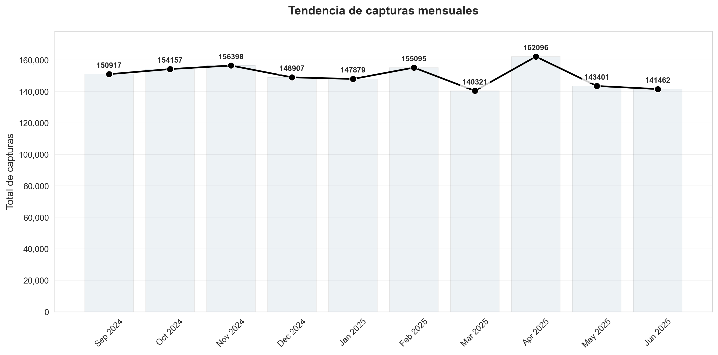

|  |  |
| --- | --- |
| Mes | total |
| Sep 2024 | 150917 |
| Oct 2024 | 154157 |
| Nov 2024 | 156398 |
| Dec 2024 | 148907 |
| Jan 2025 | 147879 |
| Feb 2025 | 155095 |
| Mar 2025 | 140321 |
| Apr 2025 | 162096 |
| May 2025 | 143401 |
| Jun 2025 | 141462 |