
Servant guide

Servant installation
To install Servant please following these steps:
- Go to the following shared link: https://microsoft-my.sharepoint.com/:f:/p/jujimen/EiJc0fwlwrFLjF1af_Mcop4BlAmNMiUceWeK9J7XbfFsbg?e=5FkLKm
- Download the MSI file you will find there named Setup.msi
- Now double click on the setup file and follow the installation process
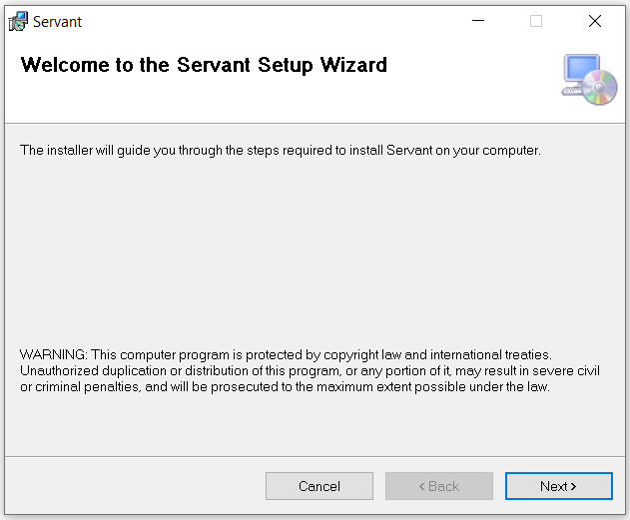

- Once Servant is installed, you will be able to see in your desktop the tool icon.
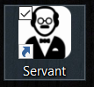

How to use it
- Open the tool by double clicking on the Servant icon and the tool will be started by default:
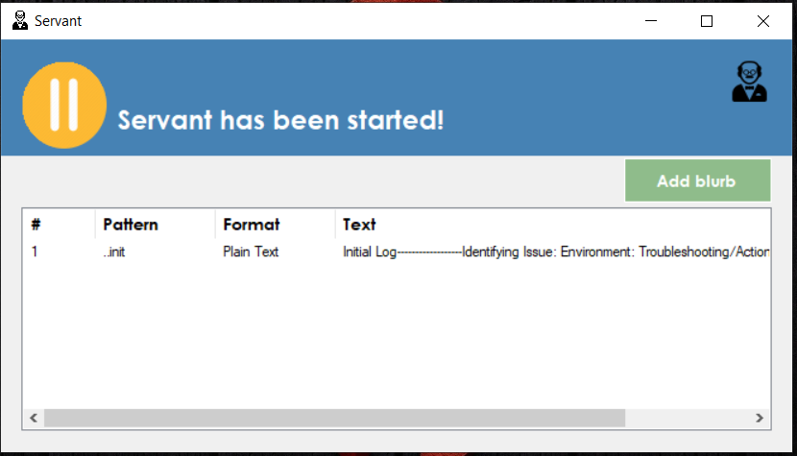

In case you want to pause the tool, simply click on the pause button on top.

- The list displayed, correspond to the list of blurbs that you currently have, obviously at the beginning the list will be empty, so you will have to add a new blurb by click on the Add blurb button.
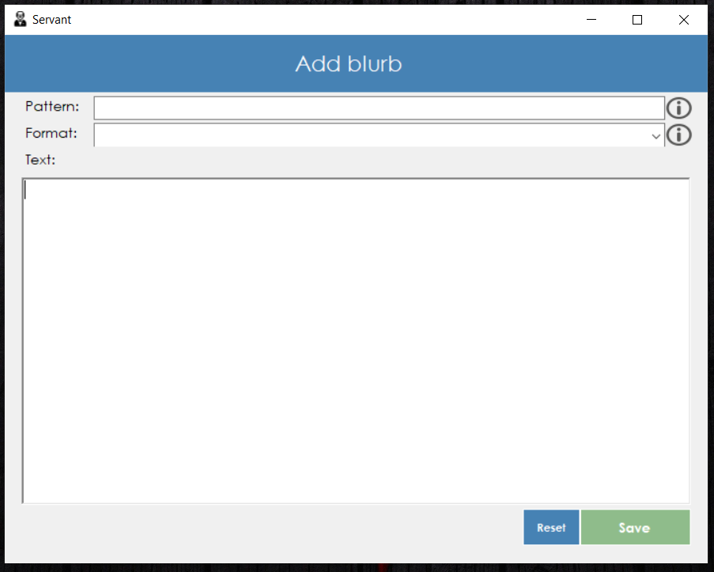
- To add the blurb, simply complete the required information (Pattern, Format and Text) and then click the button named Save.
  - Pattern: You can use the combination of letters, numbers, special characters or empty spaces that you want.
  - Format: We have two formats: Plain text or Rich Text (RTF).
    - Select Plain text when you do not need the text to be formatted.
    - Select RTF when you need to have the text formatted and it’s going to be used in an editor that supports RTF format (Word, Outlook).
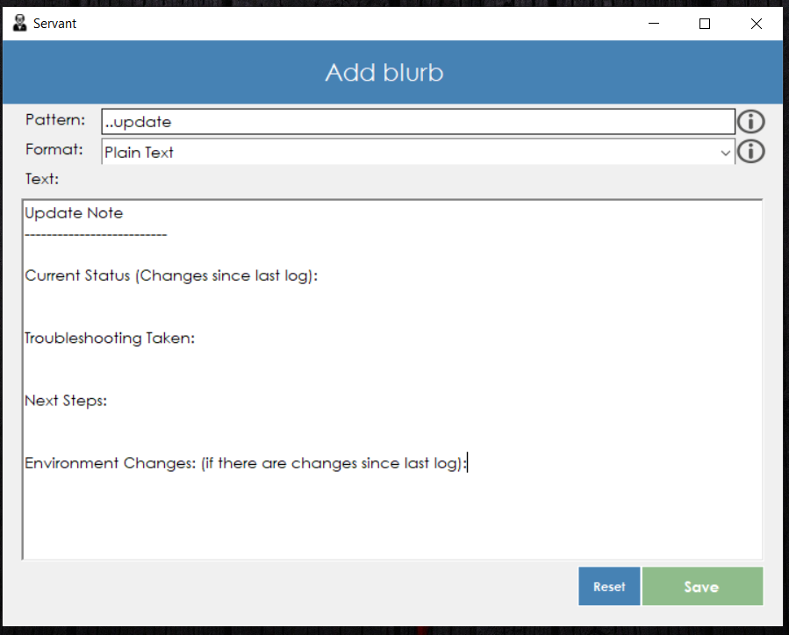

Once you Save the blurb you will get a confirmation window. Once you click Ok on it, you will be able to see the new blurb as part of the blurb list.
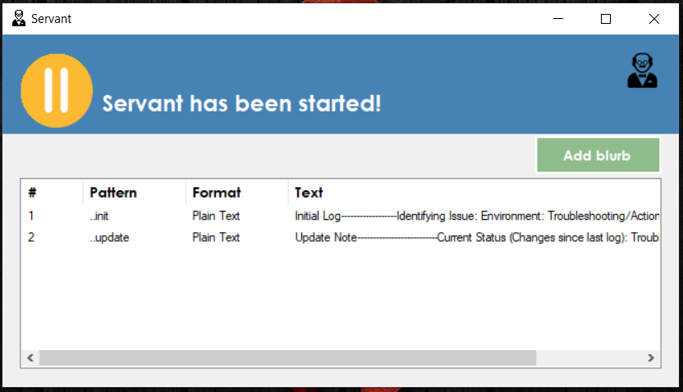
- To edit or delete an existing blurb, right click on the record row and then select the option that you want to execute.
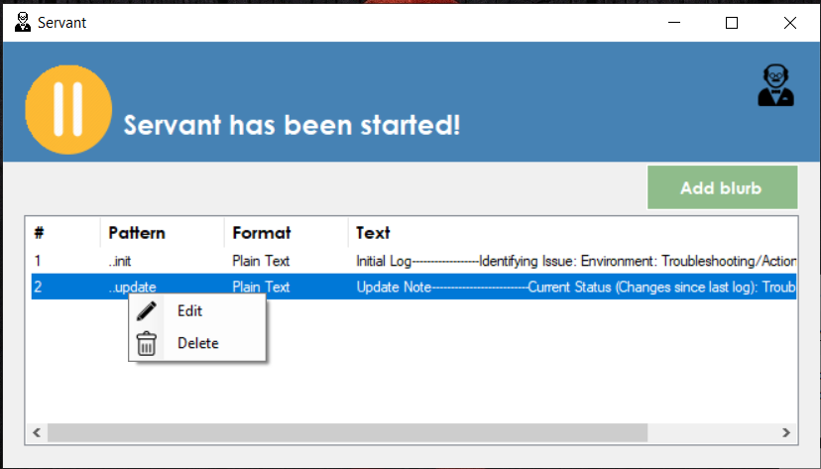

Delete: You will get a confirmation window asking you if you are truly sure to delete the selected blurb, if you click Yes, the blurb is going to be completely deleted.
Edit: There are two ways to enter the edit section, clicking the Edit option or double clicking the record row.
Once you enter the edit mode, you will get displayed the same window as the one when you create the blurb.
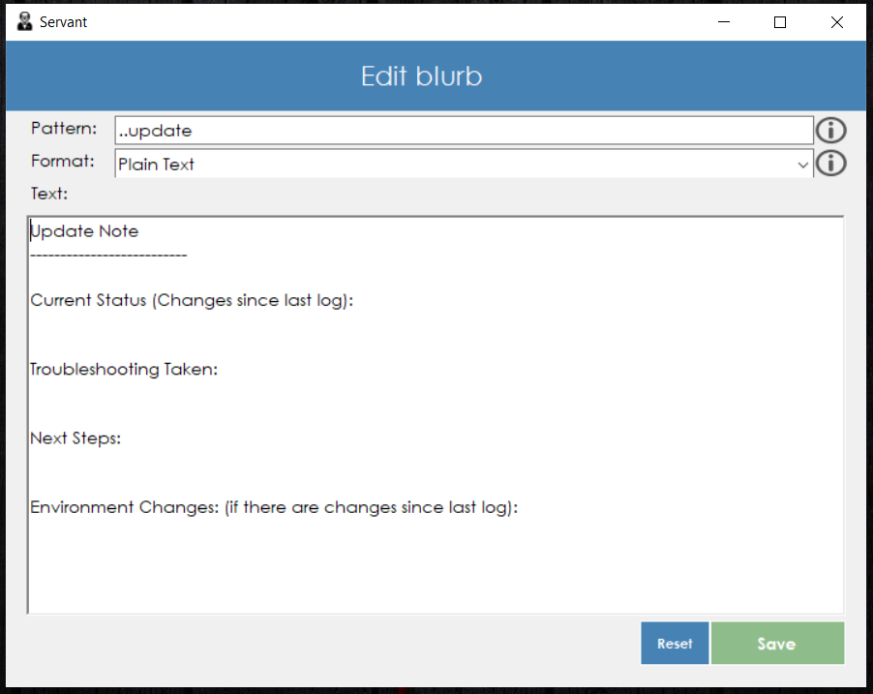

- Now Servant is going to be constantly listening the keys that you type and validating if the key combination matches one of the blub patterns that you have. So if you type one of the patterns for any of the blubs that you have, the pattern text will be removed from the text editor that you are using, and replaced with the blurb text

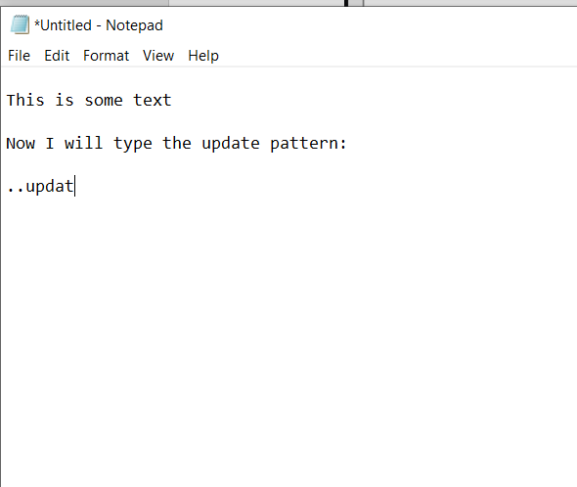

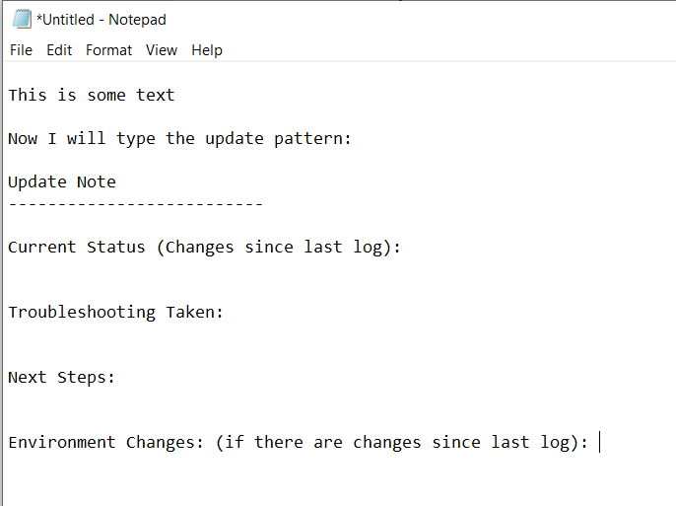

Same thing is going to happen for RTF text:
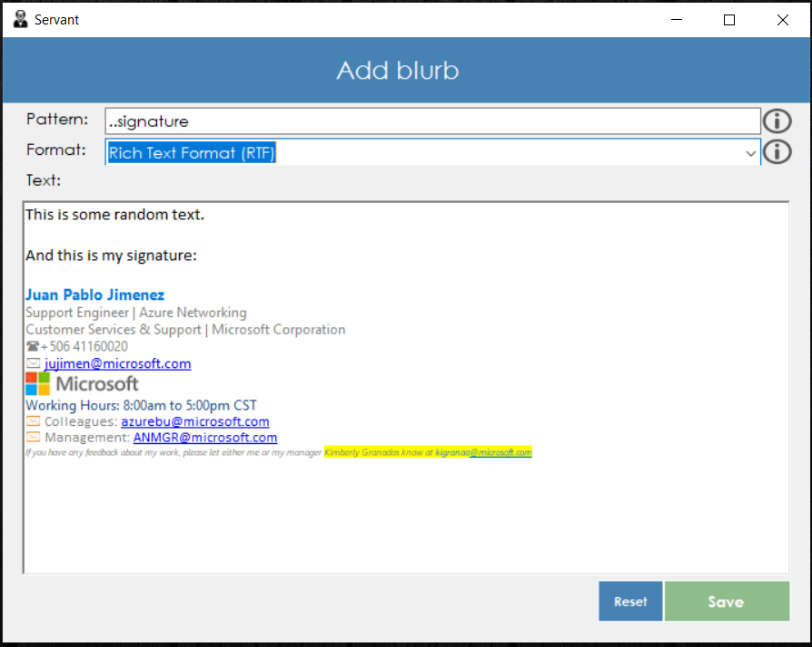

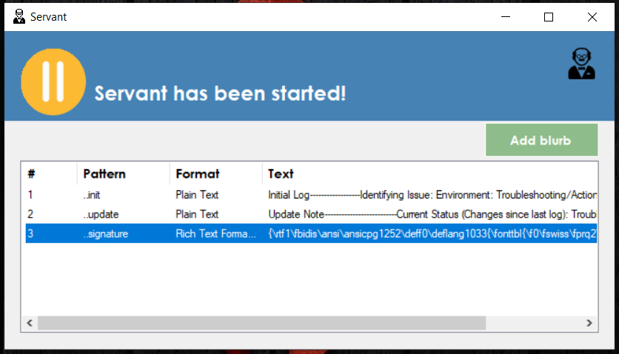

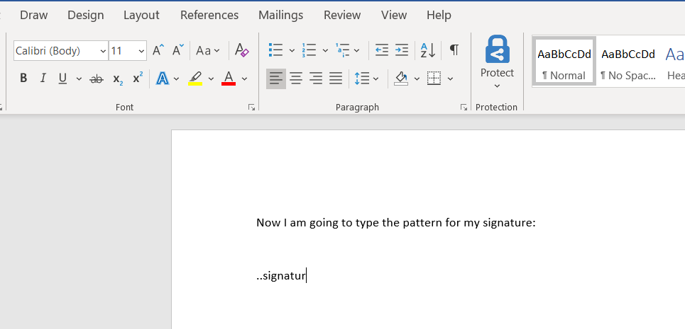
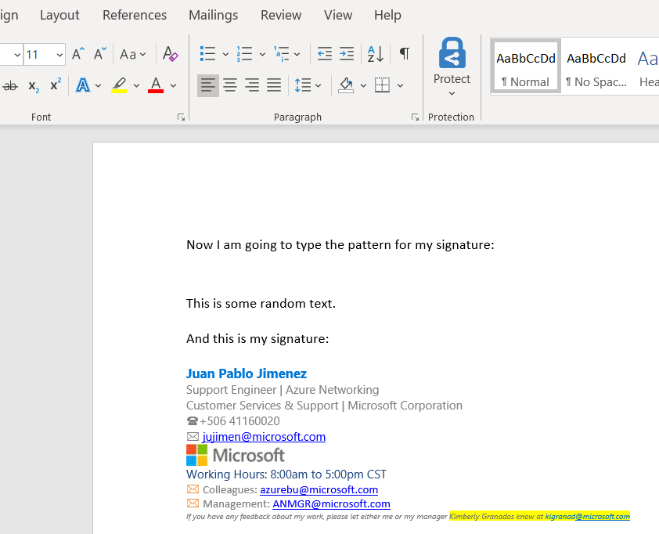

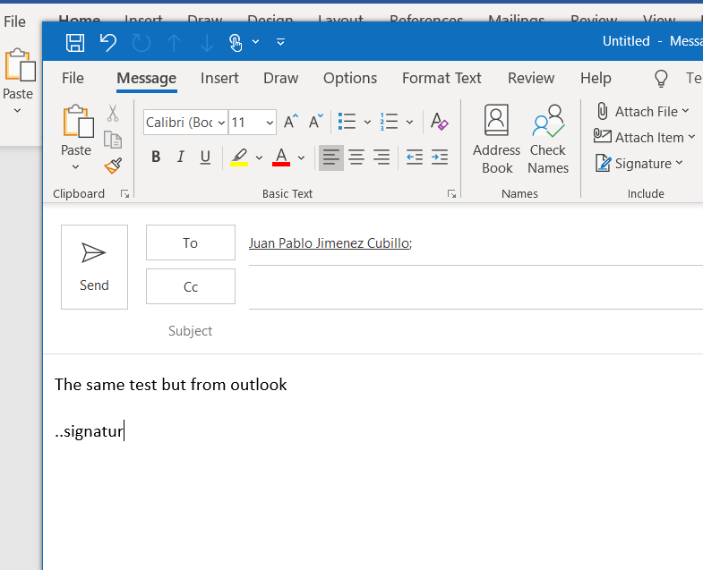

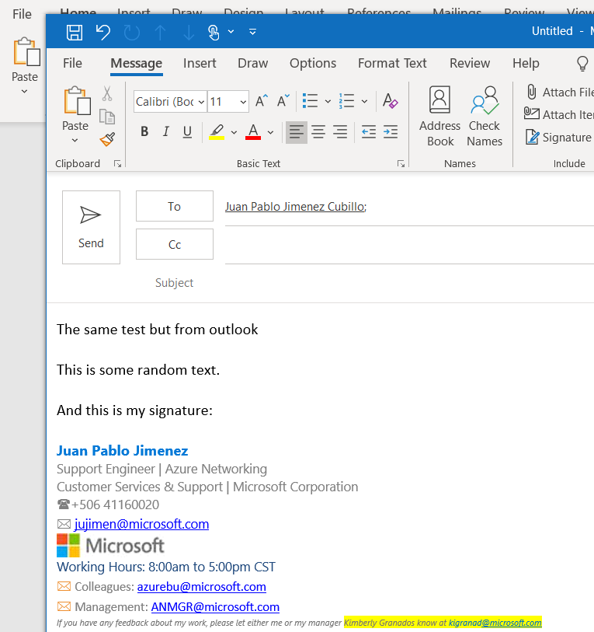
Limitations:
- If you save a blurb as Rich Text Format (RTF) you will not able to paste that text as simple text format in an editor which do not support RTF. What is going to happen is that you will paste an empty space.
- Not able to paste RTF format in web text editors. Currently Servant only allows you to paste Plain text format in web editors.
- In case you press the pattern keys, the text will be pasted after the last letter which means that in case you are pressing the keys in the right order, but in different text editors, Servant is not going to consider that, and will paste the text after the last letter, so be careful with that.

