Juan Pablo de Legarreta
IT 215 – Scripting
Lab 13

- Questions (Each of the following questions are worth 2 points each):
  - What is data visualization?
Data visualization is the graphical representation of information and data, which includes charts, graphs, and maps.
  - What is one reason someone might use data visualization?
To see trends and understand patterns in data that would be challenging (if not impossible) to do by just staring at the raw data.
  - Provide 3 examples of types of charts that might be used with data visualization?
Bar charts, line graphs, and scatter plots are 3 examples of charts used for data visualization.
  - What are the 2 data visualization libraries covered in lecture this week?
Matplotlib and plotly
  - What are 2 libraries mentioned in lecture that are for data management?
Pandas and numpy
  - What data management library is normally used with matplotlib?
numpy
  - What module from matplotlib did we use when we imported it as “plt”
Matplotlib.pyplot
  - What type of file does plotly create to display the charts to you?
An HTML file
  - What module did we use from plotly?
Plotly.express, (we also had plotly.subplots, and plotly.graph_objects in the provided examples)
  - What data management library is required when using the module that we used with plotly?
pandas

- Starwars_pandas.py graphs:
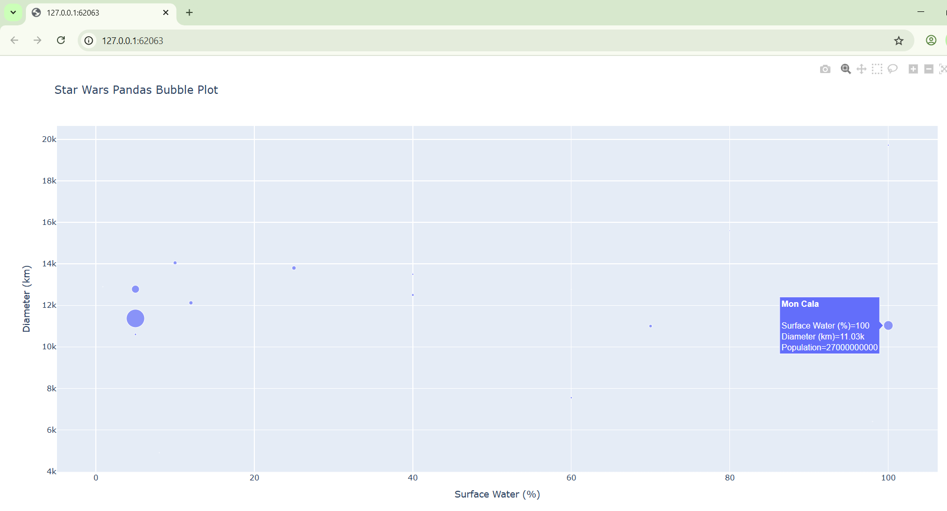
Above is the screenshot of the program’s fig 1.
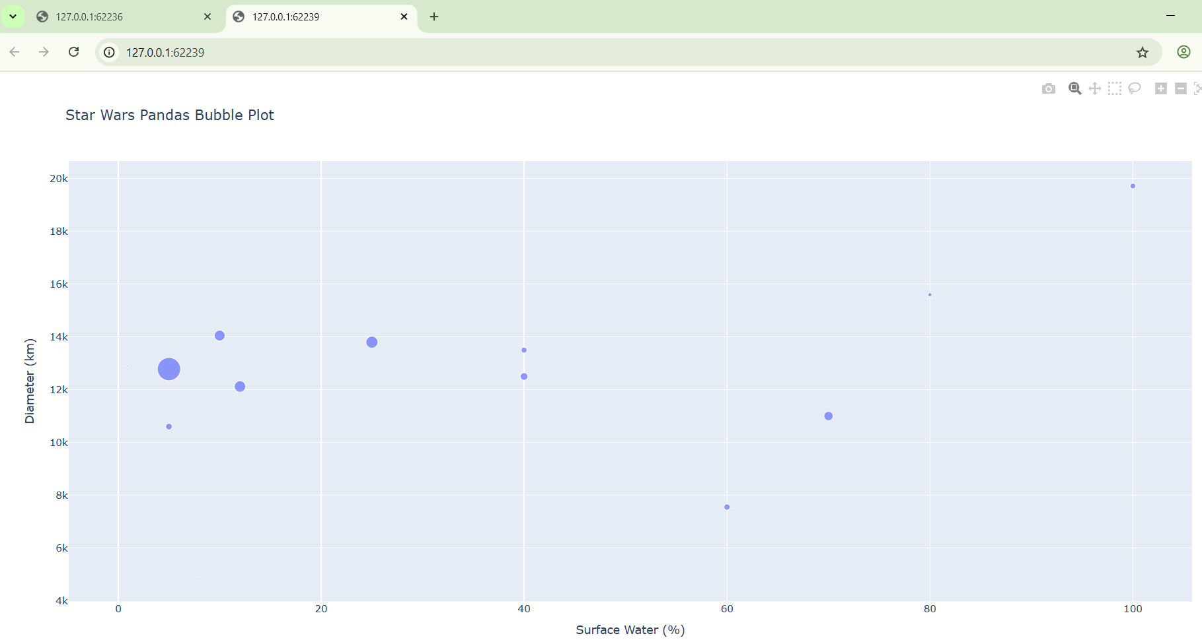
And here is fig 2 with the newly output fig 1 at the top left corner, which looks the same as screenshot 1. If you review screenshot 1, you can see that the server is a different number, as well.

- MatPlotLib screenshot:

