Juan Pablo de Legarreta
IT 215 – Scripting
Lab 2
  - Would “fluffy_bunnies_20592595” be a good variable name to use in a script that is used to patch routers that all start with the name of “office_rtr_”? Why or why not? If why not, what would be a better name?
No, as it is not descriptive or indicative of its role in the script. A better name would be office_rtr_1. Although, depending on the function of the variable, it could be office_rtr_1_status, office_rtr_1_patch, etc. Anything that is more descriptive.
  - What function would be used for converting the following variables
    - A variable of type “int” to a float
a=1
a=float(a)
    - A variable of type “float” to an integer
a=1.0
a=int(a)
    - A variable of type “int” to a string
a=1
a=str(a)
    - A variable of type “float” to a string
a=1.0
a=str(a)
  - What pep number is the “Zen of Python”
PEP 20
  - What is the link to the python documentation site?
https://docs.python.org/3/
  - Put the following operations in appropriate operator precedence order in terms of how python evaluates things (first being the highest precedence, last being lowest precedence):
    - Parentheses
    - Exponents
    - Multiplication and division
    - Addition and subtraction
  - Using the python interpreter, get the “help” documentation for one of the built in functions noted in the lecture (not allowed to use the “int()” function since I use it as an example below… If you use “int()”, I will mark the answer incorrect)
    - Provide a screenshot of the help output for that function
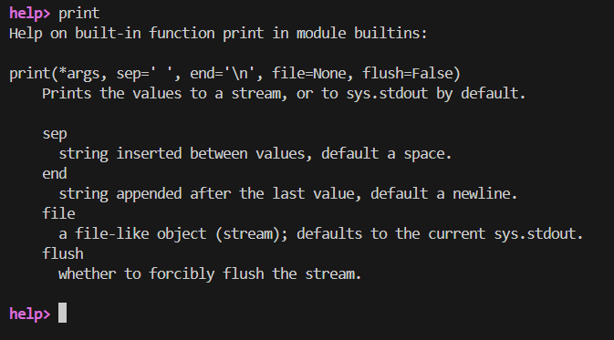
    - Provide a screenshot of you using the function in the python interpreter
