P3 AI / ML PROJECT

Rank 6
C3 - 8D / PQM Quality-Escalation Agent
8D draft + FMEA and Control Plan confirmation + quality cockpit

Document purpose | Team reference for solution definition, pilot build, validation and later productisation
Portfolio / Wave | P3 / Wave 1
Tracker baseline | 05-Sep-2026
Current tracker status | Planned
Existing asset / start point | 04_P3_BW_IA_Agent_8D_PQM_Auditor

Source baseline: AI_ML_Project_Tracker_Plan_2026-2027.xlsx - Tracker sheet. This report elaborates the tracker concept into an implementation reference; proposed targets and design details must be validated by the project team.

Contents
The document uses Word heading styles so the Navigation Pane can be used during review. The section list below is intentionally page-number free to remain stable while the team edits the document.
- Document control and usage
- Executive summary
- Tracker baseline and project charter
- Business problem and target state
- Scope and user journeys
- Functional requirements
- Proposed solution architecture
- Agent and service components
- Data and evidence model
- 8D / PQM operating workflow
- AI, ML and statistical design
- PFMEA / Control Plan / Work Instruction read-across
- Human approval, governance and guardrails
- KPIs and acceptance criteria
- Validation and test strategy
- Implementation roadmap and gate deliverables
- Roles and RACI
- Risks and mitigations
- MVP backlog and definition of done
- Open decisions and future extensions

Document control and usage
Item | Definition
Document type | Technical and functional reference - editable working document
Project reference | P3 / Wave 1 / Rank 6 / No. 2
Primary owner | P3 AI/ML Team
Review cadence | At every gate and whenever architecture, data contract or acceptance criteria change
Controlled baseline | The project tracker is the portfolio schedule baseline; this document is the solution-definition baseline
Intended users | PMO lead, product owner, quality/engineering SMEs, data engineer, AI/ML engineer, developer, validation lead, key users
Change discipline | Record material decisions, assumptions and open questions; do not silently overwrite approved requirements
How to use this report
Use it as the starting reference for architecture workshops, backlog creation, data-access requests, pilot acceptance, vendor discussions and handover. The team should update decisions and evidence as the project moves through G1-G5.

Executive summary
The Rank 6 project should be implemented as an AI Quality Resolution and Escalation Agent, not as a document-writing bot. Its purpose is to control the complete problem-solving loop from complaint intake and evidence collection through containment, root-cause validation, corrective action, PFMEA/Control Plan read-across, effectiveness verification and management escalation.
Core design principle
AI may propose, summarize, compare and challenge. It must not declare a root cause proven, close an 8D, change a controlled quality document, or communicate an official customer position without named human approval.

The tracker baseline describes the solution as complaint and test evidence -> RAG retrieval of similar past 8Ds -> 8D drafting -> PFMEA/Control Plan diff -> containment and escalation proposal -> named-lead approval -> cockpit and audit log. This report expands that concept into a buildable reference architecture and delivery plan.

Tracker baseline and project charter
Parameter | Tracker baseline / proposed interpretation
Portfolio / Wave / Rank | P3 / Wave 1 / Rank 6
Project | C3 - 8D / PQM quality-escalation agent
Business problem | Slow 8D preparation, weak evidence links, poor feedback of corrective actions into PFMEA and Control Plan, and low on-time closure performance
Priority / Complexity | High / Medium
Status | Planned
Start | 07-Sep-2026
G0 Project Definition | 14-Sep-2026
G1 Technical Review | 16-Sep-2026
G2 Pilot Readiness | 30-Sep-2026
G3 Production Trial | 14-Oct-2026
G4 Release | 28-Oct-2026
G5 Productisation | 18-Nov-2026
Expected output | Traceable 8D draft, missing-evidence questions, confirmed PFMEA/Control Plan updates, containment plan and 8D/PQM cockpit

Business problem and target state

Current-state failure modes
- Complaint evidence is fragmented across e-mails, folders, images, Excel files, test reports and presentations.
- D2 problem definitions are inconsistent and often omit Is/Is Not, boundary conditions, quantity or time window.
- Containment scope can be narrower than the true suspect population because genealogy and evidence are not connected.
- Root-cause conclusions may be opinion-driven or accepted before physical/statistical validation is complete.
- Corrective actions can close the 8D without being read across to PFMEA, Control Plan, reaction plan and work instructions.
- Historical 8Ds and lessons learned are difficult to retrieve and compare quickly.
- Aging and escalation are managed after deadlines are already at risk instead of predictively.

Target state
Create one governed digital case per complaint/PQM. Every statement in the 8D is linked to evidence; every root-cause hypothesis carries a validation status; every permanent action is checked against controlled quality documents; and the management cockpit exposes aging, missing evidence, repeated failure modes and approval status before customer deadlines are missed.

Scope and user journeys
In scope | Out of scope / guardrail
Complaint/PQM intake from structured files, notes and approved repositories | Autonomous customer communication without approval
D1-D8 draft support and completeness checks | AI-only root-cause declaration
Evidence cataloging and citation | Replacing required physical testing, metrology or DOE
Similar-case retrieval over approved history | Editing released PFMEA/Control Plan/WI without document owner approval
Containment and escalation proposal | Automatic product release or shipment disposition
PFMEA/Control Plan/WI consistency checks | Using confidential data outside the approved environment
Cockpit, aging and owner follow-up | Black-box risk scores without explanation

Primary user journeys
1. Quality engineer opens a new complaint/PQM and receives a structured case with missing-information questions.
2. Cross-functional team reviews D2, containment and root-cause hypotheses with direct links to evidence.
3. Engineer requests similar historical cases and compares previous causes/actions before defining tests.
4. Validated root cause is converted into occurrence, detection and systemic actions with named owners and evidence requirements.
5. Agent checks PFMEA, Control Plan and Work Instruction consistency and blocks closure when mandatory read-across is incomplete.
6. Quality lead approves the 8D package; management monitors aging, repeat cases and escalations in the cockpit.

Functional requirements
ID | Requirement | Priority
FR-01 | Create a unique case ID and preserve source lineage for every complaint/PQM. | Must
FR-02 | Extract structured facts for D2: who, what, where, when, how many, boundary and Is/Is Not. | Must
FR-03 | Maintain an evidence register with source, date, owner, case link and validation status. | Must
FR-04 | Generate only evidence-grounded 8D draft text and visibly flag unsupported claims. | Must
FR-05 | Retrieve similar past cases with citations and explain similarity factors. | Must
FR-06 | Represent root causes as Hypothesis -> Evidence Supported -> Validated Root Cause. | Must
FR-07 | Track containment scope, effectiveness and exit criteria. | Must
FR-08 | Compare validated cause/actions against PFMEA, Control Plan and WI content. | Must
FR-09 | Enforce named human approval for official root cause, document changes, closure and external communication. | Must
FR-10 | Publish cockpit KPIs, aging, open evidence, repeats and high-risk cases. | Must
FR-11 | Provide audit log of prompts/tool calls/approvals/version changes relevant to the case. | Should
FR-12 | After sufficient history, predict due-date risk with explainable features. | Later

Proposed solution architecture
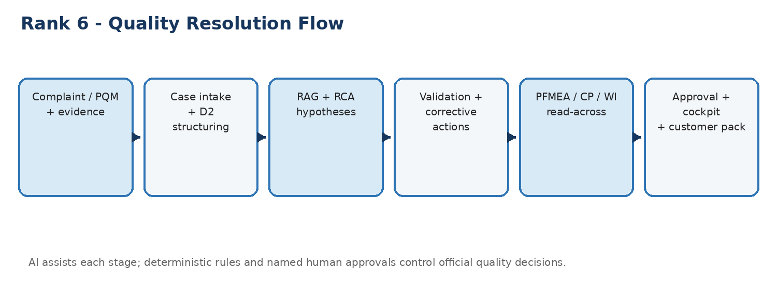
Figure 1. End-to-end quality-resolution flow.
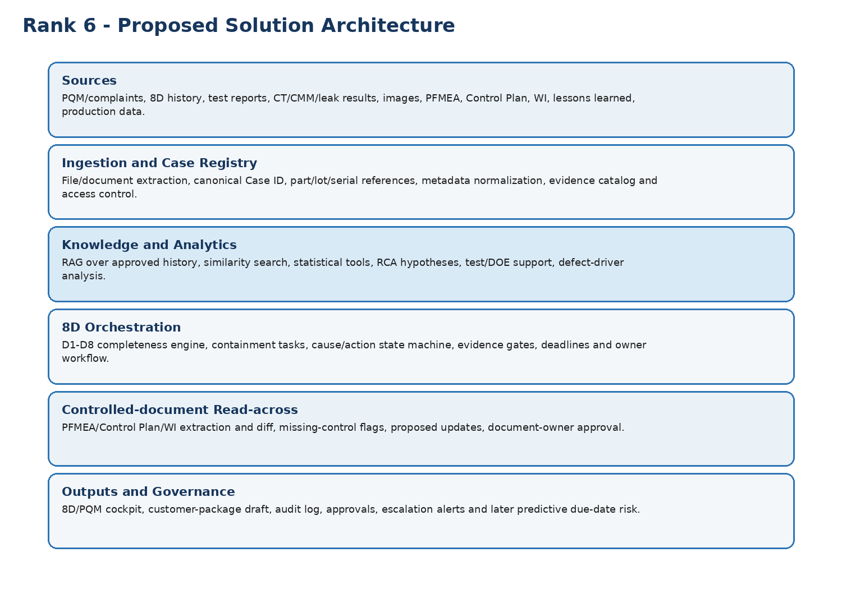
Figure 2. Logical architecture for the Rank 6 agent.

Agent and service components
Component | Responsibility
Case Intake Agent | Builds the structured case from complaint/PQM sources; asks missing-information questions.
D2 Problem Definition Agent | Enforces 5W2H and Is/Is Not; separates facts from assumptions.
Evidence Agent | Maintains evidence register and marks unsupported statements.
Similar Case RAG Service | Finds comparable 8Ds/lessons learned and returns cited excerpts/metadata.
RCA Assistant | Builds Ishikawa/5-Why hypotheses and recommends validation experiments; never self-validates the final cause.
Containment Agent | Proposes suspect scope, sorting/inspection logic, owners, exit criteria and effectiveness evidence.
Corrective Action Agent | Maps validated cause to occurrence, detection and systemic actions.
PFMEA/CP/WI Auditor | Checks whether validated failure mode/cause/controls are reflected in controlled documents.
Effectiveness Agent | Tracks post-action results and closure evidence.
PQM Escalation Agent | Calculates aging, due-date proximity and escalation status from deterministic rules.
Cockpit / Reporting Service | Publishes quality status, overdue D-steps, repeat cases, read-across gaps and approvals.

Data and evidence model
The case data model should be explicit and versioned before model development. The following minimum objects are recommended.
Object | Minimum fields
Case | Case ID, customer, project, part number, defect code, date, severity, owner, status, customer due date
Suspect population | Part/lot/serial range, plant/line/shift, start/end time, containment status, genealogy link
Evidence | Evidence ID, type, source path/link, created date, owner, case link, validation state, hash/version
Hypothesis | Hypothesis ID, cause category, description, supporting evidence, contradicting evidence, validation plan, status
Action | Action ID, type (containment/occurrence/detection/systemic), owner, due date, evidence required, status, effectiveness
Controlled document | Document ID, type, revision, affected characteristic/process step, proposed change, approver, approval status
Approval | Approval ID, role, decision, timestamp, reason/comment, linked object version
Canonical IDs are mandatory
Every case, evidence item, action, hypothesis and document version must have a stable identifier. Do not rely on file names alone for traceability.

8D / PQM operating workflow
8D stage | Agent support | Human control / exit condition
D1 - Team | Suggest roles from case type; create team/contact list | Quality lead confirms team and accountable owner
D2 - Problem | Extract facts, quantify defect, build Is/Is Not, identify missing data | Engineer approves problem statement
D3 - Containment | Propose suspect scope, sorting/inspection tasks and exit criteria | Quality/operations approve scope and disposition
D4 - Root cause | Retrieve similar cases, create hypotheses, run statistical analysis, propose tests | Engineering/quality validate occurrence and escape root causes with evidence
D5 - Corrective action | Generate options tied to validated causes and evaluate risk | Responsible function selects and approves permanent action
D6 - Implement/validate | Track implementation evidence and before/after metrics | Owner demonstrates effectiveness
D7 - Prevent recurrence | Audit PFMEA, Control Plan, WI and lessons learned read-across | Document owners approve controlled changes
D8 - Closure | Check completeness, evidence, approvals and residual risks | Quality lead/customer process closes case

AI, ML and statistical design

MVP intelligence stack
- LLM structured extraction: complaint facts, D2 fields, actions, owners and candidate causes using a fixed JSON schema.
- RAG: approved historical 8Ds, lessons learned, standards and project evidence with citation back to source.
- Sentence/embedding similarity: rank comparable past cases by failure mode, process, component, customer symptom and root-cause family.
- Deterministic rules: deadlines, completeness checks, approval gates, status logic and closure blockers.
- Statistics: Pareto, capability, hypothesis testing, regression/ANOVA and DOE support where data permits.

Later ML layer
After enough governed history exists, train a due-date risk model to estimate P(8D misses customer due date). Candidate models are LightGBM/XGBoost with SHAP explanations. Do not train before labels and data lineage are reliable.
Candidate feature family | Examples
Case profile | Customer, defect type, severity, line/process, project phase
Progress | Current D-step, days open, days to due date, extensions, missing approvals
Evidence | Evidence-completeness %, open tests, supplier evidence pending
Team / dependency | Owner workload, number of organizations, supplier dependence, laboratory dependence
Historical behavior | Similar-case duration, owner/team closure history, repeat failure pattern

PFMEA / Control Plan / Work Instruction read-across
D7 should contain a formal system check. The agent should compare the validated root cause and approved controls against the currently released documents and classify each requirement as Present, Missing, Ambiguous or Revision Mismatch.
1. Validated failure mode and effect are represented in the PFMEA at the correct process step.
2. Validated occurrence cause is represented and its prevention control is documented.
3. Validated escape mechanism is represented and its detection control is documented.
4. Control Plan characteristic, method, frequency, sample size and reaction plan match the approved action.
5. Work Instruction / standardized work reflects operator-facing changes.
6. Revision/effective date and implementation evidence are available before closure.
Closure blocker
If a required read-across item is Missing or Revision Mismatch, the agent should mark D7 incomplete and prevent an automated "ready to close" recommendation.

Human approval, governance and guardrails
Decision / action | AI role | Required human authority
Root-cause hypothesis | Generate and prioritize candidates | None for hypothesis creation
Validated root cause | Present evidence and contradictions | Quality + responsible engineering lead
Containment / product disposition | Propose scope and actions | Authorized quality/operations owner
PFMEA/CP/WI change | Draft proposed change and compare revisions | Controlled-document owner / FMEA moderator as applicable
8D closure | Check completeness and evidence | Quality lead / customer-specific process
External customer response | Draft only | Named customer-facing owner
Shipment/release decision | No autonomous authority | Existing approved release process remains authoritative

KPIs and acceptance criteria
The tracker baseline includes an 8D on-time reference near 53% versus a 75% target. The following are proposed pilot acceptance targets and should be confirmed at G1.
KPI | Proposed pilot target | Measurement
Evidence traceability | >= 95% of generated claims linked to a source/evidence item | Sampled audit of generated D2-D7 content
D2 completeness | >= 95% mandatory fields complete or explicitly flagged missing | Case checklist
Unsupported-claim detection | >= 95% of seeded unsupported statements flagged | Golden test set
Similar-case retrieval usefulness | >= 80% top-5 result judged relevant by SME | SME evaluation set
PFMEA/CP read-across coverage | 100% of G3 pilot cases checked | Workflow log
Human approval on official decisions | 100% | Audit log
8D draft preparation time | >= 60% reduction vs baseline | Time study
Critical closure blockers missed | 0 in pilot | Quality review
On-time closure trend | Improvement toward or above 75% | PQM/8D cockpit

Validation and test strategy
Test layer | Minimum evidence
Unit / schema | All extracted objects conform to versioned JSON/data schemas; fail-loud on missing mandatory fields
Golden-set extraction | Known complaints/minutes/test packs with expected D2 fields, actions and evidence links
RAG evaluation | Known queries with expected past cases and correct citations
Hallucination / unsupported claim | Seed contradictory/missing evidence and confirm the agent refuses to state unsupported facts as proven
Document diff | Known PFMEA/CP revisions with inserted/removed controls; verify correct gap detection
Workflow / approvals | Test reject/modify/approve, versioning and audit-log behavior
Security | Role access, restricted customer data, secrets, repository permissions and export controls
User acceptance | Quality engineer executes real case in shadow/assisted mode and signs acceptance

Implementation roadmap and gate deliverables
Gate / target | Minimum deliverables for this project
G0 - 14-Sep-2026 | Approved problem statement, users, process map, baseline KPIs, scope, data owners, risks and success criteria
G1 - 16-Sep-2026 | Architecture, canonical data model, source-access confirmation, guardrails, golden-set plan and prioritized backlog
G2 - 30-Sep-2026 | End-to-end pilot on real controlled cases: intake -> draft -> evidence -> read-across -> cockpit; measured baseline and evaluation report
G3 - 14-Oct-2026 | Shadow/assisted production trial with named users; defect log, approval workflow, support plan and KPI evidence
G4 - 28-Oct-2026 | Customer/production release: owner, runbook, access/RBAC, monitoring, backup/recovery, issue process, training and sign-off
G5 - 18-Nov-2026 | Customer-specific rules externalized to configuration; reusable templates, connectors, evaluation pack and product documentation

Roles and RACI
Role | Primary responsibility | RACI emphasis
Product Owner / PMO | Value, scope, schedule, gate sign-off coordination | A for backlog/scope; C on release
Quality Lead | 8D/PQM process owner, acceptance and customer-specific requirements | A for quality decisions and closure
Process / Product Engineering SME | Root-cause validation, process knowledge, DOE/test definition | R/A for technical root-cause validation
FMEA Moderator / Document Owner | PFMEA/CP/WI rules, revision approval | A for controlled-document read-across
Data Engineer | Connectors, canonical IDs, data quality, lineage | R
AI/ML Engineer | RAG, extraction, evaluation, ML, model monitoring | R
Application Developer | Workflow UI, APIs, integrations, audit trail | R
Validation / Key User | Golden set, UAT, usability and error triage | R
IT / Security | Identity, secrets, hosting, access control, retention | A/C

Risks and mitigations
Risk | Impact | Mitigation
Poor evidence quality / missing files | Agent produces incomplete or misleading draft | Evidence completeness gate; explicit Unknown/Not Available states; no silent inference
Uncontrolled documents indexed | Wrong revision used in read-across | Repository allow-list, revision metadata, released-document filter
Hallucinated root cause | Quality decision risk | Hypothesis state machine, evidence citations, named validation approval
Insufficient labeled history for ML | Weak predictive model | Start rules/statistics first; defer ML until labels are governed
User bypasses workflow | Loss of auditability | Make official outputs only available through approved/traceable path
Customer-specific requirements differ | Low product reuse | Externalize checklists, thresholds, templates and terminology as configuration
Sensitive customer/IP data | Compliance/security exposure | RBAC, approved hosting, encryption, audit logs, retention and export control

MVP backlog and definition of done
MVP epic | Definition of done
Case intake + D2 | Real case can be ingested, normalized and reviewed; missing fields are explicit
Evidence registry | Every generated statement can link back to evidence; versions are retained
Similar-case RAG | Top cases returned with source and no uncited answer in evaluation
8D drafting | D1-D8 draft generated only from approved case/evidence state
RCA workflow | Hypothesis/support/validation states visible; final cause requires approval
PFMEA/CP/WI auditor | At least one real document set checked with correct revision and gap list
Cockpit | Open cases, aging, D-step, missing evidence, read-across status and owners visible
Approval + audit log | All official transitions store approver, timestamp, version and decision

Open decisions and future extensions
- Confirm the system of record for PQM/8D cases and the approved evidence repository.
- Confirm customer-specific 8D templates, D-step deadlines and mandatory approvals.
- Define which PFMEA/Control Plan formats must be supported first (Excel, PDF export, native tool connector).
- Define the first 10-20 historical cases for the golden evaluation set.
- Agree taxonomy for defect families, root-cause categories and action types.
- Future: predictive 8D delay risk, repeat-failure early warning, cross-plant lessons learned, and automated link to the Rank 10 weekly steering report.
End of Rank 6 technical reference.

