The Werewolves of Castronegro

🧑‍🌾 VILLAGERS =============================================================================

Seer: Each night, she discovers the true nature of a player of her choice. She must help the other Villagers, but with discretion, to avoid being discovered by the Werewolves.
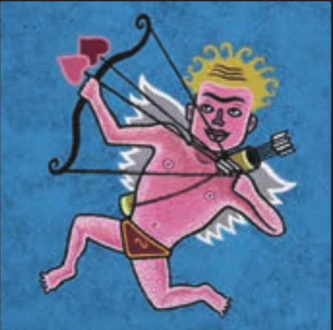
Cupid: On the first night, Cupid links two players (possibly including himself) as lovers. If one dies, the other dies of heartbreak. Lovers cannot vote against each other.
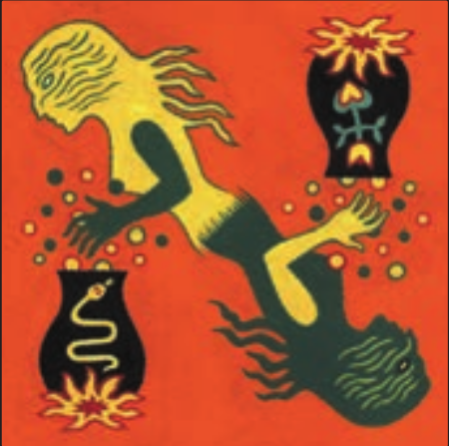
Witch: The Witch has two potions: one heals a player attacked by the Werewolves, the other kills a player during the night. Each potion can be used only once per game, even both on the same night. She can use them on herself.

Hunter: If the Hunter dies (devoured or lynched), he must shoot and eliminate a player of his choice before leaving. If he dies of heartbreak as a lover, he still shoots. If no one survives, no one wins.

Protector: Each night, the Protector chooses one player to shield from the Werewolves. The chosen player cannot be devoured that night. The Protector may protect themselves but not the same person two nights in a row. Does not block the infection from the Infected Father of All Wolves.

Elder: The Elder survives the first Werewolf attack. A second attack kills him. Other causes (lynching, poison, bullet) kill him instantly. If he dies, all Villagers lose their special powers. He resists the infection of the Infected Father of All Wolves if it’s the first time he is bitten.

Scapegoat: If there’s a tie in the vote, the Scapegoat is lynched instead. If lynched, he chooses who can vote in the next lynching. If only one person gets to vote, they’re likely to be devoured that night. If so, there may be no lynching the next day.
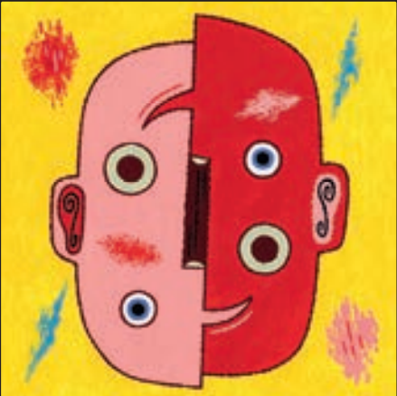
Village Fool: If the Fool is voted out, he reveals his role and is pardoned, but loses his right to vote for the rest of the game. He dies if attacked by Werewolves or shot by the Hunter. If he was the Sheriff, that role is lost.

The Fox: Each night, the Fox can check a group of three neighboring players by pointing to the one in the middle. If at least one is a Werewolf, he keeps his power for the next night. If not, he loses it.
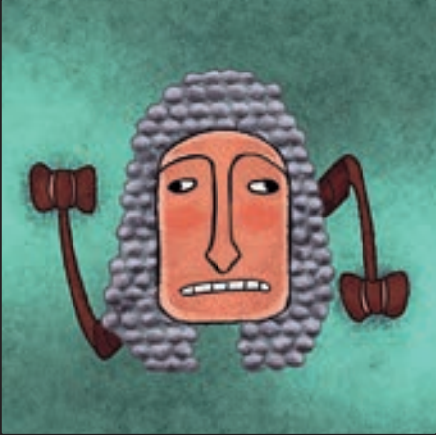
The Stuttering Judge: Once per game, the Stuttering Judge can trigger two consecutive lynchings by giving a secret signal during a vote. The second vote happens right after the first, with no debate.
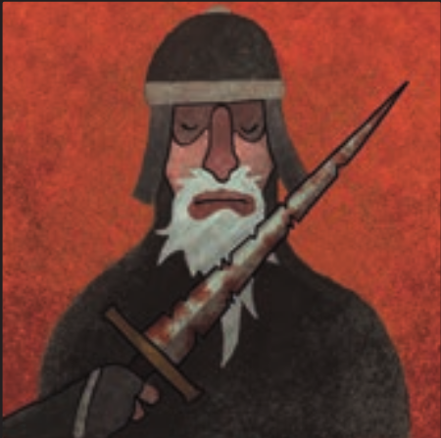
Knight of the Rusty Sword: If the Knight is devoured, the Werewolf to his left (among those who attacked) falls ill and dies the next night. This death is announced the following morning. All players between them are confirmed innocent.

🐺 WEREWOLVES ===========================================================================
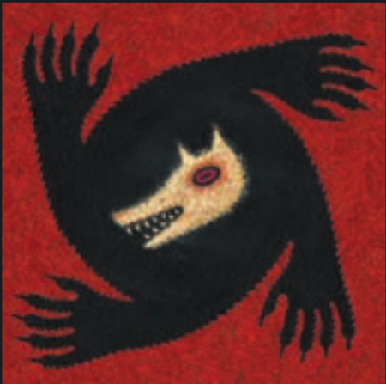
Werewolf: Each night, the Werewolves choose one Villager to devour. They must stay hidden during the day. Their number varies by game setup. They can’t devour one of their own.
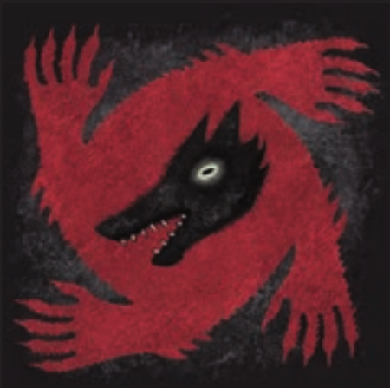
Big Bad Wolf: He attacks with the Werewolves each night. As long as no Werewolf, Wild Child, or Wolf-Hound has died, he wakes a second time to devour a victim alone. He can’t devour other Werewolves.
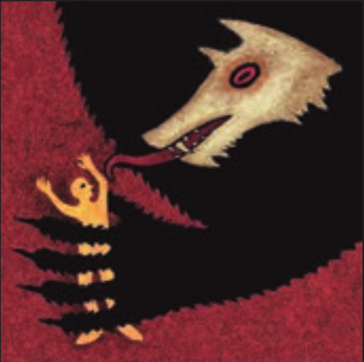
Infectious Father of All Wolves: Each night, he acts with the Werewolves. Once per game, he may secretly infect a victim instead of devouring them. That player becomes a hidden Werewolf and keeps any special power they had.

🎭 AMBIGUOUS ROLES ======================================================================
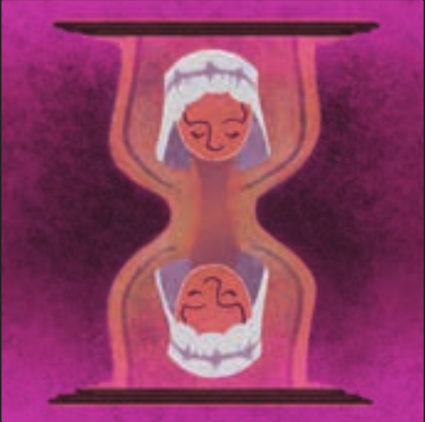
Devoted Servant: Before a lynched player’s role is revealed, the Servant may show her card and take that player’s role (with full powers), keeping it secret. She cannot do this if in love. Temporary effects on the original player do not transfer.
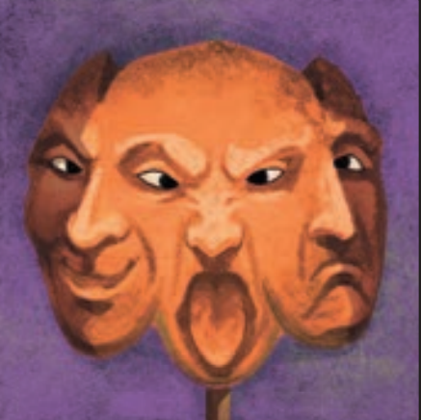
Comedian: At the start, the narrator shows 3 special role cards (non-Werewolf). Each night, the Comedian may use the power of one. Once used, that role is removed.
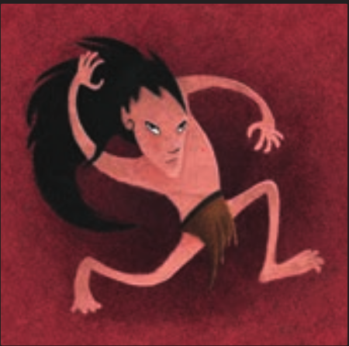
Wild Child: On the first night, the Wild Child chooses a role model. He is a Villager unless that player dies—then he becomes a Werewolf starting the next night. His win condition depends on his final team. He may help eliminate his role model.
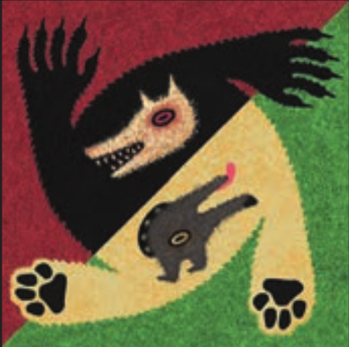
Wolf-Hound: On the first night, the Wolf-Hound chooses to be either a Villager or a Werewolf. Once chosen, his role cannot be changed.
Preparación y comiendo de la partida:
• Distribuir las cartas de personaje
• Preparar las cartas del Comediante
• Elegir al Alguacil (se puede hacer más tarde durante la partida)
Orden para llamar a los personajes:
Personajes que despiertan la primera noche:
• el Comediante
• Cupido
• la Vidente
• el Zorro
• los enamorados
• el Juez Tartamudo (acordar la señal)
• el Niño Salvaje (elije su modelo a seguir)
• el Protector
• el Perro Lobo (elije su alineación)
• todos los Hombres Lobo, incluidos el Perro Lobo si ha elegido ser un Hombre Lobo, el Infecto Padre de todos los Lobos, y el Lobo Feroz.
• el Infecto Padre de todos los Lobos (puede levantar la mano)
• el Lobo Feroz
• la Bruja
Cada noche:
• el Comediante
• la Vidente
• el Zorro
• el Protector
• todos los Hombres Lobo, incluidos el Perro Lobo si elijió ser un Hombre Lobo, el Niño Salvaje si su modelo es eliminado del juego, y cualquier jugador infectado por el Infecto Padre de todos los Lobos
• el Infecto Padre de todos los Lobos
• el Lobo Feroz (hasta que algún Hombre Lobo sea eliminado)
• la Bruja
Cada día:
• se revelan las víctimas
• se debate
• se vota y se llama a la Abnegada Sirvienta
• si el Juez Tartamudo lo decide así, se vota por segunda vez y de nuevo se llama a la Abnegada Sirvienta

