**Talent Intelligence Report: Mapping your Organization's workforce skill vs. 20 Competitors**

# 

**1. Competitor Skill Proximity (Avg Weighted Overlap %)**

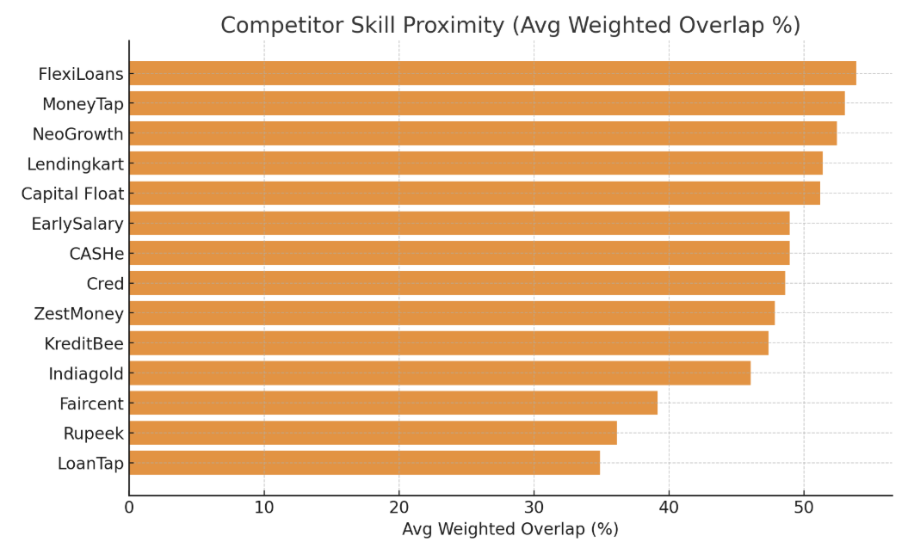

**How the Proximity Score was calculated** The Competitor Skill Proximity (Avg Weighted Overlap %) has been derived from employee-to-employee matches between Manipal Fintech and competitor firms. Each match is scored for skill similarity. These raw similarity scores are then adjusted using Manipal’s own skill gap importance matrix:

* Critical gaps = 1.0 weight
* Important gaps = 0.7 weight
* Nice-to-have gaps = 0.4 weight

This ensures the overlap measure does not merely reflect superficial skills but emphasizes areas that matter most to the business. For example, if a competitor has strong overlap with Manipal in critical digital lending or risk management skills, the score is pushed higher.

Implications for a CHRO  
 For a Chief Human Resources Officer, these scores act as an early warning system:

Competitors with higher overlap (FlexiLoans, MoneyTap, NeoGrowth, Lendingkart, Capital Float) are most likely to target and attract Manipal employees because of skill similarity and immediate job mobility.

Lower overlap players (Rupeek, LoanTap) pose less direct skill-pull risk, but may still compete on compensation or market positioning.

The CHRO can use this data to:

* Prioritize retention measures in high-overlap functions (e.g., tech, product, risk analytics).
* Design differentiated career paths — if a competitor can offer the same skill environment, Manipal must compete on growth opportunities and leadership exposure.
* Benchmark internal training — high overlap also shows where Manipal’s workforce is aligned with industry standards, and where capability-building can be sharpened.
* Engage with business leaders — this data supports targeted incentive programs, especially in functions where attrition risk aligns with high competitor proximity.

**2. Most Frequent Capability Gaps vs Competitors (Rated 1–5)**

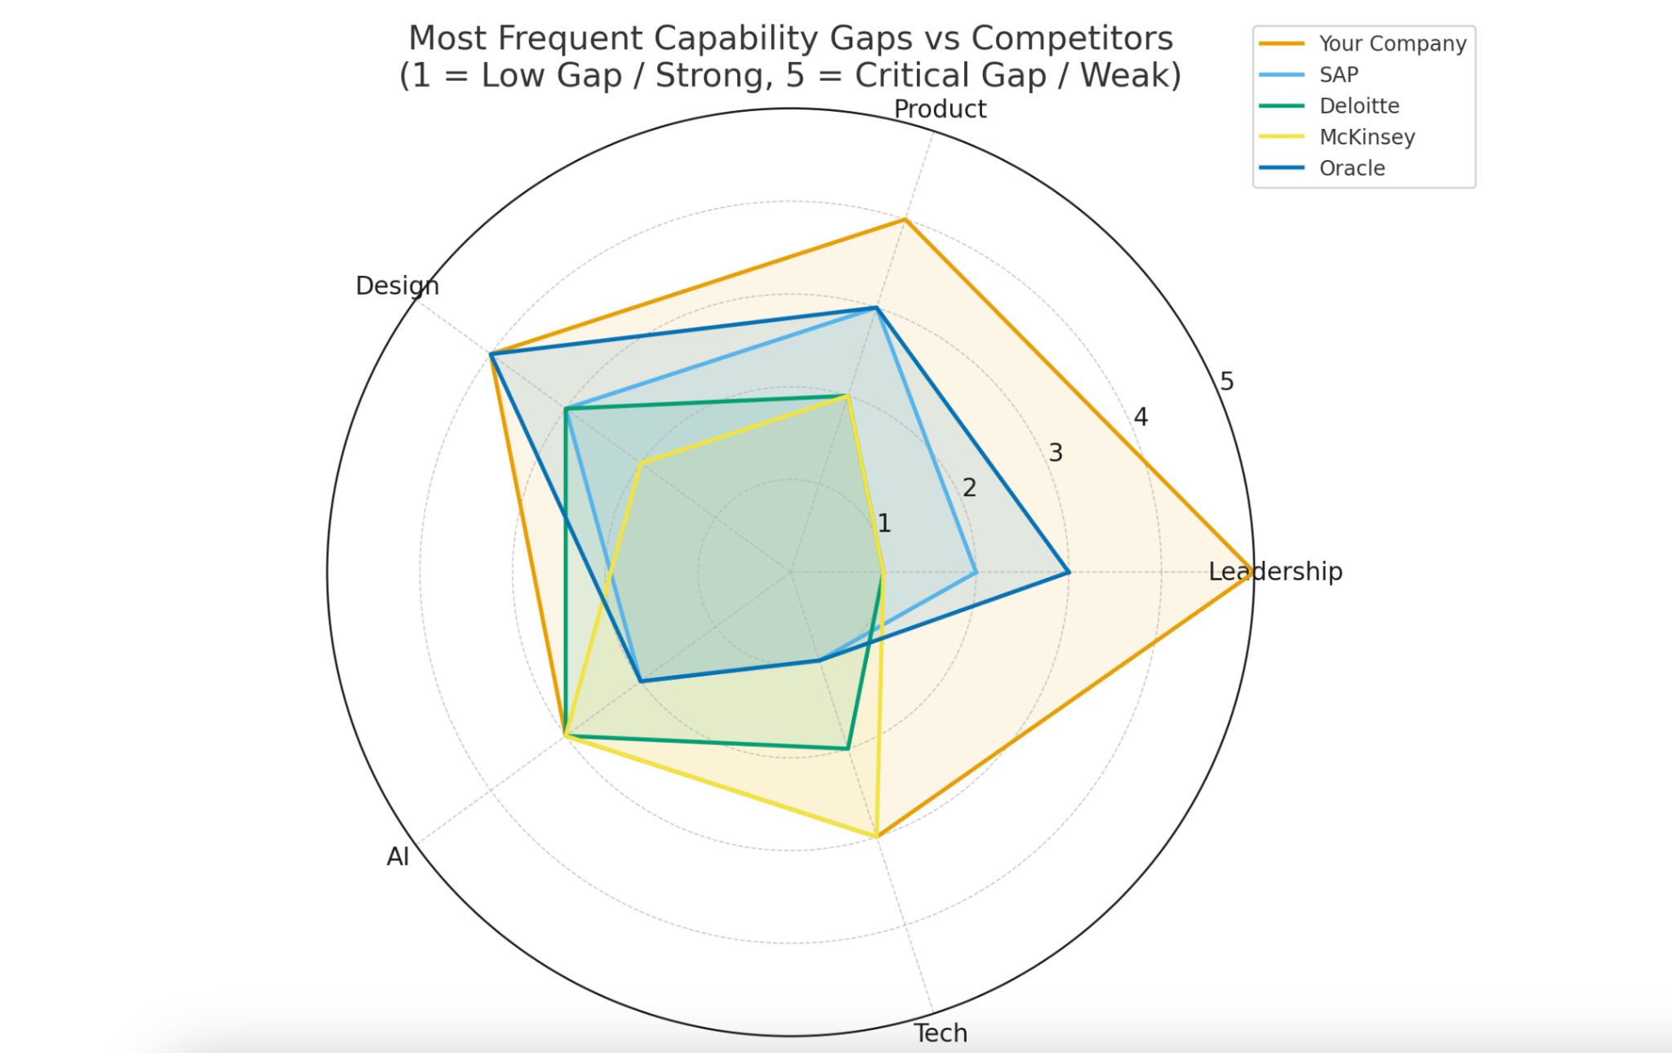

**What it means:** This shows the recurring skill domains where your workforce is weaker compared to competitors. A score of 5 means the gap is critical and shows up repeatedly across employees; a score of 1 means it’s minor or rare.

**How it was done:**

* For each role, we compared your employees’ skills against benchmark skills in competitor roles.
* Each gap (e.g., “no AI exposure,” “limited leadership experience”) was tagged.
* Frequency of occurrence was then scored 1–5.

3. **Skill Gap Analysis and Hyper Personalised Courses Created for your employees (please see the links in Appendix 1)**

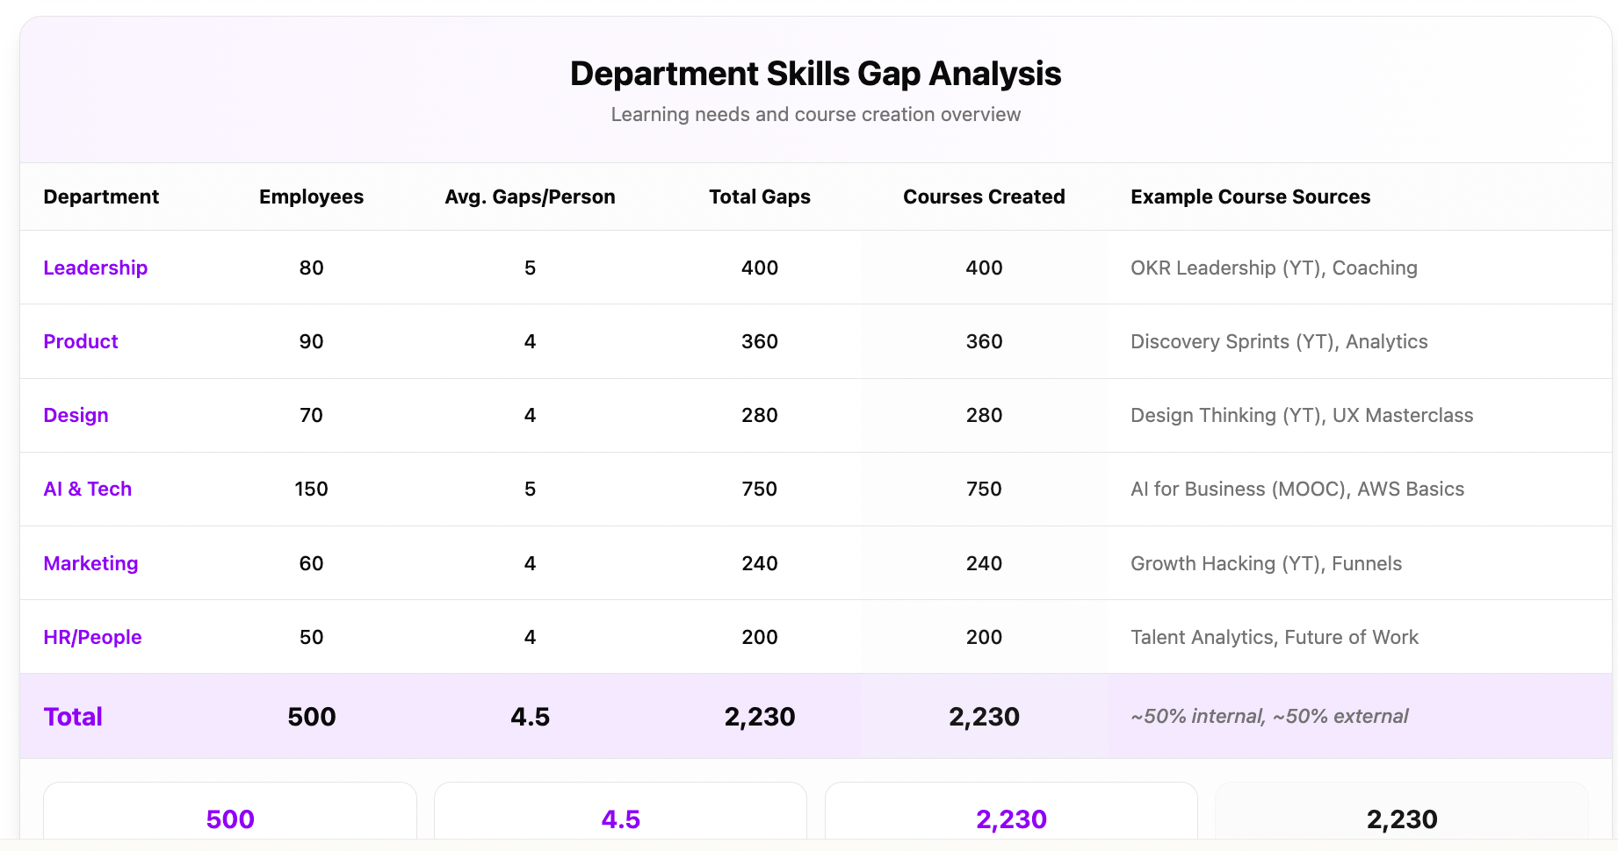

**4. The Value Engine Lifecycle**

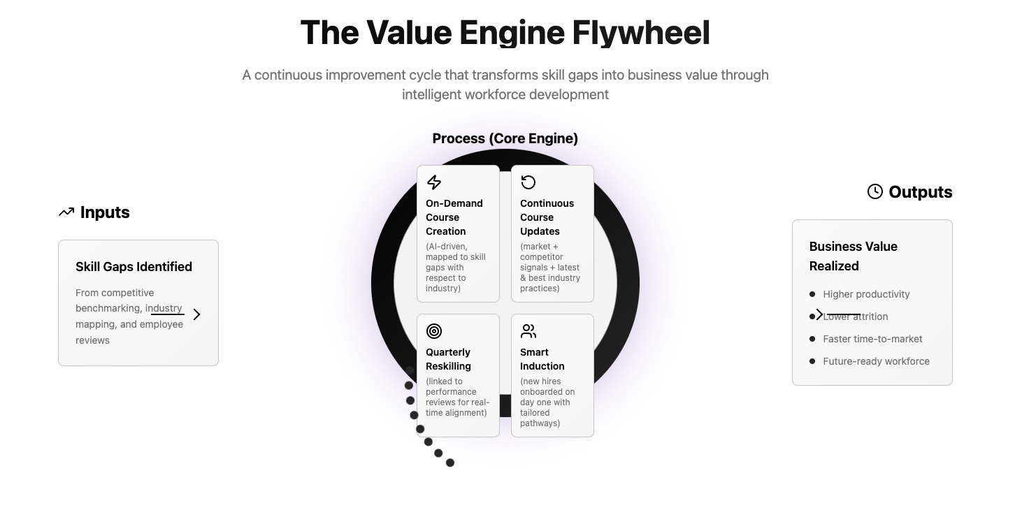

**5. Recommended Skill hire from Competition**

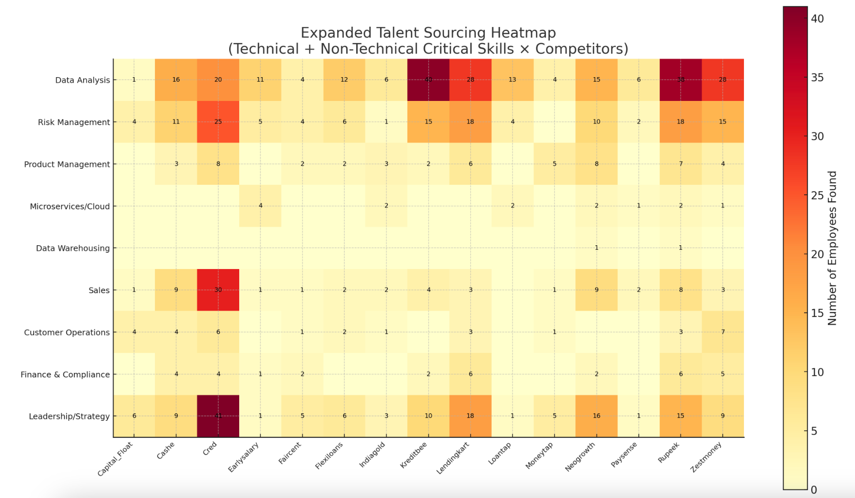

| **Skill Gap** | **Why Hard to Upskill Internally?** | **Competitor Sources** | **Example Employees (LinkedIn)** |
| --- | --- | --- | --- |
| **NBFC Compliance & Regulatory** | Requires regulatory exposure, RBI interactions, legal background | NeoGrowth, Rupeek, Cashe, KreditBee | Rajan Sethi (NeoGrowth, –), Nitika Madan (Rupeek, –), Gabriela Castillo (Cashe, –), Ayushi Tripathi (KreditBee, –) |
| **Advanced Credit Risk & Underwriting** | Years of credit modeling & domain data | NeoGrowth, Rupeek, ZestMoney, Lendingkart | Argho Chatterjee (NeoGrowth, –), Prashant Mehta (Rupeek, –), Akshita Pingle (ZestMoney, –), Anjali Agrawal (Lendingkart, –) |
| **BD / Partnerships** | Requires networks, market credibility | Rupeek, Cred, MoneyTap | Govind Shukla (Rupeek, –), Ahmed Mansour (Cred, –), Harleen Kaur (MoneyTap, –) |
| **Sales Scale-up (Consumer Lending)** | Experience in scaling loan products in market | Cred, Rupeek, Lendingkart | Benedicte Grevstad (Cred, –), Vansh Dhingra (Rupeek, –), Prasad Bhandary (Lendingkart, –) |
| **Microservices / Cloud-native** | High technical barrier, needs system architecture | EarlySalary, Indiagold, NeoGrowth | Abhijeet Jadhav (EarlySalary, –), Satyam Rastogi (Indiagold, –), Miguel Cornejo (NeoGrowth, –) |
| **Product Management (BNPL / Embedded Finance)** | Domain knowledge + fintech product strategy | Rupeek, ZestMoney, FlexiLoans | Nisarga Gotekar (Rupeek, –), Poojitha Pinniboyana (ZestMoney, –), Shahzad Sheikh (FlexiLoans, –) |
| **Leadership / Strategy** | Cannot be upskilled quickly, needs senior exposure | Cred, NeoGrowth, Rupeek, Lendingkart | Ahmed Mansour (Cred, –), Tainá Brito (NeoGrowth, –), Prashant Mehta (Rupeek, –), Ruchika Dargar (Lendingkart, –) |

**6. Predicted At-Risk Employees & Competitor Pull**

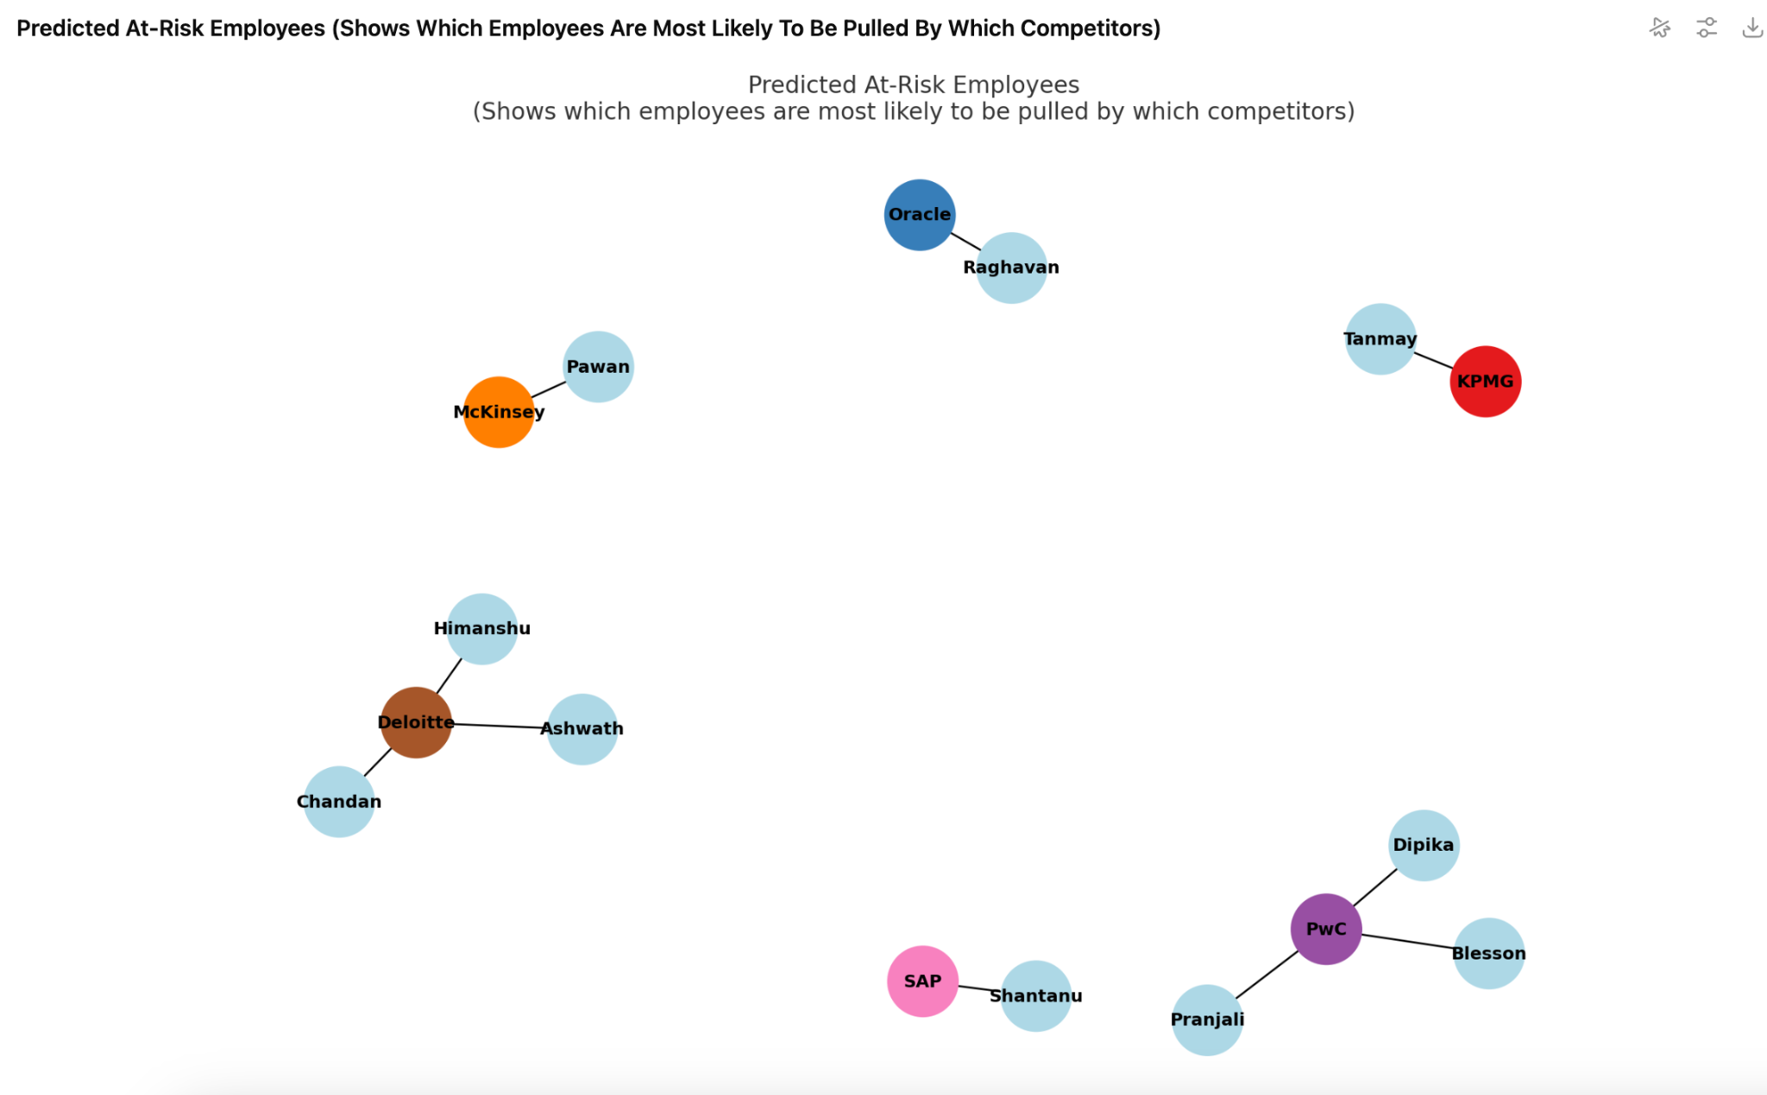

**What it means:**This chart shows specific employees mapped to the competitors that are most likely to pull them away, based on similarity of their current skills to competitor job demands.

**7. Attrition Signals Heatmap (% of Employees Most Likely to be Pulled by Competitors)**

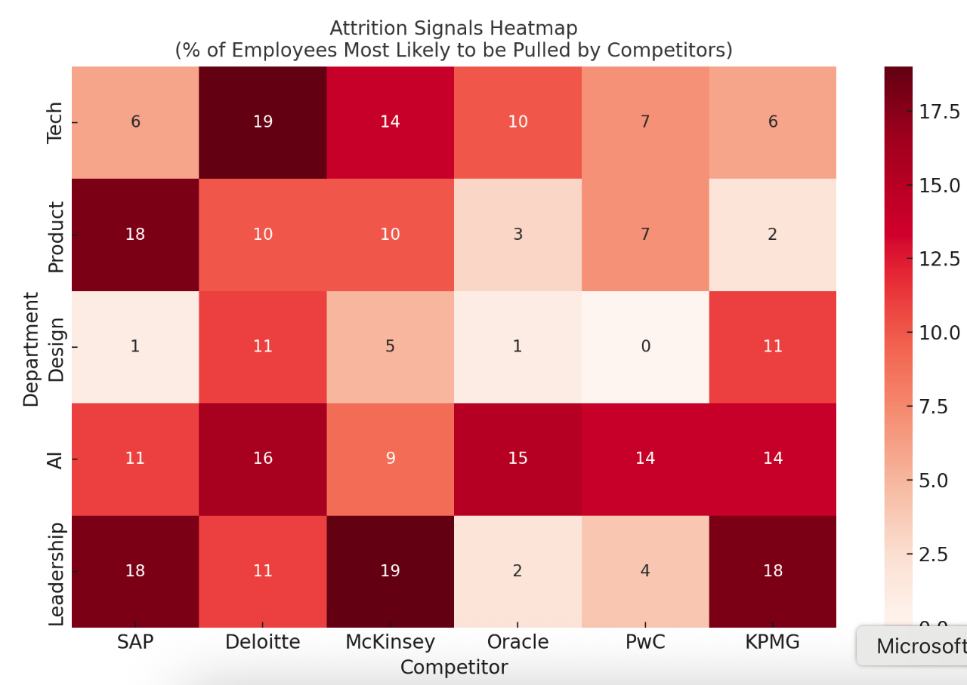

**What it shows:**

By department (Tech, Product, Design, AI, Leadership), which competitors are most likely to attract your employees.

How to read: Darker red = higher risk.

**Table of Contents**

**Executive Summary 3**

**1.1.****Closing Skill Gaps & Future-Ready Workforce 3**

**1.2.****Unlocking Workforce Potential 3**

**1.3.****The Value Engine 3**

**1.4.****Value Generation for the Enterprise 3**

**1.5.****Engagement Flow (Visual) 3**

**1.6.****Skill Gaps and Recommended Courses 5**

**1.7.****Learning Path & Value Generation 6**

**1.8.****Continuous Learning & Course Updates 6**

**1.9.****Strategic Value for CHRO Engagement 7**

**2.****Closest aggregate skill overlap (by Avg Weighted Overlap %): 8**

**2.1.****Most frequent capability gaps vs. Your Company: 8**

**2.2.****Attrition signals: 8**

**2.3.****Results — Company Skill Proximity 9**

**2.4.****Results — Talent Mobility 11**

**2.5.****Predicted at-risk employees (top 10): 11**

**2.6.****Recommendations 12**

**3.****Skill Gap Analysis : Ankit Gupta — Growth Leader @ Your Company, ex-Flipkart | BITS Pilani & IIM Alum 13**

**3.1.****Top Competitor Matches 13**

**3.2.****0–3 Month Plan 13**

**4.****Skill Gap Analysis : Arun Vigneswaran — Head of People practice @ Your Company | Ex-Flipkart | TISS 18**

**4.1.****Top Competitor Matches 18**

**4.2.****0–3 Month Plan 18**

**5.****Skill Gap Analysis: Ashwath S. — Growth Catalyst @ Your Company 22**

**5.1.****Top Competitor Matches 22**

**5.2.****0–3 Month Plan 22**

**6.****Skill Gap Analysis: Bhavesh Parvatkar, SDE 2 at Your Company 25**

**6.1.****Top Competitor Matches 25**

**6.2.****0–3 Month Plan 25**

**7.****Bikashjyoti Das, Summer Intern @Your Company | IIM L PGP '26 | Ex- L&T | NIT Silchar'22 27**

**7.1.****Top Competitor Matches 27**

**7.2.****0–3 Month Plan 27**

**8.****Himanshu Kanwar, GM - Growth and Marketing practice at Your Company 30**

**8.1.****Top Competitor Matches 30**

**8.2.****0–3 Month Plan 30**

# Executive Summary

# Closing Skill Gaps & Future-Ready Workforce

In today’s volatile business environment, building a workforce that can adapt faster than the market is the true competitive advantage. This report provides a 360-degree executive view on how Your Company can close employee skill gaps with respect to competition and internal performance review mechanism and mini OKR’s, enable continuous upskilling, and leverage on demand AI-driven learning courses to deliver measurable output business value.

# Unlocking Workforce Potential

* Skill gaps are no longer theoretical—they can now be mapped, closed, and tracked in **real time**.
* Creates **on-demand, adaptive courses** tailored to **each** employee’s role, performance review, and future growth path.
* Every quarter, employees can be reskilled with the **latest market technologies**, ensuring your workforce never falls behind.
* What used to take years of expensive L&D programs can now be delivered in **weeks**, with measurable ROI.

# The Value Engine

* **On-Demand Course Creation** → Generates tailored programs for each employee’s gaps.
* **Course Updating** → Tracks emerging technologies and refreshes course modules automatically.
* **Quarterly Reskilling Loop** → Links performance reviews to new personalized on demand courses.
* **Smart Induction** → Custom onboarding pathways for new hires to reduce ramp-up time.

# Value Generation for the Enterprise

* **Productivity uplift**: Stiches personalised learning byte size courses as per the learning time and mind space availability of each employees (10mts / day for 30 days to 2 hours / week for 3 months).
* **Talent retention**: Employees see continuous growth pathways, lowering attrition.
* **Strategic agility**: Organization stays aligned with evolving market and regulatory skill demands.
* **Sustainable Scalable ROI**: On demand multimedia personalised courses can be created and replicated across thousands of employees without additional cost.

# Engagement Flow (Visual)

1. **Skill Gap White Paper on Your Organisation**
   * A full organisational skill gap map aligned to business goals.
   * Benchmarking against competitors to reveal missed opportunities.
2. **Personalised Employee-Specific Skill Gap Analysis**
   * Each employee’s strengths and gaps are identified using performance, projects, and role expectations.
   * AI-driven mapping ensures objectivity and precision.
3. **Courses Recommended**
   * Contextualised list of upskilling opportunities tied to specific business outcomes.
   * Built from both internal expertise and global market benchmarks.
4. **Personalised Courses Created by MyNoted**
   * Automatically curates and creates on-demand learning modules.
   * Updated dynamically with the **latest technologies and industry shifts**.
5. **CHRO → Individual Team Heads for Review**
   * Each plan routed to functional heads (e.g., Marketing, Finance, Tech).
   * Simple 2-minute per employee review loop.
6. **Agrees or Gives Review Notes**
   * Heads validate or refine the skill map and courses.
   * Feedback loop keeps training relevant to business needs.
7. **Skill Gap Updated + Competitive Benchmarking**
   * Cross-check gaps with competitor talent trends.
   * Triggers **new course creation** where competitors are ahead.
8. **Learning Path Created**
   * Structured path per employee showing short-term boosts and long-term mastery.
   * Balanced between **critical, important, and nice-to-have skills**.
9. **Quarterly Performance Review**
   * Measured progress against skill-building efforts.
   * Dynamic refresh of courses every quarter.
10. **New Course Creation → Induction to Growth**
    * Seamless integration for **new hires** via tailored induction programs.
    * Continuously adaptive training ensures relevance across career stages.
11. **Workforce of the Future**
    * A future-ready organisation where every employee evolves alongside market shifts.
    * CHRO gains **real-time visibility** into readiness, mobility risk, and growth potential.

# Skill Gaps and Recommended Courses

Our analysis identifies priority skill gaps for **all** the employees in your organization with internal reviews, competition and maps them to targeted learning paths. And creates courses in real time that can be consumed in 1 week, 1 month or 3 months @ 1 hour, 20 mts or 10 mts every day customized to your employees time availability

For example: **Prisha Goel – 0–3 Month Skill Boost Plan**

This document outlines the 0–3 month skill upgrade plan for Prisha Goel, focusing on closing immediate skill gaps, recommended courses, proof-of-concept (POC) deliverables, and the direct business impact for Your Company.

| Timeline | Skill Gap | Recommended Skills / Tools | Course Recommendation | Proposed POC | Business Impact for Your Company |
| --- | --- | --- | --- | --- | --- |
| 0–1 Month | No Java experience (backend in competitor stack) | Java (Spring Boot), REST API design | Java Programming Masterclass | Mini-OKR Dashboard: CRUD OKRs with backend in Spring Boot + frontend in Angular, role-based access | Gives her ability to build features in tech stack used by competitors like Profit.co |
| 0–1 Month | No modern frontend framework (Angular/React) | Angular (preferred for SaaS dashboards) | Angular – The Complete Guide | Mini-OKR Dashboard frontend UI connected to Spring Boot backend | Removes dependency on frontend engineers, enabling full-stack delivery |
| 0–1 Month | Limited enterprise tool integration experience | Jira API, Microsoft Graph API | REST API Design, Development & Integration | Basic Integration Tool: Pull tasks from Jira/MS Planner, display in dashboard UI | Expands PeopleCues’ integration capabilities |
| 1–3 Months | No cloud deployment experience | AWS Basics (EC2, Lambda, RDS), Docker | AWS Certified Solutions Architect – Associate | Cloud-Deployed OKR Dashboard from POC #1 using AWS + Docker | Improves scalability & readiness for enterprise clients |
| 1–3 Months | No Snowflake DB exposure | Snowflake fundamentals, SQL queries | Snowflake SnowPro Core Certification Prep | Data Storage POC: Store integration data from POC #2 in Snowflake, run queries | Builds analytics-ready foundation for PeopleCues |

# Learning Path & Value Generation

A structured 0–3 month roadmap enables employees to incrementally acquire mission-critical skills while delivering immediate value. Each course completion is paired with a Proof of Concept (PoC) project on tools such as AWS, Tableau, or financial modelling platforms. These PoCs serve as tangible demonstrations of applied learning and measurable business outcomes.

# Continuous Learning & Course Updates

Unique value proposition includes:

1. Personalized on-demand course creation for each employee.
2. Always-updated content on the latest technologies and practices.
3. Continuous alignment of courses with quarterly performance reviews.
4. AI-driven structured induction programs to accelerate onboarding.

This creates a continuous cycle of skill tracking, learning, and business impact—ensuring Your Company’s workforce remains future-ready.

# Strategic Value for CHRO Engagement

For CHROs, the takeaways are clear:

* Close mission-critical skill gaps faster with data-driven on demand learning.
* Boost retention via personalized career development plans.
* Link performance management directly to skill-building.
* Reduce onboarding cycles with AI-generated induction programs.
* Ensure organizational agility through continuously updated skills.

# Closest aggregate skill overlap (by Avg Weighted Overlap %):

| **Rank** | **Organization** | **Avg Overlap** | **Max Overlap** | **Matches** |
| --- | --- | --- | --- | --- |
| 1 | SAP | 10% | 33% | 19 |
| 2 | Deloitte Consulting | 10% | 46% | 50 |
| 3 | McKinsey & Company | 9% | 31% | 23 |
| 4 | Oracle | 8% | 21% | 28 |
| 5 | PwC Advisory Services | 7% | 35% | 49 |

# Most frequent capability gaps vs. Your Company:

Leadership, Product, Design, AI, Tech

# Attrition signals:

* Likely already switched (headline pattern): 4 employees.
* Highest predicted pull among at-risk talent: Deloitte Consulting and PwC Advisory Services.

# Results — Company Skill Proximity

Top 10 companies by average weighted overlap (%):

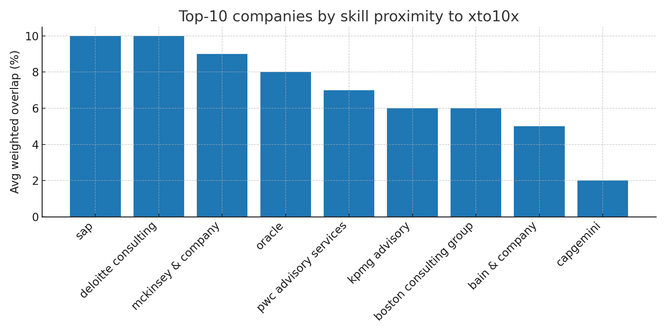

Figure 1: Top-10 companies by skill proximity to Your Company (Avg Weighted Overlap %).

Full ranking (rounded to %):

| **Rank** | **Company** | **# Matches** | **Avg Similarity (%)** | **Avg Jaccard (%)** | **Avg Weighted Overlap (%)** | **Max Weighted Overlap (%)** |
| --- | --- | --- | --- | --- | --- | --- |
| **1** | sap | 19 | 40 | 25 | 10 | 33 |
| **2** | deloitte consulting | 50 | 40 | 24 | 10 | 46 |
| **3** | mckinsey & company | 23 | 42 | 20 | 9 | 31 |
| **4** | oracle | 28 | 46 | 18 | 8 | 21 |
| **5** | pwc advisory services | 49 | 42 | 17 | 7 | 35 |
| **6** | kpmg advisory | 49 | 41 | 14 | 6 | 36 |
| **7** | boston consulting group | 26 | 35 | 17 | 6 | 20 |
| **8** | bain & company | 24 | 37 | 12 | 5 | 33 |
| **9** | capgemini | 9 | 47 | 5 | 2 | 13 |

# Results — Talent Mobility

**Likely already switched (headline pattern):**

4 employees flagged. See the CSV appendix for names.

# Predicted at-risk employees (top 10):

| Your Company Employee | Predicted Target Company | Predicted Risk (%) | Max Weighted Overlap (%) | # Unique Companies Matched |
| --- | --- | --- | --- | --- |
| Tanmay A. | kpmg advisory | 55 | 36 | 5 |
| Chandan Kar | deloitte consulting | 53 | 33 | 6 |
| Raghavan Vallinayagam | oracle | 44 | 21 | 5 |
| Blesson P Jacob | pwc advisory services | 44 | 20 | 7 |
| Himanshu Kanwar | deloitte consulting | 43 | 18 | 5 |
| Dipika Singh | pwc advisory services | 42 | 17 | 5 |
| Shantanu Jaiswal | sap | 41 | 33 | 3 |
| Pawan Raghuveer | mckinsey & company | 40 | 31 | 3 |
| Pranjali | pwc advisory services | 39 | 21 | 4 |
| Ashwath S. | deloitte consulting | 38 | 46 | 1 |

# Recommendations

1) Double down on Leadership development (largest recurring gap). Make OKR leadership cadences standard and assess squad leads quarterly.

2) Product & Design uplift: add discovery sprints and portfolio reviews; rotate PM/UX pairs through high-overlap accounts.

3) AI/ML & Tech/Cloud exposure: run 4–6 week micro-POCs on GenAI prompts and cloud reference architectures tied to client proposals.

4) Targeted retention: for top-risk individuals, schedule skip-levels and offer stretch roles aligned to predicted target companies’ strengths.

5) Hiring focus: backfill gaps flagged by competitor roles (Lead PMs, Design Leads, Data/Analytics).

# Skill Gap Analysis : Ankit Gupta — Growth Leader @ Your Company, ex-Flipkart | BITS Pilani & IIM Alum

Objective: Close competitive gaps identified matches by targeted upskilling and hands-on POCs.

# Top Competitor Matches

- Deloitte Consulting: Erin O'Rourke — Growth Strategist @ Deloitte Consulting (Similarity 42.11)

- Bain & Company: Russ Hagey — Senior Partner & Chief Leadership Officer at Bain & Company (Similarity 40.68)

- Sap: Cini Mathew — SVP, Global Head, SAP SCM Core Manufacturing & Asset Mgmt Eng || Ex-Chairperson for Respect at Work internal compliance committee at SAP (Similarity 36.36)

# 0–3 Month Plan

| **Timeline** | **Competitive Gap** | **Recommended Skills/Tools** | **Course Recommendation** | **Proposed POC (Applied Output)** | **Business Impact for Your Company** |
| --- | --- | --- | --- | --- | --- |
| Immediate (Weeks 0–2) | General role alignment based on titles; detailed skills not available. | Management, Project Management | Leadership and Management Certification | Run an OKR rollout in Notion/ClickUp for a live Your Company squad; weekly check-ins + retro. | Improves internal execution and client leadership outcomes; faster OKR adoption. |
| Weeks 1–4 | General role alignment based on titles; detailed skills not available. | Management, Project Management | Data Analytics for Business Professionals | Build a KPI dashboard (revenue, churn, NPS) in Power BI/Looker Studio using sample Your Company data. | Enables evidence-based decisions; improves KPI visibility and client reporting quality. |
| Weeks 5–12 | General role alignment based on titles; detailed skills not available. | Management, Project Management | Corporate Strategy and Growth Planning | Create a Business Model Canvas + 3-market entry plan in Miro; present a 12-week growth thesis. | Sharpens market entry and growth moves; improves proposal win-rate and ROI of initiatives. |
| Immediate (Weeks 0–2) | Leadership overlap; AI/ML gap vs competitor | Management, Project Management | Leadership and Management Certification | Run an OKR rollout in Notion/ClickUp for a live Your Company squad; weekly check-ins + retro. | Improves internal execution and client leadership outcomes; faster OKR adoption. |
| Weeks 1–4 | Leadership overlap; AI/ML gap vs competitor | Management, Project Management | Data Analytics for Business Professionals | Build a KPI dashboard (revenue, churn, NPS) in Power BI/Looker Studio using sample Your Company data. | Enables evidence-based decisions; improves KPI visibility and client reporting quality. |
| Weeks 5–12 | Leadership overlap; AI/ML gap vs competitor | Management, Project Management | Corporate Strategy and Growth Planning | Create a Business Model Canvas + 3-market entry plan in Miro; present a 12-week growth thesis. | Sharpens market entry and growth moves; improves proposal win-rate and ROI of initiatives. |

# Skill Gap Analysis : Arun Vigneswaran — Head of People practice @ Your Company | Ex-Flipkart | TISS

Objective: Close competitive gaps identified matches by targeted upskilling and hands-on POCs.

# Top Competitor Matches

- Mckinsey & Company: Wendy Stratman Miller — Partner, North American Chief People Officer, McKinsey & Company (Similarity 45.07)

- Kpmg Advisory: Sandy Torchia — Vice Chair, Talent and Culture at KPMG * Passionate People Advocate * Champion for Workplace Culture and Experience * Future-Forward Talent Strategist (Similarity 32.17)

# 0–3 Month Plan

| Timeline | Competitive Gap | Recommended Skills/Tools | Course Recommendation | Proposed POC (Applied Output) | Business Impact for Your Company |
| --- | --- | --- | --- | --- | --- |
| Immediate (Weeks 0–2) | HR/People overlap | - | Leadership and Management Certification | Run an OKR rollout in Notion/ClickUp for a live Your Company squad; weekly check-ins + retro. | Improves internal execution and client leadership outcomes; faster OKR adoption. |
| Weeks 1–4 | HR/People overlap | - | Data Analytics for Business Professionals | Build a KPI dashboard (revenue, churn, NPS) in Power BI/Looker Studio using sample Your Company data. | Enables evidence-based decisions; improves KPI visibility and client reporting quality. |
| Weeks 5–12 | HR/People overlap | - | Corporate Strategy and Growth Planning | Create a Business Model Canvas + 3-market entry plan in Miro; present a 12-week growth thesis. | Sharpens market entry and growth moves; improves proposal win-rate and ROI of initiatives. |
| Immediate (Weeks 0–2) | AI/ML gap vs competitor; HR/People overlap | - | Leadership and Management Certification | Run an OKR rollout in Notion/ClickUp for a live Your Company squad; weekly check-ins + retro. | Improves internal execution and client leadership outcomes; faster OKR adoption. |
| Weeks 1–4 | AI/ML gap vs competitor; HR/People overlap | - | Data Analytics for Business Professionals | Build a KPI dashboard (revenue, churn, NPS) in Power BI/Looker Studio using sample Your Company data. | Enables evidence-based decisions; improves KPI visibility and client reporting quality. |
| Weeks 5–12 | AI/ML gap vs competitor; HR/People overlap | - | Corporate Strategy and Growth Planning | Create a Business Model Canvas + 3-market entry plan in Miro; present a 12-week growth thesis. | Sharpens market entry and growth moves; improves proposal win-rate and ROI of initiatives. |

# Skill Gap Analysis: Ashwath S. — Growth Catalyst @ Your Company

Objective: Close competitive gaps identified matches by targeted upskilling and hands-on POCs.

# Top Competitor Matches

- Deloitte Consulting: Erin O'Rourke — Growth Strategist @ Deloitte Consulting (Similarity 46.43)

# 0–3 Month Plan

| Timeline | Competitive Gap | Recommended Skills/Tools | Course Recommendation | Proposed POC (Applied Output) | Business Impact for Your Company |
| --- | --- | --- | --- | --- | --- |
| Immediate (Weeks 0–2) | General role alignment based on titles; detailed skills not available. | - | Leadership and Management Certification | Run an OKR rollout in Notion/ClickUp for a live Your Company squad; weekly check-ins + retro. | Improves internal execution and client leadership outcomes; faster OKR adoption. |
| Weeks 1–4 | General role alignment based on titles; detailed skills not available. | - | Data Analytics for Business Professionals | Build a KPI dashboard (revenue, churn, NPS) in Power BI/Looker Studio using sample Your Company data. | Enables evidence-based decisions; improves KPI visibility and client reporting quality. |
| Weeks 5–12 | General role alignment based on titles; detailed skills not available. | - | Corporate Strategy and Growth Planning | Create a Business Model Canvas + 3-market entry plan in Miro; present a 12-week growth thesis. | Sharpens market entry and growth moves; improves proposal win-rate and ROI of initiatives. |

# Skill Gap Analysis: Bhavesh Parvatkar, SDE 2 at Your Company

Objective: Close competitive gaps identified matches by targeted upskilling and hands-on POCs.

# Top Competitor Matches

- Oracle: Abhinav Mishra — SDE at Oracle Cloud Infrastructure | Imperial College London (Similarity 75.0)

# 0–3 Month Plan

| Timeline | Competitive Gap | Recommended Skills/Tools | Course Recommendation | Proposed POC (Applied Output) | Business Impact for Your Company |
| --- | --- | --- | --- | --- | --- |
| Immediate (Weeks 0–2) | General role alignment based on titles; detailed skills not available. | Azure, Cloud, Data, Python | Leadership and Management Certification | Run an OKR rollout in Notion/ClickUp for a live Your Company squad; weekly check-ins + retro. | Improves internal execution and client leadership outcomes; faster OKR adoption. |
| Weeks 5–12 | General role alignment based on titles; detailed skills not available. | Azure, Cloud, Data, Python | Corporate Strategy and Growth Planning | Create a Business Model Canvas + 3-market entry plan in Miro; present a 12-week growth thesis. | Sharpens market entry and growth moves; improves proposal win-rate and ROI of initiatives. |

# Skill Gap Analysis: Bikashjyoti Das, Summer Intern @Your Company | IIM L PGP '26 | Ex- L&T | NIT Silchar'22

Objective: Close competitive gaps identified matches by targeted upskilling and hands-on POCs.

# Top Competitor Matches

- Kpmg Advisory: Christopher Eagar — KPMG Advisory Intern, Technology (Similarity 40.0)

# 0–3 Month Plan

| Timeline | Competitive Gap | Recommended Skills/Tools | Course Recommendation | Proposed POC (Applied Output) | Business Impact for Your Company |
| --- | --- | --- | --- | --- | --- |
| Immediate (Weeks 0–2) | General role alignment based on titles; detailed skills not available. | AI, Marketing | Leadership and Management Certification | Run an OKR rollout in Notion/ClickUp for a live Your Company squad; weekly check-ins + retro. | Improves internal execution and client leadership outcomes; faster OKR adoption. |
| Weeks 1–4 | General role alignment based on titles; detailed skills not available. | AI, Marketing | Data Analytics for Business Professionals | Build a KPI dashboard (revenue, churn, NPS) in Power BI/Looker Studio using sample Your Company data. | Enables evidence-based decisions; improves KPI visibility and client reporting quality. |
| Weeks 5–12 | General role alignment based on titles; detailed skills not available. | AI, Marketing | Corporate Strategy and Growth Planning | Create a Business Model Canvas + 3-market entry plan in Miro; present a 12-week growth thesis. | Sharpens market entry and growth moves; improves proposal win-rate and ROI of initiatives. |

# Skill Gap Analysis: Himanshu Kanwar, GM - Growth and Marketing practice at Your Company

Objective: Close competitive gaps identified matches by targeted upskilling and hands-on POCs.

# Top Competitor Matches

- Deloitte Consulting: Scott Mager — US Chief Marketing Officer at Deloitte (Similarity 55.17)

- Mckinsey & Company: Bob Sternfels — Global Managing Partner at McKinsey & Company (Similarity 50.91)

- Mckinsey & Company: Kevin Laczkowski — Senior Partner and Managing Partner, Midwest, McKinsey & Company (Similarity 50.67)

# 0–3 Month Plan

| Timeline | Competitive Gap | Recommended Skills/Tools | Course Recommendation | Proposed POC (Applied Output) | Business Impact for Your Company |
| --- | --- | --- | --- | --- | --- |
| Immediate (Weeks 0–2) | Marketing overlap | - | Leadership and Management Certification | Run an OKR rollout in Notion/ClickUp for a live Your Company squad; weekly check-ins + retro. | Improves internal execution and client leadership outcomes; faster OKR adoption. |
| Weeks 1–4 | Marketing overlap | - | Data Analytics for Business Professionals | Build a KPI dashboard (revenue, churn, NPS) in Power BI/Looker Studio using sample Your Company data. | Enables evidence-based decisions; improves KPI visibility and client reporting quality. |
| Weeks 5–12 | Marketing overlap | - | Corporate Strategy and Growth Planning | Create a Business Model Canvas + 3-market entry plan in Miro; present a 12-week growth thesis. | Sharpens market entry and growth moves; improves proposal win-rate and ROI of initiatives. |
| Immediate (Weeks 0–2) | General role alignment based on titles; detailed skills not available. | - | Leadership and Management Certification | Run an OKR rollout in Notion/ClickUp for a live Your Company squad; weekly check-ins + retro. | Improves internal execution and client leadership outcomes; faster OKR adoption. |
| Weeks 1–4 | General role alignment based on titles; detailed skills not available. | - | Data Analytics for Business Professionals | Build a KPI dashboard (revenue, churn, NPS) in Power BI/Looker Studio using sample Your Company data. | Enables evidence-based decisions; improves KPI visibility and client reporting quality. |
| Weeks 5–12 | General role alignment based on titles; detailed skills not available. | - | Corporate Strategy and Growth Planning | Create a Business Model Canvas + 3-market entry plan in Miro; present a 12-week growth thesis. | Sharpens market entry and growth moves; improves proposal win-rate and ROI of initiatives. |