Codebook for average

Autogenerated data summary from dataMaid

2019-07-21 13:17:53

# Data report overview

The dataset examined has the following dimensions:

# Feature Selection

The features selected for this database come from the accelerometer and gyroscope 3-axial raw signals tAcc-XYZ and tGyro-XYZ. These time domain signals (prefix ‘t’ to denote time) were captured at a constant rate of 50 Hz. Then they were filtered using a median filter and a 3rd order low pass Butterworth filter with a corner frequency of 20 Hz to remove noise. Similarly, the acceleration signal was then separated into body and gravity acceleration signals (tBodyAcc-XYZ and tGravityAcc-XYZ) using another low pass Butterworth filter with a corner frequency of 0.3 Hz.

Subsequently, the body linear acceleration and angular velocity were derived in time to obtain Jerk signals (tBodyAccJerk-XYZ and tBodyGyroJerk-XYZ). Also the magnitude of these three-dimensional signals were calculated using the Euclidean norm (tBodyAccMag, tGravityAccMag, tBodyAccJerkMag, tBodyGyroMag, tBodyGyroJerkMag).

Finally a Fast Fourier Transform (FFT) was applied to some of these signals producing fBodyAcc-XYZ, fBodyAccJerk-XYZ, fBodyGyro-XYZ, fBodyAccJerkMag, fBodyGyroMag, fBodyGyroJerkMag. (Note the ‘f’ to indicate frequency domain signals).

These signals were used to estimate variables of the feature vector for each pattern:  
‘-XYZ’ is used to denote 3-axial signals in the X, Y and Z directions.

tBodyAcc-XYZ tGravityAcc-XYZ tBodyAccJerk-XYZ tBodyGyro-XYZ tBodyGyroJerk-XYZ tBodyAccMag tGravityAccMag tBodyAccJerkMag tBodyGyroMag tBodyGyroJerkMag fBodyAcc-XYZ fBodyAccJerk-XYZ fBodyGyro-XYZ fBodyAccMag fBodyAccJerkMag fBodyGyroMag fBodyGyroJerkMag

Those signals are not provided but used to obtain the set of variables that were estimated from these signals:

mean(): Mean value std(): Standard deviation

|  |  |
| --- | --- |
| Feature | Result |
| Number of observations | 180 |
| Number of variables | 81 |

# Codebook summary table

|  |  |  |  |  |  |
| --- | --- | --- | --- | --- | --- |
| Label | Variable | Class | # unique values | Missing | Description |
|  | **Subjects** | integer | 30 | 0.00 % | An identifier of the subject who carried out the experiment |
|  | **Activities** | factor | 6 | 0.00 % | Its activity description: WALKING,WALKING_UPSTAIRS, WALKING_DOWNSTAIRS,SITTING,STANDING,LAYING |
|  | **Average of time BodyAcc mean x axis** | numeric | 180 | 0.00 % | from [-1,1] |
|  | **Average of time BodyAcc mean y axis** | numeric | 180 | 0.00 % | from [-1,1] |
|  | **Average of time BodyAcc mean z axis** | numeric | 180 | 0.00 % | from [-1,1] |
|  | **Average of time BodyAcc std x axis** | numeric | 180 | 0.00 % | from [-1,1] |
|  | **Average of time BodyAcc std y axis** | numeric | 180 | 0.00 % | from [-1,1] |
|  | **Average of time BodyAcc std z axis** | numeric | 180 | 0.00 % | from [-1,1] |
|  | **Average of time GravityAcc mean x axis** | numeric | 180 | 0.00 % | from [-1,1] |
|  | **Average of time GravityAcc mean y axis** | numeric | 180 | 0.00 % | from [-1,1] |
|  | **Average of time GravityAcc mean z axis** | numeric | 180 | 0.00 % | from [-1,1] |
|  | **Average of time GravityAcc std x axis** | numeric | 180 | 0.00 % | from [-1,1] |
|  | **Average of time GravityAcc std y axis** | numeric | 180 | 0.00 % | from [-1,1] |
|  | **Average of time GravityAcc std z axis** | numeric | 180 | 0.00 % | from [-1,1] |
|  | **Average of time BodyAccJerk mean x axis** | numeric | 180 | 0.00 % | from [-1,1] |
|  | **Average of time BodyAccJerk mean y axis** | numeric | 180 | 0.00 % | from [-1,1] |
|  | **Average of time BodyAccJerk mean z axis** | numeric | 180 | 0.00 % | from [-1,1] |
|  | **Average of time BodyAccJerk std x axis** | numeric | 180 | 0.00 % | from [-1,1] |
|  | **Average of time BodyAccJerk std y axis** | numeric | 180 | 0.00 % | from [-1,1] |
|  | **Average of time BodyAccJerk std z axis** | numeric | 180 | 0.00 % | from [-1,1] |
|  | **Average of time BodyGyro mean x axis** | numeric | 180 | 0.00 % | from [-1,1] |
|  | **Average of time BodyGyro mean y axis** | numeric | 180 | 0.00 % | from [-1,1] |
|  | **Average of time BodyGyro mean z axis** | numeric | 180 | 0.00 % | from [-1,1] |
|  | **Average of time BodyGyro std x axis** | numeric | 180 | 0.00 % | from [-1,1] |
|  | **Average of time BodyGyro std y axis** | numeric | 180 | 0.00 % | from [-1,1] |
|  | **Average of time BodyGyro std z axis** | numeric | 180 | 0.00 % | from [-1,1] |
|  | **Average of time BodyGyroJerk mean x axis** | numeric | 180 | 0.00 % | from [-1,1] |
|  | **Average of time BodyGyroJerk mean y axis** | numeric | 180 | 0.00 % | from [-1,1] |
|  | **Average of time BodyGyroJerk mean z axis** | numeric | 180 | 0.00 % | from [-1,1] |
|  | **Average of time BodyGyroJerk std x axis** | numeric | 180 | 0.00 % | from [-1,1] |
|  | **Average of time BodyGyroJerk std y axis** | numeric | 180 | 0.00 % | from [-1,1] |
|  | **Average of time BodyGyroJerk std z axis** | numeric | 180 | 0.00 % | from [-1,1] |
|  | **Average of time BodyAccMag mean** | numeric | 180 | 0.00 % | from [-1,1] |
|  | **Average of time BodyAccMag std** | numeric | 180 | 0.00 % | from [-1,1] |
|  | **Average of time GravityAccMag mean** | numeric | 180 | 0.00 % | from [-1,1] |
|  | **Average of time GravityAccMag std** | numeric | 180 | 0.00 % | from [-1,1] |
|  | **Average of time BodyAccJerkMag mean** | numeric | 180 | 0.00 % | from [-1,1] |
|  | **Average of time BodyAccJerkMag std** | numeric | 180 | 0.00 % | from [-1,1] |
|  | **Average of time BodyGyroMag mean** | numeric | 180 | 0.00 % | from [-1,1] |
|  | **Average of time BodyGyroMag std** | numeric | 180 | 0.00 % | from [-1,1] |
|  | **Average of time BodyGyroJerkMag mean** | numeric | 180 | 0.00 % | from [-1,1] |
|  | **Average of time BodyGyroJerkMag std** | numeric | 180 | 0.00 % | from [-1,1] |
|  | **Average of freq BodyAcc mean x axis** | numeric | 180 | 0.00 % | from [-1,1] |
|  | **Average of freq BodyAcc mean y axis** | numeric | 180 | 0.00 % | from [-1,1] |
|  | **Average of freq BodyAcc mean z axis** | numeric | 180 | 0.00 % | from [-1,1] |
|  | **Average of freq BodyAcc std x axis** | numeric | 180 | 0.00 % | from [-1,1] |
|  | **Average of freq BodyAcc std y axis** | numeric | 180 | 0.00 % | from [-1,1] |
|  | **Average of freq BodyAcc std z axis** | numeric | 180 | 0.00 % | from [-1,1] |
|  | **Average of freq BodyAcc meanFreq x axis** | numeric | 180 | 0.00 % | from [-1,1] |
|  | **Average of freq BodyAcc meanFreq y axis** | numeric | 180 | 0.00 % | from [-1,1] |
|  | **Average of freq BodyAcc meanFreq z axis** | numeric | 180 | 0.00 % | from [-1,1] |
|  | **Average of freq BodyAccJerk mean x axis** | numeric | 180 | 0.00 % | from [-1,1] |
|  | **Average of freq BodyAccJerk mean y axis** | numeric | 180 | 0.00 % | from [-1,1] |
|  | **Average of freq BodyAccJerk mean z axis** | numeric | 180 | 0.00 % | from [-1,1] |
|  | **Average of freq BodyAccJerk std x axis** | numeric | 180 | 0.00 % | from [-1,1] |
|  | **Average of freq BodyAccJerk std y axis** | numeric | 180 | 0.00 % | from [-1,1] |
|  | **Average of freq BodyAccJerk std z axis** | numeric | 180 | 0.00 % | from [-1,1] |
|  | **Average of freq BodyAccJerk meanFreq x axis** | numeric | 180 | 0.00 % | from [-1,1] |
|  | **Average of freq BodyAccJerk meanFreq y axis** | numeric | 180 | 0.00 % | from [-1,1] |
|  | **Average of freq BodyAccJerk meanFreq z axis** | numeric | 180 | 0.00 % | from [-1,1] |
|  | **Average of freq BodyGyro mean x axis** | numeric | 180 | 0.00 % | from [-1,1] |
|  | **Average of freq BodyGyro mean y axis** | numeric | 180 | 0.00 % | from [-1,1] |
|  | **Average of freq BodyGyro mean z axis** | numeric | 180 | 0.00 % | from [-1,1] |
|  | **Average of freq BodyGyro std x axis** | numeric | 180 | 0.00 % | from [-1,1] |
|  | **Average of freq BodyGyro std y axis** | numeric | 180 | 0.00 % | from [-1,1] |
|  | **Average of freq BodyGyro std z axis** | numeric | 180 | 0.00 % | from [-1,1] |
|  | **Average of freq BodyGyro meanFreq x axis** | numeric | 180 | 0.00 % | from [-1,1] |
|  | **Average of freq BodyGyro meanFreq y axis** | numeric | 180 | 0.00 % | from [-1,1] |
|  | **Average of freq BodyGyro meanFreq z axis** | numeric | 180 | 0.00 % | from [-1,1] |
|  | **Average of freq BodyAccMag mean** | numeric | 180 | 0.00 % | from [-1,1] |
|  | **Average of freq BodyAccMag std** | numeric | 180 | 0.00 % | from [-1,1] |
|  | **Average of freq BodyAccMag meanFreq** | numeric | 180 | 0.00 % | from [-1,1] |
|  | **Average of freq BodyBodyAccJerkMag mean** | numeric | 180 | 0.00 % | from [-1,1] |
|  | **Average of freq BodyBodyAccJerkMag std** | numeric | 180 | 0.00 % | from [-1,1] |
|  | **Average of freq BodyBodyAccJerkMag meanFreq** | numeric | 180 | 0.00 % | from [-1,1] |
|  | **Average of freq BodyBodyGyroMag mean** | numeric | 180 | 0.00 % | from [-1,1] |
|  | **Average of freq BodyBodyGyroMag std** | numeric | 180 | 0.00 % | from [-1,1] |
|  | **Average of freq BodyBodyGyroMag meanFreq** | numeric | 180 | 0.00 % | from [-1,1] |
|  | **Average of freq BodyBodyGyroJerkMag mean** | numeric | 180 | 0.00 % | from [-1,1] |
|  | **Average of freq BodyBodyGyroJerkMag std** | numeric | 180 | 0.00 % | from [-1,1] |
|  | **Average of freq BodyBodyGyroJerkMag meanFreq** | numeric | 180 | 0.00 % | from [-1,1] |

# Variable list

## Subjects

|  |  |
| --- | --- |
| Feature | Result |
| Variable type | integer |
| Number of missing obs. | 0 (0 %) |
| Number of unique values | 30 |
| Median | 15.5 |
| 1st and 3rd quartiles | 8; 23 |
| Min. and max. | 1; 30 |

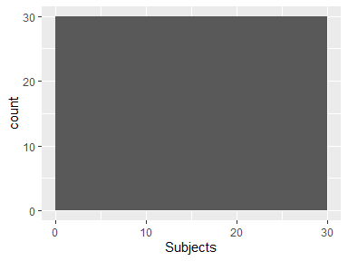

## Activities

|  |  |
| --- | --- |
| Feature | Result |
| Variable type | factor |
| Number of missing obs. | 0 (0 %) |
| Number of unique values | 6 |
| Mode | “LAYING” |
| Reference category | LAYING |

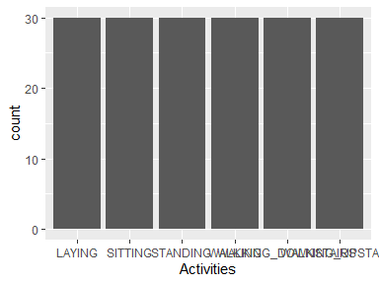

* Observed factor levels: "LAYING", "SITTING", "STANDING", "WALKING", "WALKING_DOWNSTAIRS", "WALKING_UPSTAIRS".

## Average of time BodyAcc mean x axis

|  |  |
| --- | --- |
| Feature | Result |
| Variable type | numeric |
| Number of missing obs. | 0 (0 %) |
| Number of unique values | 180 |
| Median | 0.28 |
| 1st and 3rd quartiles | 0.27; 0.28 |
| Min. and max. | 0.22; 0.3 |

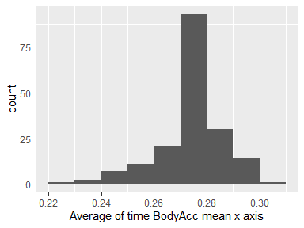

## Average of time BodyAcc mean y axis

|  |  |
| --- | --- |
| Feature | Result |
| Variable type | numeric |
| Number of missing obs. | 0 (0 %) |
| Number of unique values | 180 |
| Median | -0.02 |
| 1st and 3rd quartiles | -0.02; -0.01 |
| Min. and max. | -0.04; 0 |

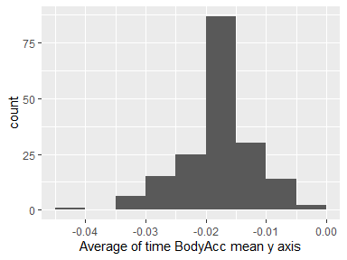

## Average of time BodyAcc mean z axis

|  |  |
| --- | --- |
| Feature | Result |
| Variable type | numeric |
| Number of missing obs. | 0 (0 %) |
| Number of unique values | 180 |
| Median | -0.11 |
| 1st and 3rd quartiles | -0.11; -0.1 |
| Min. and max. | -0.15; -0.08 |

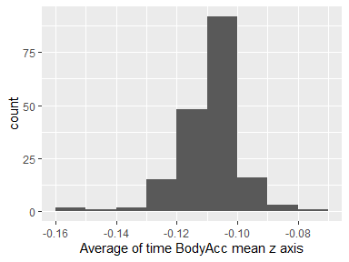

## Average of time BodyAcc std x axis

|  |  |
| --- | --- |
| Feature | Result |
| Variable type | numeric |
| Number of missing obs. | 0 (0 %) |
| Number of unique values | 180 |
| Median | -0.75 |
| 1st and 3rd quartiles | -0.98; -0.2 |
| Min. and max. | -1; 0.63 |

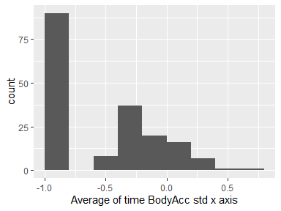

## Average of time BodyAcc std y axis

|  |  |
| --- | --- |
| Feature | Result |
| Variable type | numeric |
| Number of missing obs. | 0 (0 %) |
| Number of unique values | 180 |
| Median | -0.51 |
| 1st and 3rd quartiles | -0.94; -0.03 |
| Min. and max. | -0.99; 0.62 |

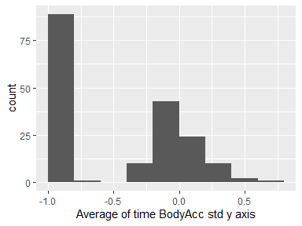

## Average of time BodyAcc std z axis

|  |  |
| --- | --- |
| Feature | Result |
| Variable type | numeric |
| Number of missing obs. | 0 (0 %) |
| Number of unique values | 180 |
| Median | -0.65 |
| 1st and 3rd quartiles | -0.95; -0.23 |
| Min. and max. | -0.99; 0.61 |

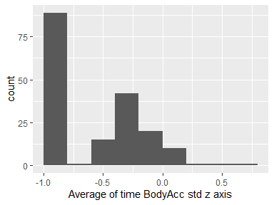

## Average of time GravityAcc mean x axis

|  |  |
| --- | --- |
| Feature | Result |
| Variable type | numeric |
| Number of missing obs. | 0 (0 %) |
| Number of unique values | 180 |
| Median | 0.92 |
| 1st and 3rd quartiles | 0.84; 0.94 |
| Min. and max. | -0.68; 0.97 |

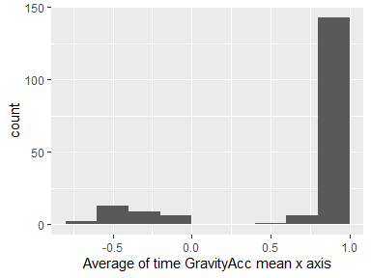

## Average of time GravityAcc mean y axis

|  |  |
| --- | --- |
| Feature | Result |
| Variable type | numeric |
| Number of missing obs. | 0 (0 %) |
| Number of unique values | 180 |
| Median | -0.13 |
| 1st and 3rd quartiles | -0.23; 0.09 |
| Min. and max. | -0.48; 0.96 |

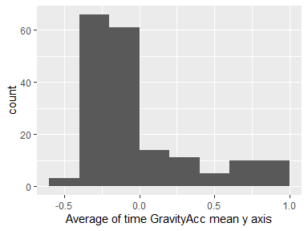

## Average of time GravityAcc mean z axis

|  |  |
| --- | --- |
| Feature | Result |
| Variable type | numeric |
| Number of missing obs. | 0 (0 %) |
| Number of unique values | 180 |
| Median | 0.02 |
| 1st and 3rd quartiles | -0.12; 0.15 |
| Min. and max. | -0.5; 0.96 |

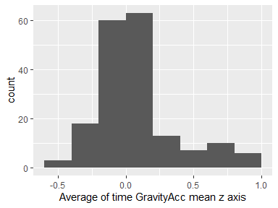

## Average of time GravityAcc std x axis

|  |  |
| --- | --- |
| Feature | Result |
| Variable type | numeric |
| Number of missing obs. | 0 (0 %) |
| Number of unique values | 180 |
| Median | -0.97 |
| 1st and 3rd quartiles | -0.98; -0.95 |
| Min. and max. | -1; -0.83 |

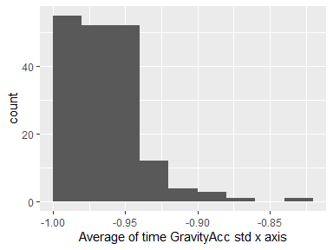

## Average of time GravityAcc std y axis

|  |  |
| --- | --- |
| Feature | Result |
| Variable type | numeric |
| Number of missing obs. | 0 (0 %) |
| Number of unique values | 180 |
| Median | -0.96 |
| 1st and 3rd quartiles | -0.97; -0.94 |
| Min. and max. | -0.99; -0.64 |

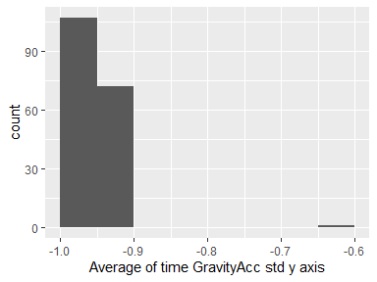

## Average of time GravityAcc std z axis

|  |  |
| --- | --- |
| Feature | Result |
| Variable type | numeric |
| Number of missing obs. | 0 (0 %) |
| Number of unique values | 180 |
| Median | -0.95 |
| 1st and 3rd quartiles | -0.96; -0.92 |
| Min. and max. | -0.99; -0.61 |

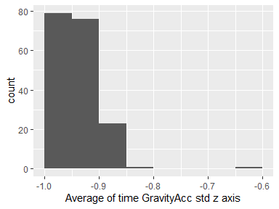

## Average of time BodyAccJerk mean x axis

|  |  |
| --- | --- |
| Feature | Result |
| Variable type | numeric |
| Number of missing obs. | 0 (0 %) |
| Number of unique values | 180 |
| Median | 0.08 |
| 1st and 3rd quartiles | 0.07; 0.08 |
| Min. and max. | 0.04; 0.13 |

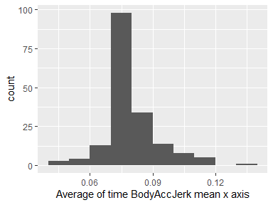

## Average of time BodyAccJerk mean y axis

|  |  |
| --- | --- |
| Feature | Result |
| Variable type | numeric |
| Number of missing obs. | 0 (0 %) |
| Number of unique values | 180 |
| Median | 0.01 |
| 1st and 3rd quartiles | 0; 0.01 |
| Min. and max. | -0.04; 0.06 |

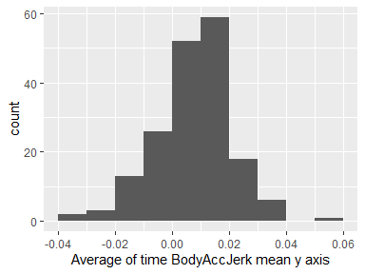

## Average of time BodyAccJerk mean z axis

|  |  |
| --- | --- |
| Feature | Result |
| Variable type | numeric |
| Number of missing obs. | 0 (0 %) |
| Number of unique values | 180 |
| Median | 0 |
| 1st and 3rd quartiles | -0.01; 0 |
| Min. and max. | -0.07; 0.04 |

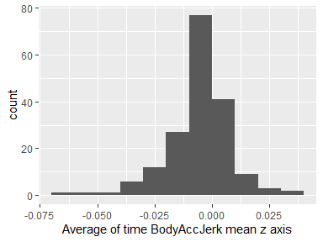

## Average of time BodyAccJerk std x axis

|  |  |
| --- | --- |
| Feature | Result |
| Variable type | numeric |
| Number of missing obs. | 0 (0 %) |
| Number of unique values | 180 |
| Median | -0.81 |
| 1st and 3rd quartiles | -0.98; -0.22 |
| Min. and max. | -0.99; 0.54 |

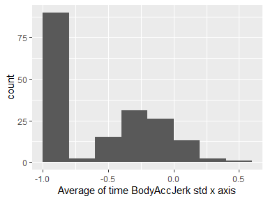

## Average of time BodyAccJerk std y axis

|  |  |
| --- | --- |
| Feature | Result |
| Variable type | numeric |
| Number of missing obs. | 0 (0 %) |
| Number of unique values | 180 |
| Median | -0.78 |
| 1st and 3rd quartiles | -0.97; -0.15 |
| Min. and max. | -0.99; 0.36 |

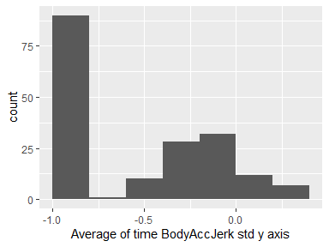

## Average of time BodyAccJerk std z axis

|  |  |
| --- | --- |
| Feature | Result |
| Variable type | numeric |
| Number of missing obs. | 0 (0 %) |
| Number of unique values | 180 |
| Median | -0.88 |
| 1st and 3rd quartiles | -0.98; -0.51 |
| Min. and max. | -0.99; 0.03 |

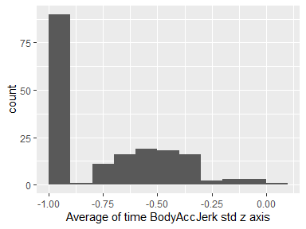

## Average of time BodyGyro mean x axis

|  |  |
| --- | --- |
| Feature | Result |
| Variable type | numeric |
| Number of missing obs. | 0 (0 %) |
| Number of unique values | 180 |
| Median | -0.03 |
| 1st and 3rd quartiles | -0.05; -0.02 |
| Min. and max. | -0.21; 0.19 |

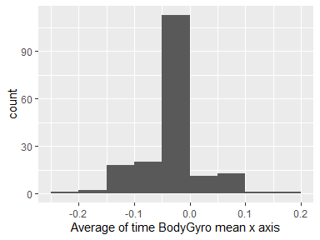

## Average of time BodyGyro mean y axis

|  |  |
| --- | --- |
| Feature | Result |
| Variable type | numeric |
| Number of missing obs. | 0 (0 %) |
| Number of unique values | 180 |
| Median | -0.07 |
| 1st and 3rd quartiles | -0.09; -0.06 |
| Min. and max. | -0.2; 0.03 |

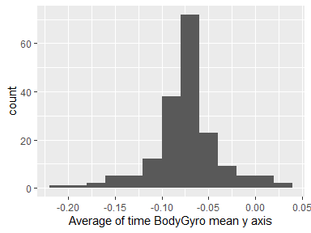

## Average of time BodyGyro mean z axis

|  |  |
| --- | --- |
| Feature | Result |
| Variable type | numeric |
| Number of missing obs. | 0 (0 %) |
| Number of unique values | 180 |
| Median | 0.09 |
| 1st and 3rd quartiles | 0.07; 0.1 |
| Min. and max. | -0.07; 0.18 |

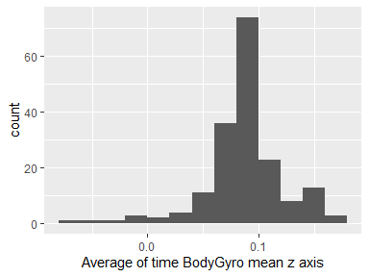

## Average of time BodyGyro std x axis

|  |  |
| --- | --- |
| Feature | Result |
| Variable type | numeric |
| Number of missing obs. | 0 (0 %) |
| Number of unique values | 180 |
| Median | -0.79 |
| 1st and 3rd quartiles | -0.97; -0.44 |
| Min. and max. | -0.99; 0.27 |

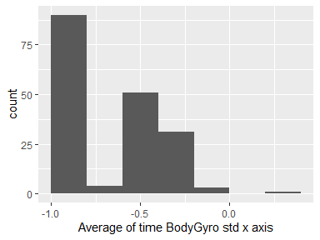

## Average of time BodyGyro std y axis

|  |  |
| --- | --- |
| Feature | Result |
| Variable type | numeric |
| Number of missing obs. | 0 (0 %) |
| Number of unique values | 180 |
| Median | -0.8 |
| 1st and 3rd quartiles | -0.96; -0.42 |
| Min. and max. | -0.99; 0.48 |

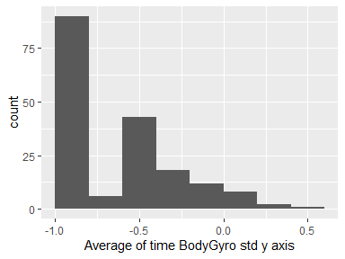

## Average of time BodyGyro std z axis

|  |  |
| --- | --- |
| Feature | Result |
| Variable type | numeric |
| Number of missing obs. | 0 (0 %) |
| Number of unique values | 180 |
| Median | -0.8 |
| 1st and 3rd quartiles | -0.96; -0.31 |
| Min. and max. | -0.99; 0.56 |

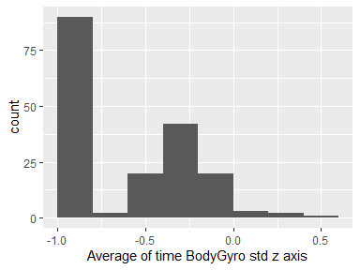

## Average of time BodyGyroJerk mean x axis

|  |  |
| --- | --- |
| Feature | Result |
| Variable type | numeric |
| Number of missing obs. | 0 (0 %) |
| Number of unique values | 180 |
| Median | -0.1 |
| 1st and 3rd quartiles | -0.1; -0.09 |
| Min. and max. | -0.16; -0.02 |

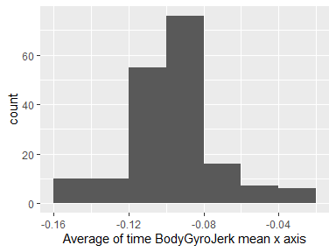

## Average of time BodyGyroJerk mean y axis

|  |  |
| --- | --- |
| Feature | Result |
| Variable type | numeric |
| Number of missing obs. | 0 (0 %) |
| Number of unique values | 180 |
| Median | -0.04 |
| 1st and 3rd quartiles | -0.05; -0.04 |
| Min. and max. | -0.08; -0.01 |

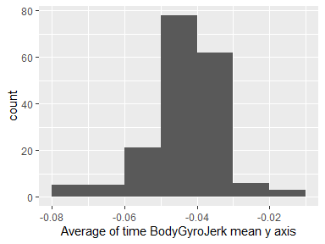

## Average of time BodyGyroJerk mean z axis

|  |  |
| --- | --- |
| Feature | Result |
| Variable type | numeric |
| Number of missing obs. | 0 (0 %) |
| Number of unique values | 180 |
| Median | -0.05 |
| 1st and 3rd quartiles | -0.06; -0.05 |
| Min. and max. | -0.09; -0.01 |

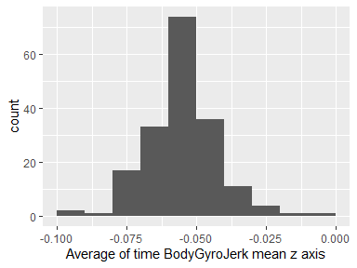

## Average of time BodyGyroJerk std x axis

|  |  |
| --- | --- |
| Feature | Result |
| Variable type | numeric |
| Number of missing obs. | 0 (0 %) |
| Number of unique values | 180 |
| Median | -0.84 |
| 1st and 3rd quartiles | -0.98; -0.46 |
| Min. and max. | -1; 0.18 |

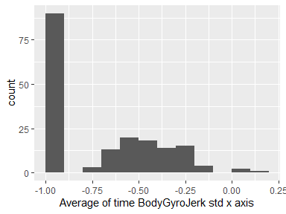

## Average of time BodyGyroJerk std y axis

|  |  |
| --- | --- |
| Feature | Result |
| Variable type | numeric |
| Number of missing obs. | 0 (0 %) |
| Number of unique values | 180 |
| Median | -0.89 |
| 1st and 3rd quartiles | -0.98; -0.59 |
| Min. and max. | -1; 0.3 |

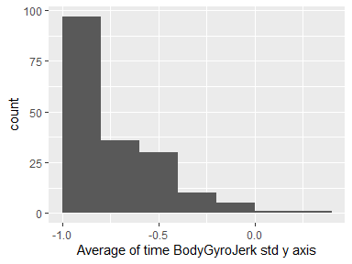

## Average of time BodyGyroJerk std z axis

|  |  |
| --- | --- |
| Feature | Result |
| Variable type | numeric |
| Number of missing obs. | 0 (0 %) |
| Number of unique values | 180 |
| Median | -0.86 |
| 1st and 3rd quartiles | -0.98; -0.47 |
| Min. and max. | -1; 0.19 |

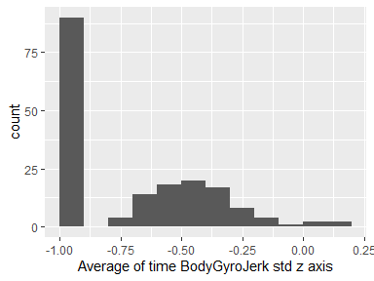

## Average of time BodyAccMag mean

|  |  |
| --- | --- |
| Feature | Result |
| Variable type | numeric |
| Number of missing obs. | 0 (0 %) |
| Number of unique values | 180 |
| Median | -0.48 |
| 1st and 3rd quartiles | -0.96; -0.09 |
| Min. and max. | -0.99; 0.64 |

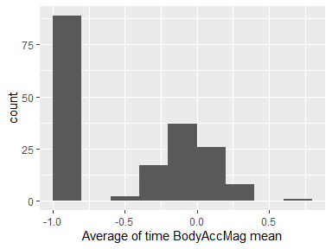

## Average of time BodyAccMag std

|  |  |
| --- | --- |
| Feature | Result |
| Variable type | numeric |
| Number of missing obs. | 0 (0 %) |
| Number of unique values | 180 |
| Median | -0.61 |
| 1st and 3rd quartiles | -0.94; -0.21 |
| Min. and max. | -0.99; 0.43 |

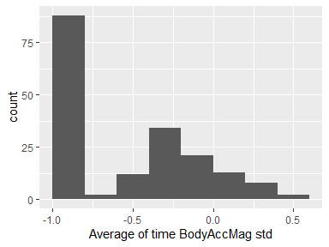

## Average of time GravityAccMag mean

|  |  |
| --- | --- |
| Feature | Result |
| Variable type | numeric |
| Number of missing obs. | 0 (0 %) |
| Number of unique values | 180 |
| Median | -0.48 |
| 1st and 3rd quartiles | -0.96; -0.09 |
| Min. and max. | -0.99; 0.64 |

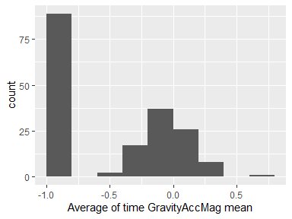

## Average of time GravityAccMag std

|  |  |
| --- | --- |
| Feature | Result |
| Variable type | numeric |
| Number of missing obs. | 0 (0 %) |
| Number of unique values | 180 |
| Median | -0.61 |
| 1st and 3rd quartiles | -0.94; -0.21 |
| Min. and max. | -0.99; 0.43 |

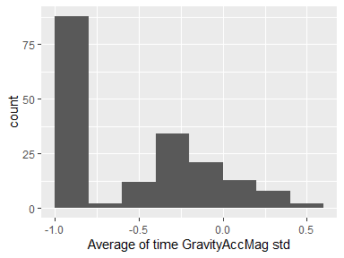

## Average of time BodyAccJerkMag mean

|  |  |
| --- | --- |
| Feature | Result |
| Variable type | numeric |
| Number of missing obs. | 0 (0 %) |
| Number of unique values | 180 |
| Median | -0.82 |
| 1st and 3rd quartiles | -0.98; -0.25 |
| Min. and max. | -0.99; 0.43 |

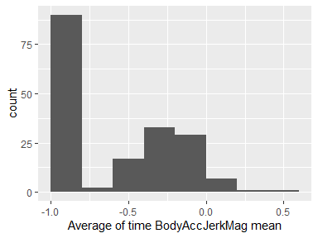

## Average of time BodyAccJerkMag std

|  |  |
| --- | --- |
| Feature | Result |
| Variable type | numeric |
| Number of missing obs. | 0 (0 %) |
| Number of unique values | 180 |
| Median | -0.8 |
| 1st and 3rd quartiles | -0.98; -0.22 |
| Min. and max. | -0.99; 0.45 |

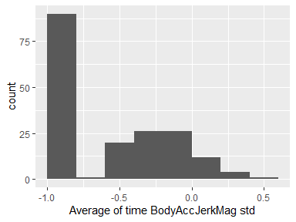

## Average of time BodyGyroMag mean

|  |  |
| --- | --- |
| Feature | Result |
| Variable type | numeric |
| Number of missing obs. | 0 (0 %) |
| Number of unique values | 180 |
| Median | -0.66 |
| 1st and 3rd quartiles | -0.95; -0.22 |
| Min. and max. | -0.98; 0.42 |

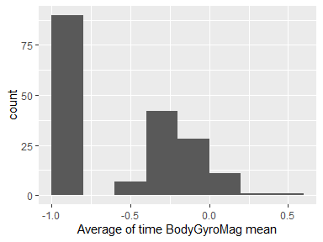

## Average of time BodyGyroMag std

|  |  |
| --- | --- |
| Feature | Result |
| Variable type | numeric |
| Number of missing obs. | 0 (0 %) |
| Number of unique values | 180 |
| Median | -0.74 |
| 1st and 3rd quartiles | -0.95; -0.36 |
| Min. and max. | -0.98; 0.3 |

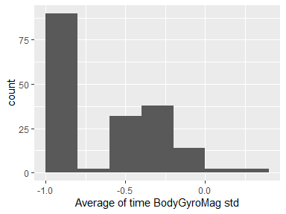

## Average of time BodyGyroJerkMag mean

|  |  |
| --- | --- |
| Feature | Result |
| Variable type | numeric |
| Number of missing obs. | 0 (0 %) |
| Number of unique values | 180 |
| Median | -0.86 |
| 1st and 3rd quartiles | -0.99; -0.51 |
| Min. and max. | -1; 0.09 |

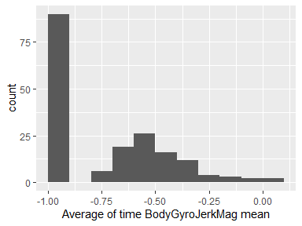

## Average of time BodyGyroJerkMag std

|  |  |
| --- | --- |
| Feature | Result |
| Variable type | numeric |
| Number of missing obs. | 0 (0 %) |
| Number of unique values | 180 |
| Median | -0.88 |
| 1st and 3rd quartiles | -0.98; -0.58 |
| Min. and max. | -1; 0.25 |

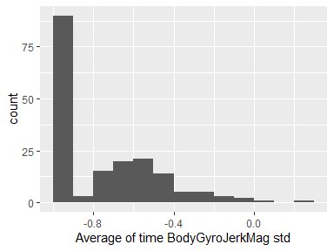

## Average of freq BodyAcc mean x axis

|  |  |
| --- | --- |
| Feature | Result |
| Variable type | numeric |
| Number of missing obs. | 0 (0 %) |
| Number of unique values | 180 |
| Median | -0.77 |
| 1st and 3rd quartiles | -0.98; -0.22 |
| Min. and max. | -1; 0.54 |

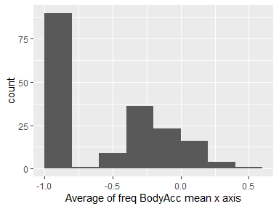

## Average of freq BodyAcc mean y axis

|  |  |
| --- | --- |
| Feature | Result |
| Variable type | numeric |
| Number of missing obs. | 0 (0 %) |
| Number of unique values | 180 |
| Median | -0.59 |
| 1st and 3rd quartiles | -0.95; -0.06 |
| Min. and max. | -0.99; 0.52 |

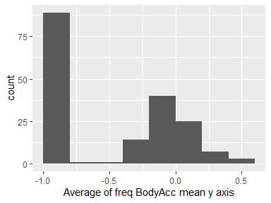

## Average of freq BodyAcc mean z axis

|  |  |
| --- | --- |
| Feature | Result |
| Variable type | numeric |
| Number of missing obs. | 0 (0 %) |
| Number of unique values | 180 |
| Median | -0.72 |
| 1st and 3rd quartiles | -0.96; -0.32 |
| Min. and max. | -0.99; 0.28 |

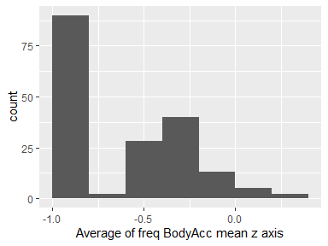

## Average of freq BodyAcc std x axis

|  |  |
| --- | --- |
| Feature | Result |
| Variable type | numeric |
| Number of missing obs. | 0 (0 %) |
| Number of unique values | 180 |
| Median | -0.75 |
| 1st and 3rd quartiles | -0.98; -0.2 |
| Min. and max. | -1; 0.66 |

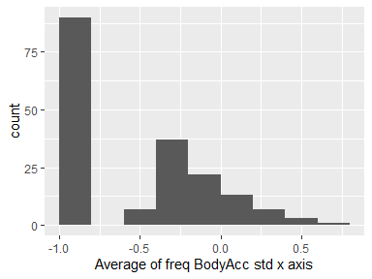

## Average of freq BodyAcc std y axis

|  |  |
| --- | --- |
| Feature | Result |
| Variable type | numeric |
| Number of missing obs. | 0 (0 %) |
| Number of unique values | 180 |
| Median | -0.51 |
| 1st and 3rd quartiles | -0.94; -0.08 |
| Min. and max. | -0.99; 0.56 |

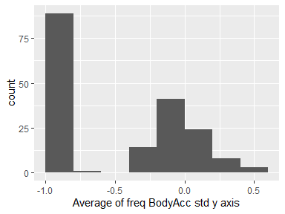

## Average of freq BodyAcc std z axis

|  |  |
| --- | --- |
| Feature | Result |
| Variable type | numeric |
| Number of missing obs. | 0 (0 %) |
| Number of unique values | 180 |
| Median | -0.64 |
| 1st and 3rd quartiles | -0.95; -0.27 |
| Min. and max. | -0.99; 0.69 |

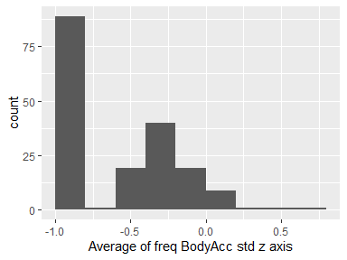

## Average of freq BodyAcc meanFreq x axis

|  |  |
| --- | --- |
| Feature | Result |
| Variable type | numeric |
| Number of missing obs. | 0 (0 %) |
| Number of unique values | 180 |
| Median | -0.26 |
| 1st and 3rd quartiles | -0.39; -0.06 |
| Min. and max. | -0.64; 0.16 |

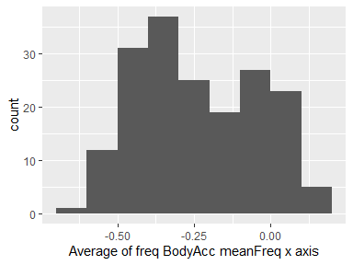

## Average of freq BodyAcc meanFreq y axis

|  |  |
| --- | --- |
| Feature | Result |
| Variable type | numeric |
| Number of missing obs. | 0 (0 %) |
| Number of unique values | 180 |
| Median | 0.01 |
| 1st and 3rd quartiles | -0.08; 0.09 |
| Min. and max. | -0.38; 0.47 |

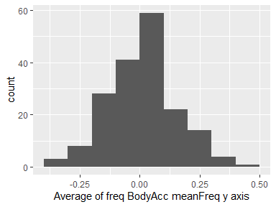

## Average of freq BodyAcc meanFreq z axis

|  |  |
| --- | --- |
| Feature | Result |
| Variable type | numeric |
| Number of missing obs. | 0 (0 %) |
| Number of unique values | 180 |
| Median | 0.07 |
| 1st and 3rd quartiles | -0.04; 0.18 |
| Min. and max. | -0.52; 0.4 |

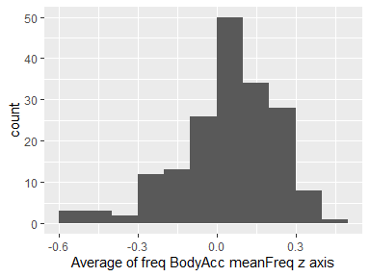

## Average of freq BodyAccJerk mean x axis

|  |  |
| --- | --- |
| Feature | Result |
| Variable type | numeric |
| Number of missing obs. | 0 (0 %) |
| Number of unique values | 180 |
| Median | -0.81 |
| 1st and 3rd quartiles | -0.98; -0.28 |
| Min. and max. | -0.99; 0.47 |

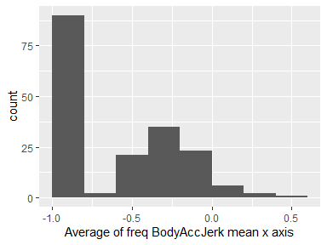

## Average of freq BodyAccJerk mean y axis

|  |  |
| --- | --- |
| Feature | Result |
| Variable type | numeric |
| Number of missing obs. | 0 (0 %) |
| Number of unique values | 180 |
| Median | -0.78 |
| 1st and 3rd quartiles | -0.97; -0.2 |
| Min. and max. | -0.99; 0.28 |

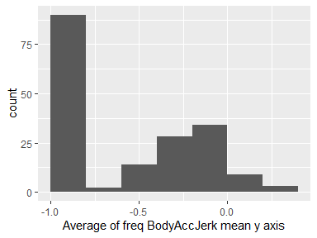

## Average of freq BodyAccJerk mean z axis

|  |  |
| --- | --- |
| Feature | Result |
| Variable type | numeric |
| Number of missing obs. | 0 (0 %) |
| Number of unique values | 180 |
| Median | -0.87 |
| 1st and 3rd quartiles | -0.98; -0.47 |
| Min. and max. | -0.99; 0.16 |

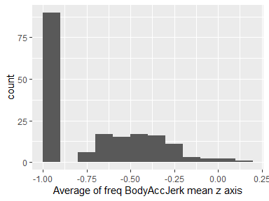

## Average of freq BodyAccJerk std x axis

|  |  |
| --- | --- |
| Feature | Result |
| Variable type | numeric |
| Number of missing obs. | 0 (0 %) |
| Number of unique values | 180 |
| Median | -0.83 |
| 1st and 3rd quartiles | -0.98; -0.25 |
| Min. and max. | -1; 0.48 |

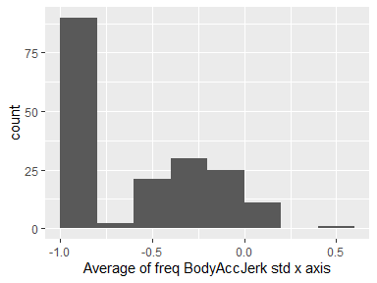

## Average of freq BodyAccJerk std y axis

|  |  |
| --- | --- |
| Feature | Result |
| Variable type | numeric |
| Number of missing obs. | 0 (0 %) |
| Number of unique values | 180 |
| Median | -0.79 |
| 1st and 3rd quartiles | -0.97; -0.17 |
| Min. and max. | -0.99; 0.35 |

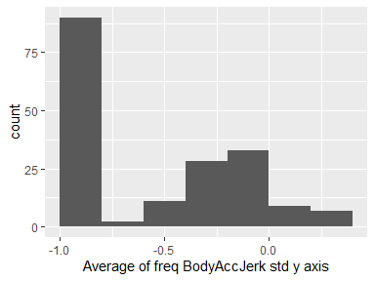

## Average of freq BodyAccJerk std z axis

|  |  |
| --- | --- |
| Feature | Result |
| Variable type | numeric |
| Number of missing obs. | 0 (0 %) |
| Number of unique values | 180 |
| Median | -0.9 |
| 1st and 3rd quartiles | -0.98; -0.54 |
| Min. and max. | -0.99; -0.01 |

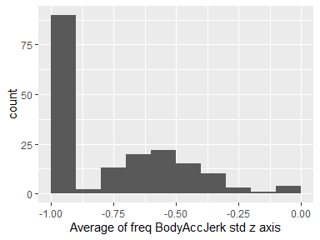

## Average of freq BodyAccJerk meanFreq x axis

|  |  |
| --- | --- |
| Feature | Result |
| Variable type | numeric |
| Number of missing obs. | 0 (0 %) |
| Number of unique values | 180 |
| Median | -0.06 |
| 1st and 3rd quartiles | -0.29; 0.18 |
| Min. and max. | -0.58; 0.33 |

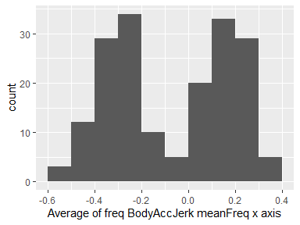

## Average of freq BodyAccJerk meanFreq y axis

|  |  |
| --- | --- |
| Feature | Result |
| Variable type | numeric |
| Number of missing obs. | 0 (0 %) |
| Number of unique values | 180 |
| Median | -0.23 |
| 1st and 3rd quartiles | -0.4; -0.05 |
| Min. and max. | -0.6; 0.2 |

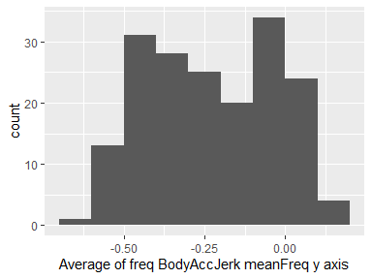

## Average of freq BodyAccJerk meanFreq z axis

|  |  |
| --- | --- |
| Feature | Result |
| Variable type | numeric |
| Number of missing obs. | 0 (0 %) |
| Number of unique values | 180 |
| Median | -0.09 |
| 1st and 3rd quartiles | -0.31; 0.04 |
| Min. and max. | -0.63; 0.23 |

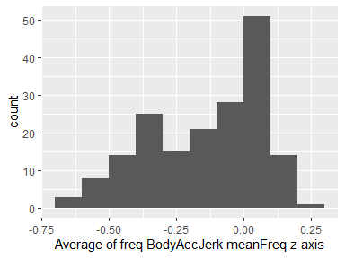

## Average of freq BodyGyro mean x axis

|  |  |
| --- | --- |
| Feature | Result |
| Variable type | numeric |
| Number of missing obs. | 0 (0 %) |
| Number of unique values | 180 |
| Median | -0.73 |
| 1st and 3rd quartiles | -0.97; -0.34 |
| Min. and max. | -0.99; 0.47 |

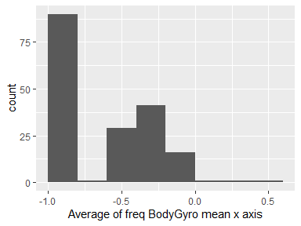

## Average of freq BodyGyro mean y axis

|  |  |
| --- | --- |
| Feature | Result |
| Variable type | numeric |
| Number of missing obs. | 0 (0 %) |
| Number of unique values | 180 |
| Median | -0.81 |
| 1st and 3rd quartiles | -0.97; -0.45 |
| Min. and max. | -0.99; 0.33 |

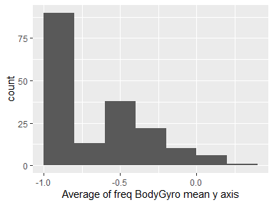

## Average of freq BodyGyro mean z axis

|  |  |
| --- | --- |
| Feature | Result |
| Variable type | numeric |
| Number of missing obs. | 0 (0 %) |
| Number of unique values | 180 |
| Median | -0.79 |
| 1st and 3rd quartiles | -0.96; -0.26 |
| Min. and max. | -0.99; 0.49 |

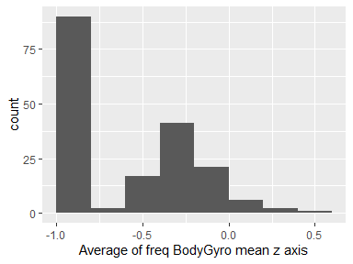

## Average of freq BodyGyro std x axis

|  |  |
| --- | --- |
| Feature | Result |
| Variable type | numeric |
| Number of missing obs. | 0 (0 %) |
| Number of unique values | 180 |
| Median | -0.81 |
| 1st and 3rd quartiles | -0.98; -0.48 |
| Min. and max. | -0.99; 0.2 |

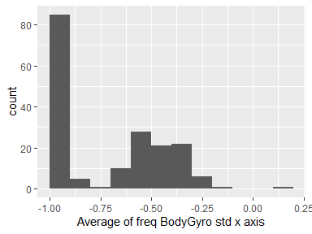

## Average of freq BodyGyro std y axis

|  |  |
| --- | --- |
| Feature | Result |
| Variable type | numeric |
| Number of missing obs. | 0 (0 %) |
| Number of unique values | 180 |
| Median | -0.8 |
| 1st and 3rd quartiles | -0.96; -0.42 |
| Min. and max. | -0.99; 0.65 |

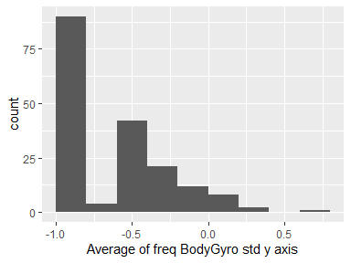

## Average of freq BodyGyro std z axis

|  |  |
| --- | --- |
| Feature | Result |
| Variable type | numeric |
| Number of missing obs. | 0 (0 %) |
| Number of unique values | 180 |
| Median | -0.82 |
| 1st and 3rd quartiles | -0.96; -0.39 |
| Min. and max. | -0.99; 0.52 |

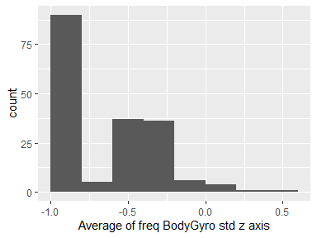

## Average of freq BodyGyro meanFreq x axis

|  |  |
| --- | --- |
| Feature | Result |
| Variable type | numeric |
| Number of missing obs. | 0 (0 %) |
| Number of unique values | 180 |
| Median | -0.12 |
| 1st and 3rd quartiles | -0.21; 0 |
| Min. and max. | -0.4; 0.25 |

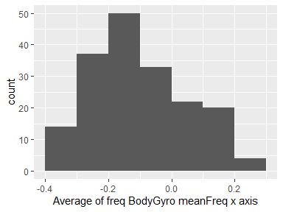

## Average of freq BodyGyro meanFreq y axis

|  |  |
| --- | --- |
| Feature | Result |
| Variable type | numeric |
| Number of missing obs. | 0 (0 %) |
| Number of unique values | 180 |
| Median | -0.16 |
| 1st and 3rd quartiles | -0.29; -0.04 |
| Min. and max. | -0.67; 0.27 |

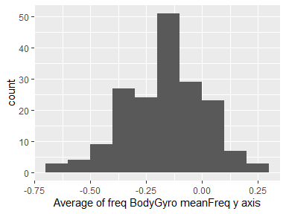

## Average of freq BodyGyro meanFreq z axis

|  |  |
| --- | --- |
| Feature | Result |
| Variable type | numeric |
| Number of missing obs. | 0 (0 %) |
| Number of unique values | 180 |
| Median | -0.05 |
| 1st and 3rd quartiles | -0.15; 0.04 |
| Min. and max. | -0.51; 0.38 |

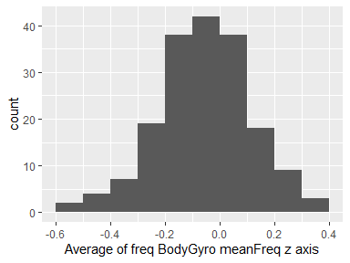

## Average of freq BodyAccMag mean

|  |  |
| --- | --- |
| Feature | Result |
| Variable type | numeric |
| Number of missing obs. | 0 (0 %) |
| Number of unique values | 180 |
| Median | -0.67 |
| 1st and 3rd quartiles | -0.96; -0.16 |
| Min. and max. | -0.99; 0.59 |

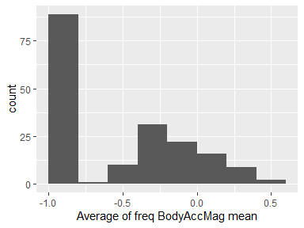

## Average of freq BodyAccMag std

|  |  |
| --- | --- |
| Feature | Result |
| Variable type | numeric |
| Number of missing obs. | 0 (0 %) |
| Number of unique values | 180 |
| Median | -0.65 |
| 1st and 3rd quartiles | -0.95; -0.37 |
| Min. and max. | -0.99; 0.18 |

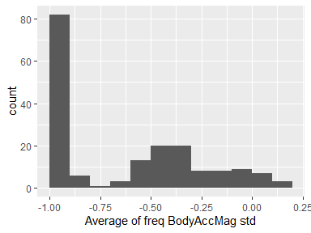

## Average of freq BodyAccMag meanFreq

|  |  |
| --- | --- |
| Feature | Result |
| Variable type | numeric |
| Number of missing obs. | 0 (0 %) |
| Number of unique values | 180 |
| Median | 0.08 |
| 1st and 3rd quartiles | -0.01; 0.17 |
| Min. and max. | -0.31; 0.44 |

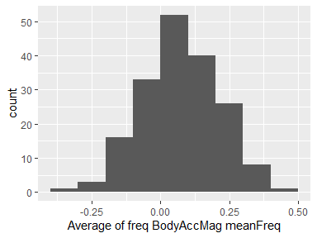

## Average of freq BodyBodyAccJerkMag mean

|  |  |
| --- | --- |
| Feature | Result |
| Variable type | numeric |
| Number of missing obs. | 0 (0 %) |
| Number of unique values | 180 |
| Median | -0.79 |
| 1st and 3rd quartiles | -0.98; -0.19 |
| Min. and max. | -0.99; 0.54 |

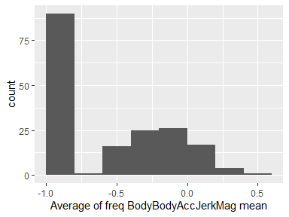

## Average of freq BodyBodyAccJerkMag std

|  |  |
| --- | --- |
| Feature | Result |
| Variable type | numeric |
| Number of missing obs. | 0 (0 %) |
| Number of unique values | 180 |
| Median | -0.81 |
| 1st and 3rd quartiles | -0.98; -0.27 |
| Min. and max. | -0.99; 0.32 |

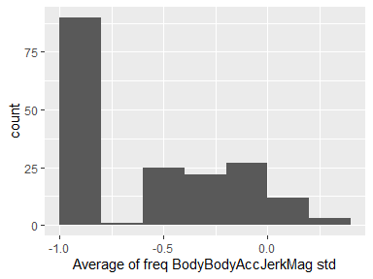

## Average of freq BodyBodyAccJerkMag meanFreq

|  |  |
| --- | --- |
| Feature | Result |
| Variable type | numeric |
| Number of missing obs. | 0 (0 %) |
| Number of unique values | 180 |
| Median | 0.17 |
| 1st and 3rd quartiles | 0.05; 0.28 |
| Min. and max. | -0.13; 0.49 |

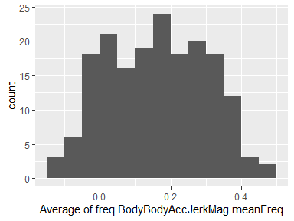

## Average of freq BodyBodyGyroMag mean

|  |  |
| --- | --- |
| Feature | Result |
| Variable type | numeric |
| Number of missing obs. | 0 (0 %) |
| Number of unique values | 180 |
| Median | -0.77 |
| 1st and 3rd quartiles | -0.96; -0.41 |
| Min. and max. | -0.99; 0.2 |

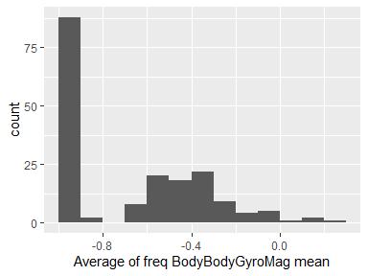

## Average of freq BodyBodyGyroMag std

|  |  |
| --- | --- |
| Feature | Result |
| Variable type | numeric |
| Number of missing obs. | 0 (0 %) |
| Number of unique values | 180 |
| Median | -0.77 |
| 1st and 3rd quartiles | -0.95; -0.43 |
| Min. and max. | -0.98; 0.24 |

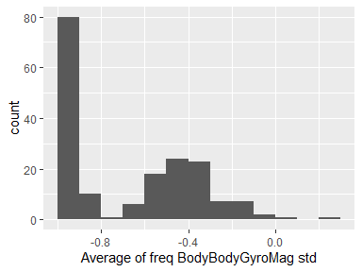

## Average of freq BodyBodyGyroMag meanFreq

|  |  |
| --- | --- |
| Feature | Result |
| Variable type | numeric |
| Number of missing obs. | 0 (0 %) |
| Number of unique values | 180 |
| Median | -0.05 |
| 1st and 3rd quartiles | -0.17; 0.08 |
| Min. and max. | -0.46; 0.41 |

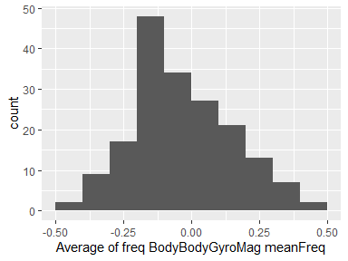

## Average of freq BodyBodyGyroJerkMag mean

|  |  |
| --- | --- |
| Feature | Result |
| Variable type | numeric |
| Number of missing obs. | 0 (0 %) |
| Number of unique values | 180 |
| Median | -0.88 |
| 1st and 3rd quartiles | -0.98; -0.58 |
| Min. and max. | -1; 0.15 |

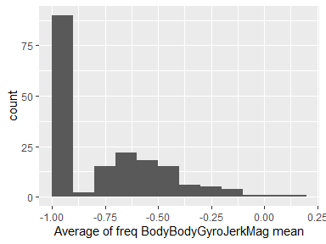

## Average of freq BodyBodyGyroJerkMag std

|  |  |
| --- | --- |
| Feature | Result |
| Variable type | numeric |
| Number of missing obs. | 0 (0 %) |
| Number of unique values | 180 |
| Median | -0.89 |
| 1st and 3rd quartiles | -0.98; -0.61 |
| Min. and max. | -1; 0.29 |

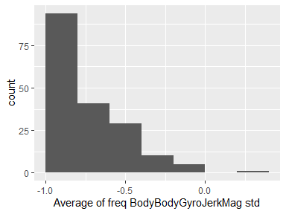

## Average of freq BodyBodyGyroJerkMag meanFreq

|  |  |
| --- | --- |
| Feature | Result |
| Variable type | numeric |
| Number of missing obs. | 0 (0 %) |
| Number of unique values | 180 |
| Median | 0.11 |
| 1st and 3rd quartiles | 0.05; 0.21 |
| Min. and max. | -0.18; 0.43 |

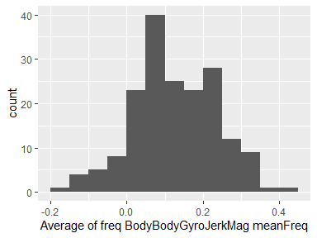

Report generation information:

* Created by Juan Rodriguez Diaz (username: juanr).
* Report creation time: do. jul. 21 2019 13:17:55
* Report was run from directory: G:/Mis documentos/CleaningDataW4
* dataMaid v1.3.1 [Pkg: 2019-07-10 from CRAN (R 3.6.1)]
* R version 3.6.0 (2019-04-26).
* Platform: x86_64-w64-mingw32/x64 (64-bit)(Windows 10 x64 (build 18362)).
* Function call: makeDataReport(data = average, mode = c("summarize", "visualize", "check"), smartNum = FALSE, file = "codebook_average.Rmd", checks = list( character = "showAllFactorLevels", factor = "showAllFactorLevels", labelled = "showAllFactorLevels", haven_labelled = "showAllFactorLevels", numeric = NULL, integer = NULL, logical = NULL, Date = NULL), listChecks = FALSE, maxProbVals = Inf, codebook = TRUE, reportTitle = "Codebook for average")