Evaluating the Impact of Discovered Causal Structures on
Structure-Aware Shapley Methods: An Experimental Pipeline
Juan David Rios Garcia
Master's Thesis Research Manuscript -- Industrial Engineering

1. Introduction
Model explainability has become a fundamental prerequisite for the deployment of machine learning systems, particularly across high-stakes socioeconomic domains such as credit scoring, healthcare access, and public resource allocation, where algorithmic decisions must be transparently justified to affected individuals and regulatory bodies (Baron, 2023).
While Shapley values derived from cooperative game theory have emerged as a gold standard for local feature attribution due to their unique axiomatic foundations, traditional implementations frequently rely on the simplifying assumption of feature independence. This assumption treats all feature permutations as equally probable during coalition formation, which can systematically misattribute credit when the true generative process involves structured causal dependencies among inputs (Lundberg & Lee, 2017; Heskes et al., 2020).
To mitigate these limitations, recent literature has introduced structure-aware Shapley frameworks that explicitly embed topological constraints into the attribution process. Asymmetric Shapley Values (ASV) restrict permutations to those consistent with a causal ordering (Frye et al., 2021); Causal Shapley Values (CSV) replace observational marginalization with interventional conditioning based on Pearl's do-calculus (Heskes et al., 2020); and Shapley Flow reframes credit assignment from nodes to directed edges in a causal graph (Wang et al., 2021). Each of these methods promises attributions that are more faithful to the underlying causal mechanism that generated the data.
A critical bottleneck in prior work is the assumption that the underlying Causal Directed Acyclic Graph (DAG) is known a priori or completely specified by a domain expert. In practical applications, the true causal graph is almost never directly observable. Practitioners must instead rely on automated causal discovery algorithms such as the constraint-based PC algorithm (Spirtes et al., 2000) and the functional causal model DirectLiNGAM (Shimizu et al., 2011) to infer a plausible graph structure from observational data. These estimated graphs are inherently noisy, subject to false-positive and false-negative edge errors, and sensitive to violations of their underlying assumptions (Glymour et al., 2019).
This thesis addresses this open gap by constructing a comprehensive experimental pipeline that integrates automated causal discovery directly into structure-aware explainability frameworks and systematically measures how graph estimation errors propagate downstream into feature attribution outputs. The pipeline evaluates three structure-aware Shapley methods (Asymmetric Shapley, Causal Shapley, and Shapley Flow) under three causal graph sources: the PC-discovered graph, the LiNGAM-discovered graph, and the True DAG used as an oracle reference. Evaluation is performed on two benchmarks: a controlled synthetic dataset with 50 features and known linear causal structure, and the real-world Sachs cell signaling dataset (Sachs et al., 2005), where an established consensus DAG allows external validation.
The central research question is: when a practitioner feeds an imperfect discovered causal graph into a structure-aware Shapley method, does the method produce attributions that meaningfully differ from a graph-free baseline, and do those attributions move closer to or further from the oracle attributions obtained with the True DAG? The answer has direct implications for how causal explainability tools should be adopted in practice.

2. Conceptual Framework and Methodology

2.1 Model Explainability and Causal Understanding
A fundamental distinction must be established regarding the objective of model explainability. Rather than attempting to reveal the underlying laws of a real-world physical system, the focus of this work is strictly bounded to explaining the predictive behavior of a trained machine learning model. This distinction mirrors the conceptual separation established by Baron (2023) between causal understanding of nature and causal understanding of a model's decision function.
In practical machine learning scenarios, conducting physical manipulations or randomized controlled treatments is often expensive, time-consuming, or ethically impossible. Consequently, model explanations must be grounded in the observational data distribution used during training, while ideally respecting the causal relationships that govern how features jointly determine model outputs. Structure-aware Shapley methods operationalize this grounding by encoding causal relationships as constraints on the attribution computation, rather than by performing physical interventions.

2.2 Counterfactual Explanations and the Structural Causal Model Framework
Counterfactual explanations provide an intuitive contrastive explainability framework by identifying the minimal input feature perturbations required to alter an algorithmic output (Wachter et al., 2018). Standard optimization methods, however, generate counterfactuals that may violate physical plausibility constraints by placing instances in low-density regions of the joint feature space or proposing changes that contradict causal relationships (Mahajan et al., 2020).
To satisfy real-world feasibility constraints, explanations must be grounded within a Structural Causal Model (SCM), formally defined as a tuple G := (S, P(epsilon)), where S is a collection of deterministic structural equations of the form x_i = f_i(Pa(x_i), epsilon_i), and P(epsilon) is a joint distribution over independent exogenous noise variables (Pearl, 2009). Full abduction-action-prediction within an SCM is computationally demanding and requires complete structural equation knowledge. Structure-aware Shapley methods circumvent this bottleneck by using the causal graph topology to define conditional distributions for feature imputation, approximating the post-interventional distribution without requiring full structural equation reconstruction.

2.3 Causal Discovery: Structure Identification
Because the true causal graph is unknown in observational settings, the pipeline implements two complementary discovery approaches:
- PC Algorithm (Spirtes et al., 2000): A constraint-based method that recovers the causal skeleton through conditional independence tests (Fisher-z at alpha = 0.05) and applies Meek's orientation rules to produce a Completed Partially Directed Acyclic Graph. Undirected edges are resolved by orienting them from lower to higher feature index, yielding a valid DAG for downstream Shapley computation.
- DirectLiNGAM (Shimizu et al., 2011): A functional causal model that exploits linear non-Gaussian structure to simultaneously identify the causal ordering and structural coefficients. The output adjacency matrix is transposed and pruned at |coefficient| < 0.10.
Both algorithms operate strictly on the X-only training partition and assume causal sufficiency. This assumption is violated in the confounded synthetic dataset, making confounding a key experimental variable for testing method robustness.

2.4 Traditional Shapley Values and the Axiomatic Framework
Traditional Shapley values provide a unique feature attribution solution satisfying four axioms: Efficiency (attributions sum to the prediction gap), Linearity (attributions from model ensembles combine linearly), Null Player (zero attribution for features with no marginal contribution), and Symmetry (identical contributors receive equal credit). The Symmetry axiom is too restrictive for causal systems: it treats all features as interchangeable coalition partners, misattributing credit from downstream effects to upstream causes when the two are correlated through the causal structure.

2.5 Structure-Aware Shapley Methods: Theoretical Foundations
Structure-aware Shapley frameworks preserve Efficiency, Linearity, and Nullity while modifying or relaxing Symmetry to accommodate causal topologies.

2.5.1 Asymmetric Shapley Values (ASV)
ASV breaks the Symmetry axiom by replacing the uniform distribution over feature orderings with a weighting scheme w(pi) that places probability mass exclusively on permutations consistent with a partial causal ordering (Frye et al., 2021). Ancestral causes always precede their downstream effects during coalition formation, preventing descendant features from receiving credit for contributions mediated by their ancestors. ASV retains observational marginalization for absent features, constraining only the permutation space and not the imputation distribution. The attribution formula is: phi_i(ASV) = Sum_{pi in Pi_G} w(pi) * [f(S_pi(i) union {i}) - f(S_pi(i))], where Pi_G is the set of valid topological orderings of the causal graph G.

2.5.2 Causal Shapley Values (CSV)
CSV retains a symmetric formulation over permutations but redefines the value function using interventional distributions rather than observational conditioning (Heskes et al., 2020). When a feature is absent from a coalition, its value is sampled from the post-interventional distribution given the values of features currently in the coalition, approximating Pearl's do-operator: phi_i(CSV) = Sum_{S} [|S|!(|N|-|S|-1)!/|N|!] * [f_do(S union {i}) - f_do(S)], where f_do(S) evaluates the model under interventional distributions on features not in S.

2.5.3 Shapley Flow
Shapley Flow moves from node-based to edge-based attribution (Wang et al., 2021). It extends the classical Shapley axioms to directed graph edges and introduces a Boundary axiom: the sum of attribution flow entering any intermediate node equals the sum leaving it, ensuring credit conservation at intermediate nodes. Node-level attributions are recovered by aggregating edge-level flows. Graph errors propagate along all paths connected to an affected edge, not only at the node level.

3. Experimental Setup and Practical Implementation

3.1 Data Synthesis and Target Datasets
The experimental pipeline employs a synthetic benchmarking framework producing datasets with known, deterministic ground-truth causal structures. The framework generates datasets as the Cartesian product of three functional forms (linear, nonlinear, mixed) and two confounding conditions, yielding six synthetic datasets. The primary analysis focuses on two cases:
- Linear System with Confounding (linear_conf_f50_s1000_p30): Strictly linear structural equations X_j = Sum_{i in Pa(j)} w_ij * X_i + epsilon_j, with epsilon_j ~ N(0, 0.5) and coefficients drawn from Uniform(0.5, 2.0) with random sign. The graph is Erdos-Renyi with edge probability p = 0.07, yielding 87 X->X edges across 50 features (~1.74 edges per node). Exactly 15 of 50 features are direct causal parents of Y (y_parents_ratio = 0.30). Five hidden confounders each additively influence 2-3 features, violating causal sufficiency for both discovery algorithms. Dataset parameters: N_FEATURES = 50, N_SAMPLES = 1000, random_state = 42.
- Sachs Cell Signaling Dataset (Real Data): 7,466 simultaneous measurements of 11 protein concentrations in stimulated human T-cells (Sachs et al., 2005), obtained from the Carnegie Mellon University Philosophy Department causal datasets repository (Scheines, 2024). Akt kinase (akt) is the regression target Y and 10 proteins are input features (raf, mek, plc, pip2, pip3, erk, pka, pkc, p38, jnk). A consensus reference DAG has 16 X->X edges and 3 direct X->Y edges (pip3->akt, pka->akt, erk->akt). Raw concentrations are preprocessed with log1p transformation and StandardScaler fitted on training data only.
Both datasets use an 80/20 train/test split with random seed 42. The synthetic graph density (~7.1%, 1.74 edges/node) was calibrated to match the Sachs network density, enabling direct comparison between the two experimental tracks.

3.2 Predictive Model
A LightGBM gradient-boosted tree regressor is fitted to each dataset using Optuna-based hyperparameter optimization (50 TPE trials, RMSE objective). Feature selection is disabled for both datasets so that all input features participate in the model, keeping the feature space consistent with the causal graph and Shapley computation.
Table 3.1: Predictive Model Performance on Test Sets
Dataset | R2 | RMSE | MAE
Linear-Conf (synthetic) | 0.900 | 1.72 | 1.36
Sachs (real data) | 0.679 | 88.78 | 17.82

3.3 Causal Discovery Framework

3.3.1 DirectLiNGAM Integration
The pipeline uses causal-learn's DirectLiNGAM. The library outputs an adjacency matrix where matrix[i,j] is the coefficient of X_j on X_i; the matrix is transposed before binarization. Edges with |coefficient| < 0.10 are pruned to remove near-zero connections.

3.3.2 PC Algorithm Integration
Constraint-based discovery uses causal-learn's pc function with the Fisher-z test at alpha = 0.05. Undirected edges in the resulting CPDAG are resolved by orienting them from the lower to the higher feature index. Cyclic edges introduced by this step are detected and removed.

3.3.3 X->Y Edge Augmentation Rule
Both PC and LiNGAM operate on the X-only feature matrix and therefore produce no edges connecting features to the target variable Y. An explicit augmentation step appends X_i -> Y edges for every feature used by the trained LGBM model (all 50 features, since feature selection is disabled). Sink nodes, i.e., features with no outgoing X->X edges, are also connected to Y to ensure the target remains a valid terminal node in the graph.
The primary motivation for this augmentation is that Shapley Flow operates explicitly on directed edges: attribution credit flows from source nodes to Y along active edge sequences. Without a direct X_i -> Y edge, a feature can only accumulate credit via indirect pathways X_i -> ... -> Y. In practice this means features not part of any discovered X->X->...->Y chain would receive zero attribution, producing an incomplete and misleading explanation. The augmentation guarantees every feature has at least one direct route to Y, preserving the completeness of the attribution decomposition.
Asymmetric Shapley and Causal Shapley do not require this augmentation to function correctly, as they use the graph to constrain permutations or define parent sets among X features only. However, the same augmentation rule is applied uniformly across all methods and to the True DAG reference graph, ensuring that differences in attribution outcomes reflect method behavior rather than differences in the graph topology presented to each method.

3.3.4 Discovery Performance
Table 3.2: Causal Discovery Performance on X->X Edges
Dataset | Algorithm | True Edges | Found | Precision | Recall | F1 | SHD
Linear-Conf | PC | 87 | 54 | 0.741 | 0.460 | 0.567 | 61
Linear-Conf | LiNGAM | 87 | 105 | 0.229 | 0.276 | 0.250 | 144
Sachs | LiNGAM | 16 | 26 | 0.231 | 0.375 | 0.286 | 30
Sachs | PC | 16 | 19 | 0.158 | 0.188 | 0.171 | 29

On the synthetic confounded dataset, PC substantially outperforms LiNGAM (F1: 0.567 vs. 0.250). PC's conditional independence framework provides partial protection against the 5 hidden confounders, recovering 40 true edges at precision 0.741 with only 14 false positives. LiNGAM over-discovers 105 edges with 81 false positives because its functional causal model cannot distinguish direct causal paths from confounder-induced correlations. On the Sachs real dataset, the hierarchy reverses: LiNGAM achieves F1 = 0.286 vs. PC's 0.171. Log-transformed protein concentrations retain non-Gaussian properties that LiNGAM can exploit, while PC's Fisher-z test loses discriminative power under real biological complexity.

3.4 Shapley Computation Settings
Computing exact Shapley values for a 50-feature system requires enumerating 2^50 coalitions, which is computationally intractable. All methods use Monte Carlo permutation approximations with T = 100 sampled permutations. For each dataset, 30% of training rows serve as the background reference distribution (240 rows for synthetic; 1,791 for Sachs), and up to 100 test instances are explained. All random operations use seed 42.
Ten combinations of structure-aware Shapley method and causal graph are computed for the synthetic dataset: Traditional Shapley (baseline) plus three Shapley methods applied to three graph sources (PC, LiNGAM, True DAG). For the Sachs dataset, seven combinations are computed: Traditional Shapley plus three methods applied to two discovery algorithms. The consensus Sachs graph is used only for evaluating discovery quality (Table 3.2) and not as a Shapley input.
Table 3.3 summarizes the key design differences among the four methods, highlighting the implementation choices made in this pipeline relative to the theoretical formulations.
Table 3.3: Comparison of Shapley Method Design Properties
Property | Traditional Shapley | Asymmetric Shapley | Causal Shapley | Shapley Flow
Permutation space | Uniform over all N! orderings | Valid topological orderings of the X-only DAG | Valid topological orderings (component-level) | Uniform over all |E|! edge orderings
Absent feature imputation | Background marginalization | Background marginalization | Post-interventional: conditional Gaussian given discovered parents | Binary fg/bg by edge activation status
Graph input | None | Full graph including Y (N+1 x N+1) | X-only graph (N x N) | Full graph including Y (N+1 x N+1)
Confounder handling | N/A | Not applicable | Component grouping; this pipeline uses no confounders -- each feature is an individual component | Not applicable
Causal X->X effects via model | N/A | No | No (parents sampled, not re-evaluated via f) | No -- fg/bg assignment is binary; no intermediate f(x) calls between X features
Sampling cost per instance | T x N model calls | T x N model calls | T x N x M model calls (M=10 inner) | T x (|E|+1) model calls
X->Y augmentation required | N/A | Not strictly required | Not strictly required | Yes -- without X->Y edges, features not on X->...->Y chains receive zero attribution

3.4.1 Traditional Shapley Values (Graph-Free Baseline)
The baseline discards all causal information. T = 100 uniformly random permutations of all features are sampled and marginal contributions are computed by replacing absent features with values drawn from the background distribution. This is the standard SHAP Monte Carlo estimator (Lundberg & Lee, 2017) and serves as the graph-free reference against which all structure-aware methods are benchmarked.
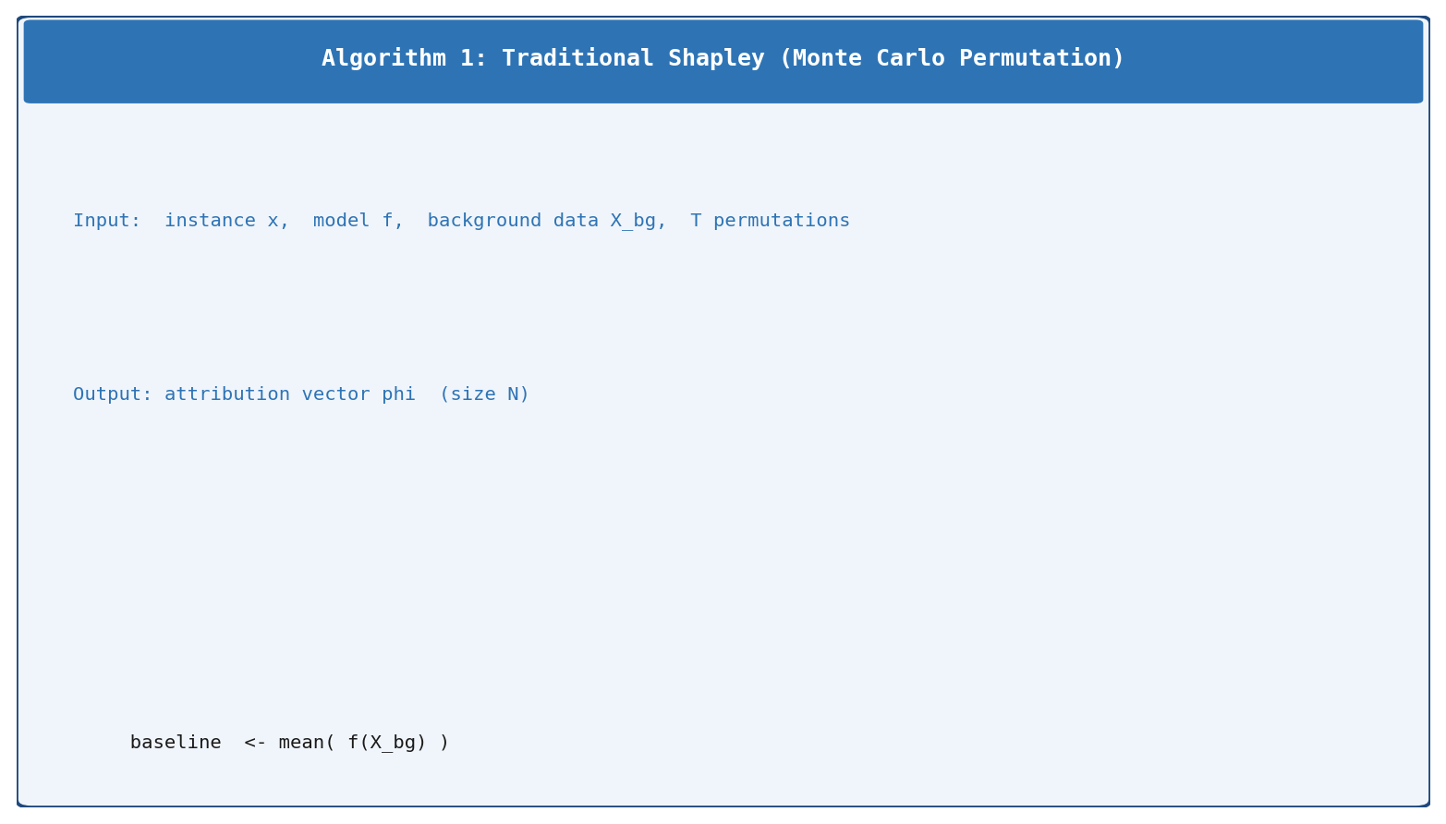
Figure 3.1: Algorithm 1 -- Traditional Shapley Monte Carlo estimator

3.4.2 Asymmetric Shapley Values
The AsymmetricShapley implementation retains the same observational marginalization as the Traditional Shapley baseline but replaces the uniform random permutation with a Kahn-style topological sort that samples uniformly from all valid linear extensions of the causal partial order. The modification is exclusively in the permutation space: coalition values are computed identically to Traditional Shapley via background marginalization.
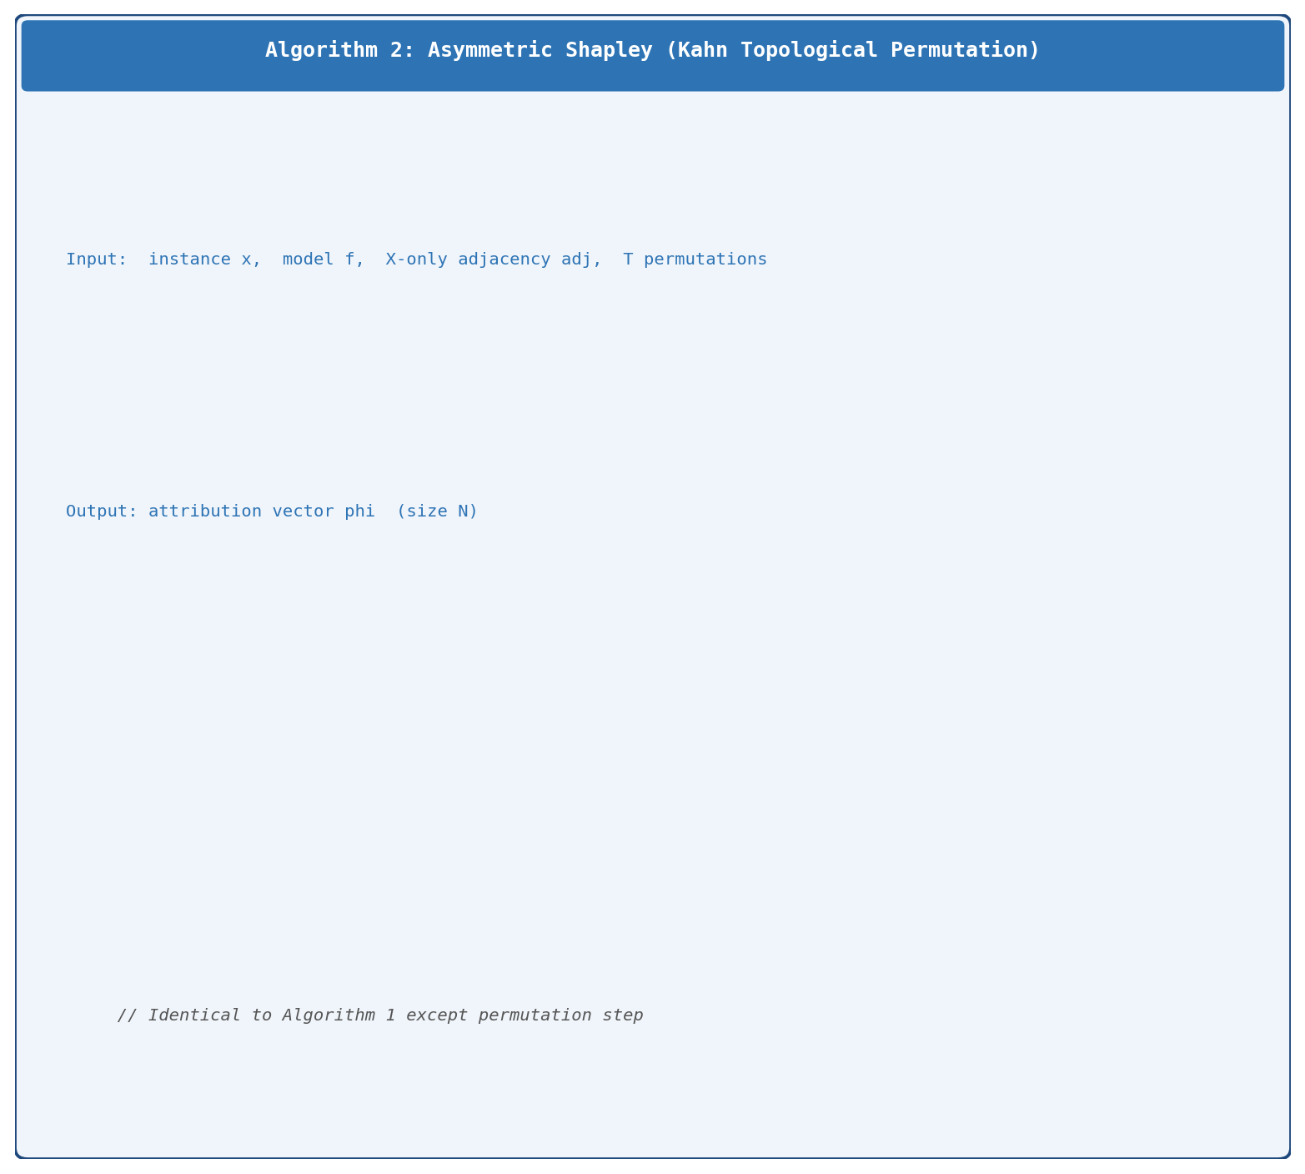
Figure 3.2: Algorithm 2 -- Asymmetric Shapley with Kahn topological permutation sampler

3.4.3 Causal Shapley Values
CausalShapley replaces background marginalization with post-interventional sampling to approximate Pearl's do-operator. For each absent feature, values are sampled from the closed-form conditional Gaussian distribution conditioned on that feature's causal parents (identified in the discovered X-only graph), not on all observed features. This is a key distinction from Gibbs sampling: only the direct parent set of each absent feature is used for conditioning, breaking the spurious correlations that would persist under observational conditioning. In this pipeline, the confounder list is passed as empty, so every feature forms its own individual component and the component-level topological ordering reduces to a feature-level topological ordering identical to Algorithm 2.
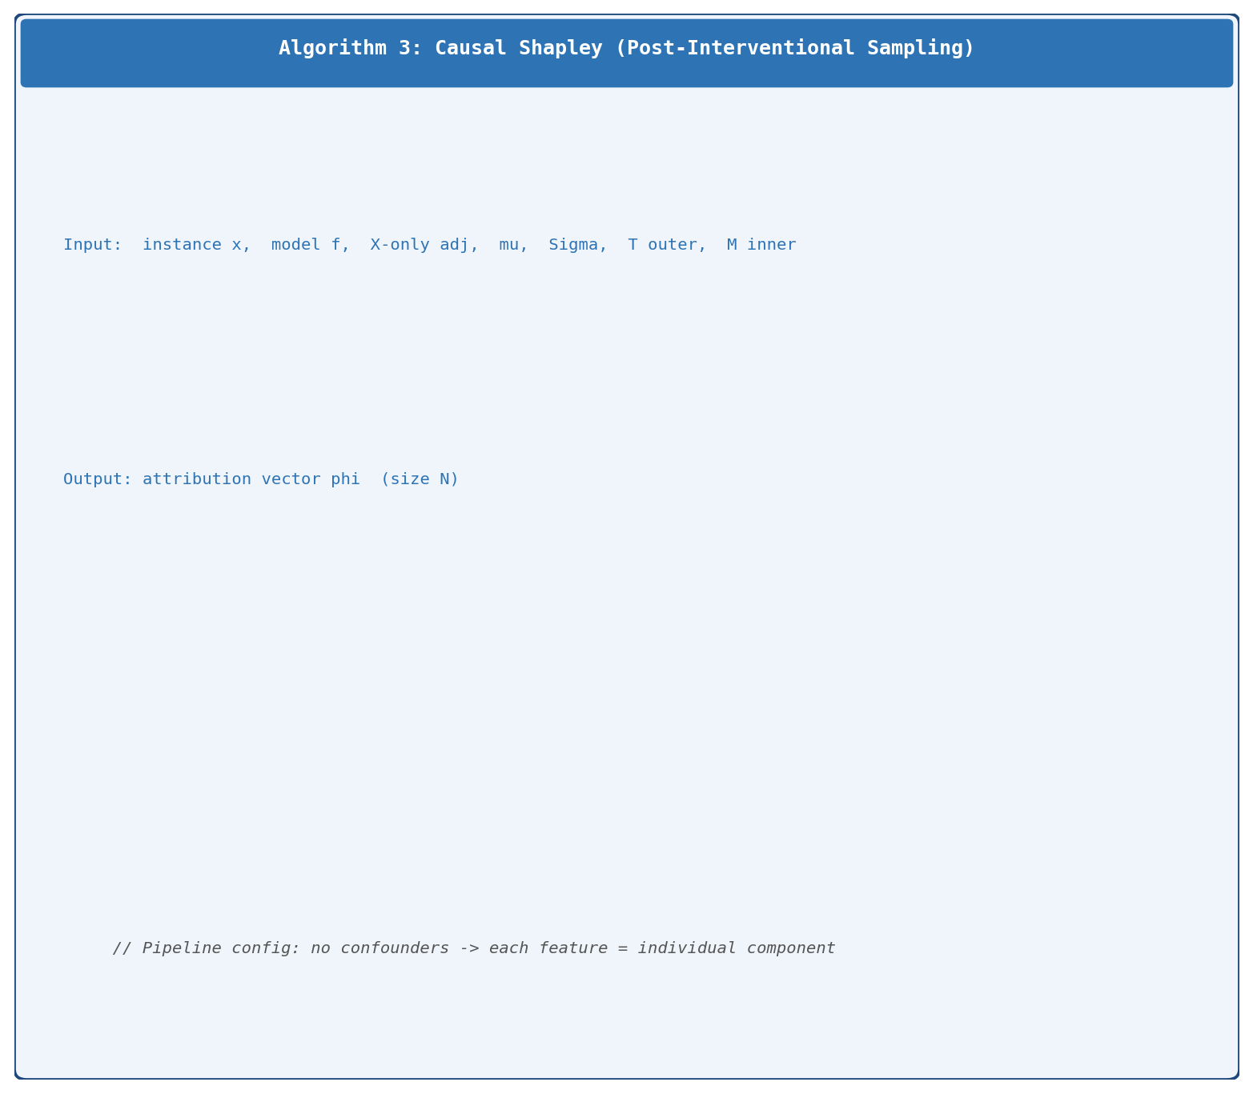
Figure 3.3: Algorithm 3 -- Causal Shapley with post-interventional Gaussian sampling

3.4.4 Shapley Flow
ShapleyFlowWrapper treats directed edges as the fundamental players in the cooperative game, permuting the full edge set rather than the feature set. In each of T = 100 trials, all edges (X->X and X->Y) are randomly permuted and activated sequentially. The node assignment rule is binary: a source node takes its foreground value if any of its outgoing edges are active; any other node takes its foreground value if any of its incoming edges are active; all remaining nodes take their background value. Critically, no intermediate model calls are made between X features -- the model is evaluated only on the complete node-value vector at each edge addition. This design deliberately avoids modeling causal X->X relationships via f(x), which would compound graph estimation errors with an additional source of approximation noise.
Node-level attributions are recovered by summing outgoing edge credits at each feature node. The X->Y augmentation discussed in Section 3.3.3 is essential here: without a direct edge from each feature to Y, features not connected to Y via any X->X path would receive zero attribution regardless of their actual contribution to the model prediction.
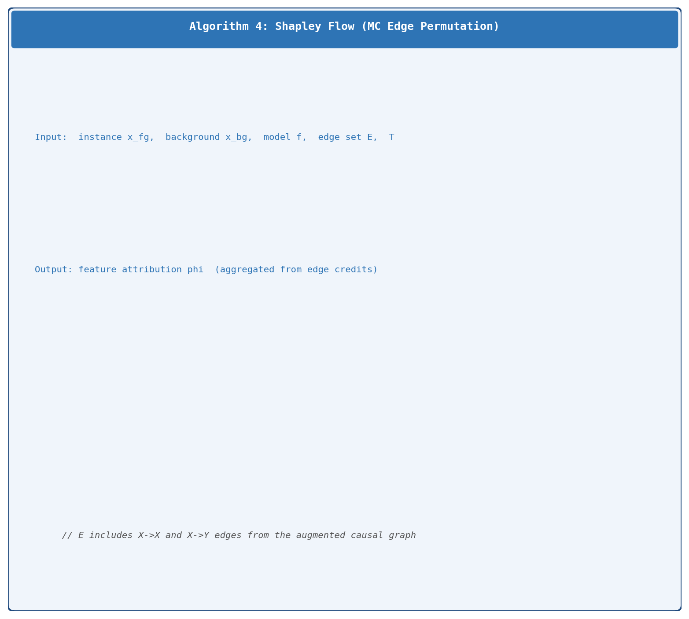
Figure 3.4: Algorithm 4 -- Shapley Flow with MC edge permutation

3.5 Evaluation Metrics

3.5.1 Notation
The following notation is used throughout the evaluation framework. Let N denote the number of input features, F = {1,...,N} the feature index set, and I the set of test instances (|I| = 100). Let f: R^N -> R denote the trained predictive model, and G = (V, E) a causal DAG over features and target Y, with V = F union {Y}.
Let m index the Shapley method (Traditional, Asymmetric, Causal, Flow), and G index the causal graph source (Traditional Shapley/no graph, PC, LiNGAM, True DAG). The per-instance per-feature attribution is denoted phi^{m,G}_{i,f}: the Shapley value assigned to feature f for instance i by method m using graph G. The mean absolute attribution (feature importance) for a given method-graph combination is phi-bar^{m,G}_f = (1/|I|) * sum_i |phi^{m,G}_{i,f}|.
Three reference configurations appear throughout the results. G_trad denotes Traditional Shapley (no graph), used as the graph-free baseline. G_true denotes the True DAG oracle, available only for the synthetic dataset. G_disc denotes a discovered graph (either PC or LiNGAM). For the Sachs dataset, G_trad replaces G_true as the reference where no oracle is available.

3.5.2 Metric Framework
The evaluation framework is organized along two orthogonal dimensions: the comparison type (against the Traditional Shapley baseline, against the True DAG oracle, or between the two discovery algorithms) and the aspect of the attribution being measured (magnitude and sign direction). Table 3.4 maps the six resulting metric cells.
Table 3.4: Evaluation Metric Framework
Aspect | vs. Traditional Shapley | vs. True DAG Oracle | PC vs. LiNGAM Sensitivity
Magnitude | Global absolute TGA vs. Traditional | Global absolute TGA vs. True DAG | Global absolute GSS
Sign / Direction | Sign Alignment vs. Traditional | Sign Alignment vs. True DAG | SSS (Sign Flip Rate = 1 - SSS)

3.5.3 Baseline and Oracle Magnitude Comparison
Global absolute TGA (Total Graph Alignment): Mean absolute deviation in per-feature attribution magnitude between two method-graph configurations, averaged over all features. Formally: global absolute TGA = (1/N) * Sum_{f=1}^{N} |phi-bar^{m,G_disc}_f - phi-bar^{m,G_ref}_f|, where G_ref is either G_trad (baseline comparison) or G_true (oracle comparison). A value near zero means the two configurations produce attribution magnitudes of the same scale across all features.

3.5.4 Baseline and Oracle Sign Comparison
Sign Alignment (SA): Per-feature rate at which a method-graph configuration agrees in sign with the reference configuration across all test instances, aggregated over features. SA = (1/N) * Sum_f (1/|{i: phi^{m,G_ref}_{i,f} != 0}|) * Sum_{i: phi^{m,G_ref}_{i,f} != 0} 1[sign(phi^{m,G_disc}_{i,f}) = sign(phi^{m,G_ref}_{i,f})]. Instances where the reference attribution is zero are excluded to focus on features with non-trivial reference signal. SA in [0,1]; SA = 1 means perfect directional agreement.

3.5.5 Discovery Algorithm Sensitivity
Global absolute GSS (Graph Sensitivity Score): Mean absolute difference in per-feature attribution magnitude between the PC-graph and LiNGAM-graph variants of the same method, averaged over features: global absolute GSS = (1/N) * Sum_f |phi-bar^{m,G_PC}_f - phi-bar^{m,G_LiNGAM}_f|. Values near zero indicate robustness to discovery algorithm choice.
SSS (Sign Stability Score): Per-feature rate at which the PC and LiNGAM variants of the same method agree on the sign of individual instance attributions: SSS = (1/N) * Sum_f (1/|{i: both nonzero}|) * Sum_i 1[sign(phi^{m,G_PC}_{i,f}) = sign(phi^{m,G_LiNGAM}_{i,f})]. Sign Flip Rate = 1 - SSS.

4. Results and Empirical Analysis

4.1 Causal Discovery Baseline Performance

4.1.1 Performance on the Confounded Linear System
The 5 hidden confounders introduce spurious correlations that directly violate the causal sufficiency assumption of both estimators. PC exhibits high structural resilience, recovering 40 of 87 true X->X edges with precision 0.741 and only 14 false positives (SHD = 61). Conditional independence tests can partially block confounder-induced association paths through careful conditioning, so PC maintains a structurally conservative graph close to the true sparse structure.
DirectLiNGAM experiences severe structural degradation, reporting 105 edges with only 24 correct and 81 false positives (F1 = 0.250, SHD = 144). The linear non-Gaussian functional model cannot distinguish a direct causal path from a confounder-induced correlation path, producing a densely over-connected graph. This over-discovery creates the central experimental contrast: the same Shapley methods receive fundamentally different structural priors from the two discovery algorithms.

4.1.2 Performance Reversal on the Sachs Cell Signaling Dataset
On the real-world Sachs dataset, the performance hierarchy reverses: LiNGAM outperforms PC (F1 = 0.286 vs. 0.171). Real intracellular signaling pathways generate joint distributions with strong non-Gaussian marginals even after log1p transformation, a property that LiNGAM's functional causal model exploits. PC's Fisher-z test, which assumes Gaussian residuals, loses discriminative power under this complexity. Both algorithms perform substantially worse on the real dataset than on the synthetic confounded case, despite the much larger sample size (5,972 vs. 800 training rows), confirming that real biological noise introduces assumption violations more severe than the synthetic confounded setting.

4.2 Graph-Free Baseline Deviation Analysis
Each combination of structure-aware Shapley method and discovered graph is compared against Traditional Shapley to measure how much injecting causal structure shifts the attributions. Tables 4.1 and 4.2 report Sign Alignment and global absolute TGA with Traditional Shapley as the reference.
Table 4.1: Baseline Deviation -- Linear-Conf Synthetic Dataset
Method | Graph | Sign Alignment vs. Traditional | Global Abs. TGA vs. Traditional
Asymmetric | PC | 0.949 | 0.0049
Asymmetric | LiNGAM | 0.942 | 0.0055
Causal | PC | 0.647 | 0.1972
Causal | LiNGAM | 0.661 | 0.1755
Flow | PC | 0.634 | 0.1803
Flow | LiNGAM | 0.623 | 0.1773

Table 4.2: Baseline Deviation -- Sachs Cell Signaling Dataset (raw Akt units)
Method | Graph | Sign Alignment vs. Traditional | Global Abs. TGA vs. Traditional
Asymmetric | LiNGAM | 0.766 | 1.890
Asymmetric | PC | 0.758 | 5.550
Causal | LiNGAM | 0.677 | 6.485
Causal | PC | 0.637 | 6.933
Flow | LiNGAM | 0.762 | 4.846
Flow | PC | 0.716 | 9.266

4.2.1 Asymmetric Shapley -- High Robustness to Graph Injection
Asymmetric Shapley achieves the closest agreement with the Traditional Shapley baseline across both datasets. On the synthetic track, Sign Alignment vs. Traditional = 0.949 (PC) and 0.942 (LiNGAM), with global absolute TGA below 0.006 for both graphs, less than 1% of the typical attribution scale. This stability follows from the high-dimensional topology buffer: with only 87 edges across 50 variables, the sparse graph constrains few of the possible permutations, leaving most coalition orderings and hence marginal contributions unaffected. Because ASV uses observational marginalization, restricting permutations to valid topological orders does not substantially change expected marginal contributions when the graph is sparse.
On the Sachs dataset, the buffer contracts. ASV with LiNGAM retains Sign Alignment = 0.766 and global absolute TGA = 1.890, while ASV with PC shows a larger shift (SA = 0.758, global absolute TGA = 5.550). The larger PC deviation arises because PC's conservative skeleton imposes stronger topological constraints in the compact 10-node network.

4.2.2 Causal Shapley -- Strong Deviation with Interventional Redistribution
Causal Shapley produces the largest divergence from Traditional Shapley on the synthetic dataset: Sign Alignment = 0.647-0.661 and global absolute TGA = 0.175-0.197. These deviations reflect a direct consequence of interventional conditioning: replacing observational marginalization with do-distributions redistributes credit from features that benefit from spurious correlations toward features whose contributions survive interventional control. On Sachs, the deviation scales with the complexity of the real data distribution, reaching global absolute TGA = 6.485 (LiNGAM) and 6.933 (PC) in raw Akt units.

4.2.3 Shapley Flow -- Intermediate Deviation with Sign Instability
Shapley Flow occupies a middle position in the deviation spectrum (Sign Alignment = 0.623-0.634 on synthetic; 0.716-0.762 on Sachs). The shift from node-level to edge-level credit assignment can invert the sign of individual instance attributions: a feature that increases the prediction under Traditional Shapley may show a negative Shapley Flow attribution if causal pathways to Y flow predominantly in the opposite direction through the graph. On Sachs, Flow with PC reaches global absolute TGA = 9.266, the largest magnitude deviation in the entire experiment, reflecting the combined effect of PC's conservative graph removing key pathway edges and the edge-routing mechanism amplifying this absence.

4.3 True-Graph Causal Alignment
The True-Graph Alignment analysis measures how closely each combination of structure-aware Shapley method and discovered graph recovers the attributions that would be obtained with the True DAG as input. Table 4.3 reports Sign Alignment and global absolute TGA with the True DAG oracle as the reference, available for the synthetic dataset only.
Table 4.3: True-Graph Alignment -- Linear-Conf Synthetic Dataset
Method | Graph | Sign Alignment vs. True DAG | Global Abs. TGA vs. True DAG
Asymmetric | PC | 0.941 | 0.0060
Asymmetric | LiNGAM | 0.937 | 0.0043
Causal | PC | 0.684 | 0.1232
Causal | LiNGAM | 0.625 | 0.2152
Flow | PC | 0.577 | 0.1496
Flow | LiNGAM | 0.551 | 0.2169

4.3.1 Asymmetric Shapley -- Near-Perfect Oracle Fidelity
ASV achieves the highest alignment with the True DAG oracle: Sign Alignment = 0.941 (PC) and 0.937 (LiNGAM), with global absolute TGA = 0.006 and 0.004 respectively. This near-zero magnitude deviation confirms that even when the discovered graph contains 81 false positives, ASV's observational marginalization absorbs the additional edges without meaningfully changing attribution magnitudes. In a 50-node sparse system, the true and discovered graphs share most of their valid topological orderings, producing nearly identical attributions regardless of graph source.

4.3.2 Causal and Flow -- Compounding Error Under Imprecise Graphs
CSV and Shapley Flow show substantial vulnerability to graph prior distortion. For CSV, LiNGAM's 81 false-positive edges inject spurious parent relationships into the interventional conditioning procedure. Each false parent link causes CSV to compute post-interventional distributions that do not correspond to any real causal mechanism, misrouting attribution credit. The result is Sign Alignment vs. True DAG = 0.625 and global absolute TGA = 0.215 for CSV+LiNGAM. PC's more conservative graph reduces but does not eliminate this distortion: Sign Alignment = 0.684, global absolute TGA = 0.123.
Shapley Flow shows a complementary vulnerability: PC's under-connected graph (54 discovered vs. 87 true edges) removes causal pathways along which credit should flow, causing systematic scale deviation (global absolute TGA = 0.150) and sign disagreements (Sign Alignment = 0.577). LiNGAM's over-connected graph creates excessive edge competition that distributes credit across spurious paths, yielding global absolute TGA = 0.217.

4.4 Discovery Algorithm Sensitivity Analysis
Tables 4.4 and 4.5 quantify how much the choice between PC and LiNGAM affects the final attributions for each Shapley method.
Table 4.4: PC vs. LiNGAM Sensitivity -- Linear-Conf Synthetic Dataset
Method | Global Abs. GSS | Sign Stability (SSS) | Sign Flip Rate
Asymmetric | 0.0071 | 0.941 | 5.9%
Causal | 0.2022 | 0.621 | 37.9%
Flow | 0.1884 | 0.867 | 13.3%

Table 4.5: PC vs. LiNGAM Sensitivity -- Sachs Cell Signaling Dataset (raw Akt units)
Method | Global Abs. GSS | Sign Stability (SSS) | Sign Flip Rate
Asymmetric | 0.737 | 0.814 | 18.6%
Causal | 4.970 | 0.682 | 31.8%
Flow | 8.343 | 0.781 | 21.9%

4.4.1 Asymmetric Shapley -- Minimal Sensitivity on Synthetic
On the synthetic dataset, ASV shows essentially zero sensitivity to discovery algorithm choice: global absolute GSS = 0.007, SSS = 0.941. Only 5.9% of (instance, feature) attribution signs differ between the PC and LiNGAM variants. In high-dimensional sparse settings, both graphs leave most ordering relationships unconstrained, and ASV's permutation sampling produces nearly identical attribution distributions regardless of which graph is supplied.
On the Sachs dataset, sensitivity increases to global absolute GSS = 0.737, SSS = 0.814, with an 18.6% sign flip rate. In the compact 10-node network, the different edge sets discovered by PC and LiNGAM impose materially different topological constraints, and these differences accumulate into visible attribution changes.

4.4.2 Causal and Flow -- High Sensitivity, Especially on Real Data
CSV and Shapley Flow are substantially more sensitive to discovery algorithm choice. On the synthetic dataset, CSV's global absolute GSS = 0.202 and Flow's global absolute GSS = 0.188 are roughly 28 and 26 times larger than ASV's respectively. CSV's 37.9% sign flip rate is the highest instability in the synthetic experiment: interventional conditioning inverts attribution signs when the parent sets differ between graphs, which occurs frequently given LiNGAM's 81 spurious edges.
On the Sachs dataset, the instability escalates further. CSV's global absolute GSS = 4.970 and Flow's global absolute GSS = 8.343 in raw Akt units indicate that choosing LiNGAM over PC produces CSV and Flow attributions that differ by several times the typical mean SHAP contribution per feature. At this level, the choice of discovery algorithm effectively becomes the dominant source of attribution variance.

4.5 Granular Case Studies
Three archetypal error mechanisms illustrate the micro-level behavior observed across both experimental tracks.

4.5.1 Out-Degree Inflation and Root Cause Overloading
Interventional frameworks (CSV) and edge-routing models (Flow) systematically over-inflate the attribution of any node incorrectly classified as a high-degree root source. On the synthetic dataset, feature X24 is a true direct parent of Y with 3 parents and 4 children. Under LiNGAM's over-connected graph, spurious incoming edges inflate its interventional parent set in CSV, causing it to absorb compounded attribution credit from paths that do not exist in the true graph.
The biological analog is protein pka, which functions as a dominant global predictor and true root source (0 incoming, up to 7 outgoing edges). LiNGAM correctly isolates pka as a root node, allowing CSV to assign large attributions through clean interventional conditioning. When PC incorrectly reverses several of pka's outgoing edges, CSV's conditioning misattributes pka's total effect to its incorrectly assigned parents, cascading the error across multiple downstream attributions.

4.5.2 Directed Edge Inversion and Causal Credit Transfer
This mechanism isolates the attribution penalties that occur when a discovery algorithm reverses the directed link between a true upstream non-parent and a dominant direct parent. On the synthetic dataset, PC incorrectly reverses the edge X21->X47, where X21 is an inactive non-parent and X47 is a dominant direct parent of Y. Under ASV, this reversal forces X21 to precede X47 in valid topological orderings, allowing X21 to absorb the marginal contribution that should belong exclusively to X47. Under CSV, the reversal inserts X21 as a false parent in X47's interventional conditioning set, directly contaminating the post-interventional distribution used to compute X47's attribution.

4.5.3 Confounded Subordination and Boundary Isolation
Synthetic feature X6 is a true intermediate channel with 3 parents and 4 children. Under LiNGAM, its parent set is inflated by 8 false incoming links. Under CSV, these false parents generate an overly constrained post-interventional distribution for X6, misrouting its attribution and exaggerating its apparent importance relative to the True DAG oracle.
The biological analog is protein erk on the Sachs dataset: in the consensus DAG, erk is a downstream node receiving inputs from pka and mek. PC deletes erk's parent links due to assumption violations, isolating it as a boundary source. Under Shapley Flow, this isolation assigns erk a disproportionately large attribution because no incoming edges distribute its credit to upstream nodes. Under CSV, the absence of parent constraints causes erk to receive attribution as if it were exogenous, when in reality its behavior is jointly determined by its upstream regulators.

5. Conclusion

5.1 Summary of Findings
This thesis constructed a comprehensive experimental pipeline to systematically evaluate how causal graph estimation errors propagate into structure-aware Shapley feature attributions. The pipeline integrates two causal discovery algorithms (PC and DirectLiNGAM), three structure-aware Shapley methods (Asymmetric Shapley, Causal Shapley, and Shapley Flow), a LightGBM predictive model, and a unified evaluation framework across a controlled synthetic benchmark and the real-world Sachs cell signaling dataset. The empirical findings organize around three central conclusions.
The three methods occupy fundamentally distinct sensitivity regimes with respect to graph estimation quality. Asymmetric Shapley Values are robust to graph errors: on the 50-feature synthetic dataset, replacing the True DAG with an imprecise discovered graph changes attribution magnitudes by less than 1% (global absolute TGA vs. True DAG < 0.006) and attribution signs by less than 6% (Sign Alignment vs. True DAG > 0.937). This robustness is structural: ASV's observational marginalization decouples attribution magnitudes from the specific edge set, and in high-dimensional sparse graphs, most topological orderings are compatible across both the true and discovered graphs. Causal Shapley Values and Shapley Flow are deeply sensitive to graph quality. CSV's interventional conditioning translates every false parent edge into a contaminated post-interventional distribution, and Flow's edge-routing mechanism amplifies graph errors across all downstream paths. On the Sachs dataset, the instability between PC and LiNGAM variants reaches global absolute GSS = 4.97 for CSV and 8.34 for Flow, values exceeding the mean SHAP attribution itself.
The performance advantage of discovery algorithms reverses between the synthetic and real experimental tracks. PC substantially outperforms LiNGAM on the confounded synthetic data (F1: 0.567 vs. 0.250), where conditional independence testing provides partial protection against latent confounders. On Sachs, LiNGAM outperforms PC (F1: 0.286 vs. 0.171), exploiting non-Gaussian protein concentration distributions. Neither algorithm achieves high absolute accuracy on either dataset, reinforcing that discovered causal graphs should be treated as noisy approximations rather than precise structural descriptions.
The unified Sign Alignment and global absolute TGA evaluation framework, applied consistently against both the Traditional Shapley baseline and the True DAG oracle, reveals that the deviation from the baseline and the alignment with the oracle are complementary dimensions. ASV deviates minimally from Traditional Shapley while simultaneously aligning closely with the True DAG oracle, indicating that its attributions are both stable and structurally faithful. CSV and Flow deviate substantially from Traditional Shapley but do not converge to the oracle either, suggesting that the large attribution shifts they produce are primarily driven by graph errors rather than by genuine causal signal.

5.2 Practical Recommendations
Asymmetric Shapley Values are the recommended default when a practitioner wants to incorporate causal structure without incurring attribution instability. In high-dimensional settings with sparse causal graphs, ASV produces attributions nearly indistinguishable from the oracle regardless of which discovery algorithm supplies the graph. The computational cost is identical to standard Monte Carlo SHAP, making ASV a low-risk augmentation for practitioners working in high-dimensional spaces.
Causal Shapley Values and Shapley Flow should be deployed only when a high-quality causal graph is available, for example a domain-expert validated graph or a discovery result with strong structural support. On the synthetic confounded dataset, using LiNGAM's erroneous graph with CSV produces attributions with global absolute TGA vs. True DAG = 0.215 and a 37.9% sign flip rate between PC and LiNGAM variants. In a real deployment context, this level of instability makes it impossible to provide consistent, justifiable explanations across audit runs.
The pipeline developed in this thesis provides a practical benchmark protocol: compute causal discovery quality metrics before running Shapley computation, and if quality is poor, particularly under suspected confounding, default to ASV or the Traditional Shapley baseline. For real datasets where ground truth is unavailable, cross-checking attribution stability across multiple discovery algorithms using global absolute GSS serves as a proxy for reliability: large global absolute GSS between PC and LiNGAM variants is a direct signal that the method's attributions are being driven more by graph uncertainty than by the model's actual predictive behavior.

5.3 Limitations and Future Work
Several limitations constrain the generalizability of these findings. The primary analysis was conducted on a single synthetic functional form (linear) and one real dataset. Nonlinear and mixed functional forms, different graph densities, and larger sample sizes remain to be evaluated. The full six-dataset synthetic battery of this pipeline was designed but the complete cross-dataset comparison exceeds the scope of the current work and is reserved for future analysis.
All Shapley computations use T = 100 Monte Carlo samples, a deliberate trade-off for the 50-feature system. Increasing T would reduce sampling noise and potentially reveal finer-grained differences between methods. The CausalShapley implementation uses a conditional Gaussian approximation (M = 10 inner samples), appropriate for linear systems but potentially underperforming on nonlinear datasets.
Future work should extend evaluation to nonlinear Shapley variants, explore ensemble graph approaches that average attributions across multiple discovered graphs to reduce instability, and investigate active learning strategies that use Shapley attribution uncertainty to guide iterative graph refinement.

References
Baron, S. (2023). Explainable AI and causal understanding: Counterfactual approaches considered. Minds and Machines, 33, 347-377. https://doi.org/10.1007/s11023-023-09632-w
Frye, C., Rowat, C., & Feige, I. (2021). Asymmetric Shapley values: Incorporating causal knowledge into model-agnostic explainability. Advances in Neural Information Processing Systems, 34, 1229-1239.
Glymour, C., Zhang, K., & Spirtes, P. (2019). Review of causal discovery methods based on graphical models. Frontiers in Genetics, 10, 524. https://doi.org/10.3389/fgene.2019.00524
Heskes, T., Sijben, E., Bucur, I. G., & Claassen, T. (2020). Causal Shapley values: Exploiting causal knowledge to explain individual predictions of complex models. Advances in Neural Information Processing Systems, 33, 4778-4789.
Lundberg, S. M., & Lee, S.-I. (2017). A unified approach to interpreting model predictions. Advances in Neural Information Processing Systems, 30, 4765-4774.
Mahajan, D., Tan, C., & Sharma, A. (2020). Preserving causal constraints in counterfactual explanations for machine learning classifiers. Advances in Neural Information Processing Systems, 33.
Pearl, J. (2009). Causality: Models, reasoning, and inference (2nd ed.). Cambridge University Press.
Sachs, K., Perez, O., Pe'er, D., Lauffenburger, D. A., & Nolan, G. P. (2005). Causal protein-signaling networks derived from multiparameter single-cell data. Science, 308(5721), 523-529. https://doi.org/10.1126/science.1105809
Scheines, R. (2024). Example causal datasets: Sachs [Data repository]. Carnegie Mellon University, Department of Philosophy. https://github.com/cmu-phil/example-causal-datasets/tree/main/real/sachs
Shimizu, S., Hoyer, P. O., Hyvarinen, A., & Kerminen, A. (2006). A linear non-Gaussian acyclic model for causal discovery. Journal of Machine Learning Research, 7, 2003-2030.
Shimizu, S., Inazumi, T., Sogourou, Y., & Hyvarinen, A. (2011). DirectLiNGAM: A direct method for learning a linear non-Gaussian structural equation model. Journal of Machine Learning Research, 12, 1225-1248.
Spirtes, P., Glymour, C., & Scheines, R. (2000). Causation, prediction, and search (2nd ed.). MIT Press.
Wachter, S., Mittelstadt, B., & Russell, C. (2018). Counterfactual explanations without opening the black box: Automated decisions and the GDPR. Harvard Journal of Law & Technology, 31(2), 841-887.
Wang, J., Wiens, J., & Lundberg, S. (2021). Shapley flow: A graph-based approach to interpreting model predictions. Proceedings of the 24th International Conference on Artificial Intelligence and Statistics (AISTATS), PMLR 130.

