Mapping Social Ecological Systems Archetypes

Juan Rocha, Katja Malmborg, Line Gordon, Kate Brauman and Fabrice DeClerk

15 July 2016

## Outline

The paper is written for PNAS audience = 3500 words max. It should focus on the method development and how it is useful on the context of poverty alleviation and food security. Roughly:

* Abstract 200w
* Intro and problem setting 1000w
  + SDG's: how do we target, measure and monitor progress in developing context?
  + volta river basing as case study
* Method 500w (it's a methods paper so it should have a methods section, but technical details should go at the end)
  + In a nutshell it's a clustering problem: how others have done it
  + Space and time
* Results 500w
  + Figure 1. Clustering all: an schema of the SES framework + clusters based on full data
  + Figure 2. the cube
  + Figure 3. Interactions vs others * 12 = the movie -> change of archetype over time?
* Discussion 1000w
* Conclusion 300w
* Methods
  + Data
  + Clustering & mapping
  + Temporal trends
* Refs 30max
* Appendix / complementary material
  + App1. All variables mapped with normalized and raw distribution
  + App2. Correlogram
  + App3. Master table (var_name, units, source, time period, Ostrom match)

## Abstract

Achieving sustainable development goals requires targeting and monitoring sustainable solutions tailored to different social and ecological contexts. Elinor Ostrom stressed that there is no panaceas or universal solutions to environmental problems, and developed a social-ecological systems' (SES) framework -a nested multi tier set of variables- to help diagnose problems, identify complex interactions, and solutions tailored to each SES arena. However, to our knowledge, the SES framework has only been applied to few hundred cases (archived in two public databases: [SES Library](https://seslibrary.asu.edu) and [SES Meta Analysis Database](https://sesmad.dartmouth.edu) ), and typically reflect the analysis of local case studies with relatively small coverage in space and time. While case studies are context rich and necessary, their conclusions might not reach policy making instances. Here we develop a data driven method for upscaling Ostrom's SES framework and applied to a context where we expect data is scarce, uncomplete, but also where sustainable solutions are badly needed. The purpose of upscaling the framework is to create a tool that facilitates decision making on developing countries. We mapped SES archetypes by applying the SES framework to poverty alleviation and food security issues in the Volta River basin in Ghana and Burkina Faso.

## Introduction

Zero hunger and no poverty are the first two sustainable development goals [REF]. Together with clean water and sanitation, they conform the most basic needs of human beings. Understanding how societies and ecosystems self-organize to provide these goods and services, to meet these basic needs, is a core challenge of sustainability science. Nobel prize winner Elinor Ostrom advocated embrassing social-ecological complexity. Ostrom recognized that there is no universal solution to problems of destruction of overuse of natural resources (Ostrom 2007) and further developed a Social-Ecological Systems' (SES) framework hoping that it will helps us accumulate knowledge and better understand what works and what does not in different SES arenas (Ostrom 2009).

## Method summary

## Results

## Discussion

## Conclusion

## Methods

# References

This is an R Markdown document. Markdown is a simple formatting syntax for authoring HTML, PDF, and MS Word documents. For more details on using R Markdown see <http://rmarkdown.rstudio.com>.

When you click the **Knit** button a document will be generated that includes both content as well as the output of any embedded R code chunks within the document. You can embed an R code chunk like this:

summary(cars)

## speed dist   
## Min. : 4.0 Min. : 2.00   
## 1st Qu.:12.0 1st Qu.: 26.00   
## Median :15.0 Median : 36.00   
## Mean :15.4 Mean : 42.98   
## 3rd Qu.:19.0 3rd Qu.: 56.00   
## Max. :25.0 Max. :120.00

You can also embed plots, for example:

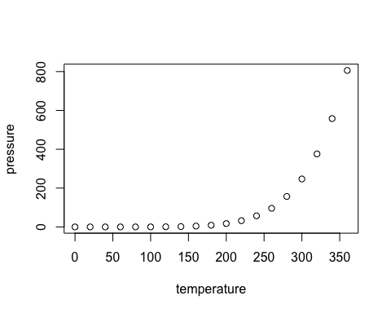

Note that the echo = FALSE parameter was added to the code chunk to prevent printing of the R code that generated the plot.

Ostrom, Elinor. 2007. “A diagnostic approach for going beyond panaceas.” *Proceedings Of The National Academy Of Sciences Of The United States Of America* 104 (39): 15181–7. doi:[10.1073/pnas.0702288104](https://doi.org/10.1073/pnas.0702288104).

———. 2009. “A general framework for analyzing sustainability of social-ecological systems.” *Science* 325 (5939): 419–22. doi:[10.1126/science.1172133](https://doi.org/10.1126/science.1172133).