**Synthentic Financial Manager System For Fraud Transactions**

|  |  |  |
| --- | --- | --- |
| Version | Author | Date |
| V1 | Juan Guillermo Rute Sanabria | April 11,2018 |
|  |  |  |

**Introduction**

This document allow us to show the important decisions taken for the implementation of the application.

**Technologies**

In the table below shown the principal tools and technologies used in the implementation.

|  |  |
| --- | --- |
| **Tool or Technology** | **Description** |
| Microsoft Visual Studio Professional 2017 | Development Environment |
| .NET Framework 4.6.1 | Framework |
| C# | Main programing language used for the development. |
| ASP.NET Web Application | Template of .Net Framework using MVC |
| Git Desktop V 1.1.1 | Tool to our repositories od source code. |
| SQL Server 14.0.17 | DataBase server using the SQLEXPRESS version. |
| Bootstrap | Front-end component library to build responsive pages |
| Razor | Markup syntax that allow us embed c# code in the views |
| Unity | Dependency injection container |

**Model Entity Relationship**

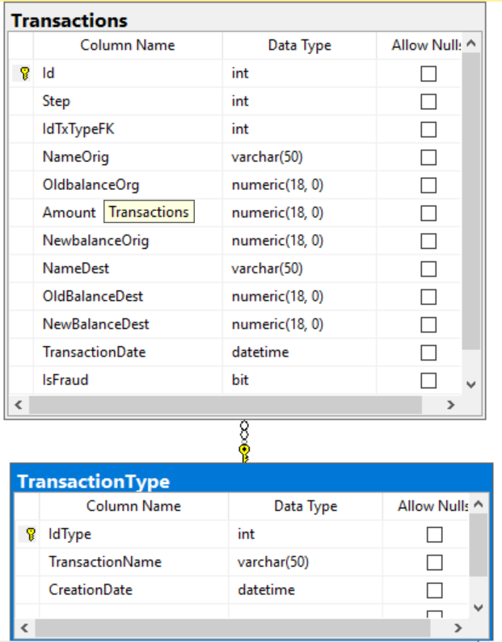

Ilustración 1Entity Relationship

Class Diagram

An storeproced called TransactionsSp was created to manage all the methods of the service

**Web Services**

Xml

<http://localhost:54041/api/Assistant?name=R>

<http://localhost:54041/api/Assistant>