# User manual Web Service

## Wep Api

Documentation of the method exposed (http://{ip}:{port}/Help):

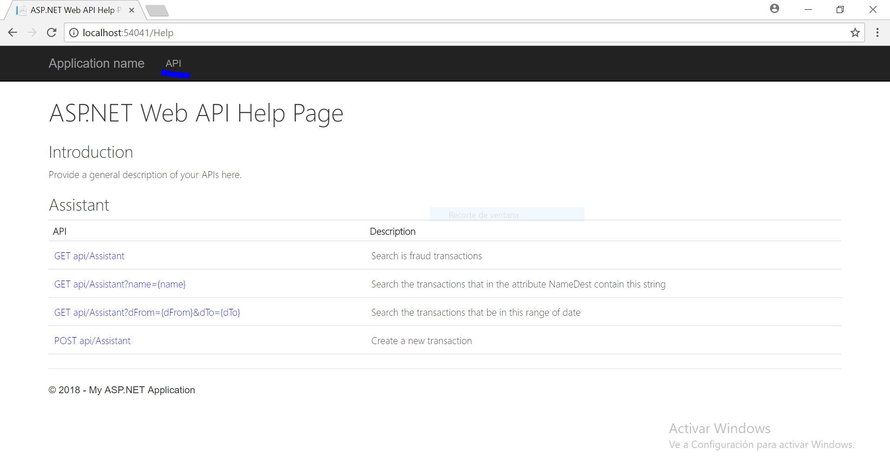

# **Web Services**

## Request

http://{ip}:{port}/api/Assistant

Description: Search all fraud transactions

## Response

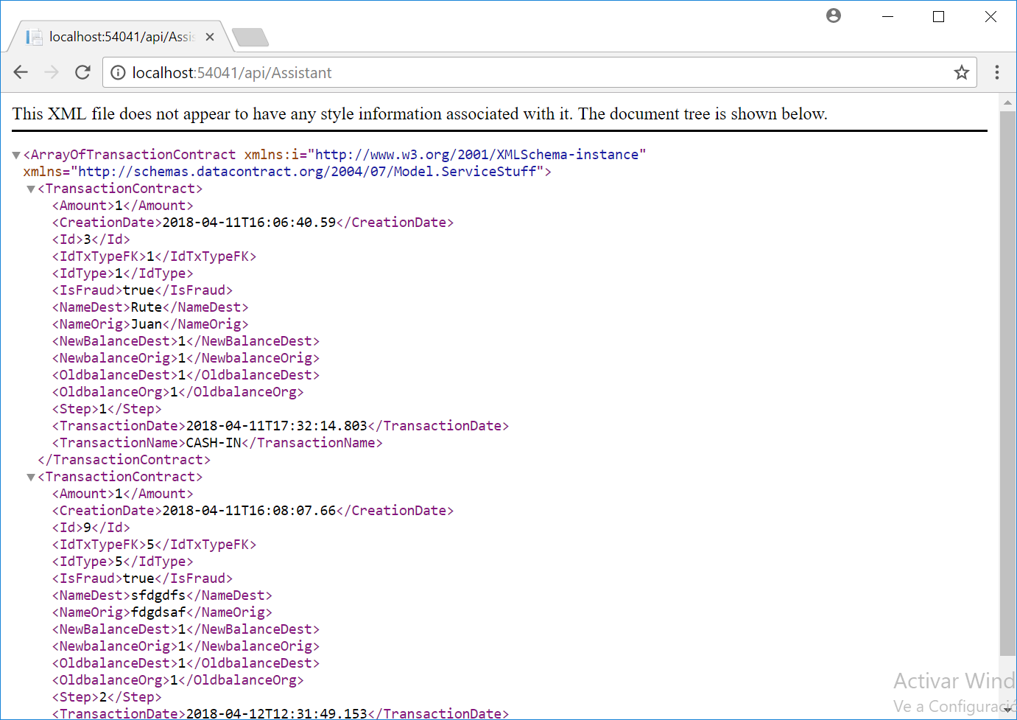

## Request

http://{ip}:{port}/api/Assistant?name=Rute

Description: Search all transactions that NameDest contain ‘Rute’

## Response

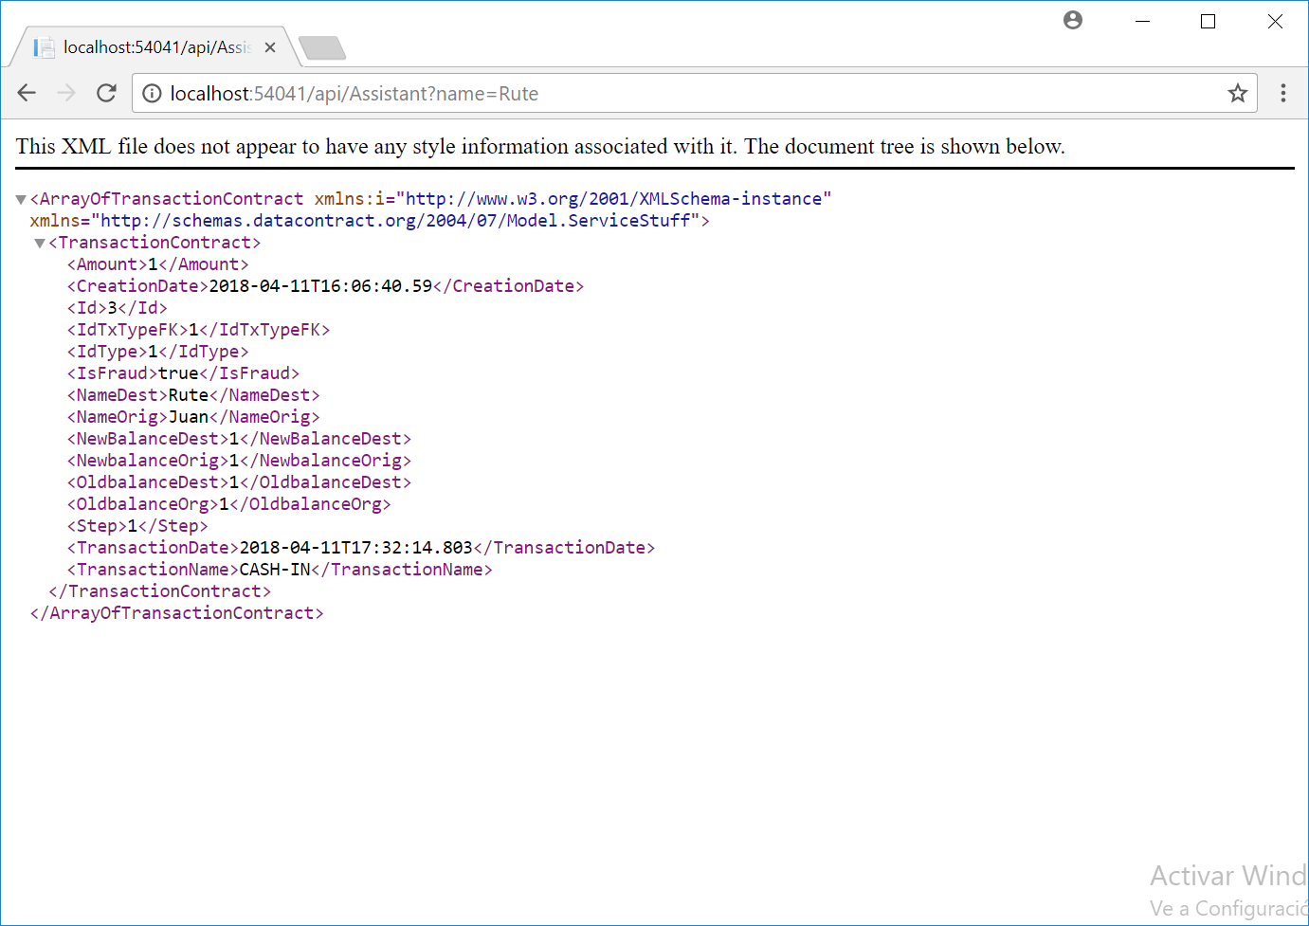

## Request

http:/ /{ip}:{port}/api/Assistant?dFrom={dFrom}&dTo={dTo}

Description: Search the transactions that be in this range of date

## Response