# User Manual

Contenido

User Manual 1

Web Application 1

Show Contact 2

Create Transaction 2

Apply Filters 4

IsFraud 4

NameDest 5

Mark transaction as a fraud 5

Detail 7

## Web Application

To start the project you must open the solution called ‘FraudTransactionsJuanRute’ in visual studio 2017, after that run the project ‘FraudTransactionsJuanRute’.

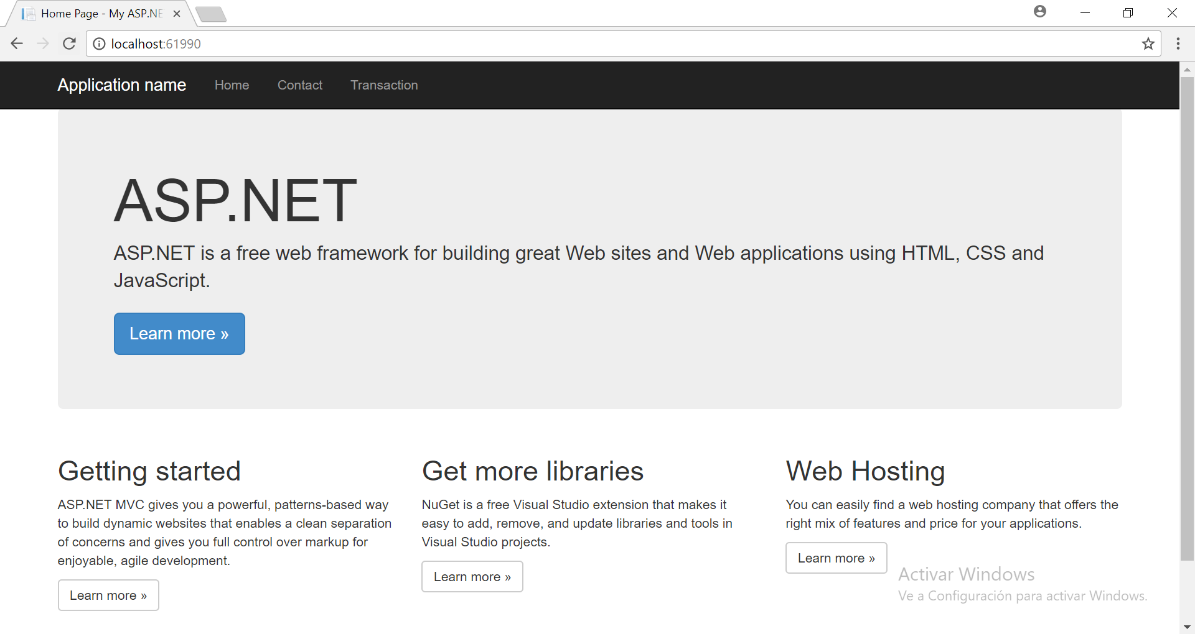

## Show Contact

Select Contact option to show all developer information:

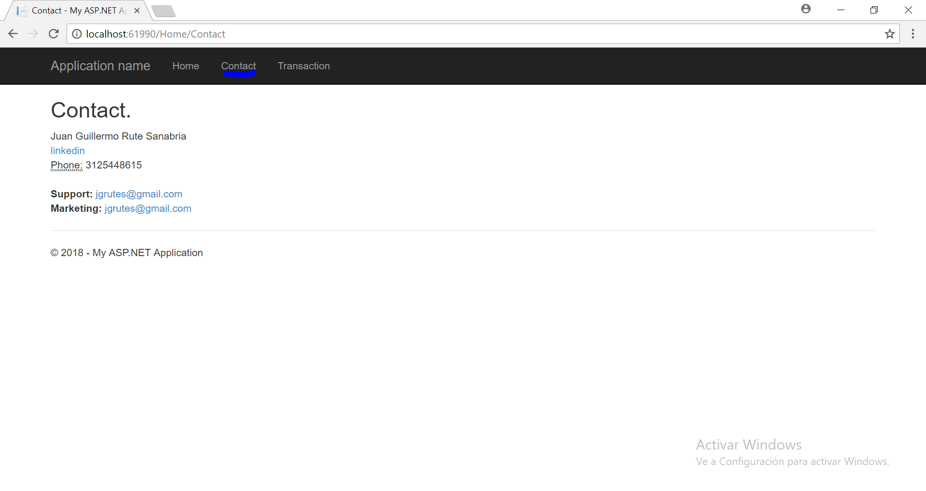

## Create Transaction

Select ‘Transaction’ option to see the main page of the solution, here you can see all the transactions and see the different options implemented:

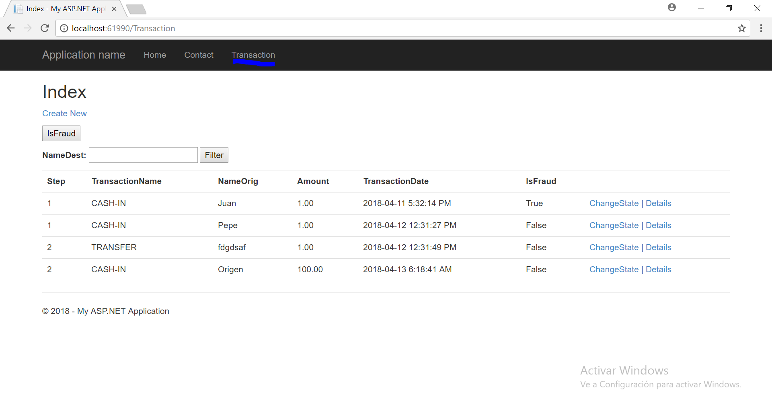

First you can create a new transaction, select ‘Create New‘ link:

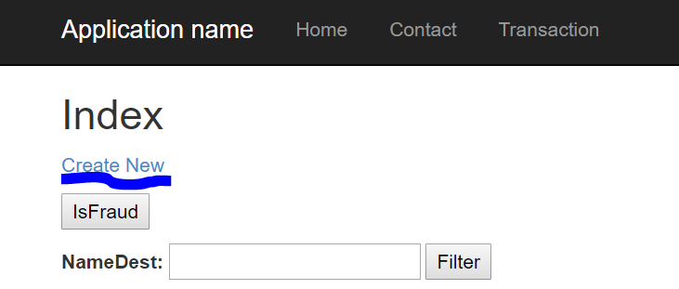

Fill the form rendered and click on create:

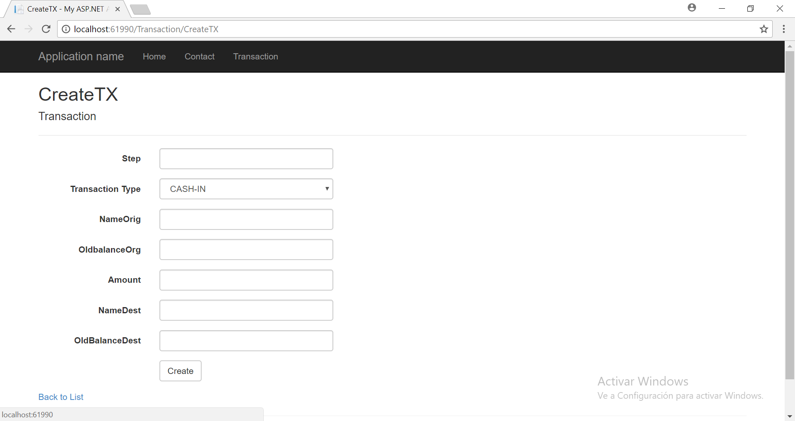

## Apply Filters

### IsFraud

If you want to show only the fraud transaction click on “IsFraud” button:

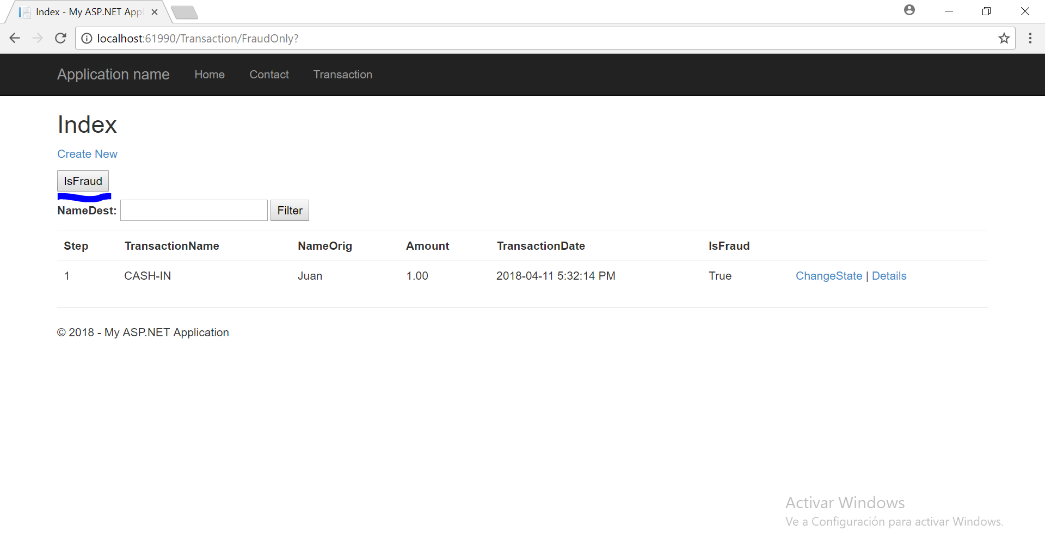

### NameDest

If you want to filter by destination name fill the textbox NameDest and click on “Filter” button:

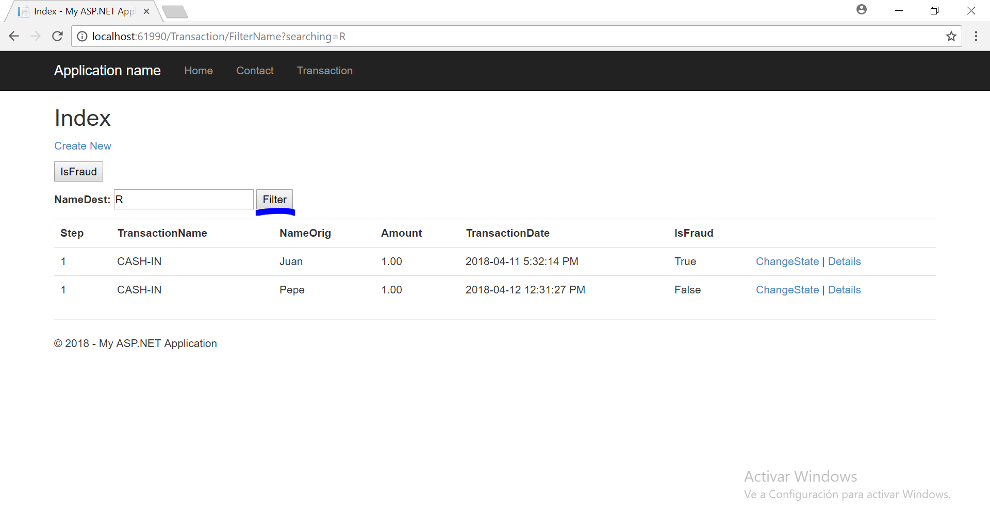

## Mark transaction as a fraud

We can change the status of the transaction clicking on “Change State” link:

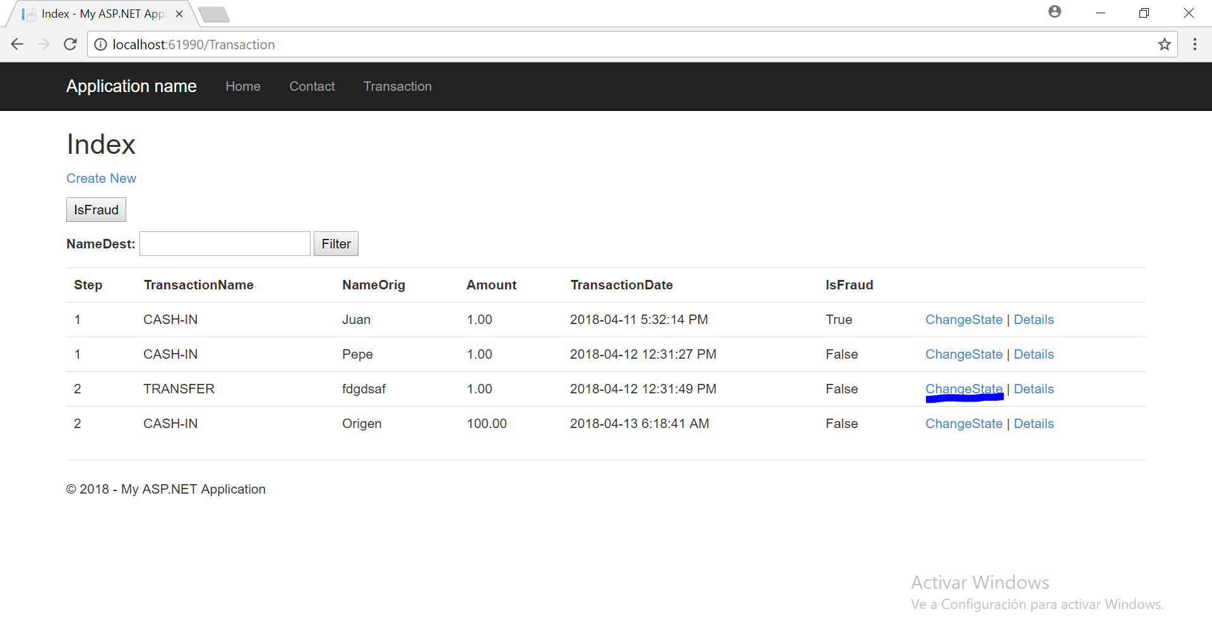

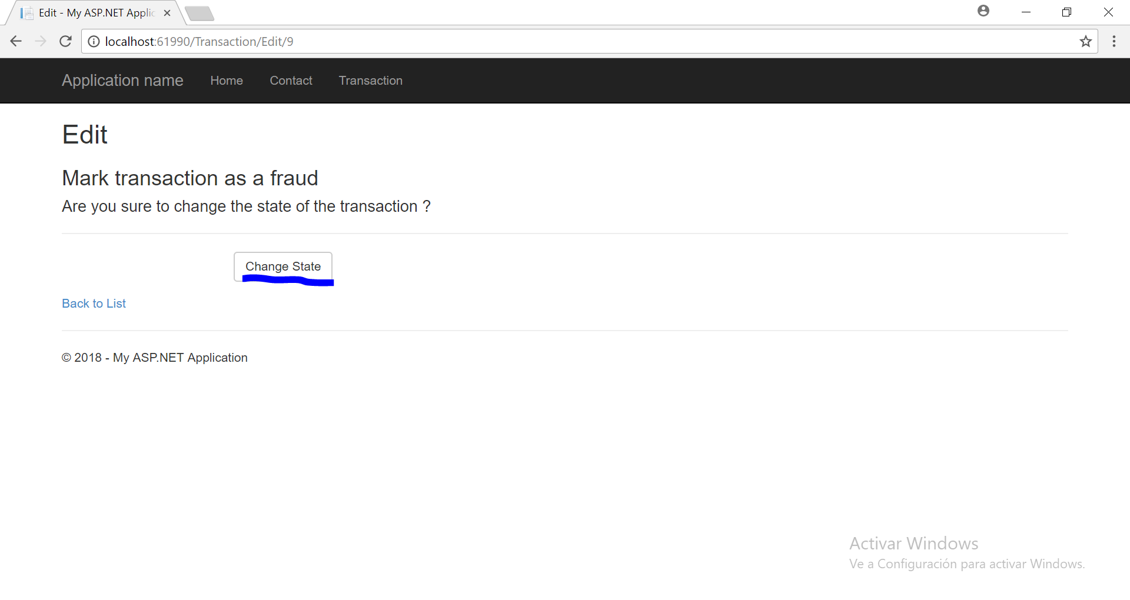

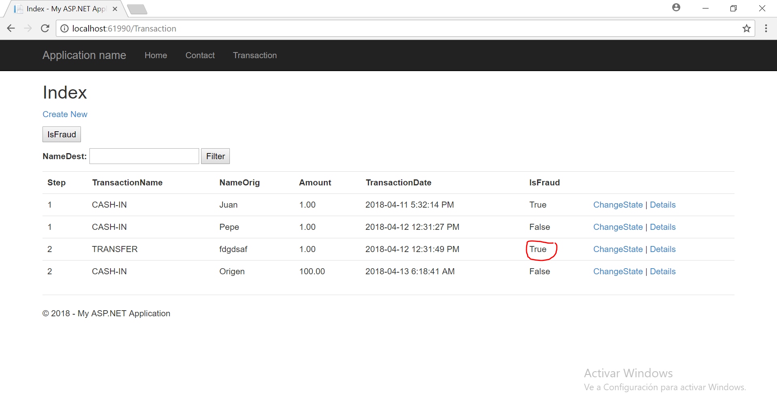

## Transaction Detail

Detail option is accessible by “Detail” link:

