Cupi2 Project | ISIS-1204 Algorithms and Object Oriented Programming 1  Description
Exercice: | Sudoku
Author: | man-muno
Date: | 01_02_2007

Description
The Sudoku is a game that has existed for some years, but recently has become popular worldwide. The basic idea of the game is to use logic to solve a simple problem, no need to have math skills to play.

The Sudoku board is composed of a 9 x 9, in which cells are grouped into nine areas. Each zone contains 9 squares, as shown below:
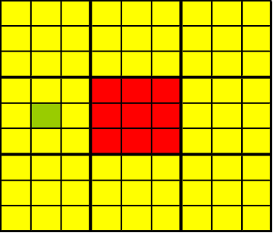

Board.
An area.
A cell.

From some numbers that are already placed, the idea of the game is to put a number from 1 to 9 in each of the cells following the bellow rules:

- The column of the board where the number is going to be placed cannot contain the same number.
- The row of the board where the number is going to be placed cannot contain the same number.
- The area cannot contain repeated numbers.
- Each Sudoku has a unique solution.

Each area is identified with a number so it can be identified easily.

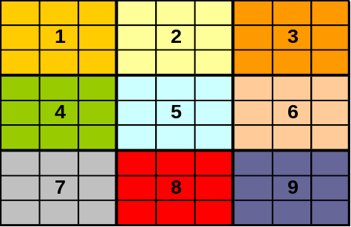

An application to play sodoku is needed. The application must allow to:
- Load a new game from a properties file which contains the numbers of the solution. In each area there must be at least three numbers to begin the game.
- Allow the user to add (and modify) the numbers in each cell of the board that is empty.
- Verify, at any time, the numbers entered by the user. To make the application friendlier, a color standard has been defined to show the errors to the user o to let him know when the game is over.

The cell is not empty.
The number is in a cell in an area, row or column where the rules are not complied.
The number in the cell is correct (it is shown only when the game is correct and completed, additionally a an information message is displayed informing that the game is over)
The cell has a number entered by the user that is ready to be validated when all the cells are filled.
- Show the Sudoku solution that is being played. The usage of this option implies the end of the game and the replacement of the values entered by the user with the solution.

Graphical user interface
