Epidemiological shifts and trends in visceral leishmaniasis incidence, relapse, and mortality in Brazil, 2007-2023: Analysis using National Notifiable Diseases Information System (SINAN)
Dawit Getachew Assefa^{1,2,3}, Glaucia Cota⁴, James P. Wilson^{1,2}, Jessica Andretta Mendes²,
Caitlin Naylor^{1,2}, Rhys Peploe^{1,2}, Sauman Singh-Phulgenda^{1,2}, Makoto Saito^{1,2}, Philippe J
Guerin^{1,2}, Prabin Dahal^{1,2*}
¹Infectious Diseases Data Observatory (IDDO), Oxford, UK
²Centre for Tropical Medicine and Global Health, Nuffield Department of Medicine, University of Oxford, Oxford, UK
³Department of Nursing, College of Health Science and Medicine, Dilla University, Dilla, Ethiopia
⁴Instituto René Rachou, Fiocruz Minas, Belo Horizonte, Minas Gerais, Brazil

Shorthand title: Visceral Leishmaniasis in Brazil

*Correspondence:
prabin.dahal@ndm.ox.ac.uk
Infectious Diseases Data Observatory (IDDO), Oxford, UK

Keywords: Visceral Leishmaniasis, Epidemiology, Brazil, South America
Abstract
Background: Brazil accounts for over 90% of visceral leishmaniasis (VL) cases reported in South America. VL is a notifiable disease in the country, with patient records captured in the Sistema de Informação de Agravos de Notificação (SINAN) system.
Methods: We reviewed 55,723 patient records from the open-access SINAN database, 2007-2023, to present temporal trends in patient demographics, drug regimens administered, and treatment outcomes. Disease incidence was modelled using a negative binomial regression, and predictors of mortality were assessed using multivariable logistic regression.
Findings: The annual VL incidence decreased by 6% per year (incidence rate ratio (IRR): 0.94, 95% confidence interval (CI): 0.92–0.97). The median age of patients increased from 10y [interquartile range (IQR): 2-33] in 2007 to 32y [IQR: 7-48] in 2023. The proportion of patients presenting with a relapse steadily increased over time with an odds ratio (adjusted for HIV) of 2.10 (95% CI: 1.87–2.37) for the 2019-2023 period compared to 2007-2009. During the same period, the use of liposomal amphotericin B increased from 6.1% to 38.1%, displacing pentavalent antimony, which declined from 68.0% to 32.7%. Following treatment, death from VL was highest among infants (10.3%, 425/4,125), and patients >50y (19.3%, 1,471/7,615), compared to the other age groups (3.5%, 2.2%, 8.0% among 1-5y, 5-15y and 15-50y, respectively).

Interpretation: The significant shift towards older patients and increased relapse proportions highlights a major change in disease epidemiology in the country. These findings indicate targeted surveillance and age-specific treatment strategies are necessitated, prioritising interventions for older and relapsing patients.

Funding: Wellcome Trust and WHO/TDR

Word count: Abstract: 248 (max allowed: 250)
Main text: 3,668 (max allowed: 3500-5000)
Keywords: Visceral leishmaniasis, SINAN, surveillance, Brazil, relapse, mortality

Introduction
Visceral leishmaniasis (VL) is principally endemic in four regions: the Indian sub-continent (ISC), East Africa, the Mediterranean basin and South America [1]. In the Americas, the transmission of the disease is zoonotic with L. infantum as the causative parasite and dogs as the main reservoir [2]. In particular, over 90% of the VL in the region is accounted for by Brazil, and approximately 3,500 cases are reported annually [2,3].
VL disproportionately affects the Northeast regions of Brazil and is strongly linked to poverty, malnutrition, environmental changes, and migration patterns [4]. Over the past three decades, the endemicity of disease has expanded from rural areas in the North and Northeast regions to many urban areas and newly developed cities throughout the country [2,5]. VL thus continues to be a major public health concern in Brazil and is recognised as a notifiable disease in the country. All cases in contact with the health system are therefore required to be reported to the national surveillance project - the Sistema de Informação de Agravos de Notificação (SINAN) system [6].
The SINAN system uses a harmonised case-report form for capturing key patient details and has been doing so since 2007. The anonymised version of the records captured within the system is publicly available [6]. The database therefore provides a unique opportunity to investigate the evolution of epidemiological features of the diseases over time, and many studies have investigated the geographical distribution of disease and mortality patterns using this database [3,4,7]. However, a comprehensive description of the disease characteristics, patient demographics, and treatment outcome are currently lacking, particularly looking at trends over time. This is particularly important as there have been several changes in the treatment strategy in the country over the past 20 years (Box 1).
In this study, we describe the spatio-temporal distribution of VL and summarise temporal trends in patients’ characteristics, drug regimens used, and treatment outcomes.
Methodology
Study setting and population
Brazil is divided into five geographical regions: North, Northeast, Central-West, Southeast and South. It comprises 27 federative units, that is, one federal district and 26 states. The states are further divided into 5,570 municipalities with a total population of approximately 212 million inhabitants in 2024 [8].

Data source
Data from 2007 to 2023 were obtained through the SINAN portal of the Brazilian Ministry of Health, accessed via the Department of Informatics of the Unified Health System (DATASUS) [6]. The following information was extracted and summarised by age, sex, ethnicity, presence of signs and symptoms at presentation, and HIV status. Details of the disease presentation and treatment were captured, including diagnostic method used for confirmation, type of case at presentation (new versus relapse cases), drug regimen administered, and treatment outcomes (cured/mortality/transferred).

Statistical analyses
Case presentation and clinical characteristics
The analysis included a comprehensive set of variables encompassing demographics, spatio-temporal information, and clinical characteristics. Spatio-temporal data included the federative unit where the case was reported, the likely location of infection, and the year of notification. Clinical variables covered key aspects such as symptom onset, reported symptoms, diagnostic methods, treatment dates, treatment type, treatment failure, and patient outcomes. Additionally, where applicable, the dataset included information on the date of death, providing a more detailed understanding of disease progression. We evaluated temporal trends in VL incidence, age and sex distribution, relapse frequency, VL-HIV co-infection, and treatment regimens used.
Linear mixed-effects regression with random intercepts across federative units was applied to evaluate the association between time period and patient age at enrolment. We examined the association between age and clinical symptoms at presentation using a mixed-effects logistic regression model. Age was scaled to allow interpretation per standard deviation increase and to improve model convergence. Federative units were included as random intercepts to account for clustering. For outcomes such as clinical symptoms at presentation, univariable logistic regression was used to explore crude associations with age.

VL incidence rate and spatio-temporal visualisation
Spatial heterogeneity in VL incidence was visualised using choropleth maps of federative units. The average annual incidence of VL was calculated at each federative unit and across pre-defined time periods. The annual incidence rate was computed as the number of confirmed cases divided by the population at risk, multiplied by 100,000. We categorised cases into four time periods (2007–2009, 2010–2014, 2015–2018, and 2019–2023) based on the year of notification to reflect distinct epidemiological and programmatic phases. For each federative unit and time period, mean annual incidence was computed to account for year-to-year variation. Transmission intensity was classified based on the Ministry of Health criteria: no transmission (mean=0 cases), sporadic (mean >0 and <2.4 cases), moderate (mean ≥2.4 and <4.4 cases), and intense (mean ≥4.4 cases) [11]. The population data was obtained from the Brazilian Institute of Geography and Statistics [8]. The shape files for administrative boundaries were obtained using geobr R package [12].
VL incidence and relapse
A negative binomial regression assessed the relationship between calendar year and disease incidence. Incidence rate ratios (IRRs) and corresponding 95% confidence intervals (CIs) were reported. Multivariable logistic regression models examined the associations between calendar time and incidence of relapse, adjusting for HIV status.

VL mortality
For mortality, univariable models assessed associations with age, sex, HIV status, treatment regimen, time period, and variables deemed clinically relevant were included in multivariable logistic regression models. Percentages for treatment outcomes were calculated using only cases with known treatment outcomes as the denominator. All analyses were performed using R statistical software version 4.3.2[13].

Ethics
This study used publicly available and anonymised data provided through the DATASUS platform of the Brazilian Ministry of Health. As the dataset contained no information that could identify individuals, such as names or addresses, and posed no risk to the study population, approval from a Research Ethics Committee was not required, in accordance with Resolution No. 466/2012 of the National Health Council (CNS), dated 12 December 2012 [14].
Role of the funding source
The funder of the study had no role in study design, data collection, data analysis, data interpretation, or writing of the report.

Results

Disease incidence and spatio-temporal trends
Between 2007 and 2023, a total of 55,723 confirmed VL cases were reported (Figure 1). The annual incidence rate of the VL (per 100,000 inhabitants) was 0.54 [95% CI: 0.53-0.55] during 2007-2009, 0.48 [95% CI: 0.47-0.49] during 2010-2014, 0.49 [95% CI: 0.48-0.50] during 2015-2018, and 0.21 [95% CI: 0.20-0.21] during 2019-2023. Each additional calendar year was associated with a 6% decrease in annual case incidence (rate ratio (RR): 0.94, 95% CI: 0.92-0.97). Overall, 40% (21,884) of the cases were reported from a few federative units, including Ceará, Minas Gerais, and Maranhão. The average annual spatio-temporal incidence rate identified Tocantins consistently had the highest VL incidence rate, followed by Maranhão, and Mato Grosso Do Sul, with an intense average annual incidence of >4.4 cases per 100,000 (Figure 2). This was followed by Piauí, Ceará, and Pará. A notable surge occurred between 2015 and 2018 in Pará, Bahia, and Minas Gerais, followed by a decline (Figure 2).

Patient characteristics
The overall median age at presentation was 19 years [interquartile range (IQR): 3-41y, range: 0-102y] with 8.5% (4,741/55,723) of the patients aged <1y, 24.2% (13,479/55,723) between 1 and 5y, 13.3% (7,411/55,723) between 5-15y, 38.4% (21,417/55,723) between 15-50y, and 15.6% (8,672/55,723) were >50y (Table 1). The median age of the patients increased steadily over the study period (2007-2023); from 10y [IQR: 2-33] in 2007 to 32y [IQR: 7-48] in 2023 (Figure 3B). In a linear regression model, compared to the reference period of 2007-2010, patients were older by 3.4 years [95% CI: 2.9 y to 3.9y] during 2010-2014, by 6.4 years [95% CI: 5.9 to 6.9] during 2015-2018 period, and by 12.5 years [11.9 to 13.0y] during 2019-2023; overall, the increasing trend was evident across all federative units (supplemental figure 1). A total of 36,123 patients (64.8%) were males (Table 1), a proportion that remained approximately stable throughout the study period (supplemental figure 2). Differences in sex distribution were observed across age-groups: sex-ratio was nearly balanced among infants (52.3% males) and children aged 1-5y (50.8% males). Among adolescents, older children, and adults, male predominance was observed with progressively increasing age (56% males in 5-15y; 76% among 15-50y, and 74% among >50y) (Figure 3A; Table 1). The proportion of patients presenting with HIV co-infections also increased between 2007-2023 (Figure 3D).

Signs and symptoms at presentation by age
Signs and symptoms at presentation included fever (89.6%), weakness (77.2%), splenomegaly (73.2%), weight loss (68.8%), hepatomegaly (62.7%), and pallor (68.9%); all other reported signs and symptoms occurred in less than 50% of the patients (Table 2). There were some notable age-specific trends; each standard deviation (SD) increase in patient’s age was associated with lower odds of fever (OR=0.40; 95% CI: 0.38–0.41), cough and/or diarrhoea (OR=0.89; 95% CI: 0.87–0.92), pallor (OR=0.74; 95% CI: 0.72–0.76), spleen enlargement (OR=0.54; 95% CI: 0.52–0.55), and enlarged liver (OR=0.64; 95% CI: 0.62–0.66). Similarly, odds of presenting with the following signs and symptoms increased with age: weakness (OR=1.95; 95% CI: 1.88–2.02), weight loss (OR=1.75; 95% CI: 1.69–1.80), bleeding (OR=1.43; 95% CI: 1.37–1.48), jaundice (OR=1.17; 95% CI: 1.14–1.21), an increased infection (OR=1.05; 95% CI: 1.02–1.08), oedema (OR=1.09; 95% CI: 1.06–1.12).

Drug regimen usage over time
Across the study time period, the reporting forms listed pentavalent antimony (PA) as the most frequently prescribed treatment, accounting for 52.7% (29,341/55,723) of the patients. This was followed by liposomal amphotericin B (L-AmB) with 20.8% (11,613/55,723), amphotericin B deoxycholate with 10.9% (6,072/55,723), and pentamidine with 0.2% (125/55,723). In some cases, although treatment was recorded as administered in the reporting forms, drug information was missing in 6.7% (3,738/55,723) of cases, and treatment status was missing for 8.7% (4,834/55,723) (Table 3).
There were some noticeable changes in drug usage over time, likely reflecting changes in drug policy (Figure 4 and Box 1); the use of L-AmB progressively increased from 6.1% during 2007-2009 period to 38.1% during 2019-2023, and these figures corresponded with a decline in PA usage from 68.0% to 32.7% during 2019-2023 relative to 2007-2009 (Table 3). The progressive evolution in the adoption of treatment regimens across different age-groups is further presented in Figure 4. The management patients with HIV co-infection largely relied on amphotericin-based regimens with 54.6% receiving L-AmB (2,884/5,278), and 18.4% amphotericin B deoxycholate (972/5,278).

The rising trend of relapse (n=2,972)
At presentation, 90.0% (50,098/55,723) of the patients were reported as new cases (primary VL), 5.3% (2,972/55,723) as relapses, 1.5% (846/55,723) as transferred cases from another health service, and 3.3% (1,807/55,723) were classified as “other” (Table 1), the latter two categories reflect cases with unavailable information.. Relapse cases at presentation were reported in 3.1% (465/15,154) during 2007-2009, 4.6% (678/14,581) during 2010-2014, 5.6% (854/15,320) during 2015-2018, and 9.1% (974/10,665) during 2019-2023; supplemental table 1 presents distribution by location. In a multivariable logistic regression adjusted for HIV status, compared to the reference period of 2007-2009, the odds of presenting with a relapse increased by 1.36-fold [95% CI: 1.20-1.54] during 2010-2014, 1.55-fold [95% CI:1.37-1.74] during 2015-2018, and by 2.10-fold [95% CI: 1.87-2.37] during 2019-2023 period. This increasing trend was apparent across almost all the federative units (Figure 3C). HIV-positive patients accounted for 22.1% (1,167/2,972) of all relapse cases. There was an increase in the proportion of relapse among HIV co-infected patients over time (Supplemental figure 5).

Treatment outcomes and mortality
Treatment outcomes were available for 48,073 (86.3%) of the 55,723 confirmed cases; outcome information was missing for 7,650 (13.7%). Overall, 81.0% (38,937/48,073) of patients were cured, 8.2% (3,925/48,073) died from causes considered likely related to VL, 2.7% (1,311/48,073) died from causes not classified as directly related to VL (Table 4). Treatment outcomes by type of treatment received are presented in Supplemental Figures 3 and 4.
Death from VL was 10.3% among infants (425/4,125), 3.5% among 1-5y (410/11,567), 2.2% among 5-15y (141/6,302), 8.0% among 15-50y (1,478/18,462), and 19.3% for patients >50y (1,471/7,615). In the multivariable logistic model, children < 1 year and patients over 50y were at 4.2-fold [95% CI: 3.5-5.1] and 9.8-fold [95% CI: 8.3-11.5] increased odds of dying of VL, compared to the population between 5 and 15y (Table 5). All-cause mortality increased over time in univariable analysis, but the time-trend was no longer apparent after adjustment for patient characteristics and drug regimens. All-cause mortality was higher among patients with HIV co-infection (adjusted odds ratio (AOR): 1.56, 95% CI: 1.42-1.71), among patients receiving other than pentavalent antimony region (AOR: xxx, 95% CI: xx-xx], and was lower among patients who presented with a relapse at baseline compared to the freshly diagnosed cases (AOR: xxx, 95% CI: xxx-xxx]) (Table 5). A steadily increasing trend in case fatality rate over time was observed (Supplemental figure 5).

Treatment failure to PA (n=3,318)
Of the total cases, 52.7% (29,341/55,723) of patients were treated with PA. Among these, treatment failure was observed in 8.4% (860/10,134) during 2007-2009, 10.5% (870/8,282) during 2010-2014, 13.8% (1,026/7,434) during 2015-2019, and 16.4% (573/3,491) during 2019-2023 across successive year ranges, indicating a steadily increasing trend in PA treatment failure over time (Supplemental figure 5).

Discussion
Between 2007 and 2023, an annual average decline in VL incidence by 6.0% was observed in Brazil. This likely reflects the cumulative impact of Brazil’s integrated vector control efforts, including implementation of insecticide spraying, canine reservoir control, and improvements in housing and sanitation [15,16]. The establishment of surveillance and reporting systems such as SINAN in 2007 enabled improved case tracing and management [6]. A key point to caution, however, is that such national trends may obscure some important regional variations (Figure 2). VL transmission in Brazil is strongly influenced by socio-environmental factors and spatial clustering, suggesting that reductions in incidence may vary by region due to unmeasured heterogeneity in intervention coverage and evolving ecological risk such as urbanisation, particularly in the Northeast and Central-West regions such as Tocantins and Mato Grosso do Sul [17–19].
We observed a major change in the demographic profile of VL patients over the 16-year period included in this analysis. The median age of patients increased from 10 years in 2007 to 32 years in 2023, indicating a shift in disease burden from paediatric to adult populations (Figure 3B). This trend may be linked to changing exposure patterns in peri-urban areas and the expansion of VL into previously unaffected regions, and likely reflects the urbanisation of transmission [20]. In a sylvatic model, exposure typically occurs predominantly in childhood, and adults are relatively protected due to prior subclinical infections and acquired immunity. With the emergence of new foci of transmission in urban peripheries, infections now occur across all age groups, including immunologically naïve adults, thereby increasing the proportion of adult cases [5]. Gender disparities in VL incidence further support this hypothesis, with males comprising 64.8% of cases overall and the male predominance becoming more pronounced with increasing age (Figure 3A). This likely reflects gendered occupational exposures, such as migration to high VL endemic areas for agricultural work, and may also be influenced by HIV co-infection [21,22].
Our analysis identified a rising proportion of patients presenting with relapse, with a proportion which tripled from 3.1% in 2007–2009 to 9.1% in 2019–2023. The observed increase in VL-HIV co-infections over time likely amplifies this trend, but we found this increase persisted even accounting for HIV status, suggesting that factors beyond acquired immunosuppression may be contributing to relapse risk (Figure 3D). Overall, the intersection of these two infections underscores a growing public health concern in Brazil; a pattern also observed in other key endemic regions of East Africa and South Asia [23,24]. Together, these findings highlight that both biological (e.g., HIV co-infection, parasite factors), treatment resistance, and programmatic factors (e.g., treatment approaches) likely contribute to the increasing relapse burden, reinforcing the need for comprehensive VL control strategies and targeted interventions in the most susceptible populations.
In parallel with these shifts in patient and disease characteristics, our analysis highlighted a clear shift in treatment practices over time. A progressively increased adoption of L-AmB was observed, particularly in infants and those older than 15 years (Figure 4). This reflects the changes in national guidelines that gradually expanded the indications for L-AmB, including not only patients with restrictions on antimonial use, but also cases meeting severity criteria and subgroups with a recognised poorer prognosis, such as the extremes of age and immunocompromised patients, marking a positive trend toward safer and more effective therapies (See Box 1) [11]. However, PA remains the predominant regimen, especially in those aged 5-15 years, raising concerns due to its known toxicity, risk of treatment failure in areas with drug resistance, and prolonged recovery times (18).
Following treatment, mortality attributed to VL was reported in 7.0% of the patients. As expected, extremes of age emerged as a risk factor for mortality with infants (<1y) and older children and adults (>15y) presenting higher mortality (Table 4). The high mortality rates in this sub-population are most likely due to complications such as sepsis, bleeding, liver failure, and cardiotoxicity from treatment and associated risk factors such as severe anaemia at inclusion [4,25–28]. However, there were two somewhat paradoxical findings: i) a lower mortality was observed among patients presenting with a relapse compared to those newly diagnosed with VL and ii) a higher mortality was observed following the L-AmB regimen. The former is potentially explained by a survivorship bias, as patients who survive initial VL episodes may likely receive more attentive care during relapses, which could have explained lower lethality in this group. Disease immunology provides additional perspective: in patients presenting with a relapse, residual parasitaemia may induce a form of immune tolerance, allowing a prolonged, low-grade infection with reduced inflammatory-mediated tissue damage, whereas primary VL in immunocompetent patients often triggers a robust inflammatory response (“immune storm”) that contributes to higher morbidity and mortality [29]. The second paradoxical finding of a higher mortality among those treated with non-antimony regimens such as L-AmB is likely due to confounding by indication. Pentavalent antimony is typically used for uncomplicated VL, whereas L-AmB regimens are reserved for high-risk cases e.g., HIV co-infection, renal dysfunction, or severe symptoms like jaundice, which carry 2–5 times higher mortality risk and inflate mortality rates in the non-antimony cohort [4].
Our study has some limitations to be considered. First, as an observational analysis, it is subject to reporting bias and incompleteness of routine surveillance data. The reliability of some variables is a particular concern. For example, the case definition of “relapse” (a recurrent episode within 12 months) may have been inconsistently applied. The “treatment” variable is also likely to capture only the initial regimen and not subsequent rescue therapy, which may have led to misclassification of treatment regimens or outcomes. In addition, the limited number of available covariates restricted our ability to adjust for important predictors of treatment outcome, such as disease severity. Although a validated severity score for VL exists in Brazil [11], not all relevant data required for estimating this score were available in the SINAN system, which precluded the possibility of adjudicating disease severity status. Further limitation was that the definitions used for “other causes of mortality” were not fully clear, and it is uncertain whether deaths in the ‘other’ category could include treatment-related toxicity or complications arising from VL, as no formal guidance was provided. Missing data were also a concern, as treatment outcomes were not recorded for a proportion of patients, and exploring the underlying causes of missingness remains challenging.
Despite these limitations, our study has important strengths. The SINAN database represents the largest single source of open-access VL case data globally, providing a unique opportunity to examine epidemiological trends over time and compare with other endemic regions. Standardised reporting procedures have been applied consistently across federative units. The large sample size and national coverage enhance the generalisability of our findings within the region and allow exploration of outcomes for some key subgroups, such as infants, which would be difficult to assess in smaller or local studies. An additional strength of this study is that it highlights the value of open national surveillance data for secondary analysis. Using routinely collected SINAN data, we identified epidemiological shifts directly relevant to disease control and patient care; Brazil’s Ministry of Health should be commended for this active open science policy. Open-access availability of similar datasets captured using a harmonised system would be undoubtedly valuable for other major endemic regions. Such an approach would enable comparative analyses and provide deeper insights into disease trends and evolving pathophysiology. For funders, this underscores the benefit of supporting data reuse and maximising returns on existing investments. The extent of missing data for some key covariates emphasises there is room for improvement and need for a more systematic collection and harmonisation, requiring coordinated efforts by national programmes, researchers, donors, and industry to strengthen surveillance and generate evidence for the common good.

Conclusions
The observed increase in patients presenting with a relapse over time, despite a declining overall incidence rate of VL, together with the rising median age of affected patients, suggests a shift in the epidemiology of the disease in Brazil. This evolving pattern is further characterised by a growing burden of HIV co-infection and persistent use of antimony regimen. Such trends underscore the need for more targeted and adaptive control strategies, including integrated HIV/VL management, expanded access to safer treatments such as L-AmB, and strengthened post-treatment monitoring for relapse.

References

[1] World Health Organization (WHO). Leishmaniasis, Key facts n.d. https://www.who.int/news-room/fact-sheets/detail/leishmaniasis (accessed May 26, 2024).
[2] Romero GAS, Boelaert M. Control of visceral leishmaniasis in latin america-a systematic review. PLoS Negl Trop Dis 2010;4: e584. https://doi.org/10.1371/journal.pntd.0000584.
[3] Bruhn FRP, Werneck GL, Barbosa DS, Câmara DCP, Simões TC, Buzanovsky LP, et al. Spatio-temporal dynamics of visceral leishmaniasis in Brazil: A nonlinear regression analysis. Zoonoses Public Health 2024; 71:144–56. https://doi.org/10.1111/zph.13092.
[4] Cota G, Erber AC, Schernhammer E, Simões TC. Inequalities of visceral leishmaniasis casefatality in brazil: A multilevel modeling considering space, time, individual and contextual factors. PLoS Negl Trop Dis 2021; 15:1–23. https://doi.org/10.1371/journal.pntd.0009567.
[5] Harhay MO, Olliaro PL, Costa DL, Costa CHN. Urban parasitology: visceral leishmaniasis in Brazil. Trends Parasitol 2011; 27:403–9. https://doi.org/10.1016/j.pt.2011.04.001.
[6] Departamento de Informática do Sistema Único de Saúde do Brasil (DATASUS). Transferência de Arquivos 2024. https://datasus.saude.gov.br/transferencia-de-arquivos/ (accessed September 19, 2025).
[7] de Melo SN, Barbosa DS, Bruhn FRP, Câmara DCP, Simões TC, Buzanovsky LP, et al. Spatio-temporal relative risks and priority areas for visceral leishmaniasis control in Brazil, between 2001 and 2020. Acta Trop 2023;242. https://doi.org/10.1016/j.actatropica.2023.106912.
[8] Brazilian Institute of Geography and Statistics. Population Projections for Brazil and its Federative Units: 2000-2070 2024. https://www.ibge.gov.br/estatisticas/sociais/populacao/9109-projecao-da-populacao.html (accessed September 8, 2025).
[9] Brasil. Ministério da Saúde. Secretaria de Vigilância em Saúde. Departamento de Vigilância Epidemiológica. Manual de Vigilância e Controle da Leishmaniose Visceral. Brasília: Ministério da Saúde; 2006.
[10] Brasil. Ministério da Saúde. Secretaria de Vigilância em Saúde. Departamento de Vigilância Epidemiológica. Manual de vigilância e controle da leishmaniose visceral. 1. ed., 5. Brasília: Ministério da Saúde; 2014.
[11] Brasil. Ministério da Saúde. Secretaria de Vigilância em Saúde. Coordenação-Geral de Desenvolvimento da Epidemiologia em Serviços. Guia de Vigilância em Saúde: volume único [recurso eletrônico]. 3ª ed. Brasília: Ministério da Saúde; 2019.
[12] Pereira R GC. geobr: Download Official Spatial Data Sets of Brazil. R package version 1.9.1 2025.
[13] R Foundation for Statistical Computing, R Core Team, Vienna A. A Language and Environment for Statistical Computing 2020.
[14] National Health Council. Resolution No. 466, of December 12, 2012 2012. https://www.gov.br/conselho-nacional-de-saude/pt-br/centrais-de-conteudo/publicacoes/relatorios (accessed September 25, 2025).
[15] Santos Júnior CJ Dos, Santos MM Dos, Lins FCC de O, Silva JP, Lima KC de, Júnior CJDS, et al. Temporal trend in the incidence of human visceral leishmaniasis in Brazil. Ciencia e Saude Coletiva 2023; 28:2709–19. https://doi.org/10.1590/1413-81232023289.15422022.
[16] José Cláudio S, Cassiano V, Carlos Magno Castelo Branco F. Poverty, Urban Environmental Factors and Spatial Distribution of Visceral Leishmaniasis in an Area of Recent Emergence in Inner Brazil. International Archives of Public Health and Community Medicine 2022; 6:6–8. https://doi.org/10.23937/2643-4512/1710081.
[17] Maia-Elkhoury ANS, Alves WA, Sousa-Gomes ML de, Sena JM de, Luna EA, De Sousa-Gomes ML, et al. Visceral leishmaniasis in Brazil: Trends and challenges. Cad Saude Publica 2008; 24:2941–7. https://doi.org/10.1590/S0102-311X2008001200024.
[18] de Almeida Marzochi MC, Barbosa DS, Belo VS, de Araújo GR, da Silva AF, Pimentel MI, et al. Visceral Leishmaniasis in Brazil: Scenarios and Challenges for the Surveillance and Control. Rev Patol Trop 2023; 52:1–10. https://doi.org/10.5216/rpt.v52i1.74769.
[19] Werneck GL. Visceral leishmaniasis in Brazil: Rationale and concerns related to reservoir control. Rev Saude Publica 2014; 48:851–6. https://doi.org/10.1590/S0034-8910.2014048005615.
[20] Harhay MO, Olliaro PL, Vaillant M, Chappuis F, Lima MA, Ritmeijer K, et al. Who is a typical patient with visceral leishmaniasis? Characterizing the demographic and nutritional profile of patients in Brazil, East Africa, and South Asia. American Journal of Tropical Medicine and Hygiene 2011; 84:543–50. https://doi.org/10.4269/ajtmh.2011.10-0321.
[21] de Albuquerque LCP, Mendonça IR, Cardoso PN, Baldaçara LR, Borges MRMM, Borges J da C, et al. HIV/AIDS-related visceral leishmaniasis: A clinical and epidemiological description of visceral leishmaniasis in northern Brazil. Rev Soc Bras Med Trop 2014; 47:38–46. https://doi.org/10.1590/0037-8682-0180-2013.
[22] Martins-Melo FR, Lima M da S, Alencar CH, Ramos ANJ, Heukelbach J, da Silveira Lima M, et al. Epidemiological patterns of mortality due to visceral leishmaniasis and HIV/AIDS co-infection in Brazil, 2000-2011. Trans R Soc Trop Med Hyg 2014; 108:338–47. https://doi.org/10.1093/trstmh/tru050.
[23] F. A, G. B, S. B, V. G, S. M, C. M, et al. Recent Development of Visceral Leishmaniasis Treatments: Successes, Pitfalls, and Perspectives. Clin Microbiol Rev 2018; 31:1–30.
[24] Naylor-Leyland G, Collin SM, Gatluak F, Den Boer M, Alves F, Mullahzada AW, et al. The increasing incidence of visceral leishmaniasis relapse in South Sudan: A retrospective analysis of field patient data from 2001–2018. PLoS Negl Trop Dis 2022; 16:1–14. https://doi.org/10.1371/JOURNAL.PNTD.0010696.
[25] Donato LE, de Freitas LRS, Duarte EC, Romero GAS, Freitas LRS de, Duarte EC, et al. Visceral leishmaniasis lethality in Brazil: an exploratory analysis of associated demographic and socioeconomic factors. Rev Soc Bras Med Trop 2020;53: e20200007. https://doi.org/10.1590/0037-8682-0007-2020.
[26] Rocha NA, Oliveira MJCC, Franco LFLGLG, Silva GB, Alves MPMP, Sampaio AM, et al. Comparative analysis of pediatric and adult visceral leishmaniasis in Brazil. Pediatr Infect Dis J 2013;32: e182-5. https://doi.org/10.1097/INF.0b013e3182814eae.
[27] Driemeier M, De Oliveira PAPA, Druzian AF, Lopes Brum LF, Pontes ERJC, Dorval MEC, et al. Late diagnosis: A factor associated with death from visceral leishmaniasis in elderly patients. Pathog Glob Health 2015; 109:283–9. https://doi.org/10.1179/2047773215Y.0000000029.
[28] Belo VS, Struchiner CJ, Barbosa DS, Nascimento BWL, Horta MAP, da Silva ES, et al. Risk Factors for Adverse Prognosis and Death in American Visceral Leishmaniasis: A Meta-analysis. PLoS Negl Trop Dis 2014;8. https://doi.org/10.1371/journal.pntd.0002982.
[29] Costa CHN, Werneck GL, Costa DL, Holanda TA, Aguiar GB, Carvalho AS, et al. Is severe visceral leishmaniasis a systemic inflammatory response syndrome? A case control study. Rev Soc Bras Med Trop 2010; 43:386–92. https://doi.org/10.1590/s0037-86822010000400010.

Declarations

Acknowledgements
We would like to thank the SINAN registry system for the open-access database.

Author contributions: CREdiT taxonomy
Conceptualisation: PD, GC, PJG
Data curation: DGA, JAM
Formal analysis: DGA, PD
Funding acquisition: PJG
Investigation: DGA, JPW, PJG, GC, PD
Methodology: DGA, JPW, PD
Project administration: PD, CN
Resources: PD, PJG
Software: DGA, RP, PD
Supervision: PD
Validation: PD
Visualisation: DGA, PD
Writing – original draft: DGA, PD
Writing – review & editing: DGA, GC, JPW, JAM, CN, SSP, RP, MS, PJG, PD

Financial support
This work is funded by a Wellcome Trust grant to the Infectious Diseases Data Observatory, Oxford University, UK (Recipient: Prof. Philippe Guerin). DAG is a WHO/TDR Clinical Research Leadership fellow and is partly supported through a grant awarded by Wellcome to the University of Oxford through the Intellectual Property Revenue Retention mechanism. GC is supported by Conselho Nacional de Desenvolvimento Científico e Tecnológico (CNPq grant number: 302069/2022-4).

Disclosures
The funders had no role in the design and analysis of the research or the decision to publish the work.

Ethics
This is a secondary analysis of publicly available anonymised data, and ethics approval was not required.

Data Availability
The database supporting the conclusions of this article is publicly available through the SINAN website [6].

Box 1: Evolution of VL treatment recommendations in Brazil (2007–2025)

2007–2012
- First-line: Pentavalent antimony (20mg/kg/day, IV/IM, 20–30 days) for uncomplicated cases [9].
- Alternatives: Amphotericin B deoxycholate (0.7–1 mg/kg/day, 15–20 days) for severe cases; liposomal amphotericin B (3–5 mg/kg/day, 3–5 days) for HIV co-infection, pregnancy (limited availability) [9].

2013–2018
- First-line: Pentavalent antimony continued; lower doses (10–15 mg/kg/day) for elderly [10].
- Alternatives: Increased use of liposomal amphotericin B (18–24 mg/kg total dose) for HIV patients, and pregnant women [10].

2019–2025
- First-line: Pentavalent antimony for uncomplicated cases [11].
- Alternatives: Liposomal amphotericin B (20–40 mg/kg total dose) preferred for HIV, pregnancy, and severe cases [11].

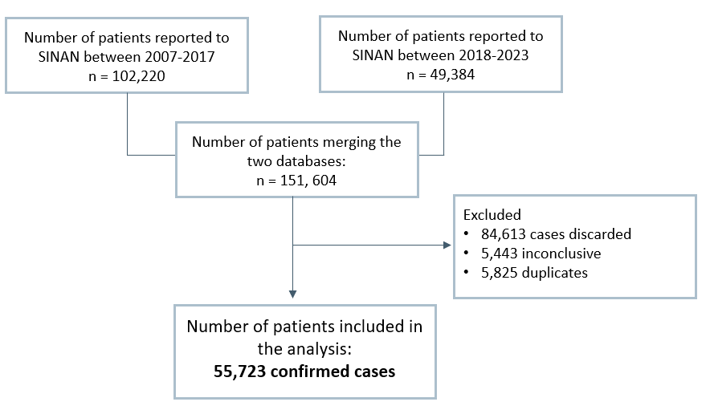

Figure 1: Identification of patients from the SINAN database for inclusion in the analysis.

Discarded cases are those where VL was ruled out, usually due to negative laboratory results or alternative diagnoses. Inconclusive cases occur when the investigation could not confirm or exclude VL, often because of missing tests or loss to follow-up. Duplicated cases arise when the same patient is reported more than once, such as during referrals between facilities. For epidemiological analyses, only confirmed cases are included, while these categories are excluded to avoid misclassification and overestimation [11].
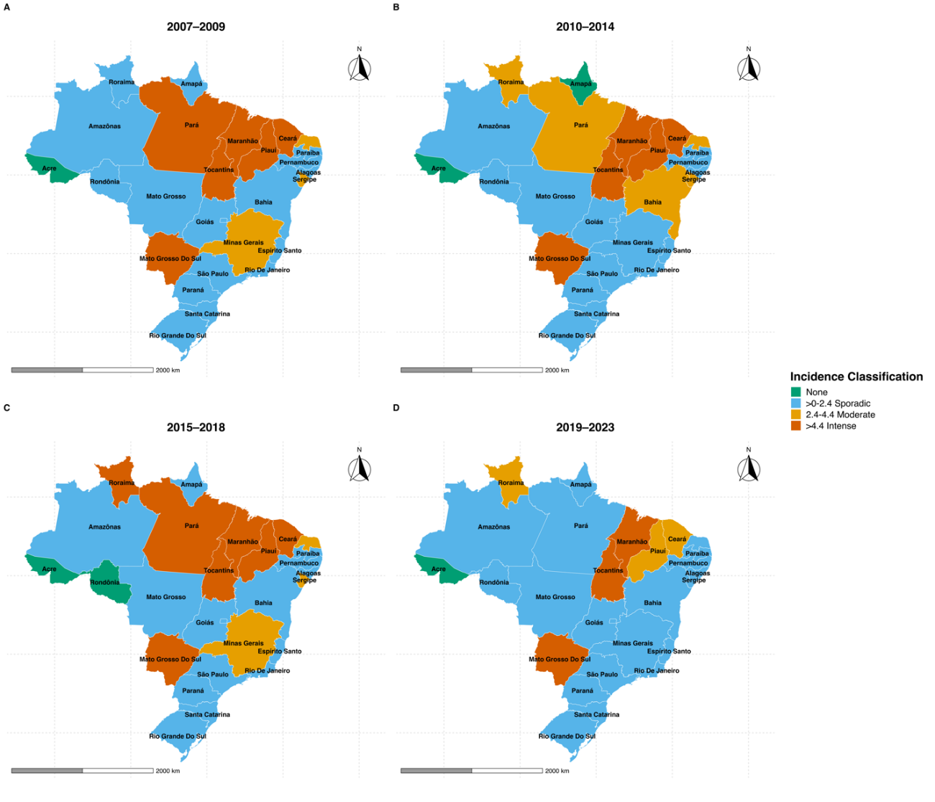

Figure 2: Incidence rate of VL per 100,000 population, between 2007-2009, 2010-2014, 2015-2018 and 2019-2023.

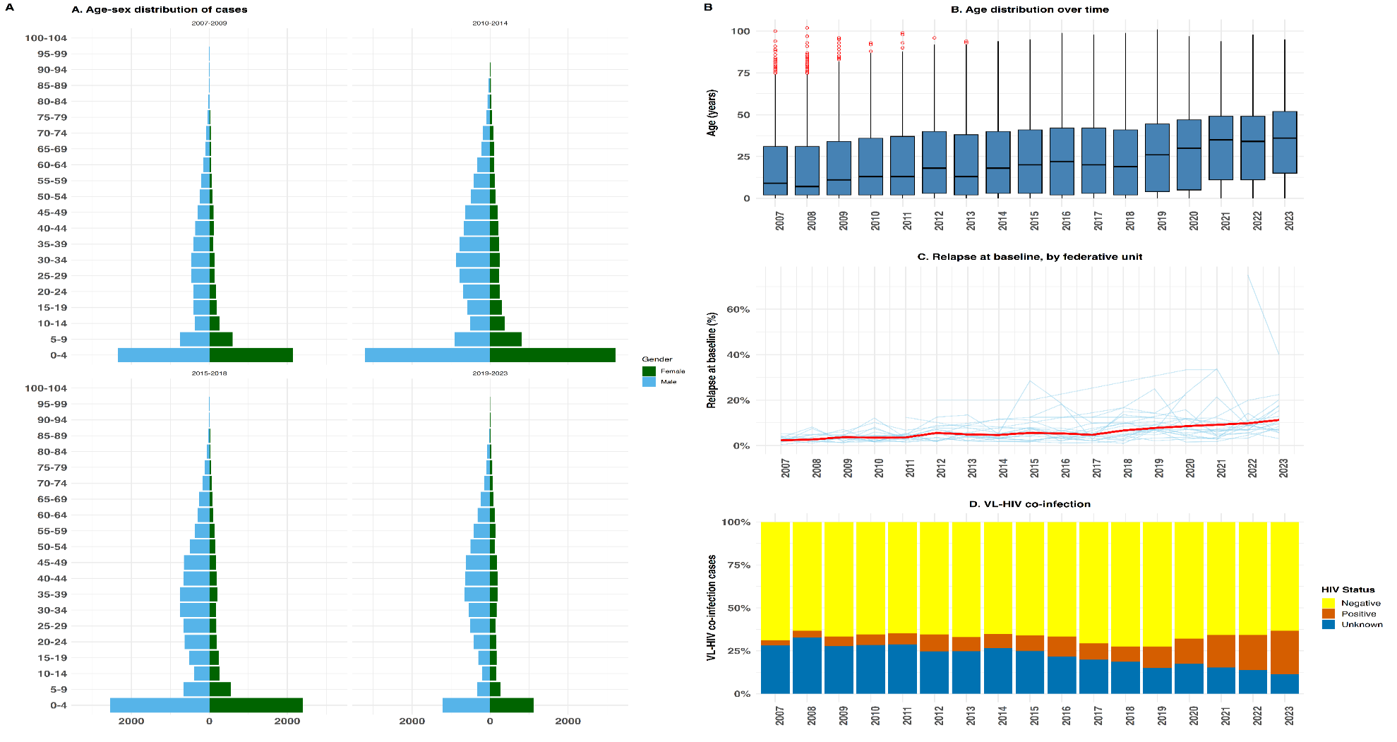
Figure 3: Patient distribution by age, sex, federative units, HIV status and calendar year (2007-2023).
Legend: (A) Distribution of VL cases by age group and sex; (B) Age -distribution by year of notification, 2007–2023; (C) distribution of relapse at presentation, D) distribution of VL-HIV co-infection.
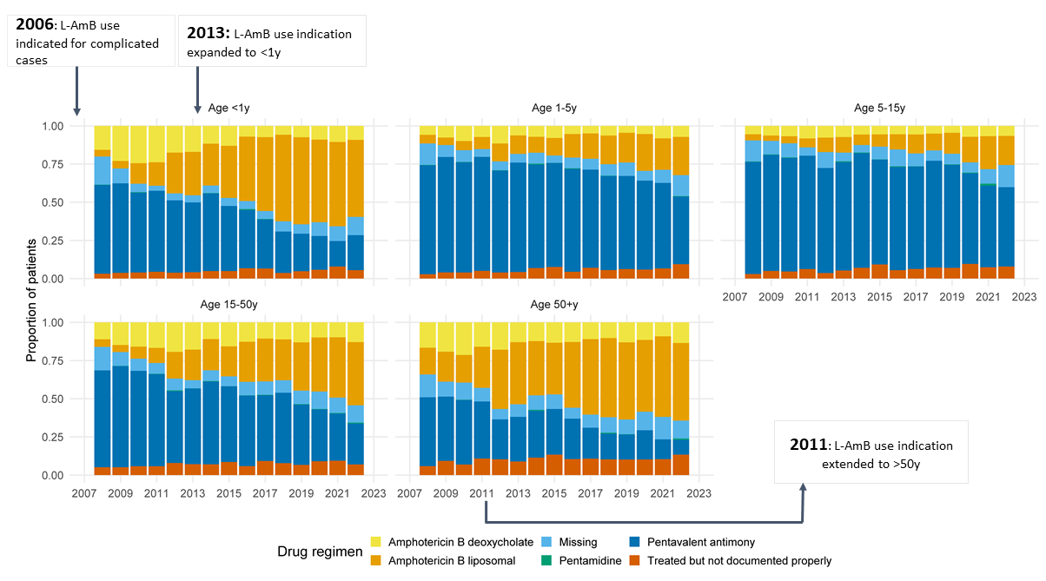
Figure 4: Drug regimens used over time (2007-2023), by age-group.

