Oscillatory dynamics during sense-making of complex naturalistic symbolic and non-symbolic mathematical demonstrations

**Symbolic and non-symbolic skills**

Researchers have speculated that we are born with an intuitive sense of quantity (Feigenson, Dehaene, & Spelke, 2004), argued to develop in the first two years of life (Wood & Spelke, 2005; Gelman & Gallistel, 1986). This non-symbolic number understanding, or as Geary (1995) would categorize it, *biologically primary cognitive ability*, helps students explore the concept of numbers by estimating, comparing, and combining sets of visuals, such as dots or other geometric forms. While *non-symbolic skills* are innate, *symbolic skills* are believed to be culturally acquired, *biologically secondary cognitive abilities* (Geary, 1995), developing from the age of approximately 2.5 years (DeLoache, Miller, & Rosengren, 1997). These acquired skills include the ability to represent numbers verbally (strings of words) and visually (strings of Arabic number symbols), but do not contain any semantic information about the meaning of the number words and symbols (Dehaene & Cohen, 1995).

Typically, children understand non-symbolic magnitudes before they understand what number words and numbers represent. It has been argued that children must understand non-symbolic quantities before they can apply number words to quantities; in other words, non-symbolic quantities give meaning to numbers. The triple-code model (Dehaene, 1992) assumes that numerical processing happens in an analog, Arabic, or verbal code (or format). The first code is also referred to as non-symbolic format, whereas the two latter codes are also referred to as symbolic skills (Dehaene, 1992). Per Geary’s primary and secondary skills, as well as Dehaene’s triple-code model, the “access deficit hypothesis” assumes that having difficulties in learning math can be attributed to not having well-developed or acquired symbolic skills (e.g., De Smedt & Gilmore, 2011), even while non-symbolic skills remain intact. An empirical source of evidence in support of different areas of mathematical development comes from longitudinal studies examining the relations between non-symbolic and symbolic skills and their effect on math achievement. Those studies show that both skills directly predict math achievement (e.g., Jordan et al., 2010; Gashaj, Oberer, Mast, & Roebers, 2018).

This suggests that symbolic and non-symbolic skills can be distinguished behaviorally. Moreover, the effect of non-symbolic skills can be mediated by symbolic skills (e.g., Cirino, 2010). Indeed, some researchers argue that symbolic skills enhance non-symbolic skills in the course of development, and vice versa (Piazza, Pica, Izard, Spelke, & Dehaene, 2013). Tall (1998) claimed that students move to formal mathematics in different ways; some build up on imagery (i.e., more non-symbolic forms), while others build a consistent theory of symbolic, more formal mathematics from the beginning. He concludes:

The cognitive development of students needs to be considered so that demonstrations are presented in forms that are potentially meaningful for them. This requires educators and mathematicians to rethink the nature of mathematical demonstration and to consider the use of different types of demonstration related to the cognitive development of the individual. (Tall, 1998, p.18)

In short, mathematical cognition appears to rely upon both symbolic and non-symbolic processes—yet the relationship between these factors and their relative impact remains inadequately understood at the neural level, inviting further investigations.

**Neural Correlates of Symbolic and Non-Symbolic Reasoning**

Numerical processing activates a vast neural network. Its areas include the posterior parietal lobe, the superior, medial, and inferior frontal gyri, the precentral gyrus, the cingulate gyrus, the insula, the left fusiform gyrus, as well as regions of the cerebellum and the basal ganglia (Arsalidou & Taylor, 2011). Parietal areas specifically recruited by diverse numerical tasks are found within and around the horizontal intraparietal sulcus (Dehaene, Piazza, Pinel, & Cohen, 2003;Piazza & Eger, 2016). Neuropsychological models posit that numerical quantity is expressed in an abstract format bilaterally in the intraparietal sulci (e.g., Ansari, 2007). While the left intraparietal sulcus is involved in quantity estimations independent of stimulus format, the right intraparietal sulcus responds to quantities expressed in a symbolic (Arabic) format. Thus, there are two different but overlapping networks for symbolic and non-symbolic processing (see Sokolowski, Fias, Mousa, & Ansari, 2017).

Even though the parietal area findings are widely reported, involvement of the frontal cortex is also consistently activated in numerical processing studies, even during simple numerical comparison tasks (Sokolowski, Fias, Mousa, & Ansari, 2017). Therefore, it has been suggested that number perception is represented in the frontoparietal network. Another area that is recruited for number and calculation tasks is the insula (Arsalidou & Taylor, 2011). The activation of the insula has been suggested to have a critical role in numerical processing. However, this could be due to more generic processes like intrinsic motivation for learning and training (Arsalidou, Pawliw-Levac, Sadeghi, & Pascual-Leone, 2018), task difficulty (Vatansever, Üstün, Ayyıldız, & Çiçek, 2020), response execution (Huettel, Guzeldere, & McCarthy, 2001), error processing (Hester, Fassbender, & Garavan, 2004), task switching (Uddin & Menon, 2009), and emotional processing (e.g., Britton et al., 2006). In other words, many different processes are involved when we manipulate numbers, estimate quantities, solve mathematical tasks, and think mathematically. Nonetheless, there appear to be two distinguishable neural networks specialized for symbolic and non-symbolic processes.

Moreover, there appear to be different oscillations associated with non-symbolic and symbolic skills. Non-symbolic skills have been suggested to rely on visuospatial abilities (Gallistel & Gelman, 2000). Since those abilities are associated with beta-band activity (12-30 Hz) in parietal regions during visuospatial processing and integration of visual features (Caplan, Madsen, Raghavachari, & Kahana, 2001; Costa, Duarte, Martins, Wibral, & Castelo-Branco, 2017), beta oscillations seem to be relevant for non-symbolic skills. Furthermore, Rubinsten and colleagues (2020) measured EEG oscillations to test the hypothesis that symbolic and non-symbolic processing are segregated by employing frequency ranges. Their data supported the hypothesis that gamma oscillations are related to symbolic numerical representations and suggest that beta oscillations are exclusively related to non-symbolic processing, not general numerical processing.

In summary, research posits the existence of two distinct cognitive systems for processing numerical representations, a symbolic and a non-symbolic system. The evidence indicates that these systems are behaviorally distinct yet appear to take place at approximately the same place and time in the brain. Thus, it is reasonable to assume the existence of some “neuronal dynamics that modulates the behavioral distinction between symbolic and non-symbolic numerical information” (Rubinsten et al., 2020, p. 762). Indeed, recent work by Rubinsten and colleagues (2020) suggests that symbolic and non-symbolic processing are segregated “by means of activation pattern of functionally relevant networks in different frequency ranges” (2020, p. 762). As is typical of more basic research in cognitive neuroscience, this finding was made in the context of very basic stimuli, with the non-symbolic condition entailing the comparison of magnitudes of dot clusters, and the symbolic condition entailing the comparison of standard Arabic numerals (e.g., 37 vs. 54). Thus, we asked whether the neural correlates of more basic processing also appear when engaged in more advanced and naturalistic mathematical reasoning. In our study, we explore a similar neural dynamic in the context of drastically more complex stimuli: visual, geometric demonstrations in the non-symbolic condition, and algebraic demonstrations in the symbolic condition. Specifically, building on previous research, we asked: Are symbolic and non-symbolic processing of the same yet mathematically complex tasks segregated through functionally relevant networks (activity in parietal and frontal regions) in different frequency ranges (lower gamma 30-40 Hz, and lower beta 12– 17 Hz)?

In the present study, we pursue the above research question by reporting a within-designed behavioral and electrophysiological investigation of the effects of symbolic (i.e., Arabic numerals, letters) and non-symbolic (i.e., geometric forms) mathematical processing in university level students with more complex mathematical stimuli (mathematical demonstrations). Within-subjects studies of more advanced mathematical symbolic versus non-symbolic stimuli are scarce in research on mathematical cognition, even more so in EEG studies.

In this study, we administered new measures of non-symbolic and symbolic demonstrations to university students. In previous work investigating students’ reasoning with mathematical demonstrations (numerical vs geometrical), the students’ responses were evaluated on a scale of 1-5: The lowest score 1 indicated a deficient answer, and the highest score 5 indicated a “substantially correct demonstration, which includes an appropriate symbolisation“ (Recio & Godino, 2001, p. 86). The distribution of scores differed for geometric and arithmetic demonstrations. For geometric demonstrations, it was equally likely for a student to get a score from 1 to 5, inclusive. At the same time, it was more likely for students to solve an arithmetic demonstration correctly (i.e., achieving scores 3–5). The mathematician David Tall argues that it is initially easier to *see* a prototypical geometric demonstration to then understand the more advanced meaning of the algebraic one (Tall, 2002). With this in mind, our hypotheses for the behavioral outcomes were as follows:

1. Students will rate non-symbolic demonstrations as easier to understand, leading to higher Likert scale scores on “time”, “understanding”, and “engagement” questions.
2. Students will rate symbolic demonstrations as more familiar than non-symbolic demonstrations because, in school and university, they are more frequently confronted with symbolic math.

Since Rubinsten and colleagues (2020) showed that *symbolic* numerical processing is associated with *gamma* frequencies, and *nonsymbolic* numerical processing with *beta* frequencies, our hypotheses were the following:

1. While making sense of symbolic demonstrations, students will show higher gamma oscillations than making sense of identical demonstrations in a non-symbolic format.
2. While making sense of non-symbolic demonstrations, students will show higher beta oscillations than making sense of identical demonstrations in a symbolic format.

**Method**

**Participants**

At a research university in Switzerland, students were recruited from a range of majors (please see *link removed for blinded review* for more information), from mathematics to art students to students in economics and literature. After data cleaning and preprocessing, and removing noisy EEG signals, the final sample consisted of 28 participants (10 female, 18 male). This sample size is justified in previous work (Gebuis & Reynvoet, 2012; Rubinsten et al., 2020). The study was conducted under the Declaration of Helsinki and approved by the local Ethics Commission. All participants were right-handed, reported no hearing loss or history of neurological illnesses, and provided written informed consent. Table 1 shows the descriptive data of the sample.

Table 1. *Descriptive Statistics*

|  |  |  |  |  |  |  |  |  |
| --- | --- | --- | --- | --- | --- | --- | --- | --- |
|  |  | *Range* |  | *M* |  | *SD* |  | |
| Age (years) |  | 19.00 - 35.00 |  | 22.71 |  | 3.55 |  | |
| Numerical IQ (score) |  | 479.00 - 748.00 |  | 625.60 |  | 65.71 |  | |
| Weekly Math Hours (hours) |  | 0.00 - 55.00 |  | 12.58 |  | 17.64 |  |  |
| ***Note:*** Numerical IQ = raw score on Berlin Intelligence Scale (BIS); Weekly Math Hours = self-reported weekly hours in which the participant is engaged in mathematical activities, such as math lessons or work-related mathematical tasks. | | | | | | | | |

**Procedure and Materials**

The researchers searched for mathematical demonstrations similarly understandable in two different formats, symbolic and non-symbolic. An online pilot study with mathematics experts and novices revealed eight demonstrations to be acceptable in terms of differences in length, complexity, and familiarity. Those demonstrations varied in the number of slides (mean 7, with a range of 4–12 slides) and duration (mean 33 seconds, with a range of 13–68 seconds). The task, showing the chosen 16 (8 demonstrations x 2 formats) math demonstrations in a slide-based presentation, was programmed in MATLAB using the Psychophysics Toolbox extensions (Brainard, 1997; Pelli, 1997; Kleiner et al., 2007). Figure 1 can be consulted for a schematic example of the task.

Figure 1. *Schematic example of the procedure*  
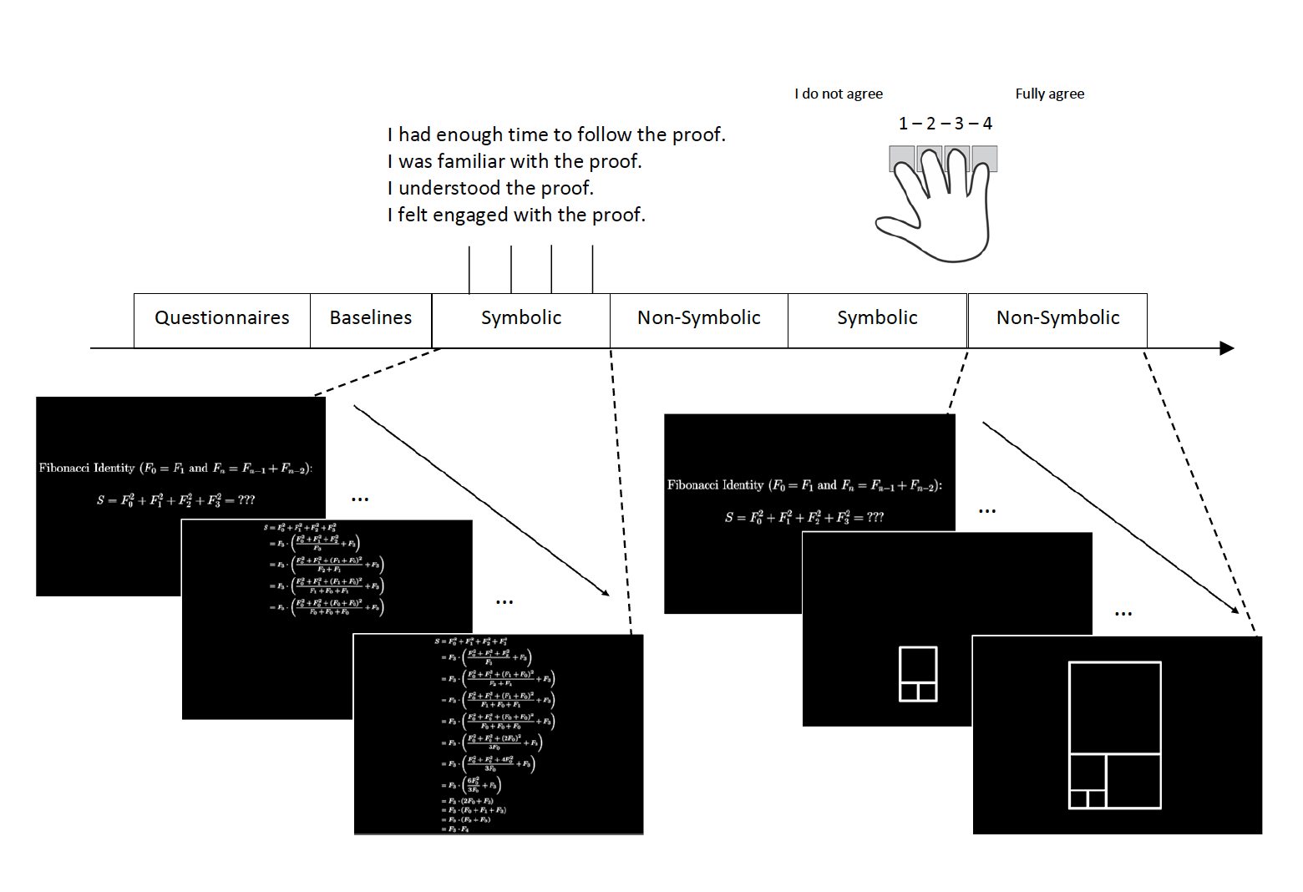

In a naturalistic educational context, the participants were tested in a tutor-student situation. First, they completed a short version of the Berlin Intelligence Scale (to estimate numerical IQ - BIS; Jäger, Süß, & Beauducel, 1997), provided the number of hours a week they spend on math and recorded a baseline EEG. Subsequently, they watched eight demonstrations in symbolic (Arabic) and non-symbolic (geometric) formats. Half of the participants started with four symbolic demonstrations, then their non-symbolic counterparts; the other half started with four non-symbolic demonstrations, then their symbolic counterparts. The order between the blocks of symbolic or non-symbolic demonstrations was kept constant. In a setting similar to a tutor-student situation, the students were asked to watch the demonstrations and make sense of them. Later, they were asked to explain the demonstrations in their own words to the tutor (experimenter). After each demonstration, they were asked about their agreement with the following statements on a 4-point Likert scale:

1. I had enough time to follow the demonstration.
2. I am familiar with the demonstration.
3. I understood the demonstration.
4. I engaged with the mathematical demonstration.

While the screen showed these questions, participants could answer with a four-button response box. The total length of the mathematical demonstrations task was approximately 15 minutes.

**Measures**

Data were recorded using a mobile scalp EEG to keep the situation as naturalistic as possible and not restrict the students (Wave-Guard™ EEG cap and eego™ mylab amplifier; ANT Neuro, b.v., Hengelo, the Netherlands). The EEG electrodes were placed according to the extended international 10–20 system (Jasper, 1958). Eye movements were recorded via electrooculography (EOG), using four external electrodes placed below, above, and on the left side of the left eye as well as on the right side of the right eye. The ground electrode was placed behind the right ear. Electrode impedance was kept below 30 kΩ and data were digitized at a rate of 2048 Hz. The triggers, which marked the beginning of a new set of slides—representing a new mathematical demonstration—were sent to the computer wirelessly via Lab Streaming Layer (LSL). We only focused on electrode clusters relevant to our hypotheses (see figure 2 and the text below for further information).

To perform the brainwave analysis, we used Welch’s method (1967) for obtaining amplitude signal power estimation. Drawing on previous research (see Rubinsten et al., 2020, who based their analysis on Schadow et al., 2007; Völker et al. 2018; and a meta-analysis of fMRI studies comparing symbolic and non-symbolic tasks by Sokolowski et al., 2017), we selected a frontocentral cluster of electrodes, namely **FC1, FC2, FC3, FC4, and FCz for the gamma band analysis. For the beta band analysis, we selected a parietal cluster of electrodes, namely P1, P2, Pz, and POz electrodes, again based on previous research (see Rubinsten et al., 2020, who based their analysis on Avancini, Soltész, & Szűcs, 2015; Szűcs & Soltész, 2008).**

Figure 2. *Schematic example of the selected electrodes*

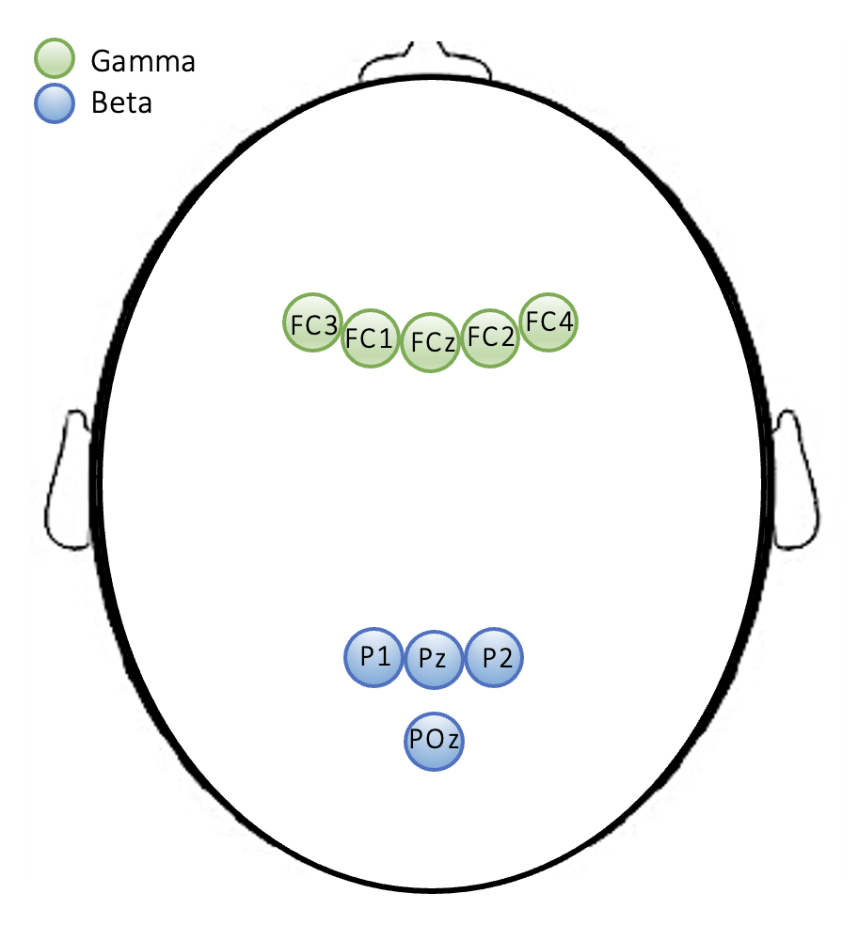

**Data Preprocessing and Analysis**

*Behavioral data*. For the self-reflection questions sum scores were formed for each scale (time, familiarity, understanding, and engagement). The raw score was analyzed for all other measures (reported weekly math hours and numerical IQ).

*Neurophysiological data*. MATLAB custom scripts were used to preprocess and analyze the EEG data (materials can be found on *link removed for blinded review*). The toolbox EEGLAB was used (Delorme & Makeig, 2004), including Independent Component Analysis (ICA) for artifact correction such as eye-blink artifacts (Hoffmann & Falkenstein, 2008). A High Pass IIR Filter (1 Hz) has been applied to obtain static data for ICA (Blum et al., 2019; Winkler et al., 2015) as well as for artifact subspace reconstruction (ASR; Blum et al., 2019; Chang, 2018). The clean line plug-in removed initial line noise (50 Hz). Subsequently, noisy channels have been removed, and the data has been corrected using ASR (parameter set to 10). After interpolating removed channels via spherical spline (acceptable rate: 10%), the data has been re-referenced to the average reference. Regarding the ICA pipeline, we generated a temporal data set of 1-second epochs for ICA, removed significant artifacts in this temporal data set, and estimated the data rank to estimate the number of independent components to extract with ICA (Amica algorithm; Delorme et al., 2007). The derived independent component weights were applied to the original continuous data set, and ocular and cardiac artifact components were removed via the iclabel plug-in (Pion-Tonachini et al., 2019). Finally, we applied a low pass IIR filter (40Hz). We integrated the amplitude power over the frequency ranges at the electrodes as mentioned above to estimate the power values for beta and gamma waves. Epochs have been created according to the formats (symbolic and non-symbolic). Missing data analysis revealed that one participant was generating suspiciously noisy data, since the percentage of missing data was higher than 20%, we removed this participant from further EEG-analysis. For missing data (< .10) at the item-level, multiple imputation was performed (Mazza, Enders, & Ruehlman, 2015), with 5 imputations and as per SPSS default 2000 draws were applied. Finally, we applied the Bar Procedure to compress the five datasets after imputation into one single pooled data file before calculating the mean scores (Baranzini, 2018).

*Statistical Analysis*: Paired *t*-tests were used to compare self-reflections between the symbolic demonstrations and their non-symbolic counterparts. In addition, correlational analysis was performed to investigate whether background variables such as numerical IQ, and the weekly engagement with math in hours are related to the four self-reflections. Furthermore, we investigated the differences in beta and gamma waves by conducting two repeated measures ANOVAs with Bonferroni adjusted pairwise comparisons.

**Results**

The answers to the self-reflection questions were compared in a within-subject manner using paired *t*-tests. The familiarity score was on average lower for the non-symbolic version (*M* = 8.86, *SD* = 3.30) than the symbolic one (*M* = 10.39, *SD* = 3.05), and the difference reached statistical significance *t*(27) = 3.39, *p* = .002, Cohen’s *d* = 0.64. Similarly, the score for understanding was on average lower for the non-symbolic version (*M* = 10.79, *SD* = 2.57) than the symbolic one (*M* = 12.14, *SD* = 3.33), and this difference also reached statistical significance *t*(27) = 3.29, *p* = .003,Cohen’s *d* = 0.62.

Even though the score on time (“I had enough time”) was descriptively lower on average for the non-symbolic version (*M* = 11.68, *SD* = 2.65) than the symbolic one (*M* = 12.79, *SD* = 2.54), the difference did not reach statistical significance *t*(27) = 1.90, *p* =.068, Cohen’s *d* = 0.36. For engagement, the same was observed: the score was lower on average for the non-symbolic version (*M* = 10.57, *SD* = 2.69) than the symbolic one (*M* = 11.36, *SD* = 3.27), but the difference did not reach statistical significance *t*(27) = 1.50, *p* =.145, Cohen’s *d* = 0.28.

Table 2 *Pearson Correlations*

|  |  |  |  |  |  |  |  |  |  |  |  |  |  |
| --- | --- | --- | --- | --- | --- | --- | --- | --- | --- | --- | --- | --- | --- |
|  |  | 1 | 2 | 3 | 4 | 5 | 6 | 7 | 8 | 9 | | 10 | |
| 1. Numerical IQ | | -- |  |  |  |  |  |  |  |  | |  | |
| 2. Math in hours | | .21 | -- |  |  |  |  |  |  |  | |  | |
| 3. Time NS | | -.03 | .51** | -- |  |  |  |  |  |  | |  | |
| 4. Familiarity NS | | -.41* | .19 | .49** | -- |  |  |  |  |  | |  | |
| 5. Understanding NS | | .09 | .39 | .73** | .54** | -- |  |  |  |  | |  | |
| 6. Engagement NS | | .09 | .35 | .24 | .26 | .64** | -- |  |  |  | |  | |
| 7. Time S | | -.05 | .32 | .30 | .23 | .58** | .48** | -- |  |  | |  | |
| 8. Familiarity S | | -.31 | .14 | .58** | .72** | .66** | .30 | .45* | -- |  | |  | |
| 9. Understanding S | | .06 | .36 | .52** | .22 | .76** | .51** | .74** | .60** | -- | |  | |
| 10. Engagement S | | -.00 | .35 | .21 | .08 | .42* | .58** | .68** | .33 | .67** | | -- | |
| *Note*. * p < .05; ** p < .01; Math in hours = self-reported weekly engagement with math, estimated in hours; NS = non-symbolic; S = symbolic. | | | | | | | | | | |  | |  |

Surprisingly, the correlation analysis showed that the numerical IQ was negatively correlated with familiarity with non-symbolic math demonstrations, meaning that the higher the student’s numerical IQ was, the less familiar they were with non-symbolic demonstrations. Furthermore, the engagement with math in hours was positively related to having enough time to follow the non-symbolic demonstration. This might reflect the fact that experience with mathematics is helpful in following the demonstrations more quickly, even if they are in a non-symbolic format.

Repeated-measures ANOVA of the average gamma power revealed a significant effect for electrode, *F*(1, 26) = 22.56, *p* < .001, *η2p* =.465, as well as an electrode × format interaction, *F*(1, 26) = 5.14, *p* < .05, *η2p* =.165, with no main effect for format, *F*(1, 26) = .07, *p* = .79, *η2p* =.003. Over this frontocentral cluster, FC4 showed lower gamma power compared with FC2 (Bonferroni adjusted *p* = .004) and FCz (Bonferroni adjusted *p* = .024; see Figure 3). This finding suggests that, despite no global power difference, the electrodes in the frontocentral cluster respond divergently under the different formats. Furthermore, when looking at Figure 3 we can see how the various electrodes activity seems to behave similarly in symbolic vs non-symbolic format, except for the most outer electrode FC4 in which the non-symbolic demonstrations provoke lower gamma power compared to symbolic format. In all other electrodes, symbolic demonstrations descriptively provoked higher gamma power, even if these differences are not statistically significant.

Figure 3. *Estimated marginal means and standard errors of gamma power in voltage over frontocentral cluster, depending on symbolic versus non-symbolic format*

FC1 FC2 FC3 FC4 FCz

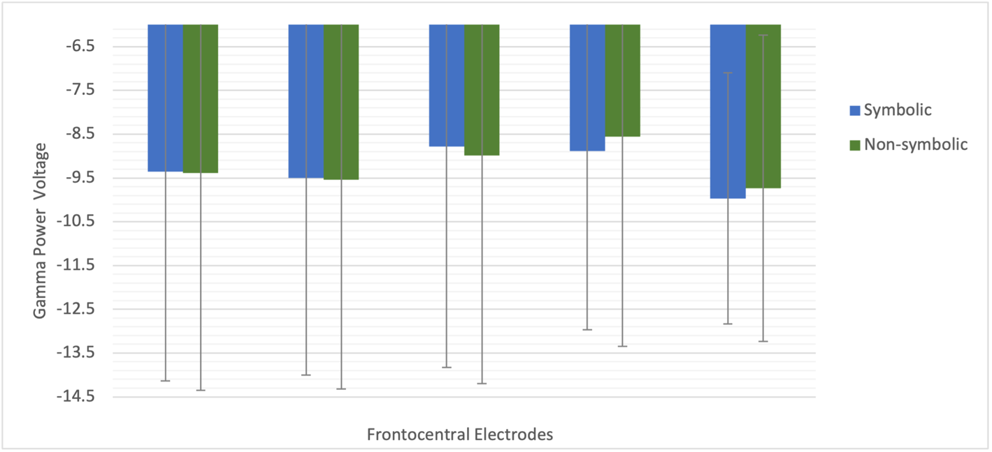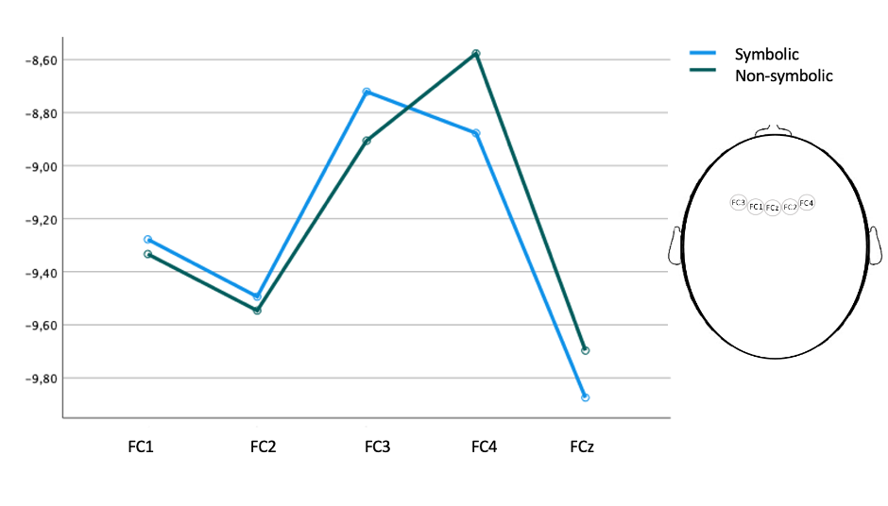

Repeated-measures ANOVA of the average beta power revealed a significant effect for electrode, *F*(1, 26) = 57.57, *p* < .01, *η2p* = .69, (see Figure 4), with no effect for format, *F*(1, 26) = .72, *p* = .41, *η2p* = .03, nor the interaction of electrode × format *F*(1, 26) = .05, *p* = .82, *η2p* =.00. Over this parietal cluster, POz showed lower beta power compared with the other three electrodes: compared to P1 *p* < .001, P2 *p* = .006, and P3 *p* < .001 (see Figure 4). All p-values are Bonferroni adjusted.

Figure 4. *Estimated marginal means and standard errors of beta power in voltage over parietal cluster, depending on symbolic versus non-symbolic format.*

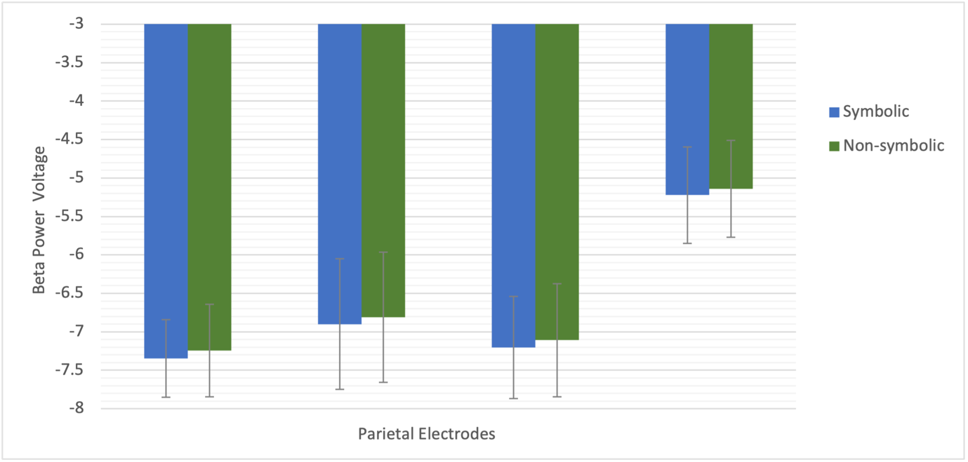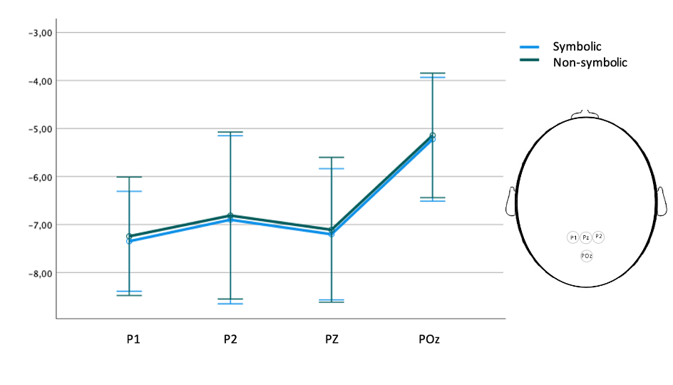

P1 P2 Pz POz

**Discussion**

This study aimed to explore the dissociation between symbolic and non-symbolic processing regarding oscillatory dynamics (Rubinsten et al., 2020) in students engaged with advanced mathematics. Since the dissociation between symbolic and non-symbolic processing has been shown behaviorally (e.g., Geary, 1995; Dehaene, 1992), neuro-spatially (e.g., Sokolowski et al., 2017), but not neuro-temporally (e.g., Libertus, Woldorff, & Brannon, 2007), it was unclear whether the dissociation in oscillatory dynamics extends to more natural stimuli, such as mathematical proofs.

The results of the behavioral measures were unexpected. Contrary to Hypothesis 1, that students will rate non-symbolic demonstrations as easier to understand, we found that the non-symbolic demonstrations were not easier to understand than symbolic demonstrations. The average rating on questions about “time” and “engagement” was lower for the non-symbolic version than the symbolic version. However, despite this descriptive difference, students reported being equally engaged and having sufficient time for sensemaking with the non-symbolic version of the demonstration. In accordance with our expectation (Hypothesis 2), symbolic demonstrations were rated as more familiar by the students.

One explanation for why the students did not rate one version as easier to understand than the other but rated symbolic demonstrations as more familiar involves the different conceptual developmental paths towards understand formal math (Tall, 2002). Although exploratory, the correlation analysis showed that there was a negative relationship between numerical IQ and being familiar with non-symbolic math demonstrations. This could mean that the student’s numerical IQ reflected a symbolic knowledge, while the students were unfamiliar with the non-symbolic demonstrations. Furthermore, the more students engaged with mathematics in hours, the more they indicated that they had enough time to follow the non-symbolic demonstration. These results might correspond to the experience with mathematics being helpful for following math demonstrations more quickly, even if they are presented in a non-symbolic format. Thus, even when the format is unfamiliar, students who engaged more with math can follow math demonstrations more easily. Some evidence indicates that students may struggle with understanding when a demonstration is first introduced in a geometric way (Uhlig, 2002). Indeed, some researchers and math educators recommend introducing mathematics in a more symbolic rather than concrete format (for a discussion, see Trninic, Sinha, & Kapur, 2020). Thus, students might be more familiar with the symbolic format simply because they were taught mathematics in a more symbolic way.

No significant differences were found in beta oscillations between non-symbolic or symbolic math demonstrations. Both symbolic and non-symbolic demonstrations provoked strong beta oscillations (i.e., greater decreases in power compared to baseline) and the pattern of activation was similar in electrode**s. This is somewhat surprising, as Rubinsten and colleagues (2020) report a beta power difference between the task format (symbolic vs non-symbolic) when analyzing a broader time window; in their case, 180 ms. The time window in the present study was broader than 180 ms, since the mean presentation time of an argument was about 13 seconds. Thus, it may be that differences in beta oscillations can only be found in specific time windows after stimulus onset.** In a recent study, where the researchers predicted mathematical ability with behavioral, cognitive, and neurophysiological factors, there was no strong evidence that periodic activity in the beta band predicts mathematical skills in children and adults (van Bueren, van der Ven, Roelofs, Cohen Kadosh, & Kroesbergen, 2022). Another explanation for a lack of difference in our study might be the visual complexity of the demonstrations in both formats. Although it did not rely on symbols, the presentation of the non-symbolic demonstration was still geometrically complex. The parietal cortex is not only associated with numerical processing, but also with visual attention and visual processing in general (see Corbetta & Shulman, 2002, for a review). Previous neurophysiological studies have shown that global continuous perception (Gestalt perception) is associated with stronger beta oscillations in parietal electrodes (Zaretskaya & Bartels, 2015). Thus, our results could actually be a reflection of Gestalt perception of the visually presented demonstrations.

Additionally, we did not find any differences in gamma frequencies between symbolic and non-symbolic demonstrations. Although previous research has shown that gamma oscillations are associated with more complex mathematical tasks (Molina del Río, Guevara, Hernández González, Hidalgo Aguirre, & Cruz Alguilar, 2019), the present study did not find such an effect. One explanation could be that although the two demonstrations differed in their format, the complexity of the content was kept similar. There is some evidence that a difference in gamma oscillations might be associated with the absolute complexity of a task (Molina del Río et al., 2019), rather than the format of the task. Interestingly, one of the electrodes behaved differently than the others. The rightmost frontal electrode showed lower gamma power for non-symbolic demonstrations than symbolic demonstrations, this was reversed in the other electrodes. Further research is needed to dive deeper into the activity of specific electrodes as well as the investigation of the source of this activity. Our findings might be a first step into that direction.

**Limitations**

Acquiring high gamma waves was impossible because of the experimental lab conditions and setup conditions. To acquire high gamma the experimental setup must be very strict allowing no auditive or motor noise in the data. Since our study was set up in a more naturalistic way, we could not restrict the participants or their environment in a strict manner. Therefore, we used low gamma waves and compared the lower frequency band with earlier research. This might have led to the findings we obtained that could not replicate the earlier findings from Rubinsten and colleagues (2020). In the present study, high gamma waves could not be dissociated from noise. However, we think that future studies could investigate high gamma in more complex mathematical stimuli, to see if the difference between symbolic and non-symbolic stimuli can be found in the upper frequencies. Furthermore, we used more complex mathematical tasks, which could have led to more overlapping cognitive skills necessary to engage in the task and understand the demonstrations. This might have led to a less pure recording of symbolic and non-symbolic processing. Lastly, our results showed large error bars that indicate large variabilities between the participants. This might be—in part—due to wide range of self-reported engagement with mathematics. While some students did report no engagement with mathematics, others spent up to 55 hours a week with some form of mathematical activity.

**Conclusions**

Established in France in 1935, Nicolas Bourbaki—the collective pseudonym of an influential group of mathematicians—significantly impacted mathematics and mathematics education throughout the last century. For example, Bourbaki was instrumental in the *Moderne Mathématique* movement that modernized mathematics education in France, and it influenced the *New Math* movement in the United States (Munson, 2010). Core to Bourbaki’s approach was the emphasis of rigor and formal, symbolic argumentation. This came at the expense of illustrations and imagery. In other words, an emphasis on symbolic rigor over non-symbolic intuition. This approach to mathematics spilled over to mathematics education, with approaches such as *New Math* emphasizing an understanding of mathematical fundamentals even at the expense of more intuitive but less rigorous examples.

The arguments regarding (symbolic) rigor over (non-symbolic) intuition in mathematics education continue to the present day (see, e.g., Trninic, Wagner, & Kapur, 2018). We believe that neuroimaging methods can provide a novel and powerful source of evidence in this debate. At the moment, however, we know very little about what goes on in the brains of students when they engage with symbolic or non-symbolic mathematics. Our study makes initial strides in this direction, finding no difference between neural processing of symbolic and non-symbolic arguments. Our study found that students rated symbolic math demonstrations as more familiar, and better understood compared to the non-symbolic demonstrations. These results, however, might largely reflect the prevalence of above-mentioned educational approaches, that is, of emphasizing symbolic examples at the expense of non-symbolic ones. Summarized, our findings suggest that there is no difference between symbolic and non-symbolic demonstrations at the neural level, and that students—even when the demonstration is less familiar—report an adequate understanding of non-symbolic demonstrations, even if they understand them less than the familiar symbolic demonstrations.

References

Ansari, D. (2007). Does the parietal cortex distinguish between “10”, “ten,” and ten dots? *Neuron, 53*(2), 165-167.

Arsalidou, M., & Taylor, M. J. (2011). Is 2+2=4? Meta-analyses of brain areas needed for numbers and calculations. *Neuroimage, 54*(3), 2382-2393. doi:10.1016/j.neuroimage.2010.10.009

Arsalidou, M., Pawliw-Levac, M., Sadeghi, M., & Pascual-Leone, J. (2018). Brain areas associated with numbers and calculations in children: Meta-analyses of fMRI studies. *Developmental Cognitive Neuroscience, 30*, 239-250. doi:10.1016/j.dcn.2017.08.002

Avancini, C., Soltész, F., & Szűcs, D. (2015). Separating stages of arithmetic verification: An ERP study with a novel paradigm. *Neuropsychologia, 75*, 322-329.

Baranzini, D. (2018). SPSS single dataframe aggregating SPSS multiply imputed split files. doi:10.13140/rg.2.2.33750.70722

Blum, S., Jacobsen, N. S., Bleichner, M. G., & Debener, S. (2019). A Riemannian modification of artifact subspace reconstruction for EEG artifact handling. Frontiers *in Human Neuroscience, 13*, 141.

Brainard, D. H. (1997) The Psychophysics Toolbox, *Spatial Vision 10*:433-436.

Britton, J. C., Phan, K. L., Taylor, S. F., Welsh, R. C., Berridge, K. C., & Liberzon, I. (2006). Neural correlates of social and nonsocial emotions: An fMRI study. *Neuroimage, 31*(1), 397-409. doi:10.1016/j.neuroimage.2005.11.027

Caplan, J. B., Madsen, J. R., Raghavachari, S., & Kahana, M. J. (2001). Distinct patterns of brain oscillations underlie two basic parameters of human maze learning. *Journal of neurophysiology, 86*(1), 368-380.

Chang, C.-Y., Hsu, S.-H., Pion-Tonachini, L., and Jung, T.-P. (2018). “Evaluation of artifact subspace reconstruction for automatic EEG artifact removal,” in *Proceedings of the 40th Annual International Conference of the IEEE Engineering in Medicine and Biology Society (EMBC)*, (Honolulu, HI: IEEE).

Cirino, P. T. (2011). The interrelationships of mathematical precursors in kindergarten. *Journal of experimental child psychology*, *108*(4), 713-733.

Costa, G. N., Duarte, J. V., Martins, R., Wibral, M., & Castelo-Branco, M. (2017). Interhemispheric binding of ambiguous visual motion is associated with changes in beta oscillatory activity but not with gamma range synchrony. *Journal of cognitive neuroscience, 29*(11), 1829-1844.

De Smedt, B., & Gilmore, C. K. (2011). Defective number module or impaired access? Numerical magnitude processing in first graders with mathematical difficulties. *Journal of experimental child psychology*, *108*(2), 278-292.

Dehaene, S., Piazza, M., Pinel, P., & Cohen, L. (2003). Three parietal circuits for number processing. *Cognitive Neuropsychology, 20*(3), 487-506. doi:10.1080/02643290244000239

Dehaene, S., & Cohen, L. Towards an Anatomical and Functional Model of Number Processing. *Mathematical Cognition*, *1*, 83-120.

DeLoache, J. S., Miller, K. F., & Rosengren, K. S. (1997). The Credible Shrinking Room: Very Young Children’s Performance With Symbolic and Nonsymbolic Relations. *Psychological Science, 8*(4), 308–313. doi: 10.1111/j.1467-9280.1997.tb00443.x

Delorme A & Makeig S (2004) EEGLAB: an open-source toolbox for analysis of single-trial EEG dynamics, *Journal of Neuroscience Methods 134*:9-21.

Delorme, A., Sejnowski, T., Makeig, S. (2007) Improved rejection of artifacts from EEG data using high-order statistics and independent component analysis. *Neuroimage. 34*, 1443-1449.

Gallistel, C. R., & Gelman, R. (2000). Non-verbal numerical cognition: From reals to integers. *Trends in cognitive sciences, 4*(2), 59-65.

Gashaj, V., Oberer, N., Mast, F. W., & Roebers, C. M. (2019). The relation between executive functions, fine motor skills, and basic numerical skills and their relevance for later mathematics achievement. *Early education and development, 30*(7), 913-926.

Geary, D. C. (1995). Reflections of evolution and culture in children's cognition: Implications for mathematical development and instruction. *American psychologist*, *50*(1), 24.

Gebuis, T., & Reynvoet, B. (2012). The interplay between nonsymbolic number and its continuous visual properties. *Journal of Experimental Psychology: General, 141*(4), 642. doi: 10.1037/a0026218.

Gelman, R., & Gallistel, C. R. (1986). *The child’s understanding of number*. Harvard University Press.

Hoffmann, S., & Falkenstein, M. (2008). The Correction of Eye Blink Artefacts in the EEG: A Comparison of Two Prominent Methods. *PLOS ONE, 3*(8), e3004. doi:10.1371/journal.pone.0003004.

Hester, R., Fassbender, C., & Garavan, H. (2004). Individual differences in error processing: a review and reanalysis of three event-related fMRI studies using the GO/NOGO task. *Cerebral Cortex, 14*(9), 986-994. doi:10.1093/cercor/bhh059.

Huettel, S. A., Guzeldere, G., & McCarthy, G. (2001). Dissociating the neural mechanisms of visual attention in change detection using functional MRI. *Journal of Cognitive Neuroscience, 13*(7), 1006-1018. doi:10.1162/089892901753165908.

Jäger, A. O., Süß, H.-M., & Beauducel, A. (1997). Test für das Berliner Intelligenzstrukturmodell. *BIS-Test. Form 4* [Test for the Berlin Intelligence Structure Model]. Göttingen: Hogrefe.

Jasper, H. H. (1958). Report of the committee on methods of clinical examination in electroencephalography. *Electroencephalography and Clinical Neurophysiology, 10*(2), 370–375. doi:10.1016/0013-4694(58)90053-1

Jordan, N. C., Glutting, J., & Ramineni, C. (2010). The importance of number sense to mathematics achievement in first and third grades. *Learning and individual differences*, *20*(2), 82-88.

Kleiner, M., Brainard, D., Pelli, D. (2007). What’s new in Psychtoolbox-3? *Perception* 36 ECVP Abstract Supplement.

Libertus, M. E., Woldorff, M. G., & Brannon, E. M. (2007). Electrophysiological evidence for notation independence in numerical processing. *Behavioral and Brain Functions, 3*(1), 1-15. doi:10.1186/1744-9081-3-1

Mazza, G. L., Enders, C. K., & Ruehlman, L. S. (2015). Addressing item-level missing data: A comparison of proration and full information maximum likelihood estimation. *Multivariate Behavioral Research, 50*(5), 504–519. doi:10.1080/00273171.2015.1068157

Molina del Río, J., Guevara, M.A., Hernández González, M., Hidalgo Aguirre, R.M., & Cruz Alguilar, M.A. (2019). EEG correlation during the solving of simple and complex logical–mathematical problems. *Cognitive, Affective, and Behavioral Neuroscience 19*, 1036–1046. doi:10.3758/s13415-019-00703-5

Munson, A. (2010). Bourbaki at Seventy-Five: Its influence in France and beyond. *Journal of Mathematics Education at Teachers College, 1*(2). https://doi.org/10.7916/jmetc.v1i2.686

Pelli, D. G. (1997) The VideoToolbox software for visual psychophysics: Transforming numbers into movies, *Spatial Vision* 10:437-442.

Piazza, M., Pica, P., Izard, V., Spelke, E. S., & Dehaene, S. (2013). Education enhances the acuity of the nonverbal approximate number system. *Psychological science, 24*(6), 1037-1043. doi:10.1177/0956797612464057

Piazza, M., & Eger, E. (2016). Neural foundations and functional specificity of number representations. *Neuropsychologia, 83*, 257-273. doi: 10.1016/j.neuropsychologia.2015.09.025.

Pion-Tonachini, L., Kreutz-Delgado, K., & Makeig, S. (2019). ICLabel: An automated electroencephalographic independent component classifier, dataset, and website. *NeuroImage, 198*, 181–197. doi:10.1016/j.neuroimage.2019.05.026.

Recio, A. M., & Godino, J. D. (2001). Institutional and personal meanings of mathematical proof. *Educational studies in mathematics, 48*(1), 83–99. doi:10.1023/A:1015553100103

Rubinsten, O., Korem, N., Levin, N., & Furman, T. (2020). Frequency-based Dissociation of Symbolic and Nonsymbolic Numerical Processing during Numerical Comparison. *Journal of Cognitive Neuroscience, 32*(5), 762–782. doi:10.1162/jocn_a_01550

Sokolowski, H. M., Fias, W., Mousa, A., & Ansari, D. (2017). Common and distinct brain regions in both parietal and frontal cortex support symbolic and nonsymbolic number processing in humans: A functional neuroimaging meta-analysis. *Neuroimage, 146,* 376-394. doi:10.1016/j.neuroimage.2016.10.028

Szűcs, D., & Soltész, F. (2008). The interaction of task-relevant and task-irrelevant stimulus features in the number/size congruency paradigm: An ERP study. *Brain Research, 1190*, 143-158.

Tall, D. (2002). Differing modes of proof and belief in mathematics. In *International conference on mathematics: Understanding proving and proving to understand* (pp. 91-107).

Tall, D. (1998, August). The cognitive development of proof: Is mathematical proof for all or for some. In *Conference of the University of Chicago School Mathematics Project.*

Trninic, D., Kapur, M., & Sinha, T. (2020). The Disappearing “Advantage of Abstract Examples in Learning Math”. *Cognitive Science, 44*(7), e12851. doi:[10.1111/cogs.12851](https://doi.org/10.1111/cogs.12851)

Trninic, D., Wagner, R., & Kapur, M. (2018). Rethinking failure in mathematics education: A historical appeal. *Thinking Skills and Creativity, 30*, 76–89. doi: 10.1016/j.tsc.2018.03.008

Uddin, L. Q., & Menon, V. (2009). The anterior insula in autism: Under-connected and under-examined. *Neuroscience & Biobehavioral Reviews, 33*(8), 1198-1203. doi:10.1016/j.neubiorev.2009.06.002.

Uhlig, F. (2002). The role of proof in comprehending and teaching elementary linear algebra. *Educational Studies in Mathematics, 50*(3), 335-346. doi:10.1023/A:1021245213997

van Bueren, N. E., van der Ven, S. H., Roelofs, K., Cohen Kadosh, R., & Kroesbergen, E. H. (2022). Predicting math ability using working memory, number sense, and neurophysiology in children and adults. *Brain Sciences, 12*(5), 550.

Vatansever, G., Ustun, S., Ayyildiz, N., & Cicek, M. (2020). Developmental alterations of the numerical processing networks in the brain. *Brain Cognition, 141*, 105551. doi:10.1016/j.bandc.2020.105551.

Welch, P. (1967). The use of fast Fourier transform for the estimation of power spectra: A method based on time averaging over short, modified periodograms, *IEEE Transactions on Audio and Electroacoustics, 15*(2), 70-73. doi: 10.1109/TAU.1967.1161901.

Winkler, I., Debener, S., Müller, K. R., & Tangermann, M. (2015, August). On the influence of high-pass filtering on ICA-based artifact reduction in EEG-ERP. In *37th Annual International Conference of the IEEE Engineering in Medicine and Biology Society (EMBC)* (pp. 4101-4105). IEEE.

Wood, J. N., & Spelke, E. S. (2005). Infants’ enumeration of actions: Numerical discrimination and its signature limits. *Developmental Science*, *8*(2), 173-181.