Oscillatory dynamics during sense-making of complex naturalistic symbolic and non-symbolic mathematical demonstrations

**Symbolic and non-symbolic reasoning in mathematics**

Established in France in 1935, Nicolas Bourbaki—the collective pseudonym of an influential group of mathematicians—made a significant impact on mathematics and mathematics education throughout the last century.Core to this approach was an emphasis on rigor and formal, symbolic argumentation that came at the expense of visuals and imagery—symbolic rigor over non-symbolic intuition. Bourbaki’s approach to mathematics spilled over to mathematics education, with approaches such as *New Math* emphasizing an understanding of mathematical fundamentals even at the expense of more intuitive but less rigorous examples.

DebatesBecause these debates concern the apparent difference between formal mathematics as a discipline (formal, symbolic) and mathematical reasoning that goes on inside the minds of mathematicians (intuitive, possibly non-symbolic), neuroimaging techniques could provide a novel and powerful source of evidence in this debate. At the moment, however, we know relatively little about what goes on in the brains of individuals when they engage with symbolic or non-symbolic mathematical reasoning in a naturalistic manner. The present study uses electroencephalogram (EEG) imaging to explore the neural activity underlying naturalistic mathematical reasoning involving symbolic and non-symbolic stimuli.

**Research on symbolic and non-symbolic skills**

It is argued that we are born with an intuitive sense of quantity (Feigenson, Dehaene, & Spelke, 2004), which develops in the first two years of life (Wood & Spelke, 2005; Gelman & Gallistel, 1986). This non-symbolic number understanding, or as Geary (1995) would categorize it, *biologically primary cognitive ability*, helps students explore the concept of numbers by estimating, comparing, and combining sets of visuals, such as dots or other geometric forms. While *non-symbolic skills* are innate, *symbolic skills* are culturally acquired, *biologically secondary cognitive abilities* (Geary, 1995), developing, approximately, from the age of two and a half years onward (DeLoache, Miller, & Rosengren, 1997). These acquired skills include the ability to represent numbers verbally (strings of words) and visually (strings of Arabic number symbols), but do not contain any semantic information about the meaning of the number words and symbols (Dehaene & Cohen, 1995).

It has been argued that children must understand non-symbolic quantities before they can apply number words to quantities. The triple-code model (Dehaene, 1992) assumes that numerical processing happens in an analog, Arabic, or verbal code (or format). The first code is also referred to as “non-symbolic” format, whereas the latter codes are also called “symbolic” skills (Dehaene, 1992). Per Geary’s primary and secondary skills, as well as Dehaene’s triple-code model, the “access deficit hypothesis” assumes that having difficulties in learning math can be attributed to not having well-developed or acquired symbolic skills (e.g., De Smedt & Gilmore, 2011), even alongside normally developed non-symbolic skills. One source of evidence supporting different areas of mathematical development comes from longitudinal studies examining the relations between non-symbolic and symbolic skills and their effect on math achievement. Those studies show that both skills directly predict math achievement (e.g., Jordan et al., 2010; Gashaj, Oberer, Mast, & Roebers, 2018). Conversely, the effect of non-symbolic skills can be mediated by symbolic skills (e.g., Cirino, 2010), and some researchers have argued that symbolic skills enhance non-symbolic skills in the course of development, and vice versa (Piazza, Pica, Izard, Spelke, & Dehaene, 2013).

In short, behavioral research suggests that mathematical cognition relies upon both symbolic and non-symbolic processes, and that these processes mutually influence each other. At the neural level, however, the relationship between these factors and their relative impact is not well understood, as we now discuss.

**Neural Correlates of Symbolic and Non-Symbolic Reasoning**

Numerical processing activates a vast neural network. Its areas include the posterior parietal lobe, the superior, medial, and inferior frontal gyri, the precentral gyrus, the cingulate gyrus, the insula, the left fusiform gyrus, as well as regions of the cerebellum and the basal ganglia (Arsalidou & Taylor, 2011). Parietal areas specifically recruited by diverse numerical tasks are found within and around the horizontal intraparietal sulcus (Dehaene, Piazza, Pinel, & Cohen, 2003;Piazza & Eger, 2016). Neuropsychological models posit that numerical quantity is expressed in an abstract format bilaterally in the intraparietal sulci (e.g., Ansari, 2007). While the left intraparietal sulcus is involved in quantity estimations independent of stimulus format, some right parietal areas are more associated with non-symbolic than symbolic processing, suggesting that there are two different but overlapping networks for symbolic and non-symbolic processing (see Sokolowski, Fias, Mousa, & Ansari, 2017).

Even though the parietal area findings are widely reported, involvement of the frontal cortex is also consistently activated in numerical processing studies, even during simple numerical comparison tasks (Sokolowski, Fias, Mousa, & Ansari, 2017). Therefore, it has been suggested that number perception is represented in the frontoparietal network. Another area that is recruited for number and calculation tasks is the insula (Arsalidou & Taylor, 2011). The activation of the insula has been suggested to have a critical role in numerical processing. However, this could be due to more generic processes like intrinsic motivation for learning and training (Arsalidou, Pawliw-Levac, Sadeghi, & Pascual-Leone, 2018), task difficulty (Vatansever, Üstün, Ayyıldız, & Çiçek, 2020), response execution (Huettel, Guzeldere, & McCarthy, 2001), error processing (Hester, Fassbender, & Garavan, 2004), task switching (Uddin & Menon, 2009), and emotional processing (e.g., Britton et al., 2006). In other words, many different processes are involved when we manipulate numbers, estimate quantities, solve mathematical tasks, and think mathematically. Nonetheless, there appear to be two distinguishable neural networks specialized for symbolic and non-symbolic processes.

Moreover, there appear to be different oscillations associated with non-symbolic and symbolic skills. Non-symbolic skills appear to rely on visuospatial abilities (Gallistel & Gelman, 2000). Since those abilities are associated with beta-band activity (12-30 Hz) in parietal regions during visuospatial processing and integration of visual features (Caplan, Madsen, Raghavachari, & Kahana, 2001; Costa, Duarte, Martins, Wibral, & Castelo-Branco, 2017), beta oscillations seem to be relevant for non-symbolic skills. Furthermore, Rubinsten and colleagues (2020) measured EEG oscillations to test the hypothesis that symbolic and non-symbolic processing are segregated by employing frequency ranges. Their data supported the hypothesis that gamma oscillations are related to symbolic numerical representations and suggest that beta oscillations are exclusively related to non-symbolic processing, not general numerical processing.

In summary, research posits the existence of two distinct cognitive systems for processing numerical representations, a symbolic and a non-symbolic system. The evidence indicates that these systems are behaviorally distinct yet appear to take place at approximately the same place and time in the brain. Thus, it is reasonable to assume the existence of some “neuronal dynamics that modulates the behavioral distinction between symbolic and non-symbolic numerical information” (Rubinsten et al., 2020, p. 762). Indeed, recent work by Rubinsten and colleagues (2020) suggests that symbolic and non-symbolic processing are segregated “by means of activation pattern of functionally relevant networks in different frequency ranges” (2020, p. 762). As is typical of more basic research in cognitive neuroscience, this finding was made in the context of very basic stimuli, with the non-symbolic condition entailing the comparison of magnitudes of dot clusters, and the symbolic condition entailing the comparison of standard Arabic numerals (e.g., 37 vs. 54). In contrast, an ERP-study by Liu et al. (2018) reported evidence supporting an automatic integration between digits and numerosities occurring during 100-200 ms after stimulus onset. Another study found individuals with stronger arithmetic skills exhibit weaker associations between symbolic and non-symbolic representations compared to those with weaker arithmetic skills (Bulthé, De Smedt, & Op de Beeck, 2018). Finally, researchers have found that, developmentally, the relationship between symbolic and non-symbolic skills weakens as proficiency with symbols increases (Schwartz et al., 2021).

Thus, we asked whether the neural correlates of more basic symbolic and non-symbolic processing also appear when engaged in more advanced and naturalistic mathematical reasoning.

**Present Study Design**

In our study, we explore a similar neural dynamic in the context of naturalistic and thus drastically more complex stimuli: visual, geometric demonstrations in the non-symbolic condition, and algebraic demonstrations in the symbolic condition. Specifically, building on previous research, we asked: Are symbolic and non-symbolic processing of the same yet mathematically complex tasks segregated through functionally relevant networks (activity in parietal and frontal regions) in different frequency ranges (lower gamma 30-40 Hz, and lower beta 12– 17 Hz)?

We pursue the above research question by reporting a within-designed behavioral and electrophysiological investigation of the effects of symbolic (i.e., Arabic numerals, letters) and non-symbolic (i.e., geometric forms) mathematical processing in university level students with more complex mathematical stimuli (mathematical demonstrations). Within-subjects studies of more advanced mathematical symbolic versus non-symbolic stimuli are scarce in research on mathematical cognition, even more so in EEG studies.

In this study, we administered new measures of non-symbolic and symbolic demonstrations to university students. In previous work investigating students’ reasoning with mathematical demonstrations (numerical vs geometrical), the students’ responses were evaluated on a scale of 1-5: The lowest score 1 indicated a deficient answer, and the highest score 5 indicated a “substantially correct demonstration, which includes an appropriate symbolisation“ (Recio & Godino, 2001, p. 86). The distribution of scores differed for geometric and arithmetic demonstrations. For geometric demonstrations, it was equally likely for a student to get a score from 1 to 5, inclusive. At the same time, it was more likely for students to solve an arithmetic demonstration correctly (i.e., achieving scores 3–5). The mathematician David Tall argues that it is initially easier to *see* a prototypical geometric demonstration to then understand the more advanced meaning of the algebraic one (Tall, 2002). With this in mind, our hypotheses for the behavioral outcomes were as follows:

1. Students will rate non-symbolic demonstrations as easier to understand, leading to higher Likert scale scores on “time”, “understanding”, and “engagement” questions.
2. Students will rate symbolic demonstrations as more familiar than non-symbolic demonstrations because, in school and university, they are more frequently confronted with symbolic math.

Since Rubinsten and colleagues (2020) showed that *symbolic* numerical processing is associated with *gamma* frequencies over the frontocentral region, and *nonsymbolic* numerical processing with *beta* frequencies around the parietal lobe, our hypotheses were the following:

1. While making sense of symbolic demonstrations, students will show higher gamma oscillations in frontal electrodes than making sense of identical demonstrations in a non-symbolic format.
2. While making sense of non-symbolic demonstrations, students will show higher beta oscillations in parietal electrodes than making sense of identical demonstrations in a symbolic format.

**Method**

**Participants**

At a research university in the German-speaking part of Switzerland, 46 students were recruited from a range of majors (please see *link* for more information), from mathematics to art students to students in economics and literature. During data cleaning and preprocessing, we identified missing data for several participants. One participant's data could not be clearly attributed to a specific experimental condition and was therefore excluded from the analysis. In addition, two participants were missing most data for one format of the demonstrations, which was found to be due to EEG-signal loss, leading to their exclusion from the analysis. Two more participants were missing data for one non-symbolic demonstration but given that the amount of missing data was below 20%, we opted to impute their missing data with the mean value for that condition. To do this, we followed the imputation methodology suggested by Mazza, Enders, and Ruehlman (2015). The final sample consisted of 42 participants (15 female, 27 male). This sample size is justified in previous work (Gebuis & Reynvoet, 2012; Rubinsten et al., 2020). The study was conducted under the Declaration of Helsinki and approved by the local Ethics Commission. All participants were right-handed, reported no hearing loss or history of neurological illnesses, and provided written informed consent. Table 1 shows the descriptive data of the sample.

Table 1. *Descriptive Statistics*

|  |  |  |  |  |  |  |  |  |
| --- | --- | --- | --- | --- | --- | --- | --- | --- |
|  |  | *Range* |  | *M* |  | *SD* |  | |
| Age (years) |  | 19.00 - 35.00 |  | 22.36 |  | 3.38 |  | |
| Numerical IQ (score) |  | 420.00 - 794.00 |  | 645.33 |  | 76.08 |  | |
| Weekly Math Hours (hours) |  | 0.00 - 60.00 |  | 16.83 |  | 19.97 |  |  |
| ***Note:*** Numerical IQ = raw score on Berlin Intelligence Scale (BIS); Weekly Math Hours = self-reported weekly hours in which the participant is engaged in mathematical activities, such as math lessons or work-related mathematical tasks. | | | | | | | | |

**Procedure and Materials**

To ensure comparability between the symbolic and non-symbolic demonstrations, the researchers searched for mathematical demonstrations that matched as closely as possible regarding length, complexity, and familiarity. Following an online pilot study with mathematics experts and novices, eight demonstrations were identified as acceptable for use in the study. Those demonstrations varied in the number of slides (mean 7, with a range of 4–12 slides) and duration (mean 33 seconds, with a range of 13–68 seconds). The task, showing the chosen 16 (8 demonstrations x 2 formats) math demonstrations in a slide-based presentation, was programmed in MATLAB using the Psychophysics Toolbox extensions (Brainard, 1997; Pelli, 1997; Kleiner et al., 2007). Figure 1 can be consulted for a schematic example of the task.

Figure 1. *Schematic example of the procedure*

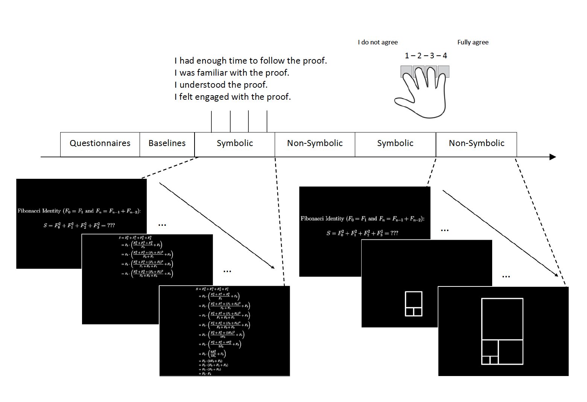

In a naturalistic educational context, the participants were tested in a tutor-student situation. First, they completed a short version of the Berlin Intelligence Scale (to estimate numerical IQ - BIS; Jäger, Süß, & Beauducel, 1997), provided the number of hours a week spent on math, and recorded EEG baseline conditions (eyes open, eyes closed). Subsequently, they watched sixteen demonstrations; eight in symbolic (Arabic) and eight in non-symbolic (geometric) format. In order to control for order effects, half of the participants started with symbolic demonstrations, then their non-symbolic counterparts; the other half started with non-symbolic demonstrations, then their symbolic counterparts. The order between the blocks of symbolic or non-symbolic demonstrations was kept constant. The students were asked to watch and make sense of the demonstrations. After each demonstration, they were asked about their agreement with the following statements on a 4-point Likert scale:

1. I had enough time to follow the demonstration.
2. I am familiar with the demonstration.
3. I understood the demonstration.
4. I engaged with the mathematical demonstration.

While the screen showed these questions, participants could answer with a four-button response box. The total length of the mathematical demonstrations task was approximately 15 minutes. Similar to a tutor-student situation, the students were asked to explain the demonstrations in their own words to the tutor (experimenter) after they watched and rated all demonstrations. However, this part is out of the scope of the current study and, therefore, not reported here.

**Measures**

Data were recorded using a mobile scalp EEG to keep the situation as naturalistic as possible and not restrict the students (Wave-Guard™ EEG cap and eego™ mylab amplifier; ANT Neuro, b.v., Hengelo, the Netherlands). The EEG electrodes were placed according to the extended international 10–20 system (Jasper, 1958). Eye movements were recorded via electrooculography (EOG), using four external electrodes placed below, above, and on the left side of the left eye as well as on the right side of the right eye. The ground electrode was placed behind the right ear. Electrode impedance was kept below 30 kΩ, and data were digitized at a rate of 2048 Hz. The experimental setup included triggers that marked the beginning of each demonstration and format. During the demonstration, additional triggers were utilized to indicate changes in subslides. All triggers were transmitted to the computer wirelessly using the Lab Streaming Layer (LSL). We only focused on electrode clusters relevant to our hypotheses (see Figure 2 and the text below for further information).

To perform the brainwave analysis, we used Welch’s method (1967) for obtaining amplitude signal power estimation. Drawing on previous research (see Rubinsten et al., 2020, who based their analysis on Schadow et al., 2007; Völker et al. 2018; and a meta-analysis of fMRI studies comparing symbolic and non-symbolic tasks by Sokolowski et al., 2017), we selected a frontocentral cluster of electrodes, namely FC1, FC2, FC3, FC4, and FCz for the gamma band (lower gamma 30-40 Hz) analysis. For the beta band (lower beta 12– 17 Hz) analysis, we selected a parietal cluster of electrodes, namely P1, P2, Pz, and POz electrodes, again based on previous research (see Rubinsten et al., 2020, who based their analysis on Avancini, Soltész, & Szűcs, 2015; Szűcs & Soltész, 2008).

Figure 2. *Schematic example of the selected electrodes*

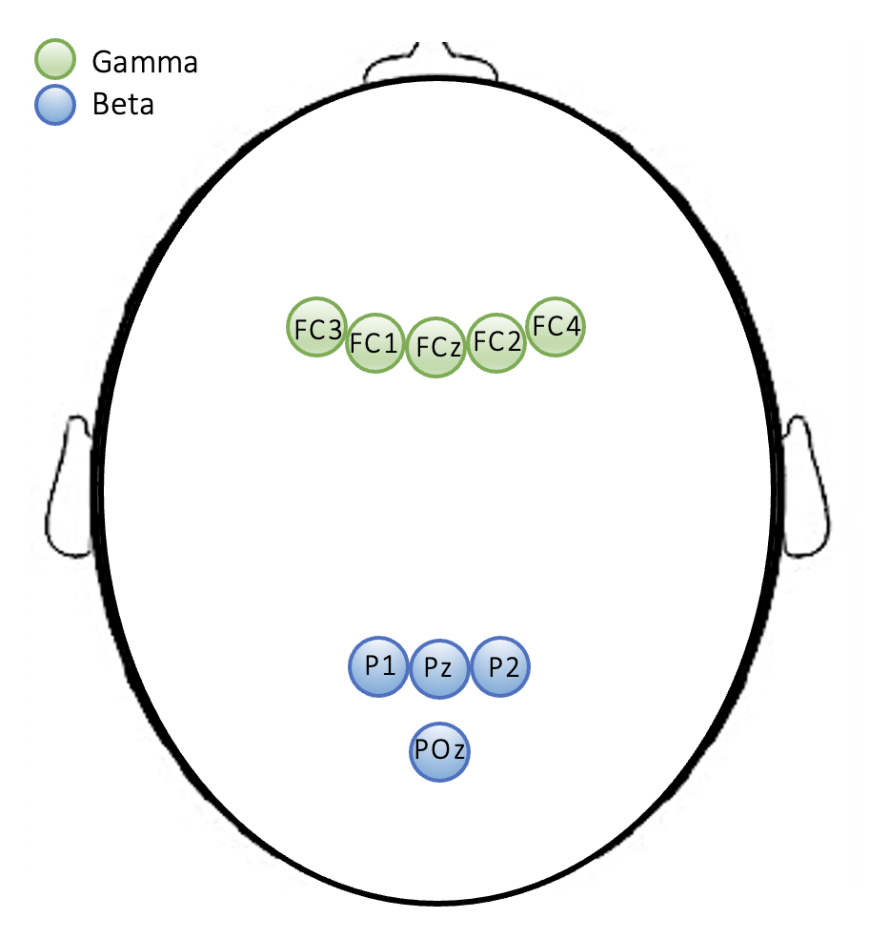

**Data Preprocessing and Analysis**

*Behavioral data*. For the self-reflection questions, sum scores were formed for each scale (time, familiarity, understanding, and engagement). The raw score was analyzed for all other measures (reported weekly math hours and numerical IQ). Bivariate pearson correlations between behavioral measures were calculated and are shown in table 1. Furthermore, paired *t*-tests were used to compare self-reflections between the symbolic demonstrations and their non-symbolic counterparts. In addition, correlational analysis was performed to investigate whether background variables such as numerical IQ, and the weekly engagement with math in hours are related to the four self-reflections.

*Neurophysiological data* underwent preprocessing using EEGLAB (version 2019.1; Delorme & Makeig, 2004). The average of all electrodes served as the reference. A high (0.5 Hz) and low (40 Hz) pass filter were applied to the data. Furthermore, data were filtered using finite impulse response filtering (based on the firls MATLAB function). Independent component analysis (ICA) decomposition using the runica algorithm of EEGLAB (Delorme & Makeig, 2004) was applied to identify and remove eye movement and blink artefacts. The ICA decomposition produced spatial signal source components equal to the number of channels in the EEG data, one to four ICA components associated with eye artefacts were eliminated. Noisy EEG channels were corrected using interpolation. Data was baseline corrected (eyes open, eyes closed), and divided into the frequency bands of 12-17 Hz (beta) and 30-40 Hz (gamma) using high-pass and low-pass filtering. Epochs reflecting each demonstration (excluding the rating) and according to the formats (symbolic and non-symbolic) were created.

We investigated the differences in beta and gamma waves by conducting two repeated measures ANOVAs with Bonferroni-adjusted pairwise comparisons. The first ANOVA assessed gamma power on fronto-central electrodes with electrodes and task format as within-subject factors. The second ANOVA assessed beta power on parietal electrodes with electrodes and task format as within-subject factors. All data analyses were performed using SPSS Version 28.0.01.

**Results**

Table 2 *Pearson Correlations*

|  |  |  |  |  |  |  |  |  |  |  |  |  |  |
| --- | --- | --- | --- | --- | --- | --- | --- | --- | --- | --- | --- | --- | --- |
|  |  | 1 | 2 | 3 | 4 | 5 | 6 | 7 | 8 | 9 | | 10 | |
| 1. Numerical IQ | | -- |  |  |  |  |  |  |  |  | |  | |
| 2. Math in hours | | .02 | -- |  |  |  |  |  |  |  | |  | |
| 3. Time NS | | -.09 | .40* | -- |  |  |  |  |  |  | |  | |
| 4. Familiarity NS | | -.17 | .09 | .30* | -- |  |  |  |  |  | |  | |
| 5. Understanding NS | | .17 | .31 | .61** | .52** | -- |  |  |  |  | |  | |
| 6. Engagement NS | | .24 | .23 | .36* | .41** | .76** | -- |  |  |  | |  | |
| 7. Time S | | .13 | .49** | .40** | .39* | .73** | .58** | -- |  |  | |  | |
| 8. Familiarity S | | .08 | .19 | .28 | .67** | .55** | .41** | .64** | -- |  | |  | |
| 9. Understanding S | | .19 | .54** | .43** | .28 | .80** | .62** | .85** | .61** | -- | |  | |
| 10. Engagement S | | -.13 | .05 | .27 | .32* | .48** | .65** | .57** | .47** | .60** | | -- | |
| *Note*. * p < .05; ** p < .01; Math in hours = self-reported weekly engagement with math, estimated in hours; NS = non-symbolic; S = symbolic. | | | | | | | | | | |  | |

Surprisingly, the correlation analysis showed that the numerical IQ did not correlate with any self-reflection. The engagement with math in hours was positively related to having enough time to follow the non-symbolic as well as the symbolic demonstration. This might reflect the fact that experience with mathematics is helpful in following the demonstrations more quickly, no matter which format they are presented in. Furthermore, the engagement with math in hours positively related to understanding the symbolic demonstrations. This might reflect the fact that symbolic proofs are more widely used in university math settings.

The answers to the self-reflection questions were compared in a within-subject manner using paired *t*-tests (see Figure 3). The familiarity score was on average lower for the non-symbolic version (*M* = 17.55, *SD* = 5.60) than the symbolic one (*M* = 20.55, *SD* = 4.78), and the difference reached statistical significance *t*(41) = 4.56, *p* < .001, Cohen’s *d* = 0.70. Similarly, the score for understanding was on average lower for the non-symbolic version (*M* = 22.10, *SD* = 5.57) than the symbolic one (*M* = 25.07, *SD* = 5.75), and this difference also reached statistical significance *t*(41) = 5.32, *p* < .001,Cohen’s *d* = 0.82.

Figure 3. *Self-reflections-sum scores about the symbolic and non-symbolic demonstrations*

The score on time (“I had enough time”) was similar (non-symbolic version (*M* = 24.17, *SD* = 4.42, symbolic *M* = 24.71, *SD* = 5.37) for both formats and did not differ significantly *t*(41) = 0.65, *p* =.52, Cohen’s *d* = 0.10. For engagement, the same was observed, (non-symbolic *M* = 22.00, *SD* = 5.88; symbolic *M* = 21.91, *SD* = 6.10), and no statistical significance *t*(27) = 1.50, *p* =.145, Cohen’s *d* = 0.28.

For all repeated-measures ANOVAs Sphericity was violated (as checked with Mauchly’s test); thus, Huynh-Feldt corrected values are reported (*F*HF). Furthermore, because of multiple comparisons, we report the Bonferroni-adjusted p-values (*p*bonf). Repeated-measures ANOVA of the average gamma power revealed a significant effect for electrode, *F*HF (1.96, 38) = 41.93, *p* < .001, *η2p* =.51, as well as an electrode × format interaction, *F*HF (1.24, 38) = 25.33, *p* < .001, *η2p* =.38, with no main effect for format, *F*HF (1, 41) = 2.82, *p* = .10, *η2p* =.06. Over this frontocentral cluster, FC4 showed lower gamma power compared with FC1, FC2, and FC3 (*p*bonf < .001), similarly, FCz showed lower gamma power compared with FC1, FC2, and FC3 (*p*bonf < .001; see Figure 4). This finding suggests that, despite no global power difference, the electrodes in the frontocentral cluster respond divergently under the different formats. Furthermore, the interaction effect was driven by the difference in electrodes FC4 and FCz, which showed differences between the format. The gamma power in FC4 was significantly (*p*bonf = .016) higher when non-symbolic demonstrations were watched than symbolic demonstrations. Similarly, non-symbolic demonstrations provoked higher gamma power in FCz (*p*bonf < .001) than symbolic demonstrations.

Figure 4. *Estimated marginal means and standard errors of gamma power in voltage over frontocentral cluster, depending on symbolic versus non-symbolic format*

Repeated-measures ANOVA of the average beta power revealed a significant effect for electrode, *F*HF(2.4, 39) = 10.61, *p* < .01, *η2p* = .21, (see Figure 5), with no effect for format, *F*HF (1, 41) = 3.39, *p* = .07, *η2p* = .08, nor the interaction of electrode × format *F*HF(1.95, 39) = .39, *p* = .67, *η2p* =.01. Over this parietal cluster, P1 showed higher beta power compared with P2 and POz (*p*bonf = .006, and *p*bonf < .001), and Pz showed higher beta power compared to POz *p*bonf < .001. Since format almost reached statistical significance, we looked at the pairwise comparisons of the electrodes regarding format. P1 and Pz showed higher beta power for non-symbolic demonstrations (*p*bonf = .06) but did not reach significance, while POz showed significantly higher beta power for non-symbolic (*p*bonf = .044) compared to symbolic demonstrations.

Figure 5. *Estimated marginal means and standard errors of beta power in voltage over parietal cluster, depending on symbolic versus non-symbolic format.*

Exploratory Analysis: To investigate the impact of behavioral variables on the brain signal associated with each task, we conducted an exploratory analysis. To do this, we calculated difference scores for the familiarity and understanding of the tasks. This involved subtracting the score of familiarity with the non-symbolic version from the score of the familiarity with the symbolic version and doing the same for the scores of understanding. This approach allowed us to assign a positive value to a higher familiarity or understanding of the symbolic version, while a negative value indicated a greater familiarity or understanding of the non-symbolic version. These difference scores were then included as covariates in the repeated measures ANOVAs. Repeated-measures ANCOVA of the average gamma power revealed a significant effect for electrode × familiarity, *F*HF (2.98, 38) = 2.85, *p* < .041, *η2p* =.068, while repeated-measures ANCOVA of the average beta power revealed a significant effect for electrode × familiarity, *F*HF(2.59, 39) = 4.26, *p* = .01, *η2p* = .098, and a marginally significant effect for electrode × understanding, *F*HF (2.59, 41) = 2.78, *p* = .053, *η2p* = .067.

Since our stimuli were different in length and more naturalistic than the stimuli used in Rubinsten et al.’s (2020) study, we did further exploratory analyses. Our aim was to replicate earlier findings. To achieve this, we focused on the time window of 100-200 ms (Liu et al., 2018) and selected the second slide of each demonstration for comparison. We made this selection because the first slide typically contained a question, whereas the second slide was when the demonstration's symbolic or non-symbolic aspect began. Repeated-measures ANOVA of the average gamma power between 100-200 ms after stimulus onset revealed a significant effect for electrode, *F*HF (2.38, 38) = 20.15, *p* < .001, *η2p* =.33. Over this frontocentral cluster, FC4 showed lower gamma power compared to all other electrodes (*p*bonf ≤ .001), similarly, FCz showed lower gamma power compared with FC2, (*p*bonf = .036).

Repeated-measures ANOVA of the average beta power between 100-200 ms after stimulus onset revealed a significant effect for electrode, *F*HF(2.3, 39) = 6.53, *p* = .01, *η2p* = .14, as well as an effect for format, *F*HF (1, 41) = 5.23, *p* = .027, *η2p* = .11, and interaction of electrode × format *F*HF(2.29, 39) = 5.48, *p* = .004, *η2p* =.118. Over this parietal cluster, POz showed higher beta power compared with P1 and Pz (*p*bonf = .003, and *p*bonf = .002). Furthermore, non-symbolic format provoked higher beta oscillations compared to symbolic format (*p*bonf = .027). P1, Pz, and POz showed higher beta power for non-symbolic demonstrations (*p*bonf = .006, *p*bonf = .011, and *p*bonf = .003, respectively).

**Discussion**

This study aimed to explore the dissociation between symbolic and non-symbolic processing regarding oscillatory dynamics (Rubinsten et al., 2020) in students engaged with advanced mathematics. Since the dissociation between symbolic and non-symbolic processing has been shown behaviorally (e.g., Geary, 1995; Dehaene, 1992), neuro-spatially (e.g., Sokolowski et al., 2017), but not neuro-temporally (e.g., Libertus, Woldorff, & Brannon, 2007), it was unclear whether the dissociation in oscillatory dynamics extends to more natural stimuli, such as mathematical proofs.

The results of the behavioral measures were unexpected. Contrary to Hypothesis 1, that students will rate non-symbolic demonstrations as easier to understand, we found that the non-symbolic demonstrations were harder to understand than symbolic demonstrations. The average rating on questions about “time” and “engagement” was lower for the non-symbolic version than the symbolic version. However, despite this descriptive difference, students reported being equally engaged and having sufficient time for sensemaking with the non-symbolic version of the demonstration. In accordance with our expectation (Hypothesis 2), symbolic demonstrations were rated as more familiar by the students.

One explanation for why the students rated symbolic versions as easier to understand and more familiar than non-symbolic demonstrations involves the different conceptual developmental paths towards understanding formal math (Tall, 2002). Although exploratory, the correlation analysis showed that the more students engaged with mathematics in hours, the more they indicated that they had enough time to follow the non-symbolic and symbolic demonstration, and the better they understood the symbolic demonstrations. These results might correspond to the experience with mathematics being helpful for following math demonstrations more quickly, even if they are presented in a non-symbolic format. Thus, even when the format is unfamiliar, students who engaged more with math can follow math demonstrations more easily. Some evidence indicates that students may struggle with understanding when a demonstration is first introduced in a geometric way (Uhlig, 2002). Indeed, some researchers and math educators recommend introducing mathematics in a more symbolic rather than concrete format (for a discussion, see Trninic, Sinha, & Kapur, 2020). Thus, students might be more familiar with the symbolic format simply because they were taught mathematics in a more symbolic way.

No significant differences were found in beta oscillations between non-symbolic or symbolic math demonstrations. Both symbolic and non-symbolic demonstrations provoked strong beta oscillations (i.e., greater decreases in power compared to baseline) and the pattern of activation was similar in electrodes. This is somewhat surprising, as Rubinsten and colleagues (2020) report a beta power difference between the task format (symbolic vs non-symbolic) when analyzing a shorter time window; in their case, 150-200 ms. The time window in the present study was broader than 180 ms, since the mean presentation time of an argument was about 13 seconds. To check if there are differences in beta oscillations early in the math demonstrations, when participants are introduced to the symbolic or non-symbolic demonstration, we analyzed a time window of 100-200 ms. Similar to Rubinsten et al (2020), we found a difference in beta oscillations: namely, stronger beta oscillations for non-symbolic demonstrations compared to symbolic demonstrations. Thus, it may be that differences in beta oscillations can only be found in specific time windows after stimulus onset. In a recent study, where the researchers predicted mathematical ability with behavioral, cognitive, and neurophysiological factors, there was no strong evidence that periodic activity in the beta band predicts mathematical skills in children and adults (van Bueren, van der Ven, Roelofs, Cohen Kadosh, & Kroesbergen, 2022). Another explanation for a lack of difference when the whole demonstrations are considered, might be the visual complexity of the demonstrations in both formats. Although it did not rely on symbols, the presentation of the non-symbolic demonstration was still geometrically complex. The parietal cortex is not only associated with numerical processing, but also with visual attention and visual processing in general (see Corbetta & Shulman, 2002, for a review). Previous neurophysiological studies have shown that global continuous perception (Gestalt perception) is associated with stronger beta oscillations in parietal electrodes (Zaretskaya & Bartels, 2015). Thus, our results regarding the whole demonstration could be a reflection of Gestalt perception of the visually presented demonstrations.

Additionally, we found differences in gamma frequencies between symbolic and non-symbolic demonstrations. The association between gamma oscillations and more complex mathematical tasks was reported in previous research (Molina del Río, Guevara, Hernández González, Hidalgo Aguirre, & Cruz Alguilar, 2019). Interestingly, this effect was only shown in two electrodes, namely the fronto-central (FCz), and the rightmost frontal electrode (FC4) showed lower gamma power for symbolic than non-symbolic demonstrations. These two electrodes behaved differently than the others, suggesting a lateralization in the right hemisphere. Previous research on mathematical problem-solving has shown a lateralization in the right hemisphere with increasing solution times (Lin et al., 2015). This lateralization could be related to the involvement of visual attention (Rouhinen, Panula, Palva, & Palva, 2013), or insight (Shen et al., 2013).

**Limitations**

To acquire high gamma, the experimental setup must be quite strict in order to eliminate auditive or motor noise in the data. To set up our study in a more naturalistic manner, we opted to relinquish this degree of control. Therefore, we used low gamma waves and compared the lower frequency band with earlier research. However, we think that future studies could attempt to investigate high gamma in more complex mathematical stimuli to see if the difference between symbolic and non-symbolic stimuli can be found in the upper frequencies.

A suggested approach to overcome the limitations of naturalistic studies in future research would be to incorporate baseline conditions. Specifically, conditions in which participants view symbols or geometric figures with similar visual complexity as those present in the symbolic and non-symbolic demonstrations, but lacking mathematical meaning. This setup could serve as a viable control for the oscillatory activity observed during the demonstrations. By doing so, researchers would have an opportunity to differentiate neural activity that is specific to mathematical information processing from that which is simply a result of perceptual demands.

**Conclusions**

Tall (1998) claimed that mathematicians develop knowledge in different ways: some build up on imagery (i.e., more non-symbolic forms), while others build a consistent theory of symbolic, more formal mathematics from the beginning (see also Hadamard, 2020). He concludes that “the cognitive development of students needs to be considered so that demonstrations are presented in forms that are potentially meaningful for them” (p.18). A better understanding of neural processing of symbolic and non-symbolic mathematics is valuable to not only basic cognitive research, but also to the practice of mathematics education. In mathematics education, the success of symbolic formalism in mathematics proper became the reason for the formalization of mathematics education, yet—in terms of cognition and learning—this may be putting the cart before the horse.

From a neuroimaging perspective, we know relatively little about what goes on in the brains of students when they engage with symbolic or non-symbolic mathematics. Our study makes initial strides in this direction. While we replicated the original finding (Rubinsten et al., 2020) with regards to the *initial* difference in neural processing of symbolic and non-symbolic stimuli, our study found no difference when considering mathematical reasoning over more naturalistic time scales.

Behaviorally, we found that students rated symbolic math demonstrations as more familiar and more understandable compared to the non-symbolic demonstrations. This result, however, might only reflect the prevalence of above-mentioned educational approaches, that is, of emphasizing symbolic examples at the expense of non-symbolic ones.

Our study highlights some of the challenges associated with using EEG methods to investigate mathematical reasoning in ecologically valid settings. Although laboratory studies have provided insights into the neural mechanisms underlying mathematical cognition, the use of more controlled and simplified stimuli may not adequately represent real-world mathematical problem-solving complexity and variability. Future research should, in addition to more controlled experiments, thus also pursue more naturalistic paradigms. By combining more naturalistic approaches with more controlled experiments, it may be possible to develop a more nuanced and thorough understanding of the neural basis of authentic mathematical reasoning.

References

Ansari, D. (2007). Does the parietal cortex distinguish between “10”, “ten,” and ten dots? *Neuron, 53*(2), 165-167.

Arsalidou, M., & Taylor, M. J. (2011). Is 2+2=4? Meta-analyses of brain areas needed for numbers and calculations. *Neuroimage, 54*(3), 2382-2393. doi:10.1016/j.neuroimage.2010.10.009

Arsalidou, M., Pawliw-Levac, M., Sadeghi, M., & Pascual-Leone, J. (2018). Brain areas associated with numbers and calculations in children: Meta-analyses of fMRI studies. *Developmental Cognitive Neuroscience, 30*, 239-250. doi:10.1016/j.dcn.2017.08.002

Avancini, C., Soltész, F., & Szűcs, D. (2015). Separating stages of arithmetic verification: An ERP study with a novel paradigm. *Neuropsychologia, 75*, 322-329.

Brainard, D. H. (1997) The Psychophysics Toolbox, *Spatial Vision 10*:433-436.

Britton, J. C., Phan, K. L., Taylor, S. F., Welsh, R. C., Berridge, K. C., & Liberzon, I. (2006). Neural correlates of social and nonsocial emotions: An fMRI study. *Neuroimage, 31*(1), 397-409. doi:10.1016/j.neuroimage.2005.11.027

Bulthé, J., De Smedt, B., & Op de Beeck, H. P. (2018). Arithmetic skills correlate negatively with the overlap of symbolic and non-symbolic number representations in the brain. *Cortex*, 101, 306‑308. <https://doi.org/10.1016/j.cortex.2018.01.008>

Caplan, J. B., Madsen, J. R., Raghavachari, S., & Kahana, M. J. (2001). Distinct patterns of brain oscillations underlie two basic parameters of human maze learning. *Journal of neurophysiology, 86*(1), 368-380.

Cirino, P. T. (2011). The interrelationships of mathematical precursors in kindergarten. *Journal of experimental child psychology*, *108*(4), 713-733.

Costa, G. N., Duarte, J. V., Martins, R., Wibral, M., & Castelo-Branco, M. (2017). Interhemispheric binding of ambiguous visual motion is associated with changes in beta oscillatory activity but not with gamma range synchrony. *Journal of cognitive neuroscience, 29*(11), 1829-1844.

De Smedt, B., & Gilmore, C. K. (2011). Defective number module or impaired access? Numerical magnitude processing in first graders with mathematical difficulties. *Journal of experimental child psychology*, *108*(2), 278-292.

Dehaene, S.,

Piazza, M., Pinel, P., & Cohen, L. (2003). Three parietal circuits for number processing. *Cognitive Neuropsychology, 20*(3), 487-506. doi:10.1080/02643290244000239

DeLoache, J. S., Miller, K. F., & Rosengren, K. S. (1997). The Credible Shrinking Room: Very Young Children’s Performance With Symbolic and Nonsymbolic Relations. *Psychological Science, 8*(4), 308–313. doi: 10.1111/j.1467-9280.1997.tb00443.x

Delorme A & Makeig S (2004) EEGLAB: an open-source toolbox for analysis of single-trial EEG dynamics, *Journal of Neuroscience Methods 134*:9-21.

Gallistel, C. R., & Gelman, R. (2000). Non-verbal numerical cognition: From reals to integers. *Trends in cognitive sciences, 4*(2), 59-65.

Gashaj, V., Oberer, N., Mast, F. W., & Roebers, C. M. (2019). The relation between executive functions, fine motor skills, and basic numerical skills and their relevance for later mathematics achievement. *Early education and development, 30*(7), 913-926.

Geary, D. C. (1995). Reflections of evolution and culture in children's cognition: Implications for mathematical development and instruction. *American psychologist*, *50*(1), 24.

Gebuis, T., & Reynvoet, B. (2012). The interplay between nonsymbolic number and its continuous visual properties. *Journal of Experimental Psychology: General, 141*(4), 642. doi: 10.1037/a0026218.

Gelman, R., & Gallistel, C. R. (1986). *The child’s understanding of number*. Harvard University Press.

Hadamard, J. (2020). *The mathematician’s mind: The psychology of invention in the mathematical field*. Princeton University Press.

Hester, R., Fassbender, C., & Garavan, H. (2004). Individual differences in error processing: a review and reanalysis of three event-related fMRI studies using the GO/NOGO task. *Cerebral Cortex, 14*(9), 986-994. doi:10.1093/cercor/bhh059.

Huettel, S. A., Guzeldere, G., & McCarthy, G. (2001). Dissociating the neural mechanisms of visual attention in change detection using functional MRI. *Journal of Cognitive Neuroscience, 13*(7), 1006-1018. doi:10.1162/089892901753165908.

IBM Corp. (2021). IBM SPSS Statistics for Macintosh (Version 28.0) [Computer software]. Armonk, NY: IBM Corp.

Jäger, A. O., Süß, H.-M., & Beauducel, A. (1997). Test für das Berliner Intelligenzstrukturmodell. *BIS-Test. Form 4* [Test for the Berlin Intelligence Structure Model]. Göttingen: Hogrefe.

Jasper, H. H. (1958). Report of the committee on methods of clinical examination in electroencephalography. *Electroencephalography and Clinical Neurophysiology, 10*(2), 370–375. doi:10.1016/0013-4694(58)90053-1

Jordan, N. C., Glutting, J., & Ramineni, C. (2010). The importance of number sense to mathematics achievement in first and third grades. *Learning and individual differences*, *20*(2), 82-88.

Libertus, M. E., Woldorff, M. G., & Brannon, E. M. (2007). Electrophysiological evidence for notation independence in numerical processing. *Behavioral and Brain Functions, 3*(1), 1-15. doi:10.1186/1744-9081-3-1

Lin, C. L., Jung, M., Wu, Y. C., She, H. C., & Jung, T. P. (2015). Neural correlates of mathematical problem solving. *International journal of neural systems, 25*(02), 1550004.

Liu, R., Schunn, C. D., Fiez, J. A., & Libertus, M. E. (2018). The integration between nonsymbolic and symbolic numbers : Evidence from an EEG study. *Brain and Behavior, 8*(4), e00938. <https://doi.org/10.1002/brb3.938>

Mazza, G. L., Enders, C. K., & Ruehlman, L. S. (2015). Addressing item-level missing data: A comparison of proration and full information maximum likelihood estimation. *Multivariate Behavioral Research, 50*(5), 504–519. doi:10.1080/00273171.2015.1068157

Molina del Río, J., Guevara, M.A., Hernández González, M., Hidalgo Aguirre, R.M., & Cruz Alguilar, M.A. (2019). EEG correlation during the solving of simple and complex logical–mathematical problems. *Cognitive, Affective, and Behavioral Neuroscience 19*, 1036–1046. doi:10.3758/s13415-019-00703-5

Munson, A. (2010). Bourbaki at Seventy-Five: Its influence in France and beyond. *Journal of Mathematics Education at Teachers College, 1*(2). https://doi.org/10.7916/jmetc.v1i2.686

Pelli, D. G. (1997) The VideoToolbox software for visual psychophysics: Transforming numbers into movies, *Spatial Vision* 10:437-442.

Piazza, M.,

Pica, P., Izard, V., Spelke, E. S., & Dehaene, S. (2013). Education enhances the acuity of the nonverbal approximate number system. *Psychological science, 24*(6), 1037-1043. doi:10.1177/0956797612464057

Recio, A. M., & Godino, J. D. (2001). Institutional and personal meanings of mathematical proof. *Educational studies in mathematics, 48*(1), 83–99. doi:10.1023/A:1015553100103

Rouhinen, S., Panula, J., Palva, J. M., & Palva, S. (2013). Load dependence of β and γ oscillations predicts individual capacity of visual attention. *Journal of Neuroscience*, *33*(48), 19023-19033.

Rubinsten, O., Korem, N., Levin, N., & Furman, T. (2020). Frequency-based Dissociation of Symbolic and Nonsymbolic Numerical Processing during Numerical Comparison. *Journal of Cognitive Neuroscience, 32*(5), 762–782. doi:10.1162/jocn_a_01550

Schwartz, F., Zhang, Y., Chang, H., Karraker, S., Kang, J. B., & Menon, V. (2021). Neural representational similarity between symbolic and non‐symbolic quantities predicts arithmetic skills in childhood but not adolescence. *Developmental Science, 24*(6). <https://doi.org/10.1111/desc.13123>

Shen, W., Liu, C., Zhang, X., Zhao, X., Zhang, J., Yuan, Y., & Chen, Y. (2013). Right hemispheric dominance of creative insight: an event-related potential study. *Creativity Research Journal*, *25*(1), 48-58.

Sokolowski, H. M., Fias, W., Mousa, A., & Ansari, D. (2017). Common and distinct brain regions in both parietal and frontal cortex support symbolic and nonsymbolic number processing in humans: A functional neuroimaging meta-analysis. *Neuroimage, 146,* 376-394. doi:10.1016/j.neuroimage.2016.10.028

Szűcs, D., & Soltész, F. (2008). The interaction of task-relevant and task-irrelevant stimulus features in the number/size congruency paradigm: An ERP study. *Brain Research, 1190*, 143-158.

Tall, D.

(1998, August). The cognitive development of proof: Is mathematical proof for all or for some. In *Conference of the University of Chicago School Mathematics Project.*

Trninic, D., Kapur, M., & Sinha, T. (2020). The Disappearing “Advantage of Abstract Examples in Learning Math”. *Cognitive Science, 44*(7), e12851. doi:[10.1111/cogs.12851](https://doi.org/10.1111/cogs.12851)

Trninic, D., Wagner, R., & Kapur, M. (2018). Rethinking failure in mathematics education: A historical appeal. *Thinking Skills and Creativity, 30*, 76–89. doi: 10.1016/j.tsc.2018.03.008

Uddin, L. Q., & Menon, V. (2009). The anterior insula in autism: Under-connected and under-examined. *Neuroscience & Biobehavioral Reviews, 33*(8), 1198-1203. doi:10.1016/j.neubiorev.2009.06.002.

Uhlig, F. (2002). The role of proof in comprehending and teaching elementary linear algebra. *Educational Studies in Mathematics, 50*(3), 335-346. doi:10.1023/A:1021245213997

van Bueren, N. E., van der Ven, S. H., Roelofs, K., Cohen Kadosh, R., & Kroesbergen, E. H. (2022). Predicting math ability using working memory, number sense, and neurophysiology in children and adults. *Brain Sciences, 12*(5), 550.

Vatansever, G., Ustun, S., Ayyildiz, N., & Cicek, M. (2020). Developmental alterations of the numerical processing networks in the brain. *Brain Cognition, 141*, 105551. doi:10.1016/j.bandc.2020.105551.

Welch, P. (1967). The use of fast Fourier transform for the estimation of power spectra: A method based on time averaging over short, modified periodograms, *IEEE Transactions on Audio and Electroacoustics, 15*(2), 70-73. doi: 10.1109/TAU.1967.1161901.

Wood, J. N., & Spelke, E. S. (2005). Infants’ enumeration of actions: Numerical discrimination and its signature limits. *Developmental Science*, *8*(2), 173-181.