GLP-1 Adverse Event Analysis: Identifying Pharmacovigilance Reporting Patterns

Executive Summary
This case study evaluated FAERS adverse-event reporting patterns for semaglutide and liraglutide, with primary emphasis on the comparable 2018–2022 period.
The analysis found that liraglutide had a higher proportion of reports classified as serious, while semaglutide showed greater year-to-year variability in serious-report proportions. Gastrointestinal reactions were prominent for both drugs, with nausea the most frequently reported term. Time-matched comparisons also showed that some apparent between-drug differences, such as pancreatitis reporting, became smaller when unequal observation periods were controlled.
The findings support prioritization of gastrointestinal events, temporal changes in serious reporting, and time-sensitive reaction differences for further pharmacovigilance review. Because FAERS does not provide exposure denominators and is subject to reporting bias, the results are intended for signal exploration rather than causal or comparative safety conclusions.

Introduction / Project Overview
This case study analyzes post-market adverse-event reporting patterns for two GLP-1 therapies using a structured Kaggle dataset derived from FDA FAERS/openFDA data. The project was designed to simulate a real-world pharmacovigilance analytics assignment in which a life-sciences company wants to better understand the reporting profile of its GLP-1 therapy relative to another drug in the same class and identify areas that may warrant further safety investigation.
The analysis follows the Google Data Analytics framework: Ask, Prepare, Process, Analyze, Share, and Act (Google, 2026). Python and pandas were used for data preparation and exploratory analysis, BigQuery SQL was used to reproduce and validate key results, and Tableau was used to communicate findings through stakeholder-oriented dashboards.
Because FAERS is a spontaneous reporting system, the analysis is focused on reporting patterns and signal prioritization rather than incidence, relative risk, or causal conclusions.

Business Scenario
A pharmaceutical company’s Pharmacovigilance and Regulatory Affairs teams want to understand how the adverse-event reporting profile of semaglutide compares with liraglutide. The purpose is to identify recurring, temporally variable, or otherwise notable reporting patterns that may justify deeper pharmacovigilance review.
The company is not attempting to determine which drug is “safer” based solely on FAERS data. Instead, the objective is to use post-market reporting patterns to prioritize topics for further investigation using additional clinical, regulatory, and exposure data.

My Role
In this project, I assumed the role of a Data Analyst supporting Pharmacovigilance and Regulatory Affairs.
My responsibilities included defining the analytical scope, preparing and validating the FAERS-derived datasets, conducting descriptive and temporal analyses, comparing semaglutide with liraglutide, validating key calculations using SQL, and developing Tableau dashboards to communicate the findings to non-technical and technical stakeholders.
I also evaluated data-quality limitations, including missing demographic information and unequal observation periods, and incorporated these limitations into the final interpretation and recommendations.

Ask Phase

Business Context
A hypothetical pharmaceutical company is evaluating the post-market reporting profile of semaglutide using publicly available FAERS-derived adverse-event data. The company wants to better understand reporting patterns associated with semaglutide and compare them with liraglutide, another GLP-1 receptor agonist, to identify topics that may warrant further pharmacovigilance review.

Business Task
The objective of this analysis is to identify and prioritize adverse-event reporting patterns associated with semaglutide that may warrant further pharmacovigilance investigation or regulatory evaluation. The analysis compares semaglutide with liraglutide while recognizing that FAERS data cannot establish causality or directly measure the incidence or relative risk of adverse events.
The primary business question is:
What adverse-event reporting patterns can be identified for semaglutide, and how do they compare with liraglutide to identify areas that may warrant further pharmacovigilance investigation?

Topic
Post-market adverse-event reporting patterns for semaglutide compared with liraglutide using FAERS-derived data.

Key Metrics
The analysis will focus on the following metrics:
- Number of unique adverse-event reports
- Reaction reporting proportion
- Serious report proportion
- Hospitalization report proportion
- Death report proportion
Additional demographic and time-based metrics, including patient age, sex, and reporting trends over time, may be explored when relevant to the analysis.

Stakeholders
The key stakeholders are:
- Pharmacovigilance / Drug Safety Manager
- Regulatory Affairs Manager

Audience
The primary audience for the analysis is the Pharmacovigilance / Drug Safety Manager and the Regulatory Affairs Manager.

Decision Support
The analysis will help the stakeholders identify adverse-event reporting patterns that may deserve additional review, prioritize potential safety topics for further investigation, and determine where additional evidence—such as clinical data, scientific literature, or regulatory assessment—may be required.
The findings will be used for signal exploration and prioritization rather than to establish causal relationships between a drug and a reported adverse event.

Prepare Phase

Data Sources

Source and provenance
The analytical files used in this case study were obtained from the GLP-1 Weight Loss Drugs Master Dataset 2017–2026 (Version 1.0) published on Kaggle by devtayyabsajjad (2026). The Kaggle package is a structured secondary dataset assembled from public data sources. For this project, the adverse-event component originates from the FDA Adverse Event Reporting System (FAERS) through the openFDA Drug Adverse Event API (U.S. Food and Drug Administration, n.d.; openFDA, n.d.).
The project did not retrieve patient reports directly from FDA. The Kaggle files were the immediate analytical source. Other sources included in the broader master dataset—such as ClinicalTrials.gov, Yahoo Finance, Google Trends, and Wikipedia—were outside the scope of this pharmacovigilance analysis.
Three files from this Kaggle dataset were selected for the case study:
1. adverse_events.csv — Main analytical dataset
This file contains adverse-event reports related to GLP-1 medications. The data were derived from the FDA Adverse Event Reporting System (FAERS) through the openFDA Drug Adverse Event API.
The dataset contains:
- 149,209 rows
- 16 columns
- 54,170 unique safetyreportid values
- 7 approved drugs represented in the adverse-event data
- Reporting dates ranging from November 23, 2012 to January 17, 2025
Key variables include:
- generic and queried brand name
- report date and country
- seriousness classification
- death, hospitalization, life-threatening, and disabling indicators
- patient age, sex, and weight
- reported reaction
- reaction outcome
The dataset is organized at the reaction level rather than strictly at the report level. A single safetyreportid may therefore appear in several rows when one adverse-event report contains multiple reactions.
The dataset contains an average of approximately 2.75 reaction rows per report, with a median of 2. Some complex reports contain substantially more reactions, including one report containing 95 distinct reactions.

2. drugs_overview.csv — Drug reference table
This file contains 10 GLP-1-related drugs and provides drug-level information including:
- generic_name
- brand names
- manufacturer
- indication
- first FDA approval date
- investigational status
- drug class
The file contains 10 rows and 7 columns.
Seven records represent approved drugs, while three represent investigational products:
- orforglipron
- retatrutide
- cagrilintide-semaglutide
The three investigational drugs do not appear in the adverse-event dataset.
generic_name was verified as a valid joining field between the two analytical tables. All 149,209 adverse-event rows successfully matched a record in drugs_overview.csv.

3. data_dictionary.csv — Supporting documentation
This file contains definitions of the variables included across the Kaggle dataset.
It was used as a reference to interpret column names, expected data types, and variable meanings. It is considered supporting documentation rather than a primary analytical dataset.

Data Storage
The original CSV files were downloaded from Kaggle and stored without modification in:
Data/Raw/
The project uses separate folders for raw and processed data so that the original source files remain unchanged throughout the analysis.
The project structure also separates notebooks, documentation, SQL work, and visualizations.

Data Organization
Two levels of observation were identified in adverse_events.csv.
Reaction level
Each row represents a reported reaction associated with an adverse-event report.
This level will be appropriate for analyses such as:
- reaction frequency
- reaction reporting proportion
- reaction outcomes
Report level
safetyreportid identifies an adverse-event report. Multiple rows may share the same ID because a single report can contain multiple reactions.
A report-level view is therefore more appropriate for variables such as:
- serious status
- hospitalization
- death
- life-threatening outcome
- disabling outcome
- patient age
- patient sex
- patient weight
Patient age, sex, weight, and seriousness fields were verified to remain consistent within individual safetyreportid values.

Initial Data Quality and Integrity Assessment
Several checks were performed before data cleaning.

Data types
safetyreportid was converted from integer to string because it functions as an identifier rather than a numerical measurement.
All report IDs were verified to contain eight digits.
receive_date was converted from text to a datetime data type. All 149,209 values converted successfully without generating invalid dates.
fda_first_approval_date in the drug reference table was also converted to datetime format.
The three missing approval dates correspond to the three investigational drugs.

Duplicate assessment
No completely duplicated rows were identified.
Although 95,039 rows contain a repeated safetyreportid, these are not necessarily duplicates because one report may contain several distinct reactions.
No duplicate combinations of:
safetyreportid + reaction
were identified.
This supports the internal consistency of the reaction-level structure.

Missing values
Missingness differs substantially depending on whether it is measured at the row level or the unique-report level.
At the unique-report level:
- approximately 42.8% of reports are missing patient age
- approximately 81.2% of reports are missing patient weight
Because patient weight has very limited coverage and includes implausible values, it will not be used as a primary analytical variable.
Patient age may be explored, but findings will require cautious interpretation because of substantial missingness.
reaction_outcome has no null values, but approximately 61% of reaction rows are classified as Unknown, substantially limiting outcome-based analysis.

Numerical anomalies
Patient age ranges from 0 to 100 years.
Some very low age values may represent valid pediatric cases, unusual coding, or data-quality issues and therefore require cautious interpretation.
Patient weight contains several extreme values, including:
- very low reported weights
- values above 300 kg
- one clearly implausible value of 87,075 kg
These values will be addressed during the Process phase rather than modified during initial preparation.

Geographic Coverage
The adverse-event data are strongly concentrated in the United States.
Among unique adverse-event reports, the United States accounts for the large majority of records, while considerably smaller numbers originate from other countries.
Some reports use the country code UNK, indicating that the reporting country is unknown.
This geographic imbalance limits the ability to interpret the dataset as globally representative.
Geographic analysis is not a primary objective of this case study.

Temporal Coverage
The full adverse-event dataset spans:
November 23, 2012 – January 17, 2025
However, temporal coverage differs considerably by drug.
For the drugs initially considered for comparison:
- semaglutide: 2014–2025
- liraglutide: 2012–2023
- dulaglutide: 2014–2016
The dataset also contains a small number of reports dated before the first FDA approval date contained in the drug reference table:
- semaglutide: 36 unique reports
- liraglutide: 0
- dulaglutide: 1
These records were not removed during Prepare because their origin cannot be determined from the available data alone.
The more important limitation is unequal temporal coverage across drugs.
Dulaglutide was therefore removed from the primary comparative analysis because its available records end in 2016.
The primary comparison will focus on semaglutide and liraglutide, while temporal comparisons will use overlapping periods when appropriate.

ROCCC Assessment

Reliable
The adverse-event data ultimately originate from FDA FAERS through the openFDA API, an official public pharmacovigilance source.
However, FAERS is a spontaneous reporting system. Reports may be incomplete, voluntarily submitted, or unverified, and a reported adverse event does not establish that the medication caused the event.
The dataset is therefore considered reliable for signal exploration and reporting-pattern analysis, but not for establishing causality, incidence, or comparative drug risk.

Original
The data used in this project are not downloaded directly from the original FDA database.
They are a structured secondary extract distributed through Kaggle and derived from FDA/openFDA data.
The original governmental source is therefore clearly distinguished from the analytical dataset used in the project.

Comprehensive
The dataset contains more than 54,000 unique reports and thousands of reported reactions, providing substantial information for exploratory analysis.
However, it does not represent every adverse event experienced by treated patients.
Incomplete demographic information, unknown outcomes, voluntary reporting, and unequal coverage across drugs limit comprehensiveness.

Current
The dataset contains reports through January 17, 2025.
It therefore provides relatively recent historical data, although it does not contain reports after that date.

Cited
The Kaggle dataset, FDA FAERS, and openFDA are documented as the sources supporting the analysis.

Licensing, Privacy, Security, and Accessibility
The analysis uses publicly available data.
The Kaggle master dataset is distributed under a CC0 Public Domain Dedication. The underlying FDA/openFDA data are U.S. Government public-domain data. The analysis therefore uses openly accessible data suitable for an educational portfolio project.
No direct patient identifiers such as names, addresses, telephone numbers, or contact information are included in the analytical files.
The data are therefore suitable for a public portfolio project.
Original raw files are preserved separately and are not modified.
CSV format also makes the data accessible through commonly available analytical tools such as Python, SQL, spreadsheets, and Tableau.

Relevance to the Business Question
The adverse-event dataset provides the variables required to investigate reporting patterns associated with semaglutide, including:
- reported reactions
- seriousness
- hospitalization
- death
- report timing
- patient demographics
The reference table provides additional context about drug class, manufacturer, indication, approval date, and investigational status.
Together, these data support the business objective of identifying adverse-event reporting patterns for semaglutide and comparing them with liraglutide to identify topics that may warrant further pharmacovigilance investigation.
The data cannot determine whether a medication caused an adverse event or which medication is safer.

Key Data Limitations
The main limitations identified during the Prepare phase are:
- FAERS reports cannot establish causal relationships.
- Prescription or patient-exposure denominators are unavailable, so report counts cannot be interpreted as incidence or comparative risk.
- Patient age is missing for approximately 42.8% of unique reports.
- Patient weight is missing for approximately 81.2% of unique reports and contains implausible values.
- Approximately 61% of reaction outcomes are classified as Unknown.
- Reporting is heavily concentrated in the United States.
- Temporal coverage differs substantially between medications.
- A small number of reports precede the FDA approval dates recorded in the reference table.
- Raw report volume may be influenced by medication utilization, reporting behavior, time on the market, and public awareness.
These limitations will guide the cleaning decisions and analytical methods used in the Process and Analyze phases.

Process Phase

Tools Selected
The data cleaning and transformation process was performed in Python using pandas and NumPy within a Jupyter Notebook in Visual Studio Code.
Python was selected because the dataset contains more than 149,000 rows and requires reproducible transformations, filtering, joins, validation checks, and the creation of analysis-ready datasets at different levels of granularity.
The Process phase was intentionally completed in Python rather than SQL to keep all cleaning logic in one reproducible workflow. SQL will be used later during the Analyze phase for aggregation, validation, and comparative queries.

Data Cleaning and Transformation
The Process phase began by reloading the original source files from the Data/Raw/ folder to ensure that all transformations were applied from unchanged raw data.
The following cleaning and transformation steps were performed:
- Corrected data types
  - Converted safetyreportid from integer to string because it is an identifier rather than a numeric measure.
  - Converted receive_date to datetime format.
  - Converted fda_first_approval_date to datetime format.
- Filtered the analytical scope
  - Limited the main analysis to:
    - semaglutide
    - liraglutide
  - This produced an initial subset of 72,265 reaction-level rows and 24,970 unique safety reports.
- Joined drug reference information
  - Merged selected metadata from drugs_overview.csv using generic_name as the join key.
  - Added:
    - manufacturer
    - indication
    - FDA first approval date
    - drug class
  - The join preserved all rows and produced no missing values in the added drug-reference fields.
- Removed pre-approval reports
  - Because the business question focuses on post-market safety, reports dated before each drug’s FDA approval date were excluded.
  - This removed:
    - 492 reaction-level rows
    - 36 unique safety reports
- Checked for duplicates
  - Verified that there were no exact duplicate rows.
  - Verified that there were no duplicate combinations of safetyreportid + reaction.
  - Repeated safetyreportid values were retained because one safety report can contain multiple reported reactions.
- Removed a low-quality variable
  - patient_weight_kg was removed from the processed analytical dataset because approximately 81% of unique reports were missing weight data and several implausible values were identified during the Prepare phase.
- Preserved incomplete or unknown values without artificial imputation
  - Missing patient_age values were retained as missing rather than replaced with a mean or median.
  - Explicit Unknown categories in patient_sex and reaction_outcome were retained because they represent reported source values rather than processing errors.
- Created two levels of analysis
  - A reaction-level dataset was created to preserve one row per reported reaction.
  - A report-level dataset was created with one row per unique safetyreportid.
- Created analysis-support variables
  - Added report_year to both processed datasets.
  - A provisional comparison_period flag was initially created for 2018–2023 so that a common-period comparison could be explored without discarding the full post-approval history.
  - During the Analyze phase, 2023 was found to be incomplete for liraglutide; therefore, the final primary comparison window was refined to the complete shared years 2018–2022.
- Reset the working index
  - The filtered dataset index was reset to provide a clean sequential structure before final export.

Data Integrity Verification
Several checks were performed after cleaning to verify that the processed data were ready for analysis.
The reaction-level dataset contained:
- 71,773 rows
- 21 columns
- 24,934 unique safety reports
The report-level dataset contained:
- 24,934 rows
- 19 columns
- one row per unique safety report
Additional checks confirmed that:
- no exact duplicate reaction-level rows remained;
- no duplicate safetyreportid values existed in the report-level dataset;
- both processed datasets contained the same set of safety report IDs;
- no remaining report occurred before the corresponding FDA approval date;
- all selected drug metadata matched successfully;
- no new missing values were introduced during the merge or transformation steps.
The final date ranges were:
- liraglutide: November 23, 2012 to March 2, 2023
- semaglutide: December 6, 2017 to January 17, 2025
The remaining missing values in patient_age were expected and intentionally preserved because they originate from the source data.

Output Datasets
Two analysis-ready datasets were created and saved in Data/Processed/:
- adverse_events_reaction_level.csv
- adverse_events_report_level.csv
The reaction-level dataset will be used for analyses such as:
- most frequently reported reactions
- reaction reporting patterns
- reaction outcomes
The report-level dataset will be used for analyses such as:
- serious report proportion
- hospitalization report proportion
- death report proportion
- life-threatening and disabling event rates
- demographic patterns
- temporal reporting trends
These processed datasets will serve as the primary inputs for the Analyze phase using Python and SQL.

Process Phase Conclusion
The data were cleaned, standardized, validated, and reorganized into two complementary analytical structures. The original raw files were preserved unchanged, while all cleaning decisions were documented and applied reproducibly in Python.
The processed data are now ready for comparative analysis of post-market adverse-event reporting patterns for semaglutide and liraglutide.

Analyze Phase — Summary of Analysis
The analysis was conducted using the two processed datasets created during the Process phase: a report-level dataset, containing one row per FAERS safety report, and a reaction-level dataset, containing one row per reported adverse reaction. Python/pandas was used for exploratory analysis, descriptive statistics, temporal comparisons, demographic analysis, and the creation of summary tables. BigQuery SQL was subsequently used to reproduce and cross-validate the principal analytical results.
The analysis focused on comparing post-market adverse-event reporting patterns for semaglutide and liraglutide. Because the drugs had different observation periods in the source data, both full post-approval history and common-period comparisons were evaluated. Examination of annual data showed that 2023 was incomplete for liraglutide; therefore, 2018–2022 was selected as the primary full-year comparison period.

Main analyses performed
- Report volumes and unique safety-report counts by drug.
- Seriousness indicators, including serious, hospitalization, death, life-threatening, and disabling report proportions.
- Full-history versus common-period comparisons.
- Most frequently reported adverse reactions and the percentage of reports mentioning each reaction.
- Annual report volume and serious-report trends.
- Year-to-year variability in serious-report proportions.
- Patient sex and age distributions.
- Reaction outcome distributions and missing-data assessment.
- SQL replication of report counts, safety metrics, reaction rankings, and reaction proportions to validate the Python results.

Key analytical findings
During the complete post-approval histories available in the dataset, semaglutide had 14,956 unique reports and liraglutide had 9,978. However, these totals should not be interpreted as comparative risk because the drugs had different observation periods and FAERS does not provide a denominator representing the number of exposed patients.
For the primary comparable period of 2018–2022, semaglutide had 9,215 reports and liraglutide had 2,556 reports. The proportion of reports classified as serious was approximately 34.0% for semaglutide and 57.4% for liraglutide. Hospitalization proportions were approximately 13.5% and 17.4%, respectively. Death-report proportions were similar during this common period, approximately 1.22% for semaglutide and 1.13% for liraglutide. These results show why controlling for observation period was important: some differences that appeared substantial in the full-history comparison became much smaller when both drugs were evaluated over the same years.
Temporal analysis also showed different reporting patterns. Liraglutide's annual serious-report proportion was relatively stable during 2018–2022, with a mean annual proportion of approximately 57.5% and a standard deviation of 3.8 percentage points. Semaglutide showed considerably greater year-to-year variability, with a mean annual proportion of approximately 33.8% and a standard deviation of 14.7 percentage points. This indicates that aggregate averages alone may conceal important changes in reporting patterns over time.
Nausea was the most frequently reported reaction for both drugs during the common period. Approximately 13.5% of liraglutide reports and 18.8% of semaglutide reports mentioned nausea. Vomiting and diarrhoea also represented larger proportions of semaglutide reports during 2018–2022. Semaglutide's common-period reaction ranking also included terms such as Weight decreased and Decreased appetite, while liraglutide included Weight increased and Weight loss poor. These are reported reaction terms and should not be confused with the patient_weight_kg variable, which was excluded from the processed analysis because of substantial missingness and anomalous values.
One particularly important methodological finding involved pancreatitis. In the full-history comparison, pancreatitis appeared in 7.19% of liraglutide reports versus 2.77% of semaglutide reports. When both drugs were evaluated over a common temporal window, this difference became substantially smaller. This demonstrated that unequal observation periods could materially influence apparent differences between drugs and reinforced the decision to prioritize time-matched comparisons.
Demographic analysis showed that female patients represented the majority of reports for both drugs. Among reports with known age, the 50–64-year age group was the largest for both medications, while semaglutide reports showed a somewhat older age distribution. These findings should be interpreted cautiously because age was missing from approximately 40% of liraglutide reports and 46% of semaglutide reports, and FAERS does not provide the underlying demographic distribution of all treated patients.
Reaction-outcome data also had important completeness limitations. Approximately 44% of reaction outcomes were recorded as Unknown for both drugs. Therefore, reaction-outcome comparisons were considered secondary and were not selected as a primary basis for stakeholder conclusions.

Python and SQL validation
BigQuery SQL was used to independently reproduce key calculations initially performed in Python. Report counts, seriousness metrics, reaction rankings, and reaction proportions generated in SQL matched the corresponding Python results.
This cross-validation increased confidence that the analytical results were not dependent on a single tool or implementation. Python was particularly useful for data preparation, transformation, exploratory analysis, temporal evaluation, and demographic analysis, while SQL provided a concise and efficient method for aggregation, filtering, ranking, and validation using functions such as COUNT(DISTINCT), AVG, GROUP BY, JOIN, CTEs, and window functions.

Interpretation for stakeholders
The analysis identifies several reporting patterns that may be useful for signal exploration and pharmacovigilance prioritization, rather than establishing that one drug is safer than another.
For Pharmacovigilance and Regulatory Affairs stakeholders, the most relevant areas for further investigation include the differing seriousness-report patterns between the two drugs, temporal variation in semaglutide reports, recurrent gastrointestinal reactions, and reaction patterns that change materially depending on the observation period. These topics could be prioritized for follow-up using additional evidence such as clinical trial data, prescribing information, scientific literature, exposure data, and formal pharmacovigilance assessments.

Analytical limitations
FAERS is a spontaneous adverse-event reporting system. The number or proportion of submitted reports cannot be interpreted as incidence, prevalence, relative risk, or proof that a drug caused an event. Reporting patterns may be influenced by drug utilization, time on market, indication, publicity, reporting behavior, patient characteristics, regulatory activity, and other factors that are not controlled in this dataset.
For this reason, the findings are intended to support signal detection and prioritization of topics for further review, not causal conclusions or direct claims that one medication has a superior safety profile.

Analysis outputs
The following summary datasets were generated in Data/Analysis/ for visualization and stakeholder communication:
age_distribution.csv, sex_distribution.csv, reaction_outcomes.csv, reaction_comparison_full_history.csv, reaction_comparison_2018_2022.csv, safety_metrics_full_history.csv, safety_metrics_2018_2022.csv, yearly_trends.csv, and yearly_trends_2018_2022.csv.
The main SQL queries used for independent validation were documented in SQL/glp1_faers_analysis.sql.
These outputs will be used in the Share phase to build the Tableau visualizations and communicate the main findings to Pharmacovigilance and Regulatory Affairs stakeholders.

Share Phase — Supporting Visualizations and Key Findings

The Share phase focused on translating the analytical results into clear, stakeholder-oriented visualizations for Pharmacovigilance and Regulatory Affairs decision-making. Tableau was selected because it allowed multiple safety, temporal, and demographic metrics to be presented consistently while maintaining a common visual language across the analysis.
Two dashboards were developed. The first dashboard summarizes the principal adverse-event reporting patterns and directly addresses the primary business question. It compares seriousness-related report characteristics, selected adverse-event terms, and annual serious-report proportions for semaglutide and liraglutide during the common 2018–2022 observation period.
The second dashboard provides demographic context for the submitted FAERS reports, showing age-group distributions and recorded patient sex for both drugs. Demographic results are presented as characteristics of submitted reports rather than characteristics of all patients treated with either medication.
The visualizations were designed using consistent drug colors, direct percentage labels, descriptive titles and subtitles, and concise methodological caveats. The common 2018–2022 comparison period was emphasized throughout the dashboards to reduce distortion caused by unequal observation periods.
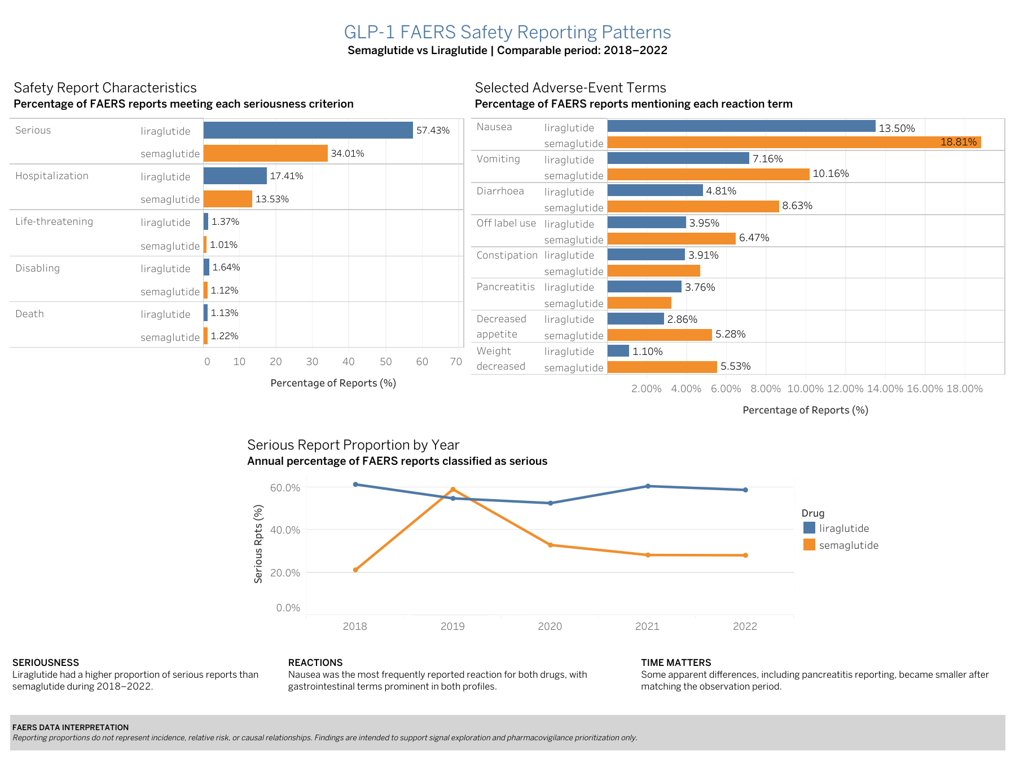
Figure 1. GLP-1 FAERS Safety Reporting Patterns — Semaglutide vs Liraglutide, 2018–2022
Source:Author’s analysis of the GLP-1 Weight Loss Drugs Master Dataset 2017–2026 (Kaggle), based on FDA FAERS data.

Dashboard 1 — Safety and adverse-event reporting patterns
Liraglutide had a higher proportion of reports classified as serious during the common period (57.4% vs 34.0%) and a somewhat higher hospitalization-report proportion (17.4% vs 13.5%). Death-report proportions were similar (1.13% for liraglutide and 1.22% for semaglutide), illustrating why individual seriousness components should be evaluated rather than interpreting the overall serious-report rate alone.
Nausea was the most frequently reported reaction for both drugs and represented a higher proportion of semaglutide reports (18.8% vs 13.5%). Vomiting and diarrhoea were also more prominent among semaglutide reports in the common period.
Temporal analysis showed that liraglutide's serious-report proportion remained relatively stable from 2018 through 2022, whereas semaglutide showed substantially greater year-to-year variation. This suggests that temporal context should be considered when prioritizing apparent differences for further investigation.
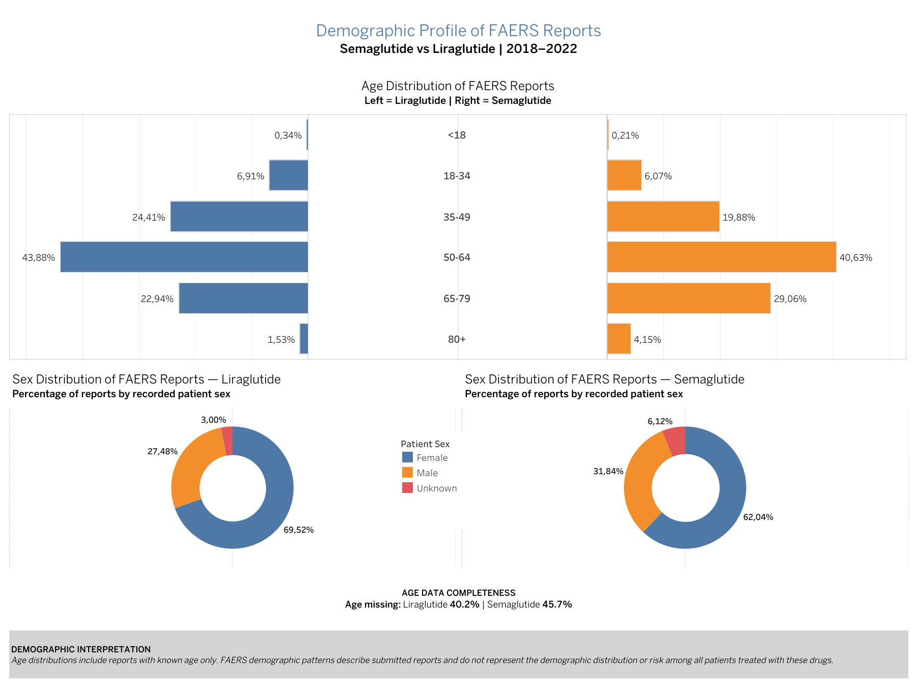
Figure 2. Demographic Profile of FAERS Reports — Semaglutide vs Liraglutide, 2018–2022
Source: Author’s analysis of the GLP-1 Weight Loss Drugs Master Dataset 2017–2026 (Kaggle), based on FDA FAERS data.

Dashboard 2 — Demographic reporting profile
Among reports with known age, the 50–64-year age group represented the largest share for both medications. Semaglutide reports showed a relatively larger contribution from older age groups, particularly patients aged 65–79 and 80+.
Female patients represented the majority of reports for both drugs. However, these patterns describe the demographic composition of submitted FAERS reports and should not be interpreted as evidence that women or particular age groups experience a higher treatment-related risk.
Age completeness represents an important limitation: age was missing from approximately 40.2% of liraglutide reports and 45.7% of semaglutide reports. For this reason, demographic findings were treated as contextual rather than primary safety conclusions.

Key Findings

- Seriousness profile: Liraglutide had a substantially higher proportion of reports classified as serious during 2018–2022, although death-report proportions were similar between the two drugs.
- Reaction profile: Gastrointestinal reactions were prominent for both therapies. Nausea was the most frequently reported reaction and represented a larger share of semaglutide reports.
- Temporal variability: Semaglutide showed substantially greater year-to-year variation in serious-report proportions than liraglutide, demonstrating that pooled averages can conceal temporal changes.
- Observation period matters: Apparent differences can change materially when both drugs are evaluated over the same years. The pancreatitis comparison was a particularly important example of this effect.
- Demographics provide context, not risk estimates: Most reports involved female patients and patients aged 50–64, but substantial missingness and the absence of exposure denominators prevent risk-based demographic conclusions.
- Decision implication: The results support prioritizing recurring gastrointestinal events, temporal changes in serious reporting, and event differences sensitive to observation period for additional pharmacovigilance review.

Stakeholder interpretation
These findings do not establish that either medication is safer than the other. Instead, they provide a structured method for prioritizing areas for additional pharmacovigilance investigation. Follow-up could incorporate prescribing exposure, clinical trial evidence, product labeling, published literature, and formal signal-assessment methods.
FAERS limitation: Reporting proportions do not represent incidence, prevalence, relative risk, or causal relationships.

Act Phase — Conclusions and Recommended Next Steps

Final conclusion
The analysis identified meaningful differences in the FAERS reporting profiles of semaglutide and liraglutide during the common 2018–2022 comparison period. Liraglutide had a higher proportion of reports classified as serious, while semaglutide showed greater year-to-year variability in serious-report proportions and a higher reporting proportion for several gastrointestinal reaction terms, including nausea, vomiting, and diarrhoea.
At the same time, some apparent differences changed substantially when both drugs were restricted to the same observation period. The pancreatitis comparison was an important example, demonstrating that unequal time on market and unequal reporting windows can materially influence apparent safety differences.
Overall, the business question was answered by identifying reporting patterns that could be prioritized for further pharmacovigilance review. However, the analysis does not establish that either drug is safer, nor does it estimate incidence or relative risk. FAERS reporting data are most useful here as a signal-exploration and prioritization tool.

Business implications
For the Pharmacovigilance and Regulatory Affairs teams, the results suggest several areas that merit closer review.
- Gastrointestinal reactions should remain a priority area because they were prominent in both drug profiles and particularly frequent among semaglutide reports.
- Temporal changes in serious-report proportions, especially the greater variability observed for semaglutide, should be investigated to determine whether they coincide with changes in utilization, labeling, publicity, indication expansion, or reporting behavior.
- Reaction differences that change after time matching, such as pancreatitis, should be interpreted cautiously and should not be escalated based on raw historical comparisons alone.
- Demographic patterns may help characterize reporting populations, but should not be used to infer higher risk in women or older patients without exposure-adjusted denominators and more complete demographic data.
These findings can help the company prioritize which potential safety topics should receive additional review rather than treating all reported differences as equally important.

Recommended next steps
The pharmacovigilance team could use these results as the starting point for a structured signal-assessment workflow.
- Review the most prominent semaglutide reaction terms against current product labeling and known safety information.
- Investigate major temporal changes in serious-report proportions and determine whether they align with regulatory, utilization, indication, or reporting changes.
- Perform focused follow-up analyses for reactions showing material between-drug differences or strong temporal shifts.
- Incorporate exposure denominators, such as prescription volume or estimated treated-patient counts, when available.
- Compare the FAERS findings with additional evidence sources before making regulatory or safety conclusions.

Additional data and analyses for further exploration
Several additional datasets or analyses would strengthen the interpretation of the current findings:
- Prescription or exposure data to calculate reporting rates rather than raw reporting proportions.
- Clinical trial safety data for controlled comparisons.
- Product labeling and regulatory safety communications.
- Published pharmacovigilance and pharmacoepidemiology literature.
- Additional FAERS variables such as reporter type, indication, concomitant medications, country, and report source.
- Formal disproportionality analyses such as Reporting Odds Ratio or Proportional Reporting Ratio, where appropriate.
- Longer and more recent time-series analyses using consistently complete annual periods.
- Additional GLP-1 comparators if the project is later expanded beyond liraglutide.

Top high-level insights
- Liraglutide had a higher proportion of serious reports than semaglutide during 2018–2022.
- Semaglutide showed greater temporal variability in serious-report proportions.
- Gastrointestinal reactions were prominent for both therapies, with nausea the most frequently reported term.
- Apparent between-drug differences can change materially when observation periods are aligned.
- FAERS results should support signal prioritization and further investigation, not direct safety or causality claims.
This case study demonstrated an end-to-end analytics workflow using Python, SQL, Tableau, and FAERS data to address a pharmacovigilance business question. The project included data preparation, validation, exploratory analysis, cross-validation of results, stakeholder-focused visualization, and the translation of analytical findings into actionable next steps for further safety investigation.

References
devtayyabsajjad. (2026). GLP-1 Weight Loss Drugs Master Dataset 2017–2026 (Version 1.0) [Data set]. Kaggle. https://www.kaggle.com/datasets/devtayyabsajjad/glp-1-weight-loss-drugs-master-dataset-2017-2026
U.S. Food and Drug Administration. (n.d.). FDA Adverse Event Reporting System (FAERS). https://www.fda.gov/drugs/surveillance/fda-adverse-event-reporting-system-faers
openFDA. (n.d.). Drug adverse event API. U.S. Food and Drug Administration. https://open.fda.gov/apis/drug/event/
Google. (2026). Google Data Analytics Professional Certificate: Case Study Roadmap. Coursera.

