Introduction

This report summarizes the outcome of the meeting between Kit Armstrong, Tuur Rumes, and Pieter-Jan Maes on 23 July 2026. The meeting focused on translating the concept of reusable Beethovenian compositional “blocks” into a computational framework based on NeuralConstraints (Vassallo, 2025). The resulting proposal centers on a first proof-of-concept implementation of Block #1.

Concept: Beethoven blocks as parameterized compositional procedures
The proposed approach builds on the framework of NeuralConstraints (Vassallo et al., 2025), which combines neural prediction with explicit compositional rules enforced through a constraint solver, rather than relying on a neural network to generate an entire composition autonomously.
Within this framework, the input consists of symbolic musical material, such as a Beethoven sketch or piano reduction. Rather than being transformed directly into an orchestral score, the input is processed by a Beethoven Block: a formal, machine-readable specification of a reusable compositional procedure. A block does not contain fixed musical content. Instead, it defines how musical material should be interpreted and transformed into an orchestral realization.
Beethoven Blocks can therefore be understood as parameterized functional transformations. They operate on musical functions—such as melody, harmony, bass, texture, or motivic material—and specify the procedures through which these functions are realized in an orchestral context.

Conceptually, each block answers the question:

« Given this musical material, which musical functions does it contain, and how should these functions be transformed into an orchestral realization according to a characteristic Beethovenian procedure? »

Each block is instantiated as a JSON specification containing the relevant constraints, rules, and parameters. Rather than encoding only low-level restrictions, such as pitch range or prohibited intervals, the JSON captures higher-level compositional procedures.

The novelty of the proposed approach does not simply lie in applying constraint-based generation to orchestration. Instead, it introduces Beethoven Blocks as an intermediate computational layer between symbolic musical input and the NeuralConstraints solver. Each block represents a reusable functional transformation that specifies how a particular type of musical material should be interpreted and realized orchestrally. Different blocks can therefore be selected and parameterized while using the same underlying generative framework.

Input score
↓
Feature extraction
↓
Beethoven Block (JSON)
↓
Constraint solver
↓
Symbolic orchestral realization

Block#1

As a next project milestone, we will implement a first Beethoven Block (Block#1) within the NeuralConstraints framework as a proof of concept. This implementation will demonstrate how a reusable Beethovenian compositional procedure can be formalized as a machine-readable JSON specification and integrated into the existing constraint-based generation pipeline.

The initial implementation focuses on Beethoven Block #1 (Melody–Harmony–Bassline realization). Given symbolic input material (e.g., a Beethoven sketch or piano reduction), the system first extracts the musical functions required by the block, such as the principal melody, harmonic progression, and structural bassline. These functions are assigned to three corresponding orchestral layers—Melody, Harmony, and Bassline—each associated with a predefined set of orchestral instruments. Rather than orchestrating the symbolic input directly, each layer applies its own functional transformation rules to realize the extracted musical function orchestrally.

The block itself is encoded as a JSON specification. Layer-specific rules govern how melody, harmony, and bassline are transformed, while shared constraints ensure coordination and balance between layers, and instrument-specific constraints account for factors such as range, playability, and timbral characteristics. Realization parameters—including orchestral density, doubling, independence of inner voices, contrapuntal complexity, timbral richness, dynamic weight, and textural transparency—allow different orchestrations to be generated from the same underlying musical functions. The resulting rule set is interpreted by the NeuralConstraints solver to generate the final symbolic orchestral realization.

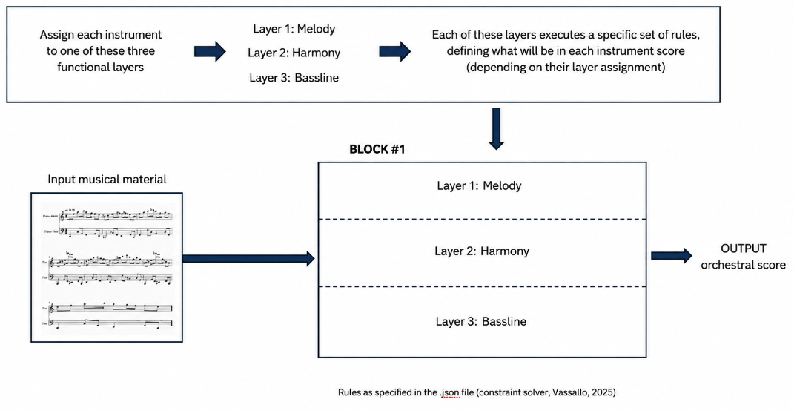
Fig.

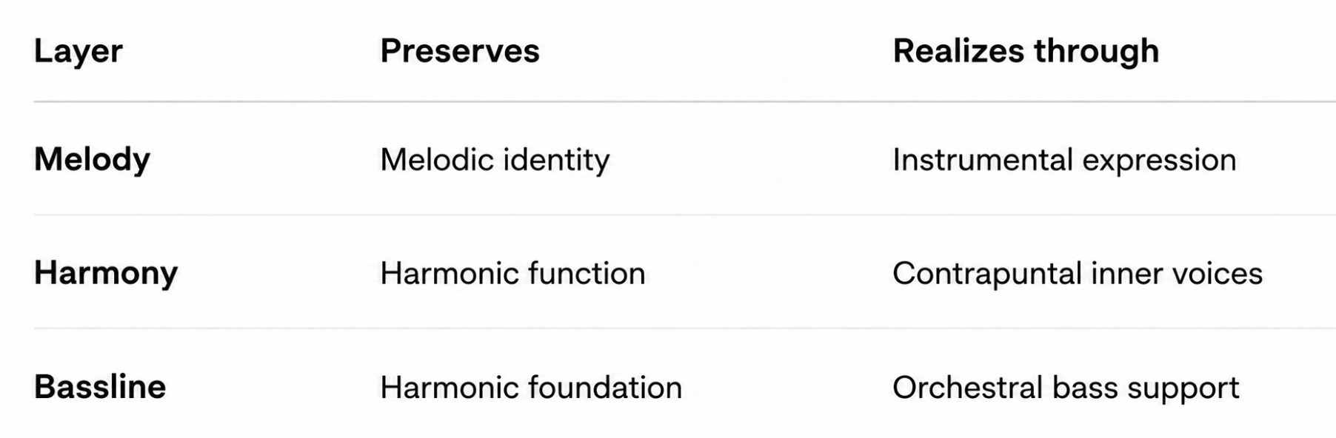
Fig. Overview of the different musical layers within Block#1. Each preserves a different musical function, and each has its own family of realization techniques.

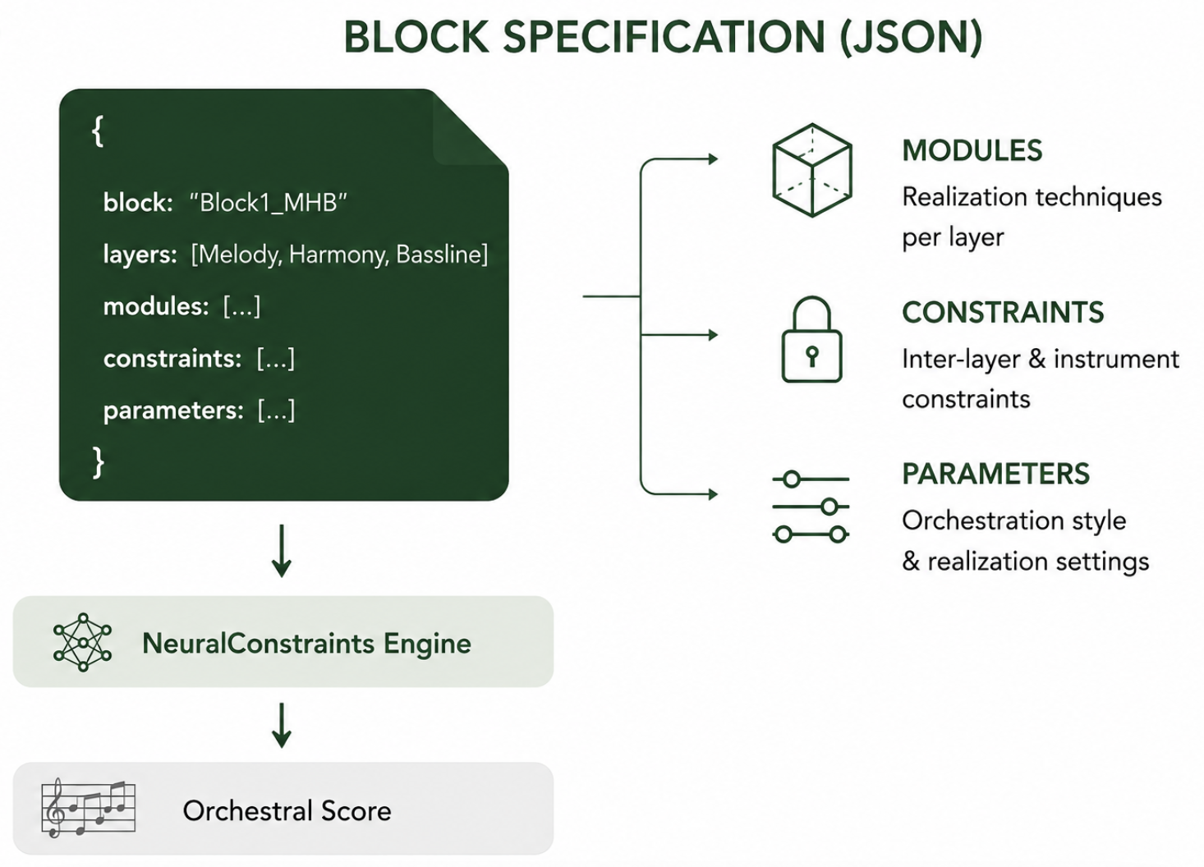

LAYER 1 – Melody

The Melody layer does not simply copy the melody from the input material. Instead, it first identifies the principal melodic line and extracts the melodic function that will serve as the basis for orchestral realization. This function preserves the essential musical characteristics of the input—such as melodic contour, rhythmic identity, phrase structure, and structurally important pitches—while allowing the realization to adapt to the assigned instruments. Depending on the orchestration strategy, the realization may include register adaptation, octave displacement, redistribution of the melody across instruments, articulation and dynamic shaping, breathing points for wind instruments, or the omission of ornamental notes.

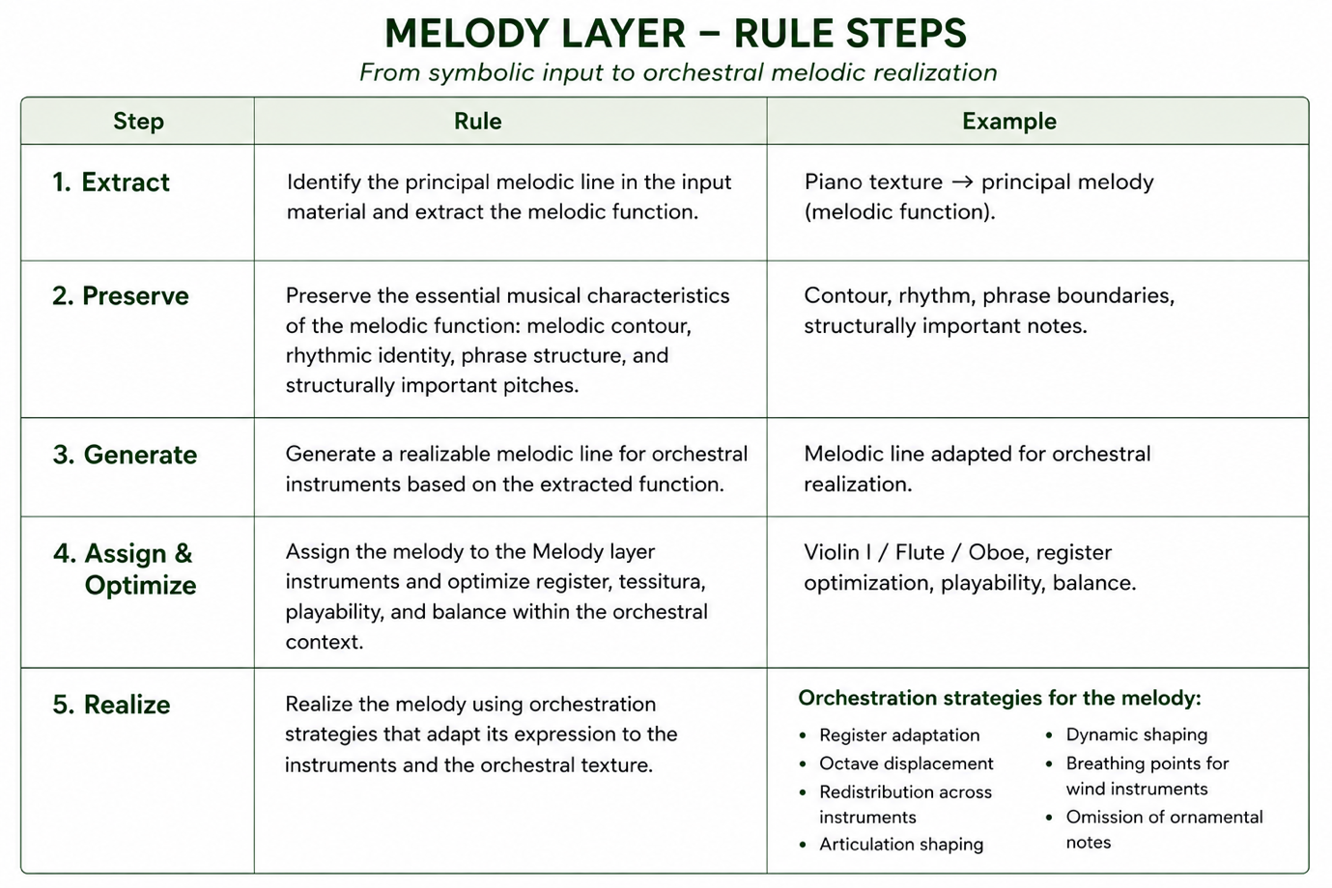

LAYER 2 – Harmony

The Harmony layer transforms the harmonic content of the input material into a coherent orchestral harmonic texture. It first extracts the harmonic progression (i.e., the underlying succession of chords or harmonic functions). Based on this, it generates independent inner voices that together realize the harmony. These voices are then assigned to the instruments of the harmony layer—e.g., horn, viola and bassoon—and optimized for smooth voice leading. The realization may employ orchestration principles such as harmonic reduction, sustained harmony, voice redistribution, common-tone retention, contrary motion, register optimization, incomplete chords, or timbre blending, depending on the desired orchestral texture. The result is an orchestral harmony that preserves the harmonic progression and its structural functions while transforming the repeated or pianistic accompaniment into sustained, contrapuntal inner voices that slow down the harmonic rhythm and create a clear, transparent harmonic colour.
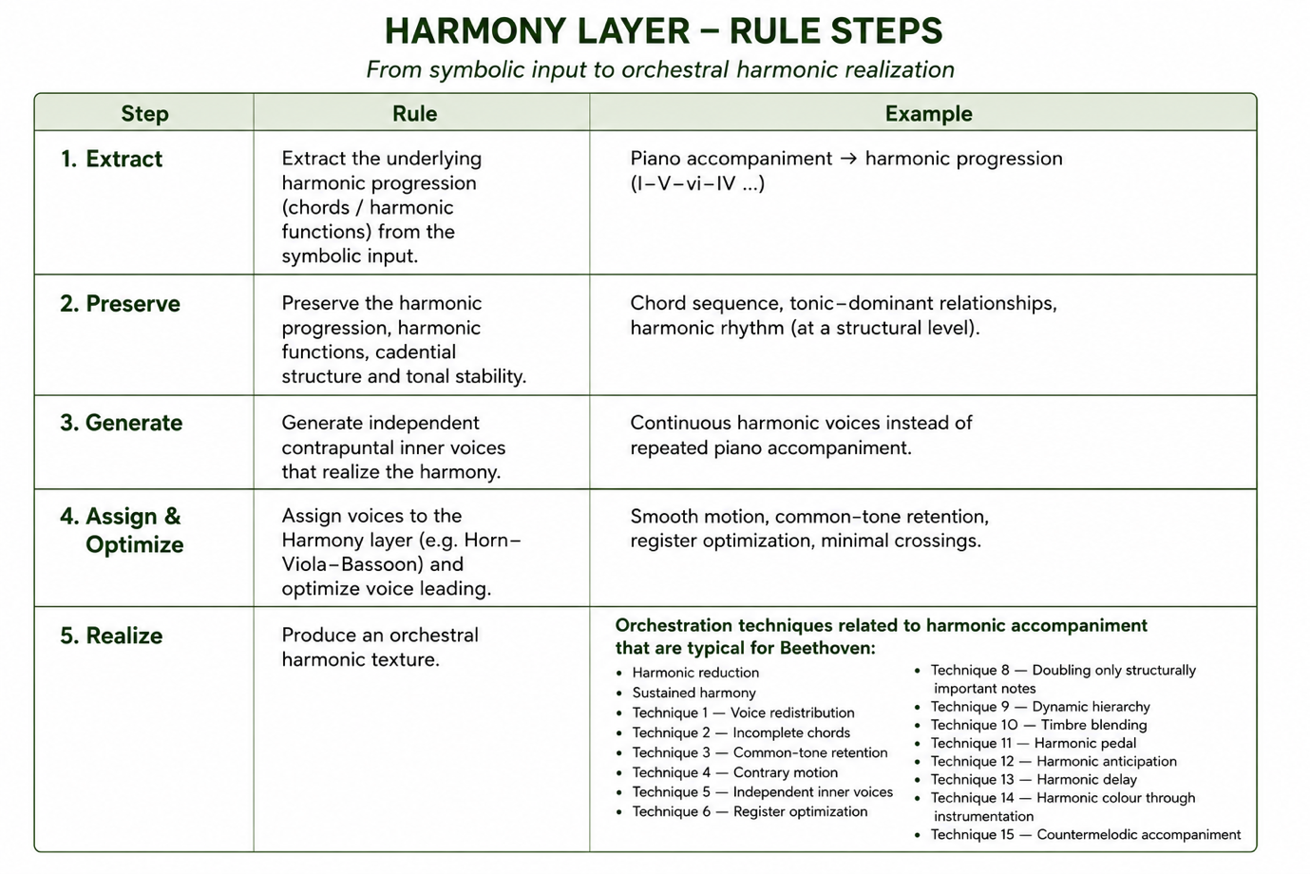
In terms of implementation, within each Beethoven Block, orchestration principles could be represented as modular rule and constraint sets in the JSON specification. For the Harmony layer, these include techniques such as harmonic reduction, voice redistribution, common-tone retention, contrary motion, incomplete chords, register optimization, timbre blending, and harmonic pedal. Depending on the implementation, modules may be selected manually, parameterized, triggered by rule-based conditions, or inferred by a machine-learning model to produce different orchestral realizations of the same underlying harmonic function.

Symbolic input
↓
Feature extraction
↓
Module selection and parameterization
(manual, rule-based, or ML-driven)
↓
Activated constraints and preferences
↓
NeuralConstraints solver
↓
Orchestral realization

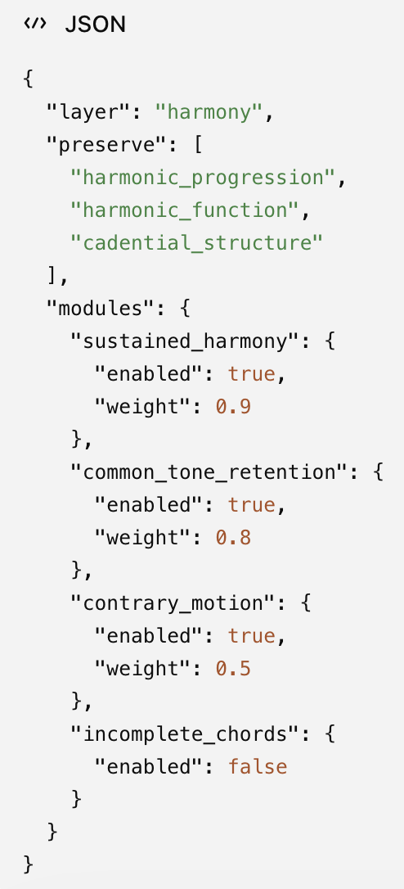

LAYER 3 – Bassline

The Bassline layer transforms the structural bass of the input material into an orchestral bass foundation. It first extracts the structural bassline underlying the harmonic progression. Based on this, it generates a bass part that establishes harmonic support while reinforcing the rhythmic and tonal stability of the orchestral texture. The bassline is then assigned to the instruments of the bass layer—e.g., cello and double bass—and optimized for register, balance, and interaction with the Harmony layer. The realization may employ orchestration principles such as simple harmonic bass, octave doubling, pedal point, ostinato, arpeggiated bass, stepwise bass motion, or rhythmic unison, depending on the desired orchestral character. The result is an orchestral bass texture that preserves the structural harmonic foundation while transforming the pianistic bass into a stable, supportive orchestral foundation.

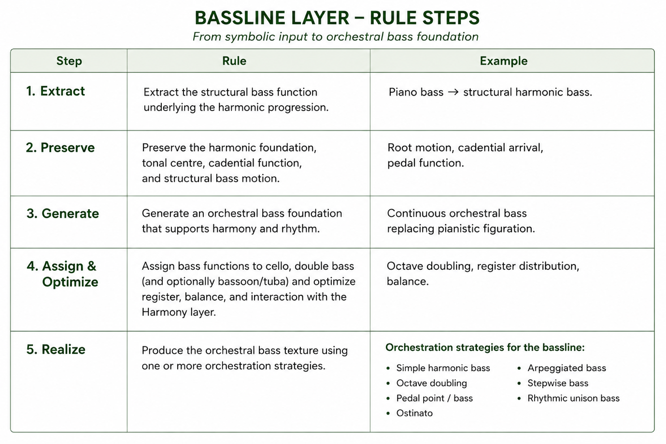

Outlook and next steps
The implementation of Block #1 establishes the underlying architecture of the Beethoven Blocks framework. Once this foundation has been validated, additional Beethoven Blocks can be introduced simply by defining new JSON-based compositional procedures, without requiring modifications to the underlying NeuralConstraints engine. Importantly, the JSON specification does not encode an orchestral score itself. Rather, it encodes the compositional procedure that transforms arbitrary symbolic musical material into such a score. In this way, Beethovenian compositional knowledge is represented explicitly as machine-readable realization procedures, while the NeuralConstraints engine remains a generic execution framework responsible for realizing these procedures.
The next project milestone is the implementation and demonstration of the first working Beethoven Block. The objective is for Tuur to present a proof-of-concept implementation of Block #1 during Kit Armstrong's visit to Ghent on 2 September. This demonstration will validate the proposed block-based realization framework and provide a foundation for evaluating the architecture, discussing additional Beethoven Blocks, and planning subsequent development.

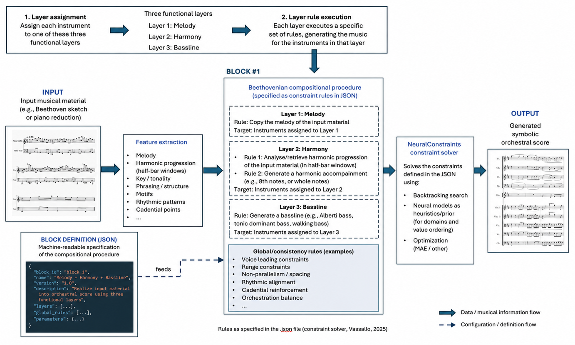

References

Vassallo, J. S., Sandred, Ö., & Vincenot, J. (2025). NeuralConstraints: Integrating a neural generative model with constraint-based composition. Frontiers in Computer Science, 7, Article 1543074.

Appendix

The meeting elaborated on an email of Kit (21/7) replying to the question of whether he could provide some examples of block types. The email is the following:

“Dear Pieter-Jan, sorry for the delay!
Here are some, I think, good examples of block types: https://drive.google.com/drive/folders/1p32uNtRZoUbcdSgaH4dnZFiDP8jtAxMY . (I took these from Beethoven Op.37)
1a,1b: 8-bar melody. Start with a melody -> harmonise -> orchestrate (basic example: clarinet + violin = melody; viola, cello, bass = bass line; everyone else = harmony.) I guess this is the most difficult one, since it involves knowing about good composition.
2: one harmony (in this case G7), different inversions and different instruments on each beat. Can be any number of bars. Piano soloist plays on top of it.
3: like 2, but more complex: stereotypical harmonic sequence + stereotypical rhythmic texture. Can be any number of bars.
4: same as 3, but add motifs (from the predetermined "motif toolbox") where they fit in the harmony.
5: series of motifs in unison. Multiple of 4 bars.
6: call-and-response: choose 1 harmony + rhythm of motif, then alternate with the same number of blank bars. (in this case: 2 iterations, with harmony = [Cm, Fm inv. 2], rhythm = |cq.s|c )
I hope this helps. I would be happy to talk together to further develop/clarify. Good times for me would be 9am on 23 July, or 27-30 July.
Best regards,
Kit
”

Via this email references were made to Figures:
1a.png
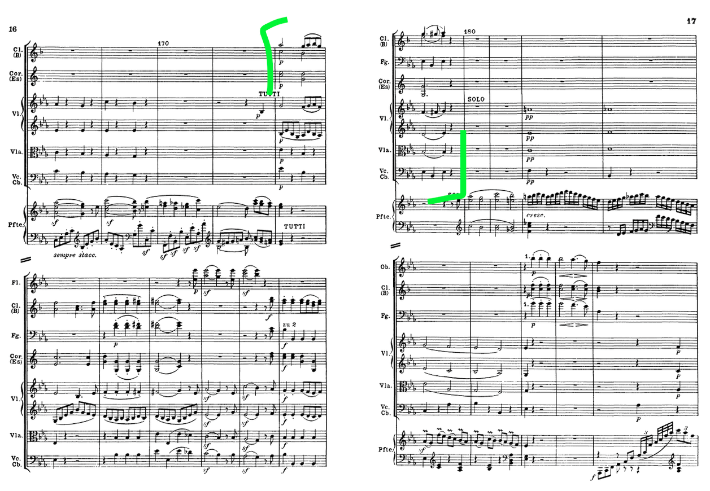
1b.png

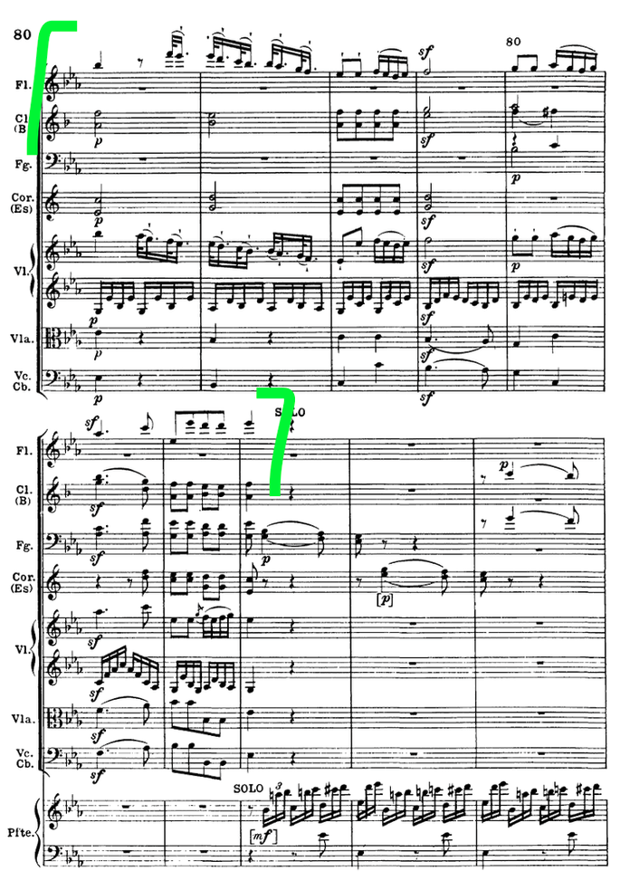

2.png
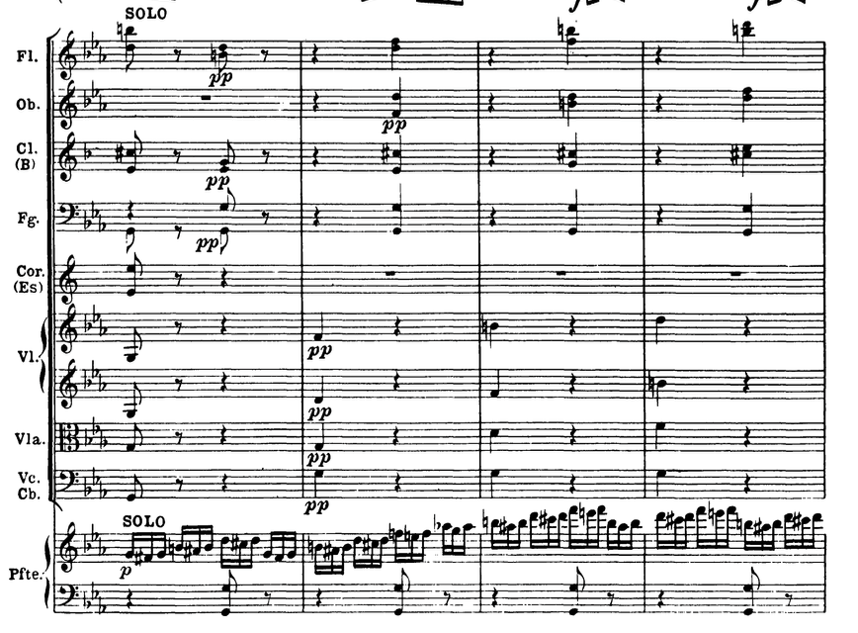

3.png
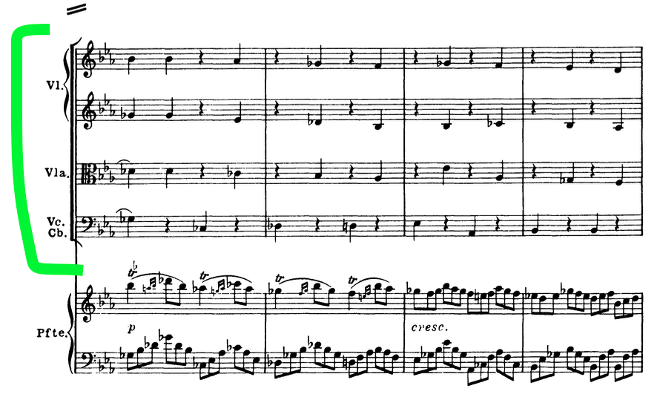

4.png
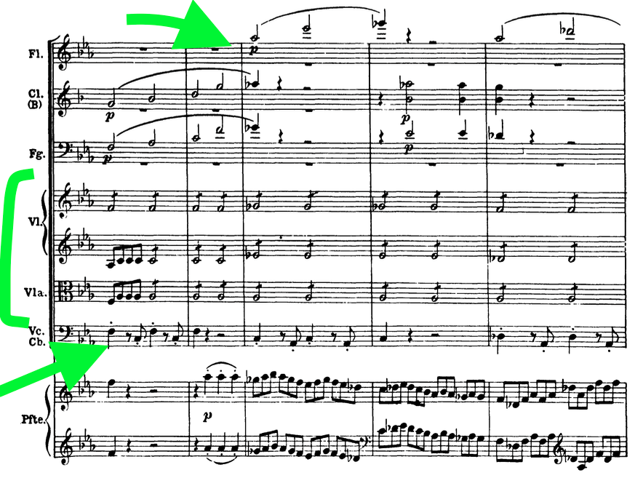

5.png
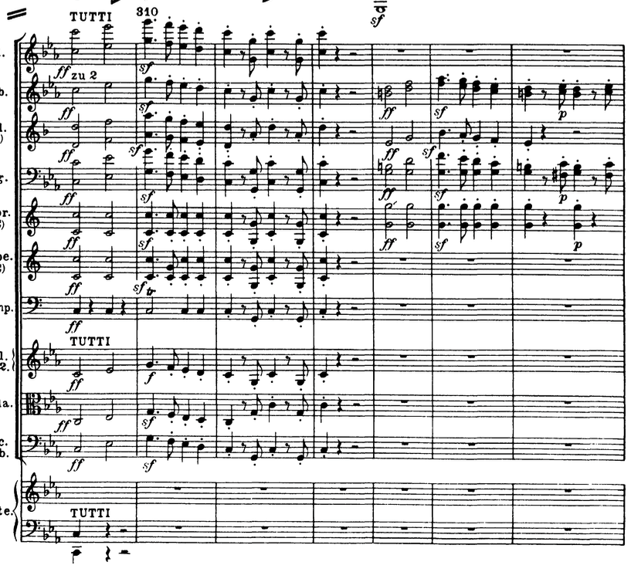
6.png
