PROJECT – Beethoven AI

TABLE OF CONTENTS
- Project concept
- Development pillars and project milestones
- Building a first minimal pipeline

- Project concept

GOAL: An emergent Beethoven piano concerto
This project creates a live-performed piano concerto that emerges in the moment and is always different. A virtuosic-improvising pianist, a full orchestra, a conductor, an audience, and a Beethoven AI-agent form a collaborative ecosystem in which music is continuously co-created. The concerto is not a fixed score but a living process, shaped by real-time interaction among human expression, historical material, and artificially intelligent systems. Every performance unfolds uniquely, never repeating, always becoming.

Core performance ecology
The performance brings together five central agents: the pianist, the orchestra, the conductor, the audience, and the Beethoven AI-agent. Each contributes to a shared creative flow. The pianist improvises at the keyboard, the conductor shapes the ensemble through gesture, the orchestra responds and realizes evolving material, the audience actively adding input, and the AI-agent listens, understands, decides, and generates. The result is a concerto that unfolds uniquely every time.

Beethoven sketches as generative seeds
At the heart of the system is a curated database of Beethoven sketches, based on the KAFKA edition (Joseph Kerman). These sketches are not used as quotations but as generative seeds—short musical ideas, motives, fragments, or harmonic trajectories that carry Beethoven’s compositional DNA. At key moments during the performance, the system retrieves a new sketch excerpt. This retrieved material serves a dual purpose: it guides the AI in generating a provisional orchestral score that the ensemble can play, and it provides inspiration and constraints for the pianist’s improvisation. In this way, Beethoven’s creative process is reactivated in real time.

Sonata form as temporal grammar
The evolving concerto is organized by the large-scale architecture of the classical sonata form. Rather than imposing a rigid template, sonata form functions as a temporal grammar—a dynamic map of expectation, tension, and release. It defines structural milestones such as the presentation of the first theme, the transition, the second theme, the development, and the recapitulation. These milestones determine when the system is allowed—or invited—to retrieve a new sketch and introduce new material. Sonata form thus becomes the decision architecture that guides the trajectory of the piece, ensuring coherence while preserving freedom.

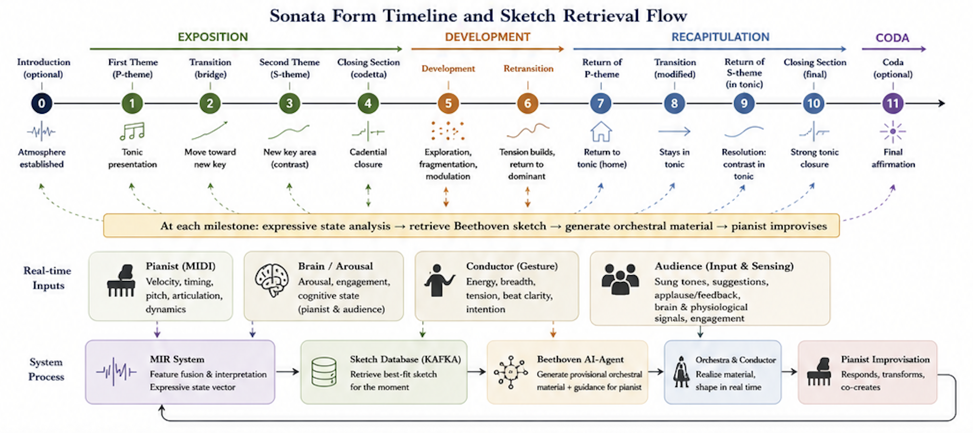

Multimodal understanding and sketch retrieval
The choice of which sketch to retrieve is informed by a real-time Music Information Retrieval (MIR) system that continuously analyzes the performance across multiple music-structural and expressive dimensions. From the pianist, the system receives MIDI data and extracts features such as velocity, articulation, timing deviation, pitch contour, harmonic density, and dynamic shape. From brain sensing, it receives indicators like arousal and engagement level, reflecting the performer’s internal state. From the conductor, computer vision and motion analysis capture gesture qualities including energy, breadth, beat clarity, and tension. These streams of information are fused into a rich expressive state vector that reflects the current musical situation. Based on this state, the system searches the sketch database and retrieves the excerpt whose character, mood, and structural potential best fit the moment and the upcoming sonata milestone.

Generation, improvisation, and real-time realization
Once a sketch is retrieved, the Beethoven AI-agent expands it into a playable orchestral score. This is not a full orchestration in the traditional sense but a basic realization, increasing in complexity throughout the performance. The orchestra performs this material under the guidance of the conductor. Simultaneously, the pianist improvises within the harmonic, motivic, and expressive context suggested by the sketch and the current section of the sonata form. The result is a living dialogue between composed material, generated material, and improvised material.

A continuous feedback loop
The system operates in a continuous loop. Performance produces expressive signals. The MIR system interprets these signals and, in light of the sonata timeline, decides what comes next. A new sketch is retrieved and transformed into music for both orchestra and pianist. This new music changes the performance, which produces new signals, and the cycle continues. This perpetual exchange between human expression and artificial intelligence drives the concerto forward, allowing it to breathe, accelerate, hesitate, intensify, or relax—always in the moment.

A living sonata
In this project, sonata form is no longer a fixed structure written on a page. It is a living ecology of decisions and possibilities. Beethoven’s sketches are no longer historical artifacts locked in the past; they are active participants in the present. Technology is not replacing human creativity but amplifying it, listening to it, and partnering with it. The outcome is a concerto that exists only once—in the here and now—where Beethoven’s genius, human virtuosity, and artificial intelligence converge to create something that could never have been written in advance.

- Development pillars and project milestones

Given the scale and interdisciplinary nature of the project, the development trajectory can be organized around three central pillars. Together, these pillars form the conceptual and technological backbone of the emergent Beethoven concerto system.

Pillar I — Beethoven sketch database and feature labeling/annotation

Goal: To create a curated and structured database of Beethoven sketches that can function as generative material within the live AI-performance system.

Methodological approach: The primary source material will consist of Beethoven sketches from the KAFKA edition. Sketches will be selected, segmented, and organized into a AI-searchable database.

Each sketch excerpt will be characterized through a multidimensional feature representation. These features may include: musical-structural characteristics (e.g., harmonic profile, rhythmic structure, texture, motivic qualities, formal function), expressive and affective qualities (e.g., tension, lyricism, instability, agitation, dramatic intensity), and historical and musicological references (e.g., links to finalized Beethoven works, compositional periods, stylistic contexts)

The outcome of this pillar is a high-dimensional feature space in which every sketch is represented as a multidimensional vector that can later be used for retrieval and generation.

Pillar II — Multimodal MIR and real-time sketch retrieval

Goal: To develop a real-time Music Information Retrieval (MIR) system capable of retrieving Beethoven sketches during live performance based on multimodal expressive input.

Methodological approach: The system will continuously analyze input from performers, conductor, audience, and physiological sensing systems.

Possible input modalities include: pianist MIDI features (e.g., timing, velocity, articulation, harmonic density), conductor gesture analysis (e.g., energy, tension, beat clarity, movement qualities), physiological and brain-related measures (e.g., arousal, engagement, activation), audience participation and sensing (e.g., sung tones, feedback, collective interaction, physiological measures)

A crucial requirement is the alignment between:
- the feature representation used to characterize sketches (Pillar I)
- and the feature representation extracted from live performance input

This shared representational space enables meaningful retrieval of sketches whose structural and expressive qualities correspond to the evolving musical situation and the current sonata-form milestone.

Pillar III — Real-time score generation and orchestral realization

Goal: To transform retrieved Beethoven sketches into playable orchestral material that can be performed immediately during live performance.

Methodological approach: This pillar focuses on the development of real-time orchestral realization strategies based on classical compositional principles and Beethovenian musical characteristics.

The generated material should:
- remain readable and playable a prima vista by a live orchestra
- support improvisation by the pianist
- evolve progressively in complexity throughout the performance

Generation strategies may draw upon: ostinato accompaniment structures, pedal textures, harmonic reinforcement patterns, rhythmic propulsion figures, characteristic Beethovenian orchestral gestures, and modular orchestral templates

An important developmental principle is the gradual evolution from relatively sparse and stable orchestral textures toward increasing density, complexity, and developmental intensity across the concerto trajectory.

Integration of the three pillars
The three pillars operate as an interconnected ecosystem: The sketch database provides the latent compositional memory of the system. The MIR framework interprets the evolving live performance and determines which sketches become activated. The score generation system transforms these retrieved materials into performable orchestral reality.
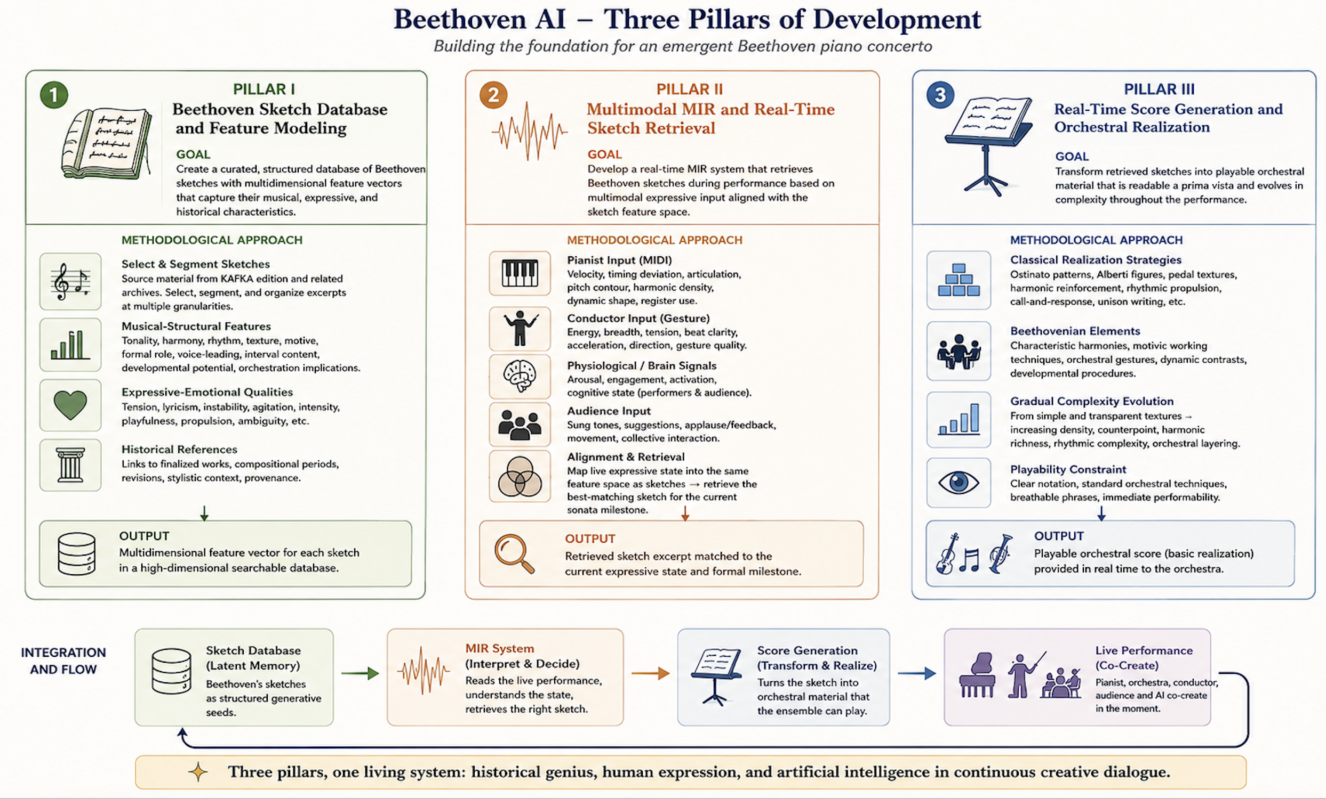

- Building a first minimal pipeline

General methodological strategy (progressive system growth)
As an initial methodological approach, the project will focus on the development of a minimal working pipeline that integrates the three core pillars in their most reduced form. The goal is not yet full artistic or technological complexity, but the creation of a first end-to-end ecosystem that already demonstrates the central project logic: sketch representation, real-time retrieval, and score generation. This minimal working pipeline establishes the conceptual and technological foundation of the broader Beethoven AI ecosystem. Once operational, additional feature dimensions, multimodal sensing strategies, retrieval mechanisms, and increasingly sophisticated generation techniques can progressively be integrated into the system.

Pillar I — Minimal sketch database

Goal: To create a first small-scale database of Beethoven sketches that can function as retrievable generative material. Within this minimal framework, sketches will initially be labeled using only one feature dimension: tonal center.

Minimal pipeline: A limited subset of sketches will be selected from the KAFKA edition or from curated selections proposed by collaborators. Based on this material, a first Optical Music Recognition (OMR) pipeline will be developed in order to transform scanned sketches into computer-readable symbolic formats such as MusicXML.

Pillar II — Minimal MIR retrieval system

Goal: To establish a first real-time retrieval mechanism connecting live performance input to the sketch database.

Minimal Pipeline: A simple piano-input interface will be developed in which piano keys (C-D-E-F-G-A-B) are used to indicate a tonal center in real time. The tonal center will then serve as the retrieval parameter used to identify the sketch(es) whose tonal center match the input key.

Pillar III — Minimal Score Generation

Goal: To generate a first playable musical output based on retrieved sketches. The objective at this stage is not yet sophisticated orchestration, but the establishment of a functioning real-time loop between performer input, sketch retrieval, and score generation.

Minimal pipeline: Once a sketch is retrieved, the system generates a highly simplified score realization. In its most basic form, this may consist of reproducing the sketch excerpt directly in score format. A slightly more advanced version may generate a simple eight-bar accompaniment pattern derived from the harmonic content of the retrieved sketch.

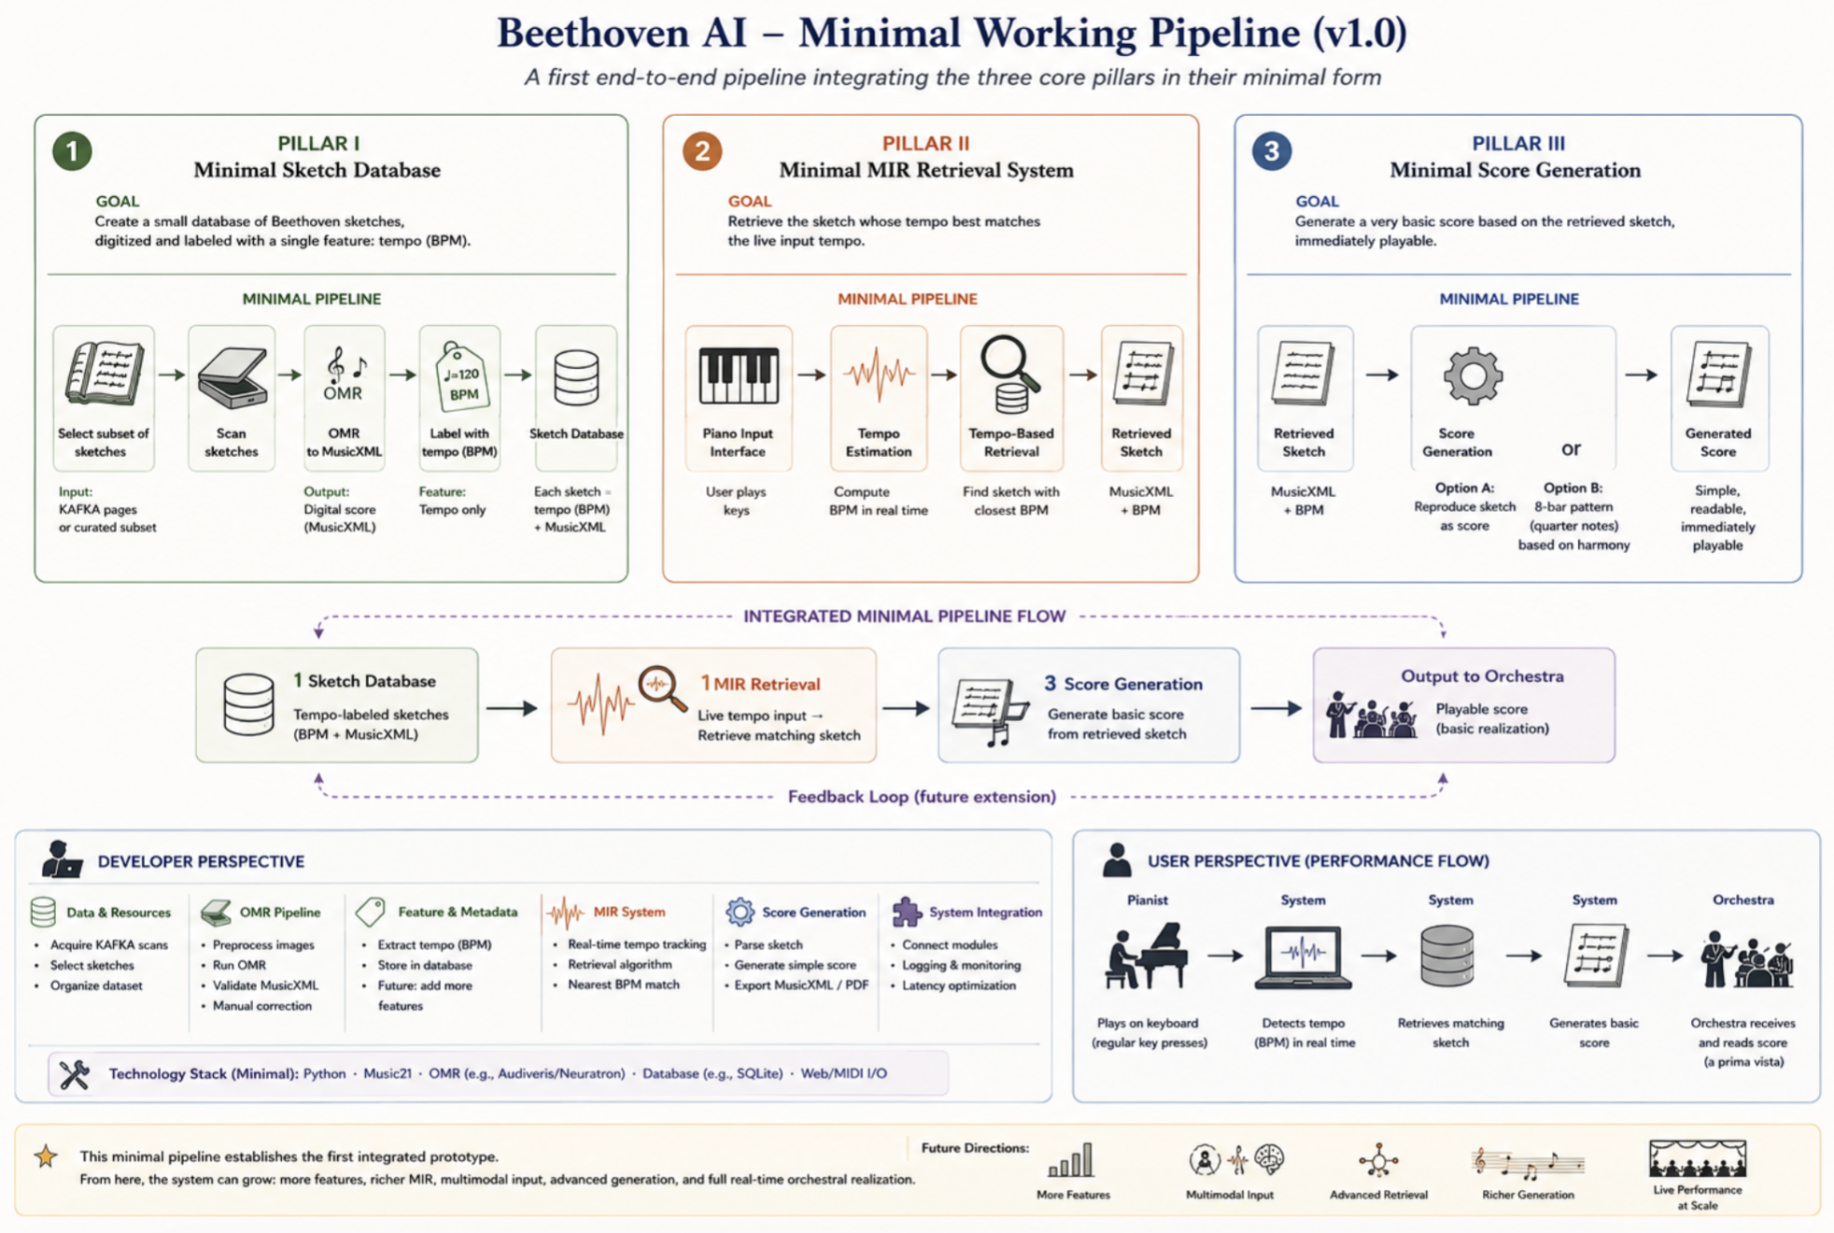

Kerman, J. (1970). Ludwig van Beethoven: Autograph miscellany: Autograph miscellany, 1786–99 (Facsimile ed.). London, England: The British Library Publishing Division.

