D2 Data Note: Steam Game Recommender

D2 Data Note: Steam Game Recommender
D2 Data preparation and EDA · November 2, 2026 · Repository: github.com/juanthom99/steam-game-recommender (tag d2-submission) · Dashboard: juanthom99--steamrec-d2-dashboard-run.us-east.modal.run

1. Goal and data
The recommender takes a player's Steam library and suggests games they are likely to enjoy. Most players never review, so "enjoyed" has to come from behavior: how long someone played a game compared with that game's other players. Three sources supply that behavior; a fourth supplies the game catalog.
Source | What it holds | Players | Played rows* | Role
McAuley Australian Steam (2017) | Full libraries, played and unplayed | 68k | 3.2M | Primary training source and 2017-era evaluation (players differ from today's, Fig 2)
Steam 2026 (our collection) | Public full libraries of recent reviewers, via Steam's official API | 2.4k | 1.4M | Modern players: own test slice and label re-test
Kaggle Steam reviews (to Oct 2023) | Reviewed games only; hours at review time | 13.7M | 40.4M | Extra training rows and label validation
FronkonGames Steam Games (Oct 2026) | 124,146 games: genres, descriptions, prices | — | — | Catalog: 72,919 of 111,167 recommendable games, incl. all 38,637 released 2024–2026
*Playtime above zero, app counts as play history, bulk reviewers excluded: the filter every model trains on (Kaggle: 40.4M of 41.15M cleaned rows). The merged catalog has 137,725 apps; 111,167 are recommendable (released, on sale, and passing our content filters, Section 2).

2. Audit and cleaning
clean/build_clean.py rebuilds every table from the raw files and runs 21 validation checks; all pass. Examples: catalog app_id is unique; every interaction joins to the catalog; each (player, game) pair appears once per source; two-week playtime never exceeds lifetime playtime; no playtest, delisted or explicit game is recommendable. Every rule is logged with the rows it touched and why (clean/cleaning_report.md).
- Kaggle repair. Duplicate reviews and two scripted accounts (identical hours on every game) were removed: under 0.0001% of 41.15M rows. Its playtime stops at 1,000 h, so 368 played rows at that ceiling are flagged as censored. Early Access reviews written before the listed release (2.85M) and bulk reviewers (230k rows) are kept but flagged.
- Keep, flag, don't delete. Zero-playtime rows, DLC and delisted games stay, flagged: they still describe what a player owns. Zero playtime means unknown, not disliked (1.85M McAuley rows; 176k Kaggle reviews).
- Text and content. HTML codes removed from 322 titles and 1,956 descriptions. Playtests (8,131), sexually explicit games (4,593) and delisted games are never recommended but count as play history.
- Price fix. The October 2026 crawl often caught sale prices ($5.99 for a $59.99 game). Where both sources have a price, the regular price is now the higher one, which corrected 23,109 games (rule G18).
- Privacy. Our 2026 collection stores only salted SHA-256 hashes of Steam IDs and no review text.

3. Data dictionary (summary)
The full dictionary (clean/data_dictionary.md / .csv) lists every column's type, missing rate, example and meaning. All tables join on app_id.
Table | One row per | Rows | Key columns
interactions_kaggle | Player × reviewed game | 41,154,753 | playtime_min (at review, capped 1,000 h), review_recommend (validation only), censored, bulk_user
interactions_mcauley | Player × owned game | 5,094,082 | playtime_min, playtime_2w_min, played (False = unknown, not a dislike)
games | Steam app (merged catalog) | 137,725 | recommendable, history_ok, genres, tags, price_regular, price_source, adult
Steam 2026 collection | Hashed player × library game; reviews | 2,696 libraries | playtime, achievements, review flag (no text)
splits/ | Player's split; hidden games | — | split (test / validation), SHA-256 checksums in manifest.json

4. What the data shows
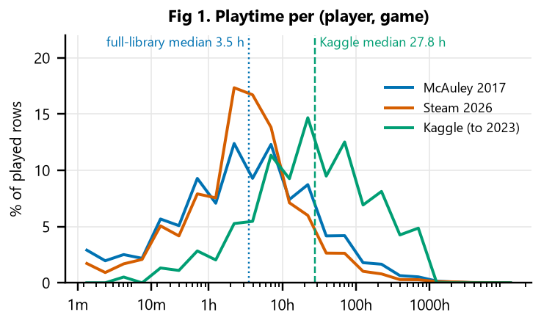
Playtime spans five orders of magnitude. The median played game gets 3.5 h in full libraries but 27.8 h in Kaggle, because people review games they played a lot. Means: raw hours can't be compared across games or sources, so the label ranks each player among the same game's players.
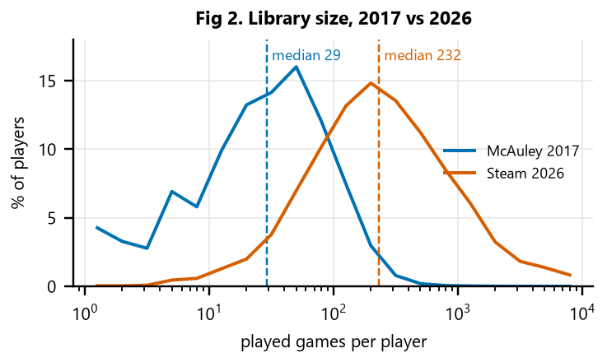
Today's libraries are 8x larger (median 232 vs 29 played games). Means: a score tuned on 2017 players (0.727 AUC) lost to plain playtime on 2026 players (0.659 vs 0.693), so we use the simple within-game percentile and test 2026 players separately.
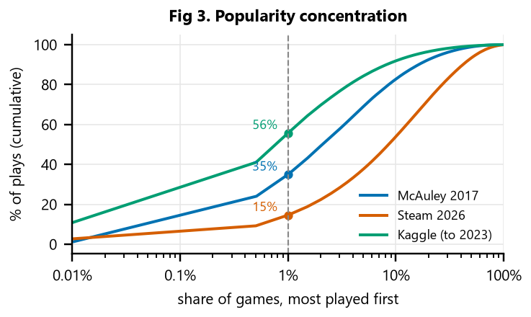
A few games take most of the play: the top 1% of games hold 56% of Kaggle plays, 35% of McAuley's, 15% of 2026's. Means: recommending hits looks accurate by default, so MostPopular is a required baseline and long-tail recall is reported.
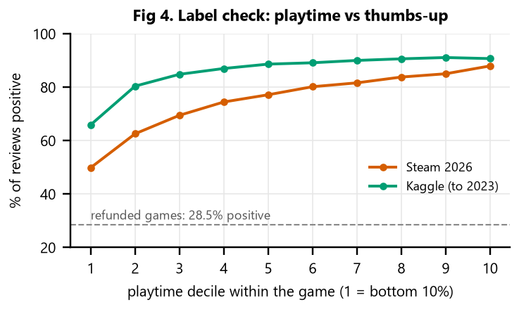
The label works. Across 94,876 unbiased 2026 reviews, positive reviews rise from 50% (bottom playtime decile) to 88% (top), +38 points; Kaggle 66% to 91%, +25. Refunded games: 28.5% positive vs 76% overall. Means: playtime can label players who never review; reviews only check the label.
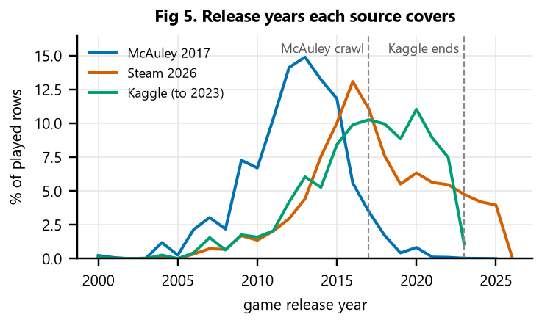
Each source sees a different era. McAuley plays center on 2012–2015 releases; Kaggle reviews stop in Oct 2023. Only 2026 libraries contain play of newer games. Means: models trained on older data may under-serve new releases (concern 2).
Correlation check (Spearman, 3.18M McAuley played rows). The label carries no game-level information; raw hours mostly encode which game it is.
Pair | ρ
Label vs game popularity / median playtime / price | 0.00
Raw hours vs game median playtime | 0.57
Raw hours vs game popularity | 0.35
Label vs per-player percentile | 0.91
Label vs two-week playtime | 0.13
Game popularity vs % positive reviews | 0.39

5. Variables we keep and drop
Variable | Decision | Evidence
Within-game playtime percentile | Keep: the label | Removes game-level effects (ρ ≈ 0); 50% → 88% positive reviews (Fig 4)
Raw playtime hours | Drop as a feature | Tracks game length and popularity, not enjoyment (ρ 0.57 / 0.35; Fig 1)
Per-player habit adjustment | Drop | ρ 0.91 with the label; lost on 2026 players (0.659 vs 0.693)
Review recency, two-week playtime | Drop | Recency looked strong (AUC 0.76) only through a sampling artifact (concern 3); two-week playtime ρ 0.13
Genres; user tags | Keep genres; tags where present | Genres missing for 0.2% of games; tags missing for 66% (concern 5)
Review votes and text; price_regular | Validation and value metric only | Votes check the label; price is used only for value per dollar
Zero-playtime rows | Neither hit nor miss | Unplayed can mean a gift, a bundle or not started yet

6. Data-quality and sampling concerns
- Reviewers aren't typical players. Kaggle holds only reviewed games, and our 2026 libraries come from reviewers too, so label validation describes reviewers; non-reviewers are untested.
- Era drift. 2017 libraries are smaller and older (Figs 2, 5); 2026 players are reported separately.
- Our collection's sampling. One page of recent and one of recent negative reviews per game; the negative page reaches further back, leaking review age into recency features. 2026 analyses use the unbiased page, one review per reviewer.
- Kaggle playtime is measured at review time and capped at 1,000 h, so it understates lifetime play.
- Missing tags. Our FronkonGames copy (from Hugging Face) has an empty tags column, so 66% of recommendable games lack tags (Kaggle's games: 11%). Genres fill in; a SteamSpy refill of tags is running (collect/steamspy_refill.py, about 24 h at SteamSpy's one-request-per-second limit).
- Prices. After the G18 fix, 72,919 recommendable games still have only the October 2026 crawl price; the same SteamSpy refill supplies their regular price. The live tool uses current store prices.
- Unplayed games are ambiguous (gift, bundle or not started), so they are excluded from hits and misses.

7. Reserved test data
Before any model comparison, players were split within each source by sha256("steamrec-split-v1|source|player") mod 10: 0 test, 1 validation, 2–9 train. For test and validation players, about 20% of played games are hidden by a second hash rule, so every model is scored on the same hidden games. Test players are excluded from all training and scored once (eval/PROTOCOL.md; clean/reserve_test.py refuses to run twice). 534 players examined in earlier checks (495 McAuley, 39 Steam 2026) were moved from test to validation, so the 2026 test slice is 187 instead of 226.
Source | Test players | Test, 5+ visible games | Validation players | Validation, 5+ visible
McAuley 2017 | 6,265 | 5,002 | 7,377 | 6,099
Steam 2026 | 187 | 184 | 308 | 308
Kaggle (secondary) | 1,368,763 | 111,930 | 1,367,004 | 111,178

8. Preparation code and dashboard
In the repository: clean/build_clean.py → clean/audit_clean.py → clean/data_dictionary.py → clean/reserve_test.py → eda/d2_figures.py, eda/note_figures.py → dashboard/load_supabase.py (Supabase public.eda_*, public read-only) → modal deploy dashboard/modal_app.py (Streamlit on Modal). Data sources: McAuley Steam data (UCSD), Kaggle "Game Recommendations on Steam", FronkonGames "Steam Games Dataset", Steam Web API.

