Nodal-Etary Transduction in Cosmology: DOAN-Ω16 (Lanzadera Ómicron) and the Boundary Coordinate of the Observable Universe
Juan Antonio Lloret Egea
Affiliation: Instituto Tecnológico Virtual de la Inteligencia Artificial para el Español (ITVIA), Madrid, Spain
Corresponding author: juanantoniolloretegea@ieee.org
ORCID: 0000-0002-6634-3351

Abstract
This article presents DOAN-Ω16, originally designated Lanzadera Ómicron, as a formal nodal-etary construction that maps an admitted domain-age record to a situated extensional coordinate. The construction separates four roles that are often conflated in large-scale determination: an etary displacement from a declared reference, a constitutive structural factor of the domain, a dimensionless nodal coordinate, and a locally calibrated extensional scale. Its operative chain is
$$ΔA_{D}→N_{A}→g_{D}→ν_{D}→σ_{Ω16}→λ_{D}.$$
For the declared observable domain, the admitted values are an access age of 13.8 billion Julian years, a declared closure age of 27.6 billion Julian years, and a Solar-System reference age of 4.568 billion Julian years. The domain factor is defined constitutively as $g_{D}:=\sqrt{\left(1+χ_{D}\right)/2}$ and is held fixed between access and boundary; the change is carried by the etary count. The construction yields a present-access coordinate and a positive closure-boundary coordinate from the terrestrial origin, related by the exact rational factor $2879/1154$. The boundary coordinate is then coordinated, by an explicit change-of-origin decomposition, with a previously declared structural radius. This coordination is not presented as a second independent derivation of that radius. Exact rational identities, multiprecision quantities, historical precision freezing, and residual classes are distinguished throughout. No observational validation, universal uniqueness of the constitutive factor, or equivalence with standard cosmological distance measures is claimed.
Keywords: nodal-etary transduction; observable universe; boundary coordinate; constitutive operator; change of origin; cosmological foundations

1 Introduction
Cosmological distance is not a single primitive quantity. Contemporary cosmology distinguishes, among other objects, line-of-sight and transverse comoving distances, angular-diameter distance, luminosity distance, lookback time, and horizon scales [1]. Each is defined through a declared observational or geometrical framework. Cosmic-chronometer methods use differential galaxy ages to estimate $dz/dt$ and thereby constrain $H\left(z\right)$ [2,3]. Type Ia supernova methods can infer luminosity distances without a spectroscopic redshift known a priori by marginalizing over redshift, while redshift remains a variable of the method [4]. General cosmological-distance algorithms calculate angular-size and related distances inside parameterized Friedmann-Lemaître models [5]. Chronometric geodesy provides a distinct example of temporal or frequency information being converted into a spatial or geopotential quantity through an explicit physical law and calibration [6,7].
The construction examined here addresses a different formal question:
Under a declared domain, reference, scale, and boundary, can an admitted age record be transformed into a situated extensional coordinate through a fully typed chain?
The technical adjective etary is used here for quantities formed from an explicitly declared age record. It does not denote probability, chronology in general, or a conventional cosmological time coordinate.
DOAN-Ω16 answers that question by separating the input record from the operator that consumes it. It does not infer $H\left(z\right)$, marginalise over redshift, introduce a new Friedmann-Lemaître distance, or claim to replace observational distance determination. It maps a declared etary difference to a dimensionless nodal coordinate and returns that coordinate through a locally constructed extensional scale.
The present article provides a formal reconstruction of a procedure previously disclosed in a Spanish-language, non-peer-reviewed preprint [8]. The earlier disclosure preserved the access and boundary outputs but did not present, in one continuous scientific argument, the complete genealogy of the scale, the constitutive status of the domain factor, the separation between structural signature and etary variation, or the precision policy required to reproduce the historical values. Those elements are made explicit here. The coordination of the boundary coordinate with a previously declared structural radius uses the change-of-origin framework later stated in a related preprint [9]; only the minimum required part of that framework is imported.
The analysis is restricted to the observable-domain execution and imports no additional domain constructions. The article establishes:
- the declared input and output types of DOAN-Ω16;
- the construction of the Ω16 scale from the Earth-Moon-Sun calibration frame;
- the constitutive status and verified regularity of the domain factor $g_{D}$;
- the formation of access and closure-boundary coordinates;
- the exact rational relation between the two coordinates;
- the distinction between exact identities and multiprecision evaluation;
- the coordination of the situated boundary coordinate with a structural radius by change of origin; and
- the limits of the construction.
It does not derive a general theory of ages, claim observational exactness, prove universal uniqueness of $g_{D}$, or determine whether the output is equivalent or inequivalent to any standard cosmological metric. Those are separate questions.
Figure 1 summarizes the typed chain and separates the dimensionless nodal branch from the extensional return.
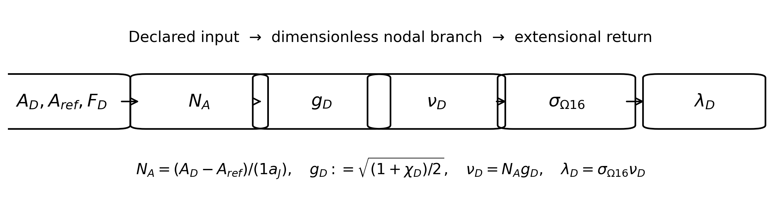
Fig. 1. Typed chain of DOAN-Ω16. The age record and declared reference feed a dimensionless nodal branch; only the Ω16 scale introduces extension.

2 Declared domain, input, and situated output

2.1 Declared observable domain
Let $Ω_{obs}$ denote the declared observable domain considered in this execution. The notation does not denote an absolute totality of physical existence. It denotes the specific cosmological domain to which the admitted age, declared closure, reference, origin, and boundary are assigned.
The calculation uses the following declared values:
 | $$A_{Ω_{obs}}=13 800 000 000 a_{J},$$ | (1)
 | $$F_{Ω_{obs}}=27 600 000 000 a_{J},$$ | (2)
 | $$A_{ΩSS}=4 568 000 000 a_{J},$$ | (3)
where $a_{J}$ is the Julian year. Equation (1) is the admitted access age of the declared observable domain, Eq. (2) is its declared closure age in the present regime, and Eq. (3) is the reference age assigned to the Solar System.
The article takes these values as admitted inputs. Their general derivation is outside scope. This restriction is essential: DOAN-Ω16 is evaluated as an operator that consumes a typed age record, not as a general age-determination theory. No result in the present article requires a general derivation of physical-domain ages.

2.2 Situated origin and boundary
The operative origin is the terrestrial reference point $T$. The boundary is denoted by
 | $$∂Ω_{obs}.$$ | (4)
The principal closure output is therefore a coordinate of the form
 | $$D​\left(T,∂Ω_{obs}\right).$$ | (5)
This quantity is distinct from the previously declared structural radius
 | $$R_{U}=D​\left(O_{U},∂Ω_{obs}\right),$$ | (6)
whose origin is the formal cosmological origin $O_{U}$. DOAN-Ω16 does not introduce a second autonomous derivation of $R_{U}$. Its own cosmological output is a terrestrial-origin boundary coordinate. The relation between Eqs. (5) and (6) is addressed only through change-of-origin decomposition in Sect. 7.

2.3 Definition of the output
For a declared domain $D$, the construction returns
 | $$λ_{D}.$$ | (7)
Within DOAN-Ω16, $λ_{D}$ is a situated nodal-etary extensional coordinate. Each qualifier is necessary:
- situated: the coordinate is referred to a declared origin;
- nodal: it is formed through an internal nodal coordinate $ν_{D}$;
- etary: its variable input is constructed from an age difference;
- extensional: its final return carries the length unit of the declared Ω16 scale.
For the closure execution of the declared observable domain,
 | $$λ_{∂}=D​\left(T,∂Ω_{obs}\right)$$ | (8)
within the formal regime of the construction.
Equation (8) assigns the completed chain its physical reading. It does not establish observational equivalence with a conventional cosmological distance measure. No equivalence rule, incompatibility result, or transformation between $λ_{∂}$ and standard cosmological distance measures is investigated or claimed.

2.4 Meaning of determination
The word determination is used in a restricted formal sense: declared inputs and constitutive rules produce one numerical output under a stated precision and residual policy. It does not mean direct observation of the cosmological boundary, empirical uncertainty equal to zero, model-independent recovery of a conventional distance, or experimental validation of the Ω16 scale.

3 Etary branch and constitutive domain factor

3.1 Etary difference and count
For a domain $D$ and reference age $A_{ref}$, define
 | $$ΔA_{D}=A_{D}−A_{ref}.$$ | (9)
The etary count is
 | $$N_{A}\left(D∣A_{ref}\right)=\frac{A_{D}−A_{ref}}{1 a_{J}}.$$ | (10)
The numerator and denominator have the same temporal dimension, so
 | $$\left[N_{A}\right]=1.$$ | (11)
For present access,
 | $$N_{A,acc}=13 800 000 000−4 568 000 000=9 232 000 000.$$ | (12)
For the declared closure boundary,
 | $$N_{A,∂}=27 600 000 000−4 568 000 000=23 032 000 000.$$ | (13)
These two counts are exact integers once the declared ages are fixed.

3.2 Structural cycle fraction
The cycle fraction is
 | $$χ_{D}=\frac{A_{D}}{F_{D}}.$$ | (14)
For the admitted observable-domain access state,
 | $$χ_{Ω_{obs}}=\frac{13 800 000 000}{27 600 000 000}=\frac{1}{2}.$$ | (15)
The quantity is dimensionless and is not interpreted as a probability. In the historical DOAN-Ω16 execution, the admitted value of $χ_{D}$ acts as the structural signature from which the domain factor is constructed. Once the access-to-boundary execution is fixed, that signature is retained. The boundary count does not replace $χ_{D}=1/2$ with $χ_{D}=1$.
This distinction prevents a category error. The access-to-boundary variation is carried by $N_{A}$, while $χ_{D}$ supplies the frozen structural signature of that execution.

3.3 Constitutive factor
The domain factor is defined by
 | $$g_{D}:=\sqrt{\frac{1+χ_{D}}{2}}.$$ | (16)
For the observable domain,
 | $$g_{Ω_{obs}}=\sqrt{\frac{1+1/2}{2}}=\sqrt{\frac{3}{4}}=\frac{\sqrt{3}}{2}.$$ | (17)
Equation (16) has constitutive status within DOAN-Ω16. It is not presented as the consequence of an independently established universal physical law. Neither is it claimed to be the unique mathematically admissible transformation of $χ_{D}$.
For $0≤χ≤1$, let
 | $$g\left(χ\right)=\sqrt{\frac{1+χ}{2}}.$$ | (18)
Then
 | $$g\left(0\right)=\frac{1}{\sqrt{2}}, g\left(1\right)=1,$$ | (19)
and
 | $$\frac{1}{\sqrt{2}}≤g\left(χ\right)≤1.$$ | (20)
Its derivatives are
 | $$g′\left(χ\right)=\frac{1}{2\sqrt{2\left(1+χ\right)}}>0,$$ | (21)
 | $$g″\left(χ\right)=−\frac{1}{4\sqrt{2}{\left(1+χ\right)}^{3/2}}<0.$$ | (22)
Thus the rule is positive, increasing, and concave on the admitted interval. It preserves ordering and compresses separation toward the upper normalized bound. These are verified properties of the definition, not a proof of universal necessity.

3.4 Frozen-factor rule and nodal coordinate
For a single declared execution,
 | $$g_{D,acc}=g_{D,∂}.$$ | (23)
In the present case,
 | $$g_{acc}=g_{∂}=\frac{\sqrt{3}}{2}.$$ | (24)
The dimensionless nodal coordinate is
 | $$ν_{D}=N_{A}g_{D},$$ | (25)
so $\left[ν_{D}\right]=1$. The access and boundary coordinates are therefore
 | $$ν_{acc}=9 232 000 000\frac{\sqrt{3}}{2},$$ | (26)
 | $$ν_{∂}=23 032 000 000\frac{\sqrt{3}}{2}.$$ | (27)
The ratio is exact:
 | $$\frac{ν_{∂}}{ν_{acc}}=\frac{23 032 000 000}{9 232 000 000}=\frac{2879}{1154}.$$ | (28)

4 Construction of the Ω16 extensional scale

4.1 Declared calibration frame
The Ω16 scale is constructed from an auxiliary Earth-Moon-Sun frame. The declared metric anchors are
 | $$D_{TS}=149 597 870 700 m,$$ | (29)
 | $$D_{TL}=384 400 000 m.$$ | (30)
The radii used in the radial ratio are
 | $$R_{⊕}=6 371 000 m, R_{L}=1 737 400 m, R_{⊙}=695 700 000 m.$$ | (31)
These values are not presented as current best-estimate astronomical constants. They are the declared frozen inputs of the historical Ω16 execution. The purpose of this section is to expose the internal genealogy of the scale and its precision policy, not to update that calibration silently.

4.2 Mean Moon-Sun distance and solar residual
Under the auxiliary assumptions of a circular lunar orbit, fixed Earth-Sun distance, and uniform phase angle, define
 | $$d_{LS}\left(θ\right)=\sqrt{D_{TS}^{2}+D_{TL}^{2}−2D_{TS}D_{TL}cosθ}.$$ | (32)
Its angular mean is
 | $${\overline{d}}_{LS}=\frac{1}{2π}\int_{0}^{2π}{\sqrt{D_{TS}^{2}+D_{TL}^{2}−2D_{TS}D_{TL}cosθ}} dθ.$$ | (33)
Using the complete elliptic integral of the second kind, with parameter
 | $$m=\frac{4D_{TS}D_{TL}}{{\left(D_{TS}+D_{TL}\right)}^{2}},$$ | (34)
Eq. (33) becomes
 | $${\overline{d}}_{LS}=\frac{2\left(D_{TS}+D_{TL}\right)}{π}E\left(m\right).$$ | (35)
The multiprecision evaluation is
 | $${\overline{d}}_{LS}=149 598 117 634.365250679780375539616884243654… m.$$ | (36)
The constructed solar residual is
 | $$N_{s}^{\left(∞\right)}\left(Sun\right)={\overline{d}}_{LS}−D_{TS}=246 934.365250679780375539616884243654… m.$$ | (37)
The historical chain freezes this quantity at twelve decimal places:
 | $$N_{s}^{\left[12\right]}\left(Sun\right)=246 934.365250679780 UFE.$$ | (38)
Here UFE denotes the extensional unit carried by the Ω16 construction. In the present execution, the metric anchors are inserted in metres and the scale preserves that length dimension. Numerical UFE outputs are therefore reported in metres under this declared calibration. No independent realization of UFE as an SI unit is claimed.
The Earth quantity is
 | $$N_{s}\left(Earth\right)=D_{TS}−D_{TL}=149 213 470 700 UFE.$$ | (39)

4.3 Two ratios and linearised coupling
Define the potential ratio
 | $$κ_{P}=\frac{N_{s}\left(Earth\right)}{N_{s}^{\left[12\right]}\left(Sun\right)}=604 263.6898615683206487433327670029405…,$$ | (40)
and the radial ratio
 | $$κ_{R}=\frac{R_{⊙}}{R_{⊕}+R_{L}}=85.7999112031966849193429036554684031….$$ | (41)
The Ω coupling is defined by
 | $$κ_{Ω}:=\sqrt{\frac{κ_{P}}{κ_{R}}}=83.9208414920315806537180865400762813….$$ | (42)
The recovered construction expresses this square-root coupling through the pair
 | $$Π_{1,Ω16}: b−\frac{a}{\sqrt{κ_{R}}}=0,$$ | (43)
 | $$Π_{2,Ω16}: c−\sqrt{κ_{P}} b=0.$$ | (44)
Their composition gives
 | $$c=a\sqrt{\frac{κ_{P}}{κ_{R}}}=aκ_{Ω}.$$ | (45)
Equations (43)-(45) establish the internal consequence of the declared coupling. They do not establish that this is the only possible coupling of the two ratios. In the present article, $κ_{Ω}$ is therefore treated as a constitutive linearisation rule of the Ω16 calibration.

4.4 Extensional step
The extensional step is
 | $$σ_{Ω16}=D_{TL}κ_{Ω}.$$ | (46)
Using the frozen solar residual gives
 | $$σ_{Ω16}^{\left(∞∣N_{s}^{\left[12\right]}\right)}=32 259 171 469.5369396032892324660053225384731672667697… UFE.$$ | (47)
The historical scale is frozen as
 | $$σ_{Ω16}^{\left[33\right]}=32 259 171 469.536939603289232466005322538473167 UFE.$$ | (48)
The scale is locally constructed and then applied as the extensional map of DOAN-Ω16. That transfer is part of the operator definition. It is not presented as a standard cosmological law or an experimentally calibrated universal conversion.
Figure 2 displays the genealogy of the locally constructed Ω16 scale.
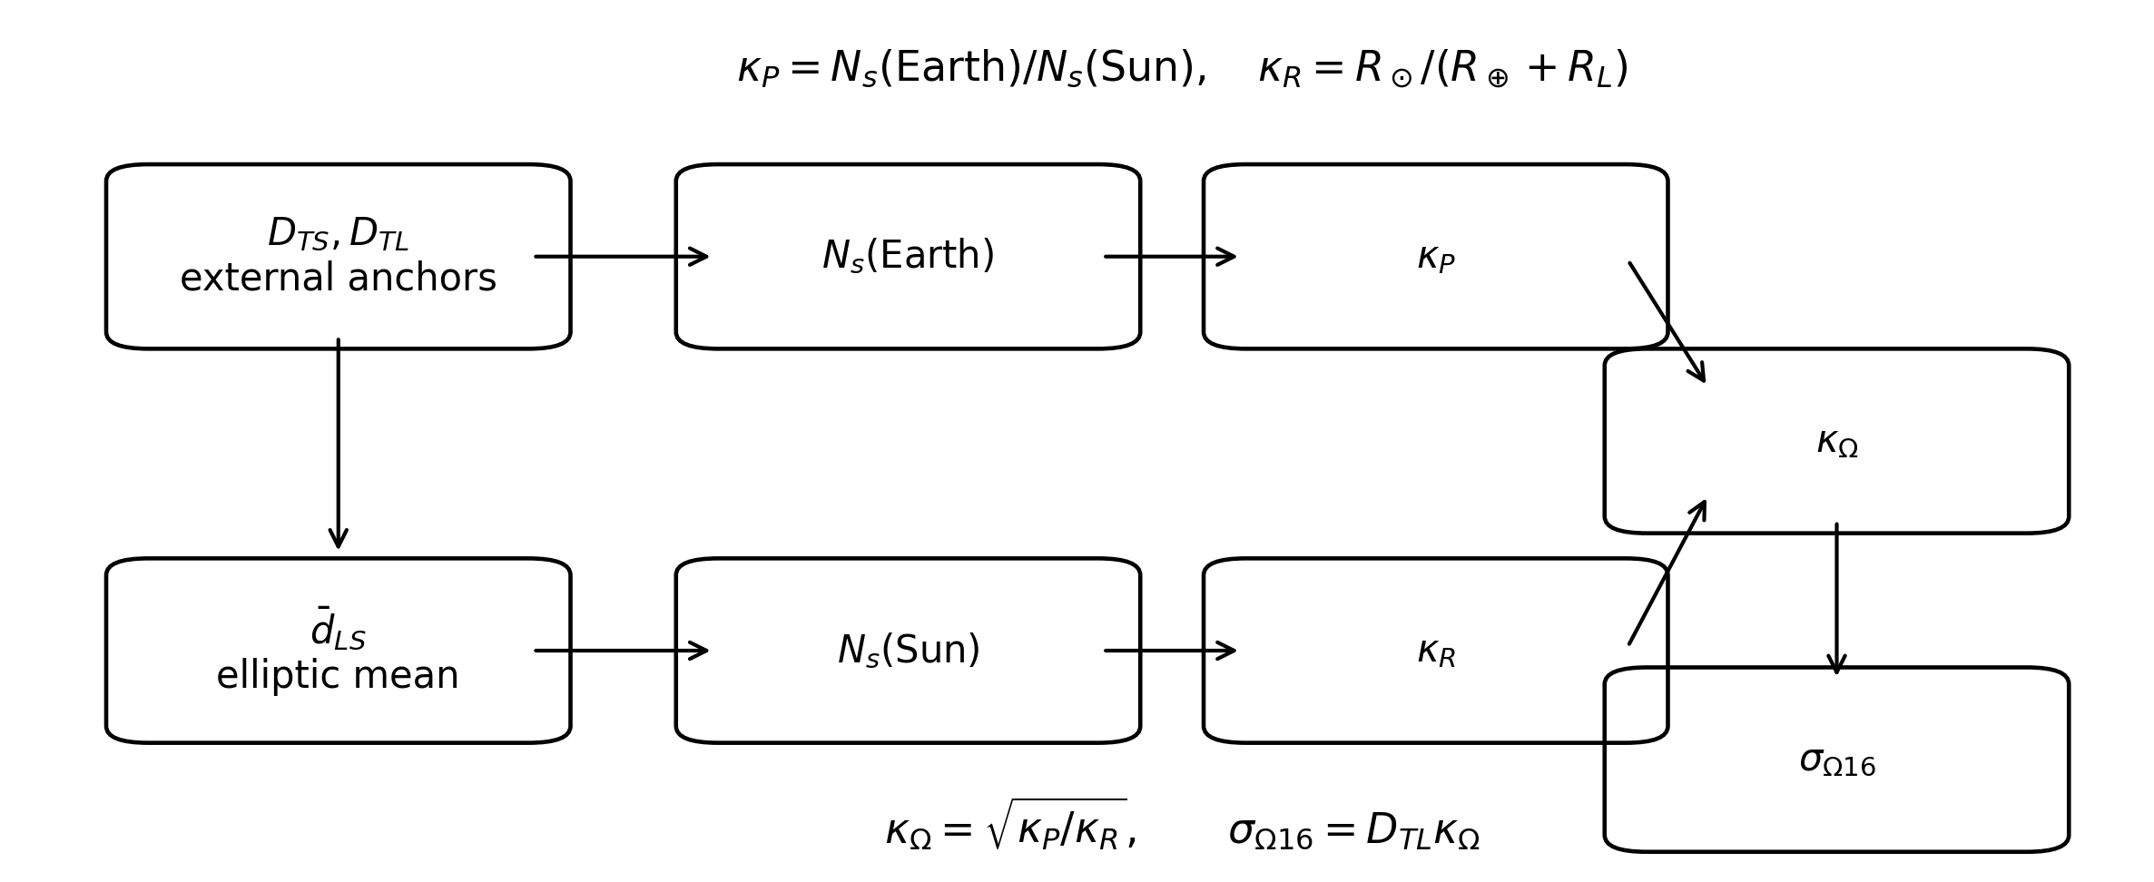
Fig. 2. Construction of the Ω16 scale. External metric anchors enter an internal geometric mean and residual; two dimensionless ratios are coupled and returned through the Earth-Moon scale.

5 Complete DOAN-Ω16 operator
The nodal-etary branch and the Ω16 scale combine as
 | $$λ_{D}=σ_{Ω16}ν_{D}=σ_{Ω16}N_{A}g_{D}.$$ | (49)
For a domain $D$ referred to $A_{ref}$,
 | $${DOAN}_{Ω16}\left(D∣A_{ref}\right)=σ_{Ω16}\left(\frac{A_{D}−A_{ref}}{1 a_{J}}\right)\sqrt{\frac{1+χ_{D}}{2}}.$$ | (50)
The dimensional chain is
 | $$\left[N_{A}\right]=\left[g_{D}\right]=\left[ν_{D}\right]=1, \left[λ_{D}\right]=\left[σ_{Ω16}\right]=UFE.$$ | (51)
Table 1 records the type and status of each quantity.
Table 1. Typed quantities in DOAN-Ω16.
Quantity | Role | Dimension / unit | Origin | Status
A_D | admitted domain age | a_J | declared input | input
A_ref | reference age | a_J | declared input | input
F_D | declared closure age | a_J | declared input | input
chi_D | structural cycle fraction | 1 | A_D / F_D | derived
g_D | domain factor | 1 | Eq. (16) | constitutive
N_A | etary count | 1 | Eq. (10) | derived
nu_D | nodal coordinate | 1 | Eq. (25) | derived
kappa_P, kappa_R, kappa_Omega | scale ratios | 1 | Eqs. (40)-(42) | constitutive / derived
sigma_Omega16 | extensional step | UFE | Eq. (46) | calibrated constituent
lambda_D | situated extensional coordinate | UFE | Eq. (49) | output
The output is not a bare scalar. Its interpretation depends on the declared domain, origin, reference, scale, and boundary. A numerically identical value under different metadata would not constitute the same result.

6 Observable-domain execution

6.1 Present access
Using Eqs. (12), (17), and (48),
 | $$ν_{acc}=9 232 000 000\frac{\sqrt{3}}{2}=7 995 146 527.7379375869226923123911068458079890515887….$$ | (52)
The access coordinate is
 | $$λ_{acc}=σ_{Ω16}^{\left[33\right]}ν_{acc}$$ | (53)
 | $$=257 916 802 762 371 004 117.802115994805413096538327928604… UFE.$$ | (54)

6.2 Closure boundary
At the declared closure age, the same structural factor is retained and only the etary count changes:
 | $$ν_{∂}=23 032 000 000\frac{\sqrt{3}}{2}.$$ | (55)
The boundary coordinate is
 | $$λ_{∂}=σ_{Ω16}^{\left[33\right]}ν_{∂}$$ | (56)
 | $$=643 451 018 330 039 966 078.988121273002412742576989693632… UFE.$$ | (57)
The access-to-boundary coefficient is
 | $$κ_{∂←acc}^{SV}=\frac{N_{A,∂}}{N_{A,acc}}=\frac{2879}{1154},$$ | (58)
so
 | $$λ_{∂}=\frac{2879}{1154}λ_{acc}.$$ | (59)
Equation (59) is exact with respect to the common scale and common frozen factor. The decimal values inherit the precision policy of $σ_{Ω16}$.
Figure 3 shows the access and boundary coordinates referred to the terrestrial origin.
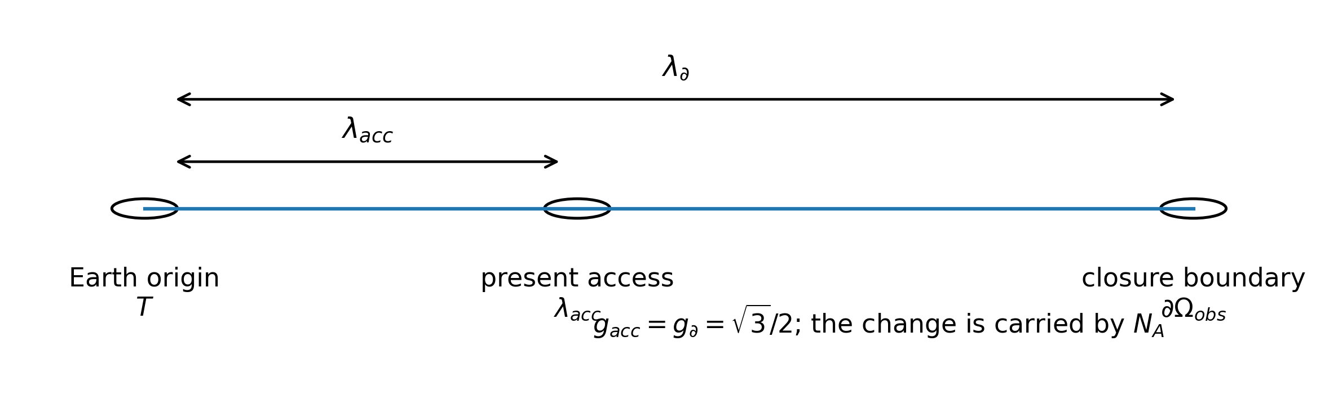
Fig. 3. Present access and closure boundary from the terrestrial origin. The constitutive factor is fixed; the etary count carries the transition.
Table 2. Observable-domain execution.
Item | Present access | Closure boundary | Status
Domain age used in count (a_J) | 13,800,000,000 | 27,600,000,000 | declared
Reference age (a_J) | 4,568,000,000 | 4,568,000,000 | declared
Etary count N_A | 9,232,000,000 | 23,032,000,000 | exact integer
Structural cycle fraction chi_D | 1/2 | retained 1/2 | frozen signature
Constitutive factor g_D | sqrt(3)/2 | sqrt(3)/2 | constitutive
Extensional output lambda | 2.5791680276 x 10^20 | 6.4345101833 x 10^20 | multiprecision
The positive value of $λ_{∂}$ establishes a limited formal result: within this construction, etary closure does not collapse the situated extensional coordinate to zero. This statement concerns the internal operator. It is not a general claim about every cyclic, terminal, or boundary model in cosmology.

7 Coordination with the structural radius
A related preprint declares the structural radius from the formal origin as [10]
 | $$R_{U}=130 558 080 521 615 040 000 000 000 m.$$ | (60)
The present article does not reproduce or defend the full derivation of Eq. (60). It uses the value only to state the change-of-origin decomposition established in the later radial framework [9]. The terrestrial-origin boundary coordinate is
 | $$λ_{∂}=643 451 018 330 039 966 078.988121273 m$$ | (61)
under the metric reading of the declared UFE calibration. The complementary origin-to-Earth term is
 | $$D\left(O_{U},T\right)=130 557 437 070 596 709 960 033 921.011878727 m.$$ | (62)
Then
 | $$R_{U}=D\left(O_{U},T\right)+λ_{∂},$$ | (63)
and substitution gives the exact displayed recomposition
 | $$D\left(O_{U},T\right)+λ_{∂}=130 558 080 521 615 040 000 000 000 m=R_{U}.$$ | (64)
The residual of Eq. (64), at the displayed decimal resolution, is zero.
This is a decomposition and recomposition under a change of origin. It is not an independent second derivation or external validation of $R_{U}$, because the complementary term in Eq. (62) is obtained relative to the previously declared total. The scientific value of the relation is narrower: the DOAN-Ω16 boundary coordinate is geometrically coordinated with the declared radial framework without identifying the terrestrial origin with $O_{U}$.
Figure 4 distinguishes the Earth-to-boundary output from the structural radius referred to the formal origin.
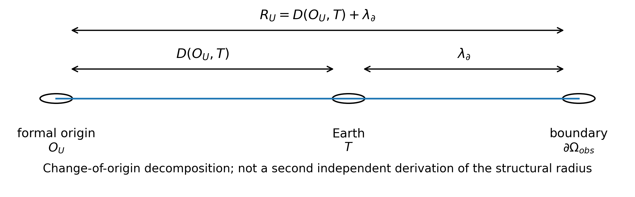
Fig. 4. Change-of-origin decomposition. The DOAN-Ω16 output is the Earth-to-boundary arm; the structural radius is referred to the formal origin.

8 Exactness, multiprecision, and residual policy

8.1 Exact identities
The following are exact after the declared inputs are fixed:
 | $$χ_{Ω_{obs}}=\frac{1}{2}, g_{Ω_{obs}}=\frac{\sqrt{3}}{2}, \frac{λ_{∂}}{λ_{acc}}=\frac{2879}{1154}.$$ | (65)
The etary counts are exact integers. Equation (64) is an exact decimal recomposition at the stated displayed resolution.

8.2 Multiprecision quantities
The elliptic integral, $κ_{P}$, $κ_{R}$, $κ_{Ω}$, $σ_{Ω16}$, $λ_{acc}$, and $λ_{∂}$ are multiprecision numerical quantities. They must not be described as physically exact to all displayed or computable decimal places.

8.3 Historical and full-precision branches
The historical branch uses the frozen values in Eqs. (38) and (48). A full-precision branch begins from Eq. (37) and gives
 | $$σ_{Ω16}^{\left(∞\right)}=32 259 171 469.5369395787592386711467601283420767… UFE.$$ | (66)
The difference from the historical scale is approximately
 | $$Δσ≈2.4529993794858562×{10}^{−8} UFE.$$ | (67)
Propagated to the access and boundary outputs, the absolute differences are approximately
 | $$Δλ_{acc}≈196.1208947143966 UFE,$$ | (68)
 | $$Δλ_{∂}≈489.2825440925024 UFE,$$ | (69)
with a relative scale of order $7.6×{10}^{−19}$. The differences are negligible relative to the global magnitude but decisive for the epistemic status of long decimal expansions. The historical branch is retained because it reproduces the disclosed construction; the full branch records the consequence of recomputing the elliptic mean without the historical freeze.

8.4 Residual classes
Table 3. Residual and precision classes.
Class | Definition | Interpretation
Algebraic residual | difference between exact symbolic routes | exact zero when the identity holds
Representation residual | difference due to displayed decimal truncation | numerical
Freezing residual | full-precision value minus historical frozen value | numerical and declared
Recomposition residual | R_U - [D(O_U,T) + lambda_boundary] | zero at displayed resolution
Input uncertainty | uncertainty or conventional status of external anchors | external to algebraic closure
Applicability status | whether domain, reference, scale, and boundary are declared | admissible / rejected / unresolved
The phrase formally exact is therefore always conditional on the stated inputs, definitions, and precision regime. It is not used as a synonym for empirical uncertainty equal to zero.

9 Conceptual neighbours and prior art
The literature search was organized by functional proximity rather than title similarity.

9.1 Cosmic chronometers
Jimenez and Loeb proposed relative galaxy ages as a route to $dz/dt$, and hence to cosmological parameters [2]. Later cosmic-chronometer implementations estimate $H\left(z\right)$ from the differential spectroscopic evolution of passively evolving galaxies [3]. Their chain is schematically
 | $$Δt_{galaxy}→\frac{dz}{dt}→H\left(z\right).$$ | (70)
DOAN-Ω16 instead uses a declared domain-age difference, a constitutive domain factor, and a calibrated extensional step to return a situated coordinate. It does not estimate $H\left(z\right)$.

9.2 Chronometric geodesy
Chronometric geodesy converts fractional frequency differences into gravitational-potential or height differences through general relativity and calibrated clocks [6,7]. It is an important conceptual neighbour because it demonstrates that temporal information can support spatial determination when a physical transformation law, reference system, and uncertainty budget are explicit. Its input, law, and output remain different from DOAN-Ω16.

9.3 Redshift-independent and general distance algorithms
Barris and Tonry determine supernova luminosity distances without a redshift known in advance by marginalizing over $z$ [4]. The method remains photometric and retains redshift as an inferred variable. Kayser, Helbig, and Schramm derive cosmological distances in homogeneous and inhomogeneous Friedmann-Lemaître models as functions of redshift and cosmological parameters [5]. Neither reproduces the DOAN-Ω16 chain.

9.4 Distance taxonomies
Hogg’s distance review makes clear that cosmological distance terminology is plural and model-defined [1]. The present article therefore avoids asserting that its situated coordinate is a new version of a named conventional distance. Comparison would require a dedicated transformation or incompatibility analysis, which is not undertaken here.
Table 4. Functional comparison.
Family | Temporal / age input | Spatial output | Key intermediate | Relation to DOAN-Omega16
Cosmic chronometers | differential galaxy ages | H(z), then model-dependent distances | dz/dt | partial conceptual neighbour
Chronometric geodesy | clock frequency difference | geopotential or height difference | relativistic redshift law | temporal-to-spatial precedent; different physics
Redshift-marginalized SN Ia | photometry, latent z | luminosity distance | likelihood marginalization | observational inference, not age-to-coordinate transduction
Friedmann-Lemaitre distance algorithms | z and cosmological parameters | standard cosmological distances | FLRW integration | different inputs and target quantities
DOAN-Omega16 | admitted domain-age record | situated boundary coordinate | N_A, g_D, sigma_Omega16 | present construction
No prior work was identified that performs the same functional operation: beginning with an admitted domain-age record, normalizing its displacement from a declared reference, retaining a frozen structural signature across access and boundary, and returning a situated extensional boundary coordinate through an explicit local calibration. The statement reports the literature search performed; it is not a claim of logically exhaustive non-existence.

10 Foundational interpretation

10.1 Constitutive rule versus universal law
The distinction between a constitutive rule and a universal law is central. Equations (16), (42), and (46) define the operator used in this work. Their mathematical consequences can be demonstrated, their dimensions can be audited, and their numerical outputs can be reproduced. Those facts do not by themselves establish that nature requires these rules uniquely.
Accordingly, the article makes a two-level claim:
- closed at the operator level: the definitions, types, dimensions, and declared execution yield one reproducible output;
- open at the universal level: uniqueness, universal physical necessity, and unrestricted transdomain application are not established.
This separation permits the construction to be evaluated without disguising a constitutive choice as a discovered law.

10.2 Age as an extensional input
DOAN-Ω16 does not assert that time is space. It asserts that, once a domain-age difference has been normalized to a dimensionless count, a declared structural factor and extensional step may map that count to an extensional coordinate. The dimensional conversion occurs only at $σ_{Ω16}$.
This structure is analogous, at a general formal level, to other scientific transformations in which a measured or declared quantity becomes spatial only through an explicit law and calibration. The analogy does not imply physical identity with chronometric geodesy or time-of-flight methods.

10.3 Situated coordinate and origin dependence
The output is meaningful only with its origin. Equation (8) is not interchangeable with Eq. (6). The change-of-origin decomposition in Eq. (63) preserves this distinction. Removing the origin metadata would turn a typed coordinate into an ambiguous scalar.

10.4 Closure without point collapse
The closure execution produces $λ_{∂}>0$. The result shows that, inside the declared apparatus, the end of the etary interval does not imply the disappearance of extension. This is a property of DOAN-Ω16 and its boundary assignment. A broader cosmological conclusion would require identification of domains, dynamics, and observables not supplied here.

11 Limitations and falsifiable failure conditions
The construction has explicit limitations.
- No observational validation. The article does not report a campaign that independently measures the computed boundary coordinate.
- Constitutive scale. The Ω16 transfer from a local Earth-Moon-Sun calibration to the etary branch is part of the operator definition; it is not an established standard cosmological law.
- No uniqueness theorem. The article does not prove that Eq. (16) or Eq. (42) is universally unique.
- Declared-age dependence. The result depends on the admitted values in Eqs. (1)-(3). Their general derivation is not reopened.
- Historical inputs. The scale reproduces a historical frozen calibration rather than silently replacing it with updated astronomical constants.
- No metric-equivalence claim. The article neither establishes nor denies equivalence to standard cosmological distance measures.
- Change of origin is not independent validation. Equation (64) is a coherent recomposition, not an external second measurement of $R_{U}$.
- Restricted domain. Generalisation to other domains requires independently declared age, reference, structural signature, scale applicability, origin, and boundary.
The construction must fail or remain unresolved if any of the following occurs:
- the domain or reference is not declared;
- the age difference is dimensionally inconsistent;
- $χ_{D}$ lies outside its admitted interval without an extended definition;
- the scale is applied with a different calibration but labelled as the historical Ω16 scale;
- the terrestrial-origin output is identified with the formal-origin structural radius without change of origin;
- precision-frozen and full-precision branches are mixed silently; or
- a decimal expansion is presented as observational certainty.
These conditions make the formal claim testable as an operator claim even before observational validation is attempted.

12 Conclusions
DOAN-Ω16 has been presented as a formal nodal-etary construction with a declared and auditable chain. An admitted domain-age record is reduced to a dimensionless etary count, weighted by a constitutive structural factor, and mapped to extension by the Ω16 scale. For the declared observable domain, the same frozen factor $\sqrt{3}/2$ governs access and boundary, while the etary count changes from 9,232,000,000 to 23,032,000,000. The resulting coordinates are related by the exact rational factor $2879/1154$.
The Ω16 scale has been reconstructed from its Earth-Moon-Sun genealogy, including the elliptic mean used to form the solar residual, the two dimensionless ratios, the square-root coupling, and the historical precision freezes. This reconstruction distinguishes exact algebraic identities from multiprecision outputs and from empirical uncertainty.
The closure-boundary coordinate is a situated Earth-to-boundary result. Its coordination with a previously declared structural radius is achieved by change-of-origin decomposition and exact displayed recomposition. The relation is not presented as a second independent determination of the radius.
The principal foundational result is therefore limited but substantive: under explicit inputs and constitutive rules, a domain-age record can be mapped to a situated extensional boundary coordinate without conflating age, nodal state, scale, origin, and radius. Observational validation, metric comparison, and universal uniqueness remain open lines of work.

Statements and Declarations

Funding
This research received no external funding.

Competing interests
The author declares no competing financial or non-financial interests that could have influenced the work reported in this article.

Author contributions
J.A.L.E. conceived the study, developed the theoretical and mathematical framework, formulated the nodal-etary construction, performed and verified the calculations, selected and assessed the sources, and wrote, reviewed, and approved the article.

Data availability
All numerical inputs used in this study are obtained from the publicly accessible sources cited in the article or from the author’s cited non-peer-reviewed preprints. All equations, transformations, intermediate quantities, and derived results required to reproduce the formal analysis are provided in the article and its referenced sources. No new experimental or observational dataset was generated.

Previous disclosure
The original nodal-etary procedure and parts of its formalism were previously disclosed by the author in Spanish-language, non-peer-reviewed preprints [8-10]. The present article is not under consideration by another journal. It provides a substantially reorganized and extended formalization for peer review, including the typed operator, the constitutive status of the domain factor, the scale genealogy, the access-boundary separation, the precision policy, the prior-art comparison, and the delimited foundational interpretation.

Declaration of generative AI and AI-assisted technologies in the manuscript preparation process
During the preparation of this work, the author used ChatGPT by OpenAI (GPT-5.6 Thinking) and Claude by Anthropic (Claude Opus 5) for English-language drafting, structural organization, adversarial review, and editorial criticism. After using these tools, the author reviewed and edited the content as needed and takes full responsibility for the content of the article. The scientific conception, prior theoretical works, mathematical framework, equations, derivations, source selection, physical interpretations, results, and conclusions are the author’s.

References
[1] D. W. Hogg, “Distance measures in cosmology,” arXiv:astro-ph/9905116 (1999), https://doi.org/10.48550/arXiv.astro-ph/9905116.
[2] R. Jimenez and A. Loeb, “Constraining cosmological parameters based on relative galaxy ages,” Astrophysical Journal 573, 37-42 (2002), https://doi.org/10.1086/340549.
[3] M. Moresco et al., “Improved constraints on the expansion rate of the Universe up to $z∼1.1$ from the spectroscopic evolution of cosmic chronometers,” Journal of Cosmology and Astroparticle Physics 2012(08), 006 (2012), https://doi.org/10.1088/1475-7516/2012/08/006.
[4] B. J. Barris and J. L. Tonry, “Redshift-independent distances to Type Ia supernovae,” arXiv:astro-ph/0408097 (2004).
[5] R. Kayser, P. Helbig, and T. Schramm, “A general and practical method for calculating cosmological distances,” Astronomy and Astrophysics 318, 680-686 (1997), arXiv:astro-ph/9603028.
[6] P. Delva and J. Lodewyck, “Atomic clocks: new prospects in metrology and geodesy,” Acta Futura 7, 67-78 (2013), https://doi.org/10.2420/AF07.2013.67.
[7] H. Denker et al., “Geodetic methods to determine the relativistic redshift at the level of ${10}^{−18}$ in the context of international timescales: a review and practical results,” Journal of Geodesy 92, 487-516 (2018), https://doi.org/10.1007/s00190-017-1075-1.
[8] J. A. Lloret Egea, “Recta-Ómicron (Lanzadera) - Trilogía Cosmológica, Parte II,” non-peer-reviewed preprint (2026), https://doi.org/10.21428/39829d0b.db21f00e.
[9] J. A. Lloret Egea, “Radio, frontera y densidad del universo observable - Trilogía Cosmológica, Parte III,” non-peer-reviewed preprint (2026), https://doi.org/10.21428/39829d0b.0430adc0.
[10] J. A. Lloret Egea, “Determinación del radio, la superficie y el volumen del Universo - Trilogía Cosmológica, Parte I,” non-peer-reviewed preprint (2026), https://doi.org/10.21428/39829d0b.101f1d12.

