Software Project Management - Summer 2025

**NAME : MIKE JUAN VICTOR  
MAT: ICTU20233888**

**LECTURER: ENGR TAMWI**

# 1) Project Charter

**Project name**: 2025 Presidential Election — Cameroon  
**Project manager**: (us — Project Manager)  
**Objective:** Conduct a fair, transparent and efficient presidential election in 2025 (complete voter registration, campaign monitoring, logistics, secure voting, and timely announcement of results).  
  
**Scope (in**): voter registration, campaign monitoring, logistics planning (venues, transport), equipment procurement & deployment, staff training, election day operations, result compilation and announcement, communications with stakeholders & public awareness.  
Scope (out): changes to election law, candidate selection decisions, judicial adjudication of disputes.  
  
**Constraints**: tight timeline, political risk & unrest, limited budget, limited skilled staff, complex procurement rules, single national deadline (election day).  
  
**Major stakeholders**: Election Commission, Presidential candidates & parties, Government administrators, Security services, International observers, National media, General voters, Suppliers of equipment, NGOs/Civil society.  
  
**Approval** / success criteria: election held on schedule, voter registration completed as planned, minimal procedural errors, results published within agreed window, independent observers report fairness, number of formal disputes kept low.

# 2) Stakeholder Analysis Grid (10 marks)

**High Power / High Interest**: Election Commission, Presidential Candidates, Security Council. Strategy: continuous engagement — meetings, progress reports, approvals.

**High Power / Low Interest**: Government administrators, funding authorities. Strategy: keep satisfied — executive summaries, briefings.

**Low Power / High Interest**: General voters, civil society, NGOs. Strategy: keep informed — campaigns, FAQ, help-lines.

**Low Power / Low Interest**: Minor observers, peripheral vendors. Strategy: monitor — publish schedule, updates.

# 3) PERT Chart & Critical Path Analysis (15 marks)

PERT expected time formula: TE = (O + 4M + P) / 6

|  |
| --- |
| Variance = ((P − O) / 6)² |
| |  |  |  |  |  |  |  | | --- | --- | --- | --- | --- | --- | --- | | Task | O | M | P | TE | Variance | Predecessors | | A: Budget Approval | 1 | 2 | 3 | 2.0 | 0.111 | — | | B: Voter Registration | 4 | 5 | 7 | 5.167 | 0.25 | A | | C: Campaign Monitoring | 3 | 4 | 6 | 4.167 | 0.25 | A | | D: Logistics Planning | 5 | 6 | 8 | 6.167 | 0.25 | A | | E: Equipment Procurement | 4 | 5 | 6 | 5.0 | 0.111 | D | | F: Training Staff | 3 | 4 | 5 | 4.0 | 0.111 | D | | G: Election Day | 1 | 2 | 3 | 2.0 | 0.111 | B,E,F | | H: Result Compilation | 2 | 3 | 5 | 3.167 | 0.25 | G | |

Critical path: A → D → E → G → H

Expected project duration: 18.33 weeks

# 4) Gantt Chart / Timeline

Start date assumed: 2 June 2025. Each week = 7 days.

A: 2 Jun – 16 Jun (critical)  
B: 16 Jun – 22 Jul  
C: 16 Jun – 15 Jul  
D: 16 Jun – 29 Jul (critical)  
E: 29 Jul – 2 Sep (critical)  
F: 29 Jul – 26 Aug  
G: 2 Sep – 16 Sep (critical)  
H: 16 Sep – 8 Oct (critical)

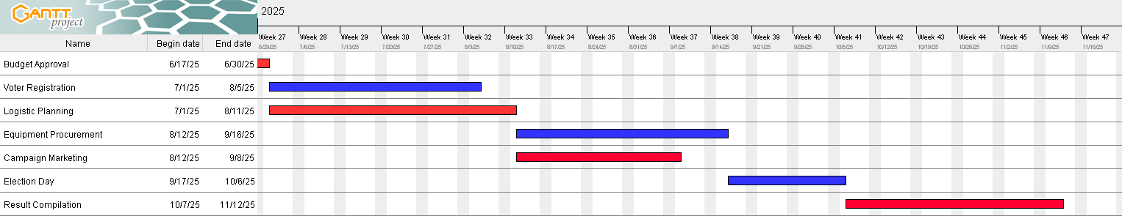

# 5) Risk Management Plan

1. Security/Violence — Likelihood: Medium, Impact: High. Mitigation: coordinate with security forces. Contingency: relocate venues.

2. Logistics delays — Likelihood: Medium, Impact: High. Mitigation: multiple providers. Contingency: local procurement.

3. Equipment procurement delays — Likelihood: Medium, Impact: High. Mitigation: prequalify suppliers. Contingency: manual backup.

4. IT/Technical failures — Likelihood: Medium, Impact: High. Mitigation: redundancy/testing. Contingency: manual tallying.

5. Low voter turnout/misinformation — Likelihood: Medium, Impact: Medium. Mitigation: campaigns. Contingency: mobile teams.

6. Staff shortages — Likelihood: Low-Med, Impact: Medium-High. Mitigation: reserve staff. Contingency: contractors.

# 6) Budget Estimation & Allocation

**Subtotal** = USD 5,000,000; **Contingency** = 10% = USD 500,000; **Total** = USD 5,500,000

**Personnel:** 40% = USD 2,000,000

**Logistics**: 30% = USD 1,500,000

**Technology:** 20% = USD 1,000,000

**Public awareness**: 10% = USD 500,000

**Contingency**: 10% of subtotal = USD 500,000

# 7) Probability Analysis & Completion Time (10 marks)

**Critical path**: A, D, E, G, H

**Total variance** = 0.833; Std dev = 0.913 weeks

**Expected duration** μ = 18.33 weeks; Target T = 18 weeks

**Z = (18 − 18.33)/0.913 ≈ −0.365; Probability ≈ 35.8%**

**Interpretation**: Low chance of finishing by 18 weeks. Recommend extending to ~19.5 weeks for 90% confidence, or shorten critical tasks.