Visual Content Generation with AI
Capstone Section 4 · PartGram automated creative scoring
Juan Salazar · September 2026

1. How AI image generation works, and why it matters here
DALL·E / ChatGPT image generation, Midjourney, Stable Diffusion and Google's Gemini (Imagen) are text-to-image diffusion models. A text encoder turns the prompt into a vector. The model then starts from random noise and removes it step by step, steering each step toward that vector. What the prompt can control is subject and key elements, image type (photo, flat vector, UI mockup, infographic), style, composition and aspect ratio, palette, and negative constraints (what to leave out). Resolution is mostly fixed by the tool (about 1024–1536 px here).
The weak spot is exact text and numbers. The model draws numbers as shapes. It does not calculate them, and nothing ties a bar's length to its value. That matters for this project. Our AI is the scale-worthiness scorer from Sections 2–3 (prompt P5: 24/24 correct verdicts on 8 test Reels), so the most useful visuals are the ones that show the video data and the score. Section 3's text rubric already penalised invented numbers. I applied the same test to the images.

2. The visual brief
Every number in the prompts comes from the repository: data/videos.csv, data/creators.csv, and P5's mean self-score over 3 runs in outputs/generations.jsonl. Colours follow the PartGram palette (#2ECC8F, #1DB97A, #1A1A2E, #4A4A6A). I made 7 generations: 3 in ChatGPT, then 4 in Gemini, because ChatGPT's free-plan image limit was reached.
Visual | Business function | Audience | Tool / iterations
A. Scorecard chart | Data visualisation of all 8 videos: score + verdict | Media buyers, Data Lead | ChatGPT · v1→v2→v3
B. Score card screen | Product concept: how one score looks in the Brand Panel | Brand clients, CTO | Gemini · v1→v2
C. Pitch hero | Marketing: "from betting to optimizing" for the $500K raise deck | Investors, brands | Gemini · v1→v2

3. Visual A: the scorecard (data visualisation)
A v1 Generate an image: an infographic showing the AI scale-worthiness scores for 8 influencer marketing videos for a company called PartGram.
A v2 Clean minimalist flat-vector infographic, 3:2, white background · title "PartGram - AI Scale-Worthiness Scorecard" · HORIZONTAL BAR CHART, exactly 8 bars sorted high→low, score printed at bar end · "Use EXACTLY these labels and values, no others": vid_001 Skincare 88 (SCALE) · vid_003 Arepa recipe 81 (SCALE) · vid_004 Headphones, 9h old 62 (DEFER) · vid_006 Missing metrics 52 (DEFER) · vid_005 Tiny reach 640 32 (DEFER) · vid_002 Leg workout 28 (DO NOT SCALE) · vid_008 Audience mismatch 28 (DO NOT SCALE) · vid_007 Bought engagement 4 (FLAG) · bar colour by verdict: #2ECC8F / #F5A623 / #9AA0A6 / #E5484D + legend · footer caveat · "No people, no photos, no extra numbers, no averages, no decorative icons."
A v3 Same chart, keep every label/value/colour, plus: visible 0–100 x-axis with gridlines at 0/25/50/75/100 "so bar lengths can be checked" · "Confidence" column (HIGH/LOW from P5) · plainer subtitle for brands · dashed line at 70 labelled "scale threshold".
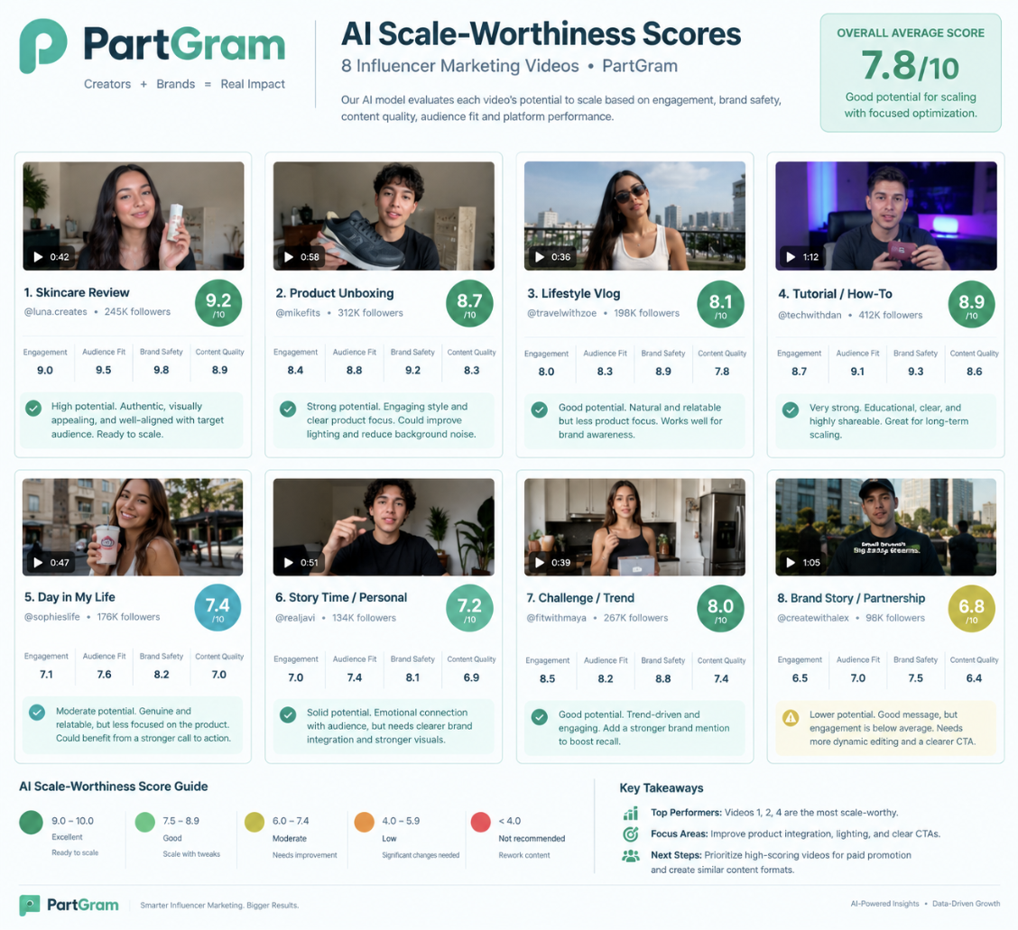  A v1 (ChatGPT): made-up data, all 8 look like winners | 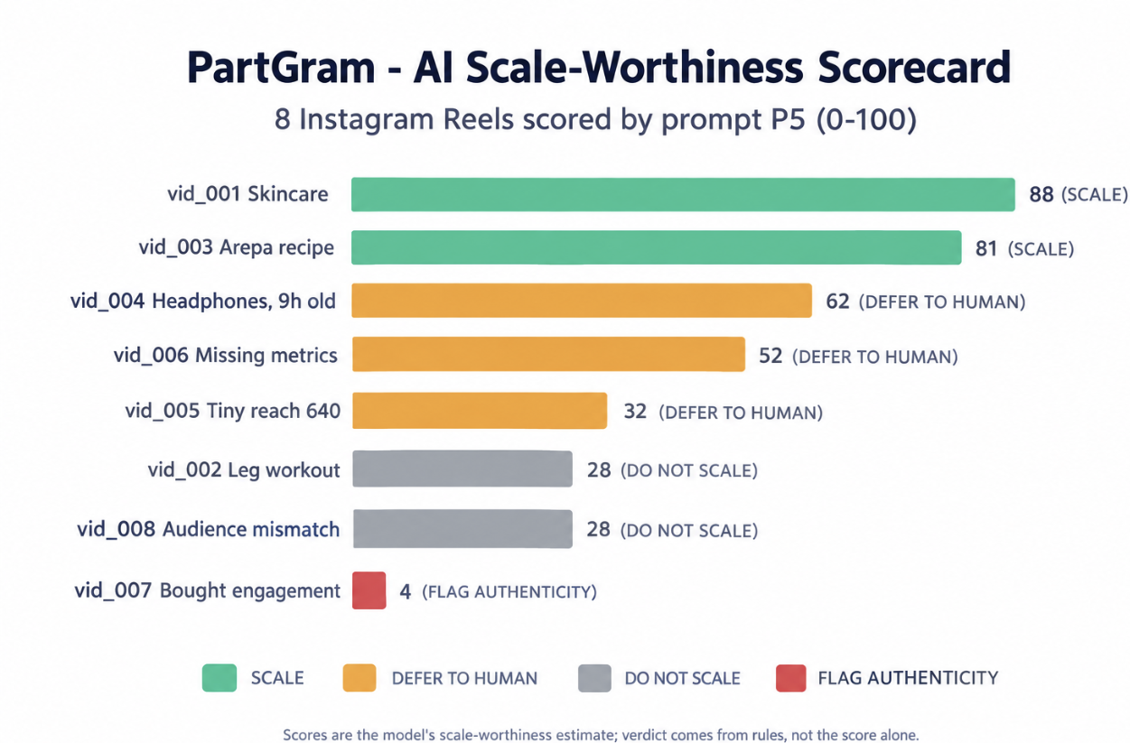  A v2 (ChatGPT): every label and value correct
v1 → v2. v1 looks polished and even guessed the green brand palette. But every figure is made up: scores out of 10 (9.2, 8.7…), a "7.8/10 overall average", creator handles and follower counts, and people's faces. It also shows all eight videos as positive, so the loser, the fraud case and the three "defer" cases disappear. That is the same failure as text prompt P1. The fix was the same too: give the model the data, the chart type and a list of things to leave out. v2 reproduced all 8 labels, scores and verdict colours correctly.
v2 → v3, measured. I measured the bar lengths in pixels (table below). v2 is proportional to within about 2 points. Adding an axis in v3 made the problem visible. The model drew uneven tick spacing, and bars fall up to 7 points short of their own axis (81 is drawn at about 74). The dashed line drawn for 70 sits at about 68. My v3 prompt also added a flaw of its own. P5 has no score threshold (verdicts come from rules), so the "scale threshold" line misrepresents the model. It would be removed in any further version.
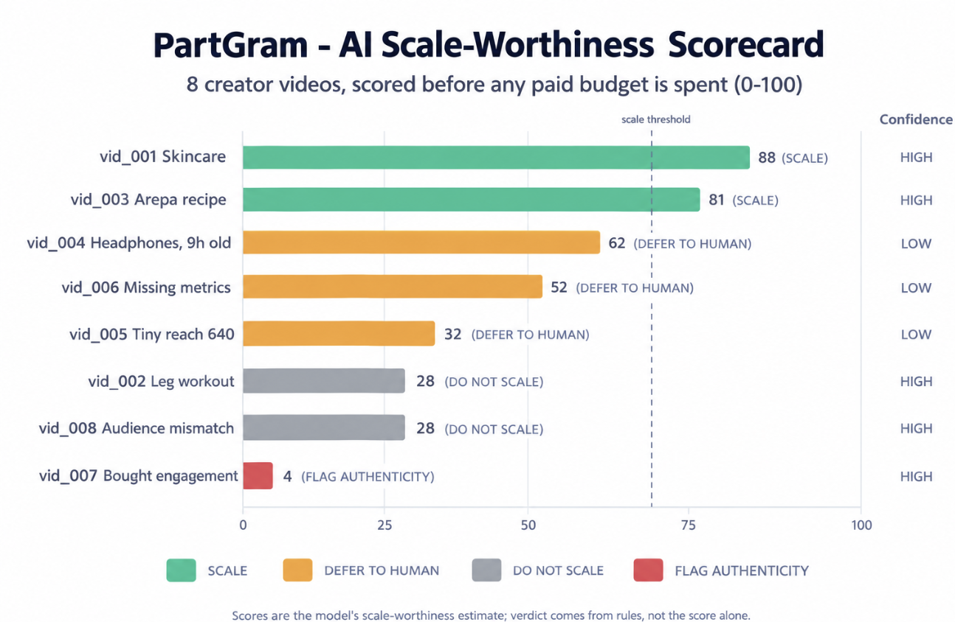  A v3 (ChatGPT): the axis exposes the bar lengths | 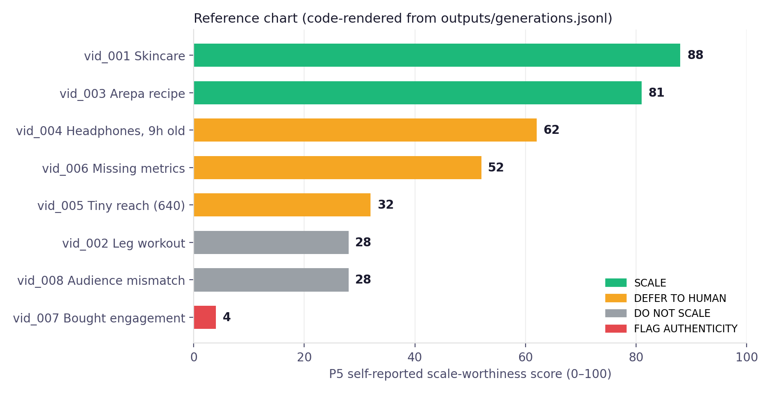  Reference: the same data rendered by code (matplotlib)
 | * bar length scaled so vid_001 = 88 (v2 has no axis).  bar end read against v3's own drawn axis (0 to 100  Measured by pixel analysis of the saved images. The largest error is vid_003: 81 drawn as about 74, which puts it under v3's own threshold line.
  Video | True score | v2 drawn* | v3 drawn**
  vid_001 | 88 | 88.0 | 82.1
  vid_003 | 81 | 80.9 | 74.1
  vid_004 | 62 | 61.1 | 57.9
  vid_006 | 52 | 52.2 | 48.5
  vid_005 | 32 | 33.9 | 31.2
  vid_002 / 008 | 28 | 29.1 | 26.2
  vid_007 | 4 | 4.4 | 4.9

4. Visual B: score card in the Brand Panel (product concept)
B v1 Generate an image: a mobile app screen for the PartGram Brand Panel showing the AI score report for one creator video: a skincare Instagram Reel by @lucia.makes for the brand Solara Skincare. Score 88/100, verdict SCALE, confidence HIGH. Reach 100,000, save rate 2.1%, share rate 1.45%.
B v2 Portrait 9:16, flat UI · "no people or faces anywhere" (mint placeholder thumbnail) · strict palette, "no blue, no pink" · plain-text header, no logo · ONLY this text: "Creative Score" / "vid_001 - @lucia.makes - Solara Skincare" / gauge "88 / 100" / "SCALE - Confidence HIGH" / "Data collected 96 h after posting" / Why: "Engagement 12.06% of reach", "Save rate 2.1% - Share rate 1.45%", "69.5% of audience in CO + EC (campaign targets)" / "Reach 100,000 - Views 142,000" / button "Send to media buyer for approval" + link "Override score" · no other numbers.
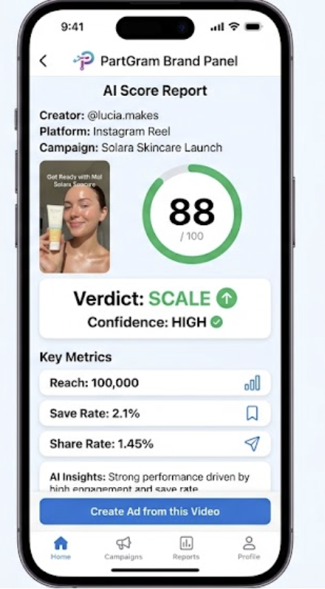  B v1 (Gemini) | 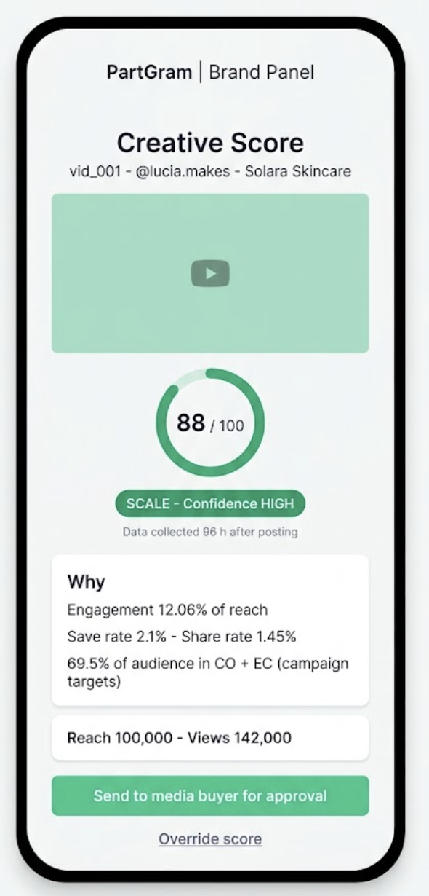  B v2 (Gemini) | v1 copied the four numbers correctly. It also made up a campaign name ("Solara Skincare Launch"), a pink-and-blue logo, a blue CTA outside the brand palette and a truncated "AI Insights" line. The biggest problem was a photoreal face that viewers would take for the real creator @lucia.makes. That is a consent and trust risk on a creator marketplace. Its "Create Ad from this Video" button also implies automatic scaling, which goes against the proposal's human-review principle.  v2 fixed all of this. There is no face, and the Why card cites the evidence (engagement 12.06% = 12,060 / 100,000; audience 69.5% = CO 26,400 + EC 7,100 of 48,200). It shows how old the data is, and the action routes to a person. Every string rendered exactly. The one gap is colour. The hex codes came out desaturated (button #5EB788 against the #2ECC8F asked for), so final assets still need a design pass.

5. Visual C: pitch-deck hero (marketing)
C v1 Generate an image: a marketing hero image for PartGram showing the idea "from betting to optimizing" marketing spend with AI.
C v2 Different concept: 16:9 isometric flat vector, #F0FFF8 background, greens + navy + one amber accent · the real mechanism, left→right: ~12 phones playing creator videos (product silhouettes, no faces) → green scanning layer adds a score badge → only the 2 best grow into ad placements, the rest fade, one gets an amber review flag · top-right third left empty for a headline · "no text, no letters, no numbers, no logos, no percentages, no charts, no people, no dice, no casino imagery, no robots".
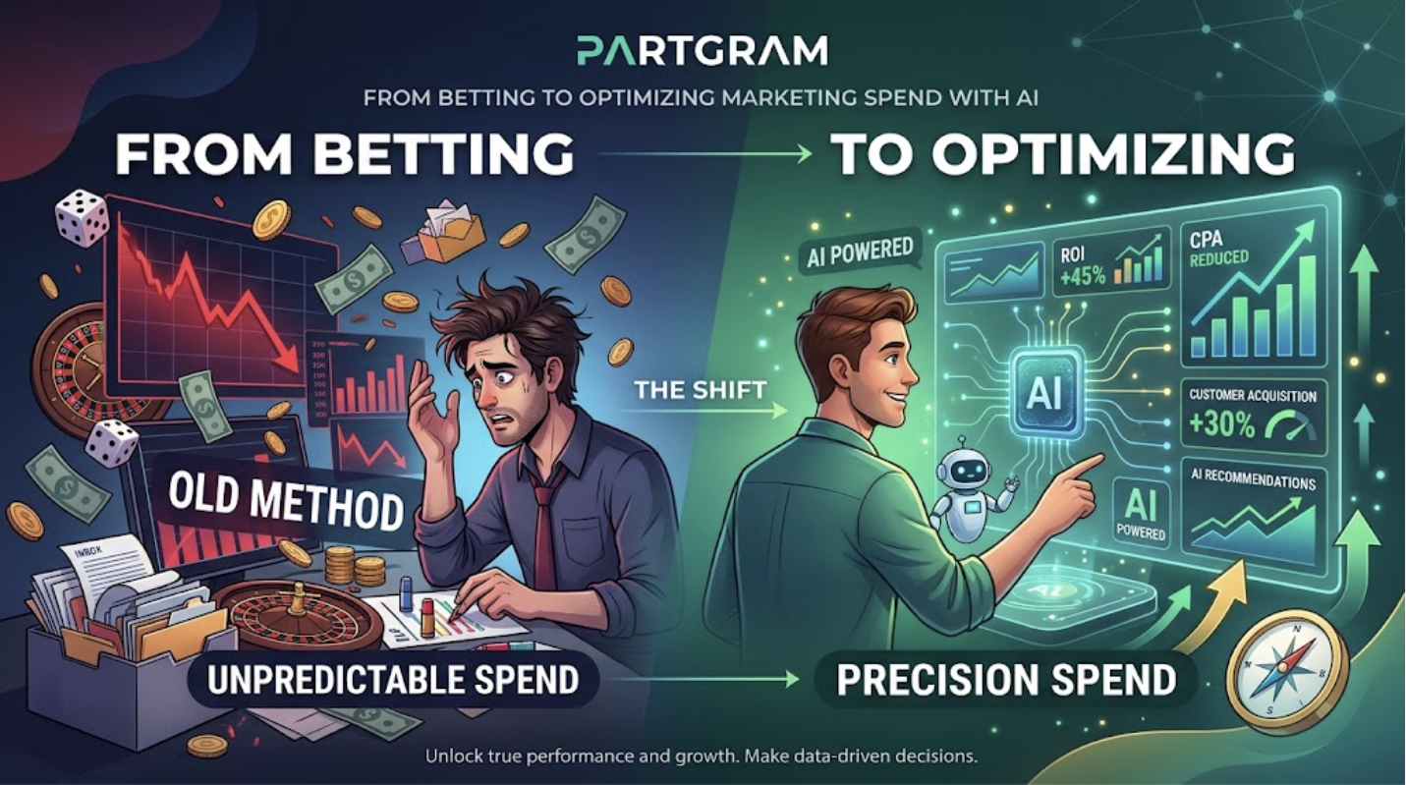  C v1: gambling clichés and invented ROI claims |   C v2: PartGram's actual scoring loop, no copy
v1 took the slogan literally: roulette, dice, a stressed marketer and a robot. It also printed "ROI +45%" and "Customer Acquisition +30%", claims PartGram cannot back up. Putting them in an investor deck would be misleading. Nothing in the image shows creators, videos or scoring. v2 replaced the metaphor with the mechanism itself (many creator tests → score → a few scaled winners) and removed every number and word. The headline goes on top in the design tool, so the copy stays exact. One remaining weakness is that all badges look the same, so the image does not show *why* two phones win.

6. Evaluation
I scored each image 1–5 on four criteria that match the Section 3 text rubric. Relevance: does it serve its business function? Data accuracy: is every figure or claim from the data? Clarity: can it be understood at a glance? Brand fit: palette, tone and trust.
Image | Relevance | Data accuracy | Clarity | Brand fit | Mean | Decision
A v1 | 2 | 1 | 3 | 4 | 2.50 | Reject: made-up data
A v2 | 5 | 4 | 5 | 4 | 4.50 | Draft chart; bars ±2 pts
A v3 | 4 | 2 | 4 | 4 | 3.50 | Reject: bars off, fake threshold
B v1 | 3 | 3 | 4 | 2 | 3.00 | Reject: synthetic face, off-palette
B v2 | 5 | 5 | 4 | 4 | 4.50 | Use as UI concept for CTO
C v1 | 2 | 1 | 2 | 2 | 1.75 | Reject: invented ROI, gambling
C v2 | 4 | 5 | 4 | 4 | 4.25 | Use in pitch deck + headline

What the iterations showed.
- Specificity fixes content but not geometry. Listing exact values took data accuracy from 1 to 4–5, but the model still does not scale bars to their values. For anything a media buyer would use to make a decision, the chart should be rendered from the data by code (reference chart, §3). Image generation is useful for layout and styling ideas.
- Say what to leave out. Most gains came from negative constraints: no faces, no extra numbers, no logos, no casino imagery. Without them the models filled space with plausible-looking invented details, the visual version of the invented benchmarks P2/P3 produced in text.
- Keep text out of marketing images. C v2 has no text, and the headline is added afterwards. That removes the risk of invented claims and typos, and one image works for Spanish and English decks.
- Avoid synthetic people on a platform built on real creators. A generated face next to a real handle can be read as that creator. Use placeholders or licensed creator content.
Adjustments for the next round: remove the invented threshold from A and render the production chart from generations.jsonl. Give C v2's badges a visible gradient (a few high, most low) so the image shows selection. Correct B v2's greens to the exact hex values in the design tool. Add a trust signal the proposal promised, such as a confidence range next to the 88.
Overall. Image generation was useful for the concept and marketing visuals (B v2, C v2), which now match the project's goal of explainable, human-reviewed scoring. For the data visualisation itself, the evaluation led to a decision: generated images are for drafting the layout, and code renders the final chart. That is the same data-accuracy standard that made P5 the best text prompt.

