Version 1.0
DATE 12/2/19


Presented by: GROUP E
ARNULFO ROMERO, BRIAN RATTANASITH, CODY COX
FERNANDO JUAREZ, MATTHIS TEXIER, YAZEED ALOTAIBI
CIS 444 PROFESSOR WU

Final Report:

Overview description:
Cougar Lifestyle is a website dedicated to improving the new student experience at CSUSM by having real students share their past experiences with all manner of things; from the best places to get food, to the quietest spots to study or relax. In this early stage of our development, there will be plenty of flaws that will be revised and many more features to consider. Nonetheless, we hope to deliver a strong, informative, and entertaining website.

Project Specifications:
The primary specifications of the project includes the overall team objectives, website design process, database implementation, and finalized documentation.

Team Objectives:
- Original Project Brainstorming & Ideas - Cougar Lifestyle
- Potential Users - New and Old Students, Admins
- Webpage illustrations/ideas, Frameworks, and outcome (Home/Index e.g.):
  - Early Stages/Frameworks - Users will land onto the homepage, bombarded with information, and can click into other web pages: Contact Us, Food, Study Zones, General Post, and Login.
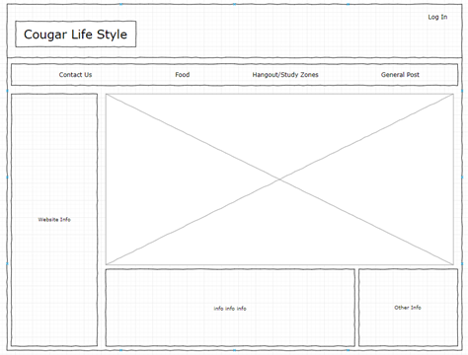
  - Live - Users Land on the homepage and have the ability to click onto other webpages: Home, Food, Study Zone, General, Contact Us, Login, and Signup
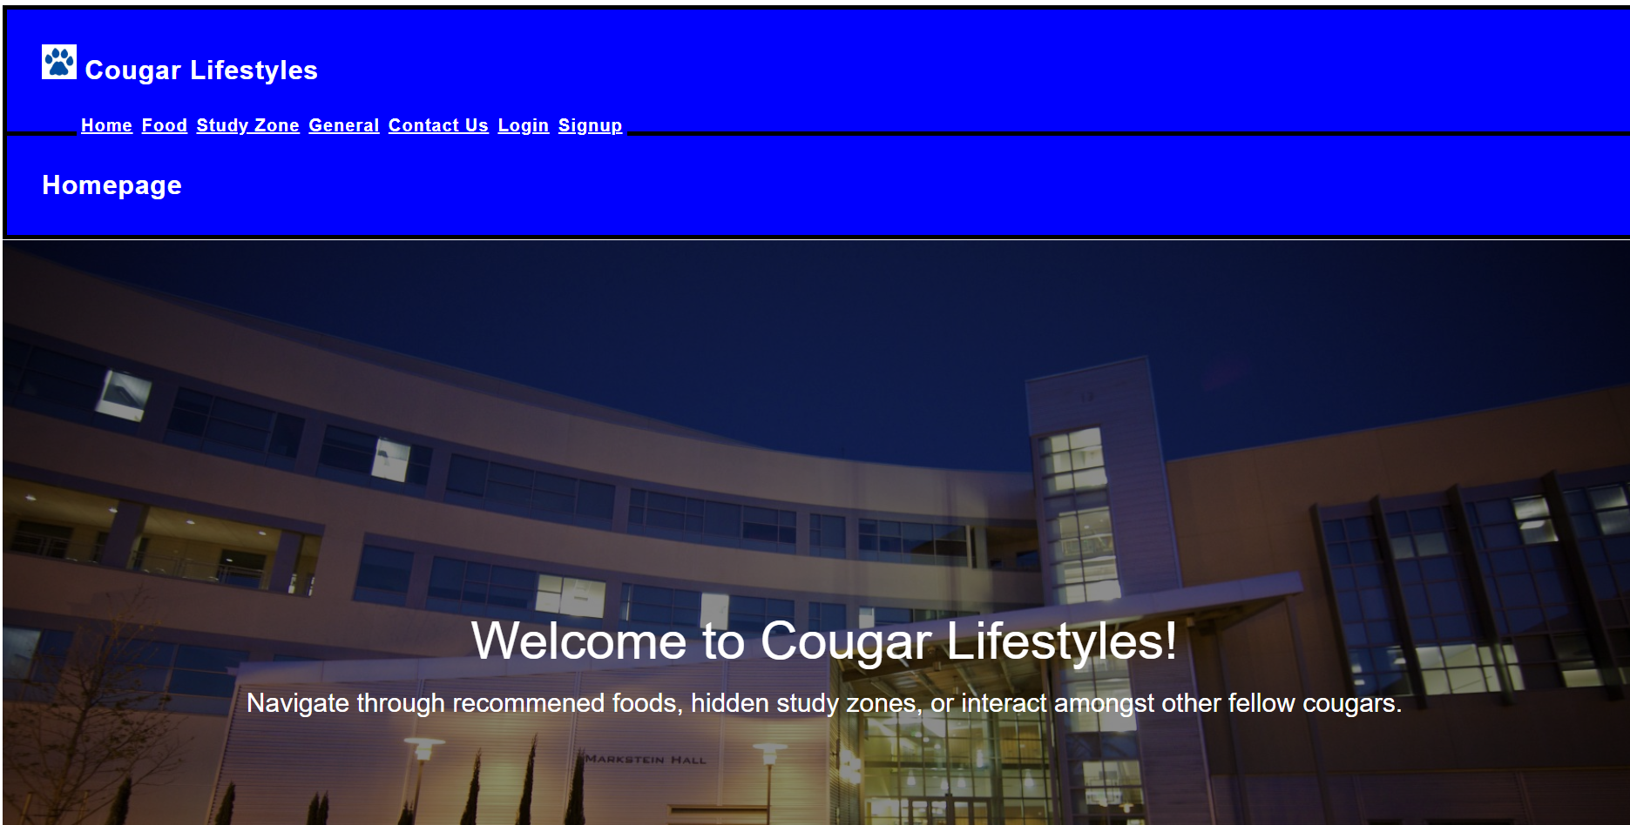
- Database design/Implementation
  - Information Flow Diagram & Basic Schema:
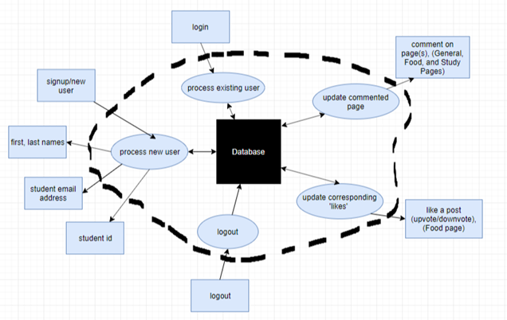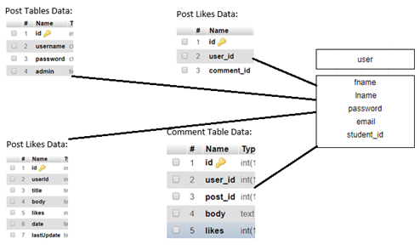

  - Refer below for detailed specifications on the database.
- Finalized documentation, further communication, and file sharing is all done through Google Drive/Doc, GitHub, and Text Messaging.

User’s Manual:
Guide To Using Cougar Lifestyle:
- User Enters: https://cis444.cs.csusm.edu/team_e/index.php into their browser.
- They will land onto the Home Page, here they have access to click onto: Home, Food, Study Zone, General, Contact Us, Login, or Signup pages. If they do not wish to comment and just view, continue onto Step 3.
  - If the user wishes to comment and post, they will have to create an account. However, if the user has an account already, they can instead hit the Login page and sign in with their Username and Password.
  - The User clicks onto the signup page, and is required to fill in the following information: Username and Password.
  - Once the account is created, they can click onto either the Food, Study Zone, or General pages to post comments in relation.
- The User can then click onto any of the corresponding pages to view information in relation.

Database Design and Implementation:

Database name & implemented passwords:
Database Name : team_e
Database Password : qo0uCaghBtri

Database Design:
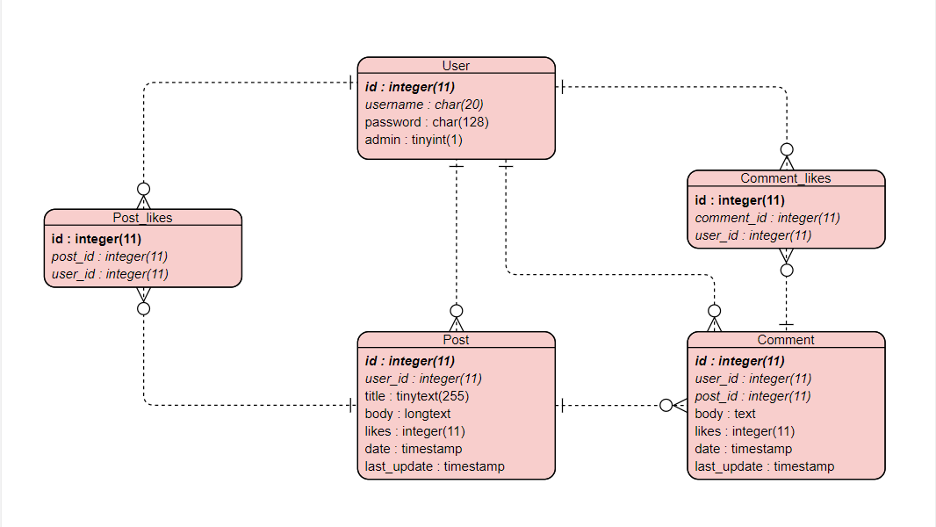

Implementation:
On team_e mysql server, the database is named ‘team_e’ and you can check the implementation here. Moreover, in /team_e/Archive/Database/ folder are all the files to show the testing part of the Database interaction with front and html web pages. Also, there is the “install_script/setup.sql” script to create the database anywhere.
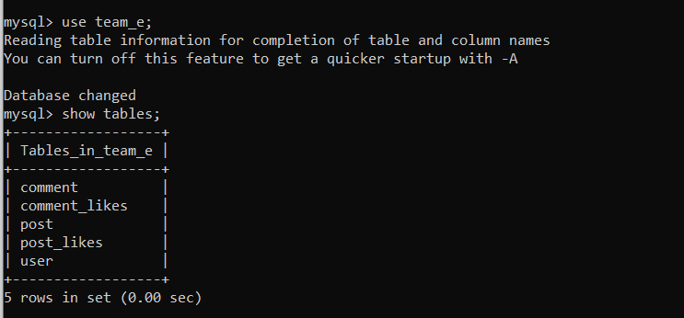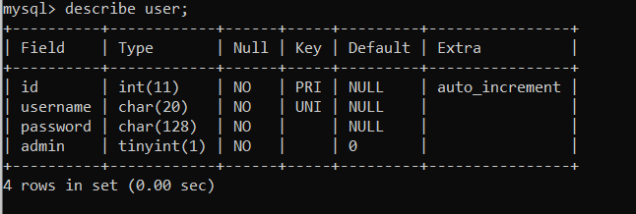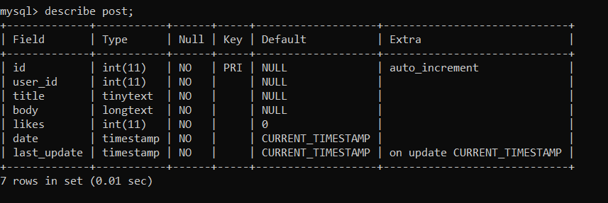

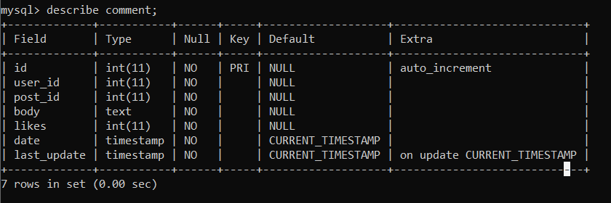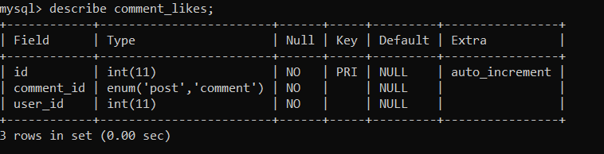

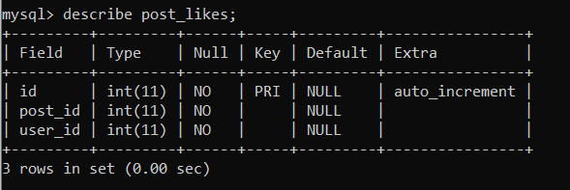

Web Design Issues & Future Improvements/Enhancements:
In the future, we would like to implement a cleaner user interface and have everything much more modernized. The website at the moment looks a bit archaic, but delivers. Not only would we like to touch up on UI, but also improve the functionalities, as well as implement more tools to navigate, communicate, and collaborate amongst other users. Modernization is goal, and so device compatibility is a huge enhancement as well.

Web Implementation Details:

Directorie(s):
- assets/ : folder containing all media files (.jpg, .png, .jpeg, ...)
- css/ : folder containing all style files (.css)
- js/ : folder containing all JavaScript files (.js)
- pages/ : folder containing all webpages (.html, .php)
- Archive/ : folder containing the work done for pasted phases (including the GitHub repository)

Directory of Web page implemented:
https://cis444.cs.csusm.edu/team_e/index.php

Individual Contributions Of Each Member:
Brian Rattanasith - Documentation, Home Page, Revisions
Cody Cox - Front end development of both the general page and contact us page, including the js and adjusting php to fill the requirements needed to communicate front and backend. Project management tasks including setting team meetings. Merging teams repository as team members finished their tasks before each milestone due dates.
Fernando Juarez - Study Zone Page, Login Page, Partial Documentation
Arnulfo Romero- Some mild documentation/ backend development with php( login.php, loginform.php, signup.php, and signupfinal.php)/ connection of database from pages. Attended team meetings.
Yazeed Alotaibi - Food page/Partial Documentation/Setting up communication channels.
Matthis Le Texier - Database Design & Implementation / Backend Development (PHP) with front communication (JS) / Merging Project and architecture

