TPAPI
B2B Customer & API Portal
High-Level Architecture & Solution Plan

Version | 1.0 — Draft
Date | March 2026
Author | TPAPI Architecture Team
Status | For Review
Technology | SAP BTP | S/4HANA | Integration Suite | Snowflake

Table of Contents

1. Executive Summary
TPAPI is a B2B digital commerce and API platform designed to automate the complete order-to-cash cycle for businesses. It enables customers to self-serve through a feature-rich portal — placing orders, tracking shipments, viewing invoices, and accessing real-time data — without requiring a sales representative to facilitate each transaction.

The platform is architected on SAP Business Technology Platform (SAP BTP), connecting to SAP S/4HANA as the core transactional ERP and leveraging SAP Integration Suite as the middleware and API management layer. A Snowflake data warehouse or HANA DB Sidecar provides a read-optimized data layer for high-performance API queries and analytics.

Key business outcomes include: accelerated repeat sales with existing customers, reduced customer acquisition costs through self-service onboarding, improved operational efficiency by automating manual order and invoicing processes, and opening a programmable API channel for B2B integration with customer systems.

2. Solution Overview

2.1 What is TPAPI?
TPAPI stands as an integrated B2B Customer & API Portal. It serves two primary audiences: business customers who want a self-service portal UI for managing their commercial relationship, and technical integrators within those businesses who want programmatic API access to automate order and fulfillment flows from within their own ERP or logistics systems.

2.2 Core Value Propositions
- Automate Order Placement — Customers can create, submit, and manage sales orders directly without sales representative involvement.
- Invoice Automation — Electronic invoicing, payment status tracking, and document retrieval are fully self-service.
- Order Fulfillment Visibility — Real-time shipment tracking, delivery confirmation, and proof-of-delivery access.
- Repeat Sales Enablement — Quick re-order flows, order templates, and product catalog browsing drive repeat purchases.
- Onboarding Automation — New customers can register, submit required business documents, and be approved through an automated workflow.
- API Marketplace — A developer portal with API documentation, interactive playground (Swagger UI / SAP API Hub), API key management, and sandbox environments.
- B2B Integration — Machine-to-machine integration via REST APIs, OData, EDI, and webhook events for direct ERP-to-ERP connectivity.

3. High-Level Architecture

3.1 Architecture Diagram
The following diagram illustrates the four-layer architecture of the TPAPI platform, from the customer-facing presentation layer through to the transactional ERP and data layers.

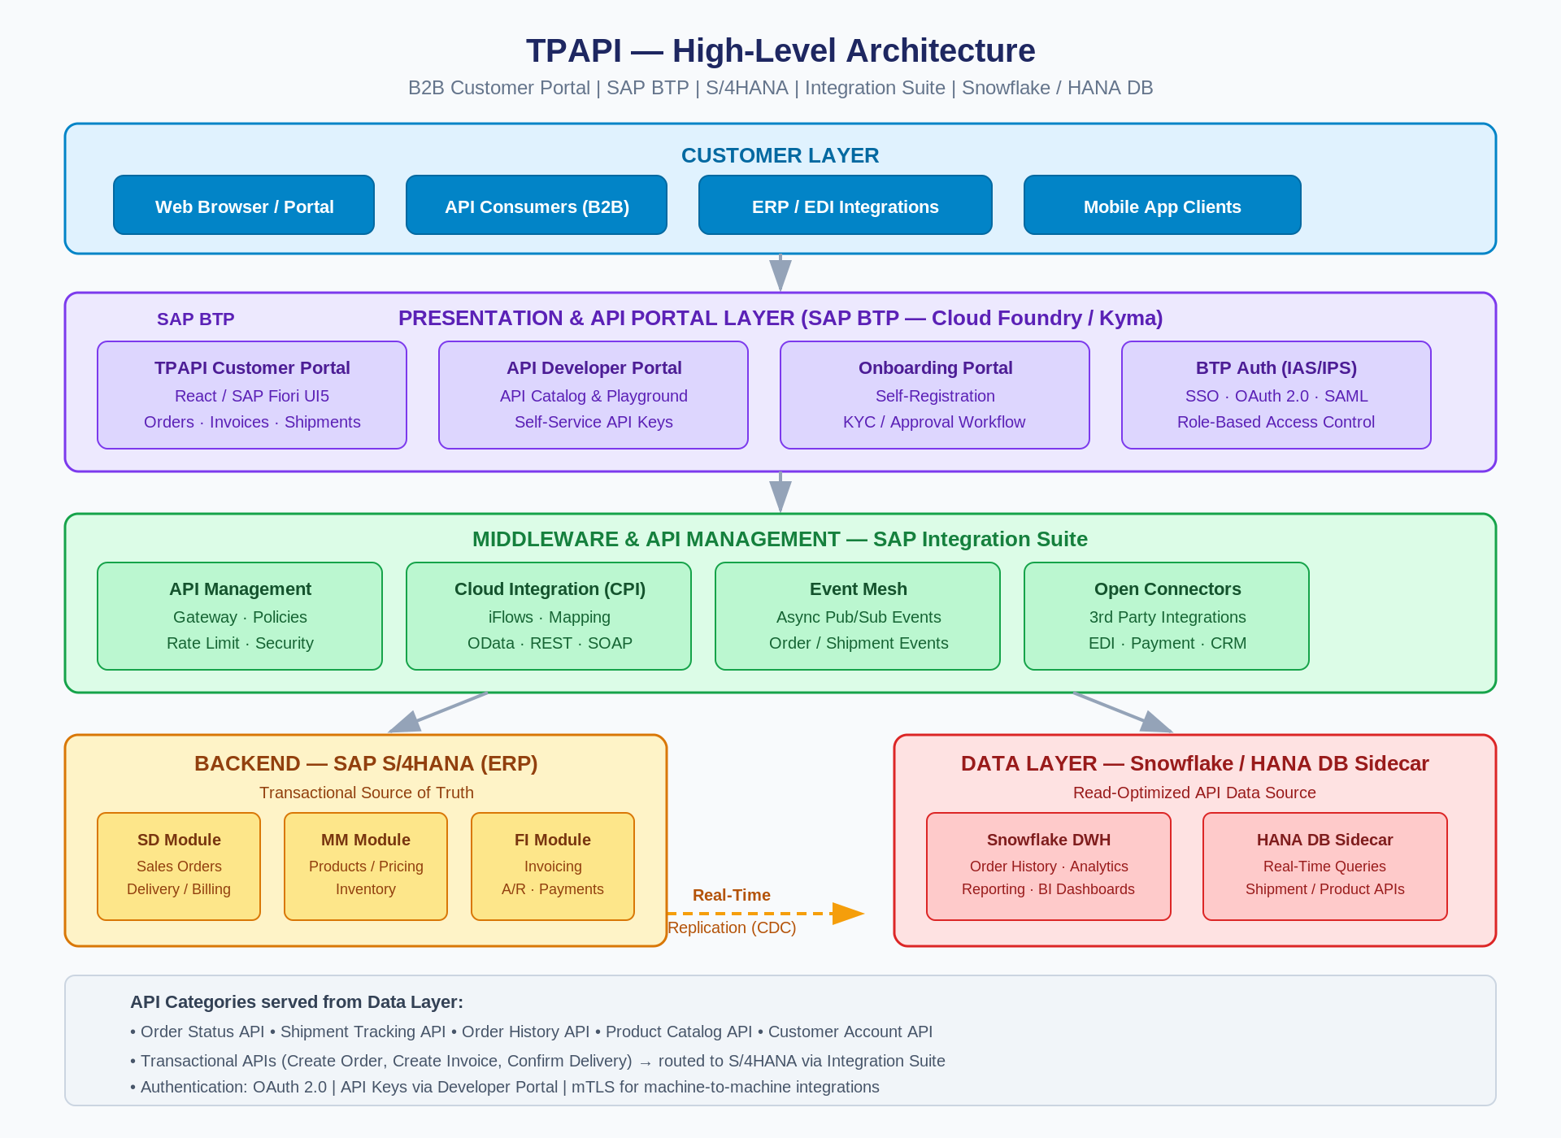

Figure 1: TPAPI High-Level Architecture — SAP BTP | Integration Suite | S/4HANA | Snowflake / HANA DB Sidecar

3.2 Architecture Layers

Layer 1 — Customer Touchpoints
External B2B customers and their systems interact with TPAPI through three primary channels: the web-based Customer Portal accessed via a browser, programmatic REST/OData APIs consumed by customer ERP systems (SAP, Oracle, Microsoft Dynamics), and EDI/file-based integration for customers with legacy systems. Mobile application access is also supported for order tracking and approvals on the go.

Layer 2 — Presentation & Portal (SAP BTP)
All customer-facing applications are hosted on SAP Business Technology Platform (BTP), using the Cloud Foundry or Kyma runtime. The TPAPI Customer Portal is built with React or SAP Fiori UI5 and served as a single-page application. The API Developer Portal leverages SAP API Management's built-in developer portal capabilities, providing interactive API documentation, API key self-service, and a sandbox playground environment. User authentication is handled by SAP Identity Authentication Service (IAS) with SSO support via SAML 2.0 and OAuth 2.0.

Layer 3 — Middleware & API Management (SAP Integration Suite)
SAP Integration Suite serves as the central middleware layer, performing four critical functions: (1) API Management — gateway policies including authentication, rate limiting, request transformation, and threat protection; (2) Cloud Integration (CPI) — iFlow-based integration processes that orchestrate data between the portal, S/4HANA, and the data layer; (3) Event Mesh — asynchronous publish/subscribe event handling for order status changes, shipment updates, and invoice generation events; and (4) Open Connectors — pre-built adapters for third-party integrations such as payment gateways, logistics providers, and CRM systems.

Layer 4A — Backend ERP (SAP S/4HANA)
SAP S/4HANA serves as the system of record for all transactional data. The Sales and Distribution (SD) module handles order creation, delivery, and billing. Materials Management (MM) provides product catalog and inventory data. Financial Accounting (FI) manages invoicing, accounts receivable, and payment application. All create/update transactions initiated by TPAPI are routed to S/4HANA via Integration Suite iFlows, ensuring a single source of truth for financial and operational data.

Layer 4B — Data Layer (Snowflake / HANA DB Sidecar)
To avoid placing excessive read load on S/4HANA and to enable high-performance API responses, S/4HANA replicates operational data in real time to either a Snowflake data warehouse or a HANA DB Sidecar instance. Read-intensive API endpoints — such as Order Status, Order History, Product Catalog, Shipment Tracking, and Customer Account queries — are served from this layer. Real-time change data capture (CDC) or SAP Data Intelligence pipelines maintain data currency. This separation of read and write workloads enables the system to scale independently for API traffic.

4. Component Breakdown
The following table summarizes the key technical components, the SAP or third-party technology used, and each component's primary responsibility within the TPAPI platform.

Component | Technology | Responsibility
TPAPI Customer Portal | React / SAP Fiori UI5 on BTP | Order management, invoice viewing, shipment tracking, account self-service
API Developer Portal | SAP API Management Developer Hub | API catalog, interactive playground, API key issuance, usage analytics
Onboarding Portal | React / BTP Workflow Service | Customer registration, document submission, approval workflow automation
Identity & Access | SAP IAS / IPS, OAuth 2.0, SAML | SSO, RBAC, API key authentication, mTLS for machine-to-machine
API Gateway | SAP API Management (Integration Suite) | API policies, rate limiting, threat protection, JWT validation, analytics
Cloud Integration (CPI) | SAP Integration Suite — CPI | iFlows for order creation, invoicing, shipment events; OData/REST adapters
Event Mesh | SAP Integration Suite — Event Mesh | Async order/shipment events, webhook delivery to customer systems
Open Connectors | SAP Integration Suite — Open Connectors | Payment gateway, logistics, CRM, and 3PL integrations
ERP — Sales | SAP S/4HANA SD Module | Sales orders, delivery, billing, returns management
ERP — Materials | SAP S/4HANA MM Module | Product catalog, pricing, inventory availability
ERP — Finance | SAP S/4HANA FI Module | Electronic invoicing, A/R management, payment application
Data Warehouse | Snowflake (primary) or HANA DB Sidecar | Read-optimized data source for all query-heavy API endpoints
Data Replication | SAP Data Intelligence / CDC | Real-time replication of S/4HANA operational data to the data layer
Monitoring & Observability | SAP BTP Alert Notification, Dynatrace | API analytics, error alerting, performance monitoring, SLA tracking

5. Key Platform Features

5.1 Customer Portal
- Dashboard — Personalized view of open orders, recent invoices, delivery status, and account KPIs.
- Order Management — Place new orders, reorder from history, use order templates; multi-line order entry with product search.
- Invoice & Payment — View electronic invoices, download PDFs, track payment status, submit payment disputes.
- Shipment Tracking — Real-time shipment status integrated with logistics providers, estimated delivery dates, delivery confirmation.
- Account Management — Manage delivery addresses, contact details, notification preferences, and user sub-accounts.
- Catalog Browsing — Browse available products with real-time pricing, availability, and lead times sourced from S/4HANA.

5.2 API Developer Portal & Marketplace
- API Catalog — Discover all available TPAPI APIs with full OpenAPI/Swagger documentation.
- Interactive Playground — Execute live API calls against a sandbox environment directly within the developer portal.
- Self-Service API Keys — Register a developer account, request API keys, manage key rotation and revocation.
- Usage Analytics — Monitor API consumption, error rates, and latency for subscribed APIs.
- Webhook Configuration — Register webhook endpoints to receive real-time event notifications for order and shipment updates.

5.3 Onboarding Automation
- Self-Registration — New business customers complete a registration form with company details, tax ID, and contact information.
- Document Submission — Upload required business documents (business license, credit application, tax certificates).
- Automated Workflow — BTP Workflow Service routes the application through internal approval stages with SLA timers.
- Account Provisioning — Upon approval, customer account is auto-provisioned in S/4HANA (Customer Master) and the portal.
- Welcome Journey — Automated welcome communications and portal onboarding guide delivered via email.

5.4 Order-to-Cash API Flow
The following APIs support the complete order-to-cash process for B2B integrators connecting programmatically:
- POST /orders — Create a new sales order (routed to S/4HANA SD via CPI iFlow).
- GET /orders/{id} — Retrieve order details and current status (served from Snowflake / HANA DB).
- GET /orders/{id}/shipments — Get shipment details and tracking information.
- GET /orders — Order history with filtering, pagination, and date range support.
- GET /products — Browse product catalog with pricing and availability (served from Snowflake / HANA DB).
- GET /invoices — Retrieve invoice list and invoice PDFs.
- POST /invoices/{id}/payment — Submit payment information for an invoice.
- GET /customers/{id}/account — Retrieve account balance, credit limit, and payment terms.

6. Integration Design

6.1 Transactional Flows (Write Path — S/4HANA)
All create and update operations initiated through the TPAPI portal or APIs are routed to SAP S/4HANA via SAP Integration Suite iFlows. The iFlow layer handles protocol transformation (REST to OData/BAPI), field mapping, error handling, and retry logic. Key transactional iFlows include order creation, invoice generation trigger, delivery confirmation, and payment application. S/4HANA remains the definitive system of record for all transactional data.

6.2 Query Flows (Read Path — Data Layer)
All read-intensive API calls are served from Snowflake or the HANA DB Sidecar to prevent performance degradation on the production S/4HANA system. S/4HANA replicates data in real time using SAP Data Intelligence pipelines or SLT (SAP Landscape Transformation Replication Server). Typical replication latency targets are under 30 seconds for order and shipment status, and near-real-time for inventory availability.

6.3 Event-Driven Integration
SAP Integration Suite Event Mesh provides asynchronous messaging for event-driven B2B integrations. When key business events occur in S/4HANA (order confirmed, goods issued, invoice posted, payment received), events are published to Event Mesh topics. Customer systems can subscribe to these events via webhooks or AMQP queues, enabling true event-driven architecture without polling.

6.4 Third-Party Integrations
SAP Open Connectors provides pre-built adapters for commonly required third-party services. Payment gateway integration (Stripe, Adyen, or similar) handles payment processing. Logistics provider integration (FedEx, UPS, DHL) enriches shipment tracking with carrier-level data. CRM integration (Salesforce or SAP Sales Cloud) keeps customer account data synchronized. Tax calculation services (Vertex, Avalara) provide real-time tax computation during order creation.

7. Security Architecture

7.1 Authentication & Authorization
- Portal Users — SAP IAS with SSO via SAML 2.0 or OpenID Connect. Multi-factor authentication (MFA) enforced for all portal logins.
- API Consumers — OAuth 2.0 Client Credentials flow for machine-to-machine integrations; API Keys with optional IP allowlisting for simpler integrations.
- Machine-to-Machine (mTLS) — Mutual TLS certificate-based authentication available for high-security B2B integrations.
- Role-Based Access Control (RBAC) — Granular roles within the portal: Order Placer, Invoice Viewer, Account Admin, API Developer.

7.2 API Security
- API Gateway Policies — JWT validation, OAuth token introspection, API key enforcement, rate limiting, and IP-based throttling.
- Threat Protection — OWASP top-10 protection, SQL injection prevention, and payload size limits enforced at the gateway.
- Data Masking — Sensitive data fields (payment details, tax IDs) masked in API responses based on caller role.
- TLS 1.3 — All communication encrypted in transit; no plaintext HTTP permitted.

7.3 Data Security
- Data at Rest — Snowflake and HANA DB data encrypted at rest using AES-256. S/4HANA encryption managed per SAP standard.
- Data Residency — SAP BTP region selection ensures data residency compliance with applicable regulations.
- Audit Logging — All API calls, portal actions, and data access events logged with immutable audit trails.
- PII Handling — Personally identifiable information handled in accordance with GDPR/CCPA; data minimization principles applied.

8. Deployment & Operations

8.1 Hosting
TPAPI is hosted entirely on SAP Business Technology Platform (BTP). The React/Fiori portal and backend microservices run on the Cloud Foundry or Kyma runtime. SAP Integration Suite is provisioned as a managed BTP service. The Snowflake instance is hosted on the cloud provider of choice (AWS, Azure, or GCP) and connected to BTP via private connectivity or SAP Private Link.

8.2 CI/CD & DevOps
- Source control managed via GitHub or Azure DevOps with trunk-based development.
- SAP CI/CD Service or GitHub Actions pipelines for automated build, test, and deployment to BTP.
- Blue-green deployment strategy for zero-downtime releases.
- Integration iFlows version-controlled and deployed via SAP CPI Transport Management.

8.3 Scalability & Availability
- BTP Cloud Foundry auto-scales application instances based on CPU and memory thresholds.
- Snowflake virtual warehouses auto-scale to handle peak API query loads.
- SAP API Management is a managed, multi-tenant service with built-in high availability.
- Target SLA: 99.9% uptime for the customer portal; 99.95% for API gateway.

8.4 Monitoring & Observability
- SAP BTP Alert Notification Service for infrastructure and application alerts.
- SAP API Management analytics dashboard for API traffic, error rates, latency, and quota consumption.
- Dynatrace or SAP Cloud ALM for end-to-end application performance monitoring (APM).
- Integration Suite monitoring console for iFlow execution tracking, error alerting, and message replay.

9. Phased Implementation Roadmap
The TPAPI platform is delivered in four phases, prioritizing core transactional capabilities first, followed by advanced API features, analytics, and ecosystem expansion.

Phase | Name | Duration | Key Deliverables
Phase 1 | Foundation & Core Portal | 3–4 months | BTP environment setup; S/4HANA OData API exposure; Customer Portal (orders, invoices, shipments); Identity & SSO; Basic API Gateway
Phase 2 | API Developer Portal & Onboarding | 3–4 months | API Developer Portal with Swagger playground; Self-service API keys; Customer onboarding workflow; Snowflake / HANA DB Sidecar setup & replication
Phase 3 | Advanced APIs & Integrations | 3–4 months | Full order-to-cash API suite; Event Mesh integration; Webhook delivery; Payment gateway; Logistics provider tracking; EDI support
Phase 4 | Analytics, AI & Ecosystem | 3–4 months | Order analytics dashboard; Demand forecasting (AI/ML on Snowflake); Open Connectors expansion; Mobile app; Multi-language / multi-currency support

Total estimated delivery: 12–16 months to full platform maturity. Phases are designed to deliver incremental business value with go-live milestones at each phase boundary.

10. Next Steps
- Architecture Review — Conduct a formal architecture review with SAP BTP and S/4HANA technical leads.
- S/4HANA API Assessment — Identify and document all required S/4HANA OData services and BAPIs needed for Phase 1.
- Snowflake / HANA DB Decision — Evaluate Snowflake vs HANA DB Sidecar based on existing licensing, skill set, and performance requirements.
- UI/UX Design — Initiate portal wireframing and prototype development with customer stakeholder validation.
- SAP BTP Provisioning — Provision BTP subaccount, enable required BTP services (IAS, Integration Suite, API Management, Workflow).
- Security Assessment — Complete threat modeling and security requirements documentation before Phase 1 development begins.
- Vendor & Partner Alignment — Confirm SAP partner support for BTP and Integration Suite implementation.
- Project Kickoff — Finalize project charter, team assignments, and Sprint 1 planning for Phase 1.

TPAPI — Powering B2B Commerce Through Automation and API-First Design

