Name: Md Jubair Pantho

UTC ID: WZS444

Course: CPSC 5010

**Problem 2.5:**

***Source code and Results:***

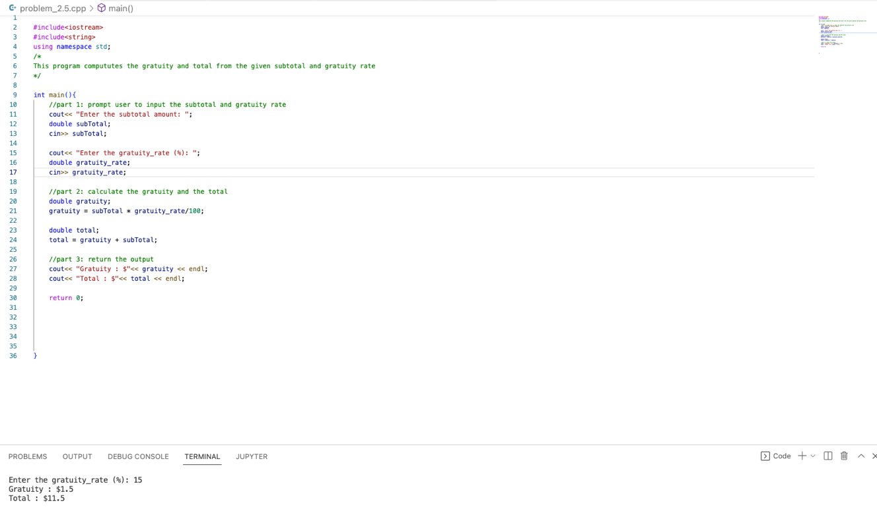

**Problem 2.6:**

***Source code and Results:***

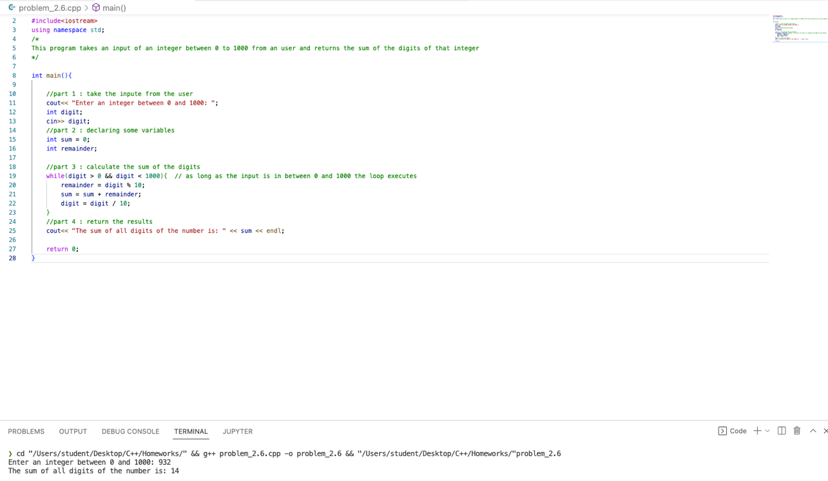

**Problem 2.13:**

***Source code and Results:***

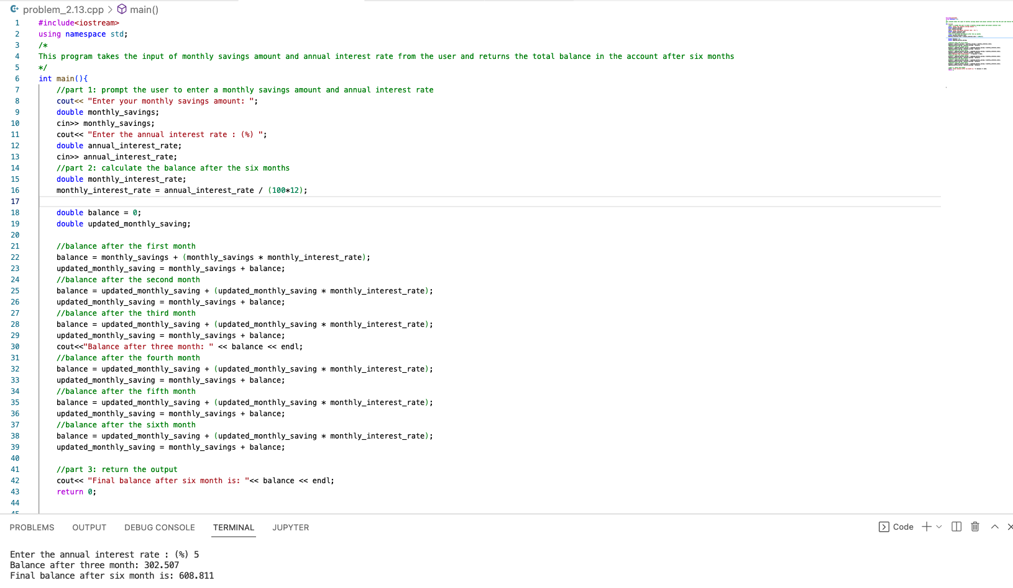

**Problem 3.1:**

***Source code and Results:***

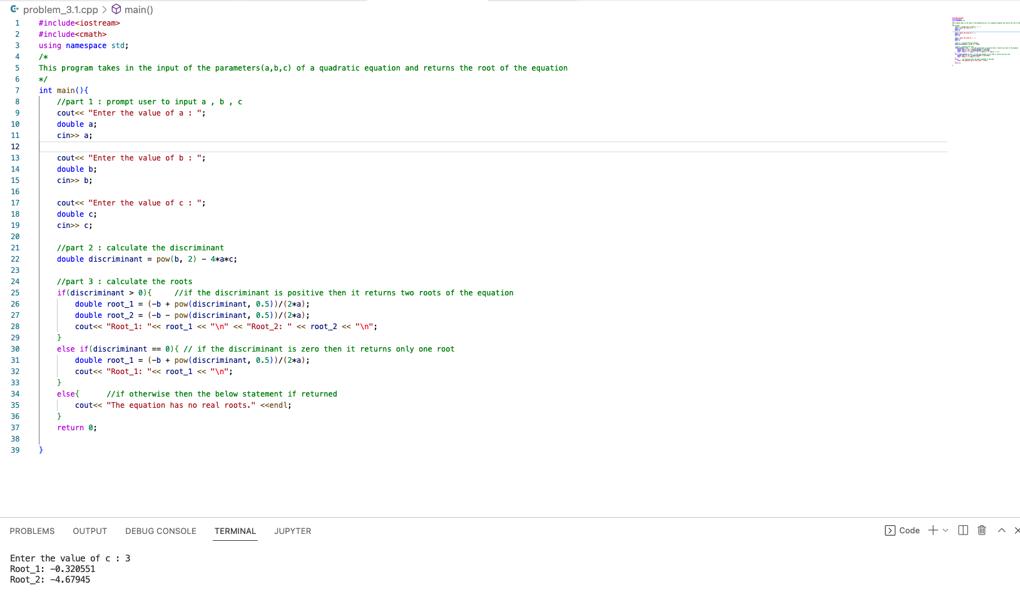

Link of the recorded coding session: <https://www.youtube.com/watch?v=In0H1Gy2zro>