Table of Content

|  |  |  |
| --- | --- | --- |
| OO. | O1. | O2. |
| O3. | O4. | O5. |
| O6. | O7. |  |



**White Paper** believes that successful business ventures are WHITE PAPER

pivotal to a developing nation. With that in mind, we help businesses to grow and thereby share their success by providing them with all the information technology management services they require, starting from customized IT equipment, accessories to IT, IT solutions, digital branding to business advisory services. From a sense of obligation to society, Whitepaper is dedicated towards maintaining ethical and environment-friendly principles in its services and work place.

**MISSION**

White Paper aims to add life to corporate existence and establish an iconic image in the industry through its diverse services, ethical practices and environmental friendly standards.

VISSION

White Paper, through its contribution to the society, envisions Bangladesh as a recognized figure in the developed world.

**Programming Skills**

Our young and talented programmers have a wide range of experience in developing systems. Our programming skill involves:

**PROGRAMMING LANGUAGES:**

VB, Visual C++, Java, Python and Microsoft .Net Platform.

**WEB PROGRAMMING LANGUAGES:**

PHP, Perl/CGI, Active Server Pages (ASP)

**SCRIPTING LANGUAGES:**

Java Script, VB Scripts

**MOBILE APPS DEVELOPMENT:**

Android & IOS

**MULTIMEDIA DEVELOPMENT:**

Adobe Creative Suite

**WEB SERVERS:**

Microsoft IIS and Apache

**OPERATING SYSTEMS:**

Microsoft Platform, OS, Linux/Unix

**DATA BASE:**

Oracle, My SQL, Mongo DB

**COMMITMENT**

Our approach focuses on new ways of business, thereby combining IT innovations and adoption while leveraging an organization’s current assets. Our team is committed to provide IT Services with:

**Quality, Technology, Innovation**

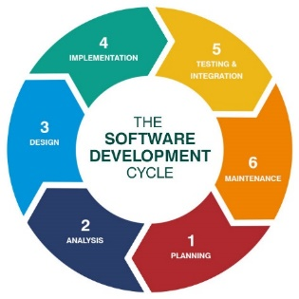

# ERP (Inventory, Accounting, Project Management, CRM, HR & Admin, Sales)

LMS (Learning Management System)

## CRM (Customer Relationship Management Software)

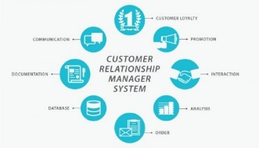

## CMS (Content Management System)

## WMS (Warehouse Management System)

## Corporate Portal

## IOT (Internet of Things)

Global Positioning System Devices(GPS) 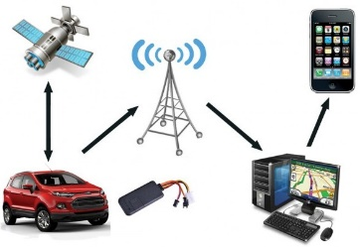

## Geographic Information System Solutions(GIS)

## Digital Marketing

**SERVICES WE PROVIDE**

**SOFTWARE SOLUTIONS**

**ACCOUNTING Software**

**- INVENTORY Software**

**- HUMAN RESOURCE & ADMINistration**

**- Point of sale (POS)**

**- PROJECT MANAGEMENT**

**- SCHOOL MANAGEMENT SYSTEM**

**WEB SOLUTIONS**

**wEBSITE**

**- WEB PORTAL**

**- NEWS PORTAL**

**- E-COMMERCE**

**- cUSTOMIZED WEB APPLICATION**

**MOBILE APPLICATION**