Thank-you for downloading the
All In One Template!

More templates to download on the:

Templates Repository for Software Development Process (click here)

Or paste the link below in your browser address bar:
http://blog.cm-dm.com/pages/Software-Development-Process-templates

This work is licensed under the:
Creative Commons Attribution-NonCommercial-NoDerivs 3.0 France License: http://creativecommons.org/licenses/by-nc-nd/3.0/fr/

Waiver:
You can freely download and fill the templates of blog.cm-dm.com, to produce technical documentation. The documents produced by filling the templates are outside the scope of the license. However, the modification of templates to produce new templates is in the scope of the license and is not allowed by this license.

To be compliant with the license, I suggest you to keep the following sentence at least once in the templates you store, or use, or distribute:
This Template is the property of Cyrille Michaud License terms: see http://blog.cm-dm.com/post/2011/11/04/License

Who am I? See my linkedin profile:
http://fr.linkedin.com/pub/cyrille-michaud/0/75/8b5

You can remove this first page when you’ve read it and acknowledged it!

TABLE OF CONTENTS

1 Introduction 3
1.1 Document overview 3
1.2 Scope 3
1.3 Abbreviations and Glossary 4
1.4 References 4
1.5 Conventions 4
2 Project Management 6
2.1 Team – human resources 6
2.2 Responsibilities 6
2.3 Customer -User involvement 6
2.4 Tasks – Planning - Milestones 7
2.5 Engineering environment 7
2.6 Other Resources 7
2.7 Software life cycle model 9
2.8 Reviews 9
2.9 Software configuration management 9
2.10 Documentation management 9
2.11 Verification 9
3 Specifications 10
3.1 States 11
3.2 Performance 12
3.3 Safety, security, and privacy protection 12
3.4 User maintenance 12
3.5 Usability and human-factors engineering 12
3.6 System environment 13
3.7 External interfaces 13
3.8 Resources 13
3.9 Internal data 13
3.10 Adaptation 14
3.11 Verification 14
3.12 Personnel and training 14
3.13 Packaging and installation 14
4 Architecture – Conception 15
4.1 Architecture 15
4.2 Conception 15
5 Verification 16
5.1 Test Plan 16
5.2 Tests Description 16
6 Tests Results 21
6.1 Rationale for decision 21
6.2 Results 21
7 Requirements traceability 27

Introduction

Document overview
This document contains the organization, the specifications, the conception, and verification tests of goEng software development project.
It covers the following goals:
- Explain product functionality.
- Unify project-related information.
- Allow for discussing all significant questions arising between stakeholders and developers.

Scope

Identification
This document applies to the iPad Mini developed in the goEng project.

Overview
Due to rapid growth of technology, the education system has changed a lot in the current world. Students now always look for easy and interesting ways of education system that might lead them to utter success. Therefore, English now, is one of the most important things to learn for the students for further success in various higher-level working platforms. It’s perhaps one of the most important skills to have. Now we can enable the students, using the latest technology, we are going to develop an app that they can learn English in a fun, exciting and attractive way. We propose an app that takes similar way such as gaming, and it allows the students to learn effectively without much pain. By taking this method, students are able to learn the subject, which is boring and tedious work for some students, without getting bored. Now more and more apps are available in the market, nothing is suitable for learning the curriculum of the school as they are seeking for their profit. But our policy is a bit different from them. In our system, opportunity is guaranteed, which means the students are allowed to make any number of attempts for learning, as details mentioned below.
As our aim is providing opportunities for students to learn without getting bored. It will be disappointing if there are flaws in the app, and it might be the reason for those to lose the opportunity to learn. Another vital problem might be lack of expertise. As a result, the students might not find the app trustworthy, and instead, find it user friendly. To avoid those things mentioned just now, we see those objectives below;
- To design the application for students in order to teach the English writing.
- To learn and implement the agile method for developing the application.
- To evaluate the performance of the designed goEng application.

Abbreviations and Glossary

Abbreviations
ID: Identification

Glossary
goEng: The name of our project.

References

Project References

# | Document Identifier | Document Title

Standard and regulatory References

# | Document Identifier | Document Title

Conventions
Requirements listed in this document are constructed according to the following structure:
REQUIREMENTS

SRS-RQ-000
Login
The user shall be able to log in.

Version 1.0
SRS-RQ-001
Register
The user shall be able to register.

Version 1.0
SRS-RQ-002
View Question & give answer
The user shall be able to view the question and give the answer.

Version 1.0
SRS-RQ-003
calculate result
The system shall be able to calculate the result upon given answer.

Version 1.1
SRS-RQ-004
Show Result
The user shall be able to view the marks he/she obtained.

Version 1.1

SRS-RQ-005
Give Comment
The teacher shall be able to give comment.

Version 1.1

SRS-RQ-006
logout
The student shall be able to see the comment.

Version 1.1

SRS-RQ-007
logout
The user shall be able to log out from the system.

Version 1.1

Project Management
The section describes the organizational structure of the goEng project.

Team – human resources

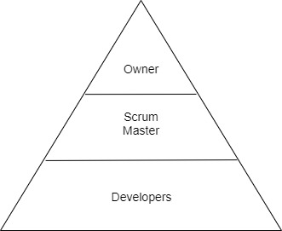

Responsibilities
The team of the project has the following responsibilities:
- Technical Manager: SHAHRIAR HASAN SAJID, SOTA KUROSAWA
- Project Manager: S M ZAHID HASAN

Customer -User involvement

The end users are the ultimate users of goEng English learning application. This app elaborates the basic concept of the school going students who will have a basic idea on how the conceptual functionalities work in developing their skills.

Meeting: We tried to show our app to the students of ‘Sekolah Sukan Tunku Mahkota Ismail’. The students of the school came to see our app in groups and got a vast idea about the basic functionalities of the app goEng.

Reviews: The students gave a positive review about our works and suggested some great ideas about how we can elevate our app modules that might help the end users to increase the usability of the app.

Tasks – Planning - Milestones

Task | Planning | Milestone
Gather Materials | Gather Materials study materials and internal files for the project
Implement App materials for Building purposes | Subtotal programming between programmers to solve this issue within one/two weeks | Milestone 1
Interface Design | Team tasks to design the interface of the project | Milestone 2
Prototype Design | Team works to manage the prototyping of the whole system module | Milestone 3
Scene Transition Manager | Team Programming to design the transitions program
Vocabulary Lesson Design | Team programming to design the Vocabulary lesson interface, making sure it meets the International IOS language standards.
Vocabulary Exercise Design | Team programming to design the interface of the Exercise and include task manager for further progress. | Milestone 4
User testing & Feedback | In this phase we will give end users to test our product and gather feedback
Deployment | Testing the ease of usage and affordability of the system for future uplifts of various functionalities | Milestone 5

Engineering environment
For our IOS app, we can have hosted server for the backend tasks. We can get hosted server which will cost $5. But there is no front end needed, though a nice admin system is always nice to have. IOS app engine is the main prospect here that plays the ultimate role.

Other Resources
The resources from where we could take some technical references and user interface examples, are quite similar to our application though there are so many changes and improvements made.
For example: Duolingo. This is another English learning app in which the motivation is almost the same; learning app.
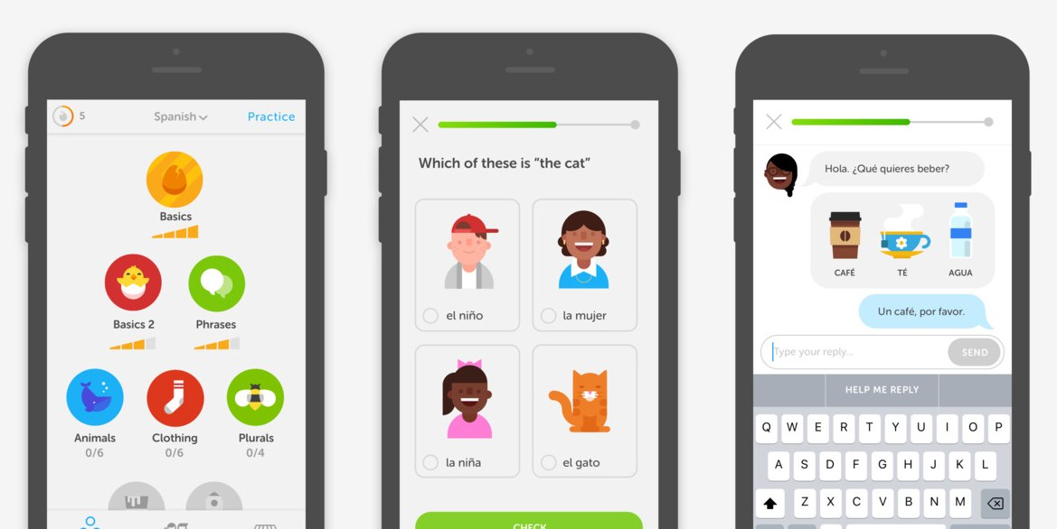
Figure 1: Duolingo interface
’
Another app is, Improve English: Word Games
This app has some technical similarities with our app. Both of the apps’ main motto is to teach English in a fun way.

Figure 2: Improve English

If specific resources are needed for the project such as a calibrated measurement tool or a simulator, they shall be identified, referenced and managed in configuration.
If not, add the following sentence
There is no particular resource needed for the project such as a calibrated measurement tool or a simulator. Hence, no specific identification of resources is needed for the project, the hardware and software resources are interchangeable COTS.

Software life cycle model
To describe our app’s software lifecycle model, our app is Agile. Our software development comprises various approaches to software development under which requirements and solutions evolve through the collaborative effort of self-organizing and cross-functional teams and our customer/end user.

Reviews
We tried to show our app to the students of ‘Sekolah Sukan Tunku Mahkota Ismail’. The students of the school came to see our app in groups and got a vast idea about the basic functionalities of the app goEng.

The students gave a positive review about our works and suggested some great ideas about how we can elevate our app modules that might help us/the developers to increase the usability of the app.

Software configuration management
Describe configuration management: what tool do you use. What are the repositories (eg:work, integration, delivery, final).

Documentation management
We, therefore, had to collect all the vital and important documents before designing the interface of the whole app. Before making the design interface, we gathered all the important information necessary to build our app, together. As for this, we used google drive where we shared all of our thoughts and ideas that helped us to build the app later on.

Verification

The verification is done by the students who are our goal end-users. They tested the app on their own and gave us satisfactory reviews and suggested some pleasant ways to make is better.

Specifications
This chapter is an extract of the Software Requirements Specifications template. Have a look at the SRS template to see some examples of requirements.

States
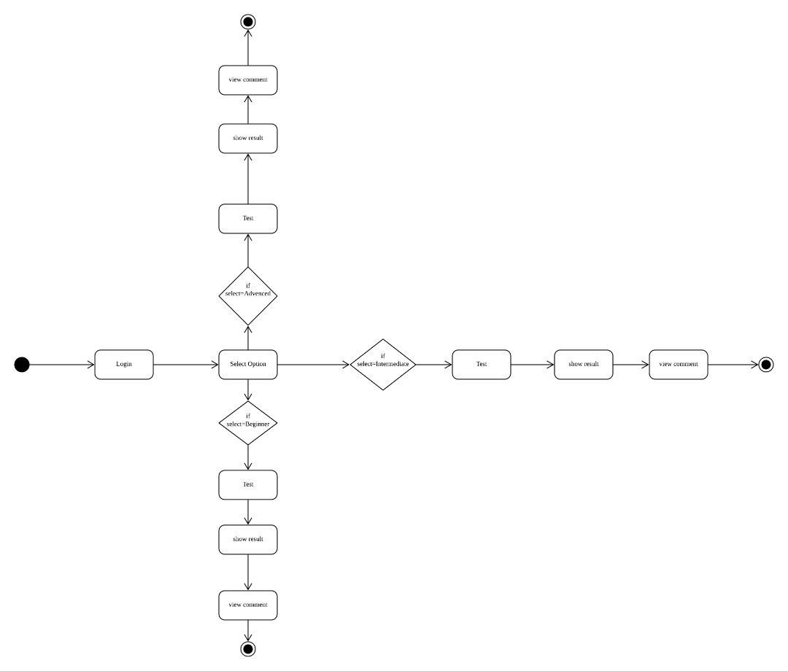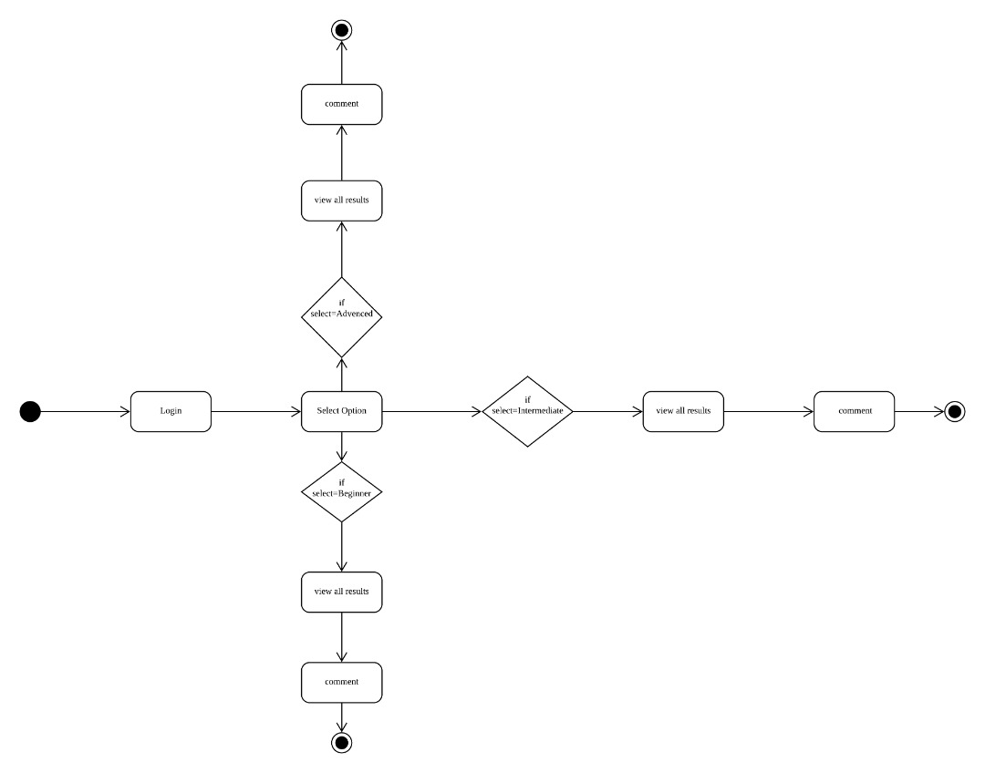
Figure 3: State diagram

Performance
The functions of the application are gravely tested as the concern of performance was always a big issue. The app installation, launching time, jumping over one page to another, usability and all; all these things were tested very gravely. The launching time of the app is almost 0.5 seconds, that gives a smooth performance for the users. So far, no lacking or hanging issue has not been found yet.

Safety, security, and privacy protection
Confidentiality: To describe about the confidentiality of the application, our app ensures the personal documents to be archived. The personal documents of the end users are inaccessible and the security system is kept totally void.

Integrity Control: Our app is designed to manage the integrity of the user data, as it is kept as the fundamental component of information security. We ensure to apply rules that verify the database and database operations, ensuring that data is not corrupted by applying integrity control features that are informed by the authority or controlling department of the application system.

Reliability: In terms of security management system and cyber security functions, our app is totally reliable. Reliability issues are totally kept under utter seriousness that might never be harmful for the end users.

Availability: This app is totally capable enough to be used or obtained all the time according to the end users’ time schedule. It will always be functioning when its needed, under any operating conditions.

User maintenance

Update > Delete > Create > Read

With this circular process, the user (student & teacher) will get into the internal functionalities of the system.

Usability and human-factors engineering
The requirements here may have traceability with result of 62366 standard implementation

Man machine interface layout

System control & user actions:

Tap | One-finger press, lift | Select
Swipe | One-finger press, move, lift | Drag
Long press | One-finger press, wait, lift | Drop
Pinch-open | Press and hold, IOS 3D button | Zoom in
Pinch-closed | Two-finger press, move, inwards, lift | Zoom out

Design with scale in mind:

Screen Resolution | Dpi | Pixel ratio | Image size (pixels)
xxxhdpi | 640 | 4.0 | 400 X 400
xxhdpi | 480 | 3.0 | 300 X 300
Xhdpi | 320 | 2.0 | 200 X 200
hdpi | 240 | 1.5 | 150 X 150
mdpi | 160 | 1.0 | 100 X 100

Help
As our application will be used offline, so the help option for the end users has not been kept yet.

System environment
Our application is an IOS ordained system, that can be found in the IOS App Store.

External interfaces
We used ‘Flutter’ for building our app which is a open source UI software development kit, created by Google. We used ‘Visual Studio Code’ for the coding part.

Hardware interfaces

The application will be held on iPad Pro 9.7 inch, iPadOS 13.2.3, as iPad mini is not available in our environment.

Network interfaces
N/A

Data exchange
The user will exchange data since the launching of the application. From log-in to log-out, the user will be exchanging data that would take the user to the different functionalities of the application system.

Resources
The application be run in iOS devices while it’s offline. There is no time limit or authentication estimated in scheduling the application run time.

Hardware resources
Laptop, MacBook Pro, Tab

Software resources
Windows, Mac OS, flutter, vs Code

Internal data
If specific requirements for internal data, like databases, binary files, xml …

Adaptation
Only on iOS

Verification
Special functions to test the software, if necessary. For example, a hidden function to activate a log file during beta tests

Personnel and training
Requirements about the capabilities/knowledge of users, the training the shall have before using software

Packaging and installation
The application will be found on App Store; simple installation process that we globally use for other applications.

Architecture – Conception

Architecture

Architecture overview
Though this application works anywhere, it is expected to be used especially in classes at schools. This application is intended to be used by both students and teachers. Students are able to learn and test their English regarding Chapter 3: Wild Weather in the textbook, and teachers are able to see how the students perform and leave a comment to students.

Logical architecture overview
There are two types of users, students and teachers. Users are differentiated by their IDs. When students make an attempt to answer questions, all the answers will be stored in offline database. After the questions, students are able to see their results. At the same time, teachers are also able to see their result after students’ attempt. Teachers will leave a comment regarding each student’s result. From the time teachers leave a comment, students are able to see comments. This application runs on iOS.

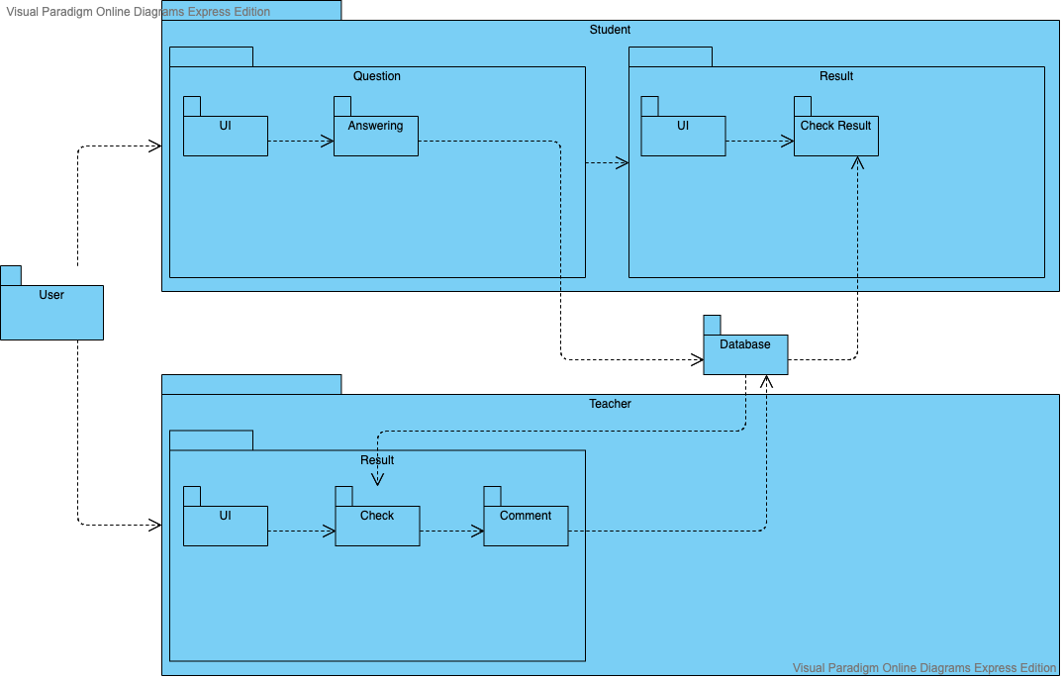
Figure 4: Package diagram

Physical architecture overview
As this application is intended to operate on offline iPad mini, no networking or other hardware required.

Conception

Verification

Test Plan

Test environment
Test for this application will be held on iPad Pro 9.7 inch, iPadOS 13.2.3, as iPad mini is not available in our environment. For test recording, Microsoft Office will be used.
The test will be carried on based on this documentation, and result will be recorded on this documentation as well.

Customer/ Field test site
As the application runs on offline iPad, field test is not necessary.

Tests Description

Test identification and content
Each test is unique and contains:
- A unique identifier,
- A textual description of test objective,
- The traceability of the requirement(s) in §3,
- The verification method (I, A, D, T),
- Data recording, post-processing and analysis procedure,
- Assumptions and constraints, if any
- Safety, security and privacy concerns, if any.

The identifier has the following structure:
The test IDs consist of three elements. The first digit of a test ID shows T for Test, and the second shows the test is for whether student module or teacher module. If the second digit is S, the test is for student module, and if T, for teacher module.

Tests description
The traceability between tests and requirements in §3 and tests below is listed in the §7 Requirements traceability.
A requirement may require more than one test to be verified. In this case, it appears in all tests, which verify it.

Describe each test with the pattern below.
For most of tests, only a subset of fields in the table is used, mark N/A (non applicable) the unused fields.

Test ID | T-S-001
Test description | Tests register process.
Verified Requirement |  | Verification method: I,A,D,T
Initial conditions | The user is in register page.
Tests inputs | Input data to register.
Data collection actions
Tests outputs | Forward to login page.
Assumptions and constraints
Expected results and criteria | Forwarded to login page. | The info keyed in is stored in database.
Test procedure
Step number | Operator actions | Expected result and evaluation criteria
1 | Key in user’s registration info | User keys in the registration info
2 | Tap submit button | Forwarded to login page.

Test ID | T-S-002
Test description | Tests login process.
Verified Requirement
Initial conditions | The user is in login page.
Tests inputs | Username and password. | Registered info in T-S-001
Data collection actions
Tests outputs | Forward to user’s home, upon successful login.
Assumptions and constraints
Expected results and criteria | Forwarded to user’s home screen upon successful login, or stay login screen if incorrect login credentials. | If the user is in the correct home screen for the user.
Test procedure
Step number | Operator actions | Expected result and evaluation criteria
1 | Key in wrong student’s username and password.
2 | Tap login button. | Stays login screen.
3 | Key in correct student’s username and password
4 | Tap login button | Student forwarded to student’s home screen.

Test ID | T-S-003
Test description | Tests answering and score calculation process.
Verified Requirement
Initial conditions | User is in home screen. | Output of T-S-002
Tests inputs | Answers for each question. | Any input for each question.
Data collection actions | Record input for each question.
Tests outputs | Score for the answers keyed in. | OP1
Assumptions and constraints
Expected results and criteria | Score for the answers keyed in. | Score shown by system and actual score has to be same.
Test procedure
Step number | Operator actions | Expected result and evaluation criteria
1 | Choose level in the home screen. | Chosen level started.
2 | Answer each question. | Answers

Test ID | T-S-004
Test description | Tests viewing score history.
Verified Requirement
Initial conditions | The user has completed any of questions, and located on home screen.
Tests inputs | Tap the level previously attempted.
Data collection actions | Record whether the result is shown.
Tests outputs | Shown result screen.
Assumptions and constraints
Expected results and criteria | Result screen showing result. | Score shown by the system has to be correct score.
Test procedure
Step number | Operator actions | Expected result and evaluation criteria
1 | Tap any level previously completed. | Forwarded to score result screen, showing previous result.

Test ID | T-S-005
Test description | Tests comment from teacher.
Verified Requirement
Initial conditions | Student has attempted any level previously,  Teacher commented on student’s result, and  Student is on home screen.
Tests inputs | Tap the level previously attempted and commented by a teacher
Data collection actions | Record whether the correct comment shown.
Tests outputs | Result screen with comment.
Assumptions and constraints
Expected results and criteria | Result screen showing previous result and teacher’s comment.
Test procedure
Step number | Operator actions | Expected result and evaluation criteria
1 | Tap any level teacher has commented. | Forwarded to score result screen, showing previous result and teacher’s comment.

Test ID | T-T-001
Test description | Tests login.
Verified Requirement
Initial conditions | The user is on login screen.
Tests inputs | Login ID and password.
Data collection actions
Tests outputs | Forwarded to home screen, upon successful login.
Assumptions and constraints
Expected results and criteria | Forwarded to user’s home screen upon successful login, or stay the login screen if incorrect login credentials.
Test procedure
Step number | Operator actions | Expected result and evaluation criteria
1 | Key in wrong teacher’s username and password.
2 | Tap login button. | Stay in login screen.
3 | Key in correct teacher’s username and password.
4 | Tap login button. | Forwarded to teacher’s home screen.

Test ID | T-T-002
Test description | Tests view student’s result.
Verified Requirement
Initial conditions | The user is in home screen.
Tests inputs | Tap view result button, and choose students from a list.
Data collection actions
Tests outputs | Forwarded to chosen student’s result page.
Assumptions and constraints
Expected results and criteria | Forwarded to chosen student’s result page.
Test procedure
Step number | Operator actions | Expected result and evaluation criteria
1 | Tap view result button. | Forwarded to page showing list of students.
2 | Tap student’s name. | Forwarded to student’s result page.

Test ID | T-T-003
Test description | Tests commenting feature.
Verified Requirement
Initial conditions | The user is on student’s result page. | Screen shown in T-T-002.
Tests inputs | Any comment in string.
Data collection actions
Tests outputs | Comment shown in student’s result page.
Assumptions and constraints
Expected results and criteria | Comment shown in student’s result page.
Test procedure
Step number | Operator actions | Expected result and evaluation criteria
1 | Key in comment in text box.
2 | Tap submit button. | Comment is stored in database and the comment is shown in student’s result page.

Test ID | T-001
Test description | Tests logout feature.
Verified Requirement
Initial conditions | The user is logged in and not on answering question.
Tests inputs | Tap logout button.
Data collection actions
Tests outputs | User logged out.
Assumptions and constraints
Expected results and criteria | User logged out.
Test procedure
Step number | Operator actions | Expected result and evaluation criteria
1 | Tap logout button. | User logged out.

Tests Results

Rationale for decision
After executing a test, the decision is defined according to the following rules:
- OK: The test sheet is set to "OK" state when all steps are in "OK" state. The real result is compliant to the expected result.
- NOK: The test sheet is set to "NOK" state when all steps of the test are set to "NOK" state or when the result of a step differs from the expected result.
- NOT RUN: Default state of a test sheet not yet executed.
- NOT COMPLETED (NC): The test sheet is set to "Not Completed" state when at least one step of the test is set "Not Run" state.

Results
Give a few information about tests.
The goEng software (version 1) was tested from the 2019/12/22 to the 2019/12/23. The tests of the test phase (ref. software test plan) where executed.
Testers where: SOTA KUROSAWA

Repeat the list of tests, with one more column named “result”.
In result, add OK or NOK or Not Run. If NOK, add a bug id.

Test ID | T-S-001
Test description | Tests register process.
Verified Requirement |  | Verification method: I,A,D,T
Initial conditions | The user is in register page.
Tests inputs | Input data to register.
Data collection actions
Tests outputs | Forward to login page.
Assumptions and constraints
Expected results and criteria | Forwarded to login page. | The info keyed in is stored in database.
Test procedure
Step number | Operator actions | Expected result and evaluation criteria | Result
1 | Key in user’s registration info | User keys in the registration info | OK
2 | Tap submit button | Forwarded to login page. | OK

Test ID | T-S-002
Test description | Tests login process.
Verified Requirement
Initial conditions | The user is in login page.
Tests inputs | Username and password. | Registered info in T-S-001
Data collection actions
Tests outputs | Forward to user’s home, upon successful login.
Assumptions and constraints
Expected results and criteria | Forwarded to user’s home screen upon successful login, or stay login screen if incorrect login credentials. | If the user is in the correct home screen for the user.
Test procedure
Step number | Operator actions | Expected result and evaluation criteria | Result
1 | Key in wrong student’s username and password. |  | OK
2 | Tap login button. | Stays login screen. | OK
3 | Key in correct student’s username and password |  | OK
4 | Tap login button | Student forwarded to student’s home screen. | OK

Test ID | T-S-003
Test description | Tests answering and score calculation process.
Verified Requirement
Initial conditions | User is in home screen. | Output of T-S-002
Tests inputs | Answers for each question. | Any input for each question.
Data collection actions | Record input for each question.
Tests outputs | Score for the answers keyed in. | OP1
Assumptions and constraints
Expected results and criteria | Score for the answers keyed in. | Score shown by system and actual score has to be same.
Test procedure
Step number | Operator actions | Expected result and evaluation criteria | Result
1 | Choose level in the home screen. | Chosen level started. | OK
2 | Answer each question. | Answers | OK

Test ID | T-S-004
Test description | Tests viewing score history.
Verified Requirement
Initial conditions | The user has completed any of questions, and located on home screen.
Tests inputs | Tap the level previously attempted.
Data collection actions | Record whether the result is shown.
Tests outputs | Shown result screen.
Assumptions and constraints
Expected results and criteria | Result screen showing result. | Score shown by the system has to be correct score.
Test procedure
Step number | Operator actions | Expected result and evaluation criteria | Result
1 | Tap any level previously completed. | Forwarded to score result screen, showing previous result. | NC

Test ID | T-S-005
Test description | Tests comment from teacher.
Verified Requirement
Initial conditions | Student has attempted any level previously,  Teacher commented on student’s result, and  Student is on home screen.
Tests inputs | Tap the level previously attempted and commented by a teacher
Data collection actions | Record whether the correct comment shown.
Tests outputs | Result screen with comment.
Assumptions and constraints
Expected results and criteria | Result screen showing previous result and teacher’s comment.
Test procedure
Step number | Operator actions | Expected result and evaluation criteria | Result
1 | Tap any level teacher has commented. | Forwarded to score result screen, showing previous result and teacher’s comment. | NC

Test ID | T-T-001
Test description | Tests login.
Verified Requirement
Initial conditions | The user is on login screen.
Tests inputs | Login ID and password.
Data collection actions
Tests outputs | Forwarded to home screen, upon successful login.
Assumptions and constraints
Expected results and criteria | Forwarded to user’s home screen upon successful login, or stay the login screen if incorrect login credentials.
Test procedure
Step number | Operator actions | Expected result and evaluation criteria | Result
1 | Key in wrong teacher’s username and password. |  | OK
2 | Tap login button. | Stay in login screen. | OK
3 | Key in correct teacher’s username and password. |  | OK
4 | Tap login button. | Forwarded to teacher’s home screen. | OK

Test ID | T-T-002
Test description | Tests view student’s result.
Verified Requirement
Initial conditions | The user is in home screen.
Tests inputs | Tap view result button, and choose students from a list.
Data collection actions
Tests outputs | Forwarded to chosen student’s result page.
Assumptions and constraints
Expected results and criteria | Forwarded to chosen student’s result page.
Test procedure
Step number | Operator actions | Expected result and evaluation criteria | Result
1 | Tap view result button. | Forwarded to page showing list of students. | OK
2 | Tap student’s name. | Forwarded to student’s result page. | OK

Test ID | T-T-003
Test description | Tests commenting feature.
Verified Requirement
Initial conditions | The user is on student’s result page. | Screen shown in T-T-002.
Tests inputs | Any comment in string.
Data collection actions
Tests outputs | Comment shown in student’s result page.
Assumptions and constraints
Expected results and criteria | Comment shown in student’s result page.
Test procedure
Step number | Operator actions | Expected result and evaluation criteria | Result
1 | Key in comment in text box. |  | NC
2 | Tap submit button. | Comment is stored in database and the comment is shown in student’s result page. | NC

Test ID | T-001
Test description | Tests logout feature.
Verified Requirement
Initial conditions | The user is logged in and not on answering question.
Tests inputs | Tap logout button.
Data collection actions
Tests outputs | User logged out.
Assumptions and constraints
Expected results and criteria | User logged out.
Test procedure
Step number | Operator actions | Expected result and evaluation criteria | Result
1 | Tap logout button. | User logged out. | OK

Requirements traceability
This table gives the traceability between requirements and tests, and the method of test.

The verification methods of the requirements are defined below:
- Inspection (I): control or visual verification
- Analysis (A): verification based upon analytical evidences
- Demonstration (D): verification of operational characteristics, without quantitative measurement
- Test (T): verification of quantitative characteristics with quantitative measurement

For each requirement of the SRS, a verification method is defined. Method is abbreviated I, A, D or T.

For each requirement, there shall be at least one test.

Req. ID | Req. label | Test ID | Test desc. | Meth
SRS-RQ-000 | Login | T-S-002, T-T-001 | Tests login | D
SRS-RQ-001 | Register | T-S-001 | Tests registration process | D
SRS-RQ-002 | View question & give answer | T-S-003 | Tests answering and score calculation process. | D
SRS-RQ-003 | Calculate result | T-S-003 | Tests answering and score calculation process. | A, D
SRS-RQ-004 | Show result | T-S-003  T-S-004 | Tests answering and score calculation process.  Tests viewing score history. | D
SRS-RQ-005 | Give comment | T-T-003 | Tests commenting feature. | D
SRS-RQ-006 | Logout | T-001 | Tests logout. | D
SRS-RQ-007 | Logout | T-001 | Tests logout. | D

