Image Processing Shopping Cart Tagger

___________________________

An Applied Research Paper for

CPE 521 (Project Design 2)

Presented to the

Faculty of the Department of Computer Engineering

University of Cebu – Main Campus

___________________________

In Partial Fulfillment

of the Requirements for the Degree

BACHELOR OF SCIENCE IN COMPUTER ENGINEERING

___________________________

By

Jubel Q. Alferez

Seigfred Geil Gregory Cañete

John Lumanog

March 2020

**Acknowledgement**

The researchers would like to express our deepest appreciation to our project design advisors, Engr. Nenette Alvarez, Engr. Myrth Manlangit, and Engr. Leodegario Gatcho who had enough patience and understanding in guiding them in the process of making the research paper. They continually and convincingly conveyed a spirit of adventure in regard to research and an excitement in regard to research to teaching. Without their guidance and persistent help, this study would not be possible.

The researchers would also like to thank the people who took the time to answer the survey questions about this study.

The researchers would also like to thank their family and friends for supporting and encouraging them to pursue in making this study. Without their encouragement, the researchers would not have finished this study.

To our God Almighty, thank you for guiding us all the way from the start of this study and for giving us the good health that ended us to finish our study.

**Abstract**

People tend to buy products that they will consume every day. They want to check the price and weight of a product that they need in order to comply some certain requirements for example are their budget and load that they can carry for health purposes. So, what if people use the image processing that will be applied to their mall or department stores experience?

Image processing is the use of computer algorithms to perform image processing on digital images. It is among rapidly growing technologies today, with its applications in various aspects of a business. Image processing has many advantages over analog image processing. It allows a much wider range of algorithms to be applied to the input data and can avoid problems such as the build-up of noise and signal distortion during processing.

Image processing is more accurately defined as a means of translation between human visual system and digital imaging devices. The human visual system does not perceive the world in the same manner as digital detectors, with displaying devices imposing additional noise and bandwidth restrictions. The researchers chose this topic because this can help ease the life of people that can use the price & weight checker right on the shopping cart.

**Table of Contents**

**Chapter 1: THE PROBLEM AND A REVIEW OF RELATED LITERATURE**

This chapter presents the problem, the related readings, literature and studies after the thorough and in-depth search done by the researchers. This will also present the synthesis and justification of the art, theoretical and conceptual framework to fully understand the research to be done.

**Related Readings**

A grocery store isn’t just made of ice cream and discount sales. They are real businesses with real business problems. Below is an overview of four major problems faced by grocery stores everywhere.

Grocery stores deal with fragile inventory every day, such as fruit that quickly spoils and boxes and cans that are vulnerable to damage. In fact, the inventory shrink rate at grocery stores is more than double that of retail stores across the board.

Grocery store inventory must survive the perilous journey from the manufacturer to the store to the shelves to the hands of the consumer. This includes loading, transporting, unloading, storing and stocking—all of which leave goods open to expiration, theft, loss and harm.

You may not think of a grocery store as a particularly dangerous place to work. But consider all the potential hazards: rolling equipment, messy spills, heavy lifting, sharp cutting tools and high stacks of products, just to name a few. One study revealed that 83% of non-cashier grocery store employees reported a musculoskeletal disorder over a one-year period.

Grocery store customers are exposed to many of the same dangers as employees. Some of the risks to customers include jagged edges on carts or shelves, slippery floors and items falling from shelves.

Grocery stores can take a big hit when customers are injured. Defending slip and fall injury claims cost grocery stores some $450 million every year.

Grocery store floors, walls, shelves and display cases take a beating from the everyday use of rolling machinery. Add on top of that the millions of shopping carts used by consumers that scrape, scratch and scuff infrastructure, and you’re left with some costly and recurring maintenance expenses.

The risk of damage extends to the property of customers as well. Stores have been forced to pay for cars damaged by runaway shopping carts in their parking lots.

**Related Literature**

There is a wide and varied literature pertinent to this study drawn from the fields of economics, nutrition, international development, retailing, social science, and geography. These previous studies are reviewed under the following categories: (1) food security, access, and rights, (2) hunger and health, (3) grocery stores, and (4) studies on grocery store access.

The US Department of Agriculture (USDA) defines food security as the ability for people to have "assured access, at all times, to enough food for an active, healthy life" (Andrews, 1999, 1). The World Bank (n.d., para. 1) adds to this definition the need for "quality, quantity, and diversity" of food. The Food and Agriculture Organization (FAO) broadens these definitions: food security is "a situation that exists when all people, at all times, have physical, social and economic access to sufficient, safe and nutritious food that meets their dietary needs and food preferences for an active and healthy life" (FAO, 2001, Glossary). Finally, Leidenfrost (1993, 2nd definition) notes that a minimum definition of food security also includes "an assured ability to acquire acceptable foods in socially acceptable ways (e.g.; without resorting to emergency food supplies, scavenging, stealing, or other coping strategies)".

The term "food security" was originally coined as a way of addressing food-related problems in industrializing countries (World Bank, 1986). Household food security is often assessed in terms of a multi-tiered rating system: food secure, food insecure without hunger, and food insecure with hunger. Food insecure with hunger can be sub-divided into moderate or severe hunger. With moderate hunger, adults reduce their own food intake, often for the sake of children. Severe hunger is where the children of a household also have their food intake reduced (Ohio Hunger Task Force, 2001).

**Theoretical Framework**

**Conceptual Framework**

**Statement of the Problem**

The main objective of this research is to create a product which improves the customer experience when shopping in departments stores, malls and markets.

Specifically, the study aimed to answer the following:

1. Determine the most common problems when it comes to customer experience when shopping in supermarkets.

2. Identify the necessary processes on how to detect objects with its price and weight efficiently.

3. Utilize Image Processing model to eliminate hassle when checking a product’s price and weight

4. Create a different and technological way of customer’s shopping experience.

**Significance of the Study**

The purpose of this paper is to develop a comprehensive set of grocery store attributes that can be standardized and used in empirical research aiming at increasing retailers’ understanding of determinants of grocery store choice, and assessing how the relative importance of the attributes is affected by consumer socio-demographic characteristics and shopping behavior.

**Scope and Limitation**

The system can check the price & weight of an object through the camera. The device will be put on top of the shopping cart. It has an application that the user can add products and it will automatically calculate the total price & weight that the user ordered.

However, the system can only detect orange, apple and banana because the object model is still limited to fruits only. In order to achieve more objects to be detected, the researchers should train a model and import large amounts of images from a single object and this process can consume lots of time.

**CHAPTER 2: METHODOLOGY**

The Chapter presents the research design methods and procedure

used in order to gather the information needed and necessary data in the study. It presents research setting, population and respondent, the data gathering procedures and instruments.

**Research Design**

The gathering of data was obtained through the use of questionnaires about this research which is a smaller group of elements drawn through a definite procedure from an accessible population. The researchers have also conducted interviews on various supermarkets and grocery stores to further understand their opinions regarding the subject matter.

Descriptive research is a purposive process of data gathering, analyzing, classifying and tabulation and interpretation of data about prevailing conditions, practices, processes and the cause-effect relationships.

**Research Setting**

The gathering of data was conducted at Colon St., Cebu City where Metro Colon Supermarket resides. According to the 2015 census, it has a population of 922,611 people, making it the fifth-most populated city in the nation and the most populous in the Visayas.

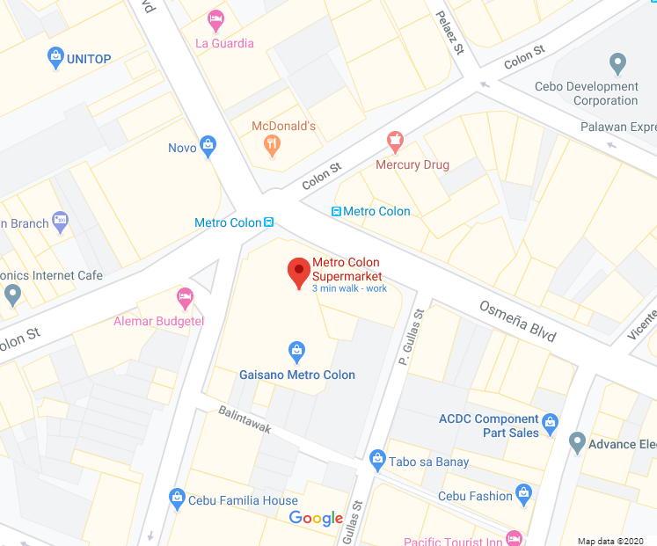

**Respondents of the Study**

The respondents of the study are fifty (50) selected customers of Metro Colon whose daily activities includes to be buying products in grocery. The

respondents were chosen through simple random sampling and also considering the availability of the respondents. It is also categorized by their age from 18 – 50. The respondents were different genders. Sampling is the method by which a researcher chooses a group of respondents. Simple random sampling is the basic sampling technique where we select a group of subjects (a sample) for study from a larger group (a population). Each individual is chosen entirely by chance and each member of the population has an equal chance of being included in the sample.

**Data Gathering Procedures**

Before conducting the gathering of data from the respondents, the researchers made a formal letter of request addressed to the respondents and noted by the research adviser, asking the respondent’s permission to gather such information by answering all the questions in the questionnaire.

**Data Gathering Instruments**

A questionnaire was used as a data gathering instrument. The questionnaire contains seven (7) questions which can be used to gather information and the opinions of the respondents. The questionnaire consisted mostly of close-ended ended questions. Closed-ended questions were included because they are easier to administer and to analyze. They are also more efficient in the sense that a respondent is able to complete more closed-ended items than open-ended items in a given period of time. A questionnaire is a printed self-report form designed to elicit information that can be obtained through the written responses of the subjects.

**Statistical Treatment**

After answering the questionnaire, the researchers covered all the necessary information and organized the responses to each questionnaire. The data gathered was tabulated, summarized and tallied for further analysis. All entries were double checked to ensure the accuracy and the reliability of the results.

**Definition of Terms**

**Image Processing** - is the use of a digital computer to process digital images through an algorithm. As a subcategory or field of digital signal processing, digital image processing has many advantages over analog image processing.

**Digital Image** - is an image composed of picture elements, also known as pixels, each with finite, discrete quantities of numeric representation for its intensity or gray level that is an output from its two-dimensional functions fed as input by its spatial coordinates denoted with x, y on the x-axis and y-axis, respectively.

**Algorithm -** a process or set of rules to be followed in calculations or other problem-solving operations, especially by a computer.

**Bandwidth** - the transmission capacity of a computer network or other telecommunication system.

**Signal Distortion** - Distortion, in acoustics and electronics, any change in a signal that alters the basic waveform or the relationship between various frequency components; it is usually a degradation of the signal. Straight amplification or attenuation without alteration of the waveform is not usually considered to be distortion.

**Grocery** - a grocer's store or business. Items of food sold in a grocery store.

**Object Detection** - Object detection is a computer technology related to computer vision and image processing that deals with detecting instances of semantic objects of a certain class (such as humans, buildings, or cars) in digital images and videos.

**CHAPTER 3: PRESENTATION, ANALYSIS AND INTERPRETATION OF THE DATA**

**CHAPTER 4: SUMMARY, CONCLUSIONS, AND RECOMMENDATIONS**

This chapter deals with the summary and findings of the study, the conclusion drawn from the data gathered and the researcher’s recommendations in improving this project.

**Summary of Findings**

The main objective of this research is to create a product which improves the customer experience when shopping in departments stores, malls and markets.

Specifically, the study aimed to answer the following:

1. Determine the most common problems when it comes to customer experience when shopping in supermarkets.
2. Identify the necessary processes on how to detect objects with its price and weight efficiently.
3. Utilize Image Processing model to eliminate hassle when checking a product’s price and weight
4. Create a different and technological way of customer’s shopping experience.

One of the most common problems for customers when shopping is the

line on the cashier when customer decides to purchase products.

**Conclusions**

Based on the findings from the data gathered, shopping experience needs to cope up with the technology today. Making innovative technology about shopping will help the customers less hassle and not a time-consuming shopping.

**Recommendations**

Based on the findings of the study, the researchers highly recommended the following:

* Import more objects to the model for object detection
* Develop a more user-friendly application for customers and cashier.

**References**

* Grocery: The Buying and Selling of Food in America (2017)

By Michael Ruhlman

* Deep Learning for Computer Vision (2018) by Adrian Rosebrock

**Appendices**

Questionnaire

Name (Optional) :________________________

Age: ____

1. Do you use shopping cart in supermarkets?

A. Yes B. No C. Sometimes D. Occasionally

2. Do you check the total price of the products in your shopping cart?

A. Always B. Never C. Sometimes D. Occasionally

3. How much do you spend in groceries in a day?

A. P0 - P500 B. P501 – P1000 C. P1001 – P2000

D. P2001 or more

4. Do you check the total weight of the products in your shopping cart?

A. Always B. Never C. Sometimes D. Occasionally

5. How many products do you buy in supermarkets in a day?

A. 1 - 5 B. 6 - 10 C. 11 – 15 D. 20 or more

6. Are you interested in a technology that should be on a shopping cart?

A. Yes B. No

7. Have you heard about image processing?

A. Yes B. No

8. Do you think barcode scanners in supermarkets is the best feature when doing grocery?

A. Yes B. No

9. Do you think shopping in supermarket is better than shopping online?

A. Yes B. No

10. Do you want a device on the shopping cart that can check the price & weight of a product?

A. Yes B. No